English Year 9 Summer 2 Blended Learning Booklet The Strange Case of Dr Jekyll and Mr Hyde

Name:
Form:
English Teacher:

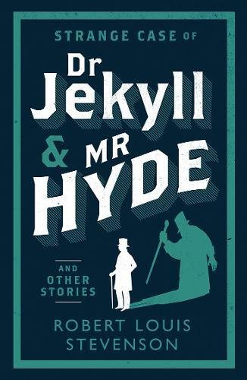

Page | Lesson Number | Title
2 | N/A | Y9 Overview
3 | N/A | Zoom In: Unit 2 Jekyll and Hyde
4 | N/A | Knowledge Organiser
5 | 1 | The Strange Case of Dr Jekyll and Mr Hyde
9 | 2 | The Story of the Door
11 | 3 | The Search for Mr Hyde
14 | 4 | Fear and Violence Extract
17 | 5 | The Carew Murder Case
19 | 6 | Newspaper Article
21 | 7 | The Incident of the Letter
24 | 8 | The Remarkable Incident of Dr Lanyon
26 | 9 | Theme of Violence
29 | 10 | The Incident at the Window
31 | 11 | The Last Night
34 | 12 | Dr Lanyon’s Narrative
36 | 13 | The Statement of the Case
39 | 14 | Fear and Terror
41 | 15 | Duality
45 | 16 | Science
47 | 17 | Reputation
50 | 18 | Trial of Dr Jekyll
52 | N/A | SAL

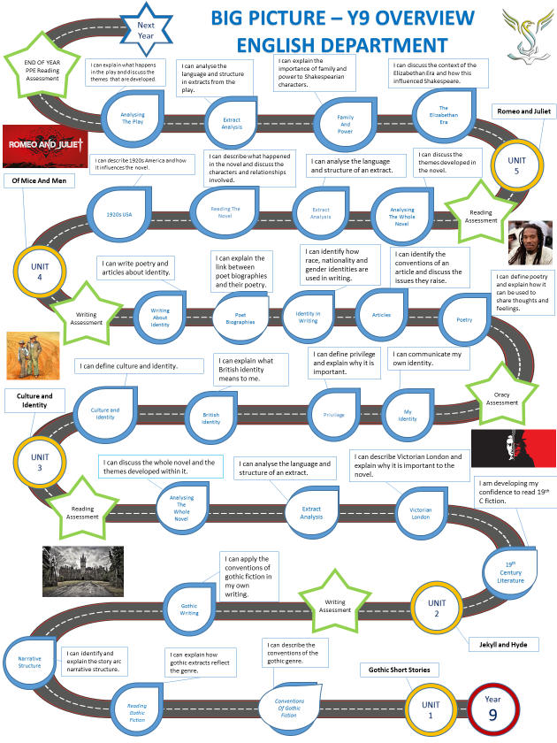

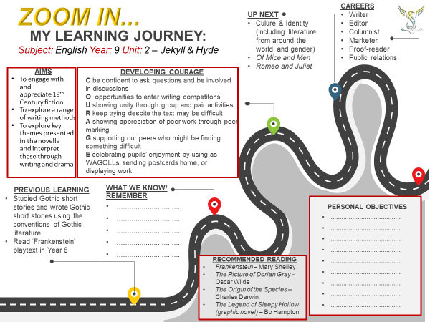

Plot summary  - The Story of the Door. On one of their regular walks, Mr Utterson and his friend Mr Enfield happen upon a door that reminds Mr Enfield of an assault he witnessed. A man called Mr Hyde trampled a young girl and, when caught by the girl’s family, paid them compensation. Hyde had a key to this door.  - Search for Hyde. Mr Utterson checks the will he made for his friend and client, Dr  Jekyll. It says that all of Jekyll’s wealth is to be given to this unpleasant Hyde. Utterson spies on the mysterious door and watches Hyde. He feels a deep dislike for him. He goes to warn Jekyll, but Jekyll isn’t in. Poole, Jekyll’s butler, says that the servants have been told to obey Hyde. In this chapter we also learn that Jekyll’s friend, Dr Lanyon, refuses to associate with Jekyll and his questionable scientific research.  - Dr Jekyll was Quite at Ease. A couple of weeks later, Dr Jekyll hosts a dinner party. Afterwards, Utterson questions Jekyll about Hyde. Jekyll confesses that his relationship with Hyde is unusual, but insists that he is in control of the situation.  - The Carew Murder Case. Just under a year later, Hyde clubs an elderly man to death in the street. A letter to Utterson is found on the body, so Utterson is called to the scene. Utterson identifies the murder weapon as part of a cane belonging to Jekyll, and takes the police to where Hyde is staying. Hyde is not there. However, they find the other half of the cane and signs Hyde left in a hurry.  - Incident of the letter. Utterson visits Jekyll and finds him looking extremely sick. He asks about Hyde. Jekyll says that Hyde has gone, and shows him a letter that says he is gone forever. Due to the similarity in handwriting, Utterson thinks that Jekyll forged the letter to cover for Hyde. He suspects Jekyll is being blackmailed. |  |  | - Remarkable Incident of Dr Lanyon. Jekyll is happier and more sociable until a sudden depression strikes and he refuses visitors. Utterson visits Lanyon, who is on his deathbed. Lanyon implies that Jekyll is the cause of his illness. Utterson writes to Jekyll and he replies saying that he is under a dark influence. Dr Lanyon dies, leaving a letter to be opened after the death or disappearance of Jekyll.  - Incident at the Window. Utterson and Enfield pass Jekyll’s window and see him sitting at it miserably. Utterson calls out to him and he looks at them in terror and despair, thrusting in the window shut. Shocked, Utterson and Enfield leave.  - The Last Night. Poole visits Utterson and asks him to come to Jekyll’s house immediately. Jekyll’s laboratory door is locked and the voice inside sounds like Hyde. For days, the voice has been asking for a chemical to be located and brought to him, but each time the chemical is rejected because it is not pure. Utterson and Poole break down the door to find Hyde’s twitching body. He has killed himself. They find a new will written by Jekyll in which everything is left to Utterson, and two letters: one is Jekyll’s confession letter and the other tells Utterson to read Lanyon’s letter first.  - Dr Lanyon’s Narrative. Lanyon’s letter reveals how he was asked by Jekyll to collect items from his laboratory and give them to a man who would call later that night. Hyde arrives and drinks a potion that transforms him into Jekyll. The shock of the experience causes Lanyon to fall ill.  - Henry Jekyll’s Full Statement of the Case. Jekyll’s letter reveals how he turned into Hyde. He created a potion to separate his ‘darker impulses’ and transform himself into a creature without a conscience. He became addicted to being Hyde until he was unable to turn back.
Key characters  Henry Jekyll – A respectable doctor known for his charitable work, but privately haunted by dark impulses. Edward Hyde – A violent, ugly man with no conscience. Jekyll’s alter ego.  Gabriel Utterson – A lawyer and close friend of Jekyll. The story is mainly told in the third person through him.  Hastie Lanyon – A friend of Jekyll and Utterson who disapproves of Jekyll’s scientific research.  Mr Enfield – A lifelong friend (and distant relative) of Mr Utterson, with whom he goes on regular walks.  Mr Poole – Dr Jekyll’s servant.  Sir Danvers Carew – a distinguished gentleman who is murdered by Hyde.  Mr Guest – Utterson’s clerk and a handwriting expert. | Key themes  - Duality/Contrast  - Mystery/Secrecy  - Human nature  - Friendship  - Reputation  - Social responsibility  - Appearance  - Violence  - Fear  - Transformation  - Supernatural/unknown  - The strange/abnormal | Context |  | Terminology & key words  - Allegory  - Ambiguity  - Antithesis  - Duality  - Dramatic irony  - Gothic  - Grotesque  - Metaphor  - Motif  - Third-person narrator  - Pathetic fallacy  - The supernatural  - Suspense  - Symbolism
 |  | Dr Jekyll and Mr Hyde represented a literary change for Stevenson. Unlike his previous stories Stevenson focused on a Gothic style, describing the story as a ‘fine bogey tale’.
 |  | Repression. Within Victorian society, rules on public behaviour were strict and to not follow these could lead to being outcast. Therefore, people had to learn to repress feelings/behaviours that were not accepted by society. The more Jekyll’s ‘forbidden’ desires are repressed, the more he desires being Hyde, and the stronger Hyde becomes.
 |  | Science vs. religion. Religion dictated that you should respect God’s work and not experiment with it. Jekyll uses his scientific knowledge to effectively ‘play God’. Also during this era, Darwinism first suggested that man was descended from apes, which made science a serious threat to the Church.
 |  | The nineteenth century was a time of huge scientific discoveries, technological progress and social growth. London was at the centre of this.
 |  | London’s population increased dramatically during this period. Overcrowding in slums was common, and many people lived in appalling conditions. Crime rates were high. Gruesome murder stories were popular.
 |  | Add your own example:

Lesson 1: The Strange Case of Dr Jekyll and Mr Hyde
L/I: To know the overview of the new unit and to understand the context of the novel.
Connect
Let’s recap:
What did you learn about the Gothic genre last half term? Where was Wild Boy set? What sort of characters do you expect in a gothic story?
Activate
Read the essay about Stevenson and the Victorian age and answer the questions that follow (DART).
Stevenson and the Victorian age
Stevenson was brought up in Edinburgh, a city which was clearly divided into the New Town where he lived, with its broad streets and imposing buildings, and the more rundown Old Town with its twisting alleyways and dilapidated buildings where poverty, crime and
prostitution were rife. Many critics feel that although the novel is set in London, Stevenson actually had the streets of Edinburgh in mind when he wrote it.
Stevenson was born into a strict Christian home. His religious upbringing, with its emphasis on sin, hell-fire and the battle between Good and Evil, frightened him so much that he suffered from nightmares for most of his life. He wrote The Strange Case of Dr Jekyll and Mr Hyde as a result of a bad dream, and many readers feel it has a strange nightmarish quality.
Victorian society seems very repressive to most of us today. If you wanted to be accepted by society, you had to be seen as respectable. A strict moral code prohibited sex outside of marriage, homosexuality was illegal and even discussion of such matters would have been considered very shocking. At the same time, there was enormous hypocrisy, as people kept up the appearance of respectability but acted quite differently in secret.
Stevenson was very interested in duality: a way of seeing the world as a series of oppositions. Although the ‘Jack the Ripper’ murders did not take place until two years after the publication of the novel, they became linked in the public mind with the theme of duality, especially as it was rumoured that the murderer was a gentleman.
The pursuit of scientific knowledge created some anxiety as there were fears that science was in effect ‘playing God’ and might run out of control. The work of Darwin on evolution meant that religious teaching was beginning to be questioned, and there was also interest in the emerging field of psychology.
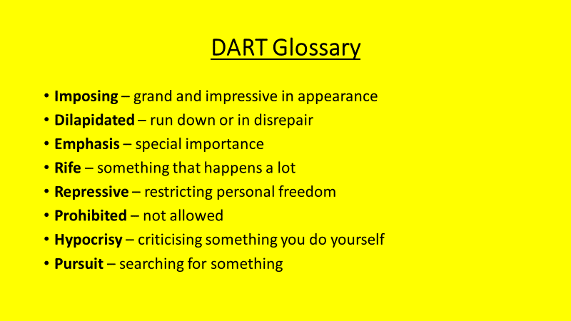

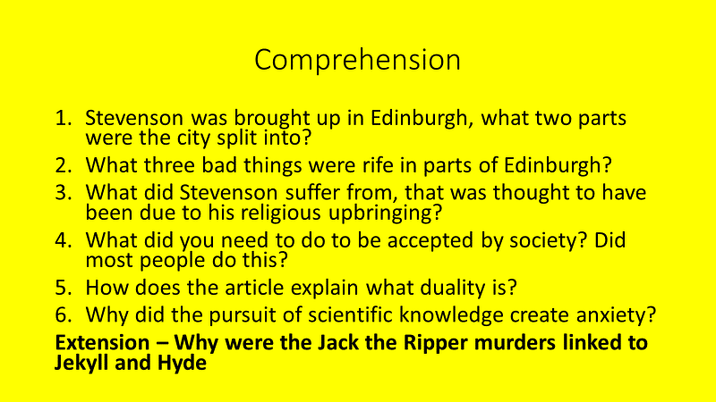
Demonstrate
Pre-Assessment - Answer the following questions: How do you think the average person in 1870 would react if:
- You told them humans were descended from apes?
- You said you didn’t believe in God?
- A teacher was seen in a pub late at night?

- You told them humans were descended from apes?
Charles Darwin published The Origin of the Species in 1859, it theorised that humans share a common ancestor with apes. The theory of evolution seemed to go against religious teachings that God made the Earth and created all living things, as they knew them.
2. You said you didn’t believe in God?
Throughout the Victorian age, religion was a dominant force in the lives of many. Social life for ordinary people revolved around choir and Sunday School outings. Many employers insisted that their employees go to church. However, there was a growing seam of doubt…
3. A teacher was seen in a pub late at night?
The Victorian era is famous for being prim and proper, even though there was a seedy 'underworld' of prostitution, drugs and crime in the 'wrong' parts of town. People in positions of authority had to be seen to be living ‘wholesome’ lives.
Write a description of what you have learnt about the context in which Jekyll and Hyde was written (DIP).
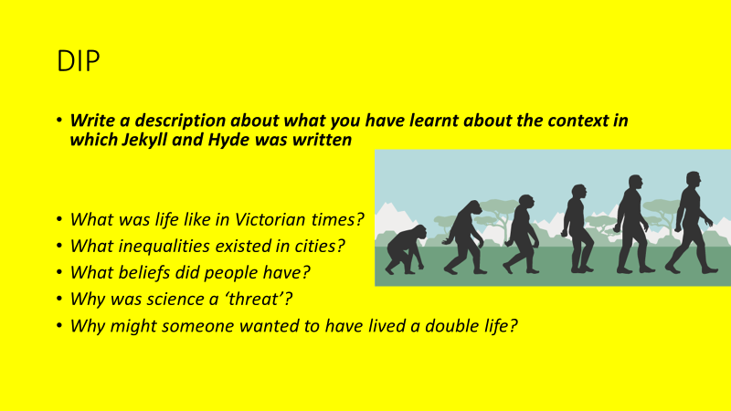
Consolidate
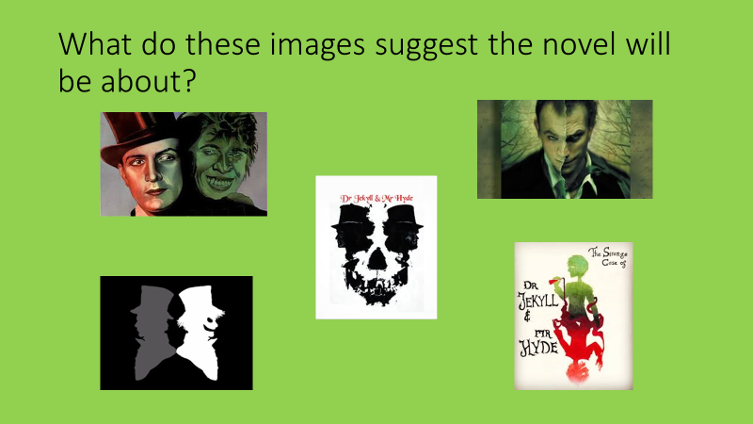
Key Questions
- What are the conventions of the gothic genre?
- Where was Wild Boy set?
- Where was Robert Louis Stevenson born?
- How is this city divided?
- What is duality?
- Why did the pursuit of scientific knowledge create anxiety?

Lesson 2: Chapter 1 – The Story of the Door
LI: To understand and analyse chapter 1
Connect
Context quiz, use your knowledge organiser - True or False:
- Stevenson was famous for his gothic stories.
- The Victorian era was unjudgmental about public behaviour.
- Some scientific experiments were considered blasphemous in Victorian times.
- The nineteenth century was a time of huge scientific discovery.
- Crime and poverty were a problem in nineteenth century London.

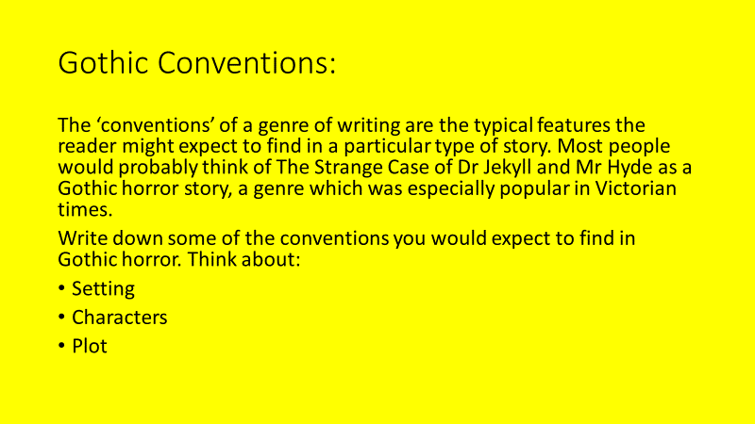

Activate
Read chapter 1 of the novel. Why does Stevenson make the following choices? (DART)
- Informing the reader what an honourable and trustworthy man Mr Utterson is?
- Showing that his friend Mr Enfield is out and coming home in the early hours of the morning?
- Choosing a little girl to be the victim of Hyde’s attack?
- Describing Mr Hyde as physically unpleasant to look at?
- Not telling the reader whose name is on the cheque?

Challenge - How can you relate what we have learnt about the genre of the novel and the context of the time to these choices?

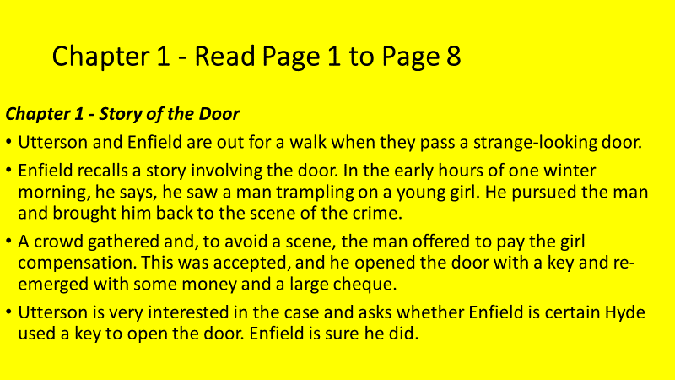
Watch chapter one summary for help: https://www.youtube.com/watch?v=cMTznZxHtwI
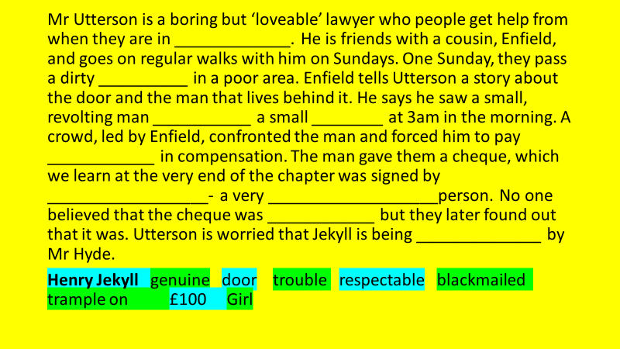
Demonstrate
What mood is established in the opening? (DIP)
- What is the mood?
- How is this shown (think of the specific events identified in the activate phase of the lesson)?
- Can you find quotes to support your answer?

Consolidate
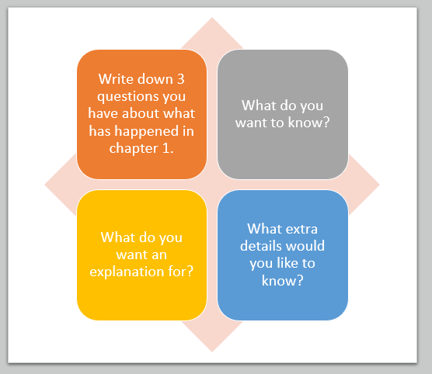
Key Questions
- What happens in chapter 1?
- What characters appear in chapter 1?
- What do we learn about Mr Hyde?
- How do context and genre influence Stevenson’s choices in chapter 1?
- What mood is established in the opening?
- What evidence do you have for this?

Lesson 3: Chapter 2 – Search for Mr Hyde
L/I – To explore the representation of Mr Hyde
Connect
What do we know about Mr Hyde?
Why is Utterson suspicious of him?
Activate
Chapter 1 recap:
What job does Mr Utterson do?
Who told him a story about a door?
What does he see a man do?
What is the man forced to do as a result?
What name is signed on the cheque?
Why might this be important for the rest of the story?

Read chapter 2 and answer the questions that follow (DART).
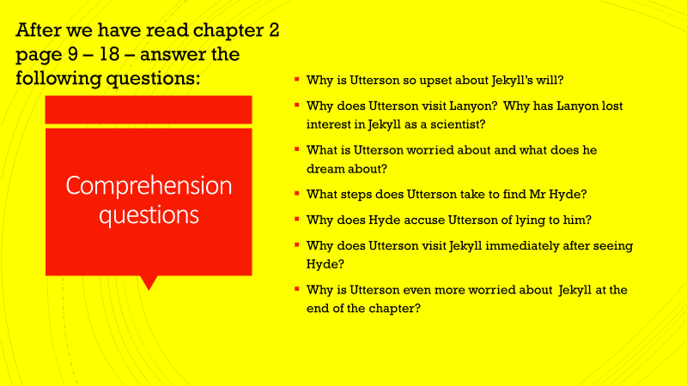
Watch chapter two summary for help: https://www.youtube.com/watch?v=xD1GTb9qDRw
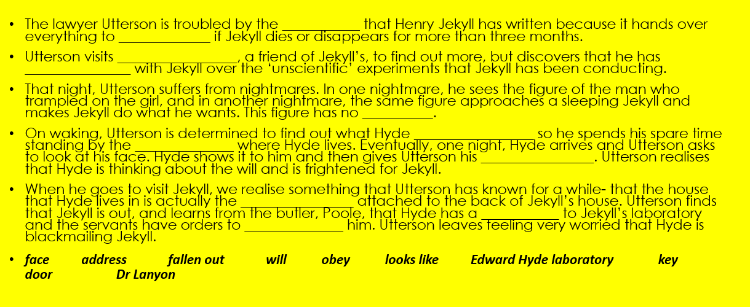
Read the information about apostrophes on the next page and complete the tasks that follow:
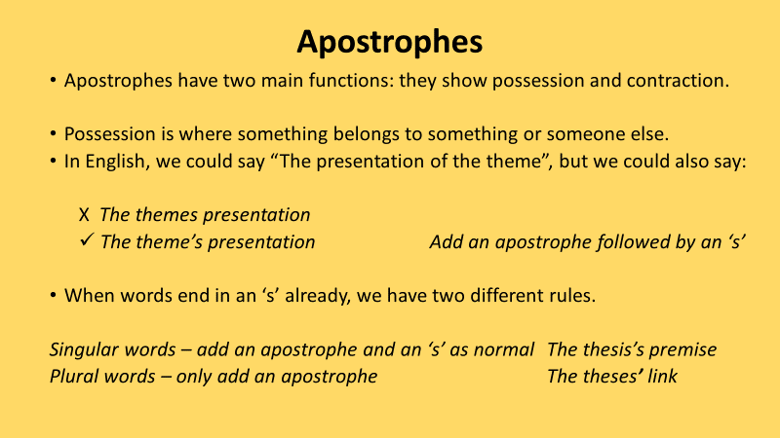
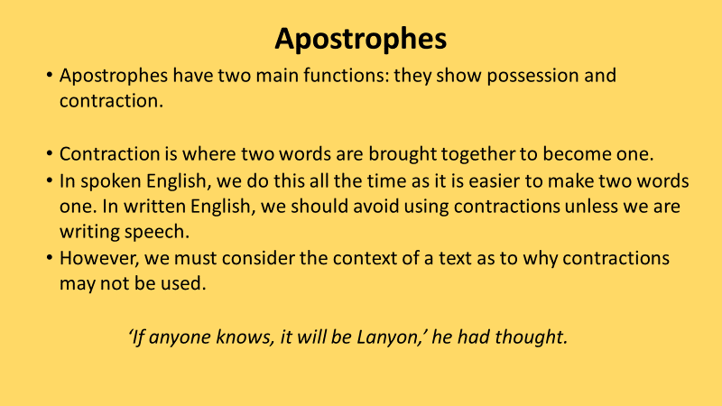
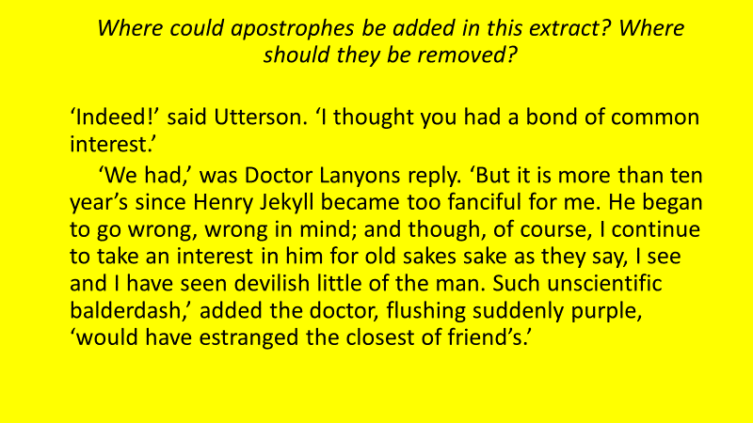
Demonstrate
What do the following quotes suggest about the character of Mr Hyde? What adjectives could be used to describe Mr Hyde? Write down five.
- “He spoke with a husky, whispering and somewhat broken voice;”
- “The other snarled aloud into a savage laugh”
- “Mr. Hyde shrank back with a hissing intake of the breath.”
Explode each quote (identify the two key words in each quote and what they show)
How has Mr Hyde been presented in the opening of the novel? (DIP)
WAGOLL: Hyde is presented as violent, powerful, and remorseless. For example, he ‘snarled aloud in a savage laugh’. The verb snarled suggests he sounded like an aggressive animal whereas the adjective ‘savage’ suggests he is dangerous and out of control. This shows Stevenson wants the reader to be suspicious of Hyde as a character and to assume he is up to no good.
Consolidate
What does Utterson think of Mr Hyde? What does Utterson think of Dr Jekyll?
Key Questions
- What happens in chapter 2?
- Why is Utterson so upset about Jekyll’s will?
- Why is Utterson even more worried about Jekyll by the end of the chapter?
- How does Stevenson present Mr Hyde?
- How do you explode a quotation?
- What is word-level analysis and why is it important?

Lesson 4 - Fear and Violence
L/I – To explore Mr Hyde’s presentation as a violent character
Connect
Hyde is presented as… (identify three adjectives for each character)
Jekyll is presented as…
Utterson is presented as…
Activate
Jekyll is one of the novel’s eponymous characters, but the reader doesn’t encounter him until the third chapter.
Why do you think that Stevenson wanted to structure the novel in this way?
What do we know about him so far?

Watch chapter three summary for help: https://www.youtube.com/watch?v=DANqU8uYXRo

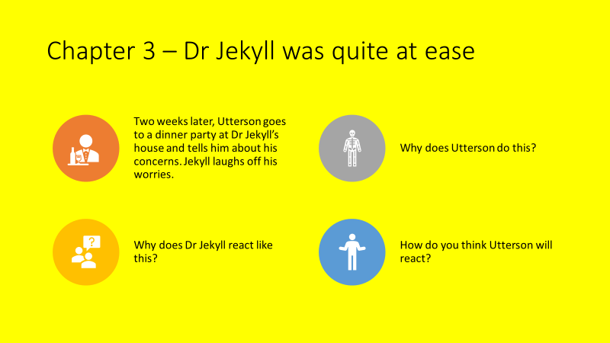

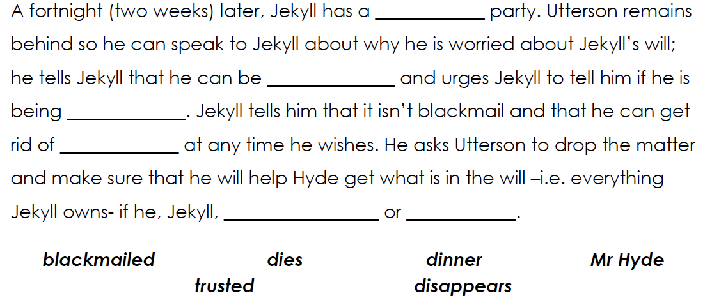

In the extract from chapter 1 Dr Lanyon is describing Hyde’s attack on the young girl. Read the extract and complete the tasks (DART).

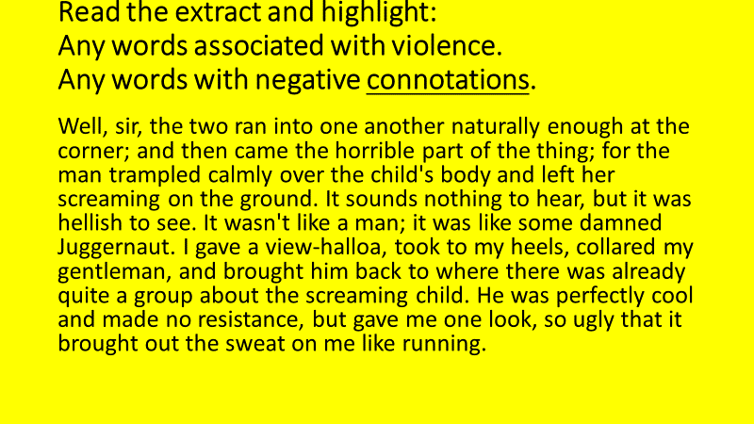
Demonstrate
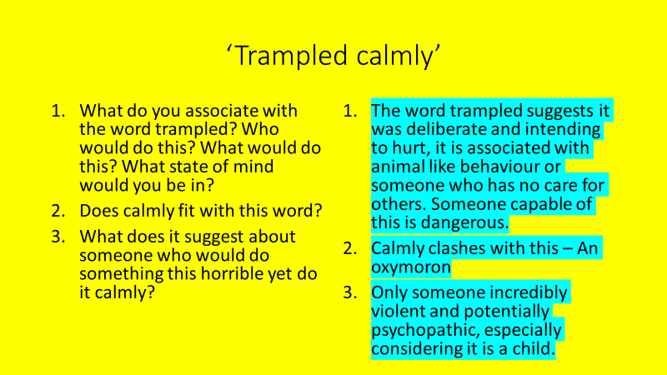
How is Mr Hyde presented as a violent character? (DIP)
- Explain the action he is described as doing
- Use the quote
- Explain the connotations and associations of the quote
- Does the quote you have identified relate to the context of the time?

WAGOLL: Stevenson presents Mr Hyde as a violent character. For example, he ‘trampled calmly’ on the young girl. The word ‘trampled’ suggests it was deliberate and he intended to hurt the girl. Trampled is associated with animal like behaviour or someone who has no care for others and someone capable of this is very dangerous. ‘Calmly’ is an oxymoron as it clashes with this; only someone incredibly violent and potential psychopathic is capable of behaving like this, especially considering the victim is a child. Public behaviour and reputation were very important during the Victorian era and therefore violence such as this would be particularly shocking to those who witnessed it.
Consolidate
What have you focused on today? How will it improve your analytical writing?
Key Questions
- What is an adjective?
- What adjectives describe Jekyll, Hyde and Utterson?
- How are Jekyll and Hyde different?
- How is Mr Hyde presented as violent?
- How do you structure an analytical paragraph?
- Why is context important to understanding a text?

Lesson 5: Chapter 4 – The Carew Murder Case
L/I: To understand the events of the Carew Murder
Connect
Which statement most accurately describes the character of Henry Jekyll in chapter 3?
- Charming, hospitable, and confident
- Defensive and uncooperative
- Evasive and secretive
- Lively, engaging, and friendly
Write a short paragraph using one (or more) of these sets of statements. Explain why you have chosen the adjectives you have.
Activate
In chapter 3 Utterson raises his concerns about Jekyll’s will and his friend’s general wellbeing with Jekyll. Read the extract and answer the questions that follow (DART):
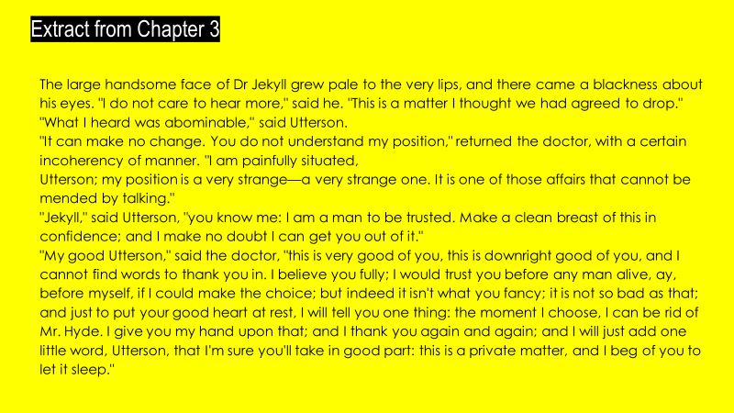
- What adjective describes Jekyll’s face?
- How does his face change?
- Why does this happen?
- What does abominable mean?
- Which word shows Dr Jekyll is confused or flustered by what Utterson says?
- How does Utterson try to persuade him to tell him the truth?
- How much does Jekyll say he trusts Utterson?
- Do you believe him?
- What ‘one thing’ does he tell Utterson?
- How does Jekyll finish the extract? What does this suggest about him?

Read chapter 4.
- Why might the maid not be a reliable witness?
- What had Mr Hyde done to his room?
- Why would tracking him down not be easy?
Watch chapter four summary for help: https://www.youtube.com/watch?v=h6A7C59hUkw 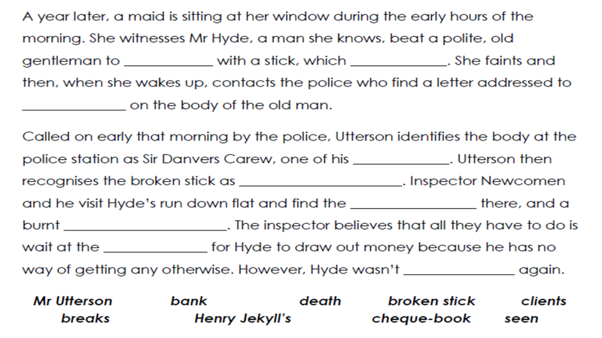
Demonstrate
Below is a description of Hyde’s brutal attack on Danvers Carew. Read the extract and complete the task below (DART).
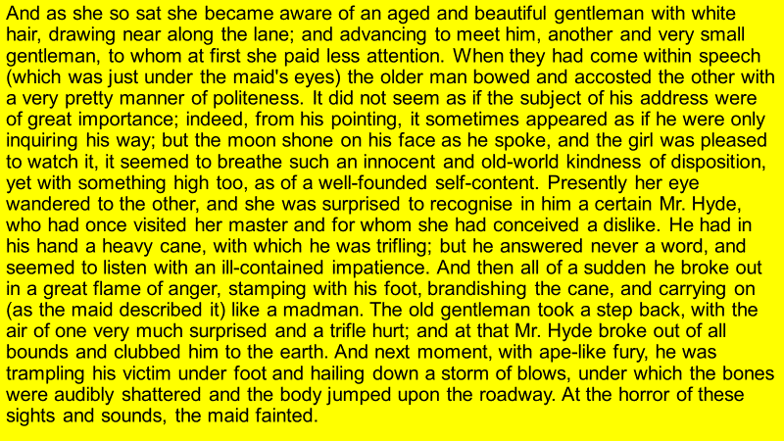
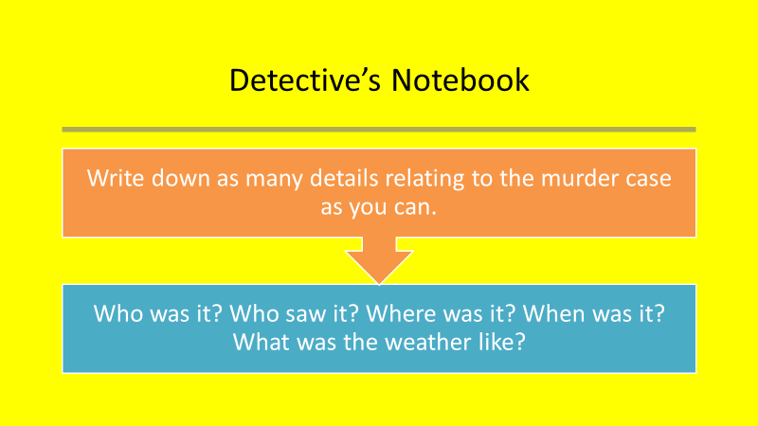
Consolidate
- Write a police report of the Carew murder case (DIP)
- Make sure you are as factual as possible, and you only write what you know or what you think you might know
Use the following to help you:
- Eyewitness saw it all through the window
- It happened at 11pm
- Sudden attack with the cane
- Intense violence- cane had snapped
- No money or valuables had been stolen
- Hyde is now missing

Key Questions
- How is Hyde presented in chapter 3?
- Why is the maid not a reliable witness?
- What happened in the murder case?
- When did it happen?
- What is the difference between a fact and an opinion?
- Where is Hyde now?

Lesson 6: Newspaper Article
L/I: To consolidate knowledge of and write a newspaper article about the Carew murder case
Connect
Look back at your notes the previous lesson. Write down five key details about the Carew murder case.
What is the purpose of a newspaper article? How is this similar/different to the type of report you wrote in the previous lesson? How will this impact what is written in a newspaper article?
Activate

Read the newspaper article below and complete the activities that follow (DART):
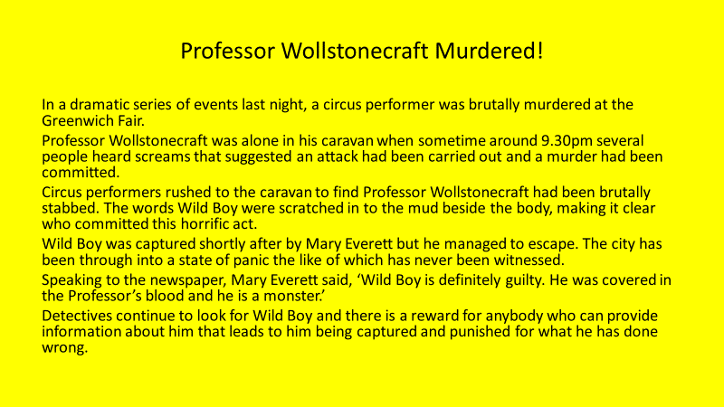
- Number the paragraphs
- What is each paragraph about?
- What is the key word in each paragraph?
- What is the purpose of each paragraph?
- What does this tell us about the conventions of a newspaper article?

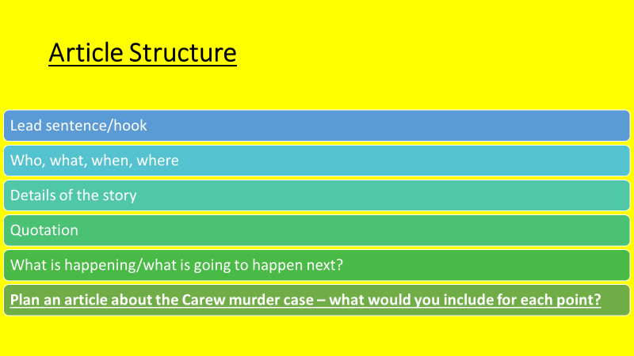

Demonstrate

How could you magpie the following lead sentence?

In a dramatic series of events last night, a young boy fell overboard from his family’s boat into the stormy water of the Coral Sea (off the east coast of Australia).

Write a newspaper article about the events of the Carew murder case (DIP).

Consolidate

Why might Utterson feel vindicated? Why was there a note for him left at the scene?

Key Questions
- How is Hyde presented in chapter 3?
- Why is the maid not a reliable witness?
- What happened in the murder case?
- When did it happen?
- What is the difference between a fact and an opinion?
- Where is Hyde now?

Lesson 7: Chapter 5 – Incident of the Letter
L/I: To explore the theme of deception
Connect
- What was the relationship between Sir Danvers Carew and Mr Utterson?
- What evidence exists to show who committed the murder?
- Why might Mr Hyde have targeted Mr Utterson through his actions?
Read chapter 5 – the chapter starts with Mr Utterson visiting Dr Jekyll. Why might he do this?

Activate
- Utterson visits Jekyll and finds him looking extremely sick.
- He asks about Hyde.
- Jekyll says that Hyde is gone and shows him a letter that says he is gone forever.
- Due to the similarity in handwriting, Utterson thinks that Jekyll forged the letter to cover for Hyde.
- He suspects Jekyll is being blackmailed.

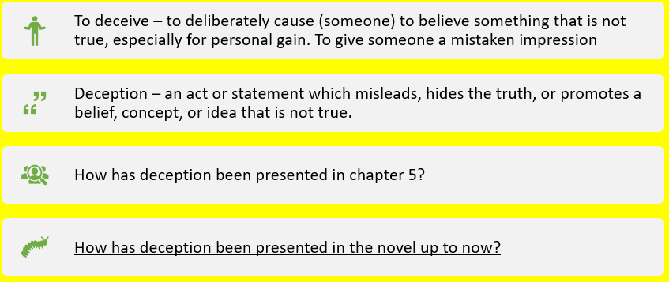

Watch the chapter five summary for help: https://www.youtube.com/watch?v=0UKVnCcQKlI

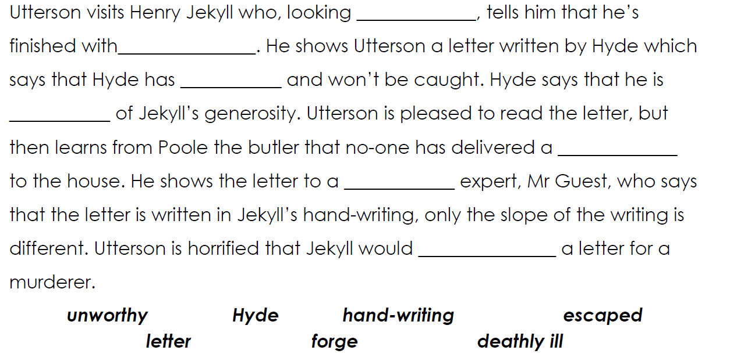

Read the interaction between Utterson and Lanyon and complete the tasks that follow (DART).

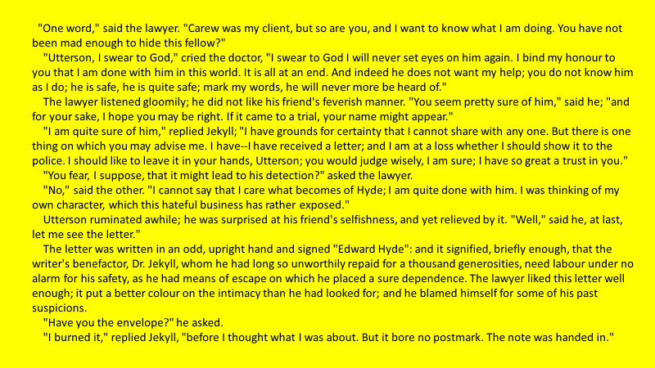

Highlight anything that suggests Utterson is being deceived
Underling anything which suggests Utterson suspects he is being deceived
Who is Utterson being deceived by?

Demonstrate
How has Stevenson created a sense of deception in the extract? (DIP)
Refer to specific examples of language and remember the definition of deception above.
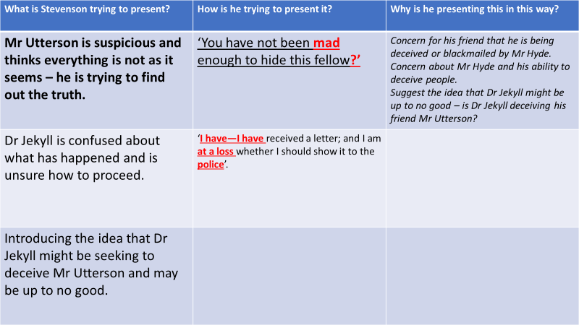

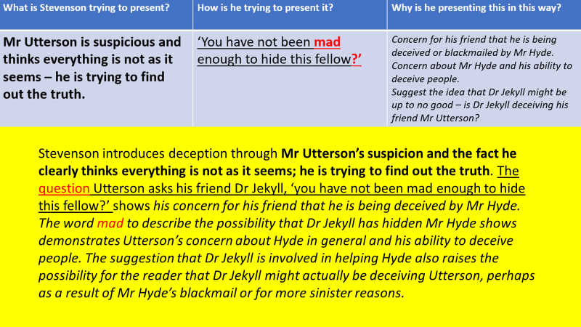
Consolidate
What have you focused on today? How will it improve your analytical writing?
Key Questions
- Why does Utterson visit Dr Jekyll?
- What does Dr Jekyll tell him?
- What does deception mean?
- How is Utterson being deceived?
- How is deception presented in the extract?
- What is the importance of word-level analysis?

Lesson 8: Chapter 6 – The remarkable incident of Dr Lanyon
L/I: To compare extracts from two parts of the novel
Connect
Who is Dr Lanyon? Where did we meet him earlier in the novel? What do we know about him?
What is Dr Lanyon’s opinion of Dr Jekyll? Why does he hold this opinion?
Activate
Chapter 6 Summary
- Jekyll is happier and more sociable until a sudden depression strikes, and he refuses visitors
- Utterson visits Lanyon, who is on his deathbed. Lanyon implies that Jekyll is the cause of his illness.
- Utterson writes to Jekyll and he replies saying that he is under a dark influence.
- Dr Lanyon dies, leaving a letter to be opened after the death or disappearance of Dr Jekyll.
Watch the chapter six summary for help: https://www.youtube.com/watch?v=JaKtVcMSycc
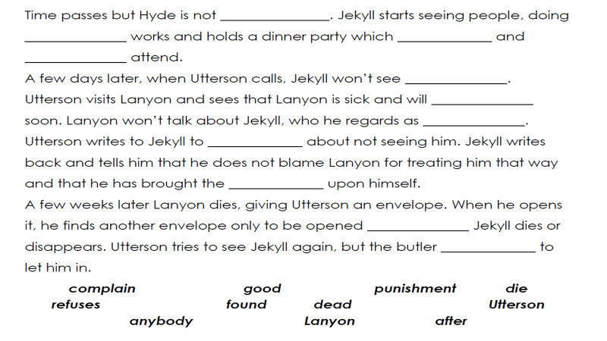
Read the two extracts about Dr Lanyon and complete the tasks below (DART):
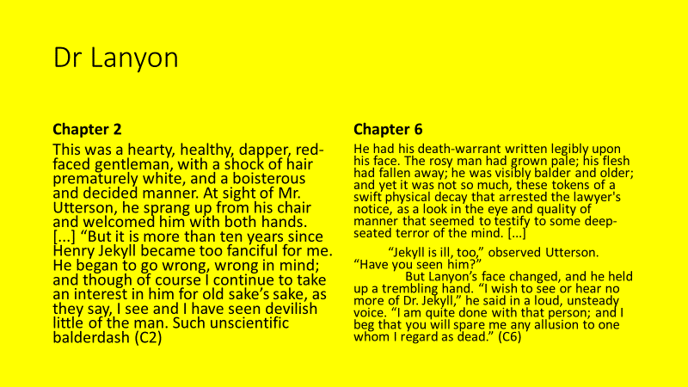
Write down five adjectives to describe Lanyon in chapter 2
Write down five adjectives to describe Lanyon in chapter 6
Identify three quotations from each extract that describes Lanyon
Why has he changed? Think of his own health and the influence of Dr Jekyll

Demonstrate
- How does Stevenson present Dr Lanyon in chapter 2 and chapter 6 of the novel? (DIP)
- In chapter 2 Dr Lanyon is presented as… (use the adjectives you have identified).
- For example…
- This shows…
- This suggests…
- By chapter 6 Lanyon is presented as…
- For example…
- This shows…
- This could be because…
- He has a letter which…
- This suggests…

Consolidate
Why do you think Stevenson chooses to do the following?
- Use the character of Mr Utterson as the main perspective. What do we know about him so far that suggests he won’t open the letter?
- Not let the reader know what the letter says.
- Not be clear on the cause of Dr Lanyon’s illness.
Challenge – What other mysteries are there still to be solved?
Key Questions
- What do you know about Dr Lanyon before now?
- What does he tell Utterson in this chapter?
- How is Jekyll presented in this chapter?
- Why is comparison important?
- How has Lanyon changed?
- Why has Lanyon changed?

Lesson 9: The Theme of Violence
L/I: To explore the theme of violence
Connect
Are some forms of violence more shocking than others?
What makes Hyde’s attacks on the girl and the murder of Sir Danvers Carew so shocking?
Activate
What do the following quotes tell us about what happened in chapter 6?
‘Utterson could not trust his eyes. Yes, it was disappearance; here again, as in the mad will. Here again were the idea of a disappearance and the name of Henry Jekyll’
‘A great curiosity came to the trustee, to disregard the prohibition, and dive at once to bottom of these mysteries; but professional honour and faith to his dead friend were stringent obligations’
Read the information about discourse markers and complete the activities that follow:
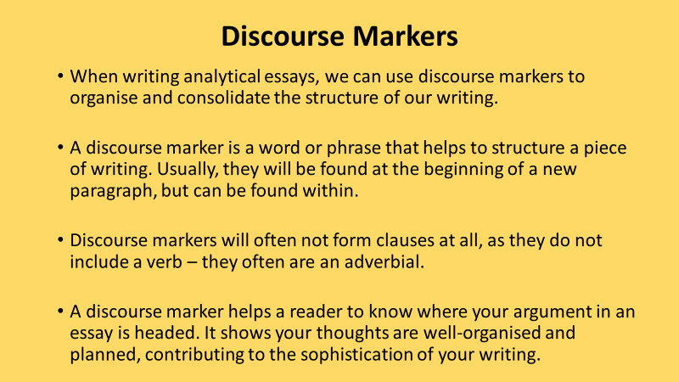
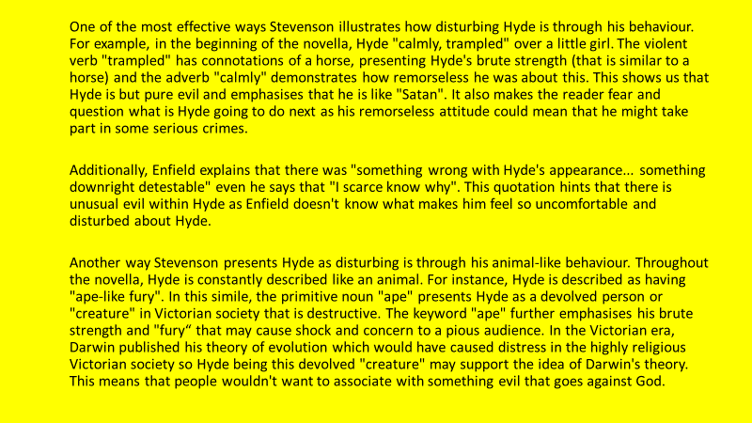
Demonstrate
How is Hyde shown to be a violent character in this extract? (DART)
Mr Hyde broke out of all bounds and clubbed him to the earth. And next moment, with ape-like fury, he was trampling his victim underfoot and hailing down a storm of blows, under which the bones were audibly shattered, and the body jumped upon the roadway. At the horror of these sights and sounds, the maid fainted.
Highlight any words associated with violence and anger. What connotations do these words have?
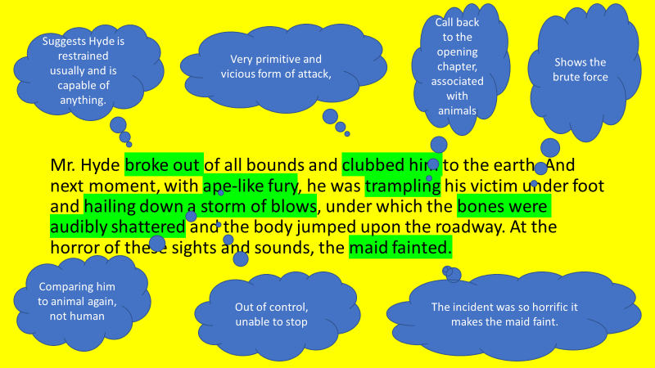
How is the theme of violence show in the extract? (DIP)
WAGOLL: The violent nature of My Hyde’s character is shown fully in this extract. He is described as having ‘broke out’ of all bounds, suggesting that what we have seen so far isn’t the full extent of what he is capable of. This is described in vivid detail as he is described as ‘clubbed him’ to death. The word ‘clubbed’ is associated with a cave man, emphasising the savage nature of his violence.
Challenge: Can you add a paragraph which discusses how violence is shown elsewhere in the novel? (Lessons 3 and 4 in your BLB might help you).
Hyde’s violence is also shown elsewhere in the novel…
Hyde’s attacks on the young girl and Sir Danvers Carew are particularly shocking because…
Consolidate
What questions remain to be answered in the rest of the novel? What do you think it says in Dr Lanyon’s letter?
Key Questions
- What does it mean to be a violent character?
- Why is the violence against the girl and Danvers Carew so shocking?
- How does Utterson feel about Hyde at this stage?
- How is Hyde presented as violent in the extract?
- Where else in the novel is he violent?
- Why is it important to consider the whole novel?

Lesson 10: Chapter 7 – The Incident at the window
L/I: To emulate Stevenson’s creation of a sense of mystery
Connect
What is mysterious about chapter 6? What three adjectives might describe Jekyll’s behaviour?
Activate
Read the information about narrative perspective and answer the questions that follow (the contents page might help you):
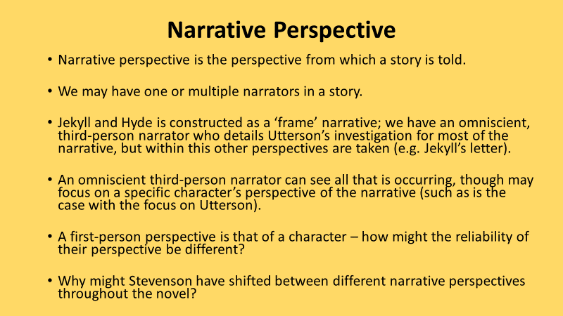
How many narrators are there in the novel?
Who are they?
What order do they narrate in?
Are these narrations from the first or third person perspective?
Why do you think this might be?

Read chapter 7
- Utterson and Enfield pass Jekyll’s window and see him sitting at it miserably.
- Utterson calls out to him, they have a brief pleasant conversation.
- Jekyll says he dare not go out; he isn’t well.
- Suddenly Jekyll looks at them in terror and despair, thrusting the window shut. Shocked, Enfield and Utterson leave.

Demonstrate

During chapter 7 Utterson spots Jekyll at the window. Read the extract and answer the questions that follow (DART).

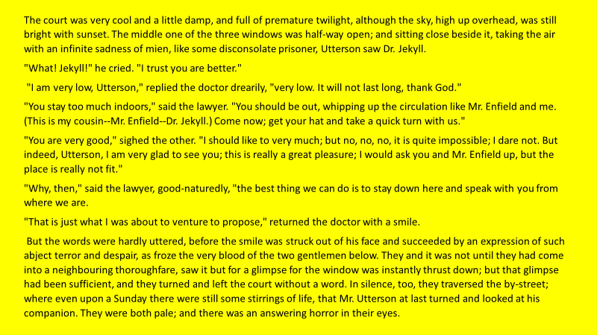
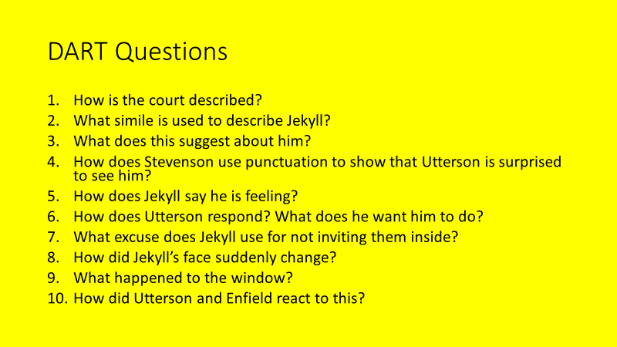

Write down three things that Jekyll says and three things that Utterson says during the extract

How are they each feeling?

What might Jekyll be hiding?

Does Utterson know?

Which previous events make Utterson suspicious of Jekyll?

Is Jekyll aware of this?

Consolidate

Divide a page in half. Look at your DART answers and your notes about Jekyll and Utterson. Write an account of the incident at the window from each of their perspectives. You should include the thoughts and feelings of the characters. (DIP)

Key Questions
- What does mysterious mean?
- How does Stevenson create mystery?
- What happens at the window?
- What is Jekyll hiding?
- How does Utterson view this incident?
- Why is perspective important?

Lesson 11: Chapter 8 – The Last Night
L/I: To identify and explain Jekyll’s strange behaviour and his transformation
Connect
Why is Utterson suspicious of Jekyll? What might Jekyll have been hiding during chapter 7?
Watch the chapter 7 summary for help: https://www.youtube.com/watch?v=1Y0urzHZjrY
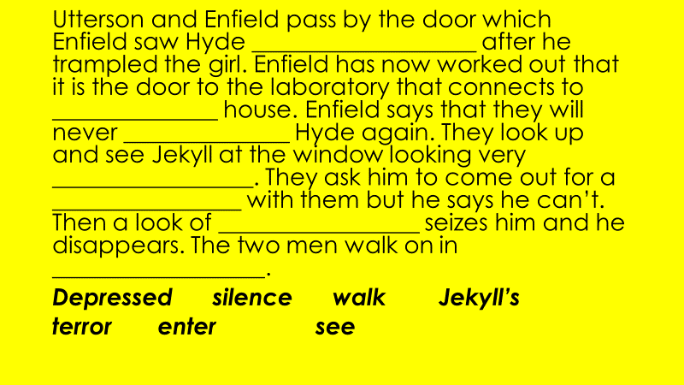
Activate
Read chapter 8
- Poole visits Utterson and asks him to come to Jekyll’s house.
- Jekyll’s laboratory door is locked and the voice inside sounds like Hyde.
- For days, the voice has been asking for a chemical to be located and brought to him, but each time the chemical is rejected because it is not pure.
- Utterson and Poole break down the door to find Hyde’s twitching body. He has killed himself.
- They find a new will written by Jekyll in which everything is left to Utterson, and two letters: one is Jekyll’s confession letter and the other tells Utterson to read Lanyon’s letter first.
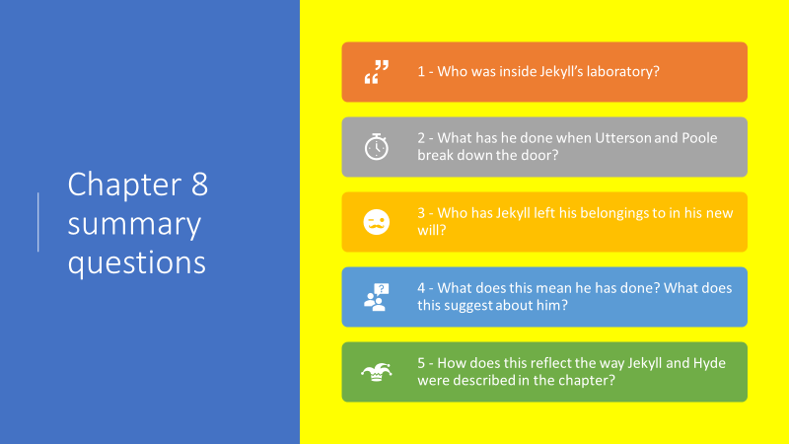
Demonstrate
Read the short letter from Jekyll to Utterson and complete the tasks that follow (DART):
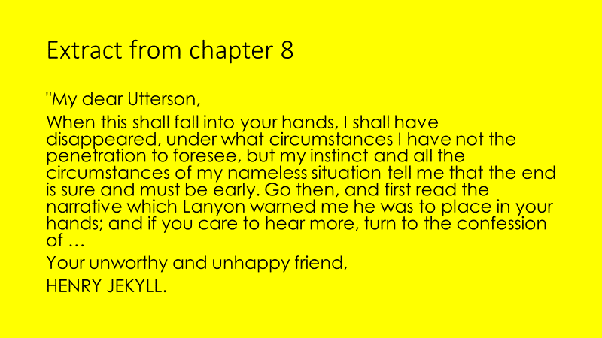
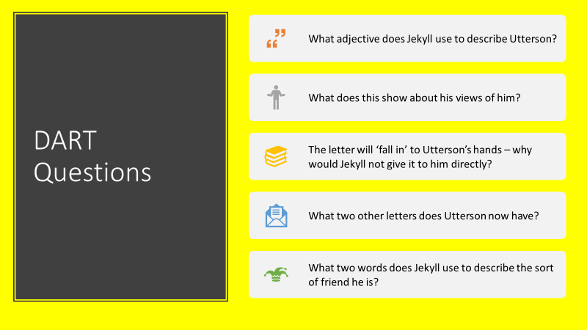
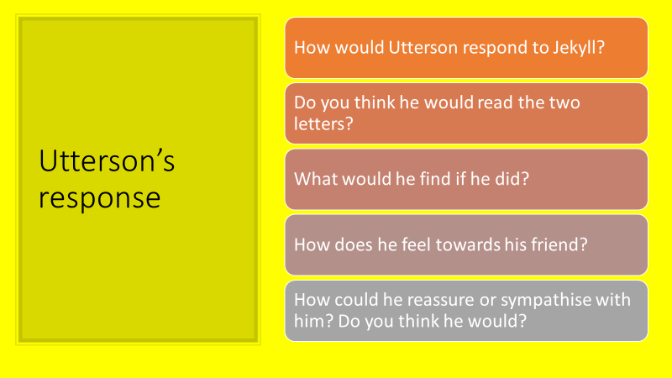
Consolidate
Write a letter from Mr Utterson to Jekyll (DIP).
Use your DART answers, notes from the previous slide, and sentence starters below to help you.
My dear old friend Henry,
I was pleased to see your letter, but I am most concerned about the predicament I fear you are in.
Key Questions
- Who was in Jekyll’s laboratory?
- What has he done?
- What do Utterson and Poole find?
- Why do you think Jekyll has changed his will?
- What does the first letter that Utterson reads say?
- How might he respond?

Lesson 12: Chapter 9 – Dr Lanyon’s Narrative
L/I: To study Stevenson’s use of the grotesque
Connect
What does grotesque mean? Name as many similar adjectives or things the word grotesque makes you think of as you can.
Watch the chapter 8 summary for help: https://www.youtube.com/watch?v=bgJNbAKDStc
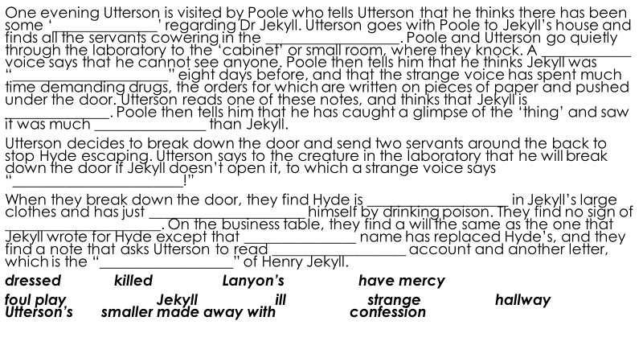
Activate
Read chapter 9
- Chapter 9 lists the contents of Dr Lanyon's letter.
- It tells of how Lanyon received a letter from Jekyll asking him to collect a drawer containing chemicals, a vial, and a notebook from Jekyll's laboratory and to give it to a man who would call at midnight.
- Lanyon says he was curious, especially as the book contained some strange entries.
- At midnight, a man appears. He is small and grotesque, wearing clothes that are too large for him.
- The man offers to take the chemicals away, or to drink the potion.
- Lanyon accepts and, before his very eyes, Hyde transforms into none other than Dr Jekyll. In horror at what he has witnessed, Lanyon becomes seriously ill.

Grotesque – a general adjective for the strange, mysterious, magnificent, hideous, incongruous, unpleasant or disgusting
What features of Jekyll and Hyde are grotesque?
Why would Victorian England have found what was happening particularly grotesque?

Read the description of Jekyll drinking the potion and answer the questions that follow (DART).

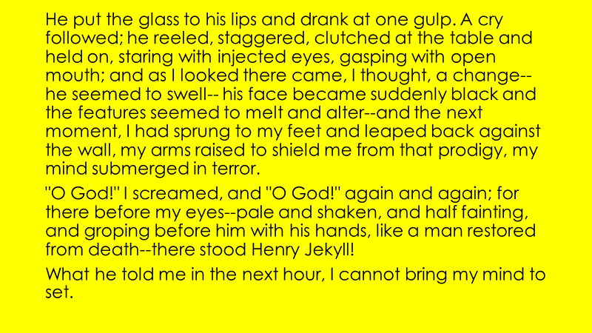
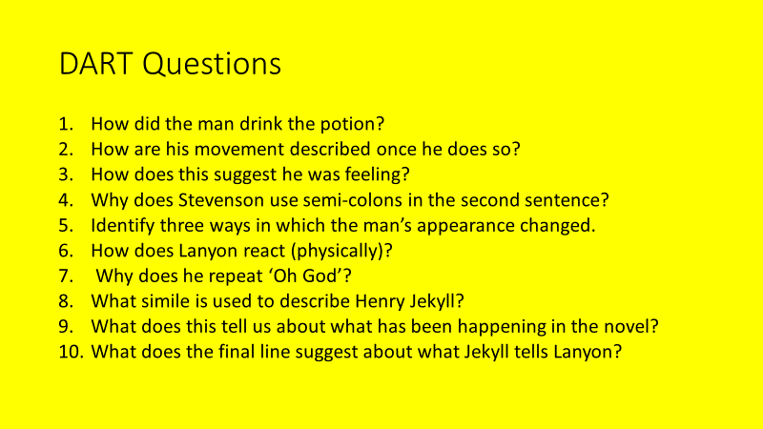
Write the moment that Jekyll took the potion in the first person (DIP)
Use the prompts and sentence starters to help you.

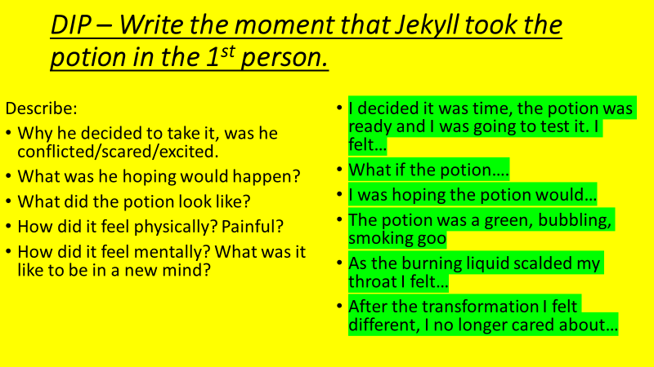
Consolidate
Self-assessment: what do you like about your work? What could you improve?
Key Questions
- What does grotesque mean?
- What other adjectives have a similar meaning?
- What happens in chapter 9?
- How does Lanyon react to what he sees?
- What does this tell us about Jekyll and Hyde?
- What is the first person?

Lesson 13: Chapter 10 – The Statement of the Case
L/I: To explore how Stevenson presents key themes in the end of the novella
Connect
What did Lanyon see? (Think ‘grotesque’) What has happened to Hyde? Why did Jekyll start to experiment?
Based on Jekyll’s narrative so far – how sympathetic or unsympathetic are you towards him?
Describe whether you feel sympathetic or unsympathetic towards Jekyll. How might hearing his version of events change your opinion?

Activate
Watch the chapter 9 summary for help: https://www.youtube.com/watch?v=QGOQa8_wzg4
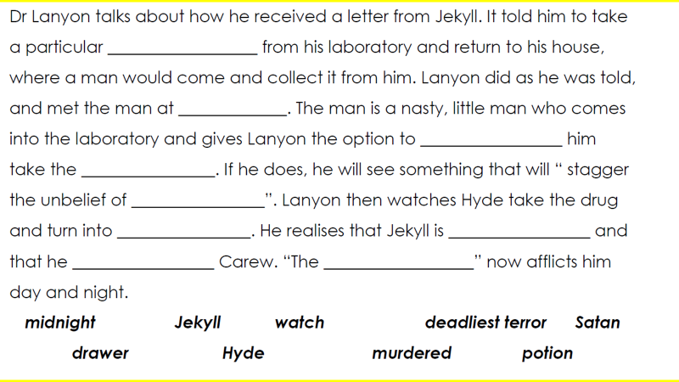
Read chapter 10
In the final chapter of the novella Jekyll is given a voice and he reveals all to Utterson and the reader about what happened and why.
Why did Stevenson leave it until the final chapter to reveal Jekyll’s thoughts?
Watch the chapter 10 summary for help: https://www.youtube.com/watch?v=KNqx_mCVtIA
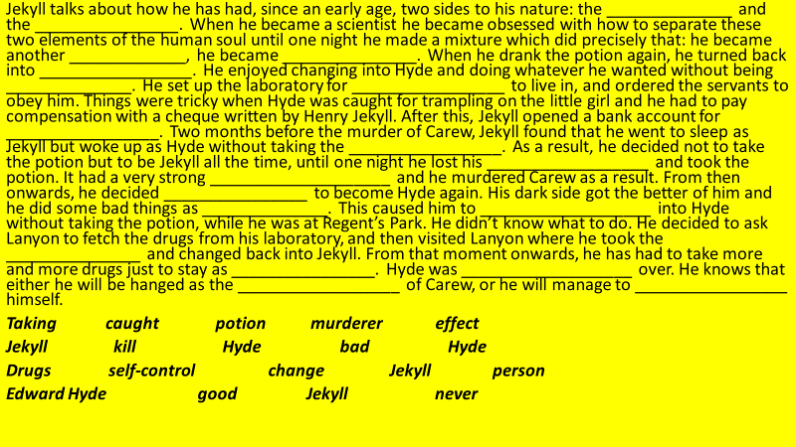

Demonstrate
What actually happens in the final chapter? Read the chapter 10 summary below and answer the questions that follow (DART).
- Jekyll reveals to Utterson that he’s always had dark desires and evil thoughts, but he hid them for most of his life.
- He came to realise that people are duplicitous or have a kind of duality: being made up of two or more separate parts.
- He began to experiment with the idea of splitting up the two sides to a person: the good and the evil.
- However, when he began experimenting on himself he managed to transform from Jekyll into a being of pure evil – his evil side.
- Looking at this creature in the mirror he could see he was younger and smaller – suggesting his evil side was also not as developed as his good side.
- Jekyll then reversed the experiment and became Jekyll once more: a combination of his good and evil self.
- He wrote his will and gave to Utterson to provide him some security should he end up as Hyde.
- Whilst Hyde, Jekyll felt a new sense of freedom and enjoyed being able to carry out his darkest desires without fear of punishment or consequence.
- When he committed these sins, he reassured himself it was Hyde who was guilty, not himself.
- However, Jekyll realised he had begun to transform into Hyde without taking his concoction. His hand was that of Hyde’s.
- It seemed the balance of his identity was shifting towards Hyde.
- In response to this, Jekyll tried to reform his character, did not take the potion anymore and felt better about himself.
- However, his dark thoughts still remained and after two months he surrendered and transformed himself into Hyde.
- Hyde was furious and took out all his pent up anger on Sir Danvers Carew.
- Jekyll transforms into Hyde in broad daylight out in public and has to hide away. He writes to Lanyon and Poole to retrieve the chemicals he needs from his laboratory.
- Every time Jekyll wakes up he is in the form of Hyde.
- He realises he has run out of the salt needed to make his transformation back into Jekyll.
- At the end of this narrative he explains he now realises his life is coming to an end. He explains the bizarre relationship that exists between him and Hyde. He signs off saying his life is over.

- What has Jekyll hidden for most of his life?
- What does it mean to be duplicitous?
- How did he try to experiment?
- What did he transform in to?
- Why did he give to Utterson in his will?
- How did he feel when he was Hyde?
- How did he legitimise his actions as Hyde?
- What started to happen over time?
- What actions did this lead to? Why?
- How does this reflect the context in which the novella was written?

Consolidate

Describe whether you feel sympathetic or unsympathetic towards Jekyll. Explain the interpretation you have made. Why do you feel this way? Has it changed? Evaluate why Stevenson felt it necessary to give Jekyll his OWN perspective at the end of the novella. Why end this way? Give evidence. (DIP)

Key Questions
- What does it mean to feel sympathy for someone?
- Is it possible to feel sympathy for someone who has wronged?
- Why does Stevenson end the novella by putting forward Jekyll’s version of events?
- Why did Jekyll start to experiment?
- Why did the experimentation start to go wrong?
- What does this show about attitudes to science and religion during the Victorian era?

Lesson 14: Fear and Terror
L/I: To evaluate the presentation of a theme
Connect
Duality – a way of seeing the world as a series of opposites
Science and Religion – the conflict between scientific developments and the natural world
Reputation – a widespread belief someone has a particular characteristic
How do these themes apply to Jekyll and Hyde?
Activate
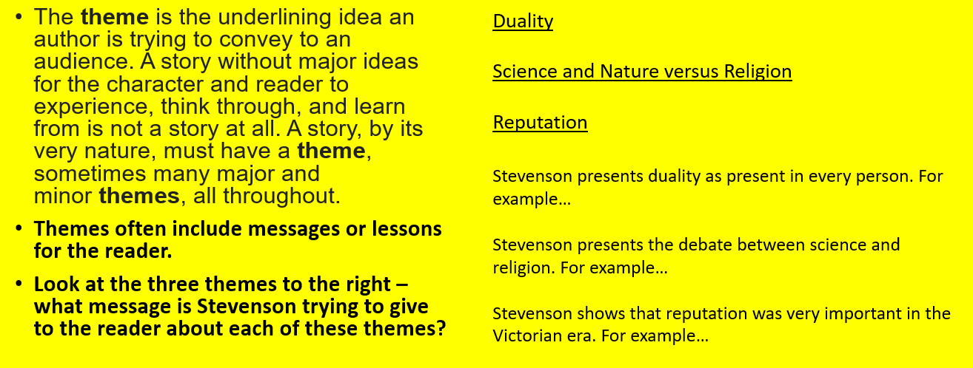
During chapter 6 Utterson visits Dr Lanyon to discuss their friend Jekyll. Read the extract from chapter 6 and answer the questions (DART):
- What was Utterson surprised about?
- Write down three changes that have taken place to Dr Lanyon’s appearance
- What did Utterson notice more than physical decay?
- How does Lanyon explain the changes that have taken place?
- How does Lanyon react and respond when Utterson mentions Jekyll?
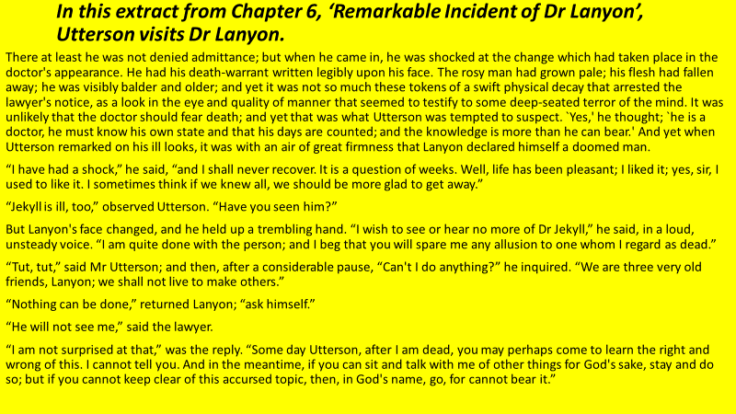
Demonstrate
How successful is Stevenson at creating a sense of fear in this extract? (DIP)
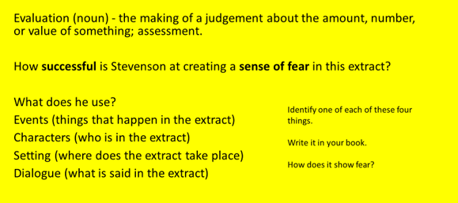
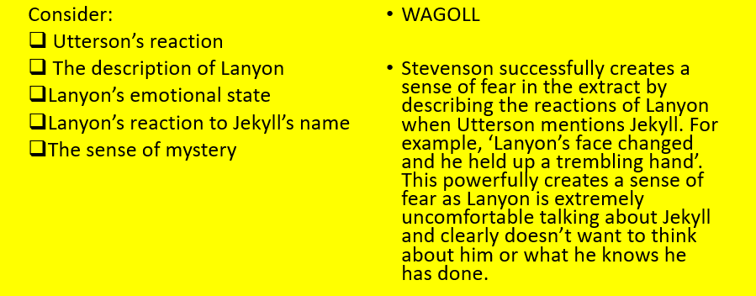
Consolidate
Look at the evaluative language below. How could you improve your answer by including examples of this?
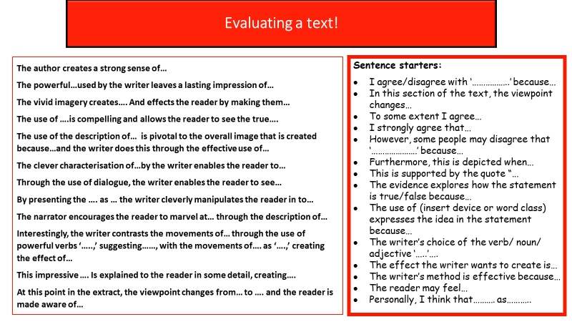
Key Questions
- What is a theme?
- What themes are presented in Jekyll and Hyde?
- What is evaluation and how does it differ to analysis?
- What is evaluative language?
- What happens in the interaction between Utterson and Lanyon?
- How does Stevenson attempt to create a sense of fear?

Lesson 15: Duality in Jekyll and Hyde
L/I: To explore the theme of duality in Jekyll and Hyde
Connect
What is duality? What about the Victorian era encouraged people to live double lives? Would it be possible today?
How do the following quotes demonstrate duality?
- ‘When I reached years of reflection and began to look round me and take stock of my progress I stood already committed to a profound duplicity of me.’ Chapter 10, ‘Henry Jekyll’s Full Statement of the Case’
- ‘It was the curse of mankind . . . That in the agonised womb of consciousness, these polar twins should be continuously struggling.’ Chapter 10, ‘Henry Jekyll’s Full Statement of the Case’

Activate
Read the information about tentative language and complete the tasks that follow:
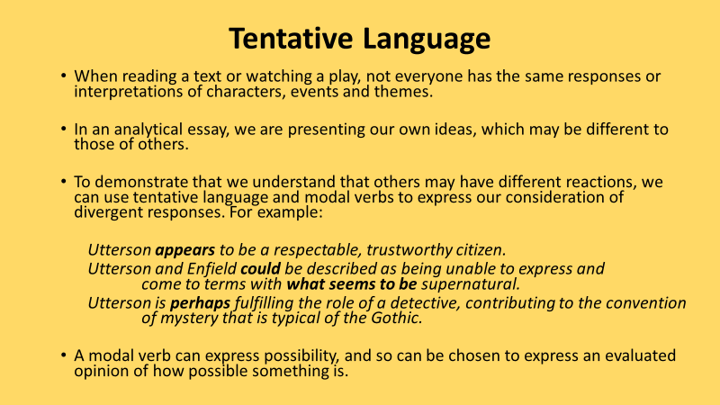
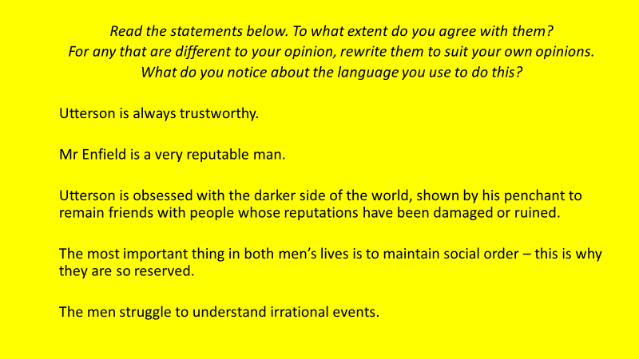

Read the essay about the Duality of Human Nature and answer the questions that follow (DART)
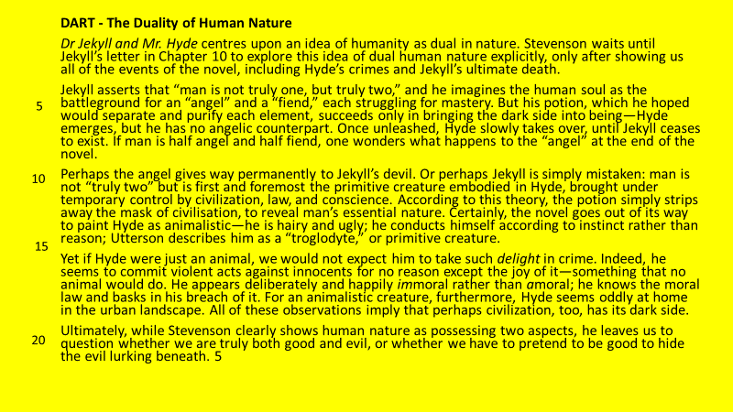
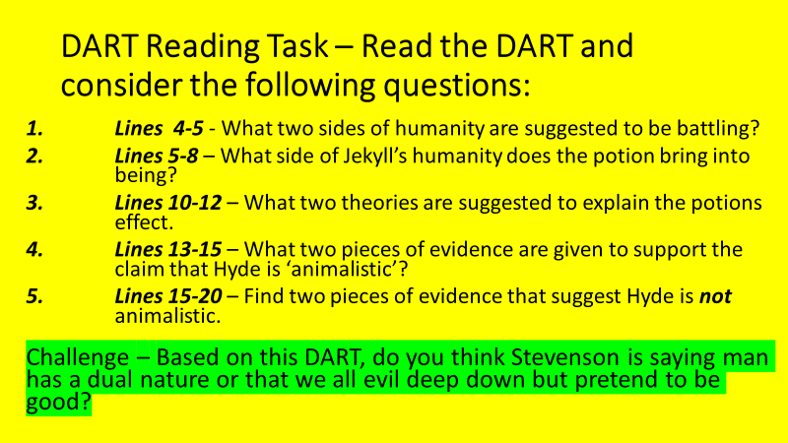
Demonstrate
How is the theme of duality shown in Jekyll and Hyde? (DIP) Think about chapter 10 and the rest of the novel.
WAGOLL: Duality is presented in Jekyll and Hyde through Jekyll’s realisation that all people have two sides to their personality, the good and the bad. For example, ‘I thus drew steadily nearer to that truth…that man is not truly one, but truly two’. Drawing towards the ‘truth’ shows Jekyll believes this is a fact about human nature and ‘not truly one, but truly two’ suggests people are made up of two elements, and these can’t be separated. Duality was important in Victorian society because people were very interested in their reputation, and therefore kept their public and private lives distinct from each other.
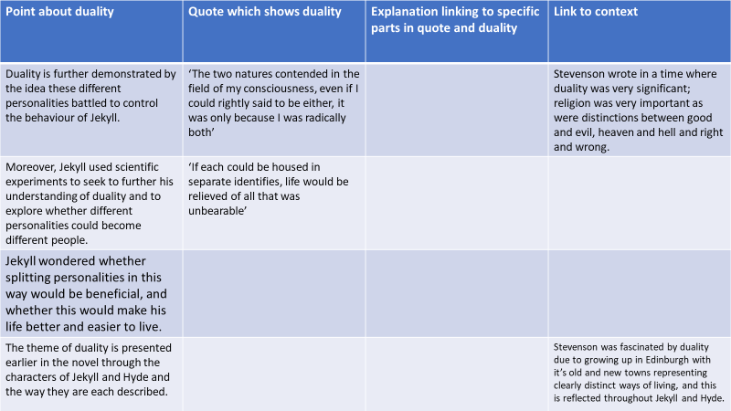
Consolidate
Look at the tentative language below. How could you use it to improve your answer?
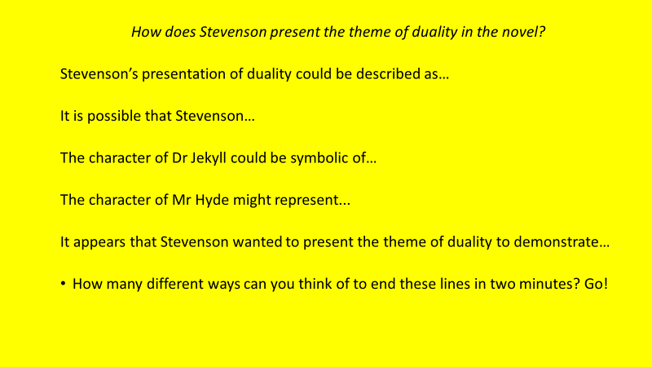

Key Questions
- What is duality?
- What about the Victorian era encouraged people to lead double lives?
- How is duality explored in chapter 10?
- Where else is it explored in the novel?
- How do you explode a quote?
- How can a quote explosion be used to write an analytical paragraph?

Lesson 16: Dr Jekyll
L/I: To explore the theme of science
Connect
Write down three positive things that science has brought to the world.
Write down three negative things that science has brought to the world.
Why was Victorian society suspicious of science?
Read the information about embedding quotations and complete the tasks that follow:
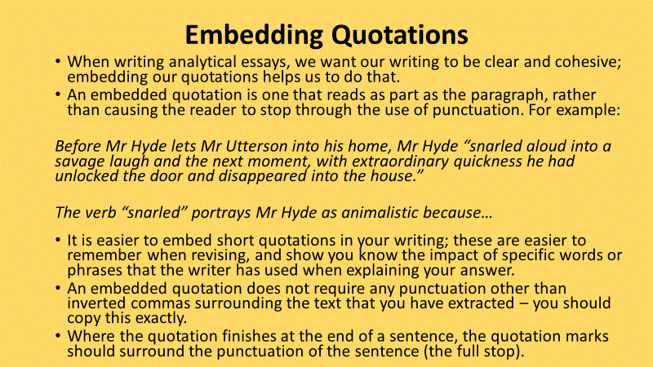
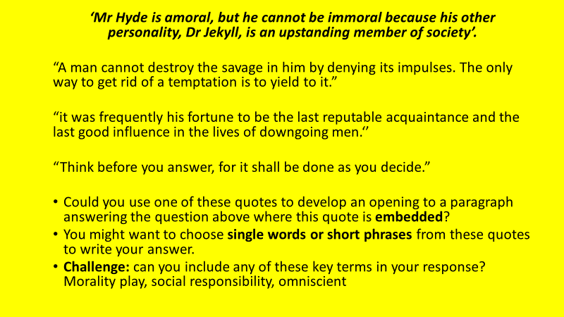
Activate
Read the essay about Scientific Progress, Evolution, and Darwinism and answer the questions that follow (DART).
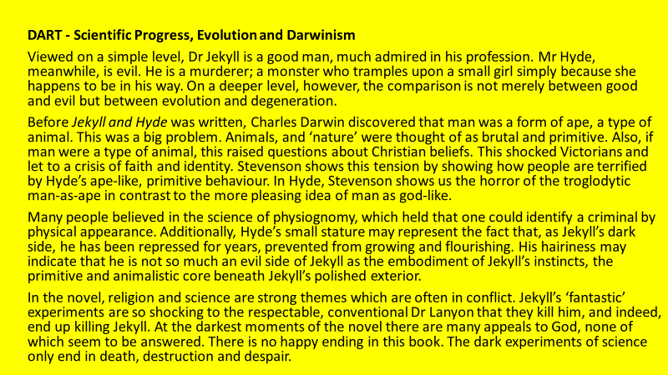
What did Charles Darwin discover just before Jekyll and Hyde was written?
What behaviour does Hyde display that shows the tension of society at the time?
What was the science of physiognomy?
How does this relate to Mr Hyde’s appearance?
What does the novel show that experimenting with science leads to?
Extension – Do you agree with this?

Demonstrate
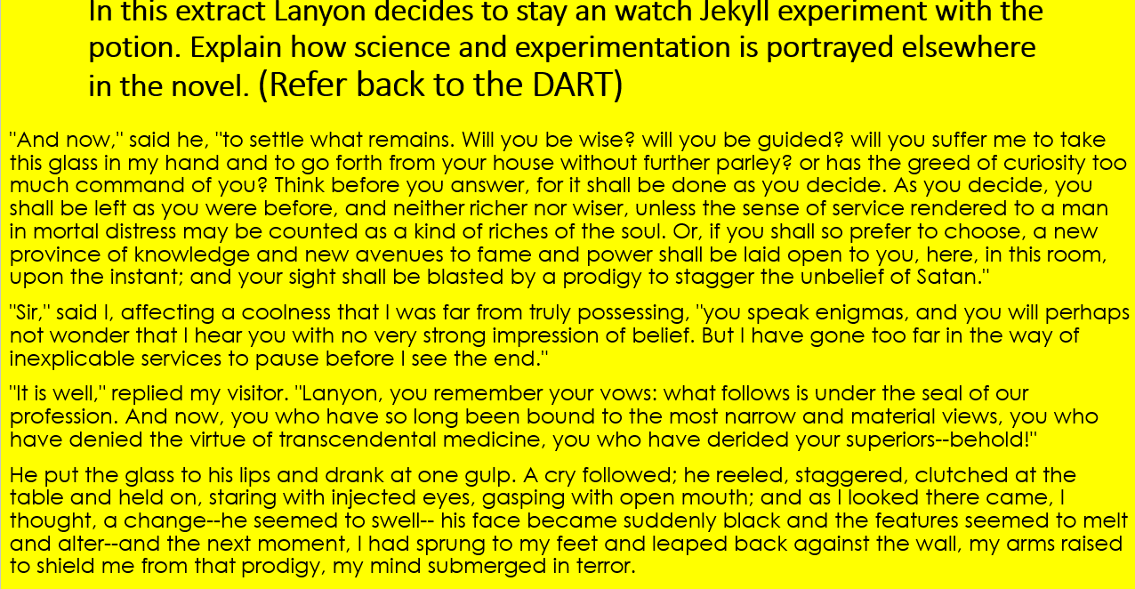
In this extract Lanyon decides to stay and watch Jekyll experiment with the potion. Explain how science and experimentation are portrayed here and elsewhere in the novel (DIP).
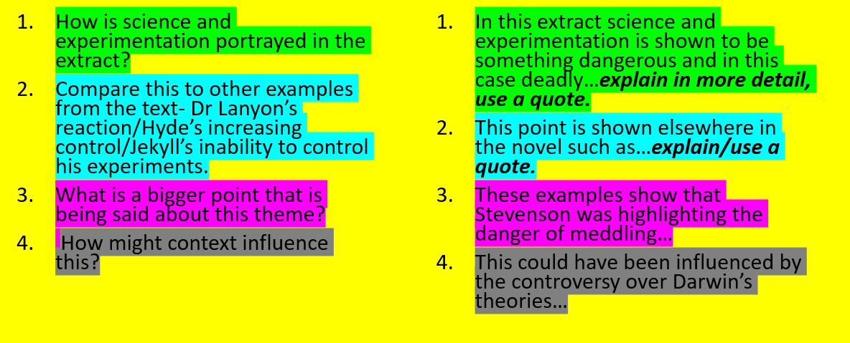
Consolidate
Look at the list you made at the beginning of the lesson.
At what point do you think scientific experimentation goes too far? Who should decide when this is the case?
Key Questions
- What is a scientific experiment?
- What did Charles Darwin discover?
- Why was this problematic?
- What was Jekyll trying to do?
- How would Victorian society have viewed his intentions?
- What point is Stevenson making about scientific experimentation?

Lesson 17: Reputation in Jekyll and Hyde
L/I: To explore the theme of reputation
Connect
Which of the following are NOT what was expected of a Victorian Gentleman?
- Never disagree with someone in conversation
- Never speak badly about anyone else
- Only wash on Christmas day
- Never refer to another person by their first name in public
- Be alone with an unmarried woman
- Be seen to be under the influence of alcohol

Read the information about analytical writing and complete the task that follows.
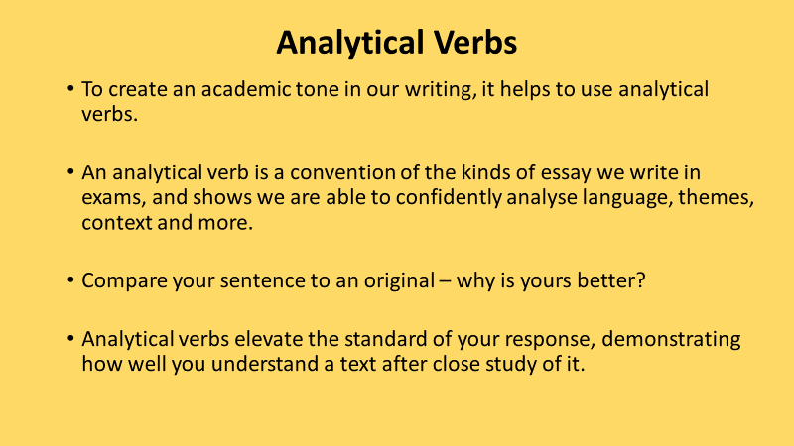
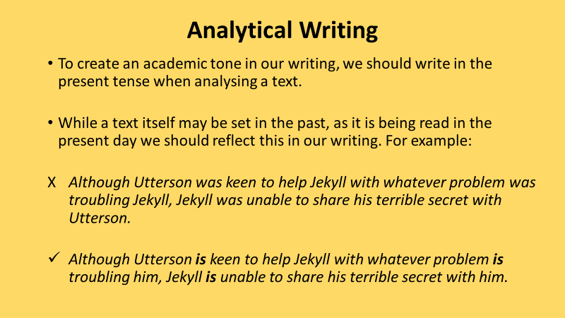
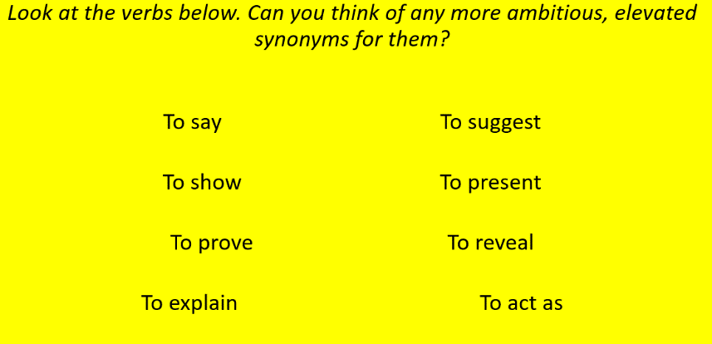
Activate
Read the essay about the importance of reputation and answer the questions that follow (DART).
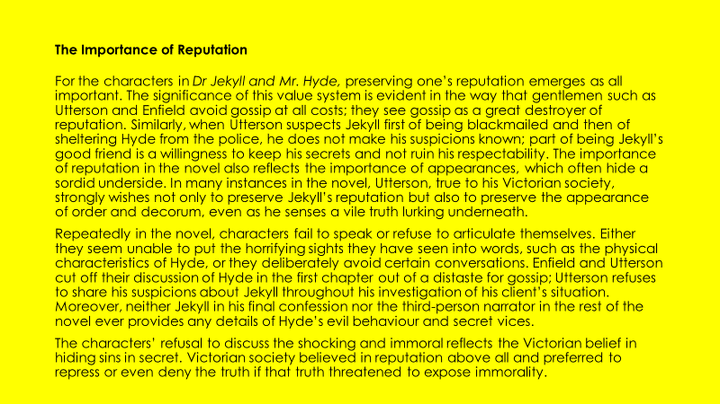
- What do Utterson and Enfield see gossip as?
- Why do you think this is?
- What examples are highlighted?
- What does the importance of reputation also reflect?
- Why, on this basis, does Utterson seek to protect Jekyll?
- What two reasons are given for characters failure to speak or articulate themselves?
- Why did Victorians prefer to ignore the truth about immoral behaviour?
- Why does Jekyll not detail Hyde’s crimes in the final chapter?
- Do you think Stevenson thought that Victorian societies obsession with reputation was a positive influence on society?
- How would this obsession with reputation encourage people to lead double lives?
Demonstrate
What type of reputation does each of these characters have? Why was reputation important to them? Choose three instances of reputation being important and find a quote to match.
Jekyll Hyde Utterson Lanyon
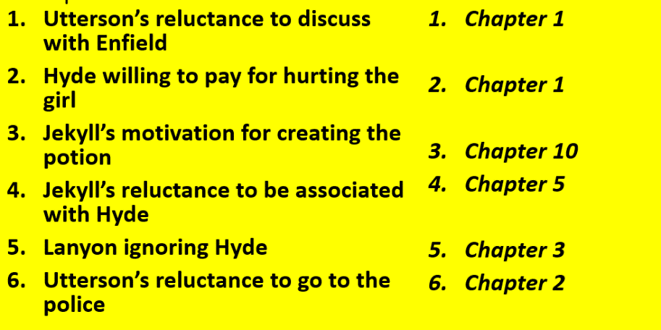
Consolidate
Jekyll and Hyde shows that the Victorian fascination with reputation prevents crime and immoral behaviour. Discuss this statement (DIP).
Do you agree or disagree?
Provide evidence – use examples from the text (and the demonstrate phase).
Explain why this example backs up your point.
Find another example to support your evidence.
Can you relate your answer to any other themes?
WAGOLL: Jekyll and Hyde shows that the Victorian fascination with reputation led to a hypocritical society where immoral behaviour and crime was ignored and gentleman lived double lives. Dr Jekyll feels so trapped by what society requires from him he creates the drug that leads to his downfall and becomes addicted as once he takes it he felt ”younger, lighter, happier in body;” without the burdens society places on him. If Dr Jekyll had been allowed a healthy outlet he may not have been driven to such extremes.
Key Questions
- What is reputation?
- Why is it important to the characters in the novel?
- How did Victorian society influence this importance?
- Which characters have the best and worst reputations?
- Why is Victorian society hypocritical?
- Does the obsession with reputation prevent crime and immorality?

Lesson 18: Dr Jekyll on Trial
L/I: To evaluate who is guilty of the murders
Connect
If you KNEW that you would not get caught would you steal a million dollars from the bank?
Is there such a thing as a completely good or bad person?
Write a short answer to these two questions – give a reason for your opinion!
Activate
Read back through the work you have completed in the previous four lessons. What were the advantages and disadvantages for Henry Jekyll of also being Mr Hyde? (DART)
Is Dr Jekyll to blame for Mr Hyde’s actions?
Write a paragraph stating whether you agree with this or not.
Can you find a quote to back up your point?

WAGOLL: Dr Jekyll is not to blame for the behaviour of Mr Hyde as he is a different person when in this persona and cannot control what he does. He expresses his sorrow for the bad things that Hyde has done, he describes his actions as a ‘turn toward the monstrous’ and even promises never to take the potion again. It was against his will that he turned into Hyde in the park.
What criminal charges could be brought against Dr Jekyll?
Demonstrate
Prepare either a prosecution or a defence (DIP).
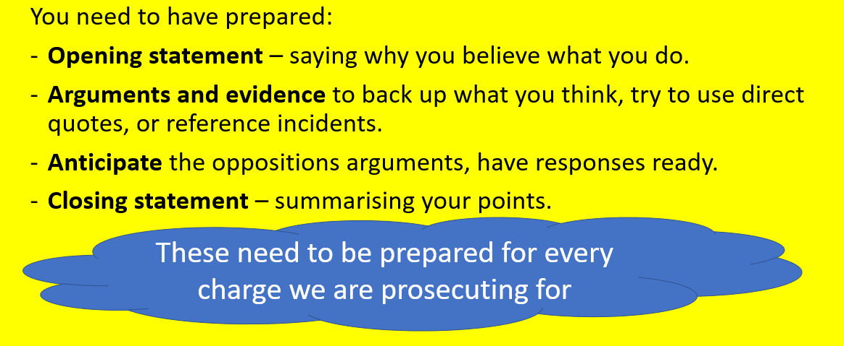
Consolidate
Is Dr Jekyll guilty or not guilty?
Key Questions
- What is a trial?
- Why crimes could Jekyll be accused of?
- What are the roles of the prosecution and the defence?
- What arguments could you make for each side?
- Is Jekyll responsible for the actions of Hyde?
- Would you find Jekyll guilty or not guilty?

 | Reading
Yellow Plus | - You use inference, context, and genre to understand the holistic or underlying meaning of the text, exploring different interpretations or different layers of meaning within it.  - You make judicious and focussed use of textual evidence to develop analytical, authentic, and thoughtful responses to the text.  - You explain the inextricable link between authorial intent and the impact on the reader, fully considering why the writer made particular choices.  - Your critical judgements fully explore how specific elements of a text reflect authorial intent, explicitly and directly explaining why they are effective in fulfilling their aims.  - You explain why the author has used a range of devices and what they sought to achieve.
Yellow | - You demonstrate a thorough understanding of texts by drawing inferences and fully exploring implicit meaning.  - Your responses demonstrate originality and are enhanced by carefully chosen evidence from the text.  - Your explanation and analysis show a well-developed understanding of authorial intent, the impact on the reader, and the link between the two.  - You make interesting and perceptive critical judgements directly supported by carefully chosen, relevant and focussed (word-level) evidence from the text.  - You explain the effect of a range of devices.
Blue | - Your understanding of a text goes beyond what is literally on the page to consider implicit meaning, the conventions of genre and the influence of context.  - Your responses to the text are detailed, sometimes original, and supported with relevant (word-level) evidence.  - You give detailed explanation and analysis beginning to explore the deliberate impact of the writer’s choices on the reader.  - You make critical judgements that are clearly supported and explained with relevant evidence from the text, explaining why you have reached that judgement.  - You explain the effect of simple devices.
Green | - Your understanding of a text is more nuanced and includes a basic sense of genre and the context in which it was written.  - Your responses to the text are valid, and you attempt to support and explain them with relevant evidence from the text.  - Your explanation and analysis are more developed, referring to the impact or effect on the reader.  - You make simple judgements and support them with relevant evidence from the text, starting to consider why you have reached that judgement.  - You identify and label a range of devices.
White | - Your explanations of the text are simple, identifying explicit meaning.  - Your responses to the text are simple but valid with some relevant reference to the text.  - Your answers include a basic attempt to explain the relevance of basic points.  - You make basic judgements and attempt to support them with relevant evidence from the text.  - You identify and label simple language devices.

Reading
Reading to understand or interpret what a text is about.

Developing a personal response to a text.

Analysing the language and structure in a text and starting to recognise deliberate choices by the writer.

Making a judgement about or starting to evaluate the effectiveness of a text in relation to authorial intent.

Using subject specific terminology to identify literary devices or techniques that are used in a text.

