Geography Year 9
Blended Learning Booklet
Y9-5 UK Resources
Name: Form:

- Aim to complete follow your existing timetable of lessons (4 lessons over 2 weeks)
- Write down the title and LI for each lesson and then complete the tasks.
- Upload all work onto ClassCharts for feedback.

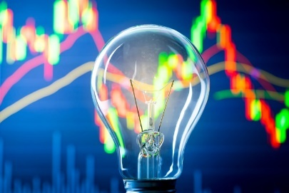
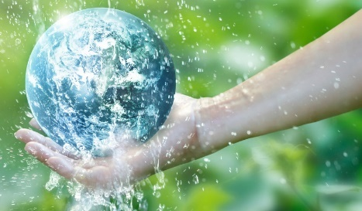

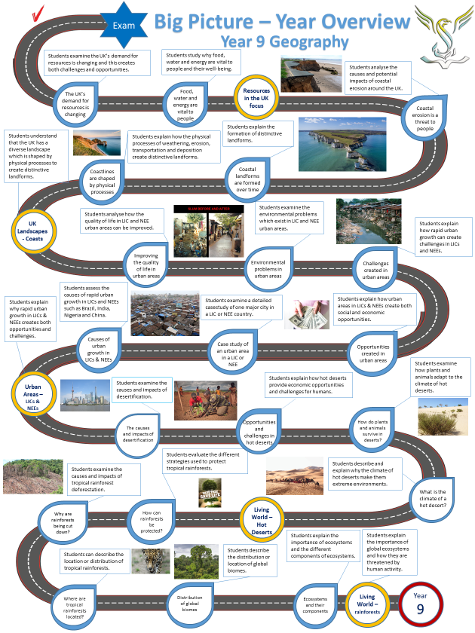
Contents

Page 1: Big Picture - Year 9 Overview
Pages 2 & 3: Lesson 1
Pages 4 - 7: Lesson 2
Pages 7- 9: Lesson 3
Pages 9 & 10: Lesson 4
Pages 11 & 12: Lesson 5
Pages 13 & 14: Lesson 6
Pages 14 - 17: Lesson 7

Lesson 1: Precious resources – food, water and energy
LI: To examine why food, water and energy are fundamental to human development

Task 1: Read through and note down the key terms

Security: having a reliable and affordable supply of a resource.

Supply: how much of something is available.

Demand: how much of it people would like.

Resources: reserves of minerals, land, and other natural assets.

Exploitation: the action of making use of and benefiting from resources, usually with negative impacts on some people and the environment.

Task 2: What factors affect the supply and demand of resources? Write your ideas in each column.
Supply (how much of a resource there is) | Demand (how much of a resource people want)

Task 3: Watch the video on resources: https://www.youtube.com/watch?v=7pPa0mRCky4

Task 4: Read through the DART about Food, Energy & Water Resources
Resources are things that people use. Some resources are essential for survival, whilst others are needed to maintain a standard of living.

Food
People cannot live without food. The average person needs to consume between 2,000 and 2,500 calories per day. The actual number of calories needed depends on factors such as gender, age, height, and level of activity.
Eating too few calories causes weight loss and a lack of energy. People who do not have enough food to eat find it difficult to work. If there are too many people in a country who are unable to work, then that country will lose a lot of money. Consuming too many calories causes weight gain. People who eat too much can also find it difficult to work.

Water
People cannot live without water. Water makes up about two thirds of a person's body. We need it for our body to function, e.g., to absorb nutrients and get rid of waste. Each person should drink between 1.6 and 2 litres of water a day. The actual amount of water needed depends on factors such as the air temperature and the type of activity that a person undertakes each day.
Water is also used to keep ourselves clean and healthy and is also needed to grow food and for industry. In drier countries or drier seasons, irrigation enables crops to grow. Industry uses water in many ways, such as cleaning, cooling and as a raw material in production.

Energy
Energy has many uses. It heats homes and offices, cooks our food and powers transport. Much of the energy that is used is in the form of electricity. This is called secondary energy - primary energy sources, such as fossil fuels or the wind, have been used to generate it.
Energy affects both food supplies and industry. Mining and growing biofuels required to generate energy takes up valuable farmland, which reduces the amount of food available to eat. And if energy is more expensive or in short supply, then it costs more to produce and transport food. This is passed on to consumers through an increase in the price of food.
Task 5: Answer the questions below:
- What is a resource? Give examples of resources which you use.
- Why do HICs have a very high demand for resources?
- Where do many of the resources HICs use come from?
- Why do LICs sell their resources to HICs?
- Is the use of resources balanced between LICs and HICs?
- Explain what environmental problems exist because of resource exploitation.
- Using examples, explain how people can save and recycle resources.

Task 6: Which of the resources are most likely to cause a war? Order from most to least in a diamond formation. Explain your choice.

Sunshine
Fresh water
Diamonds
Food
Oil
Gold
Land
Coal
Uranium

Lesson 2: Resources and global inequalities
LI: To identify the global inequalities in the supply and consumption of resources

Task 1: Complete the recap questions

- What is a resource?
- What is security?
- When does malnourishment occur?
- What is the key word beginning with ‘I’ that affects the supply of resources?
- What is the key word beginning with ‘D’ that affects the demand for resources?
- Give an environmental impact of resource exploitation.

Task 2: Read through the DART ‘Inequalities in the supply and consumption of resources’ and use the questions to help highlight some key points.

There are inequalities in the global distribution of resources. The balance between the supply and demand for resources affects a country's wealth and security.

Food security and food insecurity
Food security is when people have enough nutritious and affordable food to eat. Food insecurity is when people go hungry or are malnourished.
Wealthier countries import food and subsidise farming to make food more affordable. This creates a food surplus and there is plenty to go around. Poorer countries have a food deficit. They struggle to grow enough to feed people and cannot afford to subsidise farming or import more food.

Water surplus and water deficit
There is a fixed amount of water on the planet. Some is stored in the oceans and ice caps and some circulates as the water cycle. The amount of water available in an area is dependent on factors such as rainfall, temperature, and population.
- Higher rainfall leads to more water. Some places can have too much rainfall, which leads to flooding.
- Higher temperatures cause evaporation. If water evaporates, then less is available for people to use.
- Higher populations use more water. This means there is less available to share around.
Areas of water surplus have more water than they need. Excess water flows along rivers and out into the sea, but can become a problem if it floods the land. Areas of water deficit have too little water.

Energy security and energy insecurity
High income countries (HICs) and new emerging economies (NEEs) consume a lot of energy. The people living in these countries are usually linked to a national electricity grid. They use a lot of technology in their lives and have a high standard of living. Factories in NEEs also use energy to manufacture products. Low-income countries (LICs) use less energy. Many people living in LICs are not connected to an electricity grid, but rely on primary energy sources, such as fuelwood or animal dung.
Some countries produce large supplies of energy. They may have fossil fuel reserves or access to other energy sources, such as geothermal heat. Other countries are dependent upon imported fuel. Fuel prices are set by the exporting countries and so those importing fuel often have to pay high prices.
Places that have energy security produce a high percentage of the energy that they consume. Places that have energy insecurity consume more than they produce. Energy security is determined by the balance between the amount of energy produced in that country and energy imported from abroad.

Q1) Define ‘surplus’ and ‘deficit’.
Q2) Explain why both a ‘surplus’ and ‘deficit’ of water can cause problems.
Q3) Explain why HICs like the UK and USA often have a surplus of food and other resources.
Q4) Why do many LICs struggle to grow enough food and why do they suffer energy insecurity?
Q5) Why does the UK use a lot of energy compared to a LIC like Somalia?

Task 3: Using the information below and annotate the world map to show the unequal distribution of resources

ENERGY
- India has some of the highest levels of energy consumption.
- China consumes more than it produces in terms of energy.
- Saudi Arabia produces more energy than it consumes due to oil.
- Russia is one of the world’s largest producers of oil.
- Chad uses the least energy or is the least ‘energy intensive’.
- Germany currently uses the most renewable energy in the world.
FOOD
- Good farming conditions in Brazil means there are low levels of undernourishment.
- East Africa (Mozambique, Zimbabwe, Uganda, Tanzania) suffers from high rates of undernourishment due to poor climatic conditions for food production.
- The Central African Republic has some of the highest rates of undernourishment.
- Lack of a balanced diet causes problems of malnourishment in Malaysia.
- The USA is the highest consuming country in terms of food.
- Nauru (Micronesia) is the most obese country with 60% of its population being obese.
WATER
- Turkey is approaching water scarcity due to over extraction of resources.
- The Aral Sea has shrunk by around 2/3rds since the 1960s.
- Sub-Saharan Africa suffers from economic water scarcity due to lack of funds to develop the infrastructure to extract and distribute water resources.
- In Eritrea 80.7% of the population lack basic water services.
- Canada has high levels of water availability per person.
- Due to poverty and difficult physical geography, Guatemala, Honduras, Nicaragua, and El Salvador suffer from economic water scarcity.

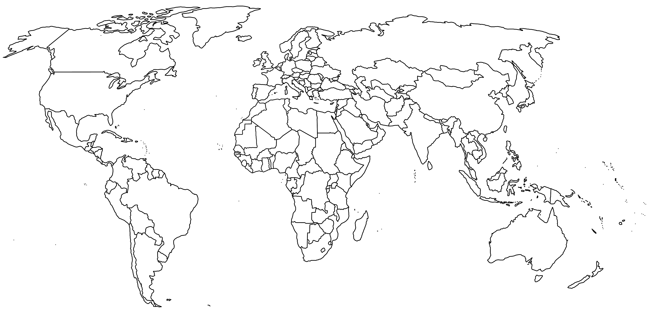

Task 4: Answer the exam practice question
Using the Figure, explain why the current consumption of resources is unsustainable and unequal. (4 marks)

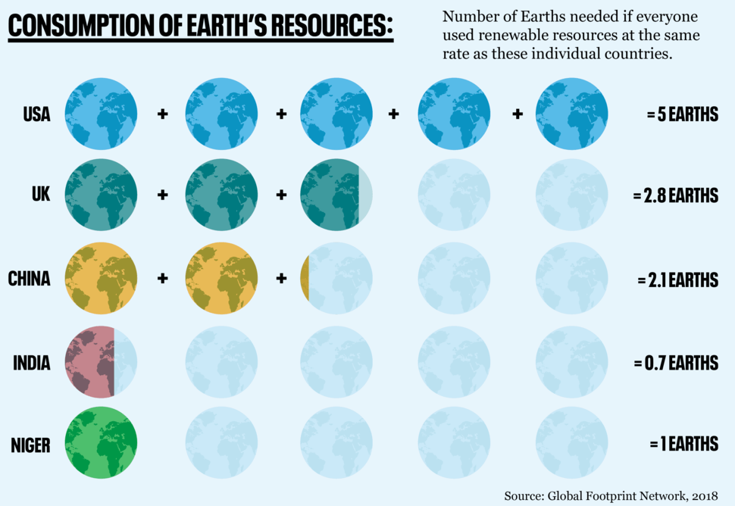

Lesson 3: How is the UK‘s demand for food changing?
LI: To examine how the UK’s demand for food is changing

Task 1: Take down the key terms
- Food security: a reliable, affordable food supply
- Carbon footprint: amount of CO2 released into the atmosphere by an economic activity.
- Food miles: distance food is transported between producers and consumer.
- Food processing: processing farm produce like wheat into foods such as flour, bread, biscuits & breakfast cereals.
- Organic food – produced without using chemicals such as pesticides which can be harmful to humans and the environment.

Task 2: Match the statistic to the fact about UK food
Fact
- Amount of food imported to the UK.
- Land used for farming in the UK.
- Value of UK exports
- Self-sufficient in producing homegrown food.
- Eggs laid each year.
- Amount of purchased food that’s thrown away.
- Amount of fruit & veg that is rejected from supermarkets.
Statistic
- 30%
- 48%
- 970 million
- 20 billion
- 76%
- 71%
- 17.7%

Task 3: Read through the changes in food demands in the UK

- Changing diet habits
- Disposable income
- Organic produce
- Want foods all year round.
- Demand for high value food
- Globalisation (we can import more food)
- Unsuitable climate
- Cheaper food abroad
- Climate change/poor harvests
- Population growth
- Quality of life
- Growing middle class
- Environmental awareness

Task 4: Suggest reasons for the patterns shown in Figure 2 (4 marks)

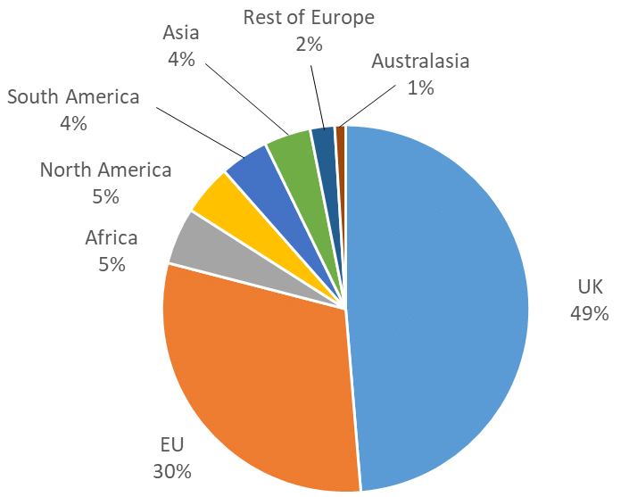
Task 5: Read through the DART and answer the questions

Food resources in the UK

There is enough food to feed everyone on the planet, but globally there are still 1 billion people experiencing food insecurity. Food supply and consumption are not evenly distributed.
The UK does have food security. Around 40% of the UK's food has been imported and much of it has been processed.

The growing demand for food imports
In the past, people ate food that was in season e.g., cabbages and leeks in the winter and tomatoes and cucumbers in the summer. Nowadays, people in wealthier nations can eat any type of food at any point in the year. Heated greenhouses allow crops to grow out of season and cold storage allows food to be transported from other parts of the world. Trans-national corporations (TNCs) work in several different countries, processing food and exporting it across the globe.
‘FOOD MILES’ refer to the distance food travels from where it is grown to where it is consumed. The further the distance often means more carbon dioxide is produced as the food is moved by lorries, ships and even planes. This is bad for the environment as carbon dioxide is the main source of greenhouse gases which are causing global warming.
The diagram below shows the food miles of several products which are consumed in the UK.
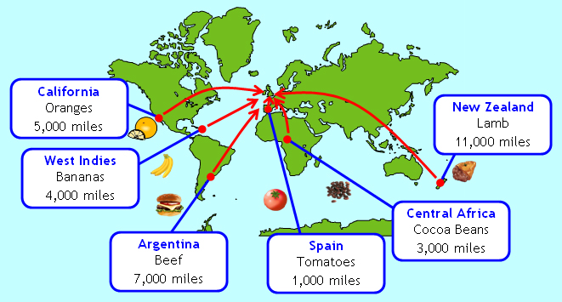

The demand for organic produce
Organic foods are grown without using any chemicals. They use natural fertilisers, such as animal manure, and natural predators instead of chemical pesticides. The consumption of organic produce has risen in the UK as fewer people are prepared to eat food that has been sprayed with harsh chemicals.
When farmland is converted to become organic, yields initially drop, but then they can improve to similar levels as non-organic crops. Organic farms are environmentally sustainable, in that they don't use artificial chemicals. Some people believe that organic farming is unsustainable as it can lead to a greater use of land area.

Questions:
Q1) Why has the demand for imported food increased in the UK? How much of our food do we import?
Q2) Using the map, give examples of foods we import and examples of countries where this food is produced. Why is importing food over long distances an environmental problem?
Q3) Explain why the demand for organic foods increased significantly in recent years.

Lesson 4: Food miles and Agri-business in the UK
LI: To examine issues of food miles and agri-business in the UK
Task 1: Read through the information about UK food supply
- All processes (from production of seeds to packaging of food) are controlled by large firms.
- Farm sizes are now bigger – smaller farms have been taken over and field size has increased.
- Chemicals used as increased.
- Number of workers employed has fallen because…
- Hedgerows removed which has led to problems of soil erosion and loss of biodiversity.
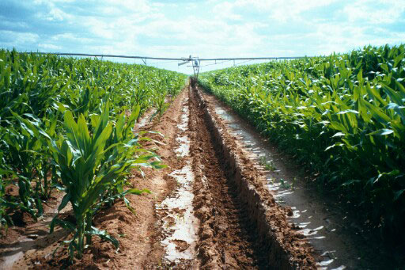
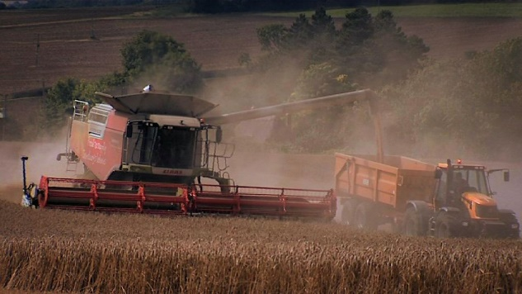

Task 2: Take down the key terms below
- FOOD IMPORTS – Bringing food into the UK from abroad.
- FOOD PROCESSING/FOOD MANUFACTORING – literally processing farm produce like wheat into foods such as flour, bread, biscuits & breakfast cereals.
- FOOD SECURITY – The UK imports 80% of the food we eat from other countries. Natural hazards and wars can disrupt this supply.
- FOOD MILES – This refers to how far our food travels. Most bananas in the UK are imported from Central America, a distance of 4000 miles.
- CARBON FOOTPRINT – Moving food produces lots of CO2 as our food is moved by lorries, ships and even planes. Higher food miles = higher carbon footprint.
- ORGANIC FOOD – This is food produced without using chemicals such as pesticides which can be harmful to humans and the environment.

Task 3: Read through and highlight the key facts and summarise key points about food miles and agribusiness

The UK food industry is worth £107 billion a year. This figure includes the money we spend shopping for groceries and the money which goes to our farming, fishing, food processing and food manufacturing industries.

In the UK, 4 million jobs are linked to the food industry with around 500,000 people working in farming and fishing and over 400,000 people in food manufacturing. There is enough food to feed everyone on the planet, but globally there are still 1 billion people experiencing food insecurity. Food supply and consumption are not evenly distributed. The UK
The UK enjoys strong food security as we are a HIC. Around 80% of the UK's food has been imported and much of it has been processed in other countries, but we have the wealth to import virtually any foods we want such as exotic fruit like avocados. If one source of food disrupted by a natural hazard (like a hurricane destroying the banana crop in Costa Rica) we have the money to buy bananas from another country.
However, the UK food industry also produces a high carbon footprint and high food miles. We create huge amounts of CO2 as we import so much food from all other the world. Fruit like avocados can travel well over 5,000 miles from the farms in South America where they are grown to UK supermarkets and finally to our homes. Most of our food is moved by lorries, ships and even planes.
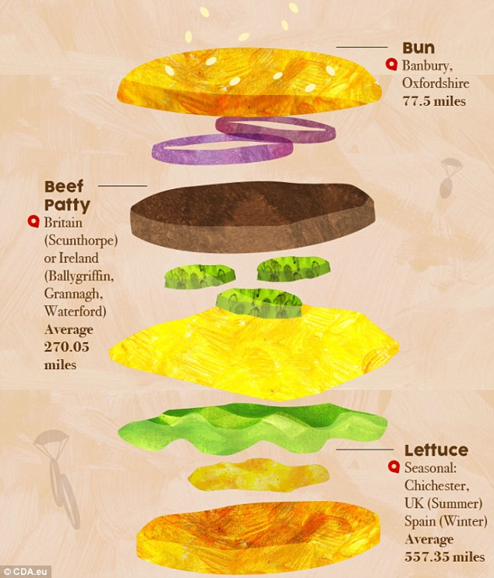
Task 4: Calculate the food miles and carbon footprint of a Big Mac
Lettuce - Chichester or Spain depending on season (557.35 miles on average)
Bun - Banbury, Oxfordshire (approx. 77.5 miles)
Big Mac sauce - Littleborough, Lancashire (approx. 222.6 miles)
Onions - the US (approx. 4,484 miles)
Beef patty - Scunthorpe, or Waterford Ireland (270.05 miles on average)
Dill pickles - Turkey (approx. 1,930 miles)
Cheese - Coleraine, Northern Ireland (approx. 509.2 miles)
Lorries: 1 mile travelled = 160g of CO2 produced
Aeroplanes: 1 mile travelled = 24,000g of CO2 produced

Task 5: How might we address some of the problems create by food miles and carbon footprint?
Lesson 5: Water insecurity in the UK
LI: To examine issues of water insecurity in the UK
Task 1: Take down the key terms below
Water stress: this occurs when the amount of water available does not meet that required. This may be due to an inadequate supply at a particular time, or it may relate to water quality.
Areas of deficit: locations where rain that falls does not provide enough water on a permanent basis. Shortages may occur under certain conditions. e.g., long periods without rain.
Areas of surplus: areas that have more water than is needed – often such areas receive a high rainfall total but have a relatively small population.
Task 2: Read through the facts about changing water demand in the UK
- Almost 50 % of the UK’s water supply is used domestically.
- 21% of water is wasted through leakage.
- Estimated that demand for water will rise by 5% by 2020.
- This is due to: growing population, more houses being built, increase in use of water-intensive household items.

Task 3: Using the rainfall and population map, identify 3 areas of water surplus and 3 areas of water deficit in the UK

UK rainfall map

UK population density map
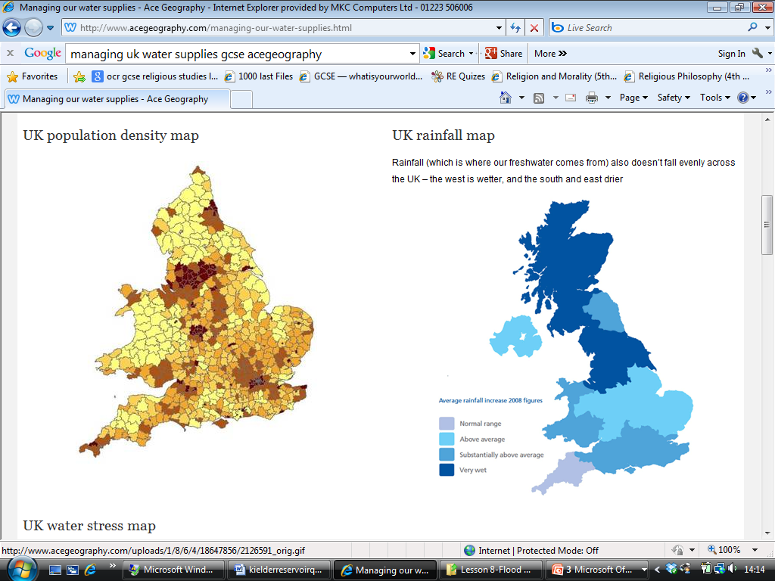

Task 4: Water transfer schemes- read through and answer questions
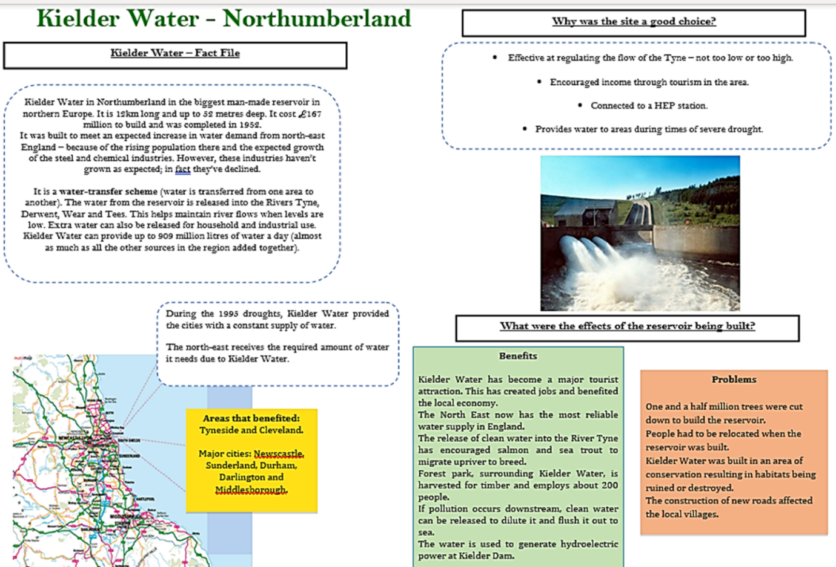

In the UK, there are systems in place to transport water from areas of surplus to areas of deficit. These are called water transfer schemes and they can be found in many parts of the UK. One example is Kielder reservoir in Northumberland. Kielder Water is located in an area of high land and so the rainfall is higher than many surrounding areas. Rainwater that collects in Kielder reservoir is transported southwards and released into rivers that flow to the cities and towns of Newcastle-upon-Tyne, Sunderland, Durham, Darlington, and Middlesbrough.
Questions
- Describe the location of the reservoir.
- Why was it build?
- Which areas benefit from the scheme?
- Why was the site a good choice for a dam? Give two reasons.
- Did the water transfer scheme prove to be successful?
- Evaluate the impacts of the reservoir. (Compare the positive and negative impacts and explain overall if you think the scheme is a success or a failure)

Lesson 6: Why is the UK’s changing energy mix changing?
LI: To explain why the UK’s energy mix is rapidly changing
Task 1: Read through the DART below

Renewable energy resources in the UK

To help combat global warming and climate change, the UK has pledged to reduce its CO2 emissions to zero by 2050. The UK has committed billions of pounds to develop renewable energy sources such as wind power and solar power. The mixture of primary energy sources used is called the energy mix.
The current energy mix of the UK consists mostly of gas, nuclear and renewables. The last oil-fired power station in the UK closed in 2015 and the last coal fired power station will close by 2025. Between 2009 and 2020, the UK’s energy mix has changed dramatically with the amount of gas and coal being used falling and the amount of renewables increasing rapidly.
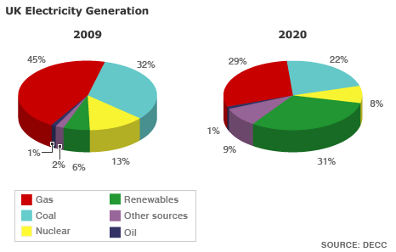

The growth of renewable energy
The UK has been reliant on fossil fuels such as gas and coal for many years. However, fossil fuels release CO2 gas when they are burnt, and this is the main cause for global climate change and global warming. It is becoming environmentally unsustainable to use fossil fuels and the UK is shifting to using more renewable energy sources.
Renewable fuels make up less than 31% of the UK's energy mix. The UK has a lot of potential for generating renewable energy:
- Over 50% of all renewable energy generated in the UK comes from wind farms. Some of this is from onshore turbines, but the number of offshore turbines is increasing rapidly as the UK is an island and the windiest country in Europe as it receives much of its weather straight from the Atlantic Ocean.
- The amount of UK electricity generated through hydroelectric power (HEP) has remained the same since 2012. This will not increase unless new dams are built.
- Less than 0.01% of UK energy is generated through tidal power. The UK is an island nation and could generate around 20% of its electricity using waves and tides.
- Solar panels are becoming more common, particularly on peoples' homes. The UK government think that 4% of our electricity could come from solar power by 2020.

Task 2: Answer the questions:
Q1) using the diagram, describe in detail how the UK’s energy mix has changed between 2009 and 2020. Include statistics in your answer.
Q2) Explain why the UK has decided to change its energy sources from non-renewable like coal and gas to renewables such as wind.
Q3) Why is offshore wind generation a very good option for the UK?

Task 3: Watch the video about the UK’s changing energy mix - https://www.youtube.com/watch?v=lA8USjDkcXk

Task 4: Compare the UK’s changing energy mix

- Largest energy source each year
- Smallest energy source each year
- Biggest growth
- Biggest reduction

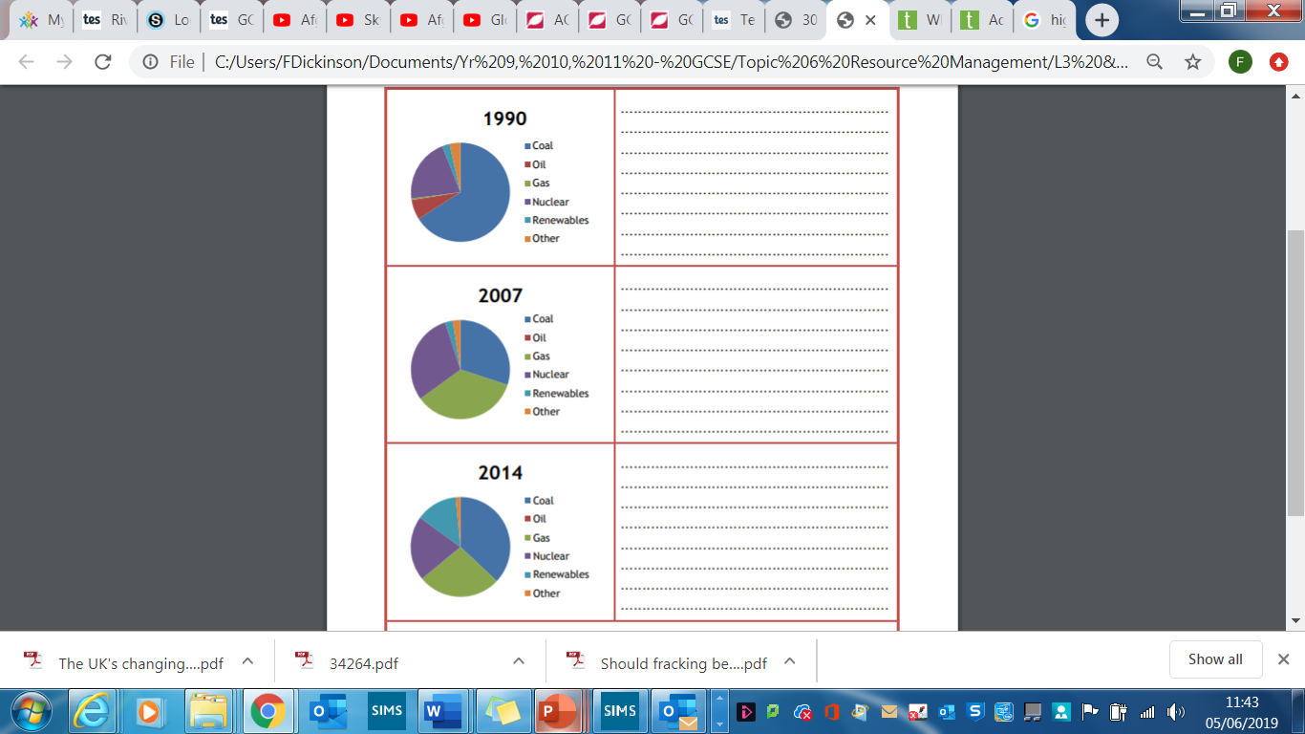

Task 5: Complete the true/false summary quiz

- The UK is completely self-sufficient in energy production.
- Renewable energy has declined in recent years.
- Gas is a fossil fuel.
- The UK’s energy use has declined since the 1970’s.
- Over 50% of the UK’s renewable comes from solar energy.

Lesson 7: Issues of energy production in the UK
LI: To examine the economic and environmental issues of energy production in the UK
Task 1: Complete the recap quiz
- Has the consumption of energy increased or decreased in the UK?
- As well as industry, what other area has seen a decrease in energy usage?
- What % of the UK’s oil and gas reserves have been used up?
- The UK has secure/insecure energy resources.
- What fossil fuel does the UK have a lot of?
- How are the UK addressing problems of an energy shortage?
- What is the main change being made to the UK’s energy mix?

Task 2: Read through and note down the main ways that the UK is addressing their changing energy mix
- Offshore oil
- Developing nuclear energy
- Fracking (shale gas)
- Investing in renewable energy

Task 3: Advantages and disadvantages of fracking
- UK has rich reserves of natural gas trapped underground.
- To extract, high-pressure liquids are used to fracture the shale and release the gas.
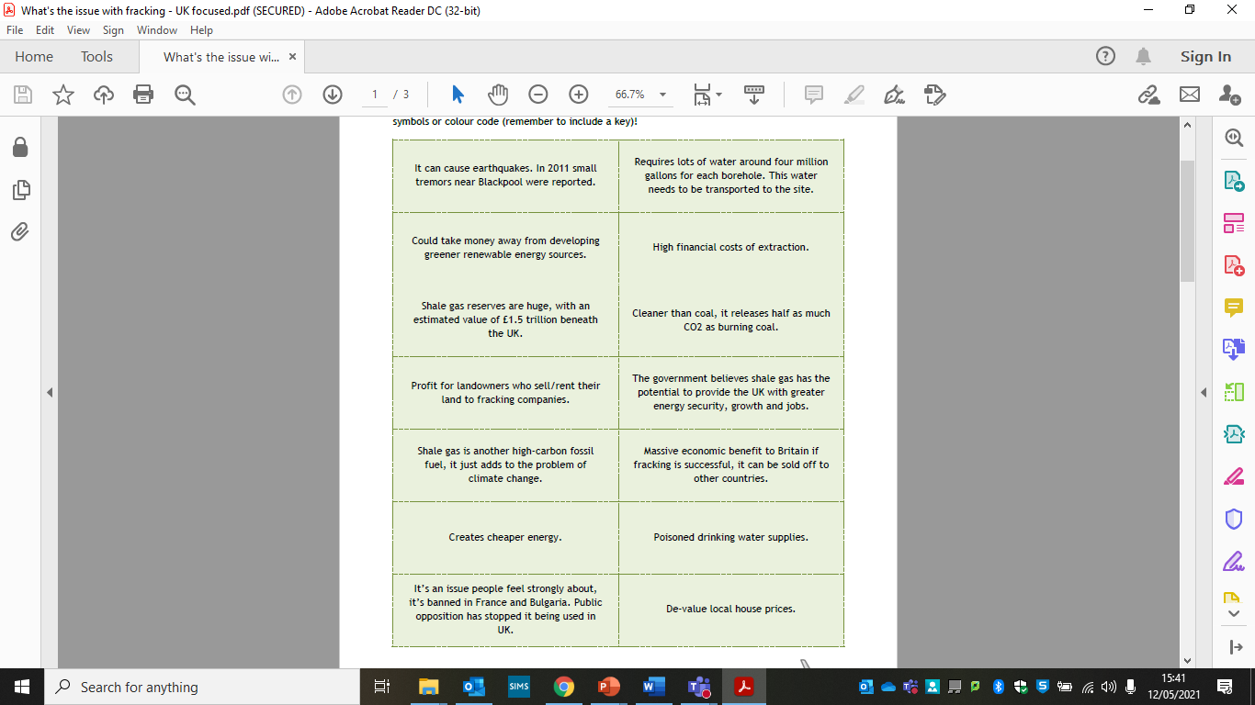
- There are many advantages and disadvantages of this process.
- Colour code the facts into advantages and disadvantages
- The use letters or symbols to categorise further into social (S), economic (Ec) and environmental (Env)

Task 4: Read through the DART and answer the questions

Issues associated with renewable energy exploitation
There are economic and environmental issues that are associated with the exploitation of energy sources:

Economic: Generating electricity costs a lot of money. There are initial costs, such as building power stations, dams, and wind farms. There are also maintenance and running costs, such as buying fuel, repairing damage to structures, and disposing of waste products. The government must balance these costs with other important things that the country must buy. They must also decide whether to invest in non-renewable or renewable options.
Generating electricity has many environmental issues:
- Fossil fuel powered stations create emissions, noise from trains transporting coal, and waste products like ash. They have also been linked to high levels of radiation.
- The uranium used in nuclear power plants is highly radioactive and the waste products have to be kept away from people indefinitely.
- Renewable energies like wind and solar power can be considered visual pollution. Tidal power and HEP dams may affect marine ecosystems.

Questions:

Q1) Explain why renewable energy sources can create economic and environmental problems in the UK.

Q2) What are the problems associated with using nuclear energy?


