English Year 8
Autumn 2
Blended Learning Booklet
Women in Literature

Name:
Form:
English Teacher:

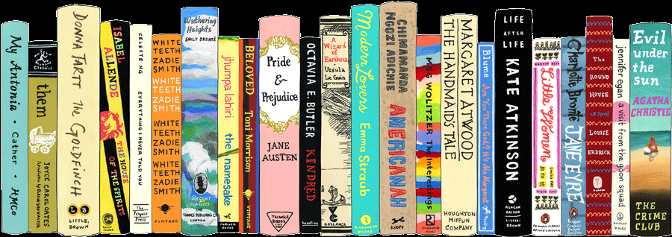

Contents

Lesson Number | Title | Page Number
1 | Women in Literature | 6
2 | Traditional Female Characters | 7
3 | Women in Shakespeare | 9
4 | The Vindication of the Rights of Woman – Mary Wollstonecraft | 11
5 | Frankenstein – Mary Shelley | 12
6 | Pride and Prejudice – Jane Austen | 14
7 | Jane Eyre – Charlotte Bronte | 15
8 | North and South – Elizabeth Gaskell | 17
9 | Little Women – Louisa May Alcott | 20
10 | Body in the Library – Agatha Christie | 21
11 | The Sweetest Dream and Wine – Doris Lessing | 22
12 | To Kill A Mockingbird – Harper Lee | 23
13 | The Handmaid’s Tale – Margaret Atwood | 24
14 | Noughts and Crosses – Malorie Blackman | 26
15 | Grand Union – Zadie Smith | 27
16 | Half A Yellow Sun – Chimamanda Ngozi Adichie | 29

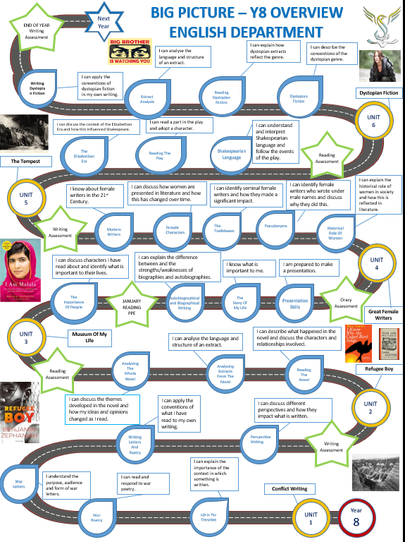

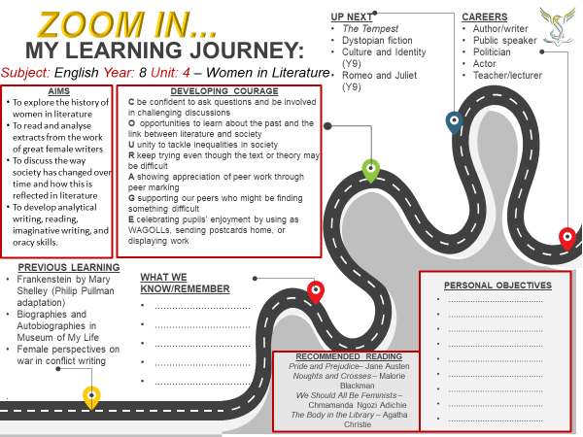Y8 Unit 4 - Women in Literature Knowledge Organiser
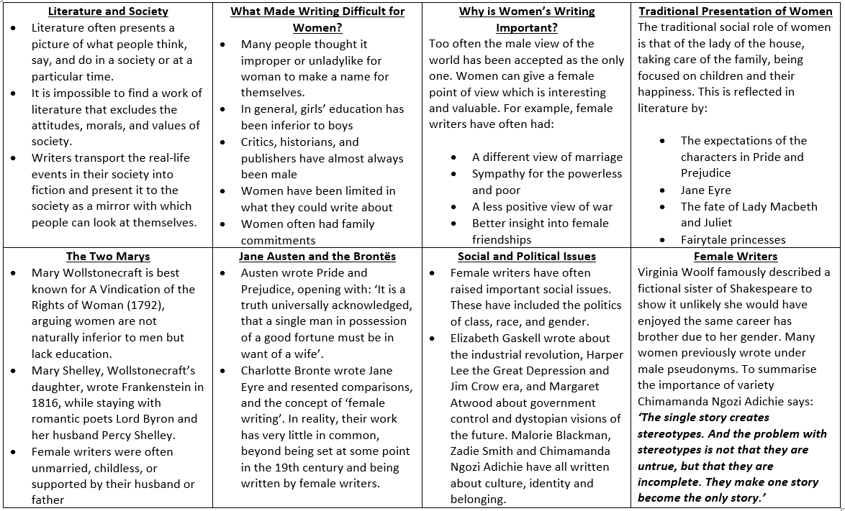

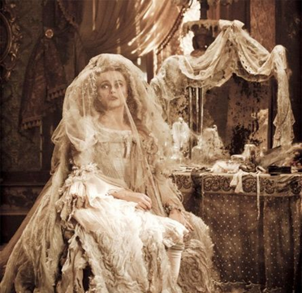
Lesson 1
Women in Literature
L/I: To introduce the unit and relate it to prior learning
- Who is Miss Havisham?
- What happened to her and how did this impact the rest of her life?
- What does this suggest about the presentation of women in literature?

Literature and Society (DART)
Literature, as an imitation of human action, often presents a picture of what people think, say, and do in a society or at a particular time. It is impossible to find a work of literature that excludes the attitudes, morals, and values in society, since no writer has been brought up completely unexposed to the world around them. Writers transport the real-life events in their society into fiction and present it to the society as a mirror with which people can look at themselves and make amends where necessary. Thus, literature is not only a reflection of society but also serves as a corrective mirror in which members of a society can look at themselves and find the need for positive change.
What made it so difficult for women to write?
Up until the nineteenth century many people thought it improper or unladylike for woman to make a name for themselves. It was hard for women to publish their work, and very often doing so endangered their own or their family’s reputation. Because of this, women often published anonymously or took pseudonyms (pen-names). This meant that their work was not recognised as their own.
In general, girls’ education has been inferior to boys. People did not think it was useful for girls to read books and gain knowledge. Consequently, women had less confidence in writing than men, and far less encouragement. Critics, historians, and publishers have almost always been male, and many have treated women’s work unfairly. Often they ridiculed or dismissed it simply because it was by a woman.
Women have been limited in what they could write about. For centuries, they were excluded from the public world of law, science, government, and politics: their experience was confined to family, friends, and home. Women, especially of the working classes, had family commitments and often had no time to concentrate on writing.
- What two roles does literature play in society?
- What two adjectives describe the prospect of women ‘making a name for themselves’?
- What is a pseudonym?
- How has girls’ education historically compared to boys’?
- Why might critics or publishers ‘ridicule or dismiss’ female work?
- How does the final line of the extract suggest writing was also linked to social class and status in society?

How do the following female characters subvert the traditional presentation of women in literature?

Hermione Granger, Moana and Katniss Everdeen

How does literature reflect society? (DIP)
Think about:
- The roles literature plays in society and difficulties female writers have historically faced
- Miss Havisham and other ‘traditional’ presentations or expectations of women
- Modern presentations of women and how they may reflect modern society

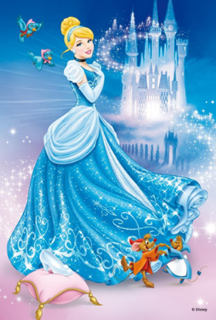
Lesson 2
Traditional Female Characters
L/I: To analyse stereotypical presentations of women in literature
- List the characters in Cinderella
- Create five bullet points summarising the story
- What’s the moral of the story? Which character wins?

Women in Fairytales (DART)
What do Snow White, Sleeping Beauty and Cinderella all have in common? Aside from porcelain skin and inexplicably glossy hair, they are each saved from a lifetime of misery and/or eternal sleep by a heroic Prince Charming figure. Typically, this character is a glorified caricature of defunct masculinity, incensed solely by the egotism of a heroic quest for “true love”. Naturally, this is as offensive to men as it is to women. “This places a large amount of unnecessary stress onto both sexes and in particular women as they believe that they should take up the western traditional role of being a woman,” explains Dr Victoria Showunmi, who lectures in gender studies at UCL.
In a culture where we’re getting hitched later than ever before and many choose never to marry at all, the compulsory “let’s get married and live happily ever after” narrative seems practically medieval. Unfortunately, it is one of perennial focus in fairytales and subsequent remakes of stories such as The Little Mermaid, Cinderella and Sleeping Beauty, all of which culminate in a grand celebration of matrimony. An everlasting romantic union is even the be-all and end-all for supposedly “modern” fairytales such as Shrek and Stardust. Not only does this present marriage as the sole goal for the male and female characters, which subsequently characterises them as vapid, but it totally abhors the value of professional, financial and social success, all of which seldom feature in these narratives. The implication, Showunmi argues, is that an unmarried person is a “failure which society has no place for.”
It is a truth universally acknowledged that Disney princesses are beautiful, slim and more often than not, white. While there are some exceptions (Mulan, Pocahontas and Princess Jasmine), traditionally, a white face reigns supreme. Equally problematic is the unrealistic body standards set by whippet-thin Belles and Ariels, who dictate the animated fairytale world. For a child encountering these stories for the first time, such restrictive aesthetic standards can be hugely detrimental, portraying the idea that beauty and happiness is synonymous with thinness. On the rare occasion that a “plus-size” character features in one of Disney’s traditional remakes of a classic Grimms fairytale, they are either the typified antagonist or the benevolent maternal figure – think The Little Mermaid’s Ursula and Beauty and the Beast’s Mrs Potts. Plus, these characters are almost always heterosexual.
Another disheartening commonality that Snow White, Belle and Cinderella share is their heightened domesticity. The only way Belle can save her poor father from the Beast’s entrapment is by becoming his house maid and Cinderella is bound to a life of floor-scrubbing while poor Snow White has to cater for seven male dwarves - one of whom is unappetisingly called Sneezy.
This is not to say that it’s all aprons and marigolds for our fairytale heroines. One Google search for “fairytale villains” generates a slew of sadistic female “baddies”: Cinderella’s evil stepmother, her “ugly sisters”, Ursula, the wicked witch of the west. These women are vindictive towards one another and negate any concept of sisterhood.
Summarise each paragraph in this extract in a single bullet point
Identify an example female character for the point being made in each paragraph

The Wife of Bath
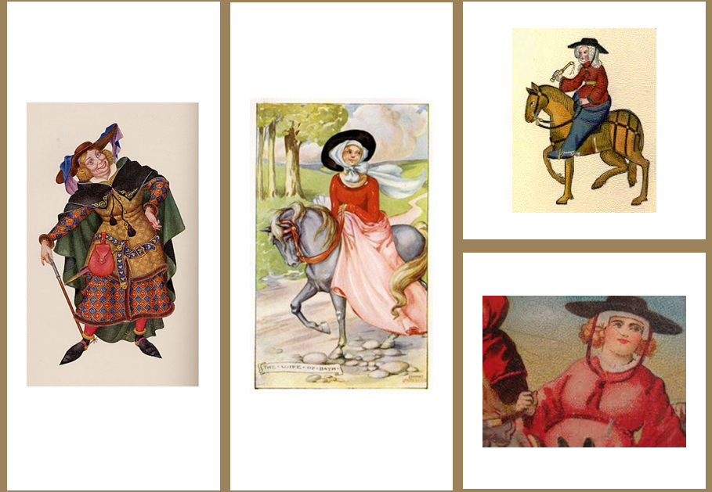
- The Queen saved the life of a Knight condemned to death and gave him one year to find out ‘what women most desire’
- He travelled the country to find the answer
- As he was returning to the Queen he met an old lady who told him – ‘what a woman most desires is to have power over her husband’ – on the condition he would do as she pleased
- She made him marry her and the Knight was very angry (she was old and ugly).
- In bed she asks him if he would wish her ugly yet faithful or beautiful and faithless. He insists the choice must be hers. This concession of her mastery restores her youth and beauty, ‘they lived in perfect joy for the rest of their lives’

Does the following extract from the Wife of Bath suggest she is strong and independent?
When the Knight saw that it was really so, that she was both young and beautiful, he caught her up in his arms for joy, his heart bathed in happiness. A thousand times he kissed her, and she obeyed him in every way that could content or please him. And they lived in perfect joy to the end of their lives.
That’s the end of my tale. May Jesus Christ send us young, submissive husbands, who are good lovers, and the luck to outlive them. May those who won’t be ruled by their wives come to an early end. As for cantankerous old skinflints, they can go to the devil.
How do Cinderella and the Wife of Bath reflect stereotypical presentations of women? (DIP)
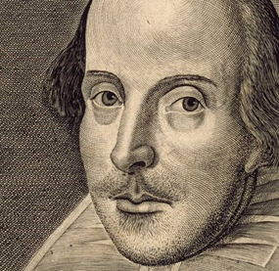
Lesson 3
Women in Shakespeare
L/I: To understand the importance of context to the fate of female characters
- How many Shakespeare plays can you name?
- How many female characters from Shakespeare plays can you name?
- How were women treated in Shakespearian times?

Gender Roles in Shakespearian Society (DART)
From the outset of Christianity, Eve was created from Adam’s rib to be his helper. Original sin is the result of Adam and Eve's disobedience to God when they ate a forbidden fruit in the Garden of Eden and some historical interpretations blamed Eve, and therefore women, for this. Furthermore, a review of the prominent late 19th-century biological writings reveals that a major plank of early evolution theory was the belief that women were intellectually and physically inferior to men.
In Elizabethan times women belonged to their fathers (or their brothers if their father died), and then to their husbands. Women could not own property of their own. This is one of the reasons Queen Elizabeth never married – she did not want to give up her power to a man.
Women were allowed to marry from the age of 12 in Shakespeare’s time, but often only women from wealthy families would marry so young. In the play Romeo and Juliet, Juliet is 13, but her mother says by that age she was already married with a child. Many marriages were arranged for the good of the family and small children might be ‘betrothed’ to each other in order to join the families together before they were old enough to get married. Men had to be able to support a household when they married.
- Why was Eve created?
- What did early evolution theory believe about women?
- Who did women belong to in Elizabethan times?
- What reason is given for Queen Elizabeth never marrying?
- Why was marriage important in Shakespearian times?
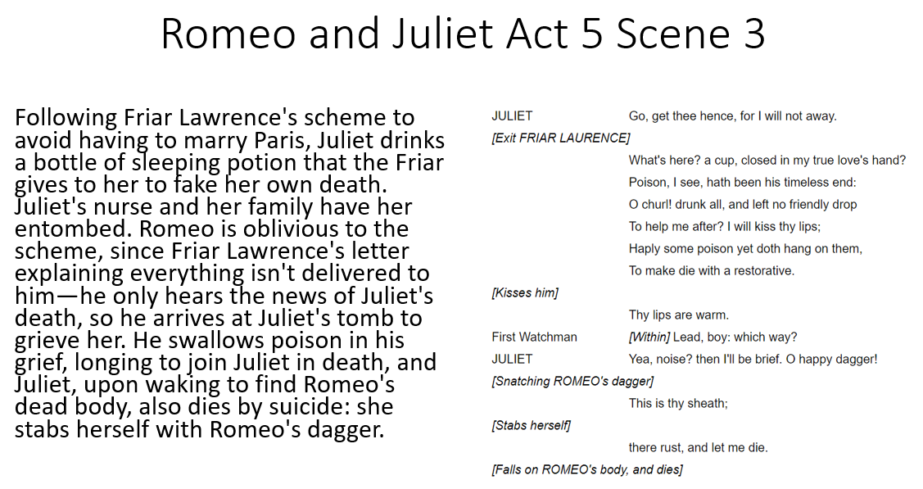
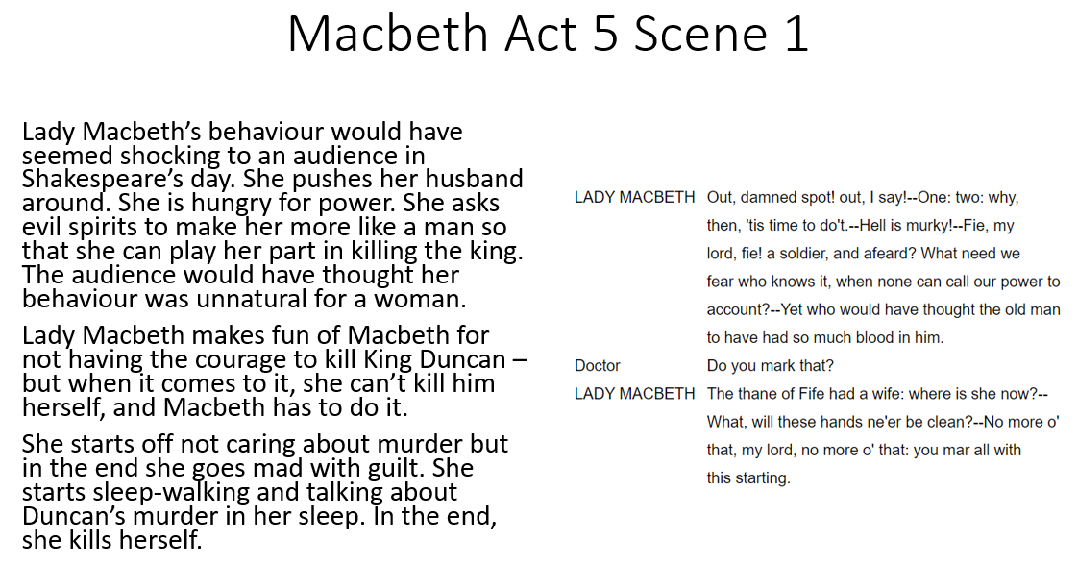Why do Lady Macbeth and Juliet both die? (DIP)
Think about:
- Juliet’s relationships with Romeo and Paris
- Lady Macbeth’s relationship with her husband
- The role of women in Elizabethan times
Lesson 4
The Vindication of the Rights of Woman – Mary Wollstonecraft
L/I: To explore how writing can be used to promote social change
Virginia Woolf
In 1928, the novelist Virginia Woolf (1882-1941) gave a series of famous lectures at Cambridge University about the history of women’s writing called A Room of One’s Own. She asked her audience to imagine the fictional story of Shakespeare’s brilliant sister: could she have become a successful writer? For a start she was not sent to school but had to sneak books from her brother. Then, her father engaged her to be married, so she ran away to London, where she was alone and vulnerable. Eventually a theatre manager took an interest in her, but she became pregnant and eventually committed suicide. The story illustrated the huge difference in the lives of men and women. Given equal talent, Shakespeare’s sister would probably never have become a famous writer – simply because she was a woman.
What point is Virginia Woolf trying to make?
How does this reflect what you have studied so far this half-term?
How did context influence Shakespeare’s writing?

Mary Wollstonecraft
Mary Wollstonecraft (27 April 1759 – 10 September 1797) was an English writer, philosopher, and advocate of women's rights. Until the late 20th century, Wollstonecraft's life, which encompassed several unconventional personal relationships at the time, received more attention than her writing.
Wollstonecraft is best known for A Vindication of the Rights of Woman (1792), in which she argues that women are not naturally inferior to men but appear to be only because they lack education.
Why did society need a writer like Wollstonecraft during the 18th Century?
Why is it significant her personal life ‘received more attention than her writing’?

Extract from the Vindication of the Rights of Woman (DART)
From the respect paid to property flow, as from a poisoned fountain, most of the evils and vices which render this world such a dreary scene to the contemplative mind. For it is in the most polished society that noisome reptiles and venomous serpents lurk under the rank herbage; and there is voluptuousness pampered by the still sultry air, which relaxes every good disposition before it ripens into virtue.
One class presses on another; for all are aiming to procure respect on account of their property: and property, once gained, will procure the respect due only to talents and virtue. Men neglect the duties incumbent on man yet are treated like demi-gods; religion is also separated from morality by a ceremonial veil, yet men wonder that the world is almost, literally speaking, a den of sharpers or oppressors.
There is a homely proverb, which speaks a shrewd truth, that whoever the devil finds idle he will employ. And what but habitual idleness can hereditary wealth and titles produce? For man is so constituted that he can only attain a proper use of his faculties by exercising them, and will not exercise them unless necessity, of some kind, first set the wheels in motion. Virtue likewise can only be acquired by the discharge of relative duties; but the importance of these sacred duties will scarcely be felt by the being who is cajoled out of his humanity by the flattery of sycophants. There must be more equality established in society, or morality will never gain ground, and this virtuous equality will not rest firmly even when founded on a rock, if one half of mankind be chained to its bottom by fate, for they will be continually undermining it through ignorance or pride.
It is vain to expect virtue from women till they are, in some degree, independent of men; nay, it is vain to expect that strength of natural affection, which would make them good wives and mothers. Whilst they are absolutely dependent on their husbands they will be cunning, mean, and selfish, and the men who can be gratified by the fawning fondness of spaniel-like affection, have not much delicacy, for love is not to be bought, in any sense of the words, its silken wings are instantly shrivelled up when anything beside a return in kind is sought. Yet whilst wealth enervates men; and women live, as it were, by their personal charms, how can we expect them to discharge those ennobling duties which equally require exertion and self-denial. Hereditary property sophisticates the mind, and the unfortunate victims to it, if I may so express myself, swathed from their birth, seldom exert the locomotive faculty of body or mind; and, thus viewing everything through one medium, and that a false one, they are unable to discern in what true merit and happiness consist. False, indeed, must be the light when the drapery of situation hides the man, and makes him stalk in masquerade, dragging from one scene of dissipation to another the nerveless limbs that hang with stupid listlessness, and rolling round the vacant eye which plainly tells us that there is no mind at home.
Use the underlined sections to help you answer the following:

- What, according to Wollstonecraft, was most respected in society?
- What did hereditary titles and wealth produce?
- Why should there be more equality in society?
- What does the dependence of women and men reduce the power of love?
- How do you think Wollstonecraft’s work was received in the 18th Century?

Why was Mary Wollstonecraft an important figure? (DIP)

Think about:
- What she wrote and the context in which she wrote it
- How people would have reacted to her work
- Biographical details about her


Lesson 5

Frankenstein – Mary Shelley

L/I: To analyse a theme in an extract from a novel

- What did Mary Wollstonecraft write?
- Why did she do this?
- How was her work received at the time?

Which women could write? (DART)
Women in the past who did have the determination to write and become successful writers, despite the many obstacles, often fell into certain categories.
- Many were unmarried – such as Jane Austen and Emily Bronte.
- Many were childless – such as Virginia Woolf and Charlotte Bronte (who only married towards the end of her life).
- Some had husbands or partners who encouraged their work, such as Elizabeth Gaskell and George Eliot, or fathers who encouraged their work. Mothers and sisters were usually powerless to provide economic support, and so appeared less significant.
- Some women writers, however, were overshadowed by more famous brothers, including William Wordsworth’s sister Dorothy and Henry Fielding’s sister Sarah.
Mary Shelley, Mary Wollstonecraft’s daughter, wrote Frankenstein in 1816. She was staying with romantic poets Lord Byron and her husband Percy Shelley, amongst others at the time. They were bored so decided to have a competition – who could write the best scary story.
What are the four ‘categories’ of female writers identified in the extract?
What biographical details about Mary Shelley made her more likely than most to write?

Extract from Frankenstein by Mary Shelley

It was on a dreary night of November that I beheld the results of my labours. With an anxiety that almost amounted to agony, I collected the instruments of life around me, that I might infuse a spark of being into the lifeless thing that lay at my feet. It was already one in the morning; the rain pattered dismally against the panes, and my candle was nearly burnt out, when, by the glimmer of a half-extinguished light, I saw the dull yellow eye of the creature open; it breathed hard, and a violent convulsion shook its limbs.

How can I describe my emotions at this catastrophe, or how describe the wretch whom with such infinite pains and care I had endeavoured to form? His limbs were in proportion, and I had selected his features as beautiful. Beautiful? Great God! His yellow skin scarcely covered the work of muscles and arteries beneath; his hair was a lustrous black and flowing; his teeth of pearly whiteness; but these features only formed a more horrid contrast to his watery eyes, that seemed almost the same colour as the dun-white sockets in which they were set, his shrivelled complexion and straight black lips.

I had worked hard for nearly two years, for the sole purpose of infusing life into an inanimate body. For this I had deprived myself of rest and health. I had finished, the beauty of the dream vanished, and breathless horror and disgust filled my heart. Unable to endure the aspect of the being I had created, I rushed out of the room and continued a long time traversing my bedchamber, unable to compose my mind to sleep.

- How is the night described?
- What time was it?
- What colour was the creature’s eye?
- How does the narrator describe the moment?
- How does the narrator describe the creature?
- Why is there a question mark after beautiful?
- What colour was his hair?
- How is his complexion described?
- What had the narrator worked on for two years?
- What filled his heart?

Should scientists try to create life? (DIP)

- Why does creating life constitute ‘playing God’?
- What are the pros/cons?
- Use examples from Frankenstein and real-life in your answer
Lesson 6
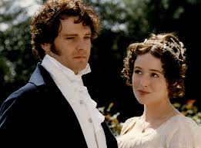
Pride and Prejudice – Jane Austen
L/I: To compare stereotypical presentations of men and women

- What constituted a successful life for a woman in the 18th Century?
- What constituted a successful life for a man in the 18th Century?
- Why do people conform to societal expectations?

Traditional Social Role of Women (DART)

The traditional social role of women is that of the lady of the house, taking care of the family, being focused on children and their happiness. Traditional occupational roles attributed to women are related to caring for others (e.g., homekeeper, nurse) and require communal characteristics (e.g., kind, sensitive). On the other hand, the traditional man is the “head” of the family, the one who is responsible for the maintenance of the house and who, through strength and determination, defends it against dangers. Traditionally men occupy the roles related to leadership (e.g., manager), which are associated with agentic characteristics (e.g., independent, competitive). The traditional gender social roles are consistent with stereotypical traits attributed to men and women. In most countries, attributes such as affection or sensitivity are considered more typical of women, whereas attributes such as aggressiveness or courage are considered more typical of men.

Extract from Pride and Prejudice by Jane Austen

It is a truth universally acknowledged, that a single man in possession of a good fortune must be in want of a wife.
However little known the feelings or views of such a man may be on his first entering a neighbourhood, this truth is so well fixed in the minds of the surrounding families, that he is considered as the rightful property of someone or other of their daughters.
‘My dear Mr Bennet,’ said his lady to him one day, ‘have you heard that Netherfield Park is let at last?’
Mr Bennet replied that he had not.
‘But it is,’ returned she; ‘for Mrs Long has just been here, and she told me all about it.’
Mr Bennet made no answer.
‘Do you not want to know who has taken it?’ cried his wife impatiently.
‘You want to tell me, and I have no objection to hearing it.’
This was invitation enough.
‘Why, my dear, you must know, Mrs Long says that Netherfield is taken by a young man of large fortune from the north of England; that he came down on Monday in a chaise and four to see the place, and was so much delighted with it that he agreed with Mr Morris immediately; that he is to take possession before Michelmas, and some of his servants are to be in the house by the end of next week.’
‘What is his name?’
‘Bingley.’
‘Is he married or single?’
‘Oh! Single, my dear, to be sure! A single man of large fortune; four or five thousand a-year. What a fine thing for our girls!’
‘How so? How can it affect them?’
‘My dear Mr Bennet,’ replied his wife. ‘how can you be so tiresome! You must know that I am thinking of his marrying one of them’
‘Is that his design in settling here?’
‘Design! Nonsense, how can you talk so! But it is very likely that he may fall in love with one of them, and therefore you must visit him as soon as he comes.’

- What does ‘universally acknowledged’ mean?
- What were single men expected to want?
- What does ‘property’ suggest about relationships at this time?
- Which words shows Mrs Bennet was slightly annoyed?
- Why was she annoyed?
- What does the young man have?
- Where does he come from?
- Why is Mrs Bennet interested in him?
- How does the punctuation used show this?
- Why does Mrs Bennet think Mr Bennet should visit Bingley?

How does the opening to Pride and Prejudice reflect stereotypical presentations of men and women? (DIP) 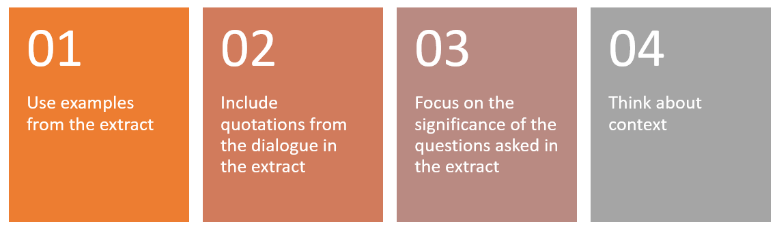
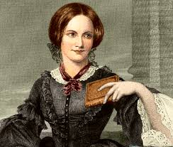
Lesson 7
Jane Eyre – Charlotte Bronte (extract on page 18)
L/I: To write from the perspective of a character in a novel
- What is a perspective?
- What is narrative perspective?
- Why is it important?

Charlotte Brontë and Jane Austen (DART)
The Brontës were a nineteenth-century literary family, born in Yorkshire. The sisters, Charlotte (1816–1855), Emily (1818–1848), and Anne (1820–1849), are well known as poets and novelists. Given Jane Austen (1775-1817) wrote in a similar time period, the Brontës and Austen are often the subject of comparison. In reality, the works of Austen and the Brontës have very little in common, beyond being set at some point in the 19th century and being written by female writers.
As an example of the comparisons, it is often assumed that Charlotte Bronte's Jane Eyre was inspired by the character of Jane Fairfax in Austen's Emma. It's easy to see the appeal of the statement. Not only is it often presented as a defence of fanfiction, but the "fact" feels like a wonderful easter egg, bringing a sense of continuity and neatness to the female literary canon. Of course, it's complete nonsense. Charlotte Bronte hated Austen's books, vocally and repeatedly. And even if she didn't, her letters suggest she didn't read any of Austen's work until after Jane Eyre was published. But the persistence of this myth is interesting (or troubling, depending on your perspective), because of why Charlotte Bronte appeared to hate Austen so much. In short, Bronte criticized Austen so fiercely because critics kept attempting to put her and Austen into the same category of "lady writers," criticizing her not on the strength of her own work but based on the idea that she and Austen must be similar and pursue the same narrative goals.
Austen and Charlotte Bronte led very different lives, during completely different eras (Bronte was only one year old when Austen died), and they wrote very different books. Austen wrote social commentary through the comedy of restrained noble life, while the Bronte sisters wrote books that were as sweeping-emotion, dramatic landscapes, ominous rainstorms and forbidden romance-y as they come. That isn't to say that Austen had no influence on Charlotte Bronte whatsoever. Even if Bronte didn't read her books until after Jane Eyre was published, Austen is often credited with "inventing the novel" as we understand it today, and the style she popularized would have been passed down to Bronte as the genre evolved. But she only influenced Bronte as much as she influenced any other 19th century writer, and less than many. Yet Bronte dealt with harsh criticism claiming she should be more like Austen, apparently simply because of their shared gender. Most of this came from critic G. H. Lewes, who wrote to Bronte to tell her that she would be better off writing less dramatically and should look to Austen for inspiration. Bronte was furious and wrote back saying that she picked up one of Austen's novels on his recommendation and found it emotionally cold.
And over 150 years later, we still find this unspoken category of "the female novel" appealing. As we now find "observation" to be a masculine writing trait and "overdramatic emotion" to be a female one, our impressions of Austen have been forced to change (she's now all about emotion and romance in popular culture, despite what the actual books contain), but we still want to group these novels together, despite the fact that they're separated by time, geography, focus, style, voice... pretty much everything except the author's gender. It seems so neat and wonderful that the second female author we can all easily name was inspired by the first, because we would like to think of these Female Novelists as somehow separate from everything else happening in British literature in the more than forty years between the two books' publications. But by forcing them together, we're still constructing the same narrative that Charlotte Bronte fought against over 150 years ago -- the idea that the works of female authors must be alike, and that they must all like and be inspired by one another, and one another alone.

1. How many Brontë sisters were there?
2. Did they write before or after Jane Austen?
3. What is assumed about Jane Eyre?
4. What did Charlotte Brontë think of Jane Austen’s work?
5. What is wrong with the concept of the ‘female novel’?

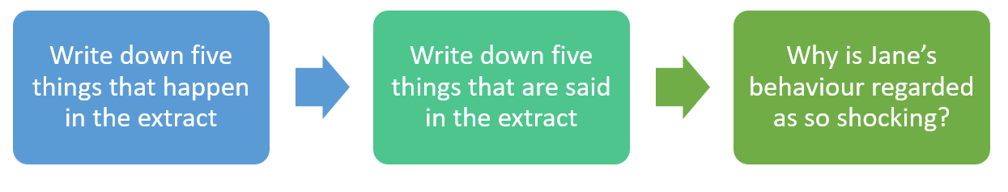
Write from the perspective of Bessie or Miss Abbot. Describe the action in the extract from their perspective (DIP). Think about what happens and the context in which the novel was written.

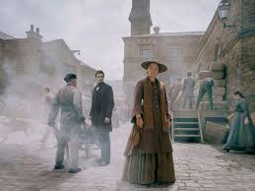
Lesson 8

North and South by Elizabeth Gaskell (extract on page 19)

L/I: To respond to the themes in an extract through imaginative writing

- Who wrote Pride and Prejudice?
- Who wrote Jane Eyre?
- What did the author of Jane Eyre think of comparisons to Pride and Prejudice?

Why is women’s writing important? (DART)
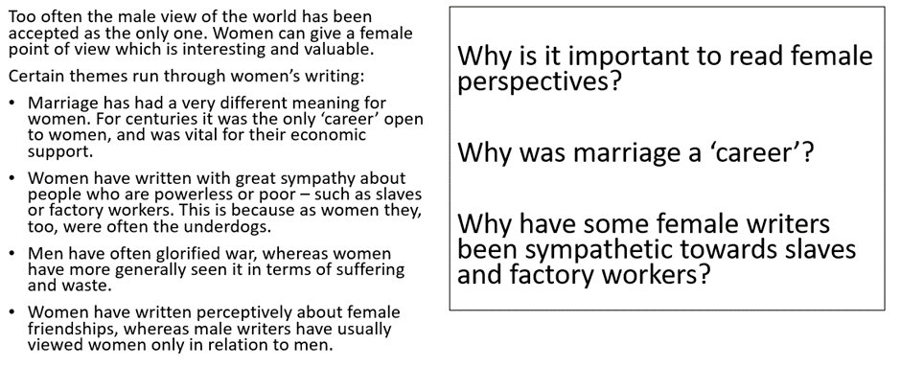

Write about a time you stood up for something you believe in (DIP).

Use sensory description and details from the extract to describe the demonstration in as much detail as possible, from the perspective of a mill worker.

Extract from Jane Eyre by Charlotte Brontë

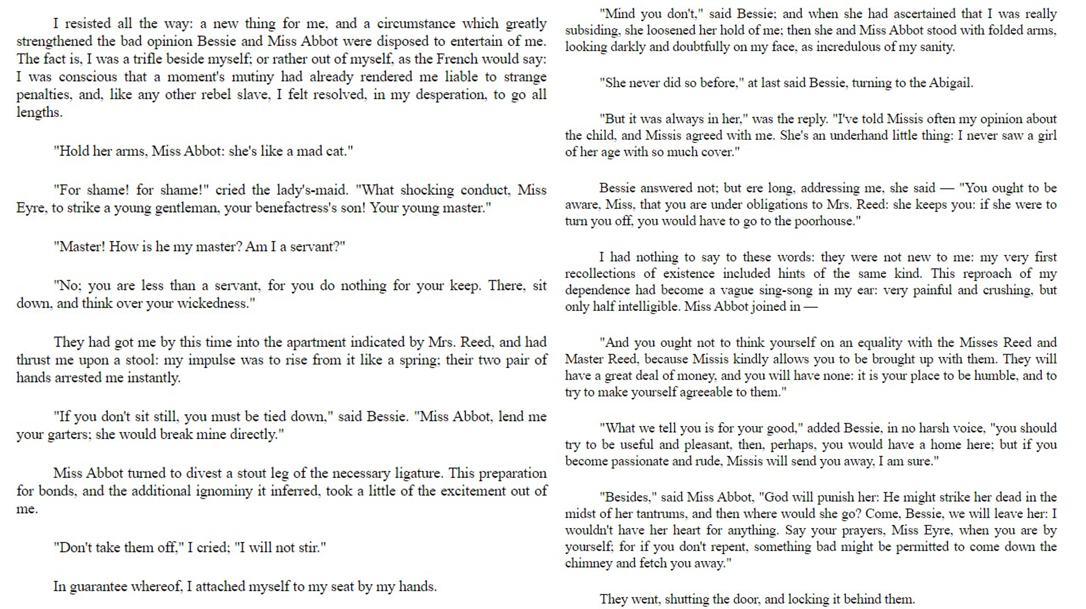

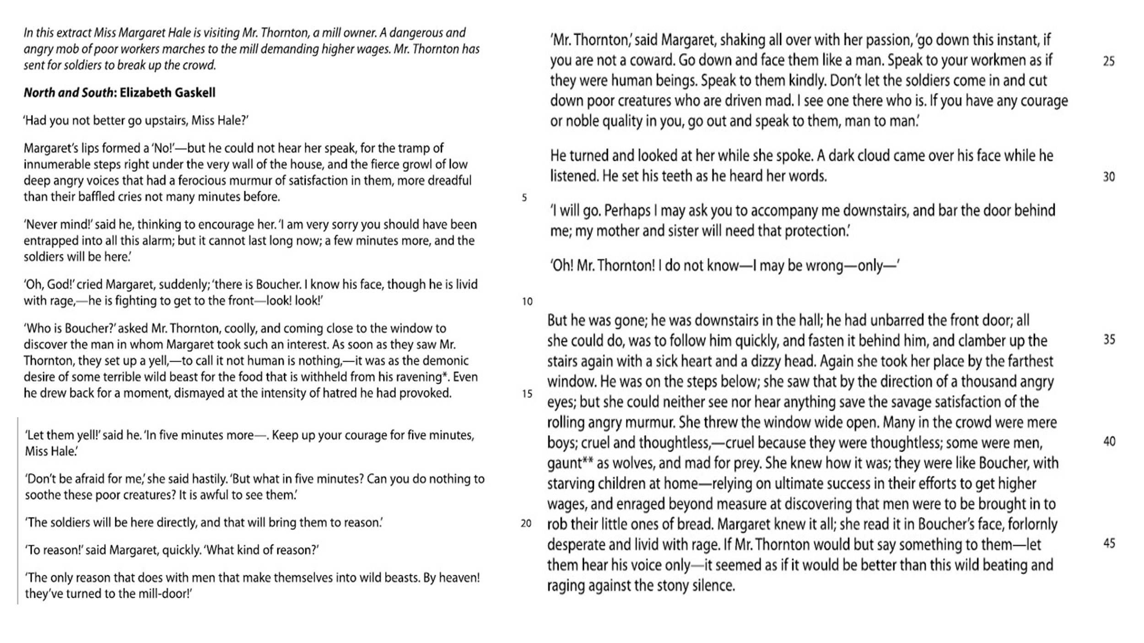

- What were the mob angry about?
- Why does Mr Thornton apologise to Miss Hale?
- ‘Speak to your workmen like human beings’. What two words (lines 19-22) suggest the workers are not being treated as such?
- What does Mr Thornton do in the final paragraph of the extract?
- Why were those protesting ‘like Boucher’?
- How would soldiers be likely to impact the situation?

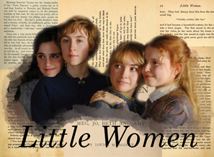
Lesson 9

Little Women - Louisa May Alcott

L/I: To analyse the use of language and structure in an extract

- What was the conflict in North and South?
- How does this reflect social class?
- Which Victorian women were more privileged than others?

Little Women is a ‘coming of age’ novel first published in 1868. The story follows the lives of the four March sisters—Meg, Jo, Beth, and Amy—and details their passage from childhood to womanhood. It is loosely based on the lives of the author and her three sisters. Scholars classify it as an autobiographical or semi-autobiographical novel.
Extracts from Little Women (DART)
Having rekindled the fire, she thought she would go to market while the water heated. The walk revived her spirits, and flattering herself that she had made good bargains, she trudged home again, after buying a very young lobster, some very old asparagus, and two boxes of acid strawberries. By the time she got cleared up, the dinner arrived and the stove was red-hot. Hannah had left a pan of bread to rise, Meg had worked it up early, set it on the hearth for a second rising and forgotten it.
1. What phrase shows visiting the market cheered Jo up?
2. What does ‘trudged’ suggest about her enthusiasm to return home?
3. What three products did she buy?
4. What temperature was the stove?
5. How does the writer suggest thing are going to take a turn for the worse?

How does the writer use language and structure to show the reactions of those eating the dinner? (DIP)

Poor Jo would gladly have gone under the table, as one thing after another was tasted and left, while Amy giggled, Meg looked distressed, Miss Crocker pursed her lips, and Laurie talked and laughed with all his might to give a cheerful tone to the festive scene. Jo’s one strong point was the fruit, for she had sugared it well, and had a pitcher of rich cream to eat with it. Her hot cheeks cooled a trifle, and she drew a long breath as the pretty glass plates went round, and everyone looked graciously at the little rosy islands floating in a sea of cream. Miss Crocker tasted first, made a wry face, and drank some water hastily. Jo, who refused, thinking there might not be enough, for they dwindled sadly, after the picking over, glanced at Laurie, but he was eating away manfully, though there was a slight pucker about his mouth, and he kept his eye fixed on his plate. Amy, who was fond of delicate fare, took a heaping spoonful, choked, hid her face in her napkin, and left the table precipitately.

Focus on Jo’s reaction and the reactions of Amy, Meg, Miss Crocker and Laurie when they taste the food. Think about the context in which the novel was written and why these reactions would be particularly embarrassing for Jo.

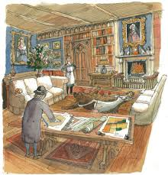
Lesson 10

Body in the Library – Agatha Christie

L/I: To explore the presentation of a character

Agatha Christie is best known for her detective novels, short story collections, plays and famous detective sleuths Hercule Poirot and Miss Marple.

Extract from Body in the Library (DART)

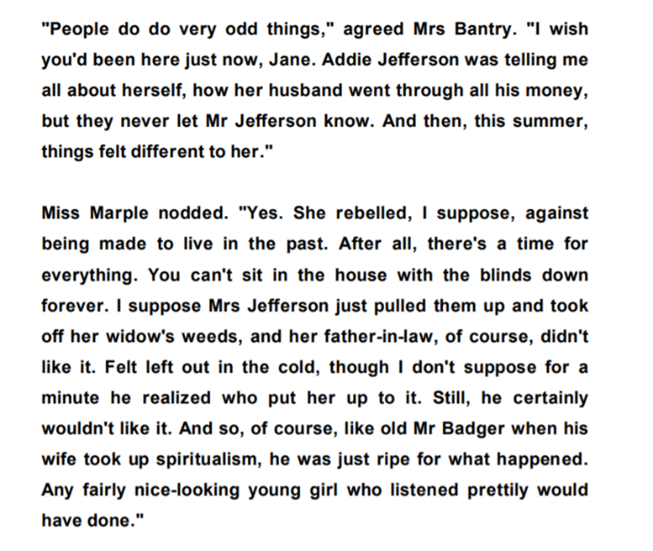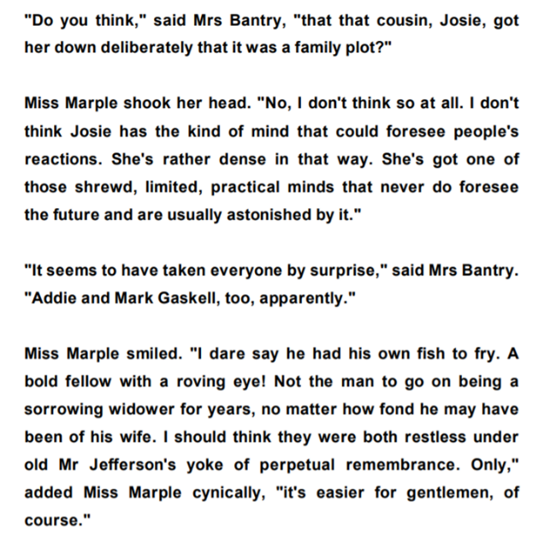

What are Mrs Bantry and Miss Marple talking about?
Write down the question Mrs Bantry asks Miss Marple
Which character dominates the interaction?
Write down one important thing that each character says.

What do we learn about Miss Marple in this extract? (DIP)

The interaction in the extract is dominated by… For example… This shows… This suggests…

Mrs Bantry clearly wants Miss Marple’s help. For example, she asks… This demonstrates… The reader will realise…

Finally, Miss Marple is shown to be… For example… This highlights… The reader can infer from this that…
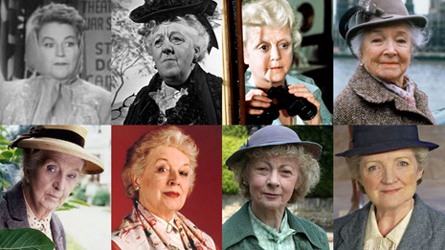
Which of these television adaptations best matches your perceptions of Miss Marple?
What does this show about reading a book versus relying on TV or film?
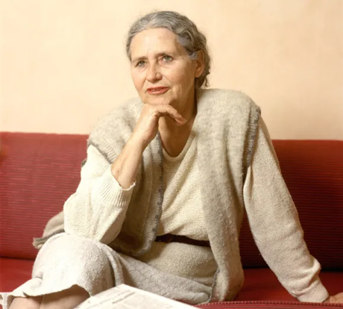
Lesson 11

The Sweetest Dream and Wine – Doris Lessing

L/I: To analyse the use of setting to create mood

- What is the setting of a novel?
- How can setting create mood?
- What is pathetic fallacy?

Doris Lessing Biography (DART)
Doris Lessing was born in Persia (present-day Iran) to British parents in 1919. Her family then moved to Southern Africa, where she spent her childhood on her father's farm in what was then Southern Rhodesia (now Zimbabwe). When her second marriage ended in 1949, she moved to London, where her first novel, The Grass is Singing, was published in 1950. The book explores the complacency and shallowness of white colonial society in Southern Africa and established Lessing as a talented young novelist.
She is now widely regarded as one of the most important post-war writers in English. Her novels, short stories and essays have focused on a wide range of twentieth-century issues and concerns, from the politics of race - which she confronted in her early novels set in Africa - to the politics of gender, which led to her adoption by the feminist movement, to the role of the family and the individual in society, explored in her space fiction of the late 1970s and early 1980s.
When Doris Lessing won the Nobel Prize for Literature in 2007, it seemed that, at last, the highest literary honour was being placed on a woman who has surveyed and judged mankind in the latter half of the 20th century like no other writer.
Identify five biographical facts about Doris Lessing
Identify four ‘twentieth-century’ issues she tackled in her writing

Extract from the Sweetest Dream
An early evening in autumn, and the street below was a scene of small yellow lights that suggested intimacy, and people already bundled up for winter. Behind her the room was filling with a chilly dark, but nothing could dismay her: she was floating, as high as a summer cloud, as happy as a child who had just learned to walk. The reason for this uncharacteristic lightness of heart was a telegram from her former husband, Johnny Lennox -- Comrade Johnny -- three days ago. SIGNED CONTRACT FOR FIDEL FILM ALL ARREARS AND CURRENT PAYMENT TO YOU SUNDAY. Today was Sunday. The 'all arrears' had been due, she knew, to something like the fever of elation she was feeling now: there was no question of his paying 'all' which by now must amount to so much money she no longer bothered to keep an account. But he surely must be expecting a really big sum to sound so confident. Here a little breeze -- apprehension? -- did reach her. Confidence was his -- no, she must not say stock-in-trade, even if she had often in her life felt that, but could she remember him ever being outfaced by circumstances, even discomfited?
Extract from Wine
A man and woman walked towards the boulevard from a little hotel in a side street.
The trees were still leafless, black, cold; but the fine twigs were swelling towards spring, so that looking upward it was with an expectation of the first glimmering greenness. Yet everything was calm, and the sky was a calm, classic blue.
The couple drifted slowly along. Effort, after days of laziness, seemed impossible; and almost at once they turned into a cafe´ and sank down, as if exhausted, in the glass-walled space that was thrust forward into the street.
The place was empty. People were seeking the midday meal in the restaurants. Not all: that morning crowds had been demonstrating, a procession had just passed, and its straggling end could still be seen. The sounds of violence, shouted slogans and singing, no longer absorbed the din of Paris traffic; but it was these sounds that had roused the couple from sleep.

How does Lessing use the description of setting to create the mood? (DIP)
What is happening in each extract?
Identify three examples of how the setting is described in each extract.
In the extract from the Sweetest Dream… The setting is described as… This shows… This suggests…
In the extract from Wine… Lessing writes that the setting is… This highlights… The reader can infer…
Lessing uses setting in both extracts. Whereas the setting of the Sweetest dream creates…, the setting of Wine shows…
Lesson 12
To Kill a Mockingbird – Harper Lee
L/I: To respond to the themes in an extract through imaginative writing
To Kill a Mockingbird takes place in the fictional town of Maycomb, Alabama during 1933–1935. These years place the events of the novel squarely within two important periods of American history: The Great Depression and the Jim Crow era. The Great Depression is reflected in the poverty that affects all of the residents of Maycomb. The Jim Crow era describes the time from the late 19th century until the mid-1960s when black people in the United States could no longer be held in slavery, but where laws limited the social, political, and economic possibilities available to black citizens.
The story centres on Jean Louise (“Scout”) Finch, an unusually intelligent girl who ages from six to nine years old during the novel.
- How do young people form their opinions?
- Should you always trust your friends and family?

Extract from To Kill a Mockingbird (DART)
For reasons unfathomable to the most experienced prophets in Maycomb County, autumn turned to winter that year. We had two weeks of the coldest weather since 1885, Atticus said. Mr Avery said it was written on the Rosetta Stone that when children disobeyed parents, smoked cigarettes and made war on each other, the seasons would change; Jem and I were burdened with the guilt of contributing to the aberrations of nature, thereby causing unhappiness to our neighbours and discomfort to ourselves.
Old Mrs Radley died that winter, but her death caused hardly a ripple – the neighbourhood seldom saw her, except when she watered her cannas. Jem and I decided that Boo had got her at last, but when Atticus returned from the Radley house he said she died of natural causes, to our disappointment.
‘Ask him’, Jem whispered.
‘You ask him, you’re the oldest’.
‘That’s why you ought to ask him’.
‘Atticus,’ I said, ‘did you see Mr Arthur?’
Atticus looked sternly around his newspaper at me: ‘I did not.’
Jem restrained me from further questions. He said Atticus was still touchy about us and the Radleys and it wouldn’t do to push him any. Jem had a notion that Atticus thought our activities that night last summer were not solely confined to strip poker. Jem had no firm basis for his idea, he said it was merely a twitch.
Next morning I awoke, looked out the window and nearly died of fright. My screams brought Atticus from his bathroom half-shaven.
‘The world’s endin’, Atticus! Please do something --!’ I dragged him to the window and pointed.
‘No it’s not,’ he said, ‘It’s snowing’.

- What did autumn turn to?
- Which word shows people didn’t understand why?
- When had the weather last been that cold?
- What did Mr Avery put it down to?
- Who died that winter?
- How did she die?
- Why does the narrator ask Atticus about Mr Arthur?
- Who told the narrator not to ask any follow up any questions?
- Why did the narrator think the world was ending?
- What suggests Atticus is a character without authority?

Write about a time you learnt something important. (DIP)
Lesson 13
The Handmaid’s Tale – Margaret Atwood
L/I: To respond creatively to a text
The Handmaid's Tale is a dystopian novel by Canadian author Margaret Atwood, published in 1985. It is set in a near-future New England, in a strongly patriarchal, quasi-Christian, totalitarian state, known as Gilead, that has overthrown the United States government. The central character and narrator is a woman named Offred, one of the group known as "handmaids," who are forcibly assigned to produce children for the "commanders" – the ruling class of men.
Extract from The Handmaid’s Tale (DART)
We slept in what had once been the gymnasium. The floor was of varnished wood, with stripes and circles painted on it, for the games that were formerly played there; the hoops for the basketball nets were still in place, though the nets were gone. A balcony ran around the room, for the spectators, and I thought I could smell, faintly like an afterimage, the pungent scent of sweat, shot through with the sweet taint of chewing gum and perfume from the watching girls, felt-skirted as I knew from pictures, later in miniskirts, then pants, then in one earring, spiky, green-streaked hair. Dances would have been held there; the music lingered, a palimpsest of unheard sound, style upon style, an undercurrent of drums, a forlorn wail, garlands made of tissue-paper flowers, cardboard devils, a revolving ball of mirrors, powdering the dancers with a snow of light.
There was sadness in the room and loneliness, and expectation, of something without a shape or name. I remember that yearning, for something that was always about to happen and was never the same as the hands that were on us there and then, in the small of the back, or out back, in the parking lot, or in the television room with the sound turned down and only the pictures flickering over lifting flesh.
We yearned for the future. How did we learn it, that talent for insatiability? It was in the air; and it was still in the air, an afterthought, as we tried to sleep, in the army cots that had been set up in rows, with spaces between so we could not talk. We had flannelette sheets, like children's, and army-issue blankets, old ones that still said U.S. We folded our clothes neatly and laid them on the stools at the ends of the beds. The lights were turned down but not out. Aunt Sara and Aunt Elizabeth patrolled; they had electric cattle prods hanging from their leather belts.
No guns though, even they could not be trusted with guns. Guns were for the guards, specially picked from the Angels. The guards weren't allowed inside the building except when called, and we weren't allowed out, except for our walks, twice daily, two by two around the football field, which was enclosed now by a chain-link fence topped with barbed wire. The Angels stood outside it with their backs to us. They were objects of fear to us, but of something else as well. If only they would look. If only we could talk to them. Something could be exchanged, we thought, some deal made, some trade-off, we still had our bodies. That was our fantasy.
We learned to whisper almost without sound. In the semidarkness we could stretch out our arms, when the Aunts weren't looking, and touch each other's hands across space. We learned to lip-read, our heads flat on the beds, turned sideways, watching each other's mouths. In this way we exchanged names, from bed to bed:
Alma. Janine. Dolores. Moira. June.
- Identify five features of the gymnasium in which the women sleep
- Who patrolled the room?
- Who could be ‘trusted’ with guns?
- How did the women exchange names?
- How does what is described represent a dystopian society?

Write an introduction to a story, modelled on the extract from Handmaid’s tale, which describes your experience of lockdown (DIP).
You could describe home, remote learning, activities, communicating with friends, staying indoors.

Lesson 14
Noughts and Crosses – Malorie Blackman
L/I: To analyse the use of language and structure to present a character’s perspective
- What is racial segregation?
- Where in the world has this taken place?
- What would it mean to subvert racial segregation?

Review of Noughts and Crosses (DART)
Not dissimilar to Romeo and Juliet, Noughts & Crosses’ plot explores themes of racism, prejudice and politics and is narrated by the two main characters Sephy, a Cross, and Callum, a Nought. Having been friends since childhood, as they both grow older it soon becomes clear that living in a segregated society, in which dark-skinned Sephy is of the ruling class, compared to colourless Callum who belongs to the underclass, will not only effect their friendship but also lead to a heart-breaking climax for them both. But while the pair are both battling the racial and class politics that are part and parcel of the society on which they live, they too are fighting battles within themselves. Callum wants to make something of himself. He believes he is capable of more than what is expected of both him and the Crosses as a whole. He’s angered and insulted by the Cross government’s attempt at integration. He is desperate for equality but struggles to achieve what feels so very far out of reach. He too is angry at himself for loving Sephy – a member of the people who oppress him and the daughter of a man who is instrumental in the mistreatment of his kind. To love Sephy means to love the source of all his pain, hatred, anger, and yet, despite her privileged position in society, Sephy is filled with shame at being a cross.
- What Shakespeare play is Noughts and Crosses compared to?
- What three themes does the plot explore?
- What do we learn about Callum and Sephy?
- What do we learn about their relationship?
- Why is their relationship problematic?
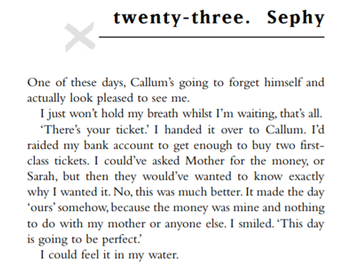
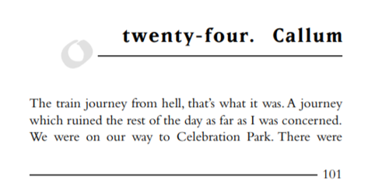
Extract from Noughts and Crosses
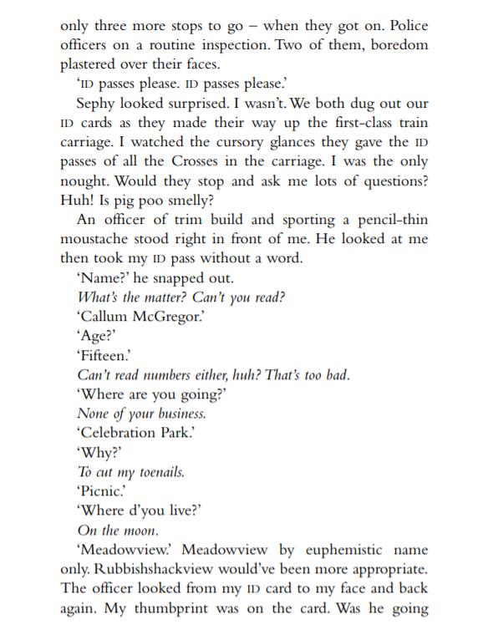
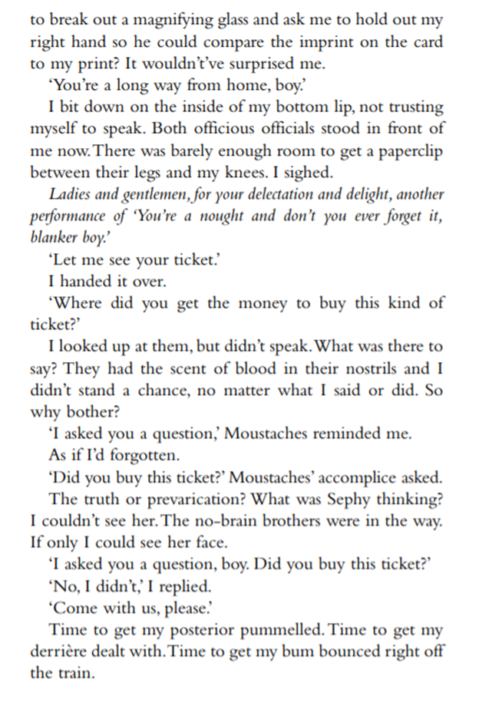
How does Blackman use language and structure to show Callum’s perspective? (DIP)
- How does Callum describe the journey?
- What did he expect to happen when the guards arrived?
- Why are the questions important?
- Why does Blackman use italics?
- Why does Blackman use lots of short sentences?
- What is the significance of the final paragraph?

**********************************************************************************
Lesson 15
Grand Union – Zadie Smith
L/I: To explore the use of dialogue in writing
- What is dialogue?
- Which form of writing uses most dialogue?
- How do novels/plays provide the reader/audience with more information than they can take just from dialogue?

Extract from Grand Union
‘I would like to be on good terms with all animals,’ remarked the woman, to her daughter. They were sitting on the gritty beach at Sopot, looking out at the cold sea. The eldest boy had gone to the arcade. The twins were in the water.
‘But you are not!’ cried the daughter. ‘You are not at all!’
It was true. What the woman had said was true, in intention, but what the girl had said was true, too, in reality. The woman, though she generally refrained from beef, pork and lamb, ate – with great relish – many other kinds of animals and fish, and put out flypaper in the summer in the stuffy kitchen of their small city apartment and had once (though her daughter did not know this) kicked the family dog. The woman had been pregnant with her fourth child, at the time, and temperamental. The dog seemed to her, at that moment, to be one responsibility too many.
‘I did not say that I am. I said that I should like to be.’
The daughter let out a cruel laugh.
‘Words are cheap,’ she said.
Indeed, at that moment the woman held a half-eaten chicken wing in her hand, elevated oddly to keep it from being covered in sand, and it was the visible shape of the bones in the chicken wing, and the tortured look of the thin, barbecued skin stretched across those bones, which had brought the subject to mind.
‘I dislike this place,’ said the daughter, definitively. She was glaring at the lifeguard, who had once again had to wade into the murk to tell the only bathers – the girl’s own brothers – not to go past the red buoy. They weren’t swimming – they could not swim. There were no waters in the city in which to take lessons, and the seven days they spent in Sopot each year was not long enough to learn. No, they were leaping into the waves, and being knocked over by them, as unsteady on their feet as newborn calves, their chests grey with that strange silt which fringed the beach, like a great smudge God had drawn round the place with a dirty thumb.
‘It makes no sense,’ continued the daughter, ‘to build a resort town around such a filthy and unwelcoming sea.’
Her mother held her tongue. She had come to Sopot with her own mother and her mother had come with her mother before that. For at least two hundred years people had come here to escape the cities and let their children run wild in the public squares. The silt was of course not filth, it was natural, though no one had ever told the woman exactly what form of natural substance it was. She only knew to be sure to wash out all their costumes nightly in the hotel sink.

- Rewrite this extract so it is only dialogue
- Identify the most important thing that each character says
- What impact does this have on the meaning of the extract?
- Identify two important details that are missed out the extract by doing this

How does Smith use dialogue to highlight the mother-daughter relationship in the extract? (DIP)
Zadie Smith describes the interaction between a mother and her daughter. They are discussing… For example, the mother says… This shows… This suggests… In response, the daughter says… This highlights… The reader can infer… about their relationship.
In addition to the dialogue Smith adds detail through her description of… This shows… This suggests… This develops our understanding of the mother-daughter relationship because…
‘Words are cheap’. Do you agree?
- What does this statement mean?
- Why does the daughter say this in the extract (what are they discussing)?
- How might this make her feel?
- Can you think of other examples from the issues we have read about this half-term?
- Can you think of real-life examples you could add to your answer?
- Use both sides of the argument in your answer
Lesson 16
Half a Yellow Sun – Chimamanda Ngozi Adichie
L/I: To review the link between literature and society
Chimamanda Ngozi Adichie
Chimamanda Ngozi Adichie is a Nigerian author, best known for her award winning novels Purple Hibiscus, Half of a Yellow Sun and Americanah.
Adichie grew up in Nigeria and moved to the United States to study communication and political science. She went on to obtain Creative Writing Master’s degree from John Hopkins University and subsequently a master’s degree in African History from Yale University.
Extract from Half a Yellow Sun
Master was a little crazy; he had spent too many years reading books overseas, talked to himself in his office, did not always return greetings, and had too much hair. Ugwu's aunty said this in a low voice as they walked on the path. "But he is a good man," she added. "And as long as you work well, you will eat well. You will even eat meat every day." She stopped to spit; the saliva left her mouth with a sucking sound and landed on the grass.
Ugwu did not believe that anybody, not even this master he was going to live with, ate meat every day. He did not disagree with his aunty, though, because he was too choked with expectation, too busy imagining his new life away from the village. They had been walking for a while now, since they got off the lorry at the motor park, and the afternoon sun burned the back of his neck. But he did not mind. He was prepared to walk hours more in even hotter sun.
He had never seen anything like the streets that appeared after they went past the university gates, streets so smooth and tarred that he itched to lay his cheek down on them. He would never be able to describe to his sister Anulika how the bungalows here were painted the colour of the sky and sat side by side like polite well-dressed men, how the hedges separating them were trimmed so flat on top that they looked like tables wrapped with leaves.
His aunty walked faster, her slippers making slap-slap sounds that echoed in the silent street.
Ugwu wondered if she, too, could feel the coal tar getting hotter underneath, through her thin soles.
They went past a sign, ODIM STREET, and Ugwu mouthed street, as he did whenever he saw an English word that was not too long ... Master sat in an armchair, wearing a singlet and a pair of shorts.
He was not sitting upright but slanted, a book covering his face, as though oblivious that he had just asked people in.
"Good afternoon, sah! This is the child," Ugwu's aunty said.
Master looked up. His complexion was very dark, like old bark, and the hair that covered his chest and legs was a lustrous, darker shade. He pulled off his glasses. "The child?"
"The houseboy, sah."

- What reasons are given for master being a ‘little crazy’?
- What does Ugwu’s auntie say about him?
- What did Ugwu believe? What did he not do?
- How do we know Ugwu has never been here before?
- How is he introduced to the master?

What does this extract show the reader about the society in which it is set? (DIP)
- Use your DART answers to help you.
- Think about what you literally know and what we can infer about social class and inequality.
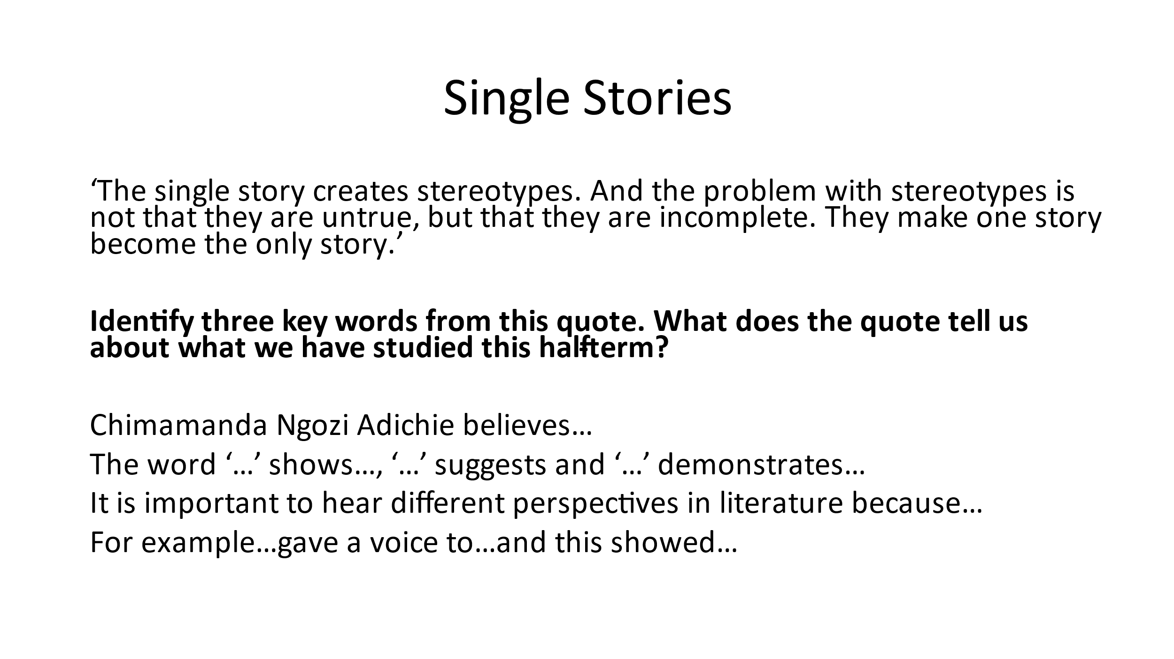

 | Reading
Yellow Plus | - You demonstrate a thorough understanding of texts by drawing inferences and fully exploring implicit meaning.  - Your responses demonstrate originality and are enhanced by carefully chosen evidence from the text.  - Your explanation and analysis show a well-developed understanding of authorial intent, the impact on the reader, and the link between the two.  - Your critical judgements are strengthened by a range of carefully chosen evidence, fully exploring how specific elements of a text reflect authorial intent and why they are effective in fulfilling their aims.  - You explain the effect of a range of devices.
Yellow | - Your understanding of a text goes beyond what is literally on the page to fully consider the conventions of genre and the influence of context.  - Your responses to the text are detailed and supported with relevant and focussed (word-level) evidence.  - You give detailed explanation and analysis beginning to explore the deliberate impact of the writer’s choices on the reader.  - You make interesting and perceptive critical judgements directly supported by relevant and focussed (word-level) evidence from the text.  - You explain the effect of simple devices.
Blue | - Your understanding of a text is more nuanced and includes a basic sense of genre and the context in which it was written.  - Your responses to the text are valid, sometimes original, and clearly supported and explained with relevant evidence from the text.  - Your explanation and analysis are well developed, referring to the impact or effect on the reader.  - You make increasingly critical judgements that are clearly supported and explained with relevant evidence from the text.  - You identify and label a range of devices.
Green | - Your explanations of the text are simple, identifying explicit meaning.  - Your responses to the text are valid and supported by/based on relevant evidence from the text.  - Your answers include an attempt at explanation or basic analysis of your points, i.e. why a point is important or relevant in answering the question.  - You make basic judgements supported with some relevant evidence from the text.  - You identify and label simple language devices.
White | - You can describe or re-tell the text.  - Your responses to the text are simple but valid with some relevant reference to the text.  - There is little or no explanation or analysis in your answers.  - You make simple but unfocused judgements with no relevant supporting examples from the text.  - You identify simple language devices without using subject terminology.

