Year 8 
Blended Learning Booklet
Autumn B
Name:_____________________

Class:__________
Music Teacher: Ms Reeves OR Ms McGruddy
Resources:
*Go to: Oak National Academy-> Lessons-> Subjects-> Key Stage 3-> Music: Band Musicianship: The Blues
*Use virtualpiano.net to play the music if you don’t have a guitar or keyboard at home
Other apps: Garageband or similar – has many different instruments you can use to play along
KO: Band Musicianship: The Blues
Weeks 8 & 9 of Autumn Term:
Blues music was first played in the 19th Century
Blues originated from the south of America, the Mississippi delta
Originally blues was played by a solo singer playing guitar or banjo
Crossroad Blues is a song written and sung by Robert Johnson
'In C' means that C is the first note and the key of the blues piece. The other notes are F & G for 12-Bar Blues
F is the 1st note, Bb is the 4th note and C is the 5th note of the scale if the Blues is played in F

Weeks 10 & 11 of Autumn Term:
African slaves were brought over to do hard manual work.
The lyrics of the song, ‘Wade in the Water’, helped slaves escape by swimming in the river
Roman numerals were used to show which chords to play, (I) means the first.
Roman numerals were used to show which chords to play, (IV) means the fourth in the scale.
Roman numerals were used to show which chords to play, (V) means the fifth.
A 'turn around' chord makes the piece sound like it is going to continue. For the Blues, we use the fifth chord (V) instead of I

Weeks 12 & 13 of Autumn Term: African people brought their musical traditions like chants, tribal music and drumming music.
Blues music inspired rock and roll artists like Little Richard to write hits like Tutti Frutti
Kick, snare and hi-hat can create a basic shuffle beat for 12-Bar blues
A walking bass line is the notes of the chords 'broken' into an ascending and descending pattern. E.g. C E G E
Double shuffle rhythm.
Blues rhythms are played in triplets or swung shuffle feel.
If you are playing a 12 bar blues in G, the I, IV, and V chords would be G, C and D

Week 14 of Autumn Term:
Blues started off with simple percussion instruments like tambourines with country banjos, and guitars
An example of a jazz artist on the vibraphone: Milt Jackson played vibraphone in the song "Bags Groove"
A main melody or theme that will repeat throughout a blues song is the Head.
In Bags’ Groove head there are 2 bars and a beat
Bass, piano and drums would then accompany this, typically.

SAL: Band Musicianship: The Blues
Grade | Knowledge | Skill
Yellow Plus 8-9 | Understand what the ‘head’ is and how to fit it in on their recording of the double shuffle and 12-Bar Blues chords with turn around  Is able to empathise with what occurred during the enslavement of humans, and apply this to the understanding of the roots of the Blues | Is able to create a cohesive performance of the 12-Bar Blues using a recording of the double shuffle and 12-Bar Blues chords with turn around, singing or playing the head over this.  Is able to show empathy and understanding of the roots of the Blues and show this in the emotion and style of the performance
Yellow 6-7 | Understands the rhythms and instruments to create a double shuffle  Understands how the rhythm is swung and how to write that | Can play a double shuffle on the chair or drum kit
Blue 4-5 | Can transpose the chords into a different key for 12-Bar Blues  Can site an early Blues musician and a piece of music played | Can play the chords in a different key for 12-Bar Blues
Green 2-3 | Understands which chords in C make the bassline for 12-Bar Blues  Knows the instruments used in early Blues | Can play the chords in C for the 12-Bar Blues
White 0-1 | Understands how to find the bassline for 12-Bar Blues  Understands the origins of Blues | Can play the bass line for 12-Bar Blues

Weeks 8 & 9 Lessons 8 & 9 of Autumn Term (Weeks beginning November 2nd and 9th)
Go to: Oak National Academy-> Lessons-> Subjects-> Key Stage 3-> Music: Band Musicianship: The Blues
LI: 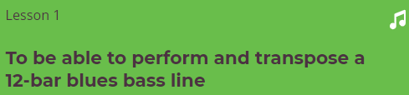
CONNECT:
Warm up: Use your voice to match the bass notes of the 12-Bar Blues

ACTIVATE:
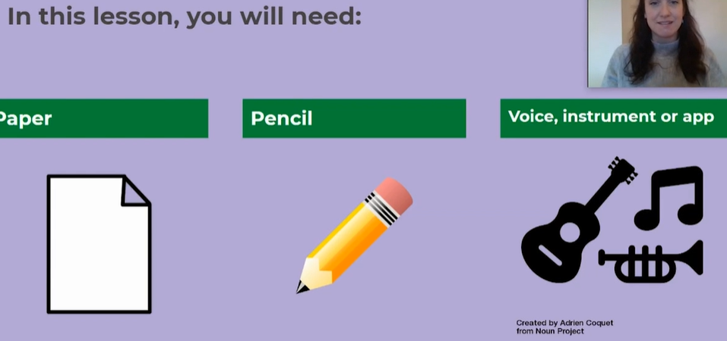
Structure of the Lesson:
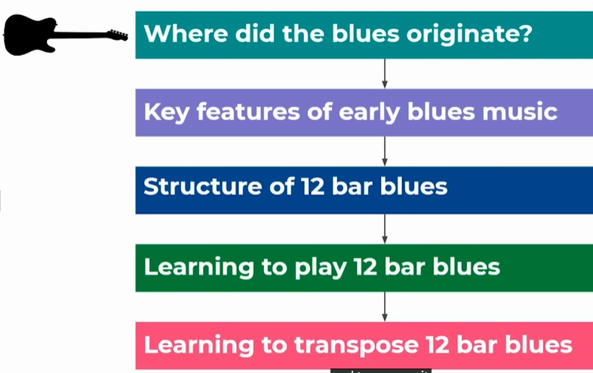

The Mississippi Delta:

Robert Johnson: Perhaps the first Blues musician we know about.
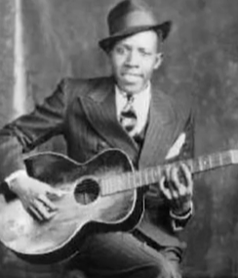

Structure of 12-Bar Blues:
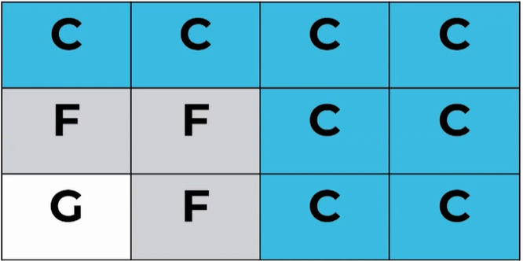
DEMONSTRATE:Use your left hand for the bass line on the keyboard/app
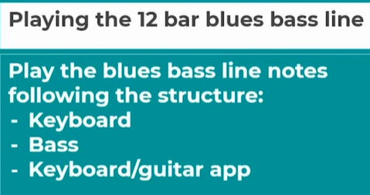

Transposing the 12-Bar Blues:
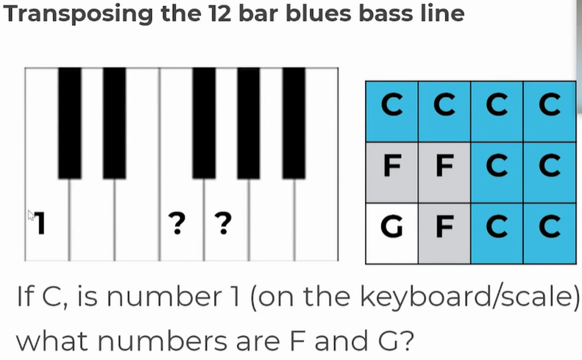
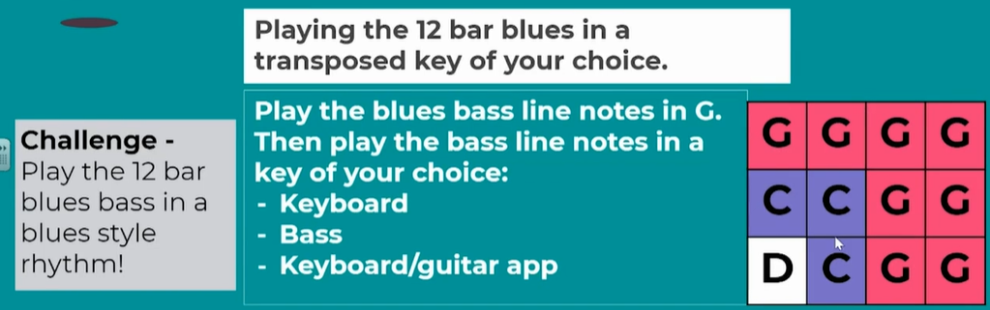

CONSOLIDATE:
Write out and play the 12-Bar Blues as shown in the video

Weeks 10 & 11 Lesson 10 & 11 of Autumn Term (Weeks Beginning 16th and 23rd November)
CONNECT:
Press Next and then Next again after the last video, and you will find questions from that video.
Please answer the questions to remember what you did in the last couple of lessons
Send a screen shot of the results to Ms Reeves through Classcharts. An example of this is shown below:
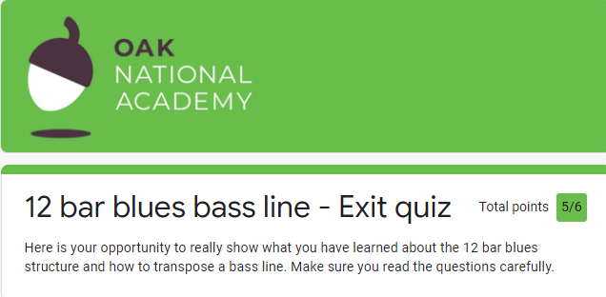
Now Go to: Oak National Academy-> Lessons-> Subjects-> Key Stage 3-> Music: Band Musicianship: The Blues. Go to the 2nd lesson:
LI:
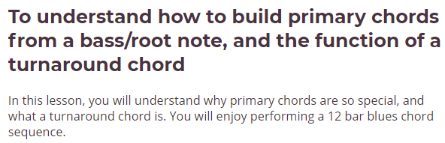
Take the introductory quiz. Check that you achieved the same score (if you attained full marks) or a higher score if you didn’t receive top marks.
ACTIVATE: Lesson Plan:
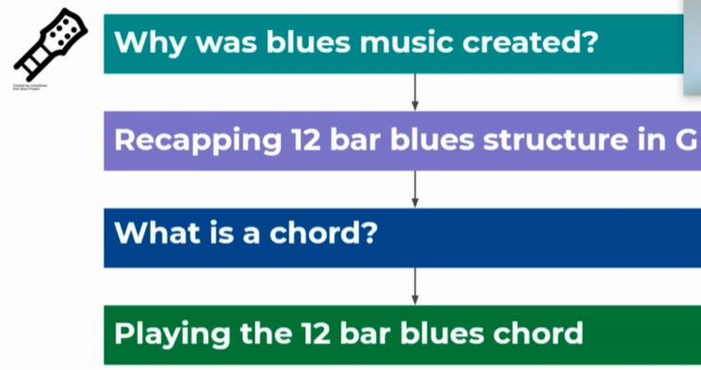
It is important to recognise that the appalling enslavement of humans from Africa is closely linked to the birth of the 12-Bar Blues and other genres of music that are close to it. You will see this depicted in this lesson:
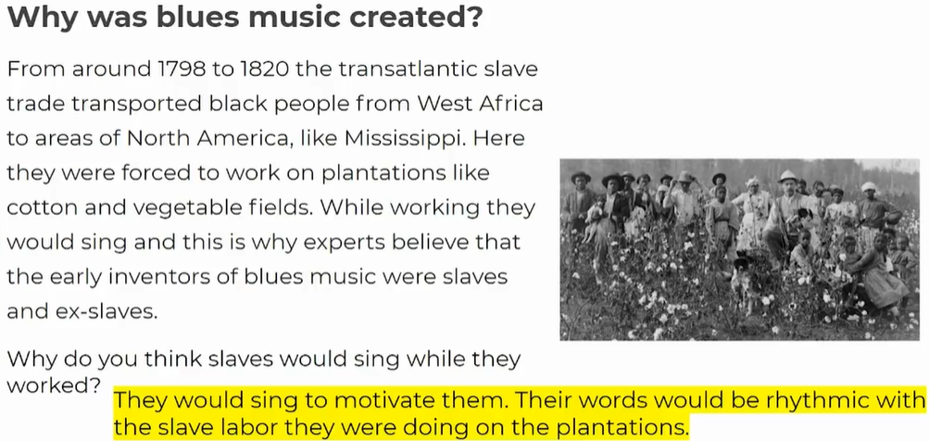

12 Bar-Blues in G with a D chord turn around
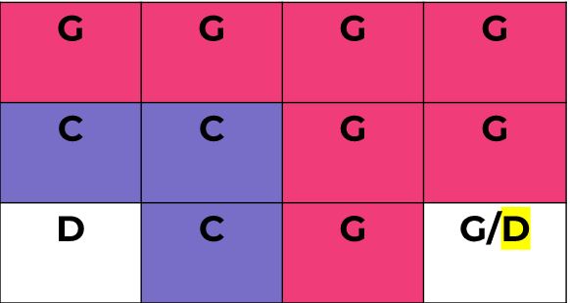
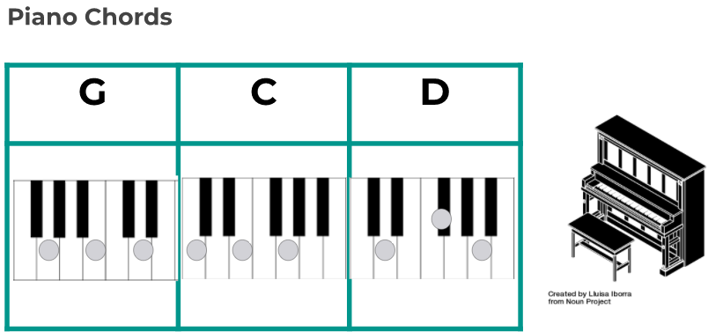
DEMONSTRATE: (use an app if you have no instrument)

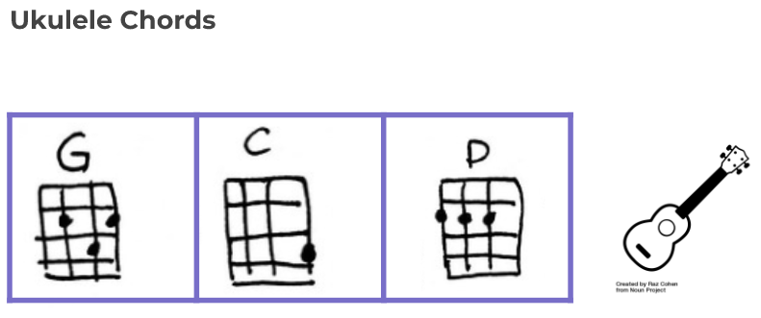
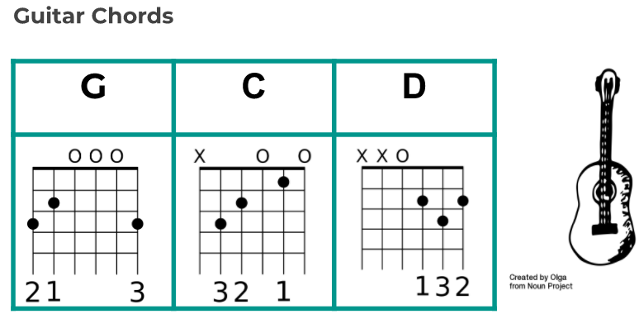

(or use Easy G if you wish – 3 fret on thin ‘E’ string)
Try to use the strumming patterns shown in the videos. You can also push yourself with the 7th chords shown. This sounds more bluesy or jazzy.
CONSOLIDATE:
Press ‘Next’ and ‘Next’ again to get to the Exit Quiz.
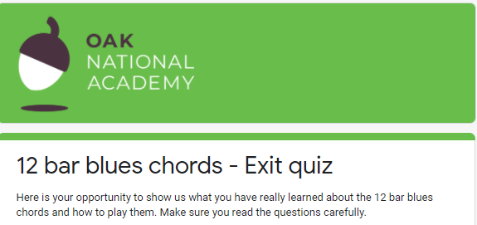
Once you have taken it, send your results to Ms Reeves with a screen shot, to Classcharts.

Weeks 12 & 13 of Autumn Term Lessons 12 & 13 (Weeks beginning 30th November & 7th December)
Go to: Oak National Academy-> Lessons-> Subjects-> Key Stage 3-> Music: Band Musicianship: The Blues Lesson 3
All Around Blues Music
LI:
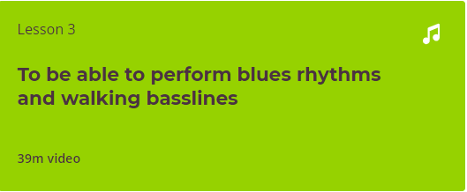
CONNECT:
Retake the quiz for the last lesson, to check for understanding and learning
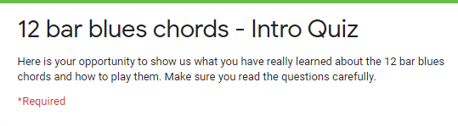
ACTIVATE:
Close the quiz and click on ‘Next’.
Warm up: Low part walking-bass line
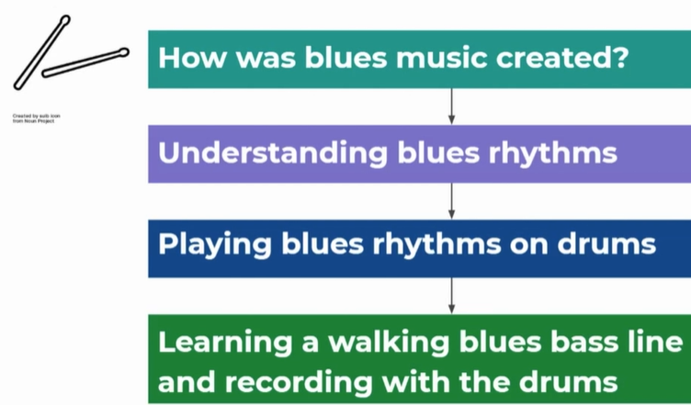
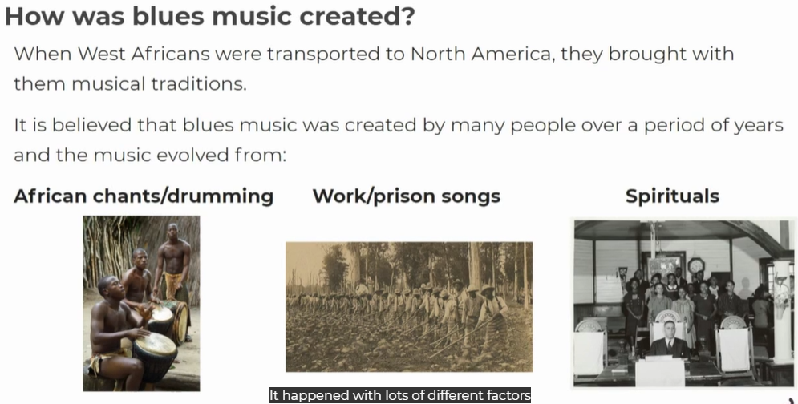
DEMONSTRATE:
Active Listening: Tutti-Frutti by Little Richard

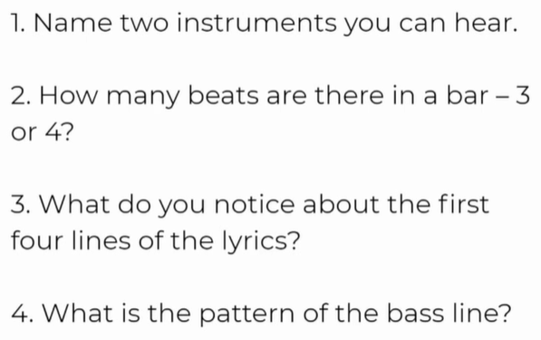
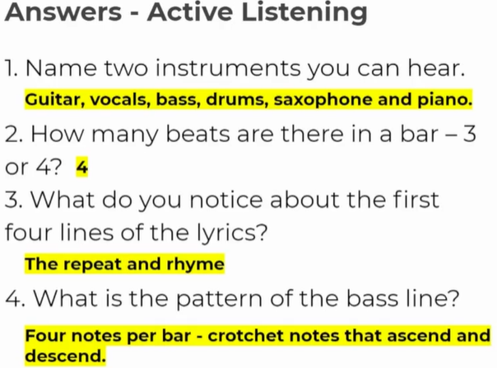

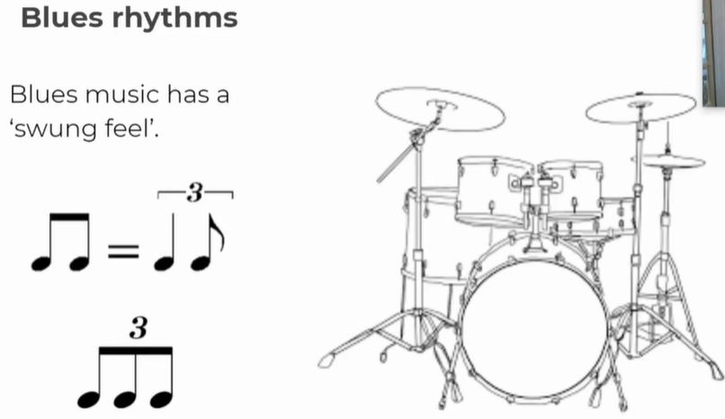
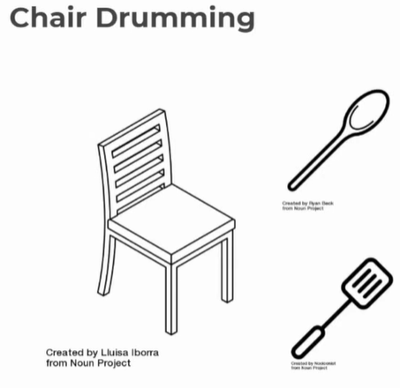

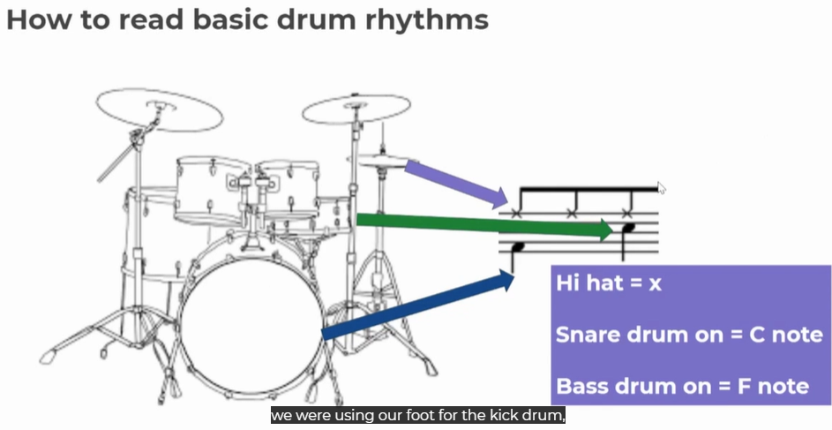
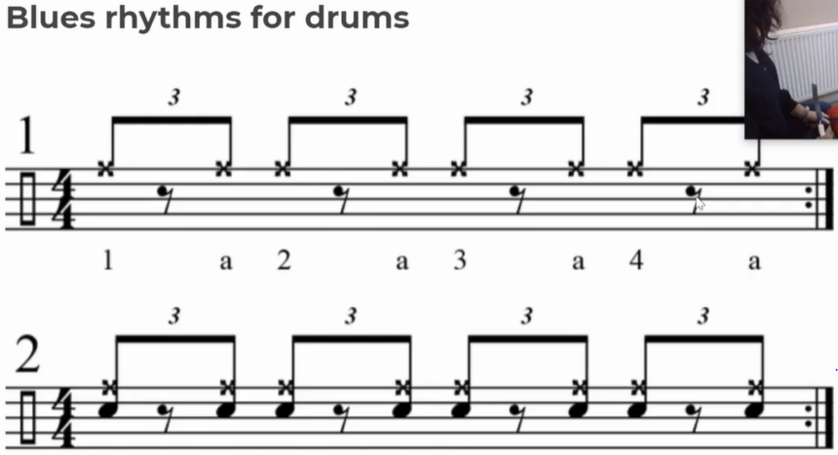

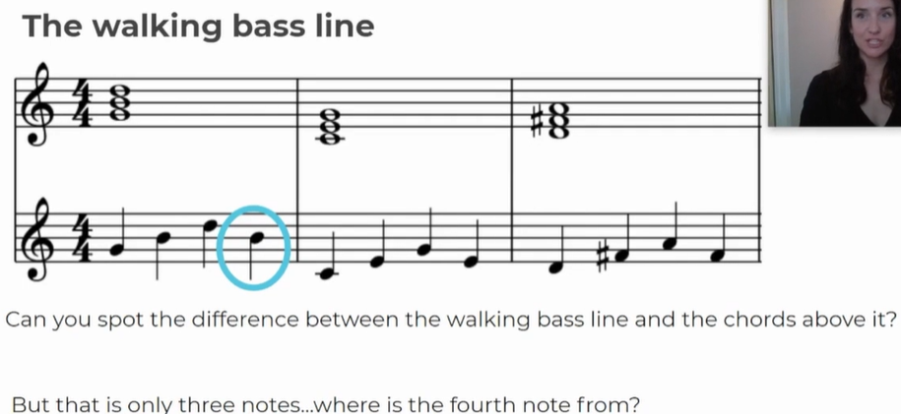
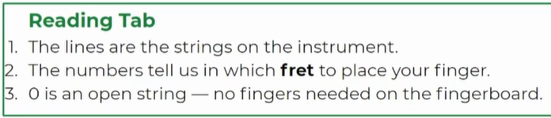

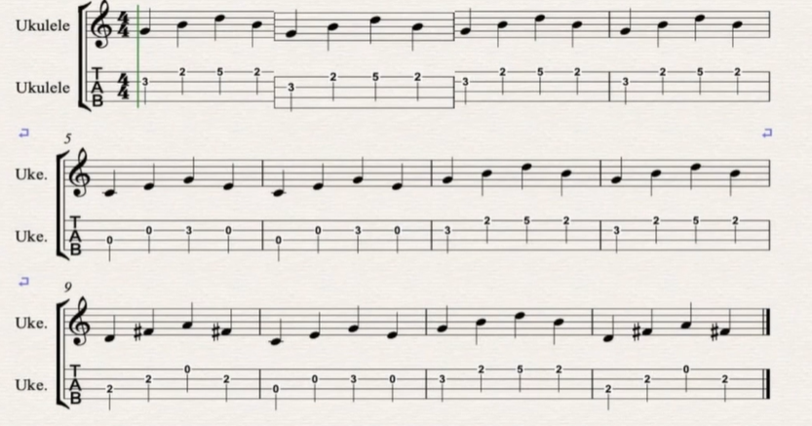
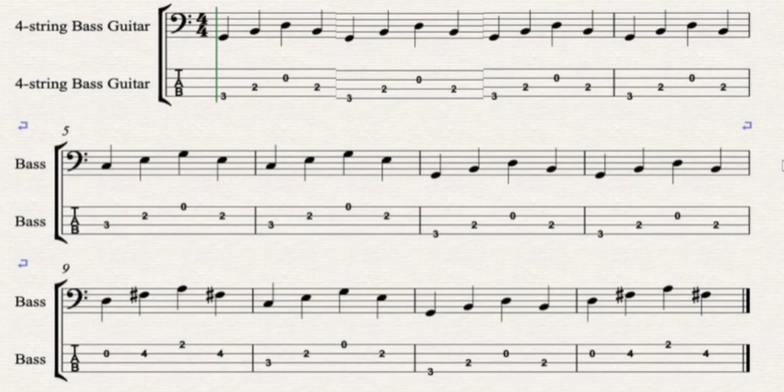

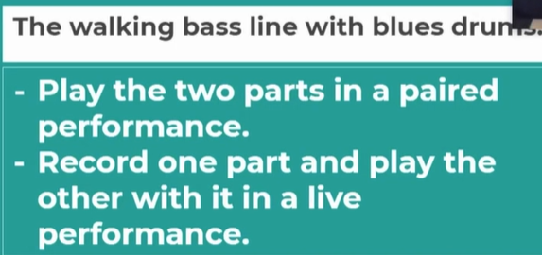
CONSOLIDATE:
Press Next and then Next again, in order to be able to take the quiz for this Lesson 3. Screen shot the results and send to Ms Reeves
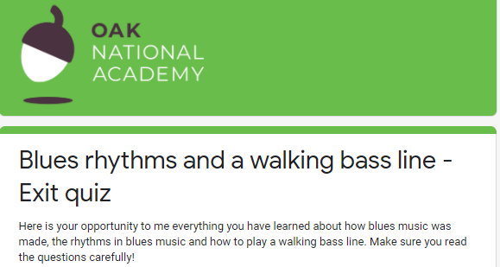

Week 14 Lesson 14 of Autumn Term (Week Beginning 14th December)
Go to: Oak National Academy-> Lessons-> Subjects-> Key Stage 3-> Music: Band Musicianship: The Blues Lesson 4

LI: To be able to perform a jazz head
In this lesson, we will look at how a main melody or theme is used in blues music and learn how to play a very famous 'head'.
CONNECT:
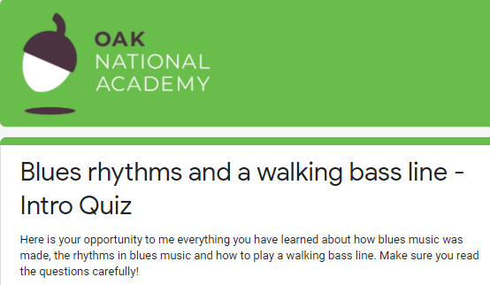

Warm Up: Clapping ‘Bluesy’ Shuffle Rhythms
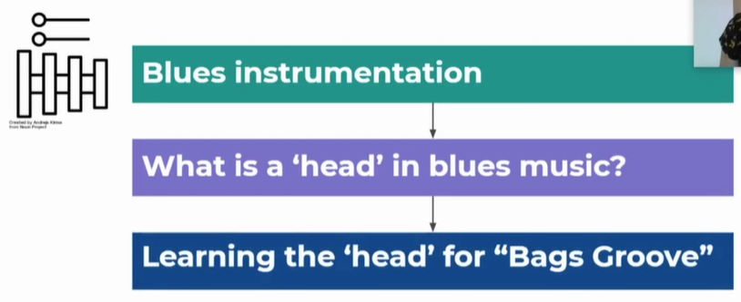
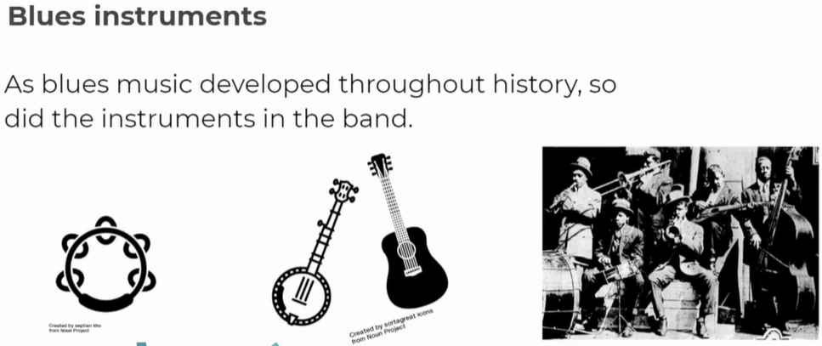
ACTIVATE:
Active Listening:

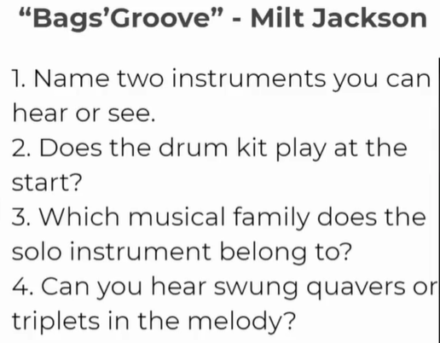
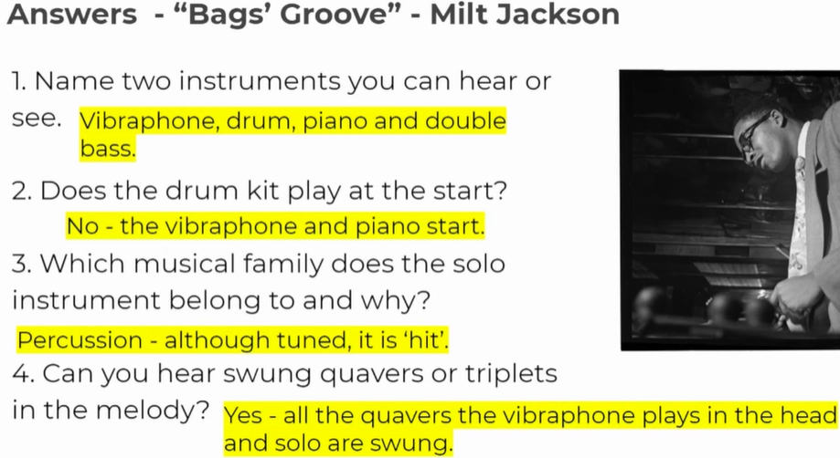
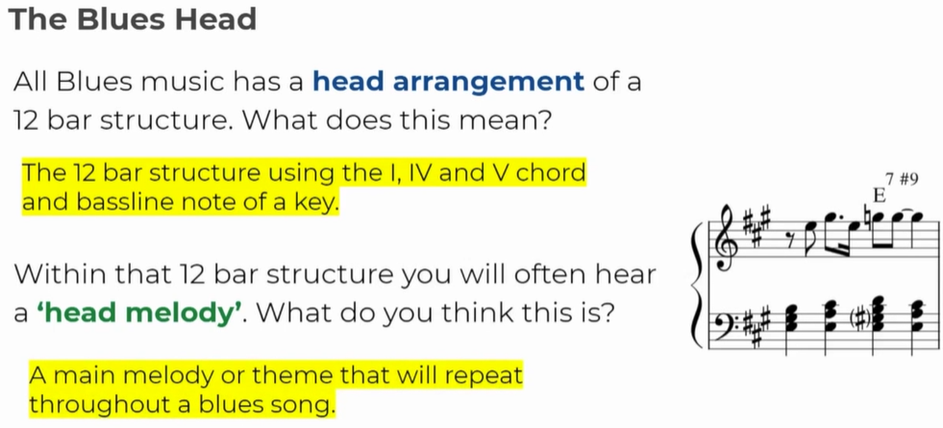
DEMONSTRATE:
Bag’s Groove: Main Groove:
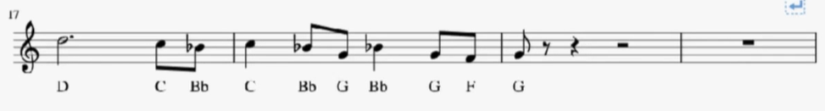
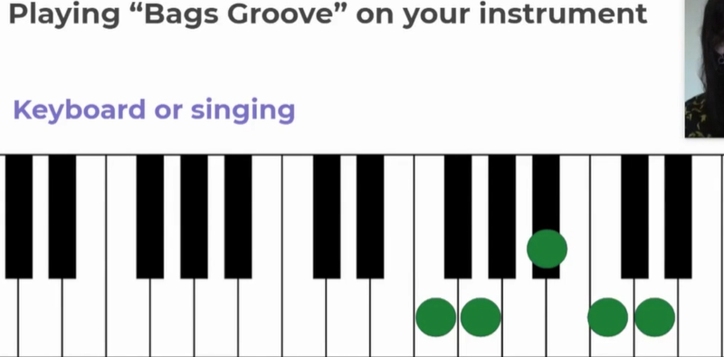

Remember: The Head is the main, repeating theme that returns every time.
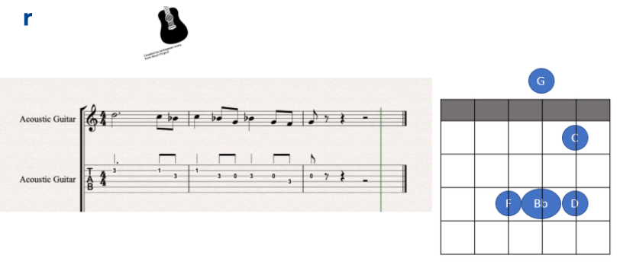

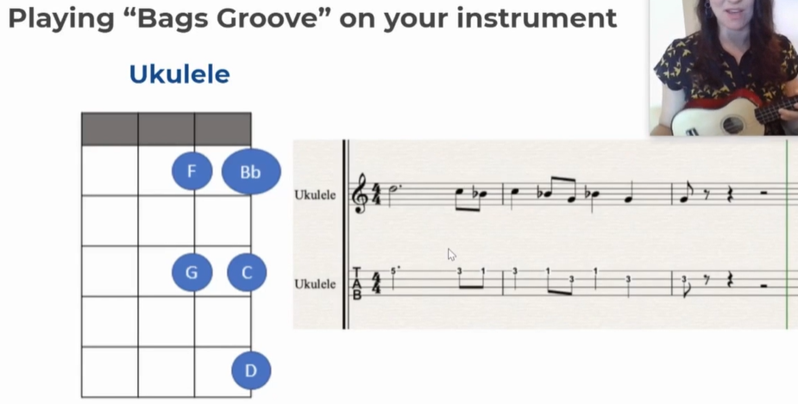

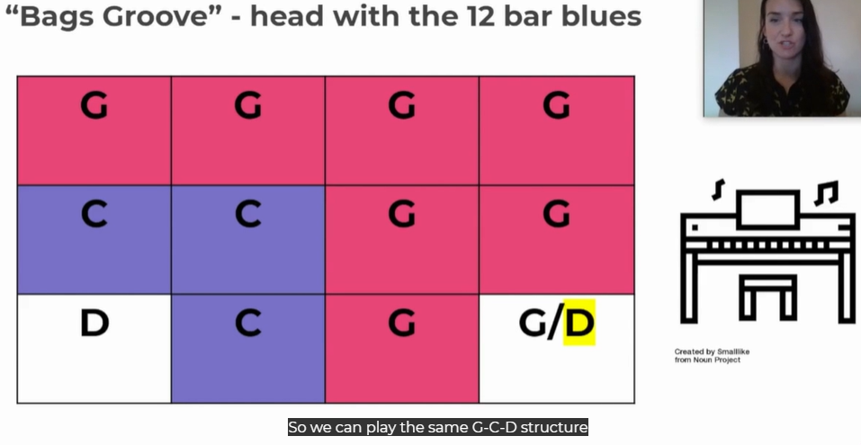

CONSOLIDATE:
Do take the Final Quiz after the lesson, in order to check your learning and understanding
Send a screen shot of your results, to Ms Reeves through Class Charts.
Thank you!
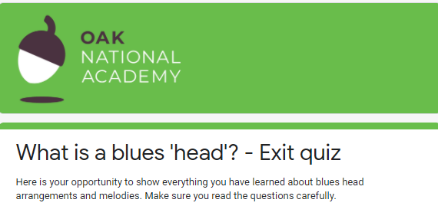

***************CONGRATULATIONS! You have completed the music learning for Music Autumn Term 2***********

