

Stewards Academy
Year 8 Spanish
Autumn 2 Blended Learning Booklet

Todo sobre mi vida (All about my life)

Name ………………………….
Form ……………..
Class Teacher ………………….

CONTENTS PAGE
YEAR 8 SPANISH
AUTUMN 2 BLENDED LEARNING BOOKLET LEARNING OVERVIEW
Todo sobre mi vida (All about my life)
PAGE TITLE | LEARNING INTENTION | PAGE NUMBER
Big Picture – Year 8 Spanish |  | 3
Zoom In – Year 8 Spanish Autumn 2 |  | 4
Lesson 1: Mi vida, mi móvil | Objetivo: To use the present tense to say what I use my phone for using the present tense | 5
Lesson 2: Uso mi móvil todos los días | Objetivo: To complete a writing activity about what we use our phones for | 7
Lesson 3: ¿Qué tipo de música te gusta? | Objetivo: To be able to say what type of music you like using a range of opinions. | 9
Lesson 4: Escuché la música clásica | Objetivo: To learn how to talk about different types of music using the preterite tense | 11
Lesson 5: Me gustan las comedias | Objetivo: To learn how to talk about TV. | 13
Lesson 6: Las comedias son más divertidas que los anuncios | Objetivo: To learn how to use comparatives to talk about TV | 15
Lesson 7: ¿Qué hiciste ayer? | Objetivo: to be able to say what you did yesterday using the present and preterite tense together. | 17
Lesson 8: Repaso: Otoño 2 | Objetivo: to recap learning in Autumn 2 in preparation for our Listening and Writing Assessment. | 19
Knowledge Organiser |  | 21
Assessment |  | 23
Assessment Ladder |  | 25

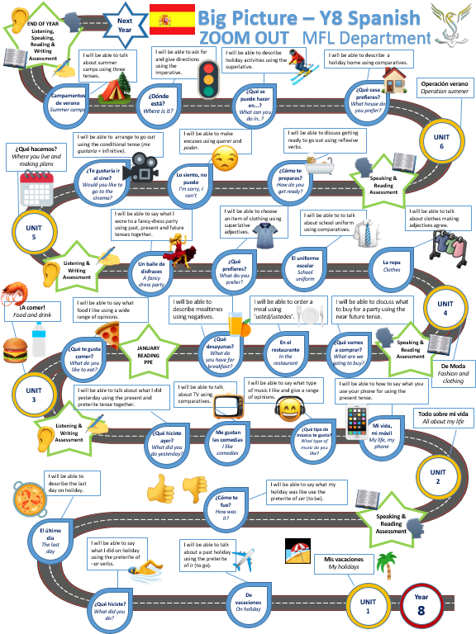

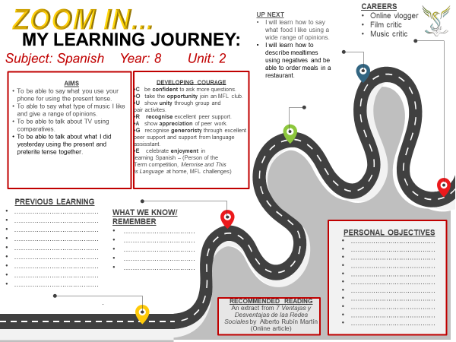

Module 2, Todo sobre mi vida: Lesson 1:
Mi vida, mi móvil
Objetivo: To use the present tense to say what I use my phone for using the present tense
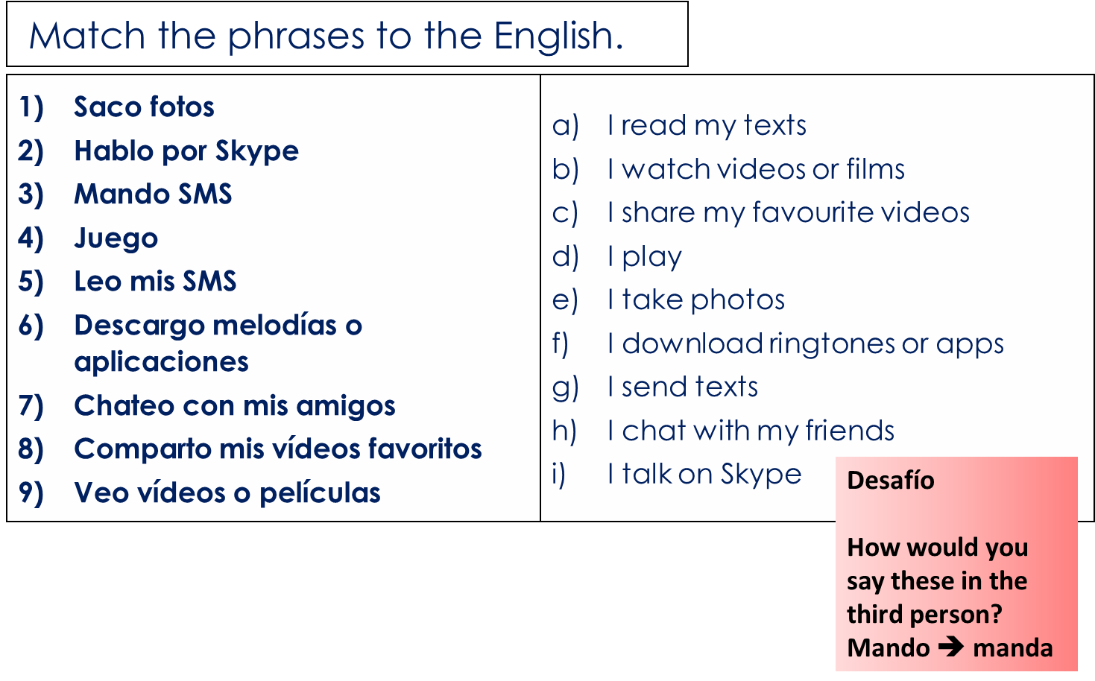
Para empezar –

Activity 1 – Make notes on how to form the present tense in Spanish
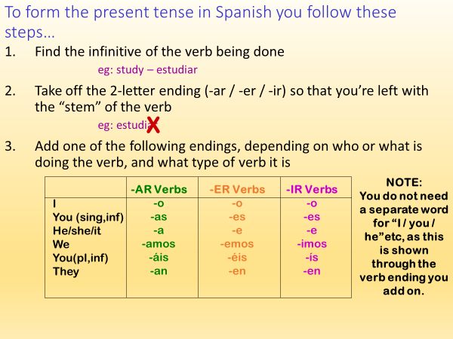

Activity 2 – Practice conjugating the present tense by putting the infinitive in brackets into the present tense. I have done number 1 as an example.
1) Yo (lavar) el coche de mi padre los domingos
2) ¿Tú (preparar) la comida en casa?
3) Mi hermano (invitar) a Pablo a la fiesta
4) Nosotros (pasar) la aspiradora
5) Vosotras (montar) en globo
6) Mi madre (hablar) con el profesor
7) Mis amigos (bailar) en la discoteca
8) Yo siempre me (aburrir) durante las vacaciones.
9) Mis padres (comer) en casa pero nosostros (comer) en la playa.
10) Mi hermano (leer) el periódico de arriba abajo.
11) Vosotros (salir) demasiado durante la semana.
12) Yo no (discutir) con él, porque no es importante.
13) Al final del día, nosotros tres (subir) a casa para reunirnos con mis padres.

Activity 3 – Can you improve these sentences by making them DORC sentences? Add opinions and reasons!
- Saco fotos
- Hablo por Skype
- Mando SMS
- Juego
- Leo mis SMS
- Colgo mis fotos
- Descargo melodías o aplicaciones
- Chateo con mis amigos
- Comparto mis vídeos favoritos
- Veo vídeos o películas

Super Desafío – can you change the 10 sentences above to different people doing them?
1. You (s) ….
2. He/she ….
3. We ….
4. They…

Ejemplo:
- Saco fotos – I take photos
sacas fotos – you (s) take photos
saca fotos – he/she takes photos
Sacamos fotos – we take photos
Module 2, Todo sobre mi vida: Lesson 2:
Uso mi móvil todos los días
Objetivo: To complete a writing activity about what we use our phones for
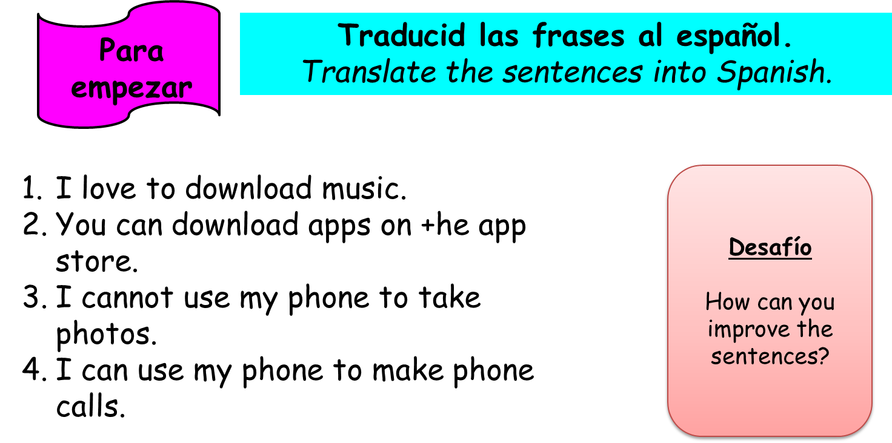

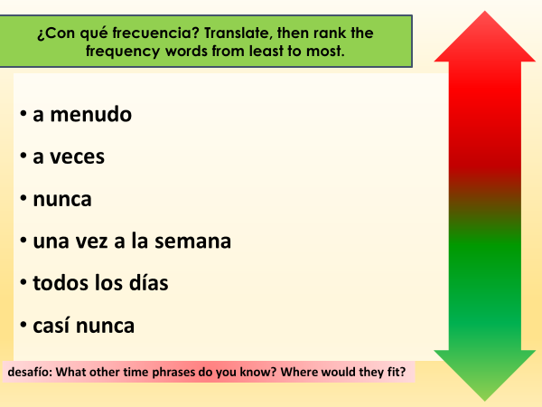
Activity 1 – Copy and translate the frequency phrases

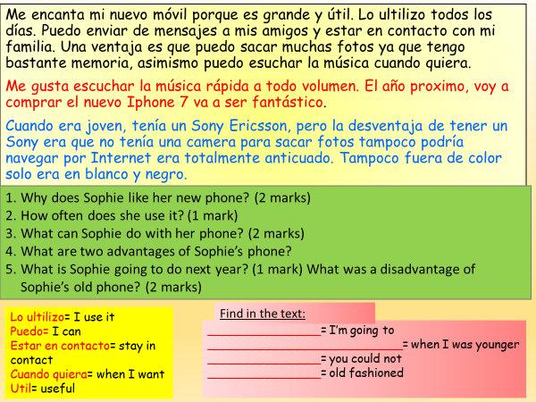
Activity 2 – Actividad de leer – Read the text, then answer the questions in English
Ac

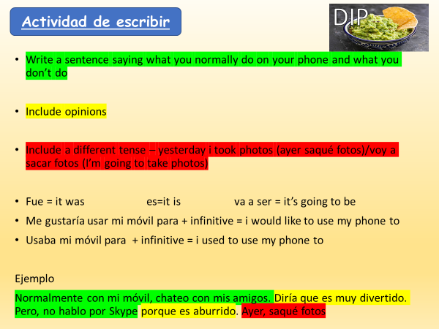
Activity 3 -

Module 2, Todo sobre mi vida: Lesson 3:
¿Qué tipo de música te gusta?
Objetivo: To be able to say what type of music you like using a range of opinions.
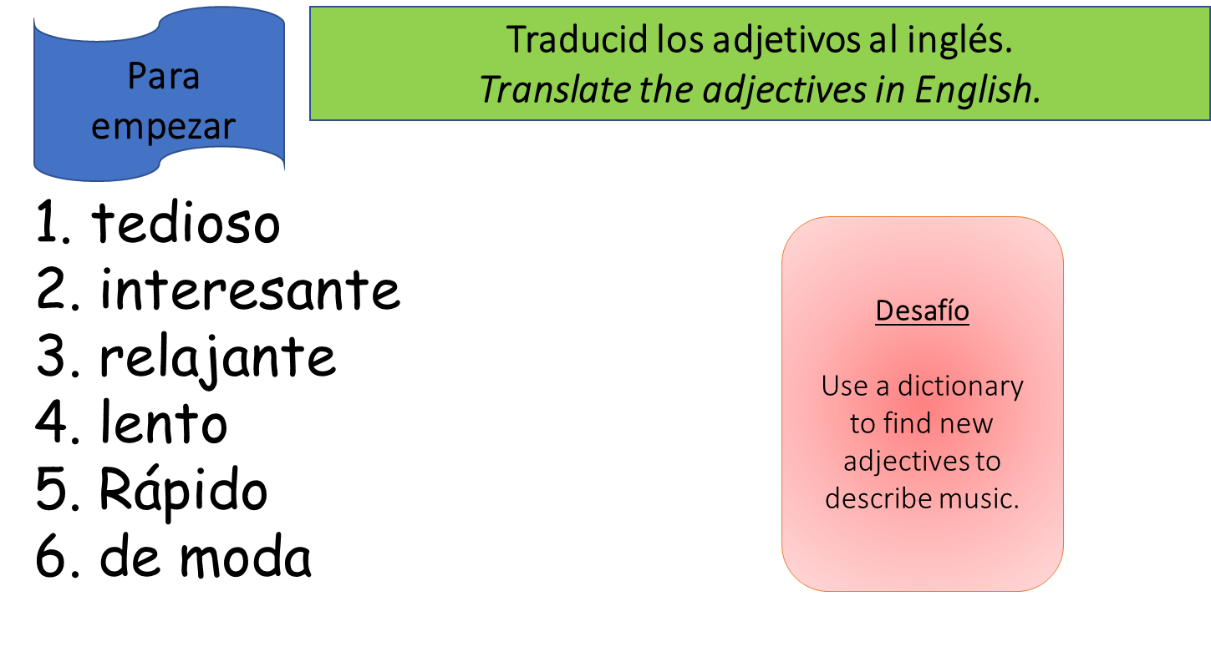

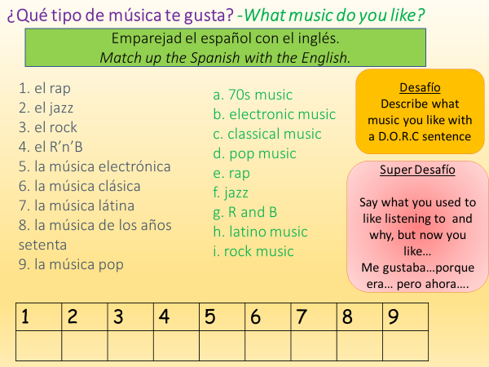
Activity 1 –

Activity 2 – Listen to these Spanish songs. Write a DORC sentence for each one, saying whether you like/dislike it and add a reason why/why not.

J Balvin – Mi gente https://www.youtube.com/watch?v=kNPtunJP3bI
Shakira – Chantaje https://www.youtube.com/watch?v=v1NJJanGEZo
Luis Fonsi – Despacito https://www.youtube.com/watch?v=RBjde4f8myE
Marc Anthony – vivir mi vida https://www.youtube.com/watch?v=YXnjy5YlDwk

Opiniones | Opinions
Me gusta (mucho)… | I like…(very much)
Me encanta… | I love…
No me gusta (nada)… | I don’t like… (at all)
la letra | The lyrics
la melodía | the tune
el ritmo | the rhythm
porque es guay / triste / horrible | because it is cool / sad / terrible

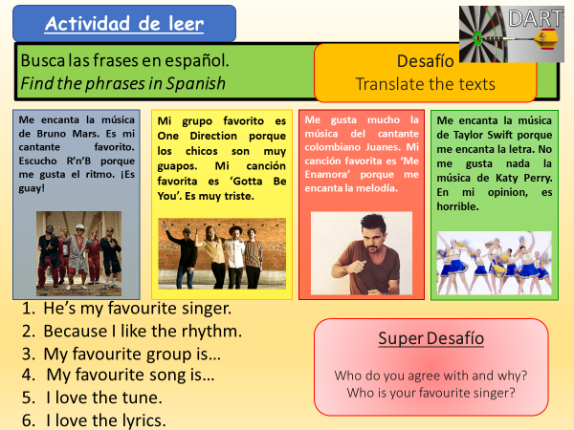
Activity 3 -

Module 2, Todo sobre mi vida: Lesson 4:
Escuché la música clásica
Objetivo: To learn how to talk about different types of music using the preterite tense.
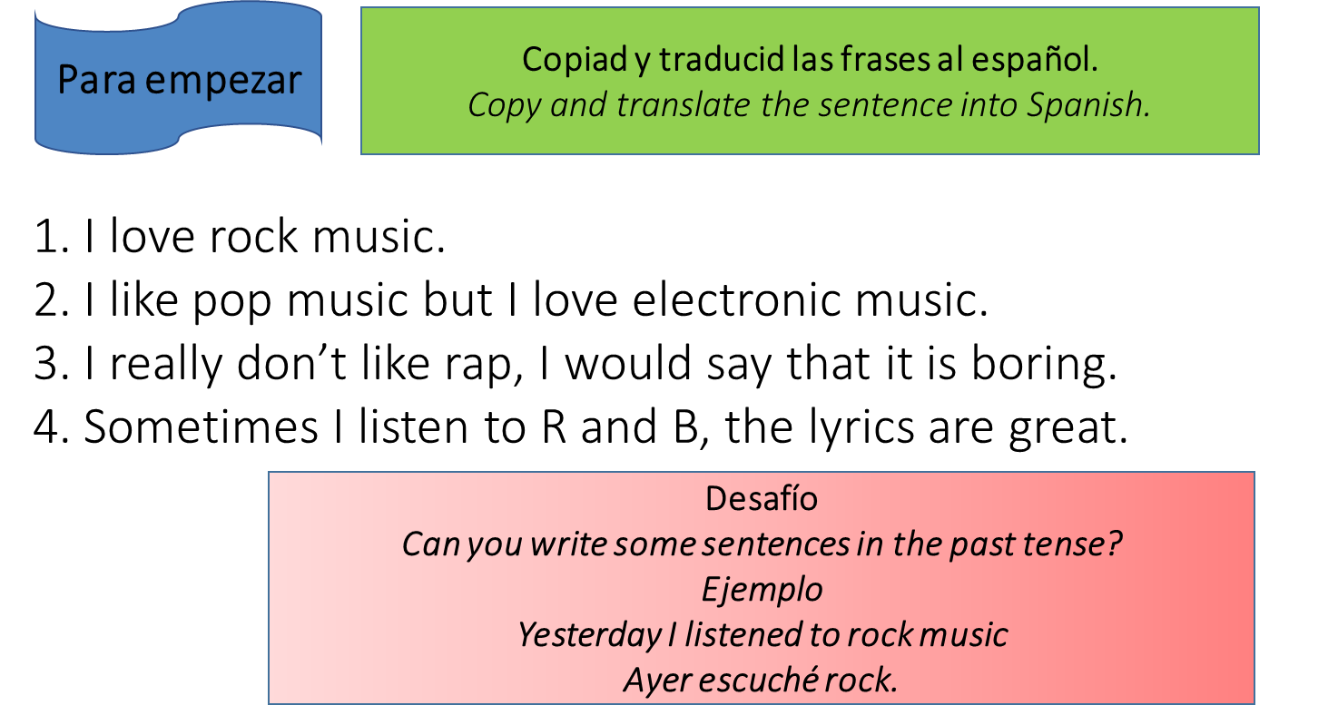

Activity 1 -
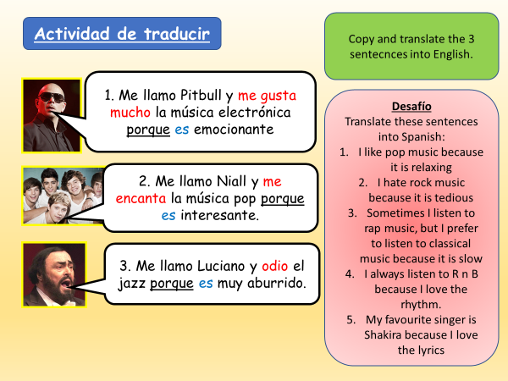

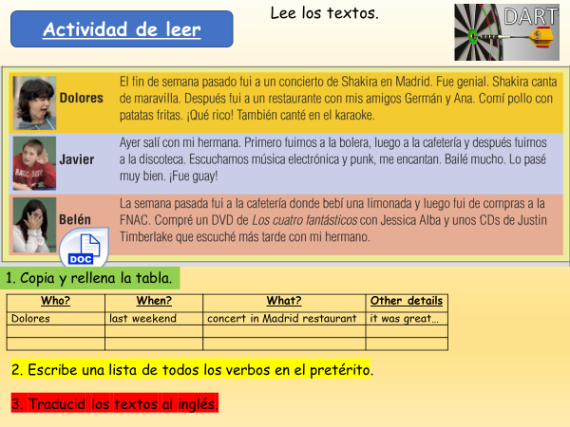
Activity 2 -

Activity 4 -
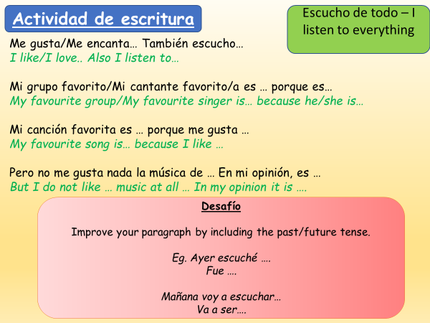

Module 2, Todo sobre mi vida: Lesson 5:
Me gustan las comedias
Objetivo: To learn how to talk about TV.

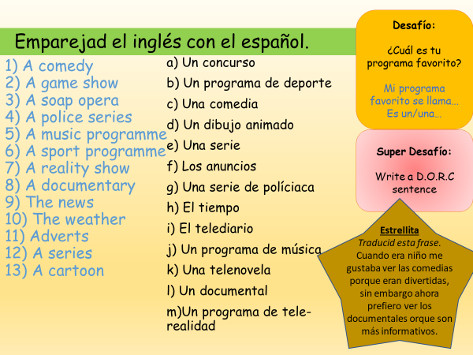
Activity 1 – Match up the Spanish to the English

Activity 2- Read these texts then complete the activities.
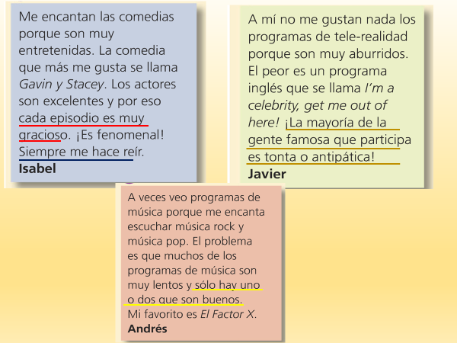

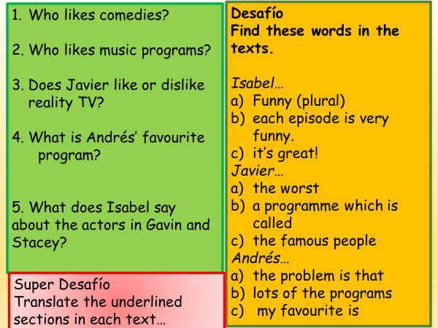

Activity 3 – Actividad de escribir
Answer the question with DORC sentences
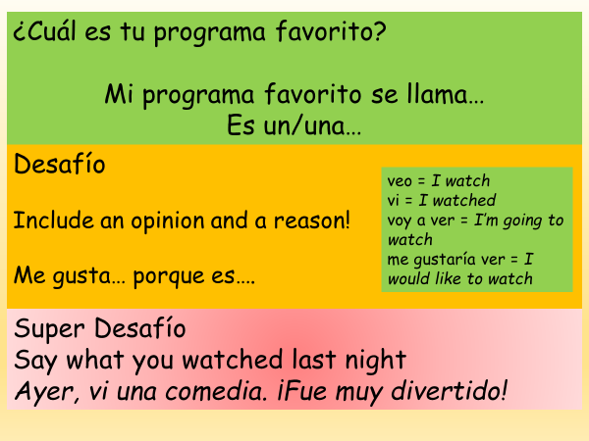

Module 2, Todo sobre mi vida: Lesson 6:
Las comedias son más divertidas que los anuncios
Objetivo: To learn how to use comparatives to talk about TV
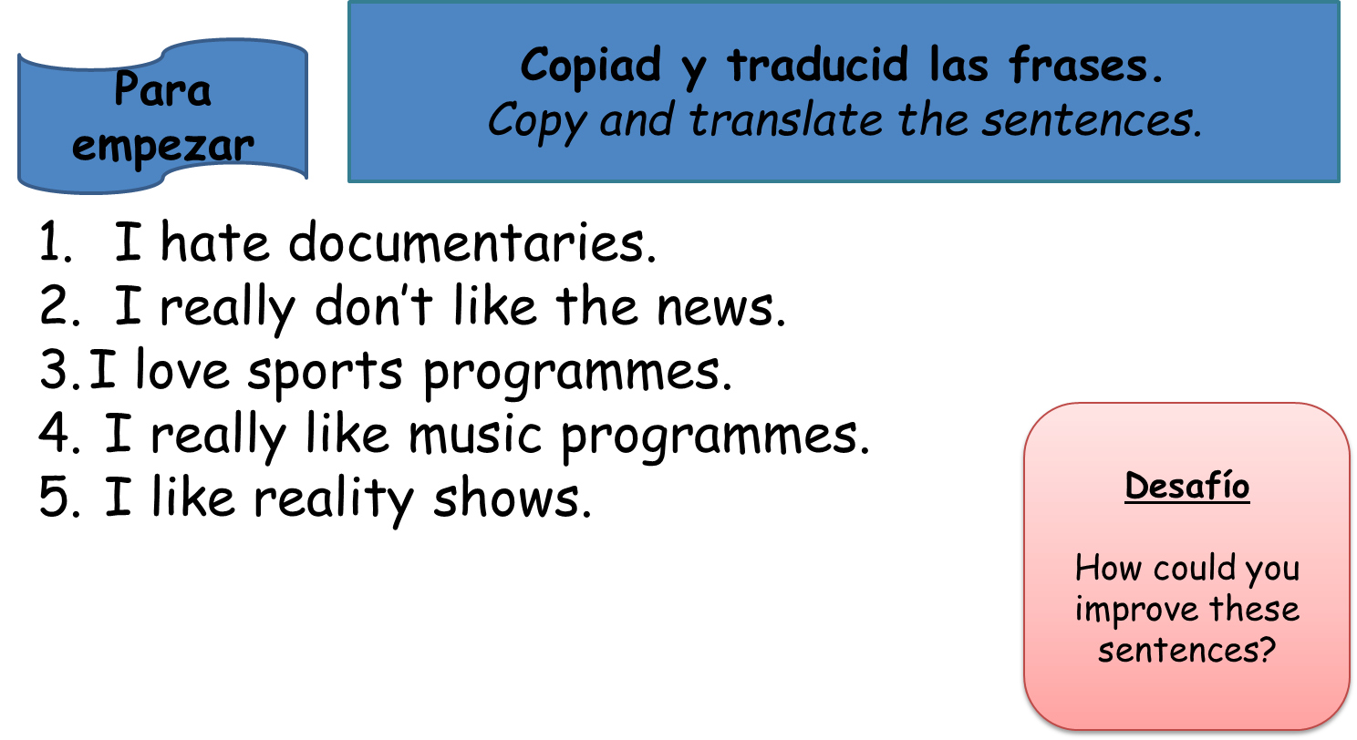

Activity 1 – Fill in the blanks with the adjective table below. You will need to translate the Spanish adjectives into English, and also make them agree depending on whether they are masculine singular (M,S) feminine singular (F,S) masculine plural (M,PL) or feminine plural (F,PL)
remember the rules -
if in M,S it ends in an O, F,S will change to A. M,PL will end in OS and F, PL will end in AS
if in M,S it ends with E, it won’t change in F,S. But will add an S in M,PL and F PL
if in M,S it ends in L, it will add an E in F,S. Both M,PL and F,PL will change to ES
The first three are done as examples.

English | Spanish (M,S) | Spanish(F,S) | Spanish (M, PL) | Spanish (F. PL)
Educational | educativo | educativa | educativos | educativas
Exciting | emocionante | emocionante | emocionantes | emocionantes
useless | inútil | inútile | inútiles | inútiles
 | gracioso
 | informativo
 | importante
 | interesante
 | estúpido/tonto
 | útil
 | divertido
 | infantil
 | aburrido
 | impresionante
 | bueno / malo
Activity 3- Mkae notes on comparatives
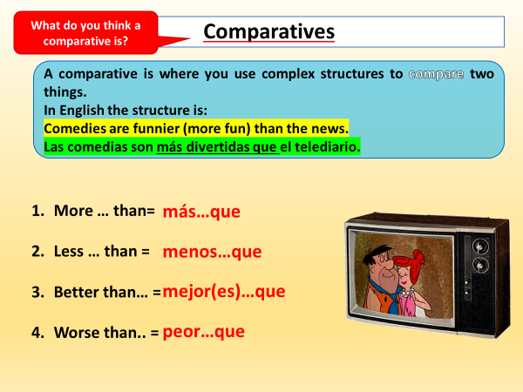

Now translate:
- I think that police series are more interesting than documentaries.
- I think that comedies are funnier than the news.
- In my opinion, documentaries are better than soaps because the characters are more interesting.
- I believe that music programs are less informative than sports programs.

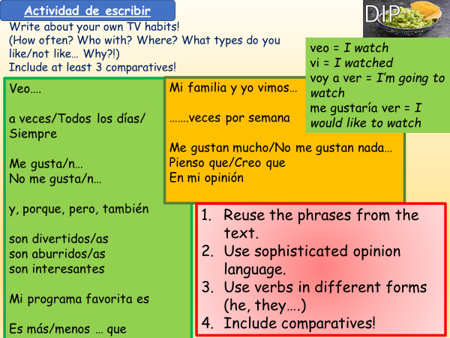
Activity 4 –

Module 2, Todo sobre mi vida: Lesson 7:
¿Qué hiciste ayer?
Objetivo: to be able to say what you did yesterday using the present and preterite tense together.
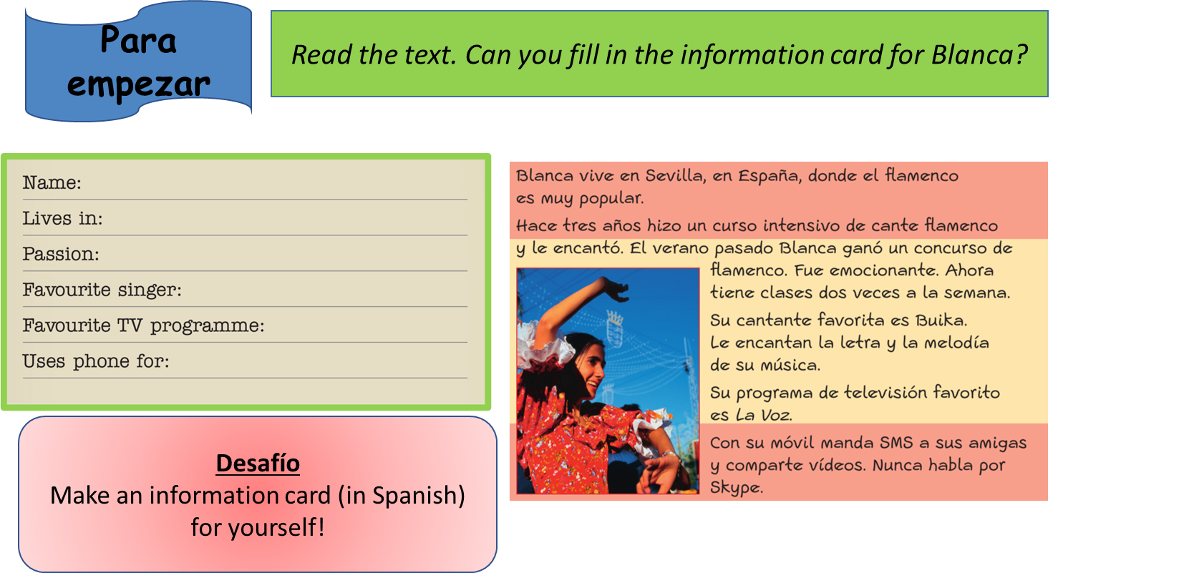

Activity 1 –
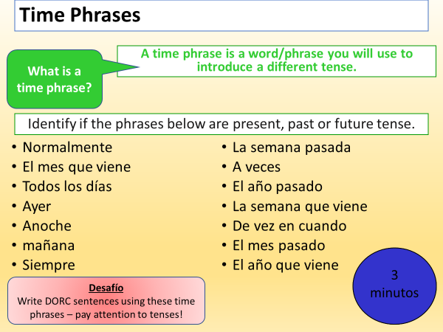

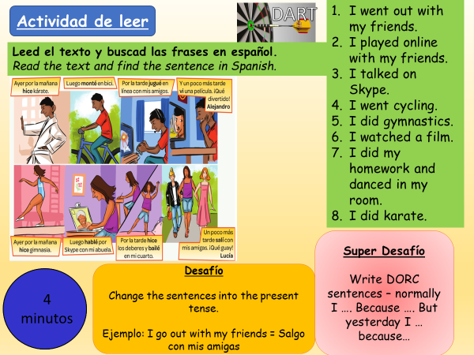
Activity 2 -

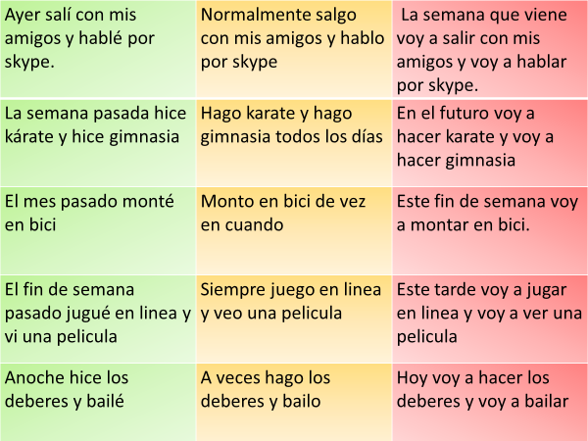
Activity 3 – Translate these sentences. Pay attention to the tense!

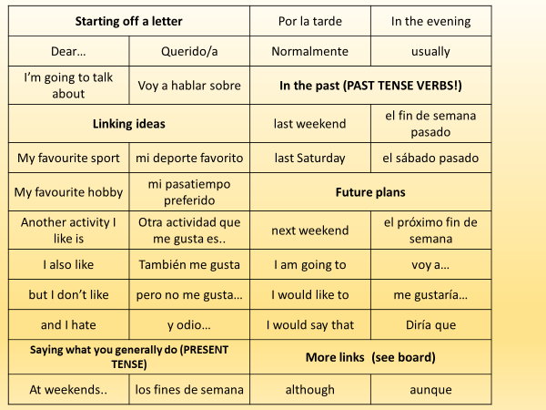
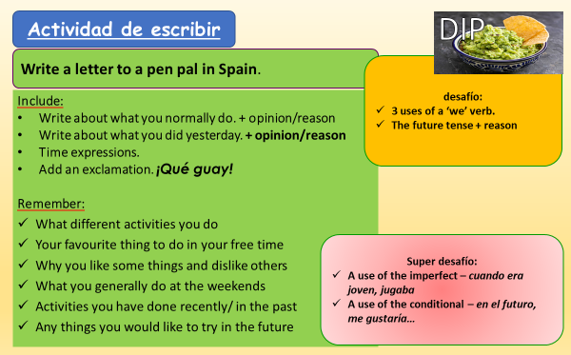
Activity 4 -

Module 2, Todo sobre mi vida: Lesson 8:
Repaso: Otoño 2
Objetivo: to recap learning in Autumn 2 in preparation for our Listening and Writing Assessment.
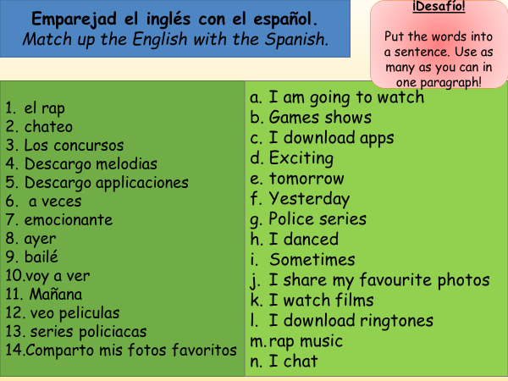
Activity 1-

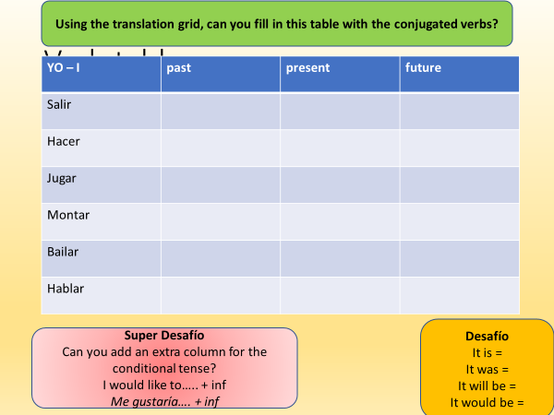
Activity 2 – Use the translation grid from Lesson 7, Activity 3, to help you complete this verb table.

Activity 2 – Prepare a draft for your writing assessment
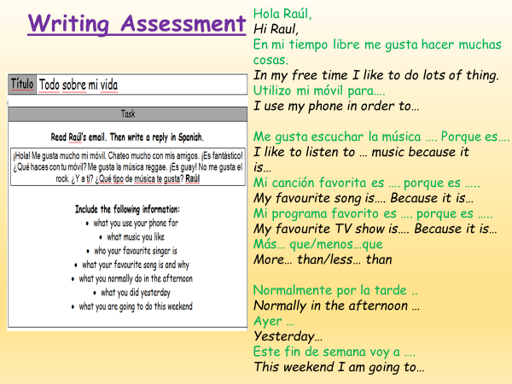
Remember – White = words, Green = Opinions, Blue = DORC sentence,
Yellow= 2 tenses, Yellow + = three tenses

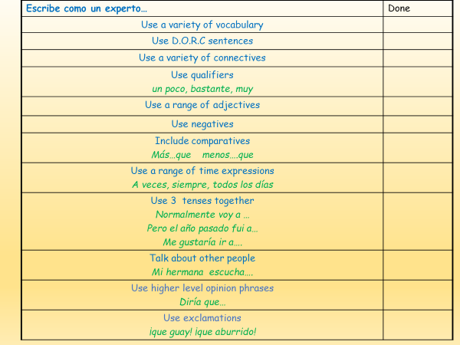

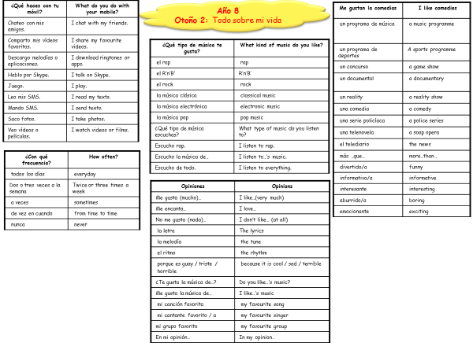

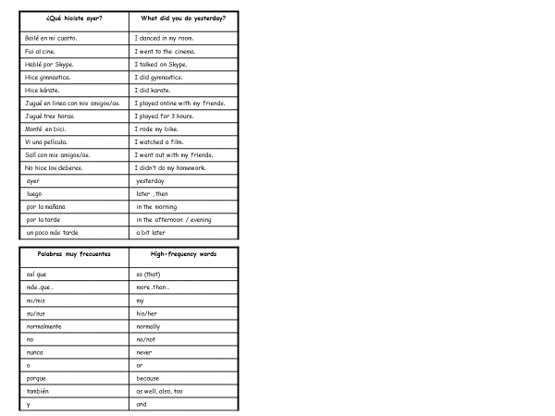

Español
Año 8 Otoño 2
Todo sobre mi vida
Writing Assessment

Nombre: Clase:  Profesor/a: |  | Stewards Academy  

Título | Todo sobre mi vida

Task
Read Raúl’s email. Then write a reply in Spanish.
¡Hola! Me gusta mucho mi móvil. Chateo mucho con mis amigos. ¡Es fantástico! ¿Qué haces con tu móvil? Me gusta la música reggae. ¡Es guay! No me gusta el rock. ¿Y a ti? ¿Qué tipo de música te gusta? Raúl

Include the following information:
- what you use your phone for
- what music you like
- who your favourite singer is
- what your favourite song is and why
- what you normally do in the afternoon
- what you did yesterday
- what you are going to do this weekend

Attainment Band : | Otoño 2: Todo sobre mi vida
Attainment Band : | Listening | Speaking | Reading | Writing
Yellow Plus  Three Tenses | Demonstrates understanding of short and longer passages which include opinions with reasons in the present, the past and the future, spoken clearly.  Transcribes sentences. | Takes part in longer conversations, expressing and justifying opinions, giving detail and uses the present, the past and the future tenses.  Shows spontaneity by asking questions and expanding answers.  Uses increasingly accurate pronunciation and intonation. | Shows understanding of a range of short and longer texts (e.g. adapted adverts, information leaflets, poems, and songs) which include opinions in the present, the past and the future tense.  Translates short passages into English. | Writes short texts in a range of contexts, giving and seeking information and opinions using the present, the past and the future tense.  Translates longer sentences into Spanish.
Yellow  Two Tenses | Shows understanding of a range of short passages which include opinions with basic reasons, in either the present and the past, or the present and the future tense.  Transcribes short sentences. | Takes part in short conversations on a range of topics giving opinions and reasons.  Asks spontaneous questions.  Uses the present and past or future tenses.  Uses increasingly accurate pronunciation and intonation. | Shows understanding of a range of short and longer texts (e.g. adapted adverts, poems and songs) which include opinions in the present and past or future tense.  Translates longer sentences into English. | Writes short texts giving and seeking information and opinions, using the present and past or future tense.  Translate longer sentences into Spanish.
Blue  Longer Paragraphs with opinions | Shows understanding of the main points, opinions and some details in short passages in either the present or the future tense.  Transcribes short phrases. | Takes part in simple conversations, using the present or future tense.  Gives opinions and simple reasons.  Gives information in short dialogues.  Begins to speak spontaneously. | Shows understanding of the main points, opinions and overall message in short written texts (e.g. menus, short adverts, songs, simple poems), in the present or future tense.  Translates simple sentences. | Writes short texts for different purposes using the present or the future tense.  Expresses opinions and gives simple reasons.  Translates simple sentences into Spanish.
Green  Shorter Paragraphs with opinions | Shows understanding of the main points and opinions from short passages spoken clearly in the present tense.  Transcribes familiar words. | Asks and answers simple questions.  Gives simple opinions.  Takes part in brief dialogues, using short phrases using the present tense. | Shows understanding of the main points and opinions in short texts.  Translates familiar words and short phrases into English. | Writes several short sentences giving information and expressing simple opinions.  Translates familiar words and short phrases into Spanish.
White  Sentences | Shows understanding of a range of familiar phrases and opinions, spoken clearly. | Answers simple questions.  Gives basic information and opinions. | Shows understanding of a range of familiar written phrases and opinions. | Writes a few short sentences with support, giving basic information.  Writes some familiar words from memory.
Teacher Feedback
WWW: | EBI:

