

Stewards Academy
Year 8 French
Autumn 2 Blended Learning Booklet

À loisir (Free Time)

Name ………………………….
Form ……………..
Class Teacher ………………….

YEAR 8 FRENCH
AUTUMN 2 BLENDED LEARNING BOOKLET LEARNING OVERVIEW
À loisir (Free Time)
PAGE TITLE | LEARNING INTENTION | PAGE NUMBER
Big picture - Year 8 French |  | 3
Zoom out – Year 8 French Autumn 2 |  | 4
Lesson 1: Les vedettes | Objectif: To talk about celebrities and television using adjectival agreement | 5
Lesson 2: Ma vie numérique | Objectif: To be able to talk about what you watch on TV | 7
Lesson 3: Je regarde la télé sur mon portable | Objectif: To learn how to talk about how you use technology | 9
Lesson 4: J’adore les films d’horreur! | Objectif: To be able to talk about film preferences | 11
Lesson 5: On va au ciné | Objectif: To be able to arrange to go out to the cinema | 13
Lesson 6: Quels sont tes loisirs? | Objectif: To be able to talk about what hobbies you do and do not do in your free tim | 15
Lesson 7: Je ne fais jamais de sport | Objectif: To complete a writing activity about what you do and do not do in your free time | 17
Lesson 8: Tu as fait des achats? | Objectif: to be able to describe a trip to the shops using the past tense | 19
Lesson 9: Révision: Automne 2 | Objectif: to recap learning in Autumn 2 in preparation for our listening and writing Assessment. | 21
Knowledge Organiser |  | 23
Assessment |  | 25
Assessment Ladder |  | 27
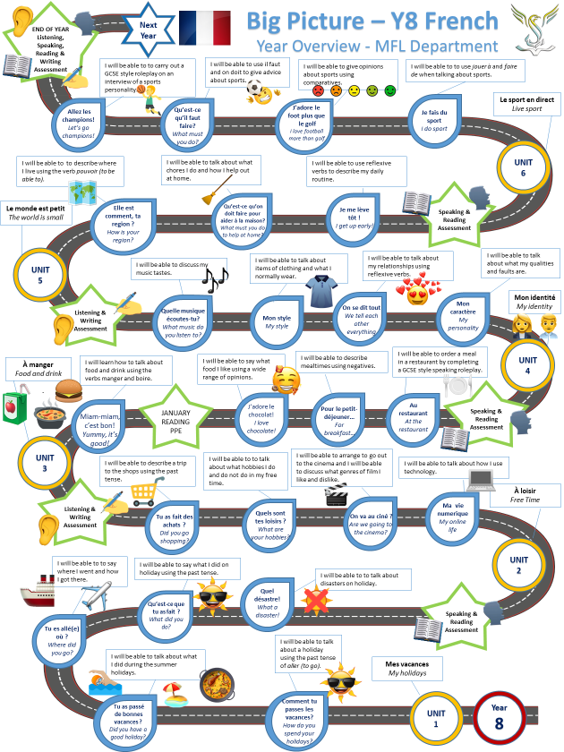

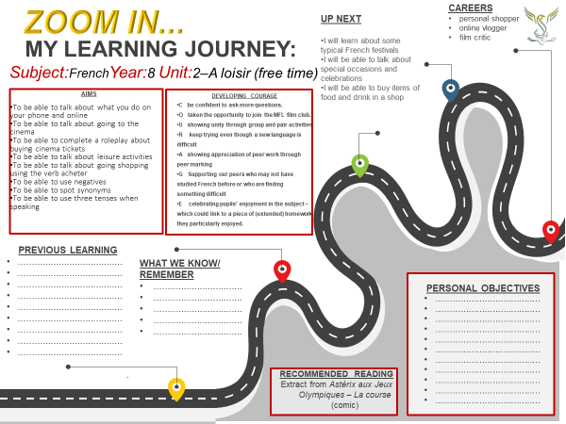

Module 2, À loisir: Lesson 1: Les vedettes
Objectif: To talk about celebrities and television using adjectival agreement
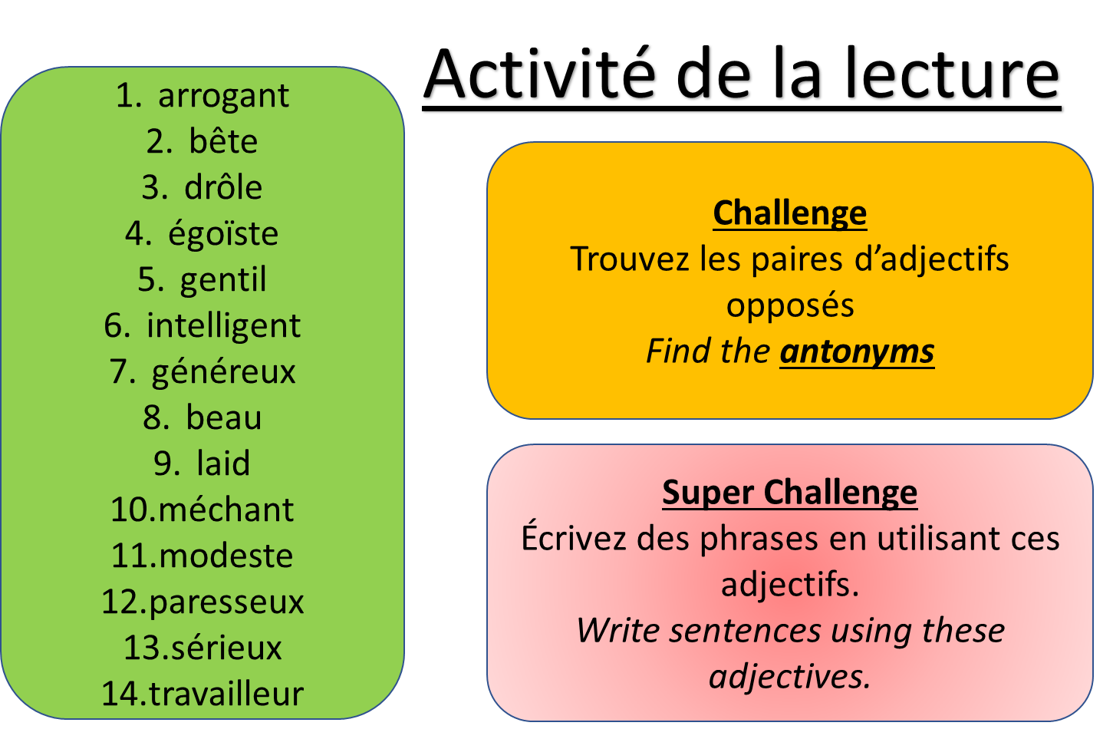
Pour commencer – Copy and translate the adjectives into English

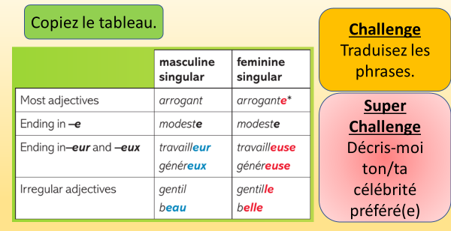

Activity 1 –
Activité de la grammarie -
copy the table then copy and
translate the sentences in the
challenge box below.

Challenge
Activité de la traduction
- Je dirais que Ed Sheeran est le meilleur! Il est intelligent, il n’est jamais méchant ou arrogant! Il n’est pas laid.
- Par contre, selon moi Kim Kardashian est le pire! Elle n’est pas intelligente, et elle est méchante et arrogante! Mais, elle n’est pas laide.
- Ma célébrité préféré c’est Stormzy. Il est modeste, et très drôle! Il n’est pas bête ou égoïste.
- J’adore aussi Rihanna, parce qu’elle est aussi modeste, et drôle. Elle n’est pas bête ou égoïste.
- J’aime Justin Bieber parce qu’il est généreux et sérieux mais il n’est pas paresseux. Aussi il est travailleur.
- De l’autre côté, je n’aime pas Selena Gomez parce qu’elle est paresseuse et elle n’est pas généreuse et sérieuse. De plus elle n’est pas travailleuse.
- À mon avis, Lewis Capaldi est très beau, et aussi il est gentil.
- Je pense que Anne-Marie est aussi belle et elle est gentille.

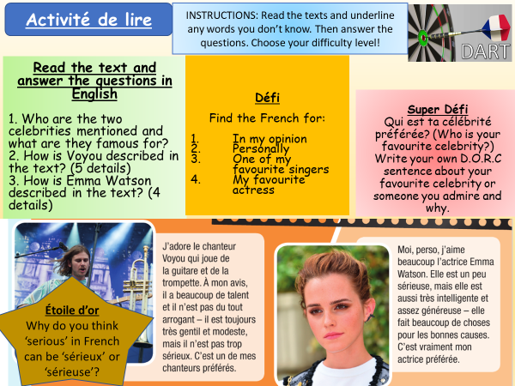
Activity 2 -

Activity 3 -
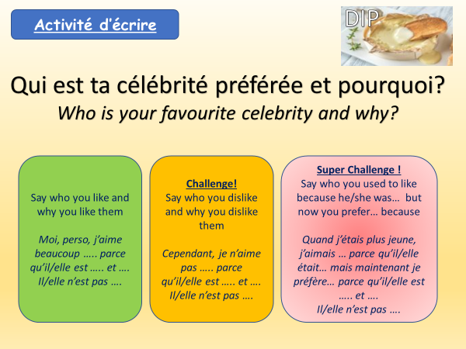

Module 2, À loisir: Lesson 2:
Ma vie numérique
Objectif: To be able to talk about what you watch on TV

Pour commencer – Copy and translate the TV genres into English
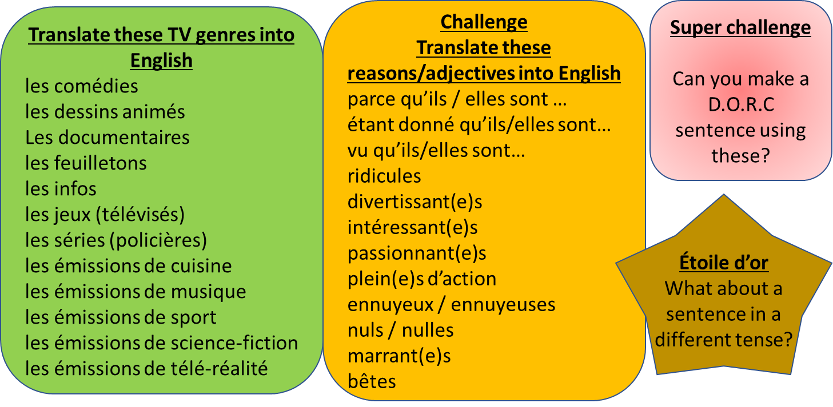

Activity 1 – Read these opinions, then copy and complete the table with the correct information.

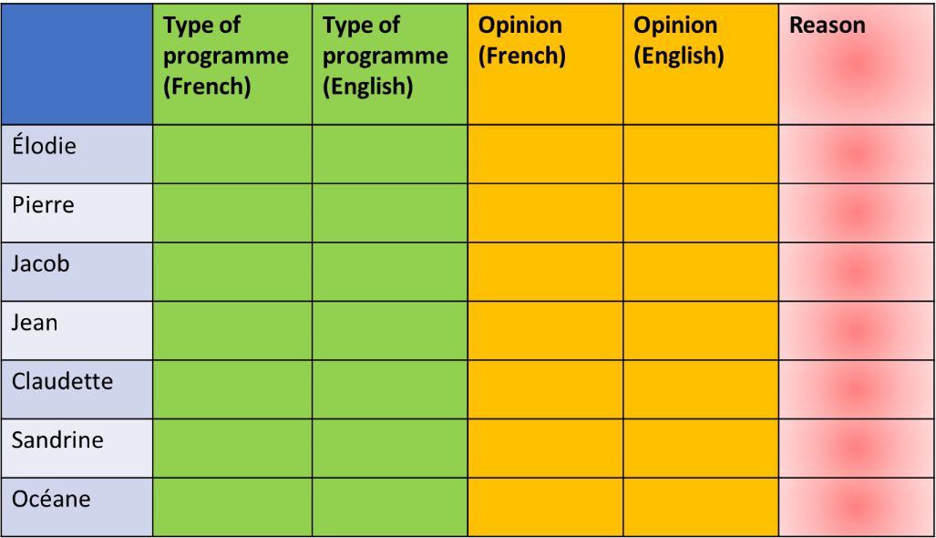
- J’aime beaucoup les infos parce qu’elles sont intéressantes – Océane
- Je n’aime pas du tout les feuilletons parce qu’ils sont bêtes! - Jacob
- Moi, personnellement, j’adore les dessins animés parce qu’ils sont marrants et divertissants. - Pierre
- Je déteste les émissions de télé-réalité parce qu’elles sont complètement ridicules! Je préfère les documentaires. -Jean
- J’adore les émissions de sport parce qu’elles sont passionnantes – et pleines d’action! - Élodie
- Je n’aime pas beaucoup les jeux télévisés. À mon avis, ils sont ennuyeux. Je préfère les émissions de cuisine. – Claudette
- Je n’aime pas tellement les séries policières. Je pense qu’elles sont vraiment nulles. Je préfère les émissions de musique! -Sandrine

Activity 2 – Activité de traduire
Copy and translate the sentences into English. If you are struggling, I have given you the first letter of each English word!
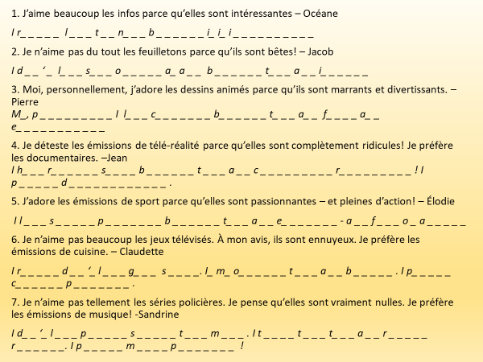

Activity 3 – Activité d’écrire

Qu’est-ce que tu aimes regarder ?

- Answer the question in your book using DORC sentences (description, opinion, reason, connectives)
- Say what types of TV show you like and give a reason why
J’aime les …. Parce que ce sont…
- Say what types of TV show you dislike and give a reason why
Je n’aime pas les… parce que ce sont…
Challenge! – Say what your brother/sister/mum/dad/friend likes dislikes!
Mon frere/ma soeur/ma mere/mon pere/mon ami/ma ami aime les.... parce que ce sont....

Module 2, À loisir: Lesson 3:
Je regarde la télé sur mon portable
Objectif: To learn how to talk about how you use technology

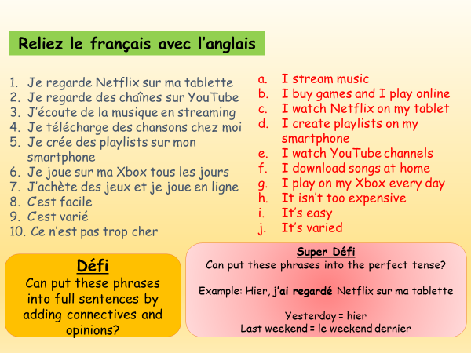
Pour commencer -
Copy the French
and the English
translation out
in your book

Activity 1 – Read the two texts, then answer the questions.
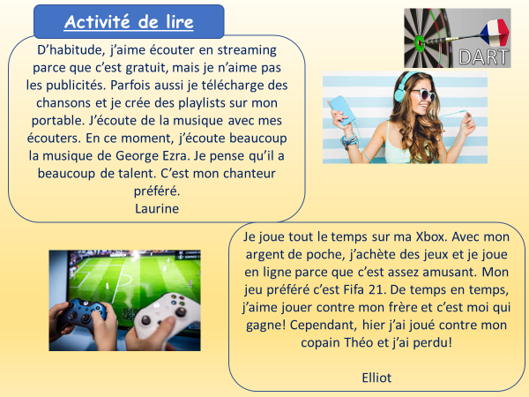

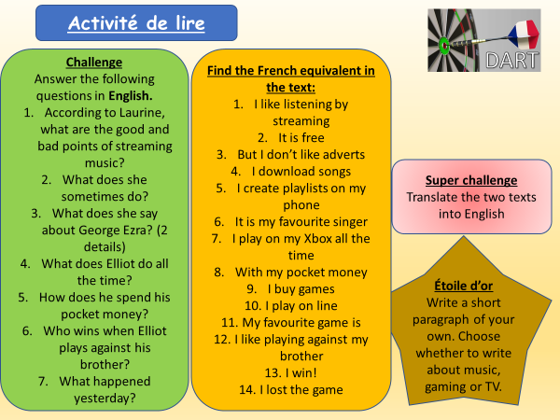

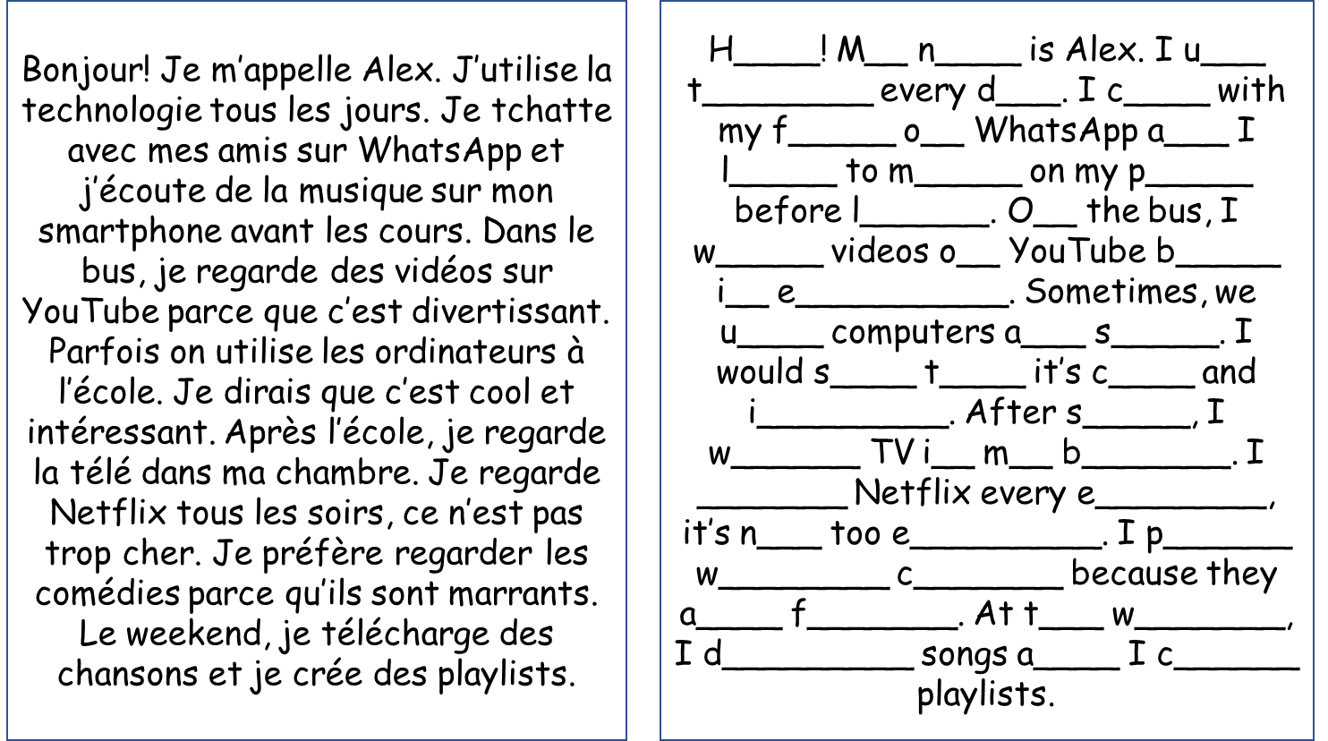

Activity 2 -
Copy and
translate
the text
into English

Challenge
Don’t use the
English
to help you!

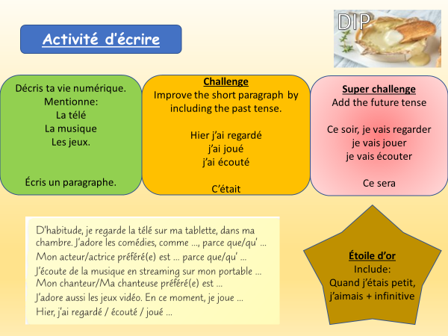

Activity 3-

Module 2, À loisir: Lesson 4:
J’adore les films d’horreur!
Objectif: To be able to talk about film preferences
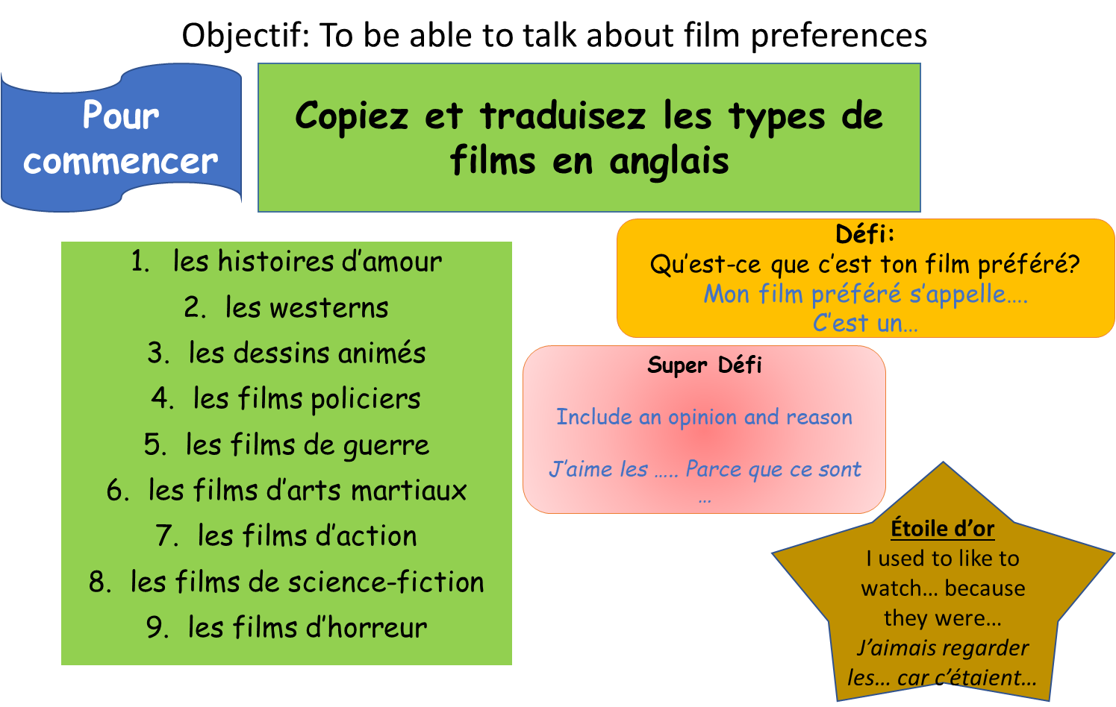

Activity 1 –
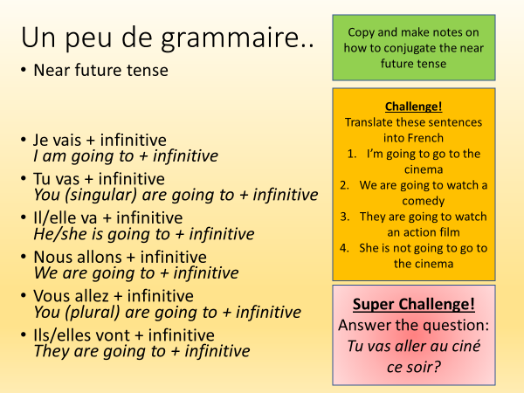
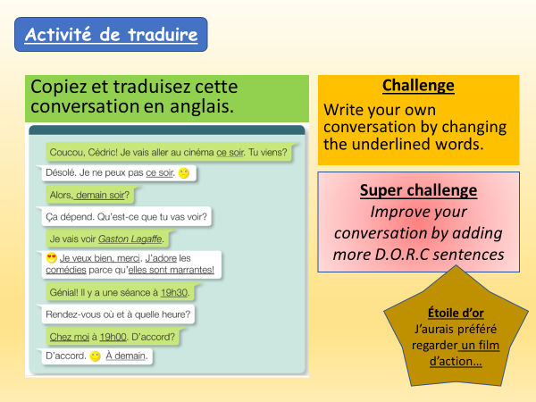
Activity 2 -

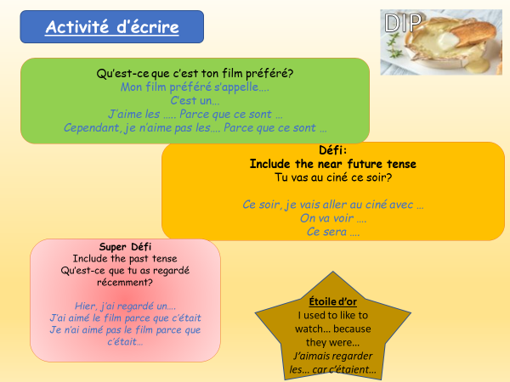

Activity 3-

Write an answer to
the question in the first
box. Include the
challenges and
super challenges to push
your writing to Yellow
and Yellow +

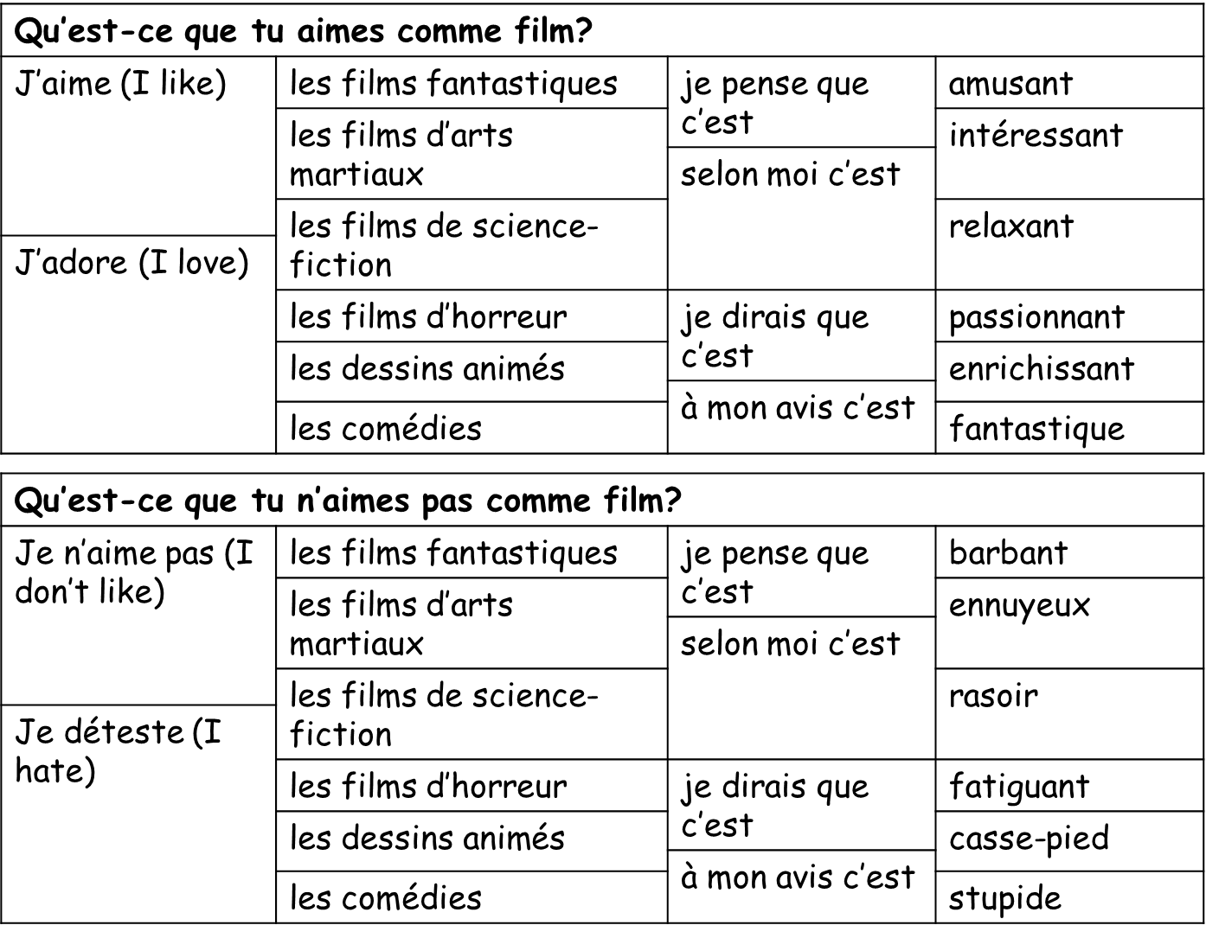

Module 2, À loisir: Lesson 5:
On va au ciné
Objectif: To be able to arrange to go out to the cinema
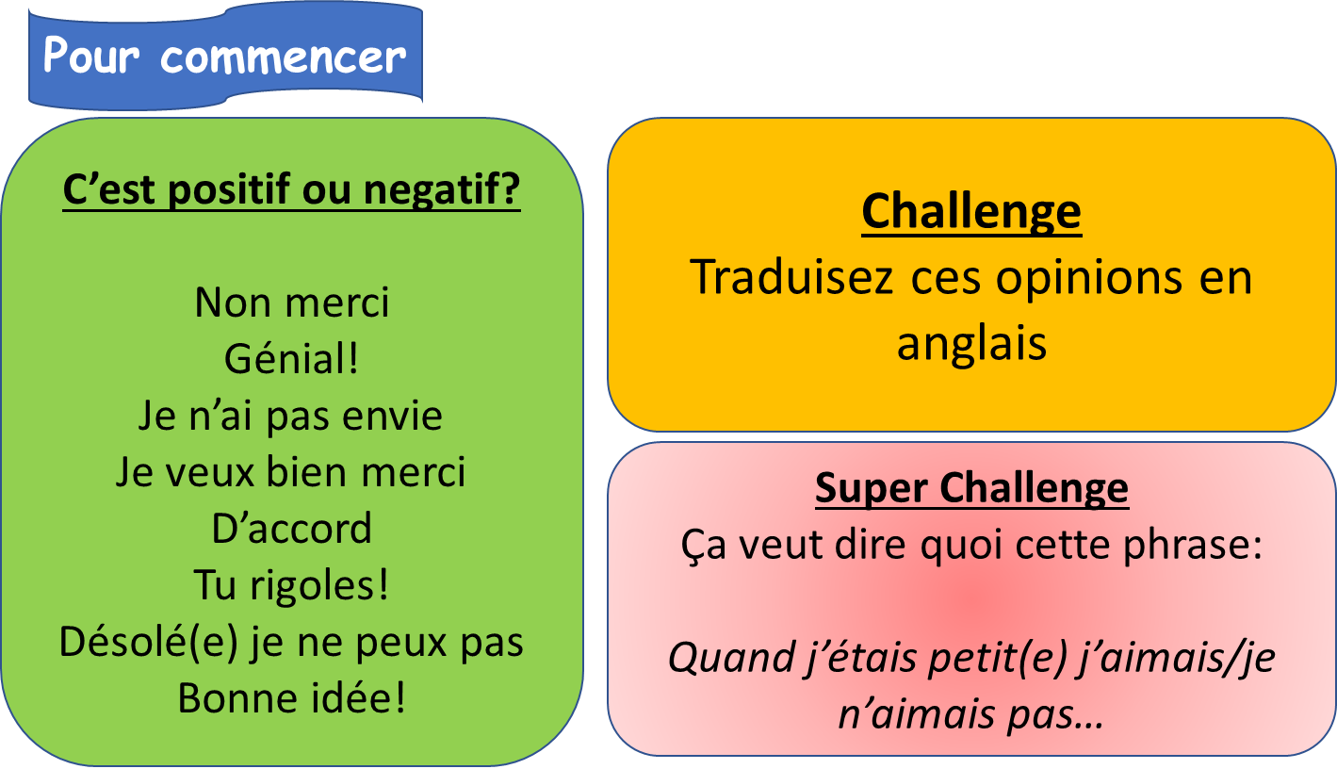

Activity 1 -
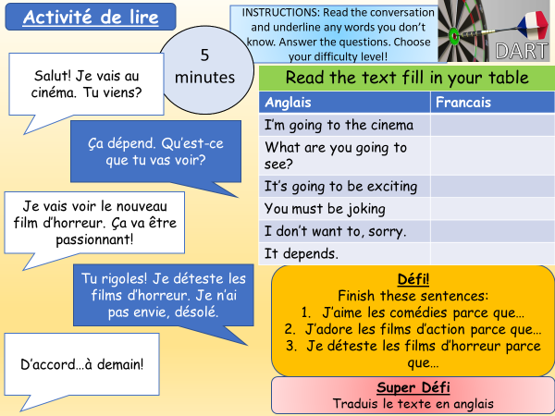

Activity 2 – Translate these sentences into French

I’m going to the cinema.
______________________________________________________
What are you going to see?
______________________________________________________
I don’t want to, sorry!
______________________________________________________
I’m going to see the new horror film.
______________________________________________________
I’m going to see the new science-fiction film.
______________________________________________________
I’m going to see the new fantasy film.
______________________________________________________
I hate martial arts films but I love cartoons because they are funny.
______________________________________________________

Activity 3 –
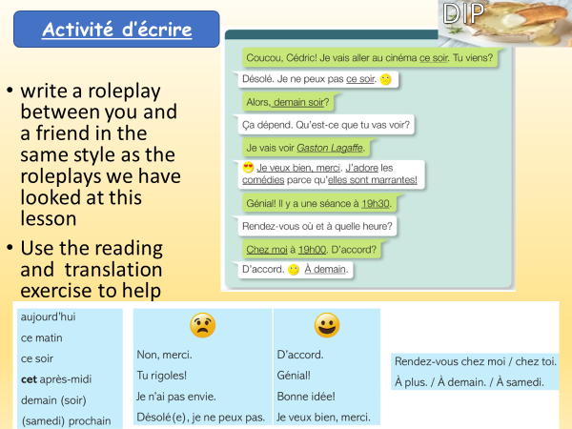

Module 2, À loisir: Lesson 6:
Quels sont tes loisirs?
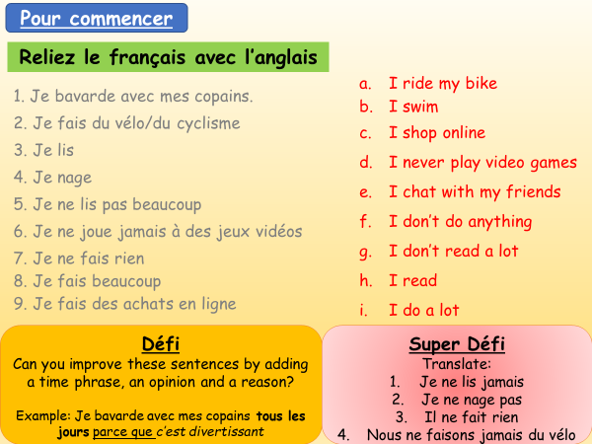
Objectif: To be able to talk about what hobbies you do and do not do in your free time

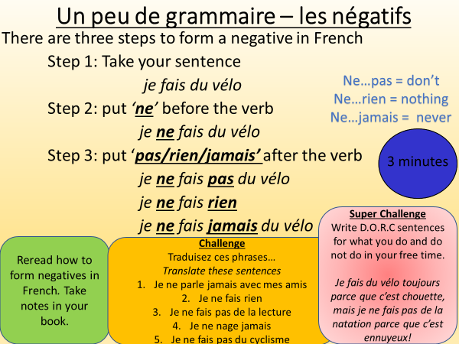
Activity 1 –

Activity 2 -
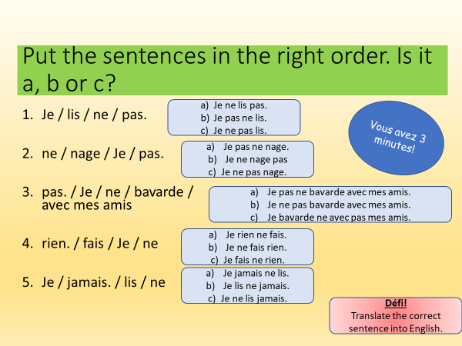

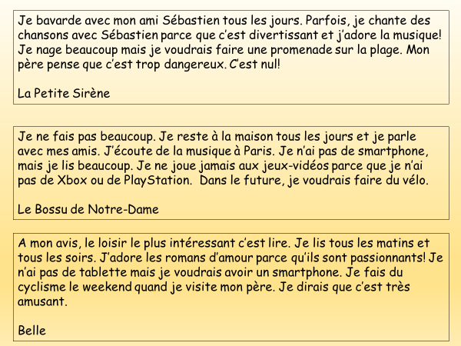
Activity 3 – Trans;late these 3 paragraphs into English.

Module 2, À loisir: Lesson 7:
Je ne fais jamais de sport
Objectif: To complete a writing activity about what you do and do not do in your free time

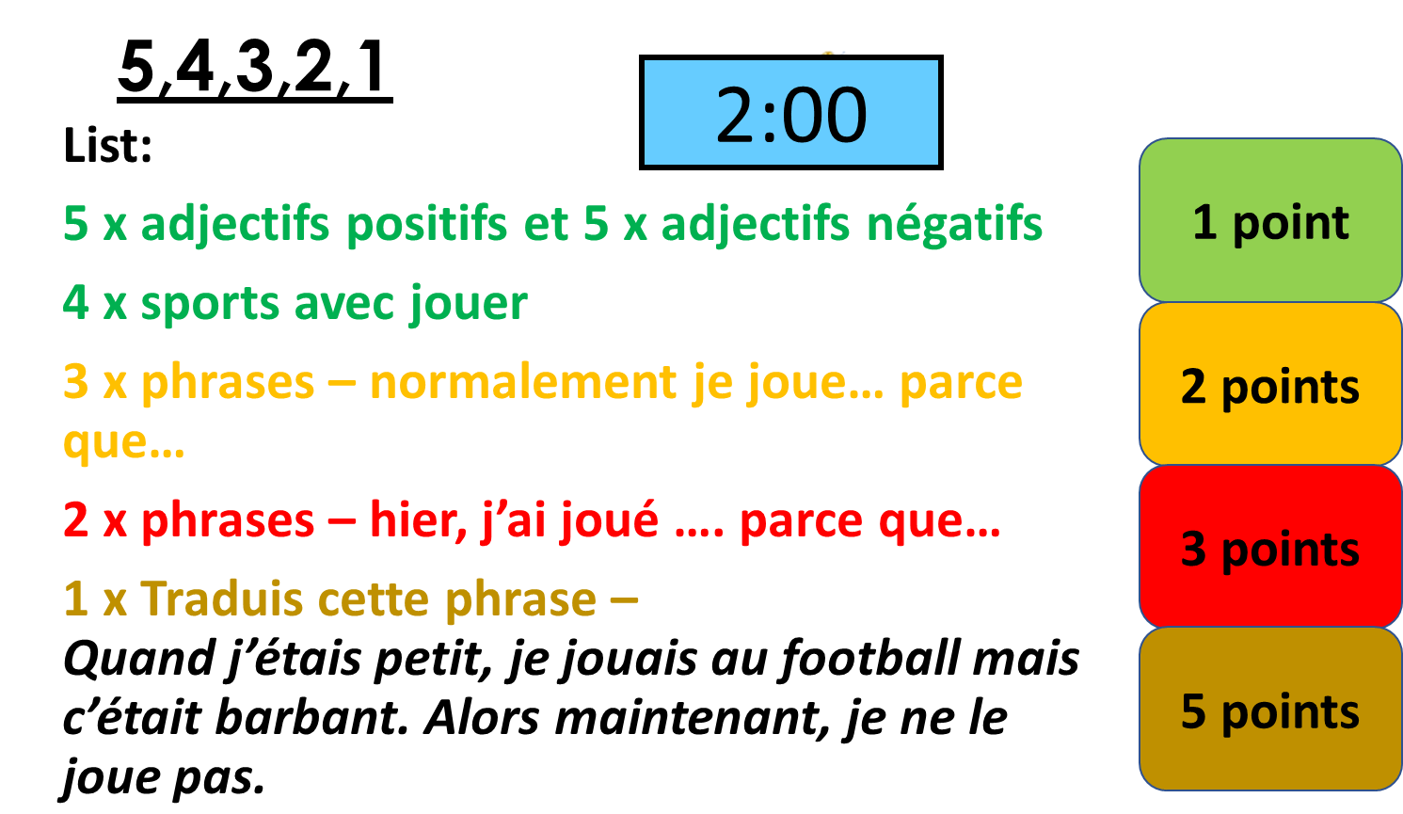
Pour commencer:

Activity 1 – Read the texts, then copy and complete the table.
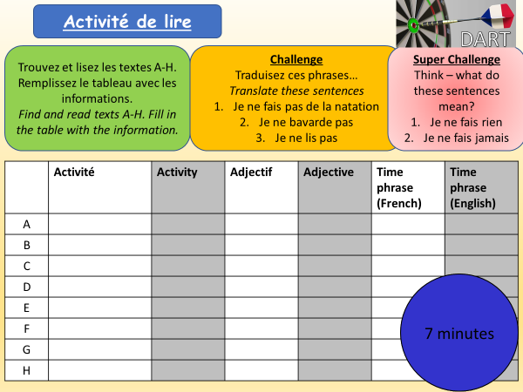

E
Je bavarde beaucoup, mais c’est affreux!
D
Je nage souvent car je pense que c’est incroyable
C
Quelquefois je fais de la natation. Je dirais que c’est chouette.
B
Je fais du vélo toujours parce que c’est fantastique
Je fais du cyclisme tous les jours parce que c’est amusant
A

F
Normalement je parle avec mes amis car c’est cool

G
Généralement je lis parce que c’est éducatif
G
F
H
Je fais de la lecture rarement parce que c’est ennuyeux
H

Activity 2 – Copy and translate these sentences into English.
- Dans mon temps libre, je fais de la natation tous les jours parce que je pense que c’est
très amusant.
- Cependant, je ne fais pas du vélo parce que c’est assez difficile.
- Je ne lis jamais parce que c’est ennuyeux.
- Hier, j’ai parlé avec mes amis et je dirais que c’était affreux parce que je n’ai fait pas mes devoirs! Quel dommage!
- Quand j’étais petite, je faisais du cyclisme après le collège, et c’était incroyable.
- Malheureusement, maintenant je n’ai pas le temps, alors je ne le fais pas.

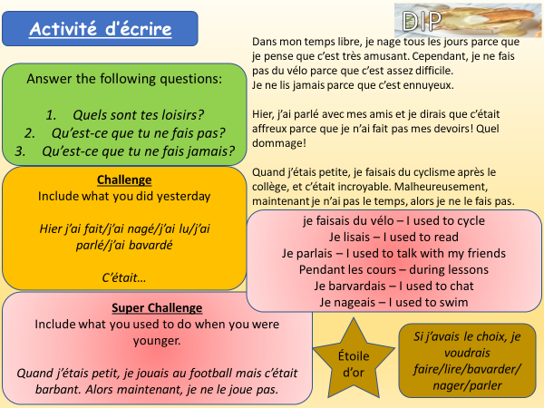
Activity 3 – Writing Activity

Module 2, À loisir: Lesson 8:
Tu as fait des achats?
Objectif: to be able to describe a trip to the shops using the past tense

Activity 1 – Watch the video below on the past tense in French. Make notes on how to form the past tense in French
https://www.youtube.com/watch?v=qGQgkE15TLg
If you can’t access the online video, look at the explanation below and make notes.
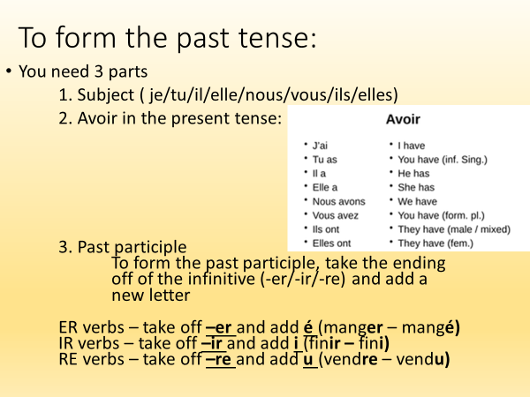
Activity 2 – Look at these sentences. You have to put the verbs in brackets at the end of the sentence into the past tense. Remember you need to have the correct bit of avoir too! I have done number 1 as an example

- Mon frère un bon film à la téle hier soir. (regarder)
2. Nous une nouvelle chaîne stéréo dans les magasins en ville. (chercher)
3. Tu ton maillot de bain? (perdre)
4. Jacques et Mireille plusieurs cassettes. (vendre)
5. J' mon travail dans la cuisine. (finir)
6. Ma mère une nouvelle voiture Renault. (choisir)
7. Mes parents des CDs. (acheter)
8. Vous , madame? (payer)
9. Les amis à notre invitation. (répondre)
10. Les plantes pendant des semaines. (fleurir)

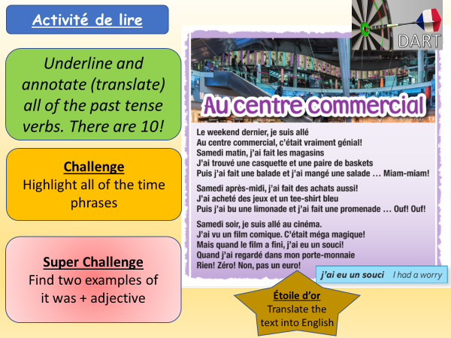
Activity 3 -

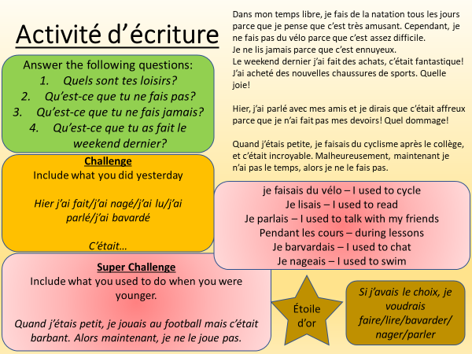
Activity 4 -

Module 2, À loisir: Lesson 9:
Révision: Automne 2
Objectif: to recap learning in Autumn 2 in preparation for our listening and writing Assessment.

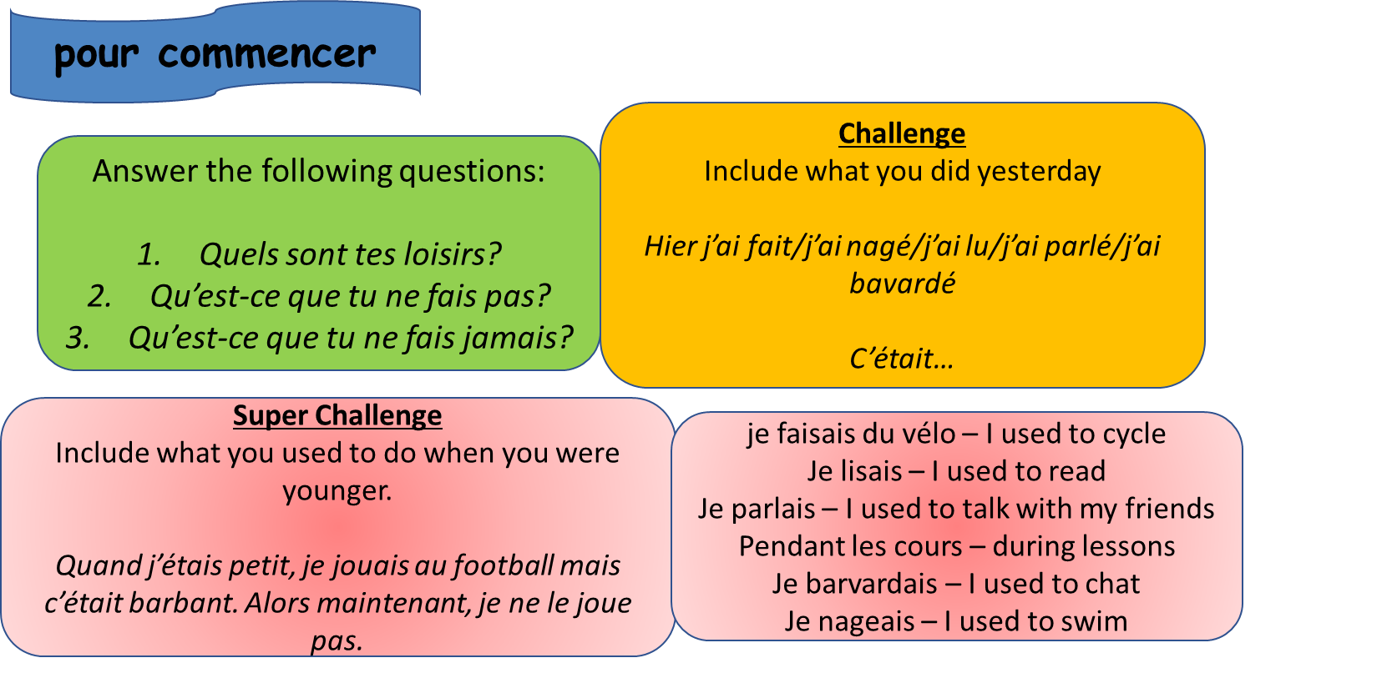

Activity 1 – Copy and translate these sentences.
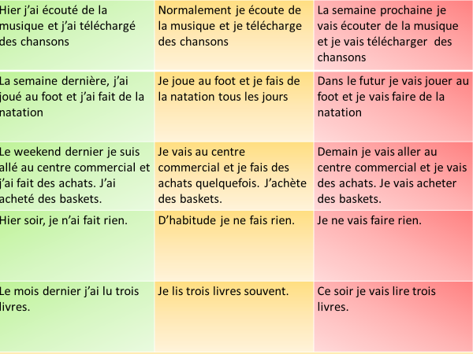

Activity 2 – Prepare a draft for your writing assessment
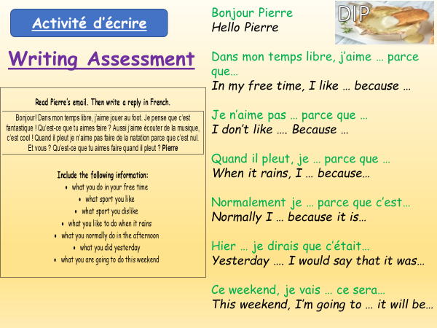
Remember – White = words, Green = Opinions, Blue = DORC sentence,
Yellow= 2 tenses, Yellow + = three tenses

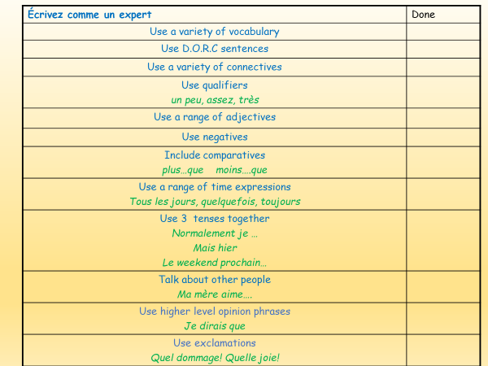

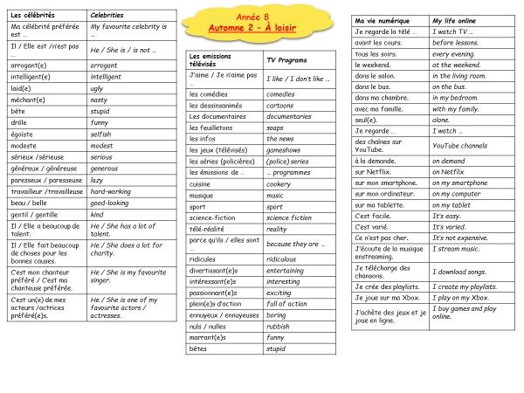

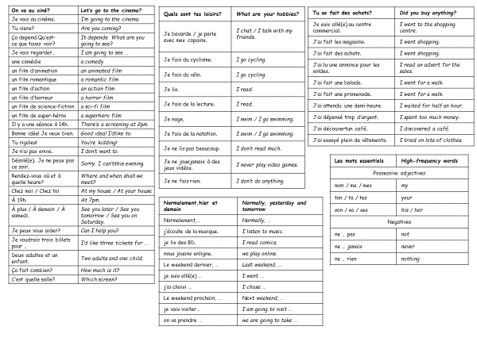

Français
Année 8 Automne 2
À loisir
Writing Assessment

Nom: Classe:  Prof: |  | Stewards Academy  

Title | À loisir

Task
Read Pierre’s email. Then write a reply in French.
Bonjour! Dans mon temps libre, j’aime jouer au foot. Je pense que c’est fantastique ! Qu’est-ce que tu aimes faire ? Aussi j’aime écouter de la musique, c’est cool ! Quand il pleut je n’aime pas faire de la natation parce que c’est nul. Et vous ? Qu’est-ce que tu aimes faire quand il pleut ? Pierre

Include the following information:
- what you do in your free time
- what sport you like
- what sport you dislike
- what you like to do when it rains
- what you normally do in the afternoon
- what you did yesterday
- what you are going to do this weekend

Attainment Band : | Automne 2: À loisir
Attainment Band : | Listening | Speaking | Reading | Writing
Yellow Plus  Three Tenses | Demonstrates understanding of short and longer passages which include opinions with reasons in the present, the past and the future, spoken clearly.  Transcribes sentences. | Takes part in longer conversations, expressing and justifying opinions, giving detail and uses the present, the past and the future tenses.  Shows spontaneity by asking questions, and expanding answers.  Uses increasingly accurate pronunciation and intonation. | Shows understanding of a range of short and longer texts (e.g. adapted adverts, information leaflets, poems and songs) which include opinions in the present, the past and the future tense.  Translates short passages into English. | Writes short texts in a range of contexts, giving and seeking information and opinions using the present, the past and the future tense.  Translates longer sentences into French.
Yellow  Two Tenses | Shows understanding of a range of short passages which include opinions with basic reasons, in either the present and the past, or the present and the future tense.  Transcribes short sentences. | Takes part in short conversations on a range of topics giving opinions and reasons.  Asks spontaneous questions.  Uses the present and past or future tenses.  Uses increasingly accurate pronunciation and intonation. | Shows understanding of a range of short and longer texts (e.g. adapted adverts, poems and songs) which include opinions in the present and past or future tense.  Translates longer sentences into English. | Writes short texts giving and seeking information and opinions, using the present and past or future tense.  Translate longer sentences into French.
Blue  Longer Paragraphs with opinions | Shows understanding of the main points, opinions and some details in short passages in either the present or the future tense.  Transcribes short phrases. | Takes part in simple conversations, using the present or future tense.  Gives opinions and simple reasons.  Gives information in short dialogues.  Begins to speak spontaneously. | Shows understanding of the main points, opinions and overall message in short written texts (e.g. menus, short adverts, songs, simple poems), in the present or future tense.  Translates simple sentences. | Writes short texts for different purposes using the present or the future tense.  Expresses opinions and gives simple reasons.  Translates simple sentences into French.
Green  Shorter Paragraphs with opinions | Shows understanding of the main points and opinions from short passages spoken clearly in the present tense.  Transcribes familiar words. | Asks and answers simple questions.  Gives simple opinions.  Takes part in brief dialogues, using short phrases using the present tense. | Shows understanding of the main points and opinions in short texts.  Translates familiar words and short phrases into English. | Writes several short sentences giving information and expressing simple opinions.  Translates familiar words and short phrases into French.
White  Sentences | Shows understanding of a range of familiar phrases and opinions, spoken clearly. | Answers simple questions.  Gives basic information and opinions. | Shows understanding of a range of familiar written phrases and opinions. | Writes a few short sentences with support, giving basic information.  Writes some familiar words from memory.
Teacher Feedback
WWW: | EBI:

