

Year 8
Music
Spring 2 BLB
Band Musicianship 2:
The Blues
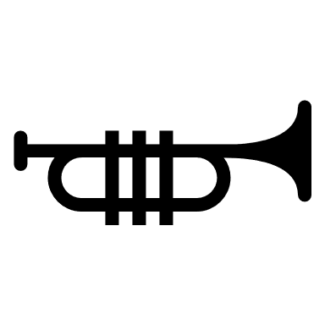

Name: Form:

Contents
KO- Knowledge Organiser
SAL- Assessment ladder
Lesson 1- Play video up to 21 minutes 46 seconds
https://classroom.thenational.academy/lessons/to-be-inspired-by-all-blues-and-understand-why-it-is-a-jazz-standard-6ngp8c?step=2&activity=video
Lesson 2 - Play video from 21 minutes 46 seconds until the end
https://classroom.thenational.academy/lessons/to-be-inspired-by-all-blues-and-understand-why-it-is-a-jazz-standard-6ngp8c?step=2&activity=video
Lesson 3 – Play video up to 16 minutes 48 seconds
https://classroom.thenational.academy/lessons/to-be-able-to-create-a-blues-accompaniment-71j3jr?step=2&activity=video
Lesson 4 – Play video from 16 minutes 48 seconds until the end
https://classroom.thenational.academy/lessons/to-be-able-to-create-a-blues-accompaniment-71j3jr?step=2&activity=video
Lesson 5 – Play video up to 22 minutes 55 seconds
https://classroom.thenational.academy/lessons/to-be-able-to-compose-a-structured-blues-melody-crtk8c
For all lessons, please go to:
Oak national academy ( www.thenational.academy )- Lessons- KS3-Music- Bandmusicanship2: The Blues– click onto the appropriate lesson
Virtual instrument apps:
https://www.musicca.com/piano?
https://www.onlinepianist.com/virtual-piano

KO- Knowledge Organiser
- We can analyse music through watching and listening to performance.
Key points to analyse are, melody, harmony, instrumentation, and structure.
Music has a time signature, which is how many beats are in a bar, “All Blues” is written in 6/8.
A tremolo is playing two different notes very fast.
Playing or singing more than one pitched note at the same time creates a harmony.

- We can add a 7th note to the chords in the 12-bar blues to make it more interesting and more authentic to the blues genre.
A walking bass line is the same as the chords in the 12-bar blues but broken up.
We can make a more interesting sounding walking bass line by adding the 6th and flattened 7th to the chord.
A repeated melodic theme in blues music is called a blues “head”.
Miles Davis was a famous blues musician and composer- he composed the classic “All Blues”

- An accompaniment is the musical support in a band, they play the chords and rhythm, backing up the melodic ideas. Typical instruments that play the accompaniment are, piano, drums, guitar, and bass guitar.
In the twelfth bar of the 12-bar blues you can play either chord I or V. If you play chord V instead of I, it is known as a turnaround chord.
By consistently reflecting on our own performance, we can improve every time we practise.

- Blues music uses swung rhythms which can be called a shuffle beat on the drums. It is a mixture of long notes followed by short ones. The main parts of a drum kit used in blues music is the snare (has a crackle sound), Hi-hat cymbals (High and tinny sounding), and the Bass/ Kick drum (very low sound, like a thud). Each separate part is represented on different lines of the stave to show the drum notation. We can add a swung rhythm to walking bass lines to make them sound more interesting. Vamping styles in blues music are, playing chord IV at the same time, adding an octave in the left-hand part, splitting the chords and playing the in a different rhythm, using the 7th note as a passing note into the next chord.

- Improvisation is the art of making up music on the spot or in the moment and is a large feature in blues music.
Melody is the main tune in any piece of music.
A chord progression is a sequence of chords played in a certain order.
12-bar blues is a well-known chord progression of 12 bars using the primary chords.
The blues scale is a scale, which is often the basis for improvisation, especially in the 12-bar blues.
Call and response is a compositional technique that works similarly to a conversation. A “phrase” of music serves as the “call,” and is “answered” by a different phrase of music. These phrases can be either vocal, instrumental, or both.

SAL- Assessment Ladder

Attainment Band | Music
Yellow Plus | - You can compose multiple blues melodies and accompaniments confidently.  - You can play a blues melody whilst playing the accompaniment, fluently, adding passing 7th notes.  - You can improvise freely and confidently.  - You can arrange who from the 'band' improvises in your blues piece, you know what will sound good stylistically.  - You can play and transpose 12-bar blues to many different keys.
Yellow | - You can compose a blues melody and accompaniment.  - You can play a blues melody and accompaniment, fluently.  - You can improvise around given notes to a good standard.  - Understands how to critically analyse their own performance of blues and jazz standards to improve performance skills.  - You can transpose the 12-bar blues to another key.
Blue | - You can compose your own blues accompaniment.  - You can fluently play the chords (accompaniment) to the 12-bar blues.  - You can create a structured blues melody.  - Understands how to critically analyse performance of blues and jazz standards.  - Can use music terminology to describe features of blues music.
Green | - Recognises the 12-bar blues structure.  - Can play sections of the 12-bar blues.  - Understands and attempts improvising.
White | - Knows what the key features of blues music are.  - Can recognise the blues music genre through the features they know.

Lesson 1 - Connect
Title- The Blues
LI- Learn how to analyse the jazz standard "All Blues" through performance

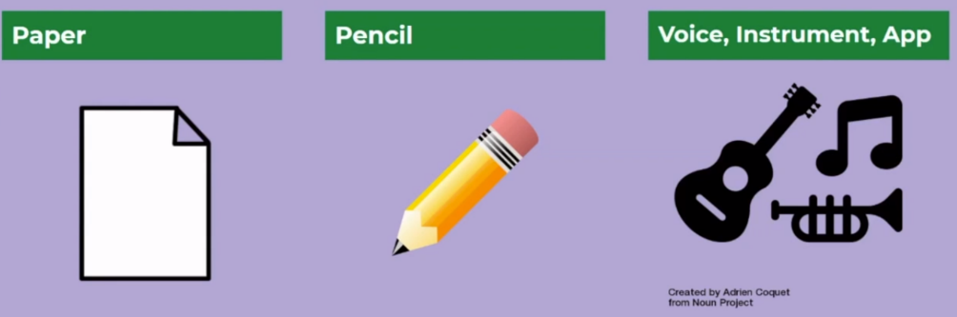
Lesson structure:
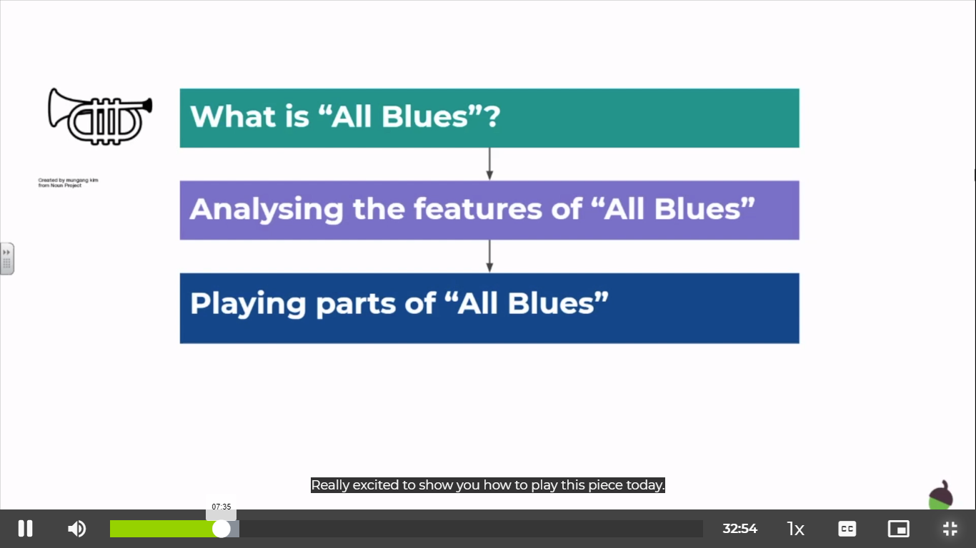

Take the intro quiz, just before playing the video
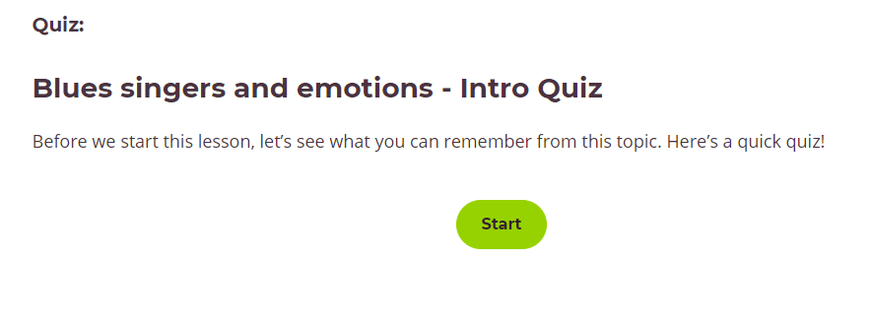

WARM UP:
Play the video and sing with Miss Friar – you will learn to sing in harmony!
Activate


Listening task- listen to the song and answer the questions underneath:
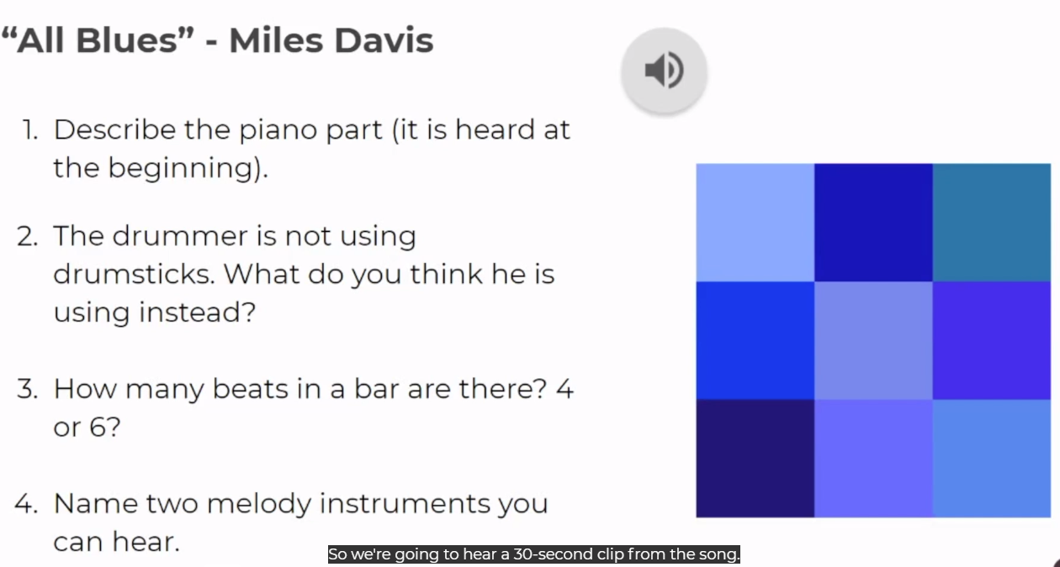

1)

2)

3)

4)
Demonstrate
Listen to “All Blues” on the video, and comment on the key points underneath.
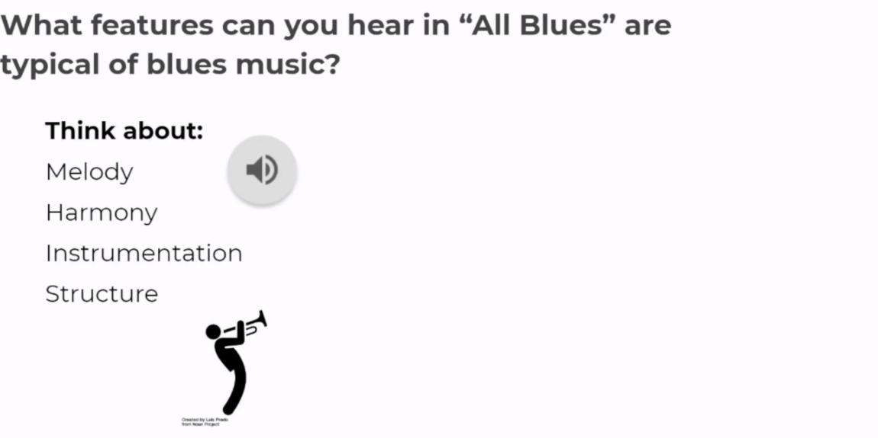

Answer here:
- Melody

- Harmony

- Instrumentation

- Structure

Features of blues music:
Swung rhythms repeated phrases 12-bar blues
Head (returning theme) Blues instruments: Saxophone, piano, drums, trumpet, bass
Consolidate
Fill in the blanks with the correct words from the blue box:
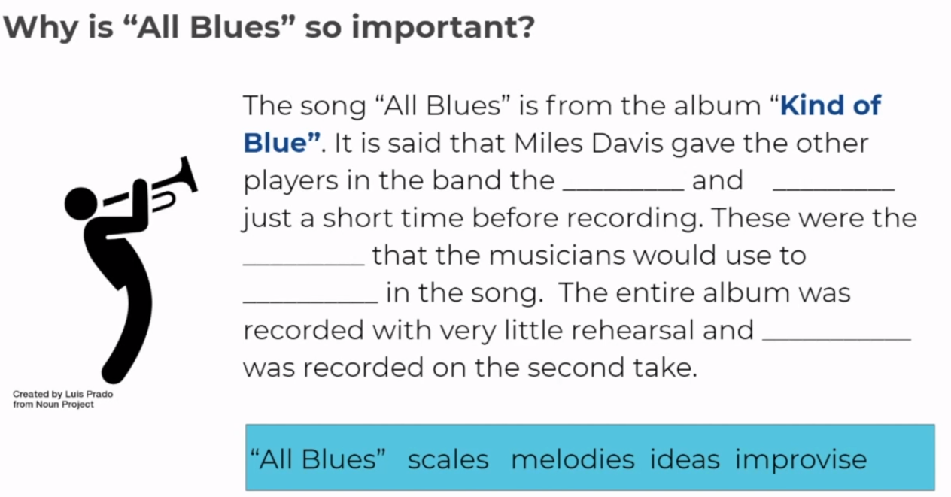

Can you name three features of Blues music?
1)
2)
3)

Lesson 2 - Connect
Title- The Blues
LI- To learn to play phrases of Blues standard “All Blues”

Lesson Structure:

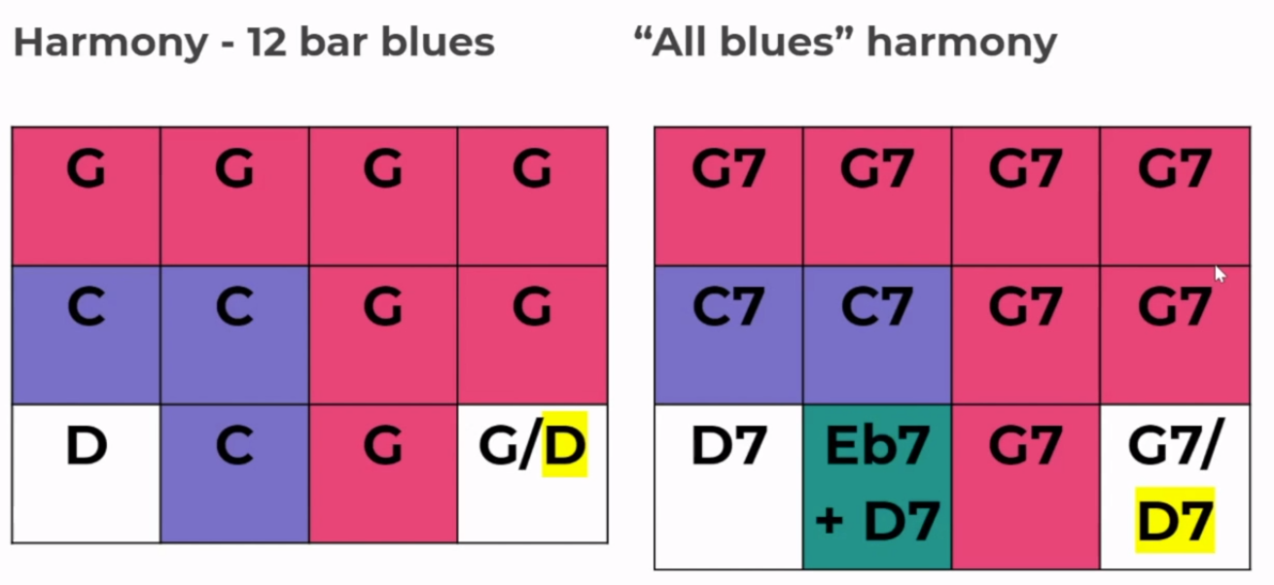
Spot the difference!

Look at the two 12-bar blues charts above. What are the two differences you see?
1)
2)

Activate
Read the DART on “All Blues”
The album Kind of Blue by Miles Davis, which features the iconic composition “All Blues,” is the best-selling jazz album of all time. In the new American Masters series documentary about Davis, The Birth of the Cool, the story of the Kind of Blue sessions is chronicled as a defining moment in American music history. And that’s not just jazz history, but the history of all of modern music.
In the key of G, “All Blues” is a 12-bar blues in 6/8 time with a fairly basic progression comprised entirely of 7th chords. The piece is a favorite at jam sessions because it’s relatively easy to solo over when compared to something like Coltrane’s “Giant Steps.” But the majority of people who are familiar with the composition are probably unaware that the song actually had lyrics written it to soon after Davis recorded it, and has been recorded by Ernestine Anderson, Rachel Gould, Kellye Gray, and by the man who wrote the words himself, Oscar Brown Jr.

Questions:
1) What key is “All Blues” written in?
2) What time signature is “All Blues” written in?
3)What chords does “All Blues” comprise of?

Key Terminology:
12-bar Blues 6/8 time progression 7th chords composition lyrics

Demonstrate
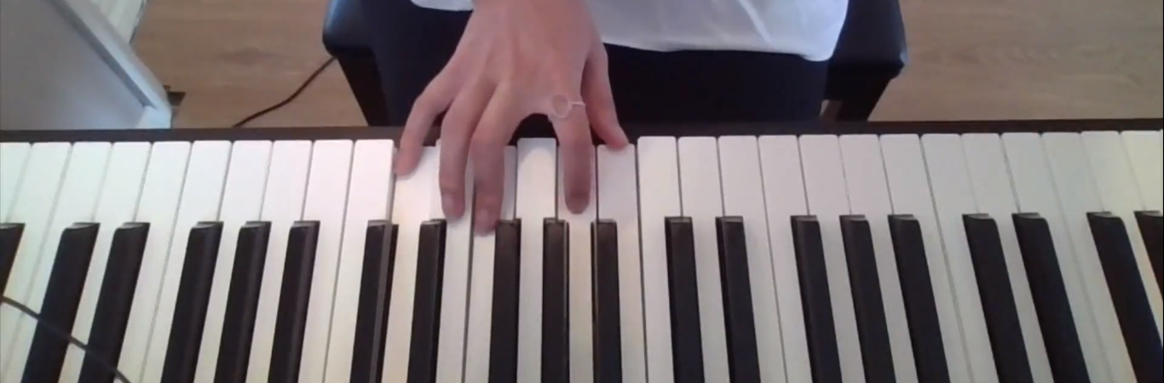
Play the video (link in contents page: lesson 2) from 21 minutes 46 seconds until the end.

- Watch Miss Friar show you how to play 7th chords.

- Try for yourself as the video continues if you don’t have access to a real or virtual instrument listen to how the chord changes with the 7th note on top.

- Watch and listen to Miss Friar playing a bass line.

- Try playing the bassline yourself, if you don’t have access to an online instrument try singing it as Miss Friar plays.

- Now Try playing the bassline and chords together!
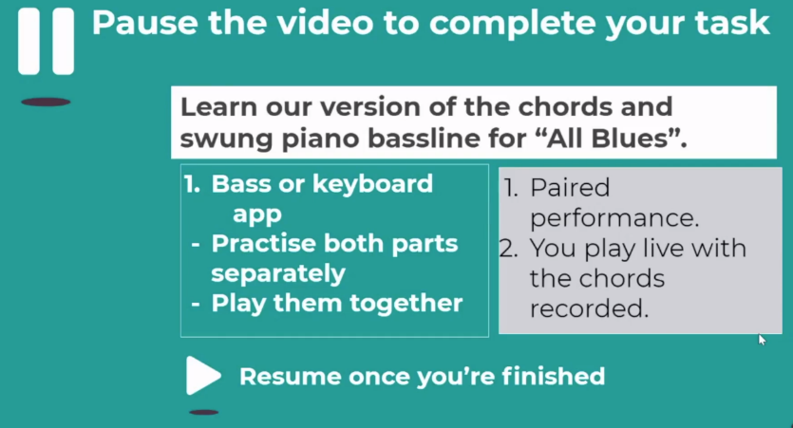
STRETCH- Try playing the melody/ Blues “head”, near the end of the video.

Consolidate
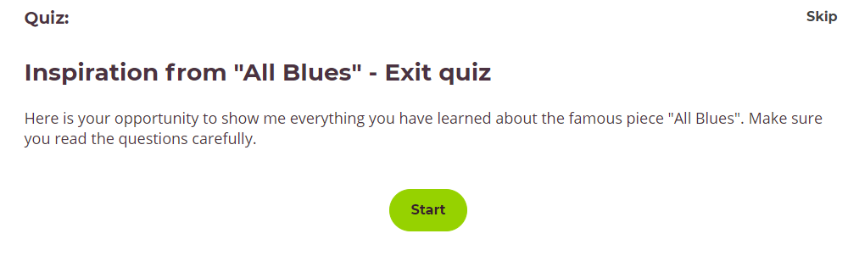
Take the exit quiz and record your score:

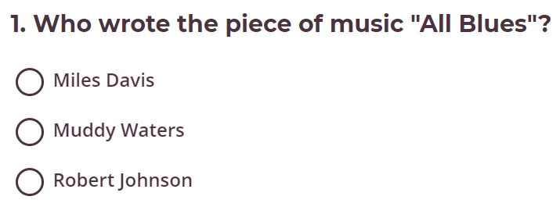
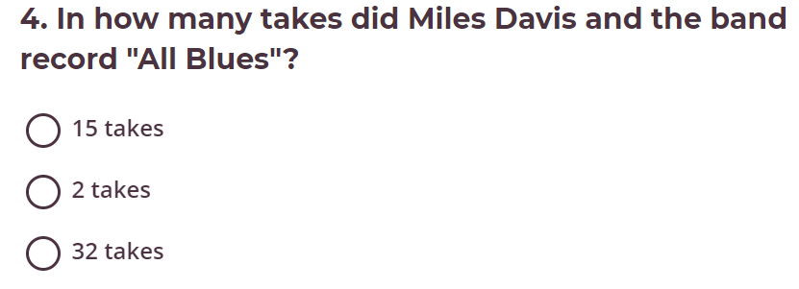
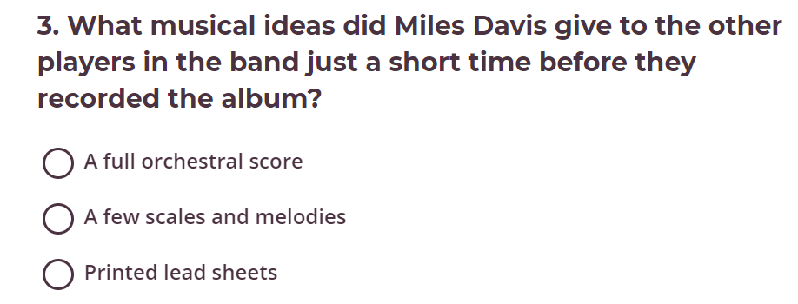
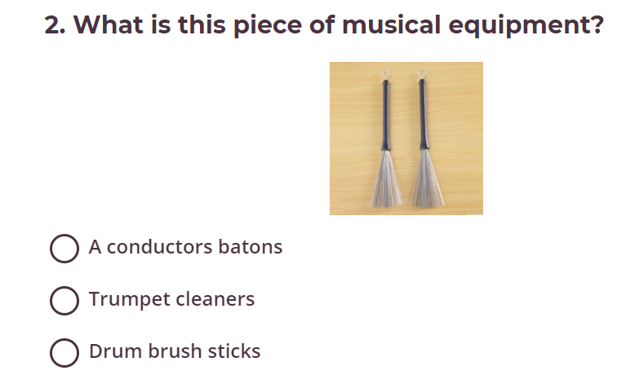
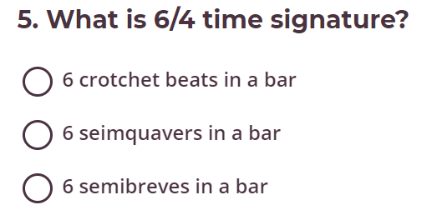
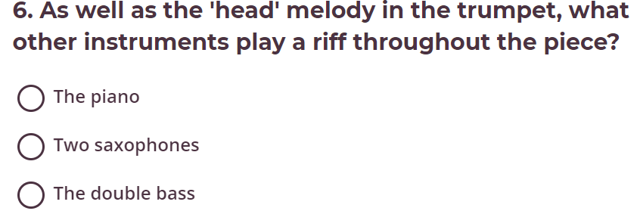

Lesson 3 – Connect
Title- The Blues
LI- To be able to create a blues accompaniment

Lesson Structure:
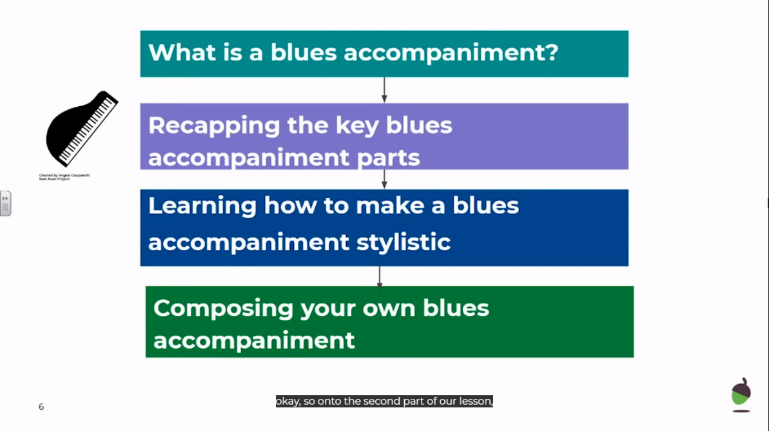

- Start by taking the intro quiz just before the video, keep your score here:

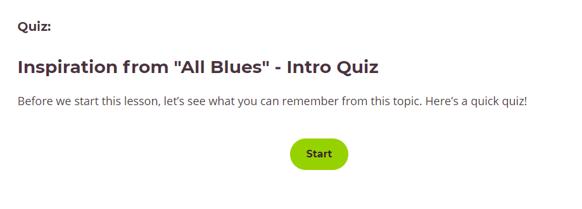

- Play the video and warm up with Miss Friar by copying her body percussion.
For the lesson you will need:
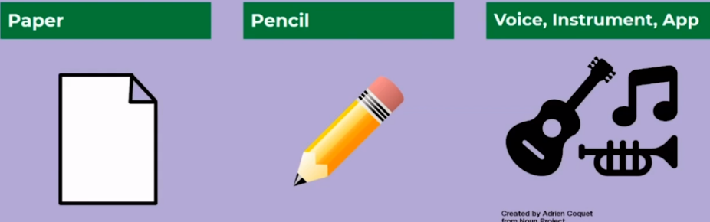

Activate
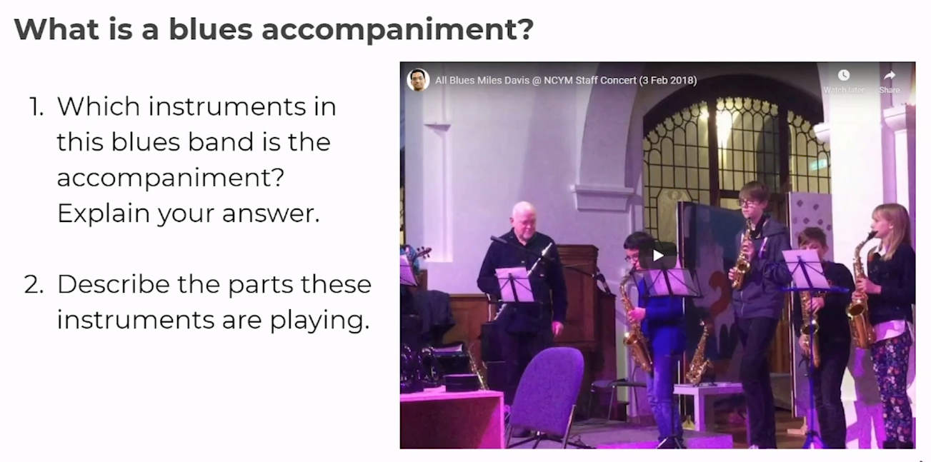
Watch and listen to the performance on the video and answer the three questions below:
1)
2)

3)

1)

2)

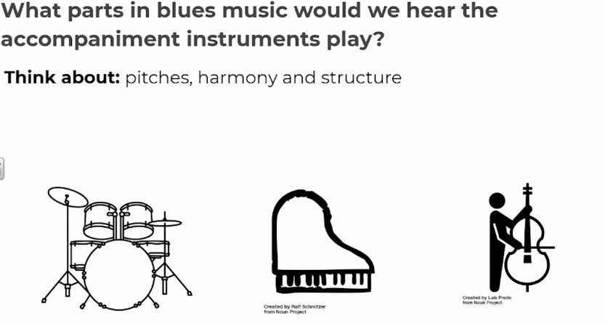
3)

STRETCH -

Demonstrate
- Recap the 12- bar blues structure and chords in G major and the walking bass line.
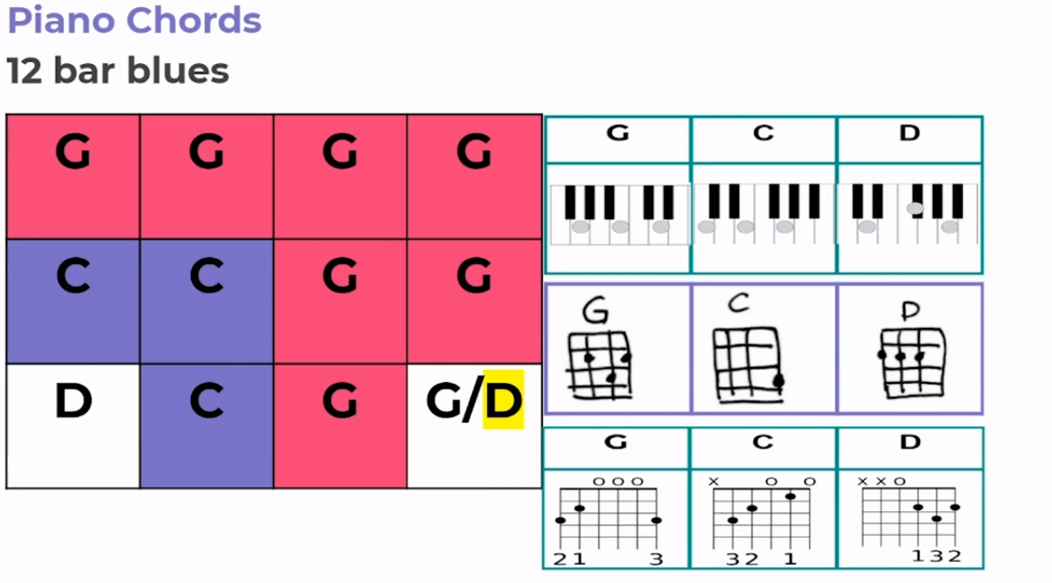

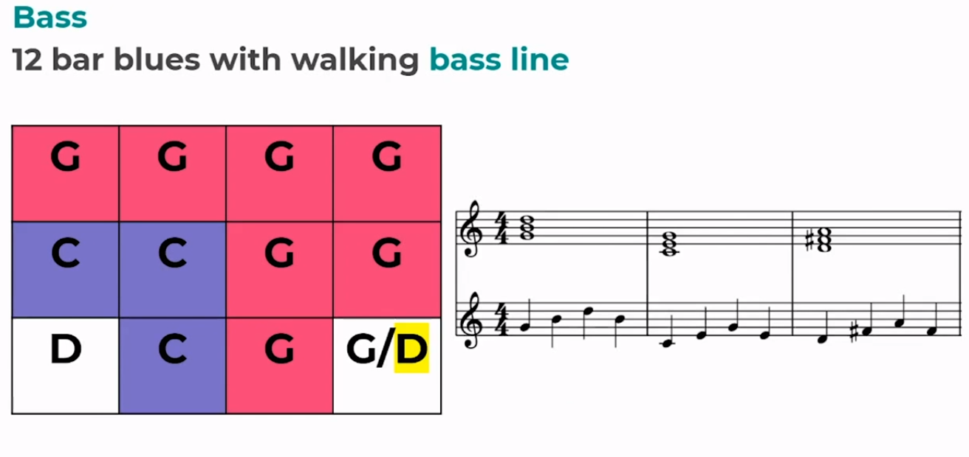
- Try playing your 12-bar chords and bass line separately first.

STRETCH- Try playing them together.

Consolidate

Think about your performance during the demonstrate task.
Write two sentences on each “What went well…” and “Even better if…”

- What went well….

- Even better if….



Lesson 4 – Connect
Title- The Blues
LI- Learn how to compose your own blues accompaniment

Lesson Structure:

Play the video (link in the contents page) to recap the following:
- Shuffle rhythms
- Parts of the drum kit and how they are shown in notation
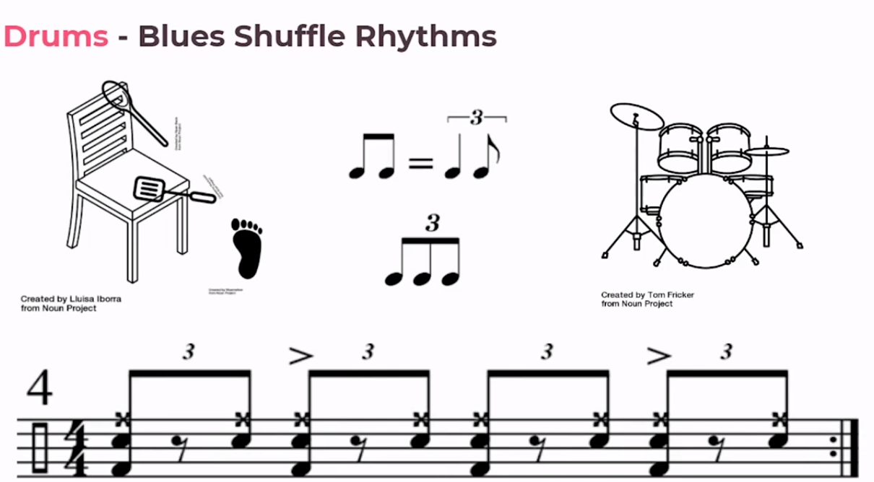

Stretch- Practise your shuffle beat by chair drumming!

Activate

- Continue playing the video and watch Miss Friar introduce another way to play a walking bass line.

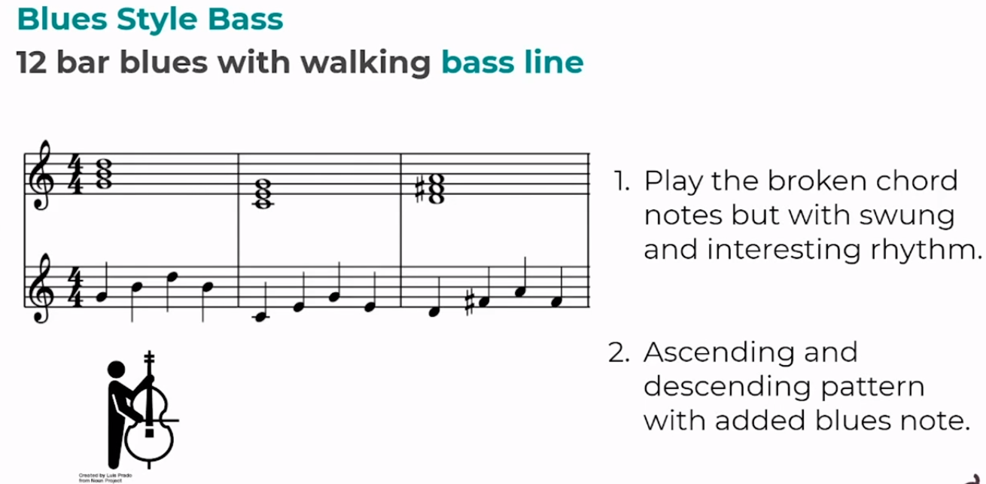

- Practise playing your walking bass line. If you do not have a real or virtual instrument, try singing it instead.

Demonstrate
Continue watching the video
1)Watch Miss Friar explain what vamping in blues music is.
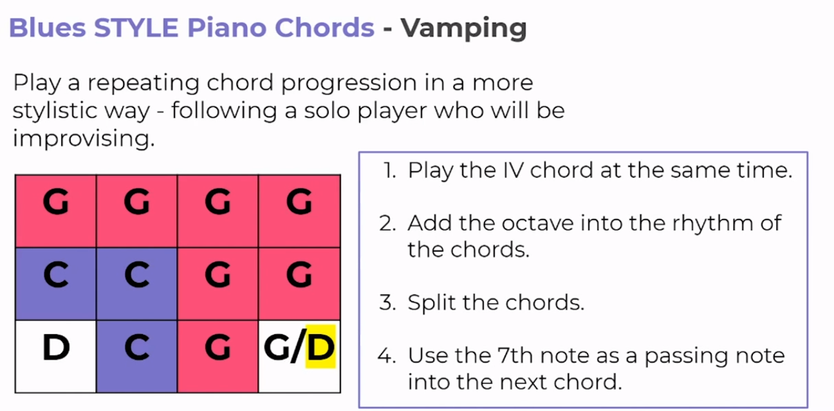
2) Try some vamping techniques on your real or virtual instruments, if you don’t have one make notes of the styles of vamping you liked in the video.

- Now pick an accompaniment you leanrt today, either bass line, vamped chords or drum shuffle and try to play along with the backing track in the video. If you do not have a real or virtual instrument try singing along the bass line from earlier in the video.
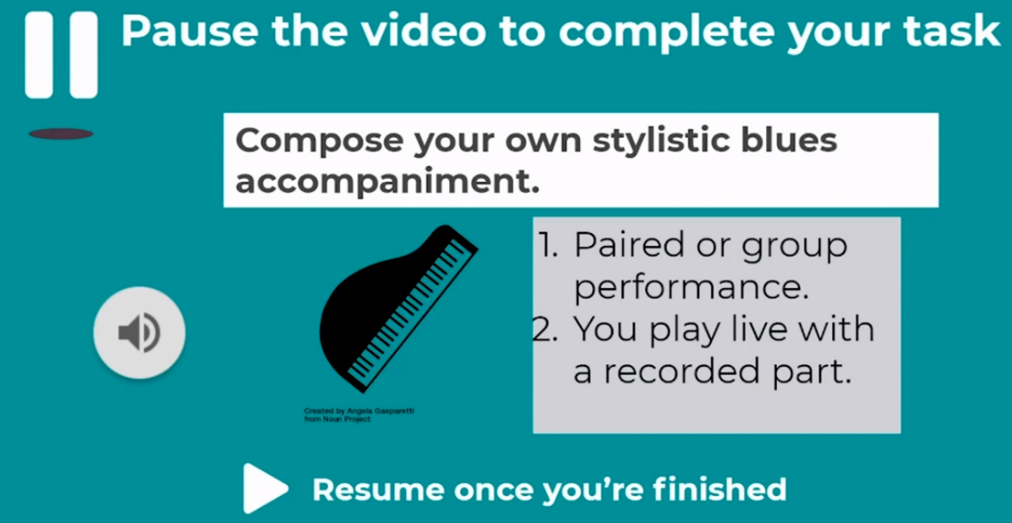

Consolidate
Take the exit quiz after the video and make note of your score here:
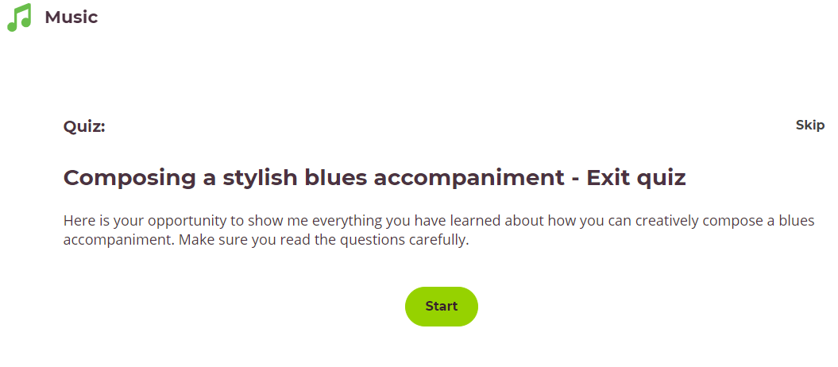

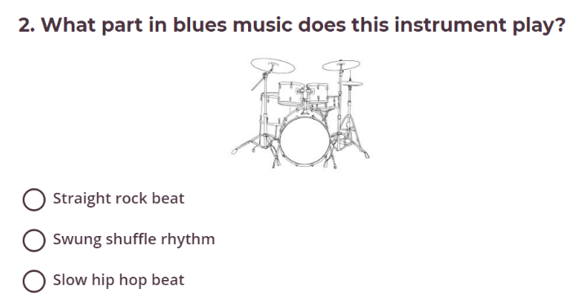
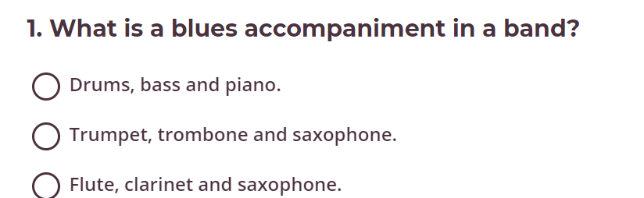
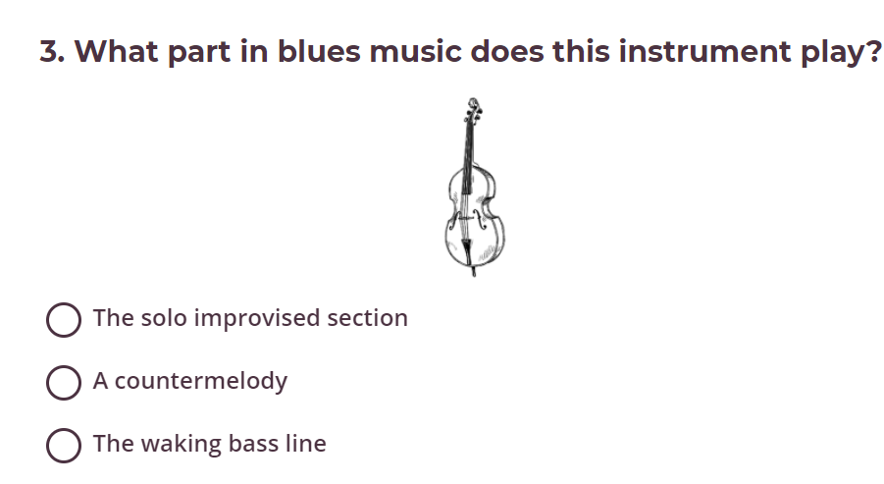
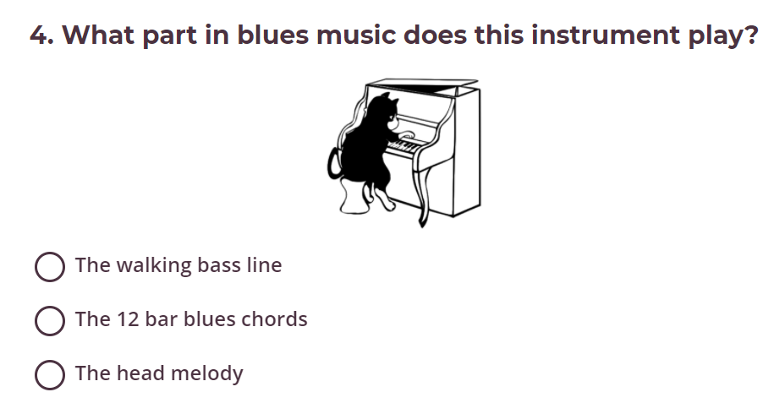

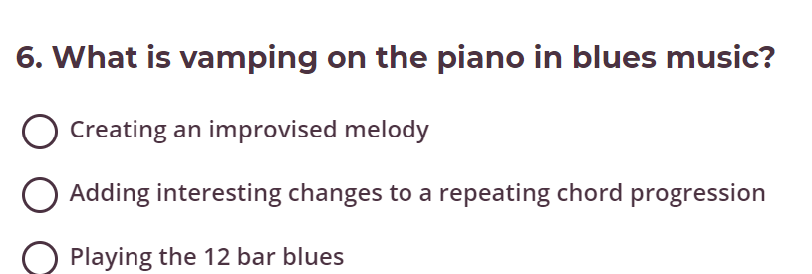
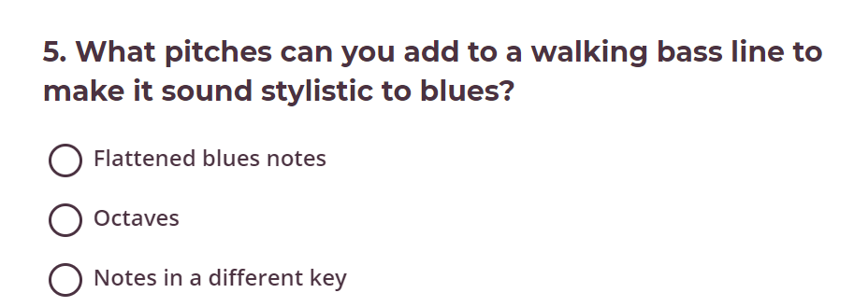
Lesson 5 – Connect
Title- The Blues
LI- To be able to compose a blues “head”
Lesson Structure:
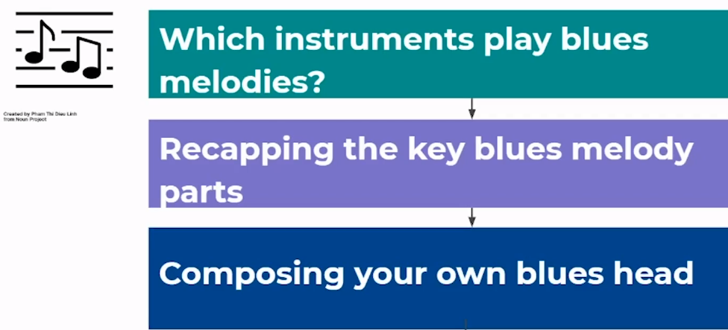

- Play the oak national academy video (link in contents page: lesson 5) and warm up with Miss Friar- hum back the same melody.

- Read the DART.

Improvise your own tune
Improvising is a great instrumental skill to have, but it can require some hard work at the beginning. When you are starting out, the first thing to remember is that you shouldn’t worry about making any mistakes - some improvisations will sound a little more ‘musical’ than others. Play a few notes on an instrument of your choice and take it from there - you don’t need to be an expert.
One of the best ways into improvisation is the 12-bar blues. This is a well-known, simple chord progression which gives you an opportunity to try out some of your ideas.

Keyword Definition
improvisation The art of making up music on the spot or in the moment.
melody The main tune in any piece of music.
chord progression A sequence of chords played in a certain order.
12-bar blues A well-known chord progression of 12 bars using the primary chords.
blues scale A scale, which is often the basis for improvisation, especially in the 12-bar blues.
Activate

- Answer the questions below whilst listening to the Broadway musical “Hellzapoppin” in the video

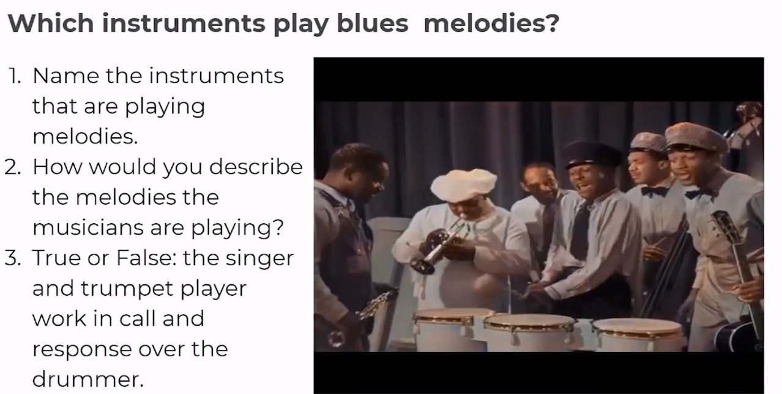

1)

2)

3)

Demonstrate

- Now it’s your turn, create a blues ‘head’ (a recurring theme) using the notes of the blues scale underneath. If you don’t have access to a real or virtual instrument, use the scale notes and sing your blues “head” melody.
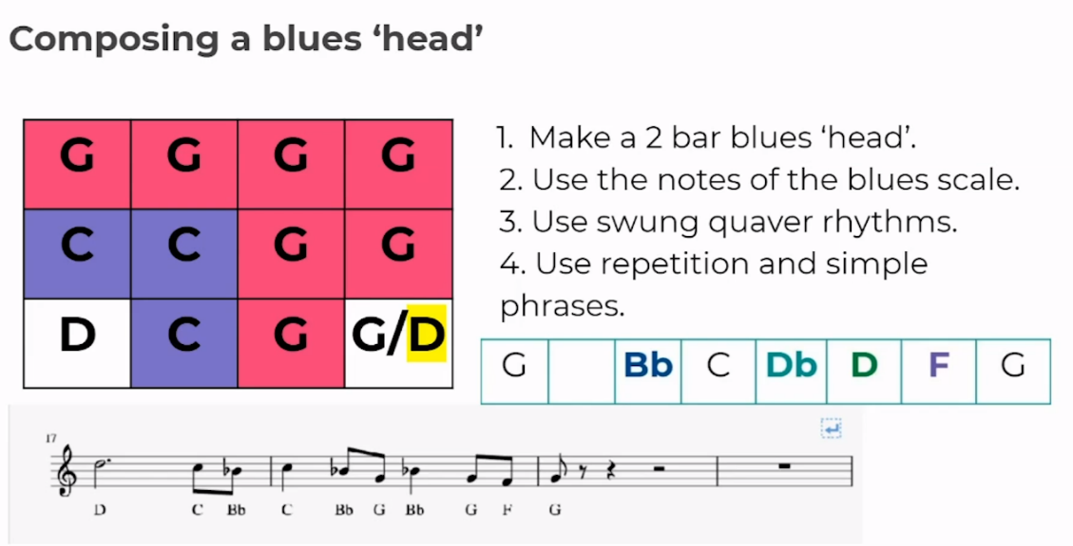



Consolidate
- If you can record your new blues “head” melody, record it now.

- Take the exit quiz and record your score here:
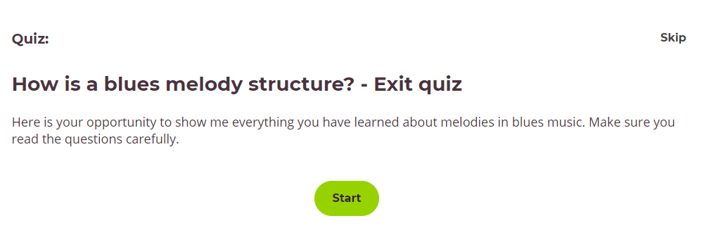

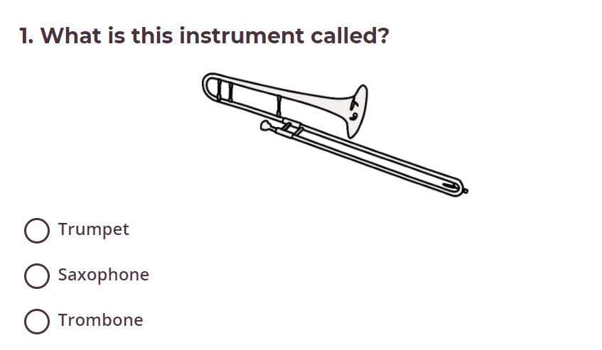
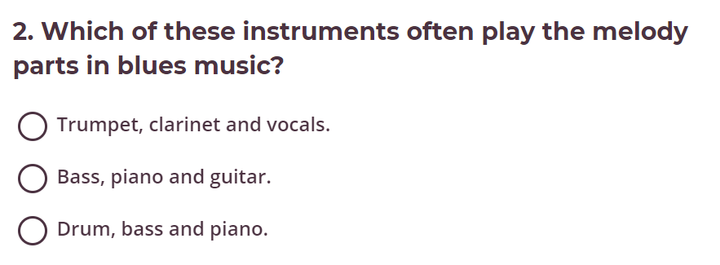

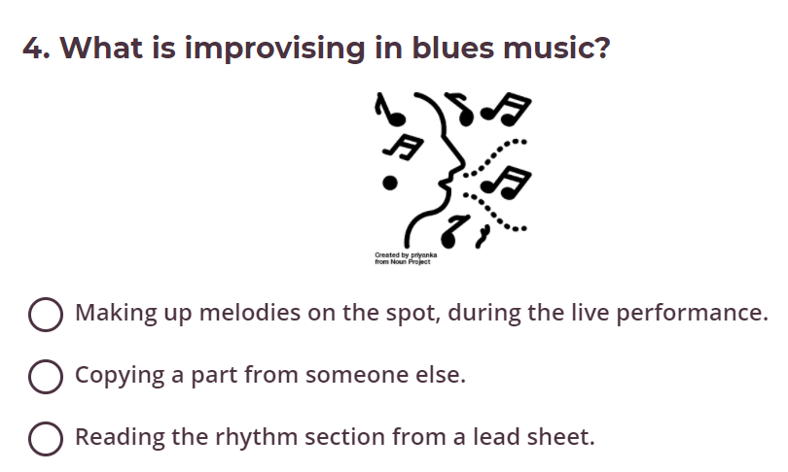
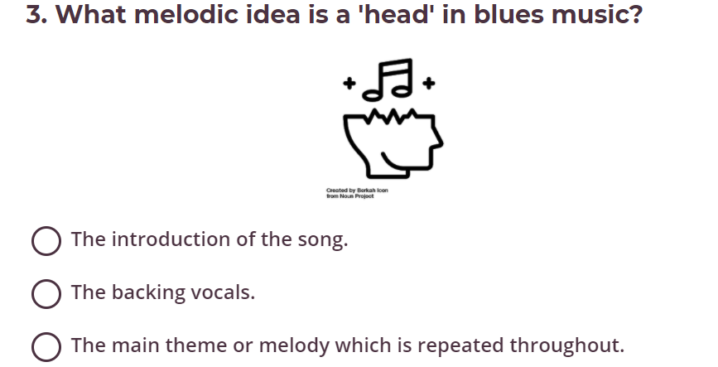

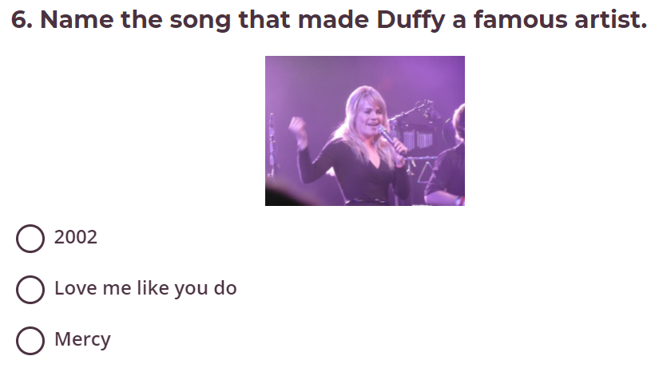
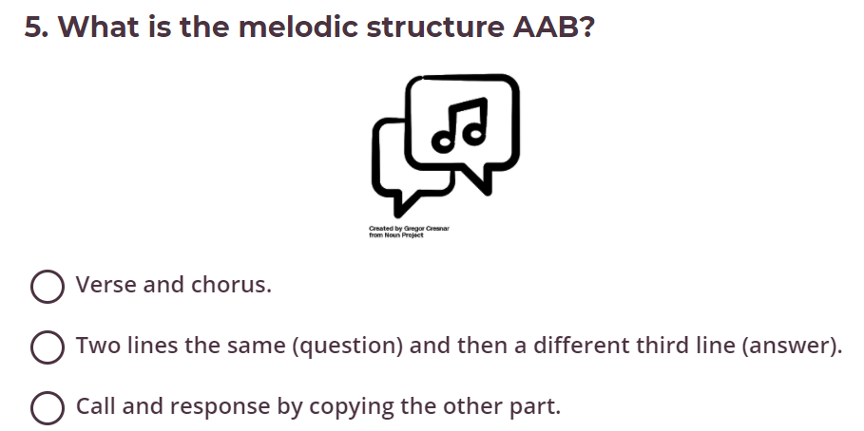



Congratulations you have completed your music Spring Term 2 booklet!

