English Year 8
Spring B
Blended Learning Booklet
Museum of My Life
Name:
Form:
English Teacher:
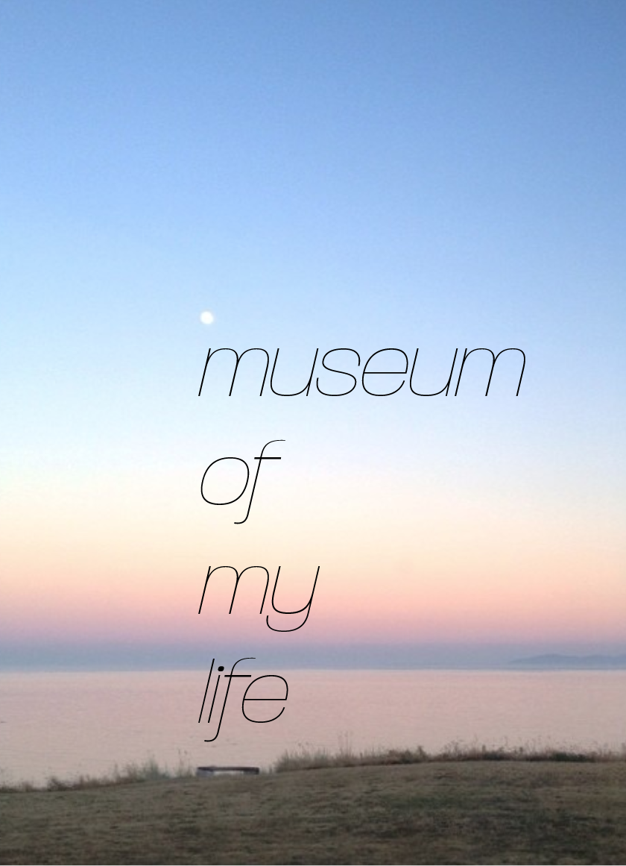

Contents

Page Number | Lesson Number | Title | Tick when complete
6 | 1 | Introduction to Museum of My Life
8 | 2 | Autobiography or Biography?
10 | 3 | Writer’s Techniques
12 | 4 | Biographies
13 | 5 | Life Milestones
15 | 6 | Ambition
17 | 7 | Heroes and Role Models
18 | 8 | Life Experiences
20 | 9 | What makes a good speaker?
23 | 10 | Presentation Planning
26 | 11 | Speech Writing
27 | 12 | Presentation Lesson
28 | SAL

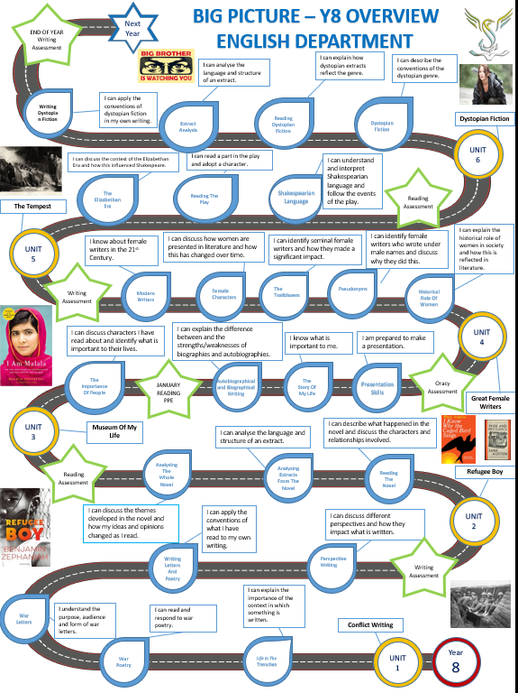

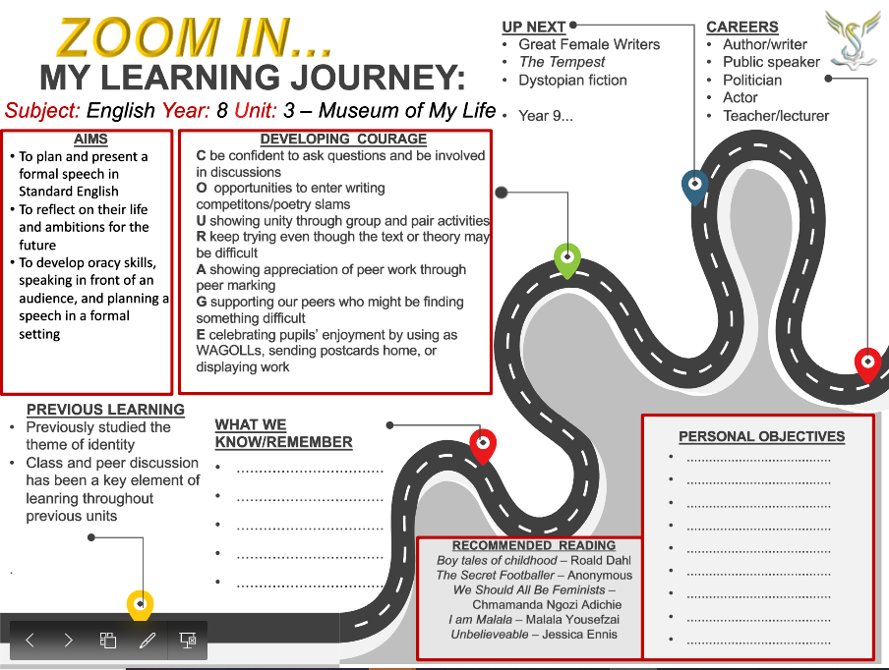

Y8 Unit 4 – Museum of My Life Knowledge Organiser

Autobiographies and Biographies  - An autobiography is written from a personal point of view, using the pronouns I, me, we and our.  - This means this type of writing is very informative about a particular person – provided they are telling the truth!  - A biography is written about another person, using the pronouns he, she, them, his, her and their.  - This type of writing is based on what the writer knows about the subject, meaning some biographies are better than others. | Ambitions and Aspirations  - An ambition is something you really want to do that would be a major challenge/achievement for you.  - You could have ambitions that fall into different categories: personal, education, leisure/before you are 20/before you are 30 etc…  - Kamala Harris believes that her becoming the first non-white and first female Vice President will encourage young people to become ambitious because she has broken down barriers that previously existed. |  | Past, Present, and Future Tenses  - The past tense includes everything that has ever occurred up to the present moment. A writer has decided to describe an event or incident using verbs that show it has already happened.  - Writing In the present tense uses verbs which show an action or incident is happening right now.  - Writing in future tense usually includes a reference to the possibility of something happening, using modal verbs such as may, might, could, and will.
Heroes and Role Models  - A hero is a person who is admired for their courage, outstanding achievements, or noble qualities  - A role model is a person looked to by others as an example to be imitated.  - Ian Wright’s hero was Mr Pidgen, his PE teacher: ‘He taught me everything: how to read and how to write, how to have patience, and how to be confident and communicate, and why sometimes I would get angry. He really opened up the world to me. He made me believe that the things I did mattered.’ | What makes a good speech?  - Non-verbal communication is the ways in which people can communicate without using language.  - Tone is the variation in the pitch of the voice while speaking.  - Body language is the conscious and unconscious movements and postures by which attitudes, and feelings are communicated.  - Good speakers, such as Martin Luther King, Barack Obama, and Winston Churchill, use a variety of strategies to engage their audiences. | FAT HORSE  Facts/statistics – 58% of people think…  Alliteration – Dangerous and disastrous  Anecdote – When I was younger…  Triplets – The situation is unacceptable, dangerous, and upsetting.  Hyperbole – There is nothing more important.  Humour – It was absolutely hilarious when…  Opinion – In my view… From my perspective…  Rhetorical questions – Would you want that to happen to your family/team/town/country?  Repetition – I believe…I believe…I believe.  Similes – It felt like… It was as if…  Emotive Language/Direct address – You can make a difference by

Lesson 1: Introduction to Museum of My Life
LI: To understand the aims of the unit and relate this unit to what I have studied before
Do now: Name as many characters as you can that you have studied in English at Stewards.
How have their experiences made them who they are?

Find the SAL in your blended learning booklet
Read through the SAL. What skills are you focusing on this half term?
Underline any words that you’re not sure of – annotate what they

Choose a celebrity and help them decide which items are the most important and should go into their ‘Museum of my Life’

Messi
- A football
- Messi’s first contract on a napkin preserved in a protective frame
- A can of coke
- A cookbook
- Argentinian flag
- A portrait of his family
- European Golden Shoe Award
- Golden cast of Messi’s left foot created by Tokyo jeweller, Ginza Tanaka
- Barcelona football shirt
- Olympic gold medal for Soccer from 2008 Beijing Olympics

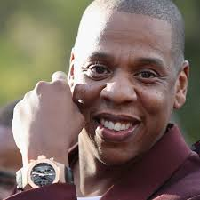
Jay-Z
- A copy of a Marvin Gaye album
- Platinum copy of Reasonable Doubt, Jay-Z’s debut album
- Ticket from Glastonbury Festival in 2008
- A copy of Rolling Stone magazine from June 2010 where Jay-Z featured on the cover
- Fela! musical programme from opening night
- A boom box
- Car he used to sell CDs out of when no one would sign him
- Rocawear sneakers
- Brooklyn Nets baseball cap
- A signed copy of his memoir Decoded

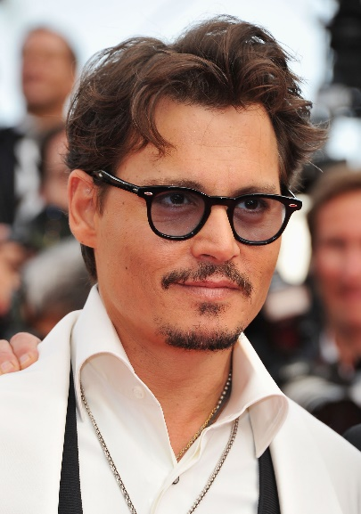
Johnny Depp
- A cast of his hands and feet from Hollywood Boulevard
- The golden ticket from Charlie and The Chocolate Factory
- A guitar
- The keys to his yacht
- A picture with Tim Burton
- An old love letter from Winona Ryder
- 2008 Golden Globe Award for Best Actor (Sweeney Todd)
- The Mad Hatter’s Hat (Alice in Wonderland)
- A painting of his Yorkshire terriers, Pistol and Boo
- A ballpoint pen from his sales job (before he was famous)

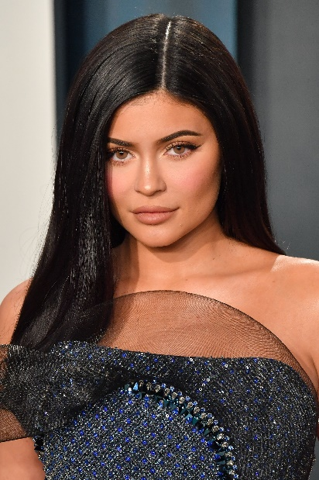
Kylie Jenner
- Make-up palette
- Selfie stick
- Smartphone
- TV set showing Keeping Up with the Kardashians
- Family portrait
- Cheerleading outfit
- A globe
- Instagram cut-out
- Promotional poster of Life of Kylie
- Copy of Forbes magazine from August 2018 where she featured on the cover


Ed Sheeran
- Custom-built ‘x’ Martin & Co. acoustic-electric guitar
- Ipswich Town FC football shirt
- Bottle of Tomato Edchup (2019 promotion)
- Looping machine
- Suit of armour from his cameo on Game of Thrones
- His grandfather’s first edition of The Hobbit
- Nando’s Black Card
- Special Ed-Abrese pizza ‘cake’ from Pizza Express
- A Pingu toy
- A photograph of Jamie Foxx

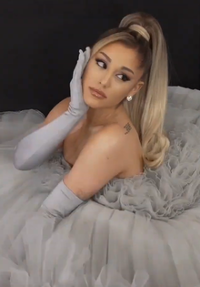
Ariana Grande
- Programme from 2008 Broadway musical 13
- Promotional poster of Nickelodeon TV series Victorious
- A copy of her first top-ten single, The Way
- 2019 Grammy Award for Best Pop Vocal Album
- Grande’s “empowering” Twitter essay from 2015
- Signed, original set list from One Love Manchester 2017
- 2019 Brit Award for Best International Female
- LGBT Pride flag
- Cat ear hair accessory
- Viva Glam Lipstick by MAC

DIP Task: Explain the choices you have made for your chosen celebrity

********************************************************************************
Lesson 2: Autobiography or Biography
L/I: To identify and explain the differences between an autobiography and a biography
Do now:
What is perspective?
- Why is it important in writing?

DART: Extract from ‘Unbelievable – From my Childhood Dreams to Winning Olympic Gold’

I am crying. I am a Sheffield schoolgirl writing in her diary about the bullies awaiting me tomorrow. They stand menacingly by the gates and lurk unseen in my head, mocking my size and status. They make a small girl shrink, and I feel insecure and frightened. I pour the feelings out into words on the page, as if exposing them in some way will help, but nobody sees my diary. It is kept in my room as a hidden tale of hurt.
Fast forward two decades and I am crying again. I am standing in a cavernous arena in London. Suddenly, the pain and suffering and frustration give way to a flood of overwhelming emotion. In the middle of this enormous arena I feel smaller than ever, but I puff out my chest, look to the flag and stand tall. It has been a long and winding road from the streets of Sheffield to the tunnel that feeds into the Olympic Stadium like an artery.
I am Jessica Ennis. I have been called many things, from tadpole to poster girl, but I have had to fight to make that progression. I smile and am polite and so people think it comes easily, but it doesn’t. I am not one of those athletes who slap their thighs and snarl before a competition, but there is a competitive animal inside, waiting to get out and fight for survival and recognition. Cover shoots and billboards are nice, but they are nothing without the work and I have left blood, sweat and tears on tracks all over the world. It is an age where young people are fed ideas of quick-fix fame and instant celebrity, but the tears mean more if the journey is hard.
So I don’t cry crocodile tears; I cry the real stuff.

DART Questions:
- Where does Jessica Ennis come from?
- What does she write in her diary?
- ‘Fast forward two decades and I am crying again’. Why is she crying now?
- Write down two things Ennis has been called. What do each of these mean?
- Why does Ennis think she has been so successful?
- How might her childhood experiences have shaped who she has become?

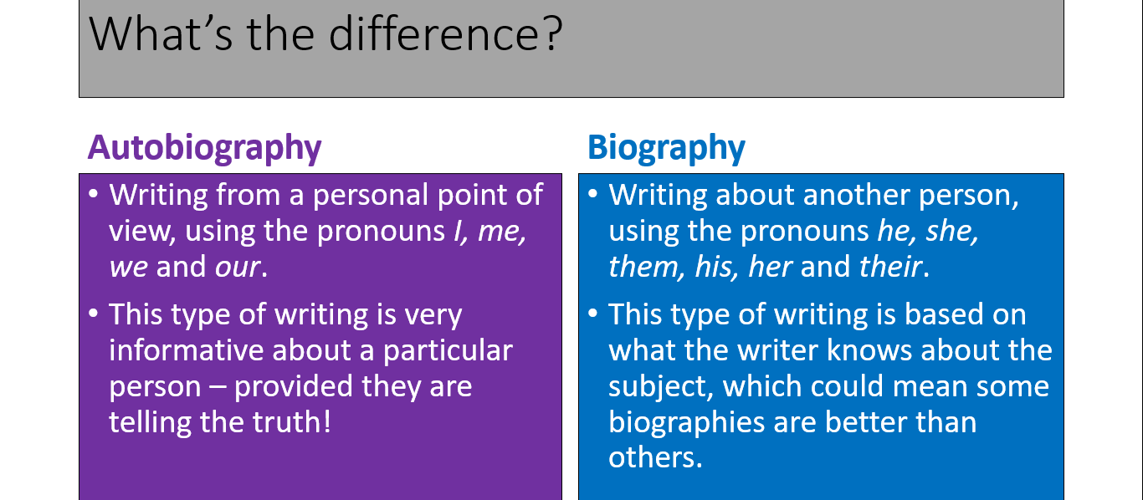
Who are you?
- Make a note of FIVE things that are interesting about you. This could be your family, friends, pets, hobbies, likes/dislikes, dreams and ambitions.
- Use the following questions to help you:
- Where were you born?
- What is your earliest memory?
- Have you ever moved home?
- What is your favourite memory?
- Can you speak any other languages?

DIP TASK: Write an autobiographical paragraph about yourself.
*************************************************************************
Lesson 3: Writer’s Techniques
L/I: To explore the form of an autobiography
Do now:
What is a biography?
What is an autobiography?

DART: Read the extracts from the two autobiographies
- What do you learn about each person?
- How has the writer made it interesting for the reader?

Extract 1: I am Malala
When I close my eyes, I can see my bedroom. The bed is unmade, my fluffy blanket in a heap, because I’ve rushed out for school, late for an exam. My school timetable is open on my desk to a page dated 9th October 2012. And my school uniform – my white shalwar and blue kamiz – is on a peg on the wall, waiting for me.
I can hear the kids playing cricket in the alley behind our home. I can hear the hum of the bazaar not far away. And if I listen very closely I can hear Safina, my friend next door, tapping on the wall we chare so she can tell me a secret.
I don’t remember anything after that, but here’s the story that’s been told to me.
Two young men in white robes stepped in front of our truck.
“Is this the Khushal School bus?” one of them asked.
The driver laughed. The name of the school was painted in black letters on the side of the van.
The other young man jumped onto the tailboard and leaned into the back, where we were all sitting.
“Who is Malala?” he asked.
No one said a word, but a few girls looked in my direction. He raised his arm and pointed at me. Some of the girls screamed and I squeezed Mobniba’s hand.
Who is Malala?
I am Malala and this is my story.

Extract 2: ‘A Long Way Gone’: Memoirs of a Boy Soldier by Ismael Beah
I lay sweating for a few minutes on the cool wooden floor where I had fallen, before turning on the light so that I could completely free myself from the dreamworld. A piercing pain ran through my spine. I studied the red exposed brick wall of the room and tried to identify the rap music coming from a car passing by. A shudder racked my body, and I tried to think about my new life in New York City, where I had been for a month. But my mind wandered across the Atlantic Ocean back to Sierra Leone. I saw myself with an AK-47 and walking through a coffee farm with a squad that consisted of many boys and a few adults. We were on our way to attack a small town that had ammunition and food. As soon as we left the farm, we unexpectedly ran into another armed group as a soccer field adjoining the ruins of what had once been a village. We opened fire until the last living being in the group fell to the ground. We walked toward the dead bodies, giving each other high fives. The group had also consisted of young boys like us, but we didn’t care about them.
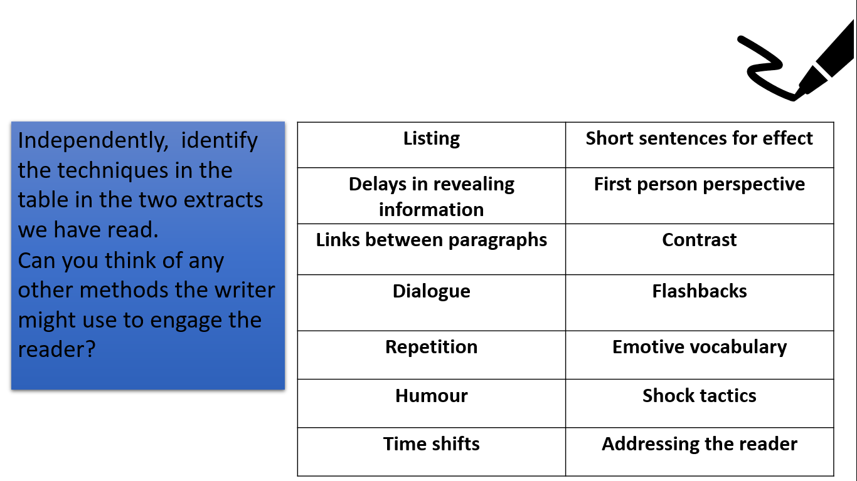
DIP TASK: How do Malala Yousafzai and Ishmael Beah use language and structure to describe their experiences?

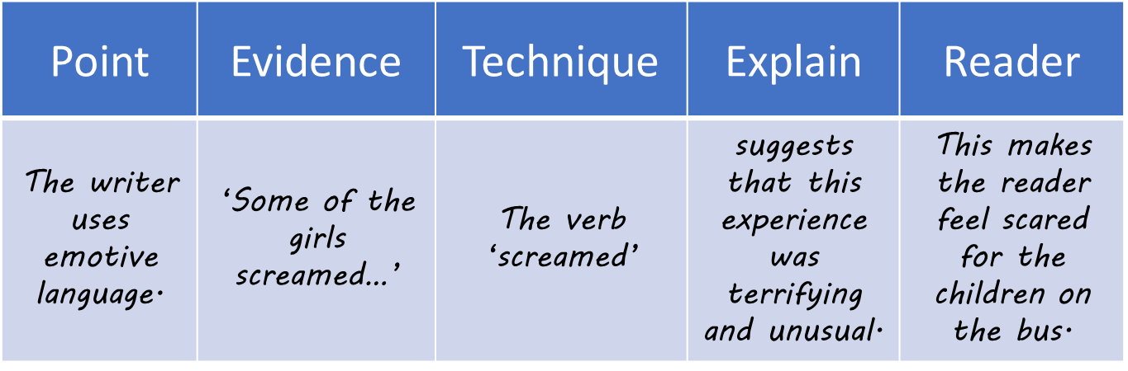

****************************************************

Lesson 4: Biographies
L/I: To explore the form of a biography and how it compares to an autobiography
Do now:
- What is the first person?
- What is the third person?
- Which would a biography be written in?

DART: Margaret Atwood Biography
Born in Ottawa, Ontario, Canada, Atwood is the second of three children of Margaret, a former dietitian and nutritionist, and Carl Edmund Atwood, an entomologist. Due to her father’s ongoing research in into forests, Atwood spent much of her childhood in the backwoods of Northern Quebec and back and forth between Ottawa, Sault Ste. Marie, and Toronto.
Atwood began writing at age six and realised she wanted to write professionally when she was 16. In 1957, she began studying at Victoria College in the University of Toronto. Her professors included Jay Macpherson, and Northrop Frye. She graduated in 1961 with a Bachelor of Arts in English (honours) and minors in philosophy and French.
In 1968, Atwood married Jim Polk; they were divorced in 1973. She formed a relationship with fellow novelist Graeme Gibson soon after and moved to a farm near Alliston, Ontario, north of Toronto. In 1976 their daughter, Eleanor Jess Atwood Gibson, was born. The family returned to Toronto in 1980.
Recently Margaret Atwood has been working with the peoples in the Gulf of Mexico in an event called “Earth Day” after a devastating oil spill savaged the land. She was engaged in several activities in and around Earth Day, including an appearance at the Earth Day event in Washington, D.C, where she learned of many organizations she had not known about before.
Margaret Atwood is also involved in many other events around America, such as the World Book Fare. She writes:
“The conference itself was a swirl of ideas- they're multiplying like amoebas in a well-stocked petrie dish – but the short message is: The book is not dead. Reading is not dead. The human interest in stories is not dead.”
Margaret says that she is always reading new books and is always writing books to be published in the future. Margaret is also heavily involved in producing a series of poems to be published in 2013, including poems that she writes on her blog.

DART Questions:
- Which country was Atwood born in?
- When did she realise she wanted to write professionally?
- How long did her first marriage last?
- What does Atwood believe about books and reading?
- ‘The conference itself was a swirl of ideas- they're multiplying like amoebas in a well-stocked petrie dish’ – explode this quote in your book.
- Choose six key events from Margaret’s life and write a timeline in your book.

DIP Task: What is the difference between a biography and an autobiography?
How does this impact what is written?
Use the examples from the last lesson or two in your answer, think about the perspective each type of writing is from, and think about what is/is not included as a result.

**********************************************************************************
Lesson 5: Life Milestones
L/I: To understand what a chronological structure is and why it is important in biographical and autobiographical writing
Do now:
What is the past tense?
What is the present tense?
What is the future tense?
Are these sentences using Past, Present or Future tenses?

- I walked to the park yesterday.
- You speak English.
- She always forgets her purse.
- Hold on. I’ll get a pen.
- I think I’ll go to the gym tomorrow.
- It will snow tomorrow.
- Every twelve months, the Earth circles the sun.
- He had won five matches until that day.
- He will play football and then he will go home.
- I grew up in the North East, and I gave lived here all my life
DART: Average Age for Life Milestones
The average age to tie the knot is 26, while buying your first home happens a year later, according to research.
A detailed study of 2,000 adults found the ages at which life’s special moments are most likely to happen, with your first kiss at 15 and getting your first real boyfriend or girlfriend at 17. Sadly, this is followed by a first heartbreak at the age of 18.
Music fans will attend their first gig at the age of 16, while thrill-seekers will experience their first rollercoaster ride when they are just 12.
It also emerged 73 per cent like to document their special moments with photos or videos, with 36 per cent admitting they spend hours scrolling back through social media to re-live good times.
Melissa Bentley, marketing manager for French bakery brand, Brioche Pasquier, which commissioned the research, said: “Many of us can still remember big life events, even if they happened decades ago. First loves, first jobs, and our first beers are all imprinted on our memories – even if sometimes we can’t remember where our glasses are today. But even though memory is a great way of capturing these times, having them in photos and videos is really great to relive some of the key moments of our lives.”
The study also found Brits go on their first flight at 14 and on their first holiday without their parents when they’re 20 years old. They’ll also first move out of their parents’ home at the age of 21 – the same year they’re likely to pass their driving test.
Other key life milestones include learning to ride a bike by the age of seven, mastering swimming the year after and joining their first sports team at 11.
Brits are also likely to have their first child at the age of 28, and upgrade from their first home when they’re 31.
It also emerged one in three feel their best life moment was the birth of their first child – with just one in ten selecting their wedding day. Another 46 per cent of Brits spend ‘a lot’ of time reminiscing about the past, according to OnePoll.com.
During the average week, they’ll photograph or video five events that may or may not become a special memory in years to come. Four times as many people prefer to capture a special moment in a photograph, than on a video. Nearly one third of people only keep social media profiles on Facebook because of the photos, videos and other memories from the past. And three in 10 believe if they don’t record a special moment on film, they’re likely to forget it. Three quarters of people also regret not keeping more solid evidence from special events in their lives so far.
Melissa Bentley added: “Whatever the special moment and whenever a person experiences it, it seems that a lot of us choose to honour the occasion in the form of a photograph. And it’s now even easier with most of us people able to reach into our pockets and capture it on our smartphones.”

DIP Task: Why doesn’t life turn out as ‘planned’?
Sentence stems to help:
- I…when I was aged…
- The average British person does this when…
- Currently, I…
- According to the article British people…
- In the future I hope to…
- The average age for this is… but…
- Average ages are interesting because…
- However, they do not apply to all people because…
- The average age for…would have been higher/lower for my grandparent’s generation because…

**********************************************************************************
Lesson 6: Ambition
L/I: To understand and explore the meaning of ambition
Do now:
- What does it mean to be ambitious?
- Is it a positive or negative character trait?

DART: 'Dream with ambition, lead with conviction': Kamala Harris delivers powerful victory speech as VP-elect
America's Vice President-elect Kamala Harris delivered a rousing victory speech in Wilmington, Delaware, hitting familiar themes and hailing Joe Biden for his "audacity" in choosing a woman as his running mate. "Every little girl watching tonight sees that this is a country of possibilities," Harris said to wild cheers.
Harris' mother Shyamala Gopalan, core to every Harris stump, came in for special mention. "My mother Shyamala Gopalan Harris...who is always in our hearts. When she came here from India at the age of 19, she could not have imagined this moment. But she believed so deeply in America, where a moment like this is possible. And so I'm thinking about her, and about the generations of women, Black women, Native American women who have paved the way for this moment tonight."
Harris arrived in a motorcade flashing red and blue lights, the first sign that the earth has shifted from beneath the Donald Trump-Mike Pence White House. When she spoke, Harris offered glimpses of the incredible promise of multicultural America. Dressed in a luminous peach and white pantsuit with satin tones, Harris beamed as she walked on stage to the sounds of her favourite hip hop music.
Supporters sat on top of cars, waved flags and lightsabres, whoops of happiness echoed through the evening sky. Masks were ubiquitous, in keeping with the campaign's public health focus.
"Congressman John Lewis, before his passing, wrote democracy is not a state. It is an act. And what he meant was that America's democracy is not guaranteed. It is only as strong as our willingness to fight for it. To guard it, and never take it for granted and protecting our democracy takes struggle. It takes some sacrifices, but there is joy in it. And there is progress. Because we, the people, have the power to build a better future."
"What a testament it is to Joe's character that he has the audacity to break one of the most substantial barriers that exist in our country, and select a woman as his vice president. But while I may be the first woman in this office, I will not be the last. Because every little girl, watching tonight sees that this is a country of possibilities. And to the children of our country, regardless of your gender, our country has sent you a clear message: Dream with ambition, lead with conviction and see yourselves in a way that others may not simply because they`ve never seen it before, but know that we will applaud you every step of the way."

Identify five quotations which can be linked to ambition.
Why does Harris think her election as VP will encourage young people to be ambitious?
How could this message be applied to your life in the UK?
DIP Task: Write a paragraph/s using the following as a guide:

What are your ambitions?
- Why do you want to achieve these ambitions?
- How are you going to achieve them?
Think of the different categories of ambition:
- Personal
- Education
- Leisure
- Before you are 20
- Before you are 30 etc...

***********************************************************************
Lesson 7: Heroes and Role Models
L/I: To understand the importance of heroes and role models and the way they can influence your life
Do now: What is a hero?
What is a role model?
What character traits do heroes and role models display?

DART: Earning my Smile by Ian Wright
There was one man in particular who helped me through those dark times when I was a kid: Mr. Sydney Pigden, a teacher at Turnham Junior. When we moved to Honor Oak, I started going to Turnham, which was down the road from our house. And I was struggling. Really struggling. I must have been about eight years old, and I could barely read or write — not because I didn’t have the intellect, it was just that my attention span was very, very, very, very short. As soon as I couldn’t grasp something in class, I would mess around and spoil things for everyone. My teacher must have sent me outside the classroom for misbehaving nearly every week, and that’s where Mr. Pigden found me one day.
Some of you may know of him, but let me tell you how we first met. I was eight years old, standing outside my classroom, when Mr. Pigden walks past. He was a very strict man, and every time he’d pass me he’d always say, “Outside the classroom again?” It must have been after the third time he saw me that I stopped making eye contact with him. I was so scared and embarrassed. One day when he walked past, he stopped and came back to look at me. You know when someone sees you? They’re looking at you like they can see something more? It’s hard to look back at them. Mr. Pigden gave me that kind of look and I had to look down at the ground. And then he went into my classroom to talk to my teacher. He spoke to her for about 10 minutes, and when he came out he said, “Come with me.”
And then he changed my life.
We went to the library, and from that moment on I stayed with him. I went into classrooms every now and then, but the majority of the time at school I was with Mr. Pigden. He taught me everything: how to read and how to write, how to have patience, and how to be confident and communicate, and why sometimes I would get angry. He really opened up the world to me. He even made me the register monitor and the milk monitor and gave me a sense of responsibility. He made me believe that the things I did mattered, even if they were as small as collecting school registers and handing out milk. It was really nice, simply because he was the first man who showed me any kind of love.
That video of when I saw him again years later and started crying? I genuinely didn’t know he was still alive. So to have this man just pop up and be there again? It was amazing. He gave me everything. Even football. When I was a kid he watched me play once and … I remember back then when I used to get close to the goal I would blast my shots. I would hit the ball so hard, as if I was trying to get all my anger out at once. But Mr. Pigden, he was the one who said to me, “Ian, you don’t have to blast it. Look where the goalkeeper is. Look where the space is. Jimmy Greaves passes it into the net.” I didn’t know who Jimmy Greaves was back then, but Mr. Pigden told me to try to score goals with finesse. “That’s the great goals, Ian,” he would say, “when the goalkeeper doesn’t even move … a great goal is where the goalkeeper’s got no chance of reaching, and he can’t blame nobody else.”

DART Tasks:
- Write down five reasons why Mr Pidgen was Ian Wright’s hero (think about what he did for him, how he spoke to him, what he taught him and how this made him feel)
- Identify how short sentences, repetition, anecdotes, questions, and emotive language are used in the extract

DIP TasK: Who is Your Hero?
Tips to help write your paragraph/s
- Write a description of your hero
- (Use the notes you have made and the Ian Wright article to help you)
- Why are they your hero
- How have they influenced your life?

***********************************************************************
Lesson 8: Life Experiences
LI: To explore the impact of what you experience on a person’s life

Do now:
Why did Alem Kelo move to England?
What happened to him while he was there?
How did Alem’s experiences impact the life he lived?

DART: A Moment that Changed me: Signing up for a half marathon – Laura Kay
Standing in the muddy field with my chubby legs – pink from the wind – poking out of my brand new polyester gym shorts, I breathlessly wobbled towards the rest of my class who had bounded on ahead. I’m a small, sweaty 11-year-old and this hellish scene was my introduction to cross-country running. In fact, it was the first time I’d run after anything that wasn’t the ice-cream van. Dragging myself around the field in front of my new class cemented it: I was not a sporty girl and it was not for me. Being bad at sports became part of my personality; I’d loudly denounce myself as terrible before anyone else could, wearing it as a badge of honour, despite feeling horrible and hopeless about it. As soon as I left school I largely gave up on exercise altogether.
This all changed last June when I signed up for the Brighton half-marathon. I had been thinking about exercise as a way to ease anxiety and I knew that if I didn’t have a goal to work towards I might not keep it up. The training admin appealed to me. I could print out plans and highlight them. I could map out routes, checking data on several apps. I dreaded the runs themselves but found that the thrill of marking off the milestones made it possible for me not only to keep going but to actually look forward to them.
I wish I could say I enjoyed the run itself but the severe wind and constant drizzle means that I can’t. Did I nearly burst into tears at the six-mile mark? Yes. Did I fantasise about tripping over so badly that I broke my ankle and had to be carried off like a hero on a stretcher? Yes.
I can honestly say that I enjoyed starting the race with one of my favourite people, for whom running was also a strange and awful experiment. I enjoyed the crowd on the home stretch who had come out in the rain to hand us sweets and tell us we were nearly there. I enjoyed the feeling that, as slow as I was, I was capable of dragging myself around for 13.1 miles in wind and rain without stopping. I enjoyed that I raised several hundred pounds for charity and that my friends and family had been kind enough to support me. I didn’t know if I would keep running after the half-marathon but I’ve found that I can’t get through the week without it. I sit at my desk and wait for the time to leave so I can move my legs and calm my chattering brain for half an hour. I have become the kind of person who recommends running to other people.

DART 2: A Moment that Changed me: Becoming godmother to a refugee’s baby – Sarah Graham
“Here, go to Auntie Sarah,” Lucy said, as she thrust her four-month-old baby into my arms – not leaving me any time to panic or protest. I’ve never felt particularly maternal. I wasn’t even sure if I wanted to have kids of my own, and other people’s babies make me nervous. Like sharks, they can usually sense my fear, and scream for their mother as soon as they come into contact with me. But with Tom it was different. Neither of us cried or screamed in terror; instead, I looked down at this little boy and fell head over heels in love.
It was March 2016 and I was six months into my communications role at Women for Refugee Women (WRW), which I left earlier this year. I’d travelled 100 miles to interview a case study as part of our research on the detention of pregnant asylum seekers in Yarl’s Wood. But Lucy was already so much more than just a case study – and I knew from that moment that “Auntie Sarah” was a job for life.
Tom and I were sitting on the bed in Lucy’s dark, cramped asylum accommodation, while she microwaved the lunch I’d bought for the two of us. It was only the second time I’d ever met him in the flesh, but I’d never before felt so invested in someone’s future.
My husband and I visit Lucy and Tom every few months, and they recently came to stay for a summer holiday in London with us. It’s been a pleasure to watch them flourish in their new lives, but – more than that – it’s been a real honour to share so much of each other’s cultures and experiences. Her jollof rice is out of this world, but so too is her ability to create such a positive and loving future out of something so bleak.
Campaigning for refugee rights, particularly in the current political climate, can make you feel jaded and pessimistic pretty quickly. But I am constantly inspired by Lucy’s hope and faith that everything will work out for the best. She gives me the strength to keep fighting for a better world – and her son gives me the reason.

DART Questions:
- How does Laura describe her 12-year-old self?
- What did she wear as a badge of honour?
- What did she do last June?
- Identify three things she ‘enjoyed’ about the half marathon
- How does she feel about running now?
- What did Lucy give to ‘Auntie Sarah’?
- How do other people’s babies normally make her feel?
- What did the role of ‘Auntie Sarah’ become?
- What had she never felt before?
- Why does Lucy inspire Sarah?

DIP Task:
How do a person’s experiences impact the rest of their life?
Think about your own experiences, Laura and Sarah in your answer. Use examples from the DART and your notes about your own life to help you.

*****************************************************************************
Lesson 9: What makes a good speaker?
L/I: Identify what makes a good speaker
Do now:
- What makes an impressive speaker?
- Why is it important to be an impressive speaker?
- ‘Young people have more confidence with speaking now than ever before’. Do you agree or disagree with this statement? Why?

Watch these three speeches and decide which speaker was best:
1. https://www.youtube.com/watch?v=vP4iY1TtS3s Martin Luther King
2. https://www.youtube.com/watch?v=skrdyoabmgA Churchill
3. https://www.youtube.com/watch?v=hIvRkjOd1f8 William Wallace
Martin Luther King/Churchill/William Wallace is the best speaker because…
They engage their audience by…
This is effective because…
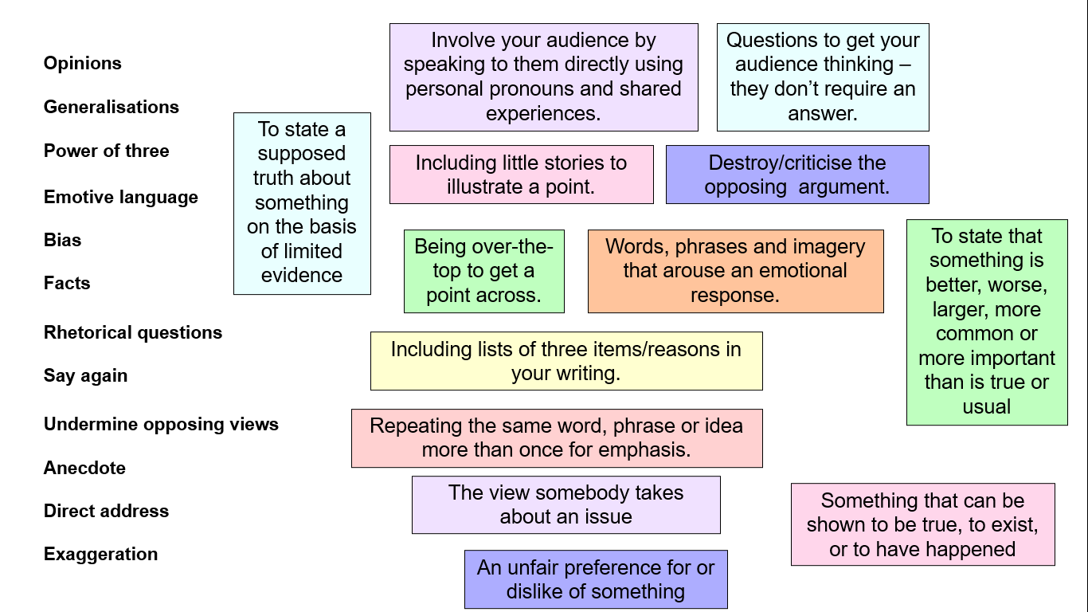
Barak Obama:
My fellow Americans, Michelle and I have been so touched by all the well-wishes that we’ve received over the past few weeks. But tonight it’s my turn to say thanks.
Whether we have seen eye-to-eye or rarely agreed at all, my conversations with you, the American people — in living rooms and in schools; at farms and on factory floors; at diners and on distant military outposts— those conversations are what have kept me honest, and kept me inspired, and kept me going. And every day, I have learned from you. You made me a better president, and you made me a better man.
So I first came to Chicago when I was in my early twenties, and I was still trying to figure out who I was; still searching for a purpose to my life. And it was a neighbourhood not far from here where I began working with church groups in the shadows of closed steel mills.
It was on these streets where I witnessed the power of faith, and the quiet dignity of working people in the face of struggle and loss.

Speech 2:
How many of you, like me, have done your bit for the environment diligently, but found yourself in the situation where you are forced to throw recyclable products into the non-recyclable bin, because you have simply run out of space in your recycling bin?
More than 77% of consumers questioned said that they were irritated by the amount of wasteful packaging they had to dispose of, while 52% of shoppers try to avoid buying over-packaged goods.
Why then do supermarkets insist on continuing this pointless practice?
Since when has an apple pie been such a perishable product that it requires four layers of packaging to protect it? Last night, fancying one such sweet pie, I made the mistake of popping to the shops and buying a box of pastries by a well-known brand. By the time I had helped my poor apple pie from its foil, plastic, polythene and card board prison, I had lost all appetite for the thing. Furthermore, two of the offending ‘protective’ elements weren’t even recyclable.
DIP Task: Choose one of the speeches you have watched or read and complete the following task:
How does the speaker interest and engage the audience?
Sentence stems to help if needed:
- …. engages the audience by…
- For example…
- The use of…shows…
- This is effective/ineffective because… (the purpose of his the speech is to win votes and gain support)
- In comparison the climate change activist engages the audience by…
- For example…
- This shows…
- This is effective because…
- A good speaker is able to…
- A less good speaker is not able to…

****************************************************************************************************

Lesson 10: Presentation Planning
L/I: To know and apply the conventions of a speech
Do now:
- What is a life ‘milestone’?
- Why are heroes and role models important?
- How do events and experiences influence people’s lives?
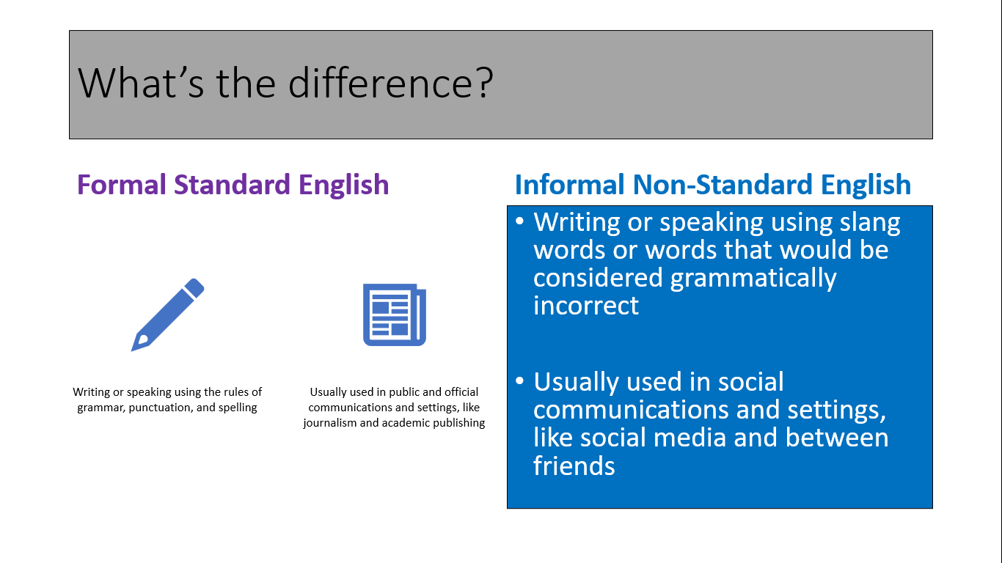
DART: Speech
Good afternoon, as you may know I am Zara and today I will be presenting to you an autobiographical speech about myself. First, I will talk about my background: when I was born; where I was born; who my family are. Next, I will be talking to you about my interests: things I like doing; favourite movies, books and tv shows. Finally, I will be talking to you about my future plans and goals. That’s about it. I hope you enjoy it!

I am the second oldest out of all my siblings. I have 3 sisters and 1 brother. My oldest sister is in year 10, she is hardworking and kind-hearted and I would love to be like her, then there is me in Year 8, my brother is in Year 6 and finally my two younger sisters. One is in Year One and the other is still a toddler and goes to nursery.

My religion is Islam. My language is called Dari, but I mostly speak English with my family and friends.
I was born in the country I currently live in which is England. I was born in Essex. The year I was born is 2007. I have travelled to a few different countries such as Dubai, Canada and the USA. I would travel to one of these countries as a holiday but not to live there. From all the countries I have travelled to, my favourite one was Dubai. Although the other countries are beautiful, for me Dubai was the most entertaining and enjoyable one. The visit also helped to strengthen my Islamic faith.

There are many things that I enjoy doing in my free time. Reading a book or using my phone is something I usually do. Sometimes I go outside and play my favourite sports which are basketball, volleyball and football. I support West Ham and my favourite player is Michail Antonio. Other times I invite my cousins and friends over to watch our favourite movies such as Maleficent, Frozen, and I am Number Four.

My favourite subjects at school are History, English, and Art. I love my History and English teachers; they are great. Subjects I dislike are Science and Maths.
I have a lot of memories and events that are very important and special to me. The first event that I will never forget is by birthday party when I was 8 years old because I got the best present I could ever get, and I had the greatest time of my life.

There are many things that I like as well as things that I dislike. To begin, something that I like is Mexican food. I like Mexican food a lot. I also usually try to go to Mexican restaurants. I find their food very flavoursome and delicious. Something I dislike is cold weathers and seasons. I dislike cold weather because you must wear so much clothing like jackets, gloves, hats and scarves. Another thing that I dislike abut cold weather is that you catch a lot of colds and get sick a lot in cold weather. These are some of the things I like and dislike.
There are many things that I wish to accomplish in the future. One of the most important goals that I have for the future is achieving my dream job as a paediatrician. It is one of the reasons I always try my best at school. When I grow up, I want to live in London and live the rest of my life there. I love how London is such a busy and vibrant city. Also, when I grow up, I want to play a role in helping make the world and the future a better place to live in.

In conclusion, this autobiographical speech told you my background, what I like and dislike, and my future plans. What is your future plan? Have you ever thought about what you’re going to do with your future? Thank you for listening. Are there any questions?

DART Tasks:
r?
- W Number each paragraph.
- What is the purpose of each paragraph?
- Write a one word summary for each paragraph.
- Identify one sentence written in the past tense.
- Identify one sentence written in the present tense.
- Identify one sentence written in the future tense.
- Identify an important life milestone for Zara.
- Identify a hero or role model for Zara.
- Identify an event or experience that has influenced her life.
- Identify a future ambition of Zara’s.
ve more confidence with speaking now than ever before’. Do you agree or disagree with this state 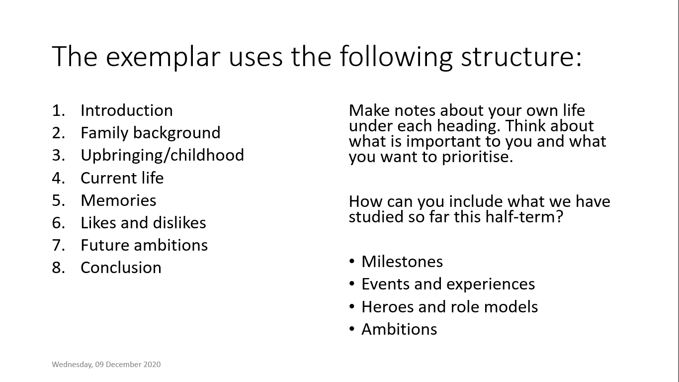DIP TASK
- Write the first sentence for each of your eight paragraphs
- How are you going to ‘hook’ the reader?

*********************************************************************
Lesson 11: Speech Writing
L/I: To independently prepare and practise a presentation
Do now: How many of the following can you define?

Facts
Anecdotes/alliteration
Triplets
Hyperbole/humour
Opinion
Rhetorical questions/repetition
Statistics/similes
Emotive language

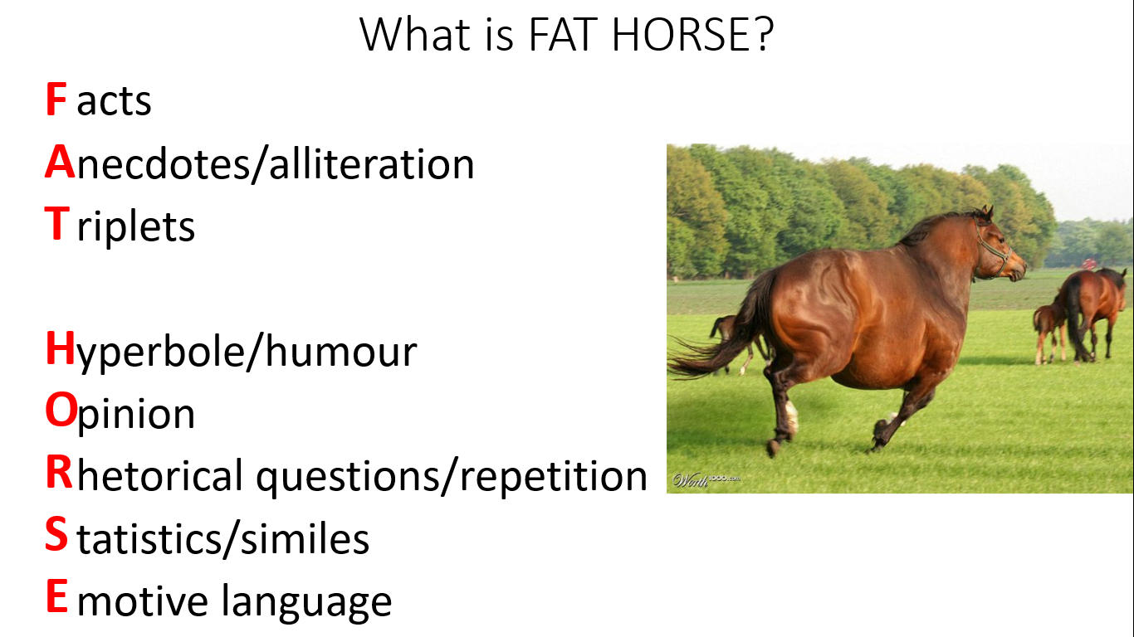
- Facts/statistics – 58% of people think… I was born in… When I was 8 years old we moved to…
- Alliteration – Dangerous, disastrous, and devastating.
- Anecdote – When I was younger… Back in 2014… I had a conversation with…
- Triplets – The situation is unacceptable, dangerous, and upsetting.
- Hyperbole – There is nothing more important than this. If this is not sorted it will be the most disastrous event in a generation.
- Humour – It was absolutely hilarious when…
- Opinion – In my view… From my perspective…
- Rhetorical questions – Would you want that to happen to your family/team/town/country?
- Repetition – I believe…I believe…I believe. Education. Education. Education.
- Similes – It felt like… It was as if…
- Emotive Language/Direct address – You can make a difference by… We can fix this together if we…

Write an example of each technique yourself

DIP TASK: Write your speech

Use your plan
Use your paragraph starters
Use FAT HORSE
***************************************************************************
Lesson 12: Presentation Lesson
L/I: To deliver and listen to presentations about people’s lives
Which of the following body language are positive and negative:
- Smiling
- Open gestures
- Mumbling
- Staring at the floor
- Nodding and responding to humour
- Calm voice
- Maintaining eye contact
- Crossed arms
- Talking into hands/notes
- Straight posture
- Fidgeting
- Speaking calmly and confidently so everyone can hear

Write down 8 bullet points you will use when you deliver your speech
What techniques can you use to remember

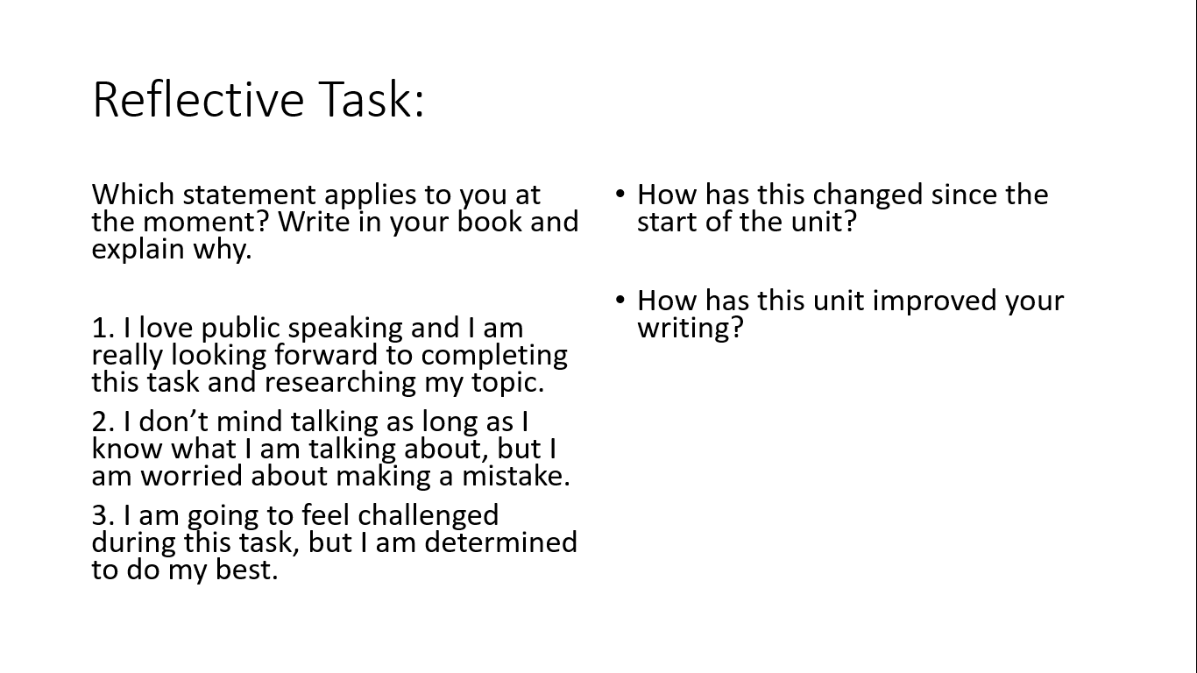
***************************************************************************

Band | Museum of My Life
Yellow Plus | - You provide direct rebuttal to counterarguments or adjust your own opinions to reflect the strengths of points that others have made.  - You actively seek the views of others to challenge and develop your own, ensuring all participants have the opportunity to speak.  - You make consistent and effective use of body language and other forms of non-verbal communication both while speaking and listening.  - All elements of your language use are specific and precise.  - You provide overall reflections, conclusions, or balanced assessment of the discussion.
Yellow | - Your arguments build on things you or others have previously said, starting to consider and critically engage with alternative ideas or opinions.  - You demonstrate the value of contributions from others by building on their points or respectfully challenging them where you do not agree.  - You consciously seek to engage your audience while speaking, e.g. explicitly using body language or the tone of your voice. You react and respond to what the speaker says, and you are able to refocus quickly.  - Your vocabulary choices are ambitious, including attempts at technical or subject-specific terminology. You demonstrate a firm grasp of your context.  - You present alternative arguments or ask questions to respectfully challenge.
Blue | - You formulate your own response or opinions and provide detailed reasons to support your ideas. You make consistent use of scaffolds or sentence stems.  - You respect the views of others and their right to have an opinion. You ask questions to clarify your understanding or to support them to justify their point.  - You speak clearly and at an appropriate volume. You make good eye contact with the speaker or your audience and provide the speaker with nods or short words of encouragement.  - Your vocabulary, register, grammar, and level of formality are appropriate for the context.  - You can develop or run with an idea and ask questions to clarify meaning.
Green | - You formulate your own responses or opinions with simple justification. You volunteer ideas unprompted and make some use of scaffolds and sentence stems.  - You are fully focused on the speaker and you remain calm and still while listening carefully to what they have to say.  - You are comfortable making yourself head but there are occasional issues with volume. You make some eye contact with the speaker or your audience.  - You move beyond simple word choices and register/grammar attempt to reflect your setting or audience.  - You can instigate a discussion by providing the first opinion.
White | - You attempt to answer a question or make a verbal contribution when prompted by the teacher or another pupil.  - You understand only one person should speak at a time and you are mostly focused on the speaker.  - What you say can be understood, and you look at the person who is speaking.  - The vocabulary you use makes sense. You can repeat what somebody else has said.

