English KS3 Spring 1 Blended Learning Booklet
Conflict Fiction
Name:
Form:
Write out the title and LI and then complete the tasks.
The Knowledge Organiser on page 3 has all the key information and vocabulary to help you with this unit.
Upload all work onto ClassCharts for feedback.

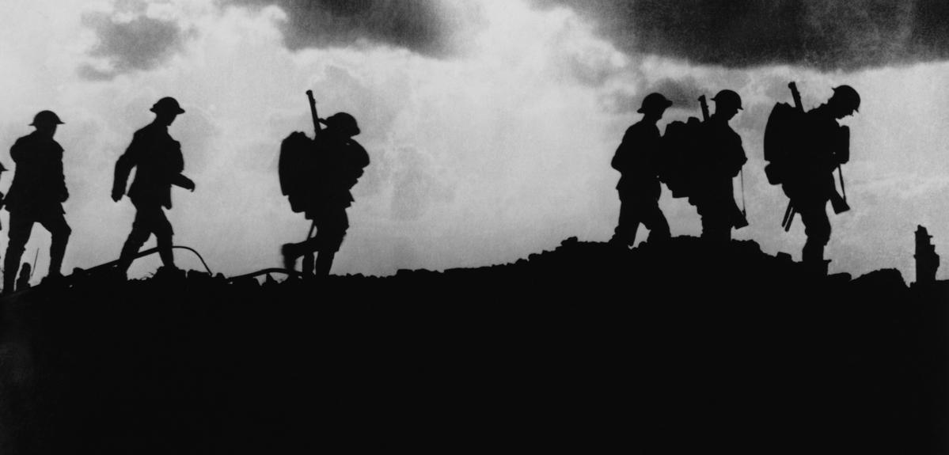

Contents
Big Picture - Year 8 Overview Page 3
Zoom in - My Learning Journey Page 4
Knowledge Organiser Page 5
Lesson 1 Page 7
Lesson 2 Page 8
Lesson 3 Page 12
Lesson 4 Page 13
Lesson 5 Page 16
Lesson 6 Page 20
Lesson 7 Page 22
Lesson 8 Page 24
Lesson 9 Page 27
Lesson 10 Page 28
Lesson 11 Page 30
Lesson 12 Page 33
Lesson 13 Page 36
Lesson 14 Page 38
Lesson 15 Page 40
Lesson 16 Page 41
Lesson 17 Page 44

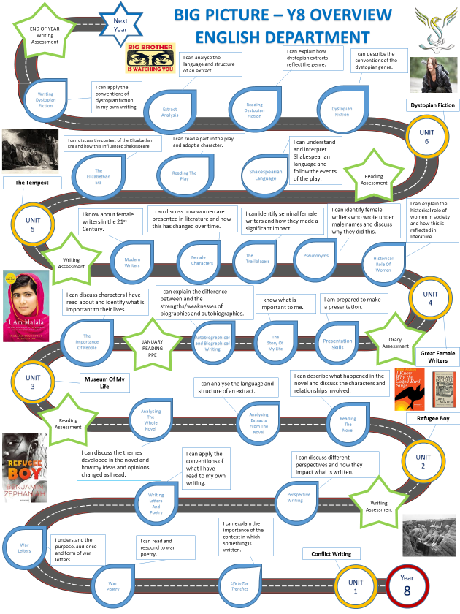
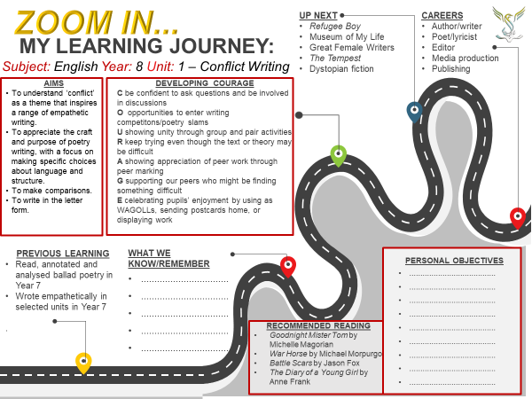
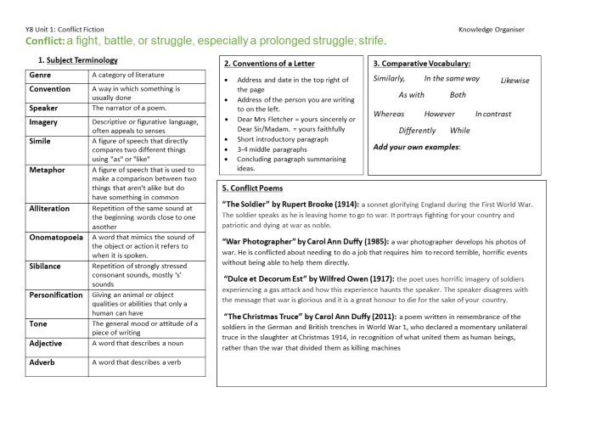
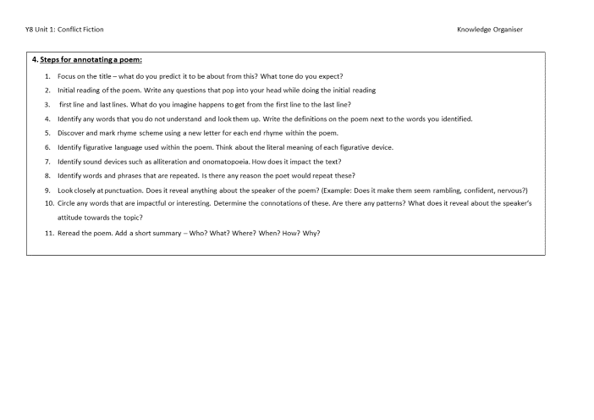

Lesson One - Unit Introduction
LI: To understand the importance of poetry/conflict writing
DART – Preface to lyrical ballads
What does Wordsworth consider the word ‘poet’ to mean? Summarise the following 3 statements in your own words.
A poet is…
- endued with more lively sensibility, more enthusiasm and tenderness
- disposition to be affected more than other men by absent things as if they were present,
- He considers man and the objects that surround him as acting and reacting upon each other so as to produce an infinite complexity of pain and pleasure.
Challenge – Do you agree with this? Can you give a reason?
From Preface to Lyrical Ballads (1802) – William Wordsworth
Taking up the subject, then upon general grounds, I ask what is meant by the word poet? What is a poet? To whom does he address himself? And what language is to be expected from him? He is a man speaking to men – a man (it is true) endued with more lively sensibility, more enthusiasm and tenderness, who has a greater knowledge of human nature, and a more comprehensive soul, than are supposed to be common among mankind; a man pleased with his own passions and volitions, and who rejoices more than other men in the spirit of life that is in him, delighting to contemplate similar volitions and passions as manifested in the goings-on in the universe, and habitually impelled to create them where he does not find them.
To these qualities he has added a disposition to be affected more than other men by absent things as if they were present, an ability of conjuring up in himself passions which are indeed far from being the same as those produced by real events, yet (especially in those parts of the general sympathy which are pleasing and delightful) do more nearly resemble the passions produced by real events that anything which, from the motions of their own minds merely, other men are accustomed to feel in themselves – whence, and from what practice, he has acquired a greater readiness and power in expressing what he thinks and feels, and especially those thoughts and feelings which, by his own choice, or from the structure of his own mind, arise in him without immediate external excitement.
…
What then does the poet? He considers man and the objects that surround him as acting and reacting upon each other so as to produce an infinite complexity of pain and pleasure. He considers man in his own nature and his ordinary life as contemplating this with a certain quantity of immediate knowledge, with certain convictions, intuitions, and deductions which by habit become of the nature of intuitions. He considers him as looking upon this complex scene of ideas and sensations, and finding everywhere objects that immediately excite in him sympathies which (from the necessities of his nature) are accompanied by an overbalance of enjoyment.
…
Poetry is the breath and finer spirit of all knowledge.
…
Poetry is the first and last of all knowledge.
…
Poetry is the spontaneous overflow of powerful feelings; it takes its origin from emotion recollected in tranquillity.

DIP - Write our own conflict poetry
Think of an emotion linked with conflict – E.G - Anger
Describe how that emotion might taste – but don’t use the word of the emotion
For example, ‘Bitterly hot and sickly like hot ash in my mouth’
- Describe how it sounds
- Describe what it looks like
- Describe how it feels
- Describe how it smells
Do you want them to rhyme? How descriptive can you be?

Key Questions
- Do you think poems should rhyme? Why?
- Can you explain in your own words what poetry is?
- Do you think poetry can mean different things to different people?
- Why do you think sensory description is an effective way of describing something?
- Is there anything poetry MUST have to be considered poetry?
- Can you think of a reason why you disagree with Wordsworth?

Lesson Two - The Soldier
LI: To use a range of strategies to help me understand a poem
LI: To know how to annotate a poem
DART – From The British Library Archives
Read the DART
- Think of 3 words to describe the life of a soldier in WW1
- What do you think made the soldiers fight?
From The British Library Archives
Combat and the soldier’s experience in the First World War by Vanda Wilcox
The men and women who served in the First World War endured some of the most brutal forms of warfare ever known. Millions were sent to fight away from home for months, even years at a time, and underwent a series of terrible physical and emotional experiences. The new technologies available to First World War armies combined with the huge number of men mobilised made the battlefields of 1914-18 horrific, deadly, and terrifying places.
Technological developments
Technological developments in the late 19th century had made artillery and machine guns extraordinarily effective defensive weapons, creating a deadly zone of fire in front of the defenders' positions. Soldiers and labourers were required to dig trenches and machine gun placements, which would protect men from enemy shelling and allow them to fire back at the enemy without exposing themselves to danger. New weapons were introduced during the war, like poison gas in 1915 and tanks in 1916, which made combat more unpredictable.
Even before battle began, the experience of life in the lines could be overwhelming. Men were living outside for days or weeks on end, with limited shelter from cold, wind, rain and snow in the winter or from the heat and sun in summer. Artillery destroyed the familiar landscape, reducing trees and buildings to desolate rubble and churning up endless mud in some areas. The incredible noise of artillery and machine gun fire, both enemy and friendly, was often incessant. Yet soldiers spent a great deal of time waiting around, and in some quiet sectors there was little real fighting and a kind of informal truce could develop between the two sides. Even in more active parts of the front, battle was rarely continuous and boredom was common among troops, with little of the heroism and excitement many had imagined before the war. The Italian infantry officer Emilio Lussu wrote that life in the trenches was ‘grim and monotonous’ and that ‘if there were no attacks, there was no war, only hard work’. The order to attack – or news of an enemy assault – changed everything.
The order to attack
Men ordered to attack – or ‘go over the top’ – had to climb out of their trenches, carrying their weapons and heavy equipment, and move through the enemy's ‘field of fire’ over complex networks of barbed wire, keeping low to the ground for safety. The objective was to reach the enemy's front line, where the defending troops would be sheltering in their own trenches, and use rifles or bayonets to attack them directly. Once the defenders were eliminated, the attacking force seized the position – at least in theory. In reality these tactics were often unsuccessful and victorious attacks were rare. Casualties were extremely high, with many men killed and wounded: attackers often suffered higher casualties than defenders. Wounded men were carried or escorted back to field hospitals for treatment, while the dead could only be buried if there was a suitable break in the fighting.
Why did soldiers keep fighting?
Unsurprisingly ‘going over the top’ was a terrifying experience for most soldiers. Yet it was rare that men disobeyed the order to attack: most First World War troops were generally compliant. What motivated men to fight under such terrible conditions? What kept their morale high despite their fear and physical exhaustion?
Traditionally, the authorities believed – or hoped – that men would be motivated by loyalty to an idea: usually patriotism. French and Serbian soldiers were defending their homeland against invasion, while British, German and Austrian soldiers were encouraged to focus on their duty to their King or Emperor. These ideas encouraged men to volunteer for military service and could keep their spirits high through long spells of front-line service, but once under fire men needed more than ideals to maintain their courage.
One important explanation for soldiers’ resilience is the idea of the ‘primary group’: men were motivated above all by comradeship as they fought alongside friends and companions. Effective training also helped, making soldiers familiar with the chaos and fear of the battlefield so that their actions in battle became second nature to them. But armies did not leave men's behaviour in battle down to chance: the system of military discipline existed to coerce them into obedience. Punishments for disobeying orders could be severe, and men who were convicted of ‘cowardice in the face of the enemy’ or desertion from their unit could receive the death sentence. Many hundreds of soldiers were executed by their own armies for military offences during the conflict.
DART Questions:
- What word is used to describe how many soldiers went to fight in WW1?
- What were soldiers and labourers required to do? Why?
- What new weapons were introduced during the war?
- Why was boredom common?
- What did it mean to ‘go over the top’?
- Why did the soldiers do this?
- How were men encouraged to join up?
- Who did soldiers fight with?
- Think of three words to describe the life of the soldiers during the war.
- Why do you think the soldiers agreed to fight?

DIP – Write your interpretation of the poem The Soldier
Write down an explanation of what this poem is about to someone who has not read it before – consider:
- From what perspective is it being written?
- What is the context?
- What is the poet saying about war?
- What are his thoughts on dying for your country?

The Soldier
BY RUPERT BROOKE
If I should die, think only this of me:
That there’s some corner of a foreign field
That is for ever England. There shall be
In that rich earth a richer dust concealed;
A dust whom England bore, shaped, made aware,
Gave, once, her flowers to love, her ways to roam;
A body of England’s, breathing English air,
Washed by the rivers, blest by suns of home.

And think, this heart, all evil shed away,
A pulse in the eternal mind, no less
Gives somewhere back the thoughts by England given;
Her sights and sounds; dreams happy as her day;
And laughter, learnt of friends; and gentleness,
In hearts at peace, under an English heaven.

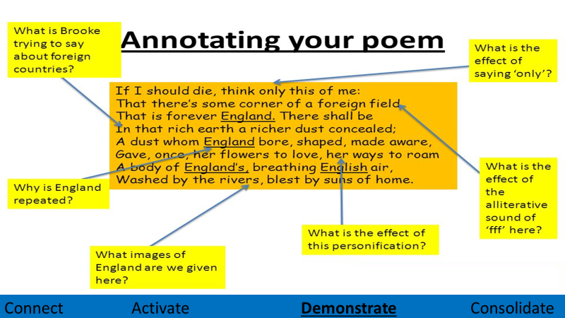

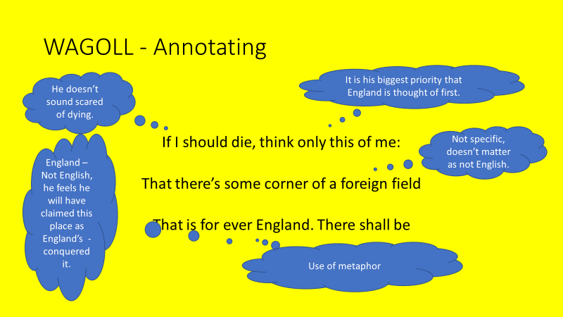
Key Questions
- What was Rupert Brooke’s view on war?
- Would you consider Brooke to be patriotic?
- What question would you like to ask Brooke?
- Do you think this poem could influence someone to join the army?
- Do you agree or disagree with Brooke’s message?
- Do you think many people agree with this in modern times?

Lesson Three - The Soldier
LI: To closely analyse a poem and explain how a writer uses language to create specific effects
DART - Re-read and annotate the rest of the poem, specifically explore how it views patriotism
Patriotic definition: having or expressing devotion to and vigorous support for one's country.
- How does the language show the reader how Brooke considers the importance of patriotism?
- Are there any metaphors/similes/personification?
- What are the connotations of any key words?
- What things does Brooke compare England and being English too? Are they positive?
- Challenge – Can you identify any other themes within the poem?

DIP WAGOLL - How does Brooke use language to explore patriotism?
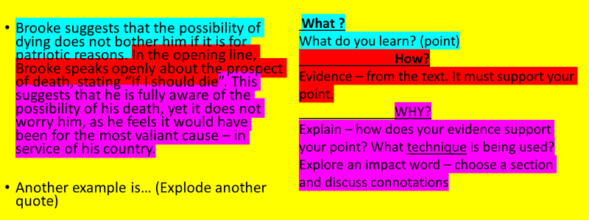
DIP - Continue from the WAGOLL, using one of the quotes and annotations to create your own paragraph.
Challenge – Continue you this further by writing further paragraphs building on previous points made using 3 different quotes.
Sentence Stems you could use:
Brooke uses personification to…
Patriotism is shown by the use of…
This highlights how …..
One example of how language is used to explore patriotism is…
Key Questions
- Can you define patriotism in your own words?
- Is patriotism a good thing?
- Can you think of ways extreme patriotism could be a bad thing?
- Does a poet have to personally experience the things they write about?
- Why would the government encourage patriotism in the population?
- How does Brooke use language to make his point?

Lesson Four - An Irishman Foresees His Death
LI: To understand the impact of choosing specific language for effect
DART – Letters to loved ones
The British Army Postal Service delivered around 2 billion letters during the war. In 1917 alone, over 19,000 mailbags crossed the English Channel each day, transporting letters and parcels to British troops on the Western Front.
Soldiers wrote letters in spare moments, sometimes from front line trenches or in the calmer surroundings behind the lines. Censorship dictated what servicemen were permitted to disclose in their letters. However, in practice, men often found ways to impart information, and their letters offer a powerful and highly personal insight into the experience of war.
Twelve and a half million letters were sent to the Western Front every week. In 1914 the Postal Section of the Royal Engineers had a staff of 250 men. By 1918 the Army Postal Service employed 4,000 soldiers. Letters only took two or three days to arrive from Britain. Even soldiers in the front line trenches received daily deliveries of letters.
Soldiers were also encouraged to write letters to friends and family in Britain. Most men decided it would be better to conceal the horrors of the trench warfare. As a result of the Defence of the Realm Act that was passed in 1914, all letters that the men wrote should have been read and censored by junior officers.
Some officers could not bring themselves to read their men's letters and these arrived in Britain unaltered. For example, Lieutenant John Reith later admitted in his autobiography, Wearing Spurs (1966): "I did my best to take an interest in the members of my platoon personally. In manual exercises and in extended order drill in a field I could take none; and they knew it. I was supposed to censor their letters home, but I informed them that they were on their honour not to say things they should not say, and I handed over the censor's stamp to the sergeant."
DART Questions:
- How many letters were sent home during the war?
- How many men were in the postal service in 1914 compared to 1918?
- Why do you think the men were encouraged to write home?
- Why do you think they concealed the truth?
- Why were the contents of their letters censored? Why did some not do this?
Censored means to remove anything offensive from books, films, etc., or to remove parts considered unsuitable from private letters, especially ones sent during war or from a prison.

An Irish Airman Foresees His Death
W. B. Yeats - 1865-1939
I know that I shall meet my fate
Somewhere among the clouds above;
Those that I fight I do not hate
Those that I guard I do not love;
My country is Kiltartan Cross,
My countrymen Kiltartan’s poor,
No likely end could bring them loss
Or leave them happier than before.
Nor law, nor duty bade me fight,
Nor public man, nor cheering crowds,
A lonely impulse of delight
Drove to this tumult in the clouds;
I balanced all, brought all to mind,
The years to come seemed waste of breath,
A waste of breath the years behind
In balance with this life, this death.
Poem Questions:
- What do you think Yeats is trying to say here?
- Has it got anything in common with ‘The Soldier’?
- What overriding emotions/feelings do you get from the poem?
- Find and highlight some words which add to this feeling.

DIP - Edit lines from the poem to change the emotion
I know that I shall meet my fate
Somewhere among ________________;
Those that I ________I do not ________
Those that I _______ I do not _________;
My country is _________________,
My countrymen ________________,
No likely end could bring them ___________
Or leave them ___________than before.
Nor law, nor duty bade me fight,
Nor __________, nor ______-ing _________,
A lonely impulse of ______________
Drove to this tumult in the clouds;
I balanced all, brought all to mind,
The years to come seemed _______________,
A ______________ the years behind
In ________with this _____, this ________.
Possible emotions:
- Patriotism
- Anger
- Sympathy
- Sadness
- Delight
- Hatred

- Why did you choose the words?
- What connotations do the words have for you?

Key Questions
- Why did soldiers write to their loved ones?
- What is the difference between an adjective and an adverb?
- What does word choice mean?
- What is censorship?
- What is an emotion?
- How does language create emotions?

Lesson Five - War Time Correspondence
LI: To know the conventions of a letter
LI: To understand formal and informal register
DART – Life in the trenches
Read the DART
- What is meant by the quote ‘War is hell’?
- Why do you think receiving correspondence from home would have been important to soldiers?
- What do you think they would have wanted to hear?

Life in the Trenches of World War I
When Union Army general William Tecumseh Sherman famously said “War is hell,” he was referring to war in general, but he could have been describing trench warfare, a military tactic that’s been traced to the Civil War. Trenches—long, deep ditches dug as protective defences—are most often associated with World War I, and the results of trench warfare in that conflict were hellish indeed.
Trench warfare in World War I was employed primarily on the Western Front, an area of northern France and Belgium that saw combat between German troops and Allied forces from France, Great Britain and, later, the United States.
Although trenches were hardly new to combat: Prior to the advent of firearms and artillery, they were used as defences against attack, such as moats surrounding castles. But they became a fundamental part of strategy with the influx of modern weapons of war.
Long, narrow trenches dug into the ground at the front, usually by the infantry soldiers who would occupy them for weeks at a time, were designed to protect World War I troops from machine-gun fire and artillery attack from the air.
As the “Great War” also saw the wide use of chemical warfare and poison gas, the trenches were thought to offer some degree of protection against exposure. (While significant exposure to militarized chemicals such as mustard gas would result in almost certain death, many of the gases used in World War I were still relatively weak.)
Thus, trenches may have afforded some protection by allowing soldiers more time to take other defensive steps, such as putting on gas masks.
At least initially in World War I, forces mounted attacks from the trenches, with bayonets fixed to their rifles, by climbing over the top edge into what was known as “no man’s land,” the area between opposing forces, usually in a single, straight line and under a barrage of gunfire.

Not surprisingly, this approach was rarely effective, and often led to mass casualties.
Later in the war, forces began mounting attacks from the trenches at night, usually with support of covering artillery fire. The Germans soon became known for effectively mounting night-time incursions behind enemy lines, by sending highly trained soldiers to attack the trenches of opposing forces at what they perceived as weak points.
If successful, these soldiers would breach enemy lines and circle around to attack their opponents from the rear, while their comrades would mount a traditional offensive at the front.
The brutality of trench warfare is perhaps best typified by the 1916 Battle of the Somme in France. British troops suffered 60,000 casualties on the first day of fighting alone.
With soldiers fighting in close proximity in the trenches, usually in unsanitary conditions, infectious diseases such as dysentery, cholera and typhoid fever were common and spread rapidly.
Constant exposure to wetness caused trench foot, a painful condition in which dead tissue spread across one or both feet, sometimes requiring amputation. Trench mouth, a type of gum infection, was also problematic and is thought to be associated with the stress of nonstop bombardment.
As they were often effectively trapped in the trenches for long periods of time, under nearly constant bombardment, many soldiers suffered from “shell shock,” the debilitating mental illness known today as post-traumatic stress disorder (PTSD).
It’s likely all of these factors, which stemmed from the widespread use of trench warfare, made World War I the deadliest conflict in global history to that point. It’s believed that as many as one in 10 of all fighting forces in the conflict were killed.
It was also the first conflict in world history to have more deaths caused from combat, rather than from disease spread during fighting.
DART Questions
- Who said ‘war is hell’?
- What did he mean by this?
- Where was trench warfare most likely to be employed?
- Why did trenches become a fundamental part of strategy?
- What was the area between the trenches called?
- How did trench warfare change later in the war?
- What year did the Battle of the Somme take place?
- How many British soldiers died on day one?
- What is PTSD?
- What proportion of those who fought in WW1 were killed?

DART - Read the official MOD letter (on the next page), how do the following show that it is a formal letter?
Use your Knowledge Organiser for tips and annotate the letter to identify these points.

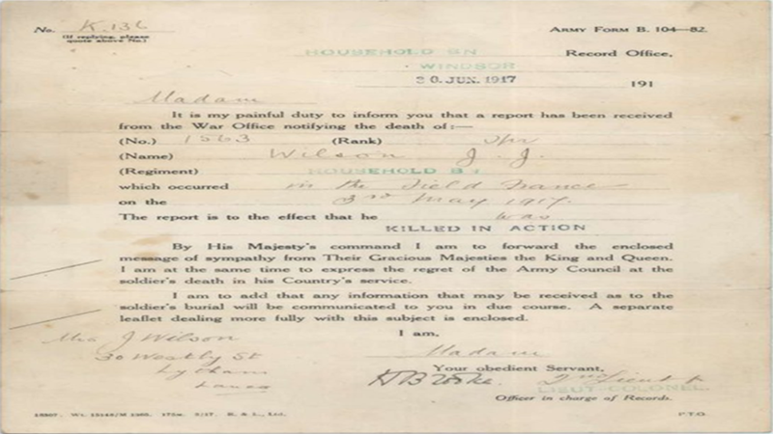

DIP - Edit the informal letter to make it formal in tone.
Look for:
- Register
- Tone
- Layout
- Purpose
- Vocabulary
- Reception

Informal Letter
28th March 1917
'My Dearest Will, I feel I must write you again dear although there is not much news to tell you. I wonder how you are getting on. I shall be so relieved to get a letter from you. I can't help feeling a bit anxious dear. I know how you must have felt darling when you did not get my letters for so long. Of course I know dear you will write as soon as ever you can, but the time seems so dull and weary without any news of you, if only this war was over dear and we were together again. It will be one day I suppose.
Don't think dear I am worrying unnecessarily about you, because I know God can take care of you wherever you are and if it's his will darling he will so are you to come back to me, that's how I feel about it dear, if we only put our trust in Him. I am sure he will. I wonder how your Cousins are getting on dear. We are feeling very anxious about George, as no news has come from him yet. We can't understand why his wife doesn't write.
How are your hands now dear? Mine are very sore, so chapped, and my left hand has got several chilblains on it and they do irritate. I could scratch it to bits. Have you been receiving the books I have sent you dear. I am very pleased to say dear I am keeping very well indeed, and I trust you are the same.
There has been a bit of a fuss over Arthur this week. He has been trying to get in the Army unbeknown to his parents, but Mrs T. thought his parents ought to be informed about it, so she wrote and told them about him and he had to go home in hot haste last night. I guess he got in a fine row, but he won't say today. He is as miserable as anything. Really Will I never saw such a boy as he is. I am afraid he is going to the bad. I don't know if Mrs T. will keep him on or not. He says he has to join up in a fortnight, but as he is under age I suppose his parents could stop him. I don't know whether they will or not. For my part I hope he does go, he will be a jolly good riddance for there is nothing but rows and deceitfulness going on where he is.
Well darling I don't know much more to say now, so will close with fondest love and kisses from your loving little girl. Emily.
P.S. Cheer up darling, and don't worry about me. I am quite alright, only anxious to get your letters. There is good news in the papers. Love from Mum and Dad.

WAGOLL
'My Dearest Will, I feel I must write you again dear although there is not much news to tell you. I wonder how you are getting on. I shall be so relieved to get a letter from you. I can't help feeling a bit anxious dear. I know how you must have felt darling when you did not get my letters for so long.
Dear Will,
After careful consideration I have decided that it is important that I write to you again even though there is nothing new to inform you about.
I would appreciate an update on your welfare and a letter that supplies this information would be convenient to all of us at home, some of whom have expressed concern about your wellbeing.
How much of the letter can you edit?

Key Questions
- What do formal and informal mean?
- In what situations would you receive a formal letter?
- How would you sign a formal letter?
- How does the subject dictate the form of communication?
- How would it feel to receive a letter from a relative in the trenches?
- Why do formal letters still exist with modern technology now available?

Lesson Six – Personal Letter Writing
LI: To demonstrate empathy in writing
LI: To apply the conventions of a letter
DART – How is empathy shown?
Read the letter (on the next page) and identify five quotations which demonstrate empathy.
Do you think empathy is truly possible in this instance?

DIP - Write a letter from the perspective of the speaker in “The Soldier”, writing to somebody you are close to back home.
Success Criteria:
- Use ideas that are conveyed in ‘the Soldier’ – reflect Brooke’s point of view
- Use appropriate language based on the audience
- Use conventions of a letter (structure)

Key Questions
- Why is it important to plan your work?
- Can you explain what is meant by empathy?
- What is the difference between empathy and sympathy?
- What might you include in a letter that you wish to show empathy?
- How might it feel to receive a letter that doesn’t show empathy?
- Is it possible to show empathy if you do not know the person?

Lesson Seven – War Photographer
LI: To understand the subject of the poem through independent analysis
DART – What is the poem about? Let’s read the poem and work out the meaning.

War Photographer - BY Carol Ann Duffy
In his dark room he is finally alone
with spools of suffering set out in ordered rows.
The only light is red and softly glows,
as though this were a church and he
a priest preparing to intone a Mass.
Belfast. Beirut. Phnom Penh. All flesh is grass.
He has a job to do. Solutions slop in trays
beneath his hands, which did not tremble then
though seem to now. Rural England. Home again
to ordinary pain which simple weather can dispel,
to fields which don’t explode beneath the feet
of running children in a nightmare heat.
Something is happening. A stranger’s features
faintly start to twist before his eyes,
a half-formed ghost. He remembers the cries
of this man’s wife, how he sought approval
without words to do what someone must
and how the blood stained into foreign dust.
A hundred agonies in black and white
from which his editor will pick out five or six
for Sunday’s supplement. The reader’s eyeballs prick
with tears between the bath and pre-lunch beers.
From the aeroplane he stares impassively at where
he earns his living and they do not care.
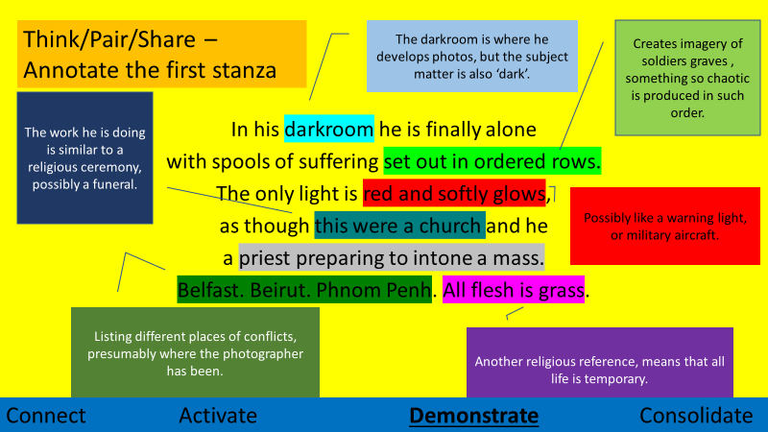
WAGOLL – Annotation

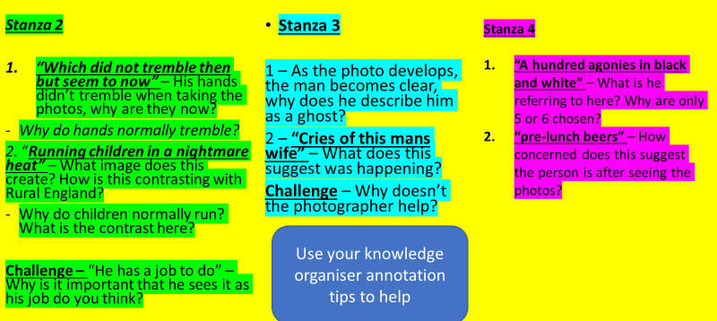
DIP - Independently annotate the rest of the poem – use the prompts below to help

- What point is Duffy trying to make about people’s attitude towards war?
- How does the structure of the poem support this?
- Make reference to the content of more than one stanza in your answer.
Key Questions
- Why are photographs a powerful tool? Do you agree that ‘a picture says a thousand words’?
- What is a dark room?
- Why doesn’t the photographer help the people he has photographed?
- Why do you think his job is important?
- What is Duffy’s attitude to war?
- How does the structure of the poem reflect the process of developing a photograph?

Lesson Eight – War Photographer
LI: To closely analyse a poem and explain how a writer uses language to create specific effects
DART – Dickey Chapelle Biography
Dickey Chapelle was an American photojournalist and war photographer. In a career spanning nearly 30 years, she documented conflicts around the globe from World War II to Vietnam. Fearless, defiant and uncompromising, she became hugely successful and revered in a profession which had previously been all but closed to women.
During World War II, Dickey secured a job as a war correspondent and photojournalist for the National Geographic. She covered the battles of Iwo Jima and Okinawa and spent time with the US Marines on training missions. This was no small achievement given that women were not officially allowed to report combat.
Following World War II, Dickey spent the next two decades covering major wars and uprisings all over the world, frequently going to extraordinary lengths to report war zone stories. She became known for her refusal to bow down to authority and for her unique ‘uniform’; combat fatigues, Harlequin glasses and pearl earrings. She won a variety of prestigious awards and earned tremendous respect from both the military and the newspaper industry.
In 1956, when covering the Hungarian Revolution, she was arrested as a spy by Russian forces and spent two months in a Hungarian prison. When the Vietnam War began, Dickey volunteered to cover the conflict and travelled to Vietnam several times during the early 1960s. In November 1965, Dickey was on operations with US Marines near Chu Lai Air Base. The lieutenant walking ahead of her kicked a tripwire rigged to a landmine. In the resultant explosion, Dickey was hit in the neck by a piece of shrapnel which severed her carotid artery. She died aged just 47, the first female reporter to be killed in action.
She was repatriated with a guard of honour and buried with full military honours, a highly unusual tribute for a civilian journalist. The US Marines still honour her memory by presenting the annual Dickey Chapelle Award, given to recognise the women who have contributed most to the morale, welfare and wellbeing of the corps.
Dickey had written an extremely humorous and self-depreciating autobiography, What’s a Woman Doing Here? and during a 1962 radio interview about the book, she was asked if the war zone was really a ‘woman’s place’. She replied, “It is not a woman’s place. There’s no question about it. There’s only one other species on earth for whom the war zone is no place, and that’s men. But as long as men continue to fight wars, I think observers of both sexes will be sent to see what happens.”
DART Questions
- What three adjectives are used to describe Dickey in the first paragraph?
- What wars did she cover during her career?
- How did she die?
- How is she remembered?
- Why was she so significant?
- What was her view on war?
DIP – Write a ‘What How Why’ or a PETER paragraph answering the question: How does Duffy use language to explore the theme of war?
Explain the poet’s use of tone and zoom-in on a high-impact word.
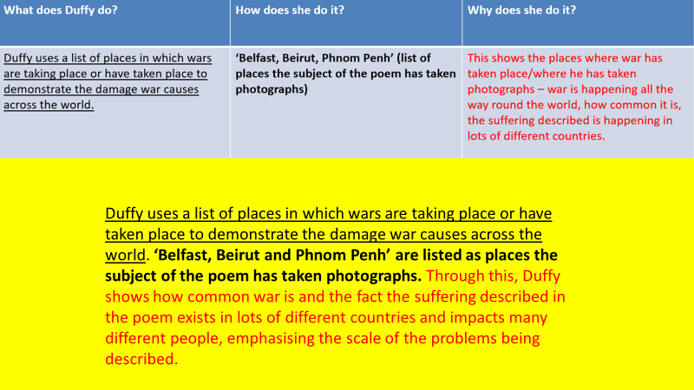
WAGOLL

Key Questions
- What is the message in the War Photographer?
- What is a biography?
- Why was Dickey Chappelle important?
- Why did she do her job?
- How do you explode a quote?
- How does the poet use language to present the theme of war?

Lesson Nine – War Photographer
LI: To understand the effect of writing from different narrative perspectives
LI: To demonstrate my interpretation of a poem
DART – Lynsey Addario
War photographer Lynsey Addario’s memoir It’s What I Do is the story of how the relentless pursuit of truth, in virtually every major theatre of war in the twenty-first century, has shaped her life. What she does, with clarity, beauty, and candour, is to document, often in their most extreme moments, the complex lives of others. It’s her work, but it’s much more than that: it’s her singular calling.
Lynsey Addario was just finding her way as a young photographer when September 11 changed the world. One of the few photojournalists with experience in Afghanistan, she gets the call to return and cover the American invasion. She makes a decision she would often find herself making—not to stay home, not to lead a quiet or predictable life, but to set out across the world, face the chaos of crisis, and make a name for herself.
Addario finds a way to travel with a purpose. She photographs the Afghan people before and after the Taliban reign, the civilian casualties and misunderstood insurgents of the Iraq War, as well as the burned villages and countless dead in Darfur. She exposes a culture of violence against women in the Congo and tells the riveting story of her headline-making kidnapping by pro-Qaddafi forces in the Libyan civil war.
Addario takes bravery for granted but she is not fearless. She uses her fear and it creates empathy; it is that feeling, that empathy, that is essential to her work. We see this clearly on display as she interviews rape victims in the Congo, or photographs a fallen soldier with whom she had been embedded in Iraq, or documents the tragic lives of starving Somali children. Lynsey takes us there and we begin to understand how getting to the hard truth trumps fear.
As a woman photojournalist determined to be taken as seriously as her male peers, Addario fights her way into a boys’ club of a profession. Rather than choose between her personal life and her career, Addario learns to strike a necessary balance. In the man who will become her husband, she finds at last a real love to complement her work, not take away from it, and as a new mother, she gains an all the more intensely personal understanding of the fragility of life.
Watching uprisings unfold and people fight to the death for their freedom, Addario understands she is documenting not only news but also the fate of society. It’s What I Do is more than just a snapshot of life on the front lines; it is witness to the human cost of war.

DART Questions
- What parts of people’s lives does Lyndsey Addario’s photography capture?
- What wars and conflicts has she photographed? Name two.
- ‘She is not fearless.’ Why is this important? What does it create?
- What does the final paragraph say that Addario is documenting?
- Whose perspective do you think Addario’s photography shows war from?
DIP – Telling the story
Write a section of the war photographer’s story in prose using first person narrative.
- Base your answer on lines from the poem
- Use language from the poem
- Include the thoughts and feelings of the photographer
Key Questions
- Who was Lyndsey Addario?
- What did her photography show?
- What is perspective and why is it important?
- Whose perspective is the War Photographer written from?
- What other perspectives could be considered?
- How do you change the perspective from which something is written?

Lesson Ten – Women during WW1
LI: To understand the effect of writing from different narrative perspectives
DART - Extracts from War Girls by Adele Geras and questions
Extract 1 – How does the writer use language to present the Sergeant’s attitude towards Merle?
Silence. Cries for help. Orders being shouted. Legs trembling. Merle got out of the van. Her first instinct was to crouch down and check that the tyres were intact. ‘Thank God! There’s an ambulance!’ Someone pulled at her arm. ‘You got stretchers in there, buddy?’ She straightened up to face an American Army Sergeant. ‘Save my stars!’ he cried. ‘The driver’s a girl!’
‘Do you want me or not?’ Merle snapped. ‘I’ll drive on somewhere else if I’m not welcome here.’
‘You tell him, hen!’ said one of his men in a familiar broad accent. ‘He’s too crabbit, by far.’
‘You’re welcome. You’re welcome,’ the sergeant told her. ‘I’d lay the table for afternoon tea to show how welcome you are, but first I need you to dig my boys out of that mess.’
‘All right!’ Merle was half laughing, half sobbing. ‘I’ll get the stretchers from my van.’ They worked for an hour pulling bodies from the rubble.
Extract Questions –
- How does the Sergeant react before and after realising that the ambulance driver is a woman?
- ‘The Sergeant is disingenuous when he announces to Merle ‘You’re welcome. You’re welcome.’ How far do you agree or disagree with this statement.
EXT: How are women’s roles in war time being presented here?

Extract 2 - How does the writer present gender stereotyping?
‘I’m just a bit cold.’ Merle took off her coat and spread it across his body.
‘Better now?’
He nodded. Then he said in a low voice, ‘I’m a bit frightened too. Didn’t like to say it in front of the sergeant, but you’re a girl so I reckon it’s OK for you to know.’
‘Oh, everyone gets scared.’
‘Really?’
‘Oh, yes. I’ve had every rank in this ambulance. Majors, brigadiers, generals, the lot. Shaking like jellies they were. Getting wounded is very scary…’ Merle’s voice trailed off.
The boy’s face had turned a colour she had never seen before. ‘I’m dying, aren’t I?’ The boy was struggling for breath now, the air rattling in his chest. Merle felt panic rising in her. She didn’t know how to deal with this. That was why she elected to be a driver. It was very well for the nurse to say ‘comfort him’, but how was she supposed to do that? His eyes were shading into pools of darkness.

Extract Questions -
- How does the Sergeant react before and after realising that the ambulance driver is a woman?
- ‘The Sergeant is disingenuous when he announces to Merle ‘You’re welcome. You’re welcome.’ How far do you agree or disagree with this statement?
EXT: How are women’s roles in war time being presented here?

DIP - How does Adele Geras present women’s roles in wartime?
Think about: the role Merle is playing, the attitudes other characters show towards her, the way she speaks to the other characters.

Key Questions
- What is a stereotype? What role is Merle playing in the extract?
- What other roles did women play during war?
- How did this compare to their stereotypical role?
- What is dialogue?
- How does it reflect the mood and attitudes of characters?

Lesson Eleven – War Girls
LI: To closely analyse a poem and explain how a writer uses language to create specific effects.
DART – Land Girls
The Land Girls of the First World War by Connie Ruzich, from an open education resource.
Most people were surprised at women’s ability to capably accomplish farm tasks; some with traditional values even viewed the Land Girls’ uniform trousers as disgraceful cross-dressing. In response, the government issued posters that celebrated the women’s patriotic efforts and feminized the new roles in an attempt to change public attitudes.
Recruitment efforts appealed to women’s patriotism and their consciences, underscoring the importance of “doing one’s bit.” Those wishing to sign up for the Women’s Land Army had to be over 20 years of age, and women were required to submit references, complete paperwork that demonstrated their education and literacy, attend an interview, and pass a physical exam. If accepted, each Land Army Girl signed a six-month or one-year contract, agreeing to be sent anywhere in the country that she was needed. She was typically paid between 20 – 25 shillings a week, and charged 17 shillings/week for room and board. The Women’s Land Army Handbook asked each recruit to pledge that she would “behave quietly,” “secure eight hours’ rest each night,” “avoid entering the bar of a public house,” “not smoke in public,” and “never wear the uniform after work without her overall, nor walk about with her hands in her breeches pockets.”
The Land Army issued each girl a knee-length tunic or overall (that could be no more than 14 inches above the ground), breeches, a hat, coat, boots, and leather leggings. After thirty days of service, she was issued a green armband to denote her patriotic service, to which was added a stripe for every six months of work. Land Girls also received a L.A.A.S. (Land Army Agriculture Service) badge after two months and were eligible to earn good service ribbons and distinguished service bars.
Volunteers who signed up with idyllic visions of the British countryside soon learned of the long days and hard work demanded by life on a farm. The women fed livestock, milked cows, trapped vermin, ploughed fields, and harvested fruits and vegetables. Formal training was scarce and offered piecemeal, but Land Army recruits were encouraged to send for leaflets on such topics as the construction of pigsties, advice to beginners in bee-keeping, thatching, potato growing, cleanliness in the dairy, and ringworm in cattle. They worked 9 to 10 hours a day in all kinds of weather, often six days a week, at wages significantly below those of women who were “doing their bit” in munitions or clerical work.

Land Girls Questions
- What surprised people about the ability of women?
- Why did the government produce posters?
- How were women persuaded to sign up?
- Hold old did women have to be to sign up?
- What did the application process involve?
- How much were they paid?
- What was their uniform?
- What jobs did they do?
- How much training was there?
- How many hours did they work?
DART – War Girls Poem

War Girls - BY JESSIE POPE
There's the girl who clips your ticket for the train,
And the girl who speeds the lift from floor to floor,
There's the girl who does a milk-round in the rain,
And the girl who calls for orders at your door.
Strong, sensible, and fit,
They're out to show their grit,
And tackle jobs with energy and knack.
No longer caged and penned up,
They're going to keep their end up
Till the khaki soldier boys come marching back.

There's the motor girl who drives a heavy van,
There's the butcher girl who brings your joint of meat,
There's the girl who cries 'All fares, please!' like a man,
And the girl who whistles taxis up the street.
Beneath each uniform
Beats a heart that's soft and warm,
Though of canny mother-wit they show no lack;
But a solemn statement this is,
They've no time for love and kisses
Till the khaki soldier-boys come marching back.

War Girls Questions
- What is it about?
- What do you like about it?
- What don’t you like about it?
- What does it remind you of?
- Do you have any questions about it?
- Can you identify any key words or phrases in the poem?
DIP - How does Jessie Pope use language, form and structure to show the role of women during the war?
Identify three points you could include in your answer:
1.
2.
3.
Jessie Pope uses the description of…to show the role of women during the war. She writes, ‘…’
This shows…
This suggests…
Key Questions
- What was a Land Girl?
- Why were they important?
- How did this change perceptions of women?
- How do you annotate a poem?
- Why is language important for explaining poetry?
- How does Jessie Pope present the role of women in War Girls?

Lesson Twelve – Jessie Pope Comparison
LI: To know how to write a comparative paragraph
DART - The Call and Who’s For The Game

The Call

Who's for the trench—
Are you, my laddie?
Who'll follow French—
Will you, my laddie?
Who's fretting to begin,
Who's going out to win?
And who wants to save his skin—
Do you, my laddie?
Who's for the khaki suit—
Are you, my laddie?
Who longs to charge and shoot—
Do you, my laddie?
Who's keen on getting fit,
Who means to show his grit,
And who'd rather wait a bit—
Would you, my laddie?
Who'll earn the Empire's thanks—
Will you, my laddie?
Who'll swell the victor's ranks—
Will you, my laddie?
When that procession comes,
Banners and rolling drums—
Who'll stand and bite his thumbs—
Will you, my laddie?

The Call Questions
- Why are there so many questions?
- Which word is repeated throughout the poem?
- What does this word suggest?
- How does Jessie Pope use structure to emphasise a point?
- What reward will young men receive?

Who’s For The Game?
Who’s for the game, the biggest that’s played,
The red crashing game of a fight?
Who’ll grip and tackle the job unafraid?
And who thinks he’d rather sit tight?
Who’ll toe the line for the signal to ‘Go!’?
Who’ll give his country a hand?
Who wants a turn to himself in the show?
And who wants a seat in the stand?
Who knows it won’t be a picnic – not much-
Yet eagerly shoulders a gun?
Who would much rather come back with a crutch
Than lie low and be out of the fun?
Come along, lads –
But you’ll come on all right –
For there’s only one course to pursue,
Your country is up to her neck in a fight,
And she’s looking and calling for you

Who’s For The Game Questions

- What is referred to as a ‘game’?
- What is significant about this?
- What does it mean to toe the line?
- Who is the poem addressed to?
- How are the young men persuaded to fight?

Comparison Questions
What is the message in the two poems you have read in this lesson?
What does this suggest about expectations of young men?
How does this differ to the stereotypical role of women?

DIP – Poetry Comparison
How does Jessie Pope present the expectations and roles of young men and women in her poetry?
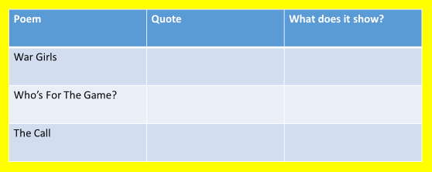

Jessie Pope’s different poems present different perspectives of the roles of young men and women during the war. For example, in War Girls, Pope writes, ‘…’ This shows…
In comparison, in ‘Who’s For The Game?’, Pope writes, ‘…’ This shows…
The different expectations are clear because…
Key Questions
- What do comparison and perspective mean?
- What is direct address and why is it effective?
- What does it mean to manipulate someone?
- How can the language you use achieve this?
- What was the expectation of young men during the war?
- What tactics were used to persuade people to fight?

Lesson Thirteen – Dulce et Decorum Est
LI: To understand how writers use structure for effect
DART – Wilfred Owen
- Where was Wilfred Owen born?
- How many of his poems were published during his life time?
- What happened to him in the summer of 1917?
- Why was he awarded the Military Cross?
- What was his self-appointed task?
- How can this task be compared to the poem War Photographer?

Wilfred Owen (1893-1918) - who was born in Oswestry on the Welsh borders, and brought up in Birkenhead and Shrewsbury - is widely recognised as one of the greatest voices of the First World War. At the time of his death he was virtually unknown - only four of his poems were published during his lifetime - but he had always been determined to be a poet, and had experimented with verse from an early age. In 1913-1915, whilst teaching at Bordeaux and Bagnères-de-Bigorre in France, he worked on the rhyming patterns which became characteristic of his poetry; but it was not until the summer of 1917 that he found his true voice.
In 1915 Owen enlisted in the British Army. His first experiences of active service at Serre and St. Quentin in January-April 1917 led to shell-shock and his return to Britain. Whilst he was undergoing treatment at the Craiglockhart War Hospital in Edinburgh, he met one of his literary heroes, Siegfried Sassoon, who provided him with guidance, and encouragement to bring his war experiences into his poetry.
When Owen returned to the Western Front, after more than a year away, he took part in the breaking of the Hindenburg Line at Joncourt (October 1918) for which he was awarded the Military Cross in recognition of his courage and leadership. He was killed on 4 November 1918 during the battle to cross the Sambre-Oise canal at Ors, exactly one week before the signing of the Armistice which ended the war, and was promoted to the rank of Lieutenant the day after his death.
Virtually all the poems for which he is now remembered were written in a creative burst between August 1917 and September 1918. His self-appointed task was to speak for the men in his care, to show the 'Pity of War', which he also expressed in vivid letters home. His bleak realism, his energy and indignation, his compassion and his great technical skill are evident in many well-known poems, and phrases or lines from his work ("Each slow dusk a drawing-down of blinds" … "The Old Lie: Dulce et decorum est …" ) are frequently quoted.
Dulce et Decorum Est - BY WILFRED OWEN
Bent double, like old beggars under sacks,
Knock-kneed, coughing like hags, we cursed through sludge,
Till on the haunting flares we turned our backs,
And towards our distant rest began to trudge.
Men marched asleep. Many had lost their boots,
But limped on, blood-shod. All went lame; all blind;
Drunk with fatigue; deaf even to the hoots
Of gas-shells dropping softly behind.

Gas! GAS! Quick, boys!—An ecstasy of fumbling
Fitting the clumsy helmets just in time,
But someone still was yelling out and stumbling
And flound’ring like a man in fire or lime.—
Dim through the misty panes and thick green light,
As under a green sea, I saw him drowning.

In all my dreams before my helpless sight,
He plunges at me, guttering, choking, drowning.

If in some smothering dreams, you too could pace
Behind the wagon that we flung him in,
And watch the white eyes writhing in his face,
His hanging face, like a devil’s sick of sin;
If you could hear, at every jolt, the blood
Come gargling from the froth-corrupted lungs,
Obscene as cancer, bitter as the cud
Of vile, incurable sores on innocent tongues,—
My friend, you would not tell with such high zest
To children ardent for some desperate glory,
The old Lie: Dulce et decorum est
Pro patria mori.
DIP - Write a description of what happens in each stanza and then answer the following question:
How does the poet use the structure of the poem to describe the nature of war?

1st Stanza – Owen describes a group of soldiers returning from battle in varying states of health, many of them injured…
Follow up Question:
How does the poet use the structure of the poem to describe the nature of war?
- How does the order of events affect the story and the reader?
- Refer back to how punctuation affects the reader.
Use a What/How/Why structure to your answer.

Key Questions
- What does the title of the poem translate to in English?
- What happened to Wilfred Owen in 1917?
- What is punctuation? How many examples of it can you identify?
- What is the impact of punctuation?
- How does Owen structure the poem?
- How does the punctuation and overall structure of the poem contribute to the meaning and message?
Lesson Fourteen – Dulce et Decorum Est
LI: To use sensory language to create a specific effect on the reader
DART - Read the poem for a second time.
Highlight or underline any references to sensory description.
- Who is writing?
- Whose perspective is it from?
- What is happening to the writer?
- Who is he addressing?
Study the language used consider:
- Language techniques – Metaphor/Simile/Powerful adjectives.
- Connotations of words used – What associations do they have?
- What effect do these choices have on the reader?
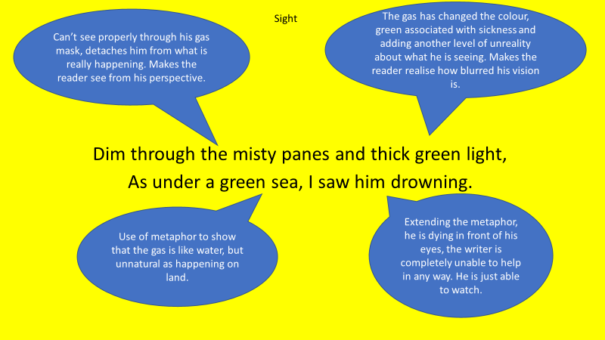
WAGOLL – Quote Explosion

WAGOLL – What How Why
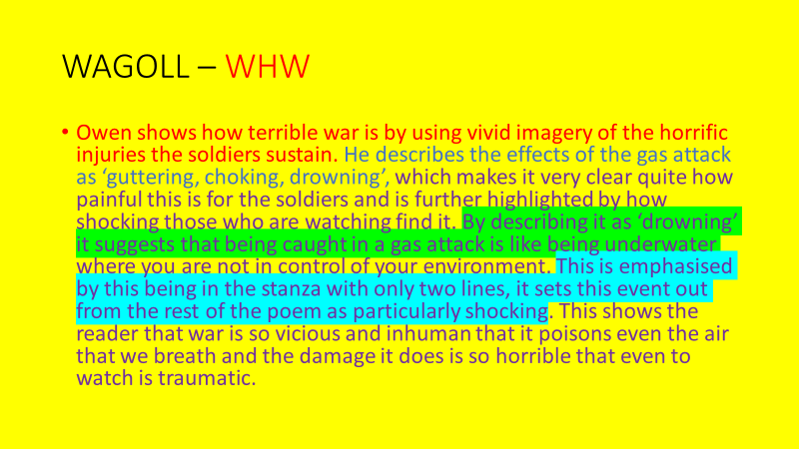
DIP – How does Owen use sensory description to portray the horror of war?
Use your quote explosions to create What/How/Why answers.
Owen uses visceral descriptions of what he sees to portray the violence of war. He describes the man dying in front of him as ‘I saw him drowning’.
Key Questions
- What does it mean to glorify war?
- What is sensory description?
- Which senses would be heightened or hindered in the trenches?
- What is a narrative?
- What events take place in the poem?
- Why is it a good idea to magpie from what we read?
Lesson Fifteen – Poetry Comparison
LI: To know how to write a comparative paragraph
DART - Re-read Dulce et Decorum Est and The Soldier – find a quote from each that shows their views on:
- The glory of war
- Dying in combat
- General views on patriotism
Do they agree or disagree with each other on these areas?
What does the War Photographer think about these issues?
DIP - Compare Dulce et Decorum Est with The Soldier
- What is it about?
- Who is it about?
- Does it have a message about war?
- What perspective is it written from?
- Do they discuss any of the same themes?
- How realistically do they depict events?
WAGOLL
- Both poems have a similar subject as they both are from the perspective of a soldier fighting in the first world war, this is shown by Brooke through the lense of… similarly Owen gives a narration of …
- Both poems portray a view of the importance of the notion of a soldier giving his life for his country. Brooke states that…
- However Owen says…
- Although…

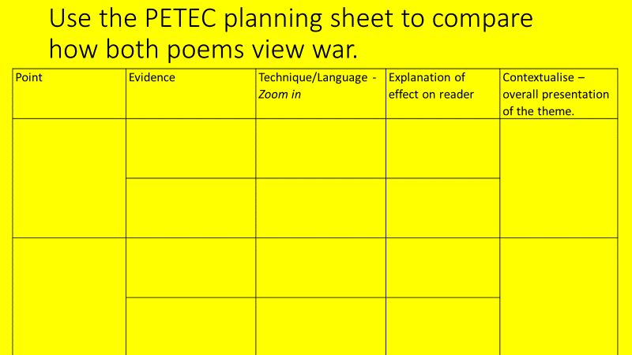

Key Questions
- What does comparison mean?
- Why is it useful or interesting?
- Why do different writers have different perspectives?
- How does their language reflect this?
- What is different about The Soldier and Dulce et Decorum Est?
- Which is the more popular view?
Lesson Sixteen – Narrative Perspective
LI: To understand the effect of writing from different narrative perspectives
DART – Wartime Propaganda
A British Approach
In 1914, the British prime minister also set up a covert propaganda department, known as Wellington House, to direct the work of influencing opinion overseas. Wellington House recruited authors, artists, journalists and newspaper editors to produce and advise on propaganda. Efforts were directed at putting across the British case in the foreign press. For the US in particular, there was also an attempt to target those seen as both sympathetic to Britain and influential in public debate on the war. The objective was to ensure that the British case was promoted in the US, but without the messages appearing to come from Britain.
The British approach to propaganda, at least that directed to people outside Britain, can be characterized by the notes made by Lord Northcliffe. Northcliffe was the owner of The Times and Daily Express newspapers, and influential in British politics. In 1917, he was appointed as head of the Committee for Enemy Propaganda. His notes for the first meetings of the committee are held by the British Library and contain the following observations:

- What can be done by open means must not be done by occult means
- Lies are the least effective form of propaganda
- Propaganda that looks like Propaganda is third rate propaganda
- Never shove your propagandee to a conclusion he can reach unaided
- Unless men are very ill or very uncomfortable they resist fears and welcome hope
- No man will blame himself if there is anyone else to blame … Indignation with others is the natural state of man

The means of propaganda were therefore: mass-production and circulation; using media and publications that were already popular; influencing those people who were already influential; harnessing the power of images; and appealing to values and characteristics that were important to the target audience. Propaganda sought to evoke sympathy for war aims and fighting forces, and the dehumanization of the enemy. The latter can be powerfully seen in the propaganda of Britain and France, which portrayed Germans as barbaric and animalistic.
DART Questions
- Why was the propaganda department set up in 1914?
- “The objective was to ensure that the British case was promoted in the US, but without the messages appearing to come from Britain.” – Why do you think this was?
- “No man will blame himself if there is anyone else to blame … Indignation with others is the natural state of man” – Can you explain this quote in your own words?
- Do you think propaganda would be effective on you?
Challenge – Do you think any of the poetry we have studied could be considered as a type of propaganda?
DIP – Informal Letter writing
Write your own letter either from the perspective of a soldier who has just been recruited into the army through propaganda or as the solider after experiencing the horrific reality of war (think “Dulce…”)
What is in a letter normally?
- Well wishes to people they love
- News about their day to day life
- What they hope to do when they are home
- How they are feeling (Do they hide the truth at all)
- Can you include details about whether war is how they imagined?
WAGOLL
Dear Mum and Dad,
I am writing this before we set off to France, I’m a little bit scared but I’m more excited than anything else. They have shown us how to use the rifle and what to do in a gas attack, so I think I’m ready. I am going to do my bit.
I hope everyone at home is okay…
Key Questions
- What is an informal letter?
- What is perspective?
- What is propaganda and why is it important?
- What perspective of war did the government try to present?
- How would the perspective of soldiers change as they grew older/spent more time at war?
- How do ex-soldiers feel about wartime now?

Lesson Seventeen – War Letter Comparison
LI: To know how to write a comparative paragraph
DART - Read the two letters below.
Are they formal or informal?
What is similar/different about them?
Letter 1
We are now fully equipped.
Dear Lack,
Many thanks for the photographs received. We all think they are good and on Saturday the six of us had out photo taken here in a similar position– in khaki. The two pictures together should make a lasting memento.
We have had little spare time since we have been training here. Having been through company drill mixed with route marches, physical drill, semaphore, knot tying and frog, long jumping etc. Some of our men were able to go to town on Saturday… but I myself with a few others have been under orders for overseas service now waiting to proceed, so popping up town seems out of the question for us. We are numbered in alphabetical order, and in the order we are sent out. We are now fully equipped. I enclose … postage for the photographs. If you are printing any more you might save me one as I am afraid I have spoilt mine, it got bent in my overcoat pocket on Saturday. Please remember me to all at the office…
N. Boyce
Letter 2
A most awful time.
Dear Gerald
Many thanks for letter which was somewhat a surprise to me. No the news was quite fresh as I do not hear from anybody in the office.
We have just come from the trenches where we were for seven days and had a most awful time. We were three days in the Reserve and put in the firing line where we took part in an attack and were also under a very heavy bombardment.
I am sorry to say we had many casualties thirty five killed and one hundred and thirty eight wounded and I can assure you it was an experience I shall never forget. Anyhow Williams, Kemball and myself came out quite safely.
I have seen Frost out here, of course his battalion (8th Argyll & Sutherland Highlanders) are in the same brigade also, as a matter of fact, they were in the firing line the night we came out. I received a letter while I was in the trenches from Mr Slater. Yes, I heard about Chamberlain, jolly sad Letters from the First World War, 1915 Trenches
was it not, if you do hear from Dick James you might pass any news on to me…
Shall be glad to hear from you. I could write more, only am a wee bit tired after seven days in trenches.
I am yours sincerely, Fred Hull.
P.S. Of course you know my address. Remember me to all I know.

DIP - Write a detailed comparison of the two letters.
Consider the language, structure, content, and perspectives of those who have written the letters (as well as both similarities and differences) in your answer.

WAGOLL – Comparison
Both letters are similar in that they are both from a soldier in the first World War writing home. Both letters show how the writer misses home by the gratefulness expressed for any correspondence. ‘embed quote’ However they differ greatly in their accounts of life in the army. ‘We are now fully equipped’ describes…
Whereas…
This differs…
A contrasting view is shown…
This implies…

Key Questions
- What are similarities and differences?
- Why would different letters present different views of war?
- What is censorship and how is this reflected in the content of the letters?
- What is comparative language?
- How can the letters be compared?
- What are the perspectives on war of the two people who wrote the letters?

