Year 8 English
Dystopian Fiction
Blended Learning Booklet
Summer B Booklet 2



Lesson 1 – Introduction to Dystopian Fiction
LI: To understand the conventions of dystopian fiction.

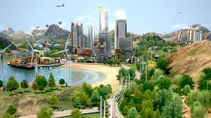
Choose five words to describe these images. Are they positive or negative words?
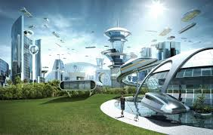


Key Terms:

Utopian – modelled on or aiming for a state in which everything is perfect; idealistic.
Dystopian – relating to or denoting an imagined state or society where there is great suffering or injustice

DART: Read the extract from ‘The Handmaid’s Tale’, then answer the questions that follow.

‘The Handmaid's Tale’ is a dystopian novel by Canadian author Margaret Atwood, published in 1985. It is set in a near-future New England, in a strongly patriarchal, quasi-Christian, totalitarian state, known as Gilead, that has overthrown the United States government. The central character and narrator is a woman named Offred, one of the group known as "handmaids," who are forcibly assigned to produce children for the "commanders" – the ruling class of men.

We slept in what had once been the gymnasium. The floor was of varnished wood, with stripes and circles painted on it, for the games that were formerly played there; the hoops for the basketball nets were still in place, though the nets were gone. A balcony ran around the room, for the spectators, and I thought I could smell, faintly like an afterimage, the pungent scent of sweat, shot through with the sweet taint of chewing gum and perfume from the watching girls, felt-skirted as I knew from pictures, later in miniskirts, then pants, then in one earring, spiky green-streaked hair. Dances would have been held there; the music lingered, a palimpsest of unheard sound, style upon style, an undercurrent of drums, a forlorn wail, garlands made of tissue-paper flowers, cardboard devils, a revolving ball of mirrors, powdering the dancers with a snow of light.

There was sadness in the room and loneliness, and expectation, of something without a shape or name. I remember that yearning, for something that was always about to happen and was never the same as the hands that were on us there and then, in the small of the back, or out back, in the parking lot, or in the television room with the sound turned down and only the pictures flickering over lifting flesh.

We yearned for the future. How did we learn it, that talent for insatiability? It was in the air; and it was still in the air, an afterthought, as we tried to sleep, in the army cots that had been set up in rows, with spaces between so we could not talk. We had flannelette sheets, like children's, and army-issue blankets, old ones that still said U.S. We folded our clothes neatly and laid them on the stools at the ends of the beds. The lights were turned down but not out. Aunt Sara and Aunt Elizabeth patrolled; they had electric cattle prods hanging from their leather belts.
No guns though, even they could not be trusted with guns. Guns were for the guards, specially picked from the Angels. The guards weren't allowed inside the building except when called, and we weren't allowed out, except for our walks, twice daily, two by two around the football field, which was enclosed now by a chain-link fence topped with barbed wire. The Angels stood outside it with their backs to us. They were objects of fear to us, but of something else as well. If only they would look. If only we could talk to them. Something could be exchanged, we thought, some deal made, some trade-off, we still had our bodies. That was our fantasy.

We learned to whisper almost without sound. In the semidarkness we could stretch out our arms, when the Aunts weren't looking, and touch each other's hands across space. We learned to lip-read, our heads flat on the beds, turned sideways, watching each other's mouths. In this way we exchanged names, from bed to bed:

Alma. Janine. Dolores. Moira. June.

- Identify five features of the gymnasium in which the women sleep
- Who patrolled the room?
- Who could be ‘trusted’ with guns?
- How did the women exchange names?
- How does what is described represent a dystopian society?

Watch: What do these trailers have in common? What dystopian conventions can you identify?

- ‘Children of Men’: http://www.youtube.com/watch?v=2VT2apoX90o
- ‘V for Vendetta’: https://www.youtube.com/watch?v=lSA7mAHolAw

Conventions of Dystopian Fiction:
- Propaganda used to control people; information is restricted
- Ordinary individuals lack power
- Individuals come together to rebel against the government
- Government attempts to crush revolution
- ‘Dark’ vision of the world
- Someone/something is worshipped by citizens
- Constant surveillance of citizens
- Dehumanised living conditions
- Citizens obey rules; punishments follow for rule-breaking
- Some citizens believe the world is actually utopian

DIP: What is dystopian fiction? Think about:
- The key conventions of the genre
- The typical characters featured in the genre
- The typical settings
- Who might enjoy these kinds of narratives
- Challenge: Why do you think people enjoy reading these kinds of stories?
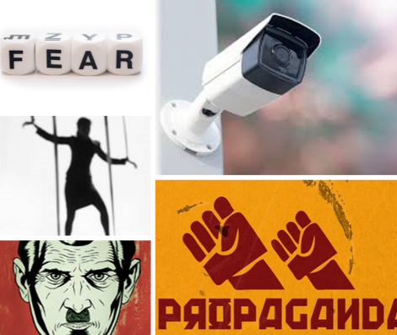
Lesson 2 – Describing Dystopian Settings
LI: To understand how writers use language to create dystopian settings.

What do these images have to do with dystopian fiction? Make a note of your ideas.

Conventions of Dystopian Settings
- New architecture installed
- Older buildings converted
- Lots of ruin
- High population density
- Sombre mood
- Absence of vivid colours
- Lack of natural life

DART: Read the two extracts below. Highlight five examples of effective descriptions in each extract. Then, annotate how each example reflects a typical dystopian setting.
Next, underline any examples of sensory description. Why is it so important in fiction?

‘Brave New World’ – Aldous Huxley
A squat grey building of only thirty-four stories. Over the main entrance the words, CENTRAL LONDON HATCHERY AND CONDITIONING CENTRE, and, in a shield, the World State's motto, COMMUNITY, IDENTITY, STABILITY.
The enormous room on the ground floor faced towards the north. Cold for all the summer beyond the panes, for all the tropical heat of the room itself, a harsh thin light glared through the windows, hungrily seeking some draped lay figure, some pallid shape of academic goose-flesh, but finding only the glass and nickel and bleakly shining porcelain of a laboratory. Wintriness responded to wintriness. The overalls of the workers were white, their hands gloved with a pale corpse-coloured rubber. The light was frozen, dead, a ghost. Only from the yellow barrels of the microscopes did it borrow a certain rich and living substance, lying along the polished tubes like butter, streak after luscious streak in long recession down the work tables.

‘The Road’ – Cormac McCarthy
When he woke in the woods in the dark and the cold of the night he'd reach out to touch the child sleeping beside him. Nights dark beyond darkness and the days more gray each one than what had gone before. Like the onset of some cold glaucoma dimming away the world. His hand rose and fell softly with each precious breath. He pushed away the plastic tarpaulin and raised himself in the stinking robes and blankets and looked toward the east for any light but there was none. In the dream from which he'd wakened he had wandered in a cave where the child led him by the hand. Their light playing over the wet flowstone walls. Like pilgrims in a fable swallowed up and lost among the inward parts of some granitic beast. Deep stone flues where the water dripped and sang. Tolling in the silence the minutes of the earth and the hours and the days of it and the years without cease. Until they stood in a great stone room where lay a black and ancient lake. And on the far shore a creature that raised its dripping mouth from the rimstone pool and stared into the light with eyes dead white and sightless as the eggs of spiders. It swung its head low over the water as if to take the scent of what it could not see. Crouching there pale and naked and translucent, its alabaster bones cast up in shadow on the rocks behind it. Its bowels, its beating heart. The brain that pulsed in a dull glass bell. It swung its head from side to side and then gave out a low moan and turned and lurched away and loped soundlessly into the dark.
With the first gray light he rose and left the boy sleeping and walked out to the road and squatted and studied the country to the south. Barren, silent, godless. He thought the month was October but he wasnt sure. He hadnt kept a calendar for years. They were moving south. There'd be no surviving another winter here.
When it was light enough to use the binoculars he glassed the valley below. Everything paling away into the murk. The soft ash blowing in loose swirls over the blacktop. He studied what he could see. The segments of road down there among the dead trees. Looking for anything of color. Any movement. Any trace of standing smoke. He lowered the glasses and pulled down the cotton mask from his face and wiped his nose on the back of his wrist and then glassed the country again. Then he just sat there holding the binoculars and watching the ashen daylight congeal over the land. He knew only that the child was his warrant. He said: If he is not the word of God God never spoke.

DIP: Imagine you are in one of the settings we have read about today. Write a description of what you see when you arrive there.
Success Criteria:
- First person
- Past or present tense
- Use sensory description (have you mentioned all the senses?)
- Focus on describing the dystopian features we have identified (you have five for each extract)
- Use language from the text/your vocabulary test
Lesson 3 – Dystopian Protagonists
LI: To understand typical features of a dystopian protagonist

- What is a protagonist?
- What is an antagonist?
- What protagonists have you studied in English so far?

What makes a dystopian protagonist?
- Usually faced with a problem to be solved by going on a journey, solving a problem or undertaking a difficult task or quest
- Often has to defeat or capture the antagonist
- Faces difficulties and danger, but wins through in the end
- Often feels trapped and struggles to escape
- Questions the existing system; believes something is wrong with their society
- Helps others and the audience realise the negative aspects of the dystopia

Watch this video: https://www.youtube.com/watch?v=e3PJ3Du_zDc
Then, answer the following:
- What is the reaping?
- What happens?
- How do the characters prepare?
- What does this tell us about the society they live in?
- Why is the government doing this?

Then, watch this video: https://www.youtube.com/watch?v=urrqW4_3IBg
‘1984’ follows the life of Winston Smith, a low ranking member of the ‘Party’, who is frustrated by the omnipresent ‘eyes’ of the party and its ominous ruler ‘Big Brother’.
- What is the significance of the ‘party’ and the ‘eyes’?

Now, watch this video: https://www.youtube.com/watch?v=XvGmOZ5T6_Y
The ‘Two Minutes of Hate’ is the two minutes of each day that members of the ‘Party’ must watch a film about ‘enemies of the state’ to loudly and passionately express their hatred for them.
- What do you think this serves in a dystopian state?

  Katniss | 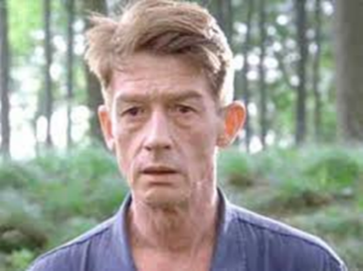  Winston
Five adjectives to describe her:  1.  2.  3.  4.  5. | Five adjectives to describe him:  1.  2.  3.  4.  5.
Dystopian hero? Why/why not? | Dystopian hero? Why/why not?
Opinions about government: | Opinions about ‘The Party’:
Reaction to ‘The Reaping’: | Reaction to ‘The Two Minutes of Hate’:

DIP: Compare Katniss and Winston using your completed worksheet and your answers about what makes them dystopian protagonists to help you.
- How do they feel about government?
- What do they do about it?
- How do they react to key events?
Both characters…
For example, Katniss…
Similarly,/On the other hand, Winston…
This shows that dystopian protagonists…
Lesson 4 – Creating Dystopian Protagonists
LI: To replicate the features of a dystopian protagonist in a new character.

DART: Read the following extract from ‘1984’ by George Orwell and answer the questions that follow.
‘We are the dead,’ he said.
‘We are the dead,’ echoed Julia.
‘You are the dead,’ said an iron voice behind them.
They sprang apart. Winston’s entrails seemed to have turned to ice. He could see the white all round the irises of Julia’s eyes. Her face had turned a milky yellow. The smear of rouge that was still on each cheekbone stood out sharply, almost as though unconnected with the skin beneath.
‘You are the dead,’ repeated the iron voice.
‘It was behind the picture,’ breathed Julia.
‘It was behind the picture,’ said the voice. ‘Remain exactly where you are. Make no movement until you are ordered.’
It was starting at last! They could do nothing except stand gazing into one another’s eyes. To run for life, to get out of the house before it was too late – no such thought occurred to them. Unthinkable to disobey the iron voice from the wall. There was a snap as though a catch had been turned back, and a crash of breaking glass. The picture had fallen to the floor, uncovering the telescreen behind it.
‘Now they can see us,’ said Julia.
‘Now we can see you,’ said the voice. ‘Stand out in the middle of the room. Stand back to back. Clasp your hands behind your heads. Do not touch one another.’
They were not touching, but it seemed to him he could feel Julia’s body shaking. Or perhaps it was merely the shaking of his own. He could just stop his teeth from chattering, but his knees were beyond his control. There was a sound of trampling boots below, inside the house and outside. The yard seemed to be full of men. Something was being dragged across the stones. The woman’s singing had stopped abruptly. There was a long, rolling clang, as though the washtub had been flung across the yard, and then a confusion of angry shouts which ended in a yell of pain.
‘The house is surrounded,’ said Winston.
‘The house is surrounded,’ said the voice.
He heard Julia snap her teeth together. ‘I suppose we may as well say good-bye,’ she said.
‘You may as well say good-bye,’ said the voice. And then another quite different voice, a thin, cultivated voice which Winston had the impression of having heard before, struck in: ‘And by the way, while we are on the subject, “Here comes a candle to light you to bed, here comes a chopper to chop off your head!”’
Something crashed onto the bed behind Winston’s back. The head of a ladder had been thrust through the window and had burst in the frame. Someone was climbing through the window. There was a stampede of boots up the stairs. The room was full of solid men in uniforms, with iron-shod boots on their feet and truncheons in their hands.
Winston was not trembling any longer. Even his eyes he barely moved. One thing alone mattered: to keep still, to keep still and not give them an excuse to hit you! A man with a smooth prizefighter’s jowl in which the mouth was only a slit paused opposite him, balancing his truncheon meditatively between thumb and forefinger. Winston met his eyes. The feeling of nakedness, with one’s hands behind one’s head and one’s face and body all exposed, was almost unbearable. The man protruded the tip of a white tongue, licked the place where his lips should have been and then passed on. There was another crash. Someone had picked up the glass paperweight from the table and smashed it to pieces on the hearth-stone.

1. Which word shows Julia repeated what she had heard?
2. What does “sprang apart” suggest?
3. What colour was Julia’s face?
4. When will she be allowed to move?
5. Which word shows they didn’t consider running?
6. What was behind the picture?
7. What does Julia realise?
8. What does the voice instruct them to do?
9. Who comes into the room?
10. How did Winston feel?

Think: The animals, as a group, are the protagonists of Animal Farm. Their goal is to achieve the vision set out by Old Major: equality and freedom for all animals.
- Does this change over the course of the novel?
- Are there any specific animals who could be considered the protagonist?

DIP: Create your own dystopian protagonist. They will need a:

Name:
Age:
Location (what is the dystopian place in which they live?):
Antagonist:
A method of control used against them:

- Why does the hero feel trapped?
- What about the political system/system of authority does the character question?
- What is wrong about the society in which the character lives?
- What are the negative aspects of the dystopian world?
- How does the hero rebel against the system?

Lesson 5 – ‘Harrison Bergeron’
LI: To explore the theme of control in dystopian fiction.
- What does control mean?
- Who controls the animals in ‘Animal Farm’?
- Why might governments want to control their citizens?

Watch this trailer for ‘2081’: https://www.youtube.com/watch?v=nL9zg7-rzPc
Then, explain how each statement relates to conventions of dystopian fiction.

- “No one is better. Everyone is worse.”
- “A brutal government”
- “A chilling vision of the future”
- “An act of defiance that changes everything”

Key Terms:
Control – the power to influence or direct people’s behaviour
Handicapping – place someone at a disadvantage

DART: Read ‘Harrison Bergeron’, then answer the questions and complete the table that follow.
- How old was Harrison?
- Why was he in prison?
- Why was he “extremely dangerous”?

Handicap | What is the effect of the handicap? | Why has Harrison been given this handicap?
“spectacle with thick wavy lenses”

 | To make him look less attractive.
THE YEAR WAS 2081, and everybody was finally equal. They weren't only equal before God and the law. They were equal every which way. Nobody was smarter than anybody else. Nobody was better looking than anybody else. Nobody was stronger or quicker than anybody else. All this equality was due to the 211th, 212th, and 213th Amendments to the Constitution, and to the unceasing vigilance of agents of the United States Handicapper General.
Some things about living still weren't quite right, though. April for instance, still drove people crazy by not being springtime. And it was in that clammy month that the H-G men took George and Hazel Bergeron's fourteen-year-old son, Harrison, away.
It was tragic, all right, but George and Hazel couldn't think about it very hard. Hazel had a perfectly average intelligence, which meant she couldn't think about anything except in short bursts. And George, while his intelligence was way above normal, had a little mental handicap radio in his ear. He was required by law to wear it at all times. It was tuned to a government transmitter. Every twenty seconds or so, the transmitter would send out some sharp noise to keep people like George from taking unfair advantage of their brains.
George and Hazel were watching television. There were tears on Hazel's cheeks, but she'd forgotten for the moment what they were about.
On the television screen were ballerinas.
A buzzer sounded in George's head. His thoughts fled in panic, like bandits from a burglar alarm.
"That was a real pretty dance, that dance they just did," said Hazel.
"Huh" said George.
"That dance-it was nice," said Hazel.
"Yup," said George. He tried to think a little about the ballerinas. They weren't really very good-no better than anybody else would have been, anyway. They were burdened with sashweights and bags of birdshot, and their faces were masked, so that no one, seeing a free and graceful gesture or a pretty face, would feel like something the cat drug in. George was toying with the vague notion that maybe dancers shouldn't be handicapped. But he didn't get very far with it before another noise in his ear radio scattered his thoughts.
George winced. So did two out of the eight ballerinas.
Hazel saw him wince. Having no mental handicap herself, she had to ask George what the latest sound had been.
"Sounded like somebody hitting a milk bottle with a ball peen hammer," said George.
"I'd think it would be real interesting, hearing all the different sounds," said Hazel a little envious. "All the things they think up."
"Um," said George.
"Only, if I was Handicapper General, you know what I would do?" said Hazel. Hazel, as a matter of fact, bore a strong resemblance to the Handicapper General, a woman named Diana Moon Glampers. "If I was Diana Moon Glampers," said Hazel, "I'd have chimes on Sunday-just chimes. Kind of in honor of religion."
"I could think, if it was just chimes," said George.
"Well-maybe make 'em real loud," said Hazel. "I think I'd make a good Handicapper General."
"Good as anybody else," said George.
"Who knows better than I do what normal is?" said Hazel.
"Right," said George. He began to think glimmeringly about his abnormal son who was now in jail, about Harrison, but a twenty-one-gun salute in his head stopped that.
"Boy!" said Hazel, "that was a doozy, wasn't it?"
It was such a doozy that George was white and trembling, and tears stood on the rims of his red eyes. Two of the eight ballerinas had collapsed to the studio floor, were holding their temples.
"All of a sudden you look so tired," said Hazel. "Why don't you stretch out on the sofa, so's you can rest your handicap bag on the pillows, honeybunch." She was referring to the forty-seven pounds of birdshot in a canvas bag, which was padlocked around George's neck. "Go on and rest the bag for a little while," she said. "I don't care if you're not equal to me for a while."
George weighed the bag with his hands. "I don't mind it," he said. "I don't notice it any more. It's just a part of me."
"You been so tired lately-kind of wore out," said Hazel. "If there was just some way we could make a little hole in the bottom of the bag, and just take out a few of them lead balls. Just a few."
"Two years in prison and two thousand dollars fine for every ball I took out," said George. "I don't call that a bargain."
"If you could just take a few out when you came home from work," said Hazel. "I mean-you don't compete with anybody around here. You just sit around."
"If I tried to get away with it," said George, "then other people'd get away with it-and pretty soon we'd be right back to the dark ages again, with everybody competing against everybody else. You wouldn't like that, would you?"
"I'd hate it," said Hazel.
"There you are," said George. The minute people start cheating on laws, what do you think happens to society?"
If Hazel hadn't been able to come up with an answer to this question, George couldn't have supplied one. A siren was going off in his head.
"Reckon it'd fall all apart," said Hazel.
"What would?" said George blankly.
"Society," said Hazel uncertainly. "Wasn't that what you just said?
"Who knows?" said George.
The television program was suddenly interrupted for a news bulletin. It wasn't clear at first as to what the bulletin was about, since the announcer, like all announcers, had a serious speech impediment. For about half a minute, and in a state of high excitement, the announcer tried to say, "Ladies and Gentlemen."
He finally gave up, handed the bulletin to a ballerina to read.
"That's all right-" Hazel said of the announcer, "he tried. That's the big thing. He tried to do the best he could with what God gave him. He should get a nice raise for trying so hard."
"Ladies and Gentlemen," said the ballerina, reading the bulletin. She must have been extraordinarily beautiful, because the mask she wore was hideous. And it was easy to see that she was the strongest and most graceful of all the dancers, for her handicap bags were as big as those worn by two-hundred pound men.
And she had to apologize at once for her voice, which was a very unfair voice for a woman to use. Her voice was a warm, luminous, timeless melody. "Excuse me-" she said, and she began again, making her voice absolutely uncompetitive.
"Harrison Bergeron, age fourteen," she said in a grackle squawk, "has just escaped from jail, where he was held on suspicion of plotting to overthrow the government. He is a genius and an athlete, is under-handicapped, and should be regarded as extremely dangerous."
A police photograph of Harrison Bergeron was flashed on the screen-upside down, then sideways, upside down again, then right side up. The picture showed the full length of Harrison against a background calibrated in feet and inches. He was exactly seven feet tall.
The rest of Harrison's appearance was Halloween and hardware. Nobody had ever born heavier handicaps. He had outgrown hindrances faster than the H-G men could think them up. Instead of a little ear radio for a mental handicap, he wore a tremendous pair of earphones, and spectacles with thick wavy lenses. The spectacles were intended to make him not only half blind, but to give him whanging headaches besides.
Scrap metal was hung all over him. Ordinarily, there was a certain symmetry, a military neatness to the handicaps issued to strong people, but Harrison looked like a walking junkyard. In the race of life, Harrison carried three hundred pounds.
And to offset his good looks, the H-G men required that he wear at all times a red rubber ball for a nose, keep his eyebrows shaved off, and cover his even white teeth with black caps at snaggle-tooth random.
"If you see this boy," said the ballerina, "do not - I repeat, do not - try to reason with him."
There was the shriek of a door being torn from its hinges.
Screams and barking cries of consternation came from the television set. The photograph of Harrison Bergeron on the screen jumped again and again, as though dancing to the tune of an earthquake.
George Bergeron correctly identified the earthquake, and well he might have - for many was the time his own home had danced to the same crashing tune. "My God-" said George, "that must be Harrison!"
The realization was blasted from his mind instantly by the sound of an automobile collision in his head.
When George could open his eyes again, the photograph of Harrison was gone. A living, breathing Harrison filled the screen.
Clanking, clownish, and huge, Harrison stood - in the center of the studio. The knob of the uprooted studio door was still in his hand. Ballerinas, technicians, musicians, and announcers cowered on their knees before him, expecting to die.
"I am the Emperor!" cried Harrison. "Do you hear? I am the Emperor! Everybody must do what I say at once!" He stamped his foot and the studio shook.
"Even as I stand here" he bellowed, "crippled, hobbled, sickened - I am a greater ruler than any man who ever lived! Now watch me become what I can become!"
Harrison tore the straps of his handicap harness like wet tissue paper, tore straps guaranteed to support five thousand pounds.
Harrison's scrap-iron handicaps crashed to the floor.
Harrison thrust his thumbs under the bar of the padlock that secured his head harness. The bar snapped like celery. Harrison smashed his headphones and spectacles against the wall.
He flung away his rubber-ball nose, revealed a man that would have awed Thor, the god of thunder.
"I shall now select my Empress!" he said, looking down on the cowering people. "Let the first woman who dares rise to her feet claim her mate and her throne!"
A moment passed, and then a ballerina arose, swaying like a willow.
Harrison plucked the mental handicap from her ear, snapped off her physical handicaps with marvellous delicacy. Last of all he removed her mask.
She was blindingly beautiful.
"Now-" said Harrison, taking her hand, "shall we show the people the meaning of the word dance? Music!" he commanded.
The musicians scrambled back into their chairs, and Harrison stripped them of their handicaps, too. "Play your best," he told them, "and I'll make you barons and dukes and earls."
The music began. It was normal at first-cheap, silly, false. But Harrison snatched two musicians from their chairs, waved them like batons as he sang the music as he wanted it played. He slammed them back into their chairs.
The music began again and was much improved.
Harrison and his Empress merely listened to the music for a while-listened gravely, as though synchronizing their heartbeats with it.
They shifted their weights to their toes.
Harrison placed his big hands on the girls tiny waist, letting her sense the weightlessness that would soon be hers.
And then, in an explosion of joy and grace, into the air they sprang!
Not only were the laws of the land abandoned, but the law of gravity and the laws of motion as well.
They reeled, whirled, swiveled, flounced, capered, gamboled, and spun.
They leaped like deer on the moon.
The studio ceiling was thirty feet high, but each leap brought the dancers nearer to it.
It became their obvious intention to kiss the ceiling. They kissed it.
And then, neutraling gravity with love and pure will, they remained suspended in air inches below the ceiling, and they kissed each other for a long, long time.
It was then that Diana Moon Glampers, the Handicapper General, came into the studio with a double-barreled ten-gauge shotgun. She fired twice, and the Emperor and the Empress were dead before they hit the floor.
Diana Moon Glampers loaded the gun again. She aimed it at the musicians and told them they had ten seconds to get their handicaps back on.
It was then that the Bergerons' television tube burned out.
Hazel turned to comment about the blackout to George. But George had gone out into the kitchen for a can of beer.
George came back in with the beer, paused while a handicap signal shook him up. And then he sat down again. "You been crying" he said to Hazel.
"Yup," she said.
"What about?" he said.
"I forget," she said. "Something real sad on television."
"What was it?" he said.
"It's all kind of mixed up in my mind," said Hazel.
"Forget sad things," said George.
"I always do," said Hazel.
"That's my girl," said George. He winced. There was the sound of a rivetting gun in his head.
"Gee - I could tell that one was a doozy," said Hazel.
"You can say that again," said George.
"Gee-" said Hazel, "I could tell that one was a doozy."

DIP: How do the government exercise control over citizens in ‘Harrison Bergeron’?
The government exercise control by…
One example of this is George…
George is controlled by…
The government do this because…
Another example of his is Harrison…
Harrison is controlled by…
The government do this because…
These forms of control are effective/ineffective because…

Lesson 6 – Government Control
LI: To explore the theme of control in dystopian fiction.
- How has the government tried to control citizens during the pandemic?
- Why have they done this?
- Do you think this is dystopian?

DART: Read this short article – ‘Is lockdown ‘dystopian’?’ – then answer the questions that follow.
Margaret Atwood, who has created dystopias from Gilead to the collapsed civilisation of Oryx and Crake, has spoken: our locked-down world might be “an unpleasant, frightening, disagreeable place you don’t want to be”, but it is not dystopian.
Speaking to BBC Radio 5 Live’s Emma Barnett, Atwood said that “a dystopia, technically, is an arranged unpleasant society that you don’t want to be living in. This one was not arranged. So people may be making arrangements that aren’t too pleasant, but it’s not a deliberate totalitarianism. It’s not a deliberate arrangement.”
What it is, said Atwood, is “an emergency crisis”. “Being in an unpleasant situation such as the blitz, that’s not a dystopia. It’s an unpleasant, frightening, disagreeable place you don’t want to be, but it wasn’t arranged by a government that is in control of you,” said the author of The Handmaid’s Tale.

- What three adjectives does Atwood use to describe lockdown?
- Why does she not believe lockdown is a dystopia?
- What is it instead?
- Why is Atwood considered an authority on this issue?

Make a note – how was control exerted in:
- ‘Animal Farm’?
- ‘Harrison Bergeron’?
- ‘1984’?
- ‘The Hunger Games’?

DART: Read the extract from ‘Harrison Bergeron’, then answer the questions below.

1. In which year is the story set?
2. Name three things that are equal about everyone.
3. Why was everyone equal?
4. How old was Harrison when he was taken away?
5. Which month was he taken away in?
6. Which word is used to describe this incident?
7. Who was more intelligent, George or Hazel?
8. How was this equalled out?
9. What happened every 20 seconds?
10. Why was Hazel crying?
THE YEAR WAS 2081, and everybody was finally equal. They weren't only equal before God and the law. They were equal every which way. Nobody was smarter than anybody else. Nobody was better looking than anybody else. Nobody was stronger or quicker than anybody else. All this equality was due to the 211th, 212th, and 213th Amendments to the Constitution, and to the unceasing vigilance of agents of the United States Handicapper General.
Some things about living still weren't quite right, though. April for instance, still drove people crazy by not being springtime. And it was in that clammy month that the H-G men took George and Hazel Bergeron's fourteen-year-old son, Harrison, away.
It was tragic, all right, but George and Hazel couldn't think about it very hard. Hazel had a perfectly average intelligence, which meant she couldn't think about anything except in short bursts. And George, while his intelligence was way above normal, had a little mental handicap radio in his ear. He was required by law to wear it at all times. It was tuned to a government transmitter. Every twenty seconds or so, the transmitter would send out some sharp noise to keep people like George from taking unfair advantage of their brains.
George and Hazel were watching television. There were tears on Hazel's cheeks, but she'd forgotten for the moment what they were about.

Think: Would you like to live in a society like this? Why/why not? How would this society allow the government to control people?

DIP: Should governments be able to control their citizens?
Use examples from what we have read and real life examples in your answer.

Lesson 7 – ‘The Pedestrian’
LI: To understand the narrative arc of a dystopian short story.
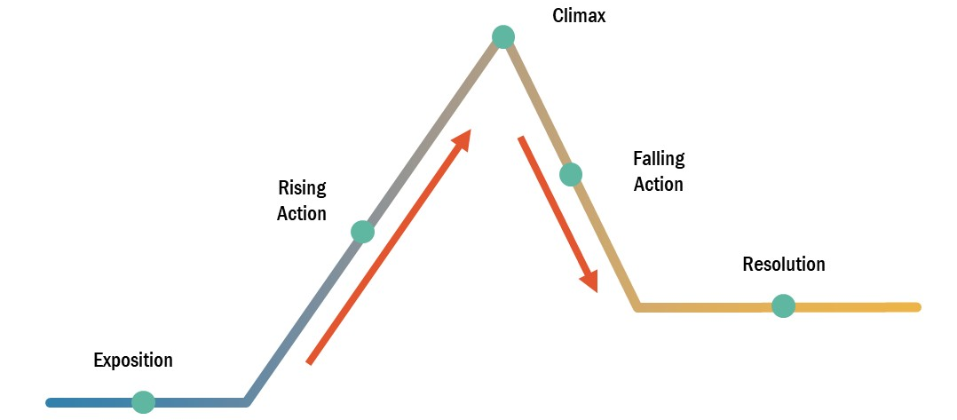
DART: Read ‘The Pedestrian’, then plot a narrative arc for it. Use the image below to help you.

To enter out into that silence that was the city at eight o'clock of a misty evening in November, to put your feet upon that buckling concrete walk, to step over grassy seams and make your way, hands in pockets, through the silences, that was what Mr. Leonard Mead most dearly loved to do. He would stand upon the corner of an intersection and peer down long moonlit avenues of sidewalk in four directions, deciding which way to go, but it really made no difference; he was alone in this world of 2053 A.D., or as good as alone, and with a final decision made, a path selected, he would stride off, sending patterns of frosty air before him like the smoke of a cigar.
Sometimes he would walk for hours and miles and return only at midnight to his house. And on his way he would see the cottages and homes with their dark windows, and it was not unequal to walking through a graveyard where only the faintest glimmers of firefly light appeared in flickers behind the windows. Sudden gray phantoms seemed to manifest upon inner room walls where a curtain was still undrawn against the night, or there were whisperings and murmurs where a window in a tomb-like building was still open.
Mr. Leonard Mead would pause, cock his head, listen, look, and march on, his feet making no noise on the lumpy walk. For long ago he had wisely changed to sneakers when strolling at night, because the dogs in intermittent squads would parallel his journey with barkings if he wore hard heels, and lights might click on and faces appear and an entire street be startled by the passing of a lone figure, himself, in the early November evening.
On this particular evening he began his journey in a westerly direction, toward the hidden sea. There was a good crystal frost in the air; it cut the nose and made the lungs blaze like a Christmas tree inside; you could feel the cold light going on and off, all the branches filled with invisible snow. He listened to the faint push of his soft shoes through autumn leaves with satisfaction, and whistled a cold quiet whistle between his teeth, occasionally picking up a leaf as he passed, examining its skeletal pattern in the infrequent lamplights as he went on, smelling its rusty smell.
'Hello, in there,' he whispered to every house on every side as he moved. 'What's up tonight on Channel 4, Channel 7, Channel 9? Where are the cowboys rushing, and do I see the United States Cavalry over the next hill to the rescue?'
The street was silent and long and empty, with only his shadow moving like the shadow of a hawk in mid-country. If he closed his eyes and stood very still, frozen, he could imagine himself upon the center of a plain, a wintry, windless Arizona desert with no house in a thousand miles, and only dry river beds, the street, for company.
'What is it now?' he asked the houses, noticing his wrist watch. Eight-thirty P.M.? Time for a dozen assorted murders? A quiz? A revue? A comedian falling off the stage?'
Was that a murmur of laughter from within a moon-white house? He hesitated, but went on when nothing more happened. He stumbled over a particularly uneven section of sidewalk. The cement was vanishing under flowers and grass. In ten years of walking by night or day, for thousands of miles, he had never met another person walking, not one in all that time.
He came to a cloverleaf intersection which stood silent where two main highways crossed the town. During the day it was a thunderous surge of cars, the gas stations open, a great insect rustling and a ceaseless jockeying for position as the scarab-beetles, a faint incense puttering from their exhausts, skimmed homeward to the far directions. But now these highways, too, were like streams in a dry season, all stone and bed and moon radiance.
He turned back on a side street, circling around toward his home. He was within a block of his destination when the lone car turned a corner quite suddenly and flashed a fierce white cone of light upon him. He stood entranced, not unlike a night moth, stunned by the illumination, and then drawn toward it.
A metallic voice called to him:
'Stand still. Stay where you are! Don't move!'
He halted.
'Put up your hands!'
'But-' he said.
'Your hands up! Or we'll shoot!'
The police, of course, but what a rare, incredible thing; in a city of three million, there was only one police car left, wasn't that correct? Ever since a year ago, 2052, the election year, the force had been cut down from three cars to one. Crime was ebbing; there was no need now for the police, save for this one lone car wandering and wandering the empty streets.
'Your name?' said the police car in a metallic whisper. He couldn't see the men in it for the bright light in his eyes.
'Leonard Mead,' he said.
'Speak up!'
'Leonard Mead!'
Business or profession?'
'I guess you'd call me a writer.'
No profession,' said the police car, as if talking to itself. The light held him fixed, like a museum specimen, needle thrust through chest.
'You might say that,' said Mr. Mead.
He hadn't written in years. Magazines and books didn't sell anymore. Everything went on in the tomb-like houses at night now, he thought, continuing his fancy. The tombs, ill-lit by television light, where the people sat like the dead, the gray or multi-colored lights touching their faces, but never really touching them.
'No profession,' said the phonograph voice, hissing. 'What are you doing out?'
'Walking,' said Leonard Mead.
'Walking!'
'Just walking,' he said simply, but his face felt cold.
'Walking, just walking, walking?'
'Yes, sir.'
'Walking where? For what?'
'Walking for air. Walking to see.'
'Your address!'
'Eleven South Saint James Street.'
'And there is air in your house, you have an air conditioner, Mr. Mead?'
Yes.'
'And you have a viewing screen in your house to see with?'
'No.
'No?' There was a crackling quiet that in itself was an accusation.
'Are you married, Mr. Mead?'
'No.'
'Not married,' said the police voice behind the fiery beam. The moon was high and dear among the stars and the houses were gray and silent.
'Nobody wanted me,' said Leonard Mead with a smile.
'Don't speak unless you're spoken to!'
Leonard Mead waited in the cold night.
'Just walking; Mr. Mead?'
'Yes.'
But you haven't explained for what purpose.'
'I explained; for air, and to see, and just to walk.'
'Have you done this often?'
Every night for years.'
The police car sat in the center of the street with its radio throat faintly humming.
'Well, Mr. Mead', it said.
'Is that all?' he asked politely.
'Yes,' said the voice. 'Here.' There was a sigh, a pop. The back door of the police car sprang wide. 'Get in.'
'Wait a minute, 1 haven't done anything!'
'Get in.'
'I protest!'
'Mr. Mead.'
He walked like a man suddenly drunk. As he passed the front window of the car he looked in. As he had expected, there was no one in the front seat, no one in the car at all.
'Get in.'
He put his hand to the door and peered into the back seat, which was a little cell, a little black jail with bars. It smelled of riveted steel. It smelled of harsh antiseptic; it smelled too clean and hard and metallic. There was nothing soft there.
'Now if you had a wife to give you an alibi,' said the iron voice. 'But-'
'where are you taking me?'
The car hesitated, or rather gave a faint whirring click, as if information, somewhere, was dropping card by punch- slotted card under electric eyes. 'To the Psychiatric Center for Research on Regressive Tendencies.'
He got in. The door shut with a soft thud. The police car rolled through the night avenues, flashing its dim lights ahead.
They passed one house on one street a moment later, one house in an entire city of houses that were dark, but this one particular house had all of its electric lights brightly lit, every window a loud yellow illumination, square and warm in the cool darkness.
'That's my house,' said Leonard Mead.
No one answered him.
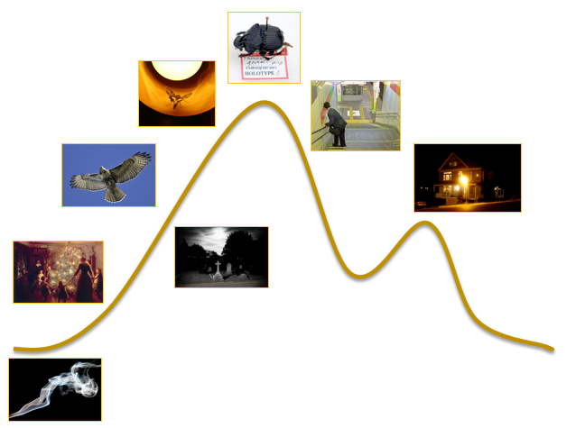
The car moved down the empty riverbed streets and off away, leaving the empty streets with the empty sidewalks, and no sound and no motion all the rest of the chill November night.

DIP: How is dystopian imagery used in ‘The Pedestrian’?
The writer uses dystopian imagery to show the way Mr Mead is feeling and the type of society he lives in. For example, ‘the street was silent and long and empty, only his shadow moving like the shadow of a hawk.’ This suggests Mr Mead is by himself, it is very dark and very quiet. The word ‘empty’ demonstrates the streets are abandoned and Mr Mead may feel lonely.
Lesson 8 – Dystopian Writing
LI: To apply my knowledge of dystopian conventions in my own creative piece.
- What are the conventions of dystopian literature?
Think:
Which elements of ‘The Pedestrian’ and its narrative arc are dystopian? Why?
How is dystopian control shown in the story?
How does the behaviour of the police reflect what we have already learnt about dystopian governments? Can you compare this to other stories we have read?

DART: Read each of the extracts from ‘The Pedestrian’, and answer the questions that follow.
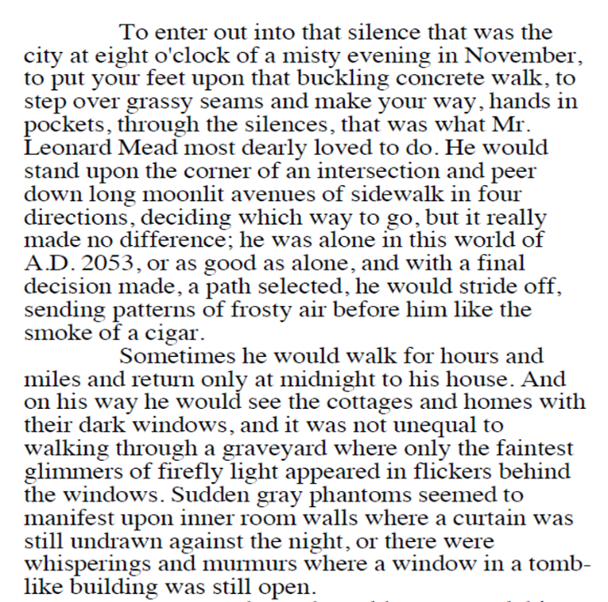
1. What time does the story start?
2. What month is it?
3. What is the protagonist’s name?
4. What year is it?
5. What did the protagonist like to do?
6. How long would he walk for?
7. What is the weather like?
8. Identify three descriptions of setting in the paragraph. What mood is created?
9. What links the “graveyard” and “phantoms”?
10. Which word in the final sentence continues this theme?

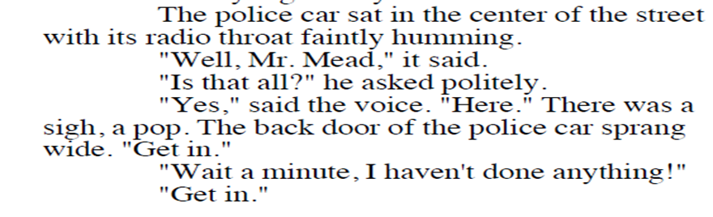
------------------------------------------------------------------
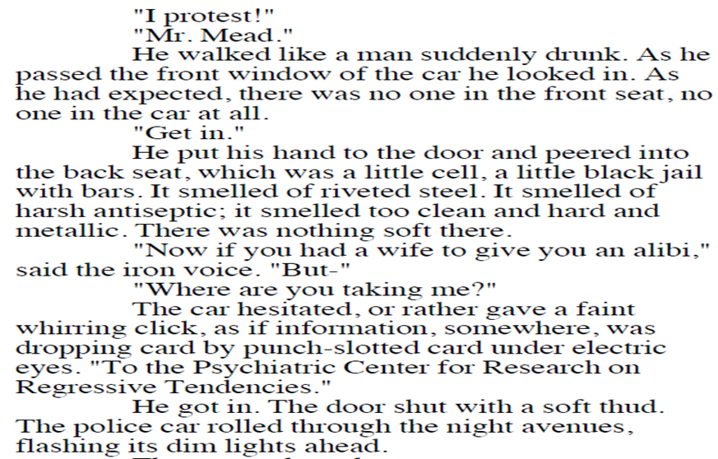
1. Where was the police car?
2. What does the voice tell Mr Mead to do?
3. How did Mr Mead walk?
4. What was in the back seat of the car?
5. What did it smell like?
6. What question does Mr Mead ask?
7. What is the answer?
8. Why does mr Mead get into the car?
9. What noise does the door make?
10. How is the movement of the car described?

Plan: How would you feel in this situation?
- Write a sentence for each of the five senses (touch, taste, smell, see, hear) that describes how you feel.
- Look back at the imagery from the previous lesson – can you identify five sentences you could use in your own writing?

DIP: Write a dystopian creative piece inspired by the events of ‘The Pedestrian’. Use one of the following prompts.

One night, while out for his daily walk, Leonard Mead came across a mysterious character.
Who were they? What happened?
Where did the police car drive to?
Who was there?
What happens next?

Success criteria:
- Use of dystopian conventions
- Use of sensory langauge for all five senses
- Use of ambitious vocabulary
- Consistent use of the past tense
- Use of a third-person perspective

Lesson 9 – ‘Divergent’
LI: To recognise common features of dystopian fiction.

DART: Read the extract from ‘Divergent’. Highlight any dystopian conventions you identify.

We walk together to the kitchen. On these mornings when my brother makes breakfast, and my father’s hand skims my hair as he reads the newspaper, and my mother hums as she clears the table—it is on these mornings that I feel guiltiest for wanting to leave them.
The bus stinks of exhaust. Every time it hits a patch of uneven pavement, it jostles me from side to side, even though I’m gripping the seat to keep myself still.
My older brother, Caleb, stands in the aisle, holding a railing above his head to keep himself steady. We don’t look alike. He has my father’s dark hair and hooked nose and my mother’s green eyes and dimpled cheeks. When he was younger, that collection of features looked strange, but now it suits him. If he wasn’t Abnegation, I’m sure the girls at school would stare at him.
He also inherited my mother’s talent for selflessness. He gave his seat to a surly Candor man on the bus without a second thought.
The Candor man wears a black suit with a white tie—Candor standard uniform. Their faction values honesty and sees the truth as black and white, so that is what they wear.
The gaps between the buildings narrow and the roads are smoother as we near the heart of the city. The building that was once called the Sears Tower—we call it the Hub —emerges from the fog, a black pillar in the skyline. The bus passes under the elevated tracks. I have never been on a train, though they never stop running and there are tracks everywhere. Only the Dauntless ride them.
Five years ago, volunteer construction workers from Abnegation repaved some of the roads. They started in the middle of the city and worked their way outward until they ran out of materials. The roads where I live are still cracked and patchy, and it’s not safe to drive on them. We don’t have a car anyway.
Caleb’s expression is placid as the bus sways and jolts on the road. The gray robe falls from his arm as he clutches a pole for balance. I can tell by the constant shift of his eyes that he is watching the people around us—striving to see only them and to forget himself. Candor values honesty, but our faction, Abnegation, values selflessness.
The bus stops in front of the school and I get up, scooting past the Candor man. I grab Caleb’s arm as I stumble over the man’s shoes. My slacks are too long, and I’ve never been that graceful.
The Upper Levels building is the oldest of the three schools in the city: Lower Levels, Mid-Levels, and Upper Levels. Like all the other buildings around it, it is made of glass and steel. In front of it is a large metal sculpture that the Dauntless climb after school, daring each other to go higher and higher. Last year I watched one of them fall and break her leg. I was the one who ran to get the nurse.
“Aptitude tests today,” I say. Caleb is not quite a year older than I am, so we are in the same year at school.
He nods as we pass through the front doors. My muscles tighten the second we walk in. The atmosphere feels hungry, like every sixteen-year-old is trying to devour as much as he can get of this last day. It is likely that we will not walk these halls again after the Choosing Ceremony—once we choose, our new factions will be responsible for finishing our education.

DIP: Pick one of these dystopian catastrophes. What problems does it cause you? What are you going to do next?
- Environmental diaaster
- Technological takeover
- Virus outbreak
- War
- End of the world
Using your chosen catastrophe, write a 100-word description of what you see as a survivor without using the words ‘and’, ‘but’, ‘so’ or ‘then’.
Next, write a 100-word description of how you feel in that moment.
Lastly, write a description of your plan moving forward and what you’re going to do next.
Think carefully about your use of sensory language, ambitious vocabulary and varied function words.

