Year 8 English
Animal Farm
Blended Learning Booklet
Summer B

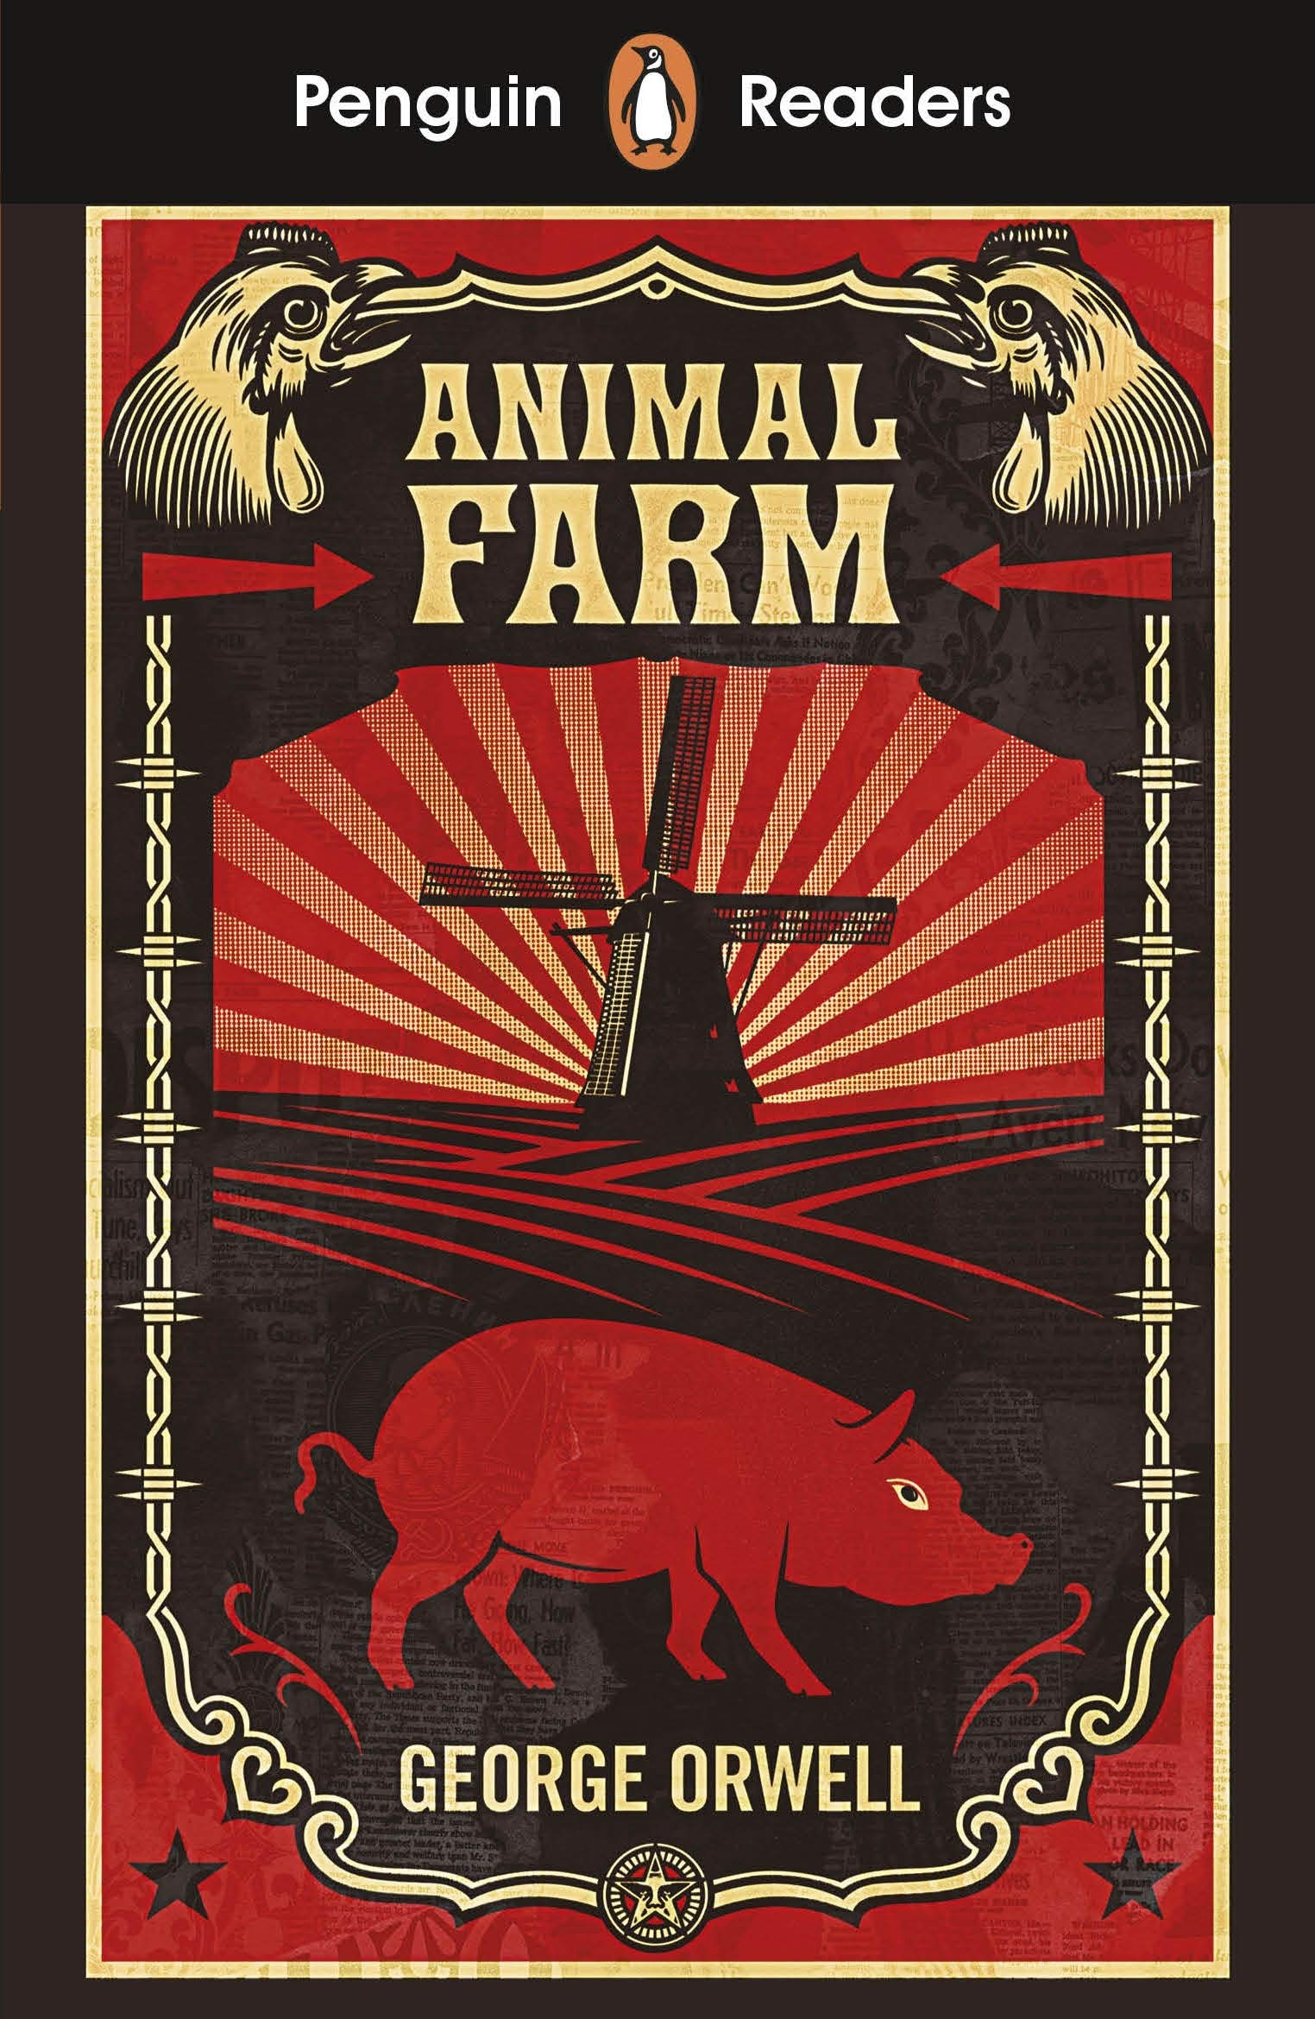

Lesson 1: Animal Farm
L/I: To introduce the novel and the key themes within it

Read Chapter 1
Rebellion - an act of armed resistance to a government or leader
Revolution - a forcible replacement of a government or social order
Comrade - a fellow soldier or member of the armed forces/a member of the same political movement
Tyrannical – exercising power in a cruel way
Why do the animals not like Mr Jones? What makes Old Major so well respected?
Read Old Major’s speech. How does he seek to persuade the animals of his point of view? Identify specific examples from the text (DART).
"Comrades, you have heard already about the strange dream that I had last night. But I will come to the dream later. I have something else to say first. I do not think, comrades, that I shall be with you for many months longer, and before I die, I feel it my duty to pass on to you such wisdom as I have acquired. I have had a long life, I have had much time for thought as I lay alone in my stall, and I think I may say that I understand the nature of life on this earth as well as any animal now living. It is about this that I wish to speak to you.
"Now, comrades, what is the nature of this life of ours? Let us face it: our lives are miserable, laborious, and short. We are born, we are given just so much food as will keep the breath in our bodies, and those of us who are capable of it are forced to work to the last atom of our strength; and the very instant that our usefulness has come to an end we are slaughtered with hideous cruelty. No animal in England knows the meaning of happiness or leisure after he is a year old. No animal in England is free. The life of an animal is misery and slavery: that is the plain truth.
"But is this simply part of the order of nature? Is it because this land of ours is so poor that it cannot afford a decent life to those who dwell upon it? No, comrades, a thousand times no! The soil of England is fertile, its climate is good, it is capable of affording food in abundance to an enormously greater number of animals than now inhabit it. This single farm of ours would support a dozen horses, twenty cows, hundreds of sheep–and all of them living in a comfort and a dignity that are now almost beyond our imagining. Why then do we continue in this miserable condition? Because nearly the whole of the produce of our labour is stolen from us by human beings. There, comrades, is the answer to all our problems. It is summed up in a single word–Man. Man is the only real enemy we have. Remove Man from the scene, and the root cause of hunger and overwork is abolished for ever.
"Man is the only creature that consumes without producing. He does not give milk, he does not lay eggs, he is too weak to pull the plough, he cannot run fast enough to catch rabbits. Yet he is lord of all the animals. He sets them to work, he gives back to them the bare minimum that will prevent them from starving, and the rest he keeps for himself. Our labour tills the soil, our dung fertilises it, and yet there is not one of us that owns more than his bare skin. You cows that I see before me, how many thousands of gallons of milk have you given during this last year? And what has happened to that milk which should have been breeding up sturdy calves? Every drop of it has gone down the throats of our enemies. And you hens, how many eggs have you laid in this last year, and how many of those eggs ever hatched into chickens? The rest have all gone to market to bring in money for Jones and his men. And you, Clover, where are those four foals you bore, who should have been the support and pleasure of your old age? Each was sold at a year old–you will never see one of them again. In return for your four confinements and all your labour in the fields, what have you ever had except your bare rations and a stall?
"And even the miserable lives we lead are not allowed to reach their natural span. For myself I do not grumble, for I am one of the lucky ones. I am twelve years old and have had over four hundred children. Such is the natural life of a pig. But no animal escapes the cruel knife in the end. You young porkers who are sitting in front of me, every one of you will scream your lives out at the block within a year. To that horror we all must come–cows, pigs, hens, sheep, everyone. Even the horses and the dogs have no better fate. You, Boxer, the very day that those great muscles of yours lose their power, Jones will sell you to the knacker, who will cut your throat and boil you down for the foxhounds. As for the dogs, when they grow old and toothless, Jones ties a brick round their necks and drowns them in the nearest pond.
"Is it not crystal clear, then, comrades, that all the evils of this life of ours spring from the tyranny of human beings? Only get rid of Man, and the produce of our labour would be our own. Almost overnight we could become rich and free. What then must we do? Why, work night and day, body and soul, for the overthrow of the human race! That is my message to you, comrades: Rebellion! I do not know when that Rebellion will come, it might be in a week or in a hundred years, but I know, as surely as I see this straw beneath my feet, that sooner or later justice will be done. Fix your eyes on that, comrades, throughout the short remainder of your lives! And above all, pass on this message of mine to those who come after you, so that future generations shall carry on the struggle until it is victorious.
"And remember, comrades, your resolution must never falter. No argument must lead you astray. Never listen when they tell you that Man and the animals have a common interest, that the prosperity of the one is the prosperity of the others. It is all lies. Man serves the interests of no creature except himself. And among us animals let there be perfect unity, perfect comradeship in the struggle. All men are enemies. All animals are comrades."
At this moment there was a tremendous uproar. While Major was speaking four large rats had crept out of their holes and were sitting on their hindquarters, listening to him. The dogs had suddenly caught sight of them, and it was only by a swift dash for their holes that the rats saved their lives. Major raised his trotter for silence.
"Comrades," he said, "here is a point that must be settled. The wild creatures, such as rats and rabbits–are they our friends or our enemies? Let us put it to the vote. I propose this question to the meeting: Are rats comrades?"
The vote was taken at once, and it was agreed by an overwhelming majority that rats were comrades. There were only four dissentients, the three dogs and the cat, who was afterwards discovered to have voted on both sides. Major continued:
"I have little more to say. I merely repeat, remember always your duty of enmity towards Man and all his ways. Whatever goes upon two legs is an enemy. Whatever goes upon four legs, or has wings, is a friend. And remember also that in fighting against Man, we must not come to resemble him. Even when you have conquered him, do not adopt his vices. No animal must ever live in a house, or sleep in a bed, or wear clothes, or drink alcohol, or smoke tobacco, or touch money, or engage in trade. All the habits of Man are evil. And, above all, no animal must ever tyrannise over his own kind. Weak or strong, clever or simple, we are all brothers. No animal must ever kill any other animal. All animals are equal.
"And now, comrades, I will tell you about my dream of last night. I cannot describe that dream to you. It was a dream of the earth as it will be when Man has vanished. But it reminded me of something that I had long forgotten. Many years ago, when I was a little pig, my mother and the other sows used to sing an old song of which they knew only the tune and the first three words. I had known that tune in my infancy, but it had long since passed out of my mind. Last night, however, it came back to me in my dream. And what is more, the words of the song also came back–words, I am certain, which were sung by the animals of long ago and have been lost to memory for generations. I will sing you that song now, comrades. I am old and my voice is hoarse, but when I have taught you the tune, you can sing it better for yourselves. It is called Beasts of England."
Write from the perspective of an animal on the farm. How does it feel to listen to Old Major? (DIP)
Lesson 2: Chapter 2
What did the animals want?
Who was their leader?
Why is this a potential contradiction?

Animal Farm and the Russian Revolution (DART)

The main setting for Animal Farm is the farm where the rebellion of the animals against the tyrannical rule of Mr Jones takes place. While it is true to say the book tells the story of an animal rebellion, Orwell based his fable on the events during and after the Russian revolution of 1917.
In 1917, two revolutions swept through Russia, ending centuries of imperial rule and setting into motion political and social changes that would lead to the formation of the Soviet Union. While the two revolutionary events took place within a few short months, social unrest in Russia had been simmering for decades.
In the early 1900s, Russia was one of the most impoverished countries in Europe with an enormous peasantry and a growing minority of poor industrial workers.
Much of Western Europe viewed Russia as an undeveloped, backwards society. The Russian Empire practiced serfdom—a form of feudalism in which landless peasants were forced to serve the land-owning nobility—well into the nineteenth century. In contrast, the practice had disappeared in most of Western Europe by the end of the Middle Ages.
In 1917, the absolute ruler of the Russian people, Tsar Nicholas II, was overthrown and there was thus a great opportunity to free the workers and peasants from both poverty and tyranny and to allow them to share in their own government. However, the next fifty years of Russian history tell a story of the betrayal of these ideals and the replacement of one tyranny by another.

- How many revolutions took place in Russia in 1917?
- What phrase shows the events that led to these had been developing for a number of years?
- Identify two reasons why Russian people may have been unhappy at this time
- Why did 1917 represent a ‘great opportunity’?
- What does the final line of the extract suggest about how the aftermath of the revolution played out?

Read Chapter 2

Who created the seven commandments? How else do they influence events in this chapter? How are Napoleon, Snowball and Squealer each described?

How has the mood changed on the farm? (DIP)

Lesson 3: Unity in Animal Farm

L/I: To evaluate the extent to which the animals are united in their cause

- Why was there a rebellion at the start of the novel?
- To what extent was it successful?
- What roles are being played by Napoleon, Snowball and Squealer?

The Russian Civil War (DART)

In 1917, the absolute ruler of the Russian people, Tsar Nicholas II, was overthrown. There were many different groups of revolutionaries, all inspired by the Communist teachings of Karl Marx, who had died in 1883. Marx believed a conflict between capitalists and the working class would ultimately lead to a revolution in which the working class would overthrow the capitalist class and seize control of the economy.
Immediately following the revolution, civil war broke out between the revolutionaries and it was the Red Army of the Bolsheviks, led by Lenin and Trotsky who triumphed, despite intervention from foreign governments, including Britain, who were fearful of revolutionary feelings spreading to their own people.
The Soviet Union, as Russia was now renamed, tried rapidly to modernise its industry and its agriculture, but after the death of Lenin there was a power struggle for leadership between Josef Stalin, the General Secretary of the Communist Party, and Trotsky. Trotsky was a brilliant intellectual, but lacked the ruthlessness and cunning of Stalin, and he was finally driven into exile in 1929.

- Who inspired the revolutionaries?
- What did he believe?
- What followed the revolution?
- Why did foreign countries involve themselves?
- Who won the power struggle?
- How does a power struggle contradict the aims of the revolution?

Read Chapter 3

What did the pigs do with the milk and apples? How does this fit with the principles of Animalism?

Read Chapter 4

What did Napoleon do during the Battle of the Cowshed? How did the animals celebrate their victory?

To what extent are the animals united in the pursuit of their cause? (DIP)

Lesson 4: Fear in Animal Farm

L/I: To analyse the presentation of fear in the novel

Intimidation – behaviour which intentionally causes someone to fear injury or harm

Manipulation - social influence that tries to change the behaviours or perceptions of others

Control - power to influence or direct people’s behaviour or the course of events

Read Chapter 5

What is the most significant development? How is fear presented?

Explode each of the following quotations (DART):

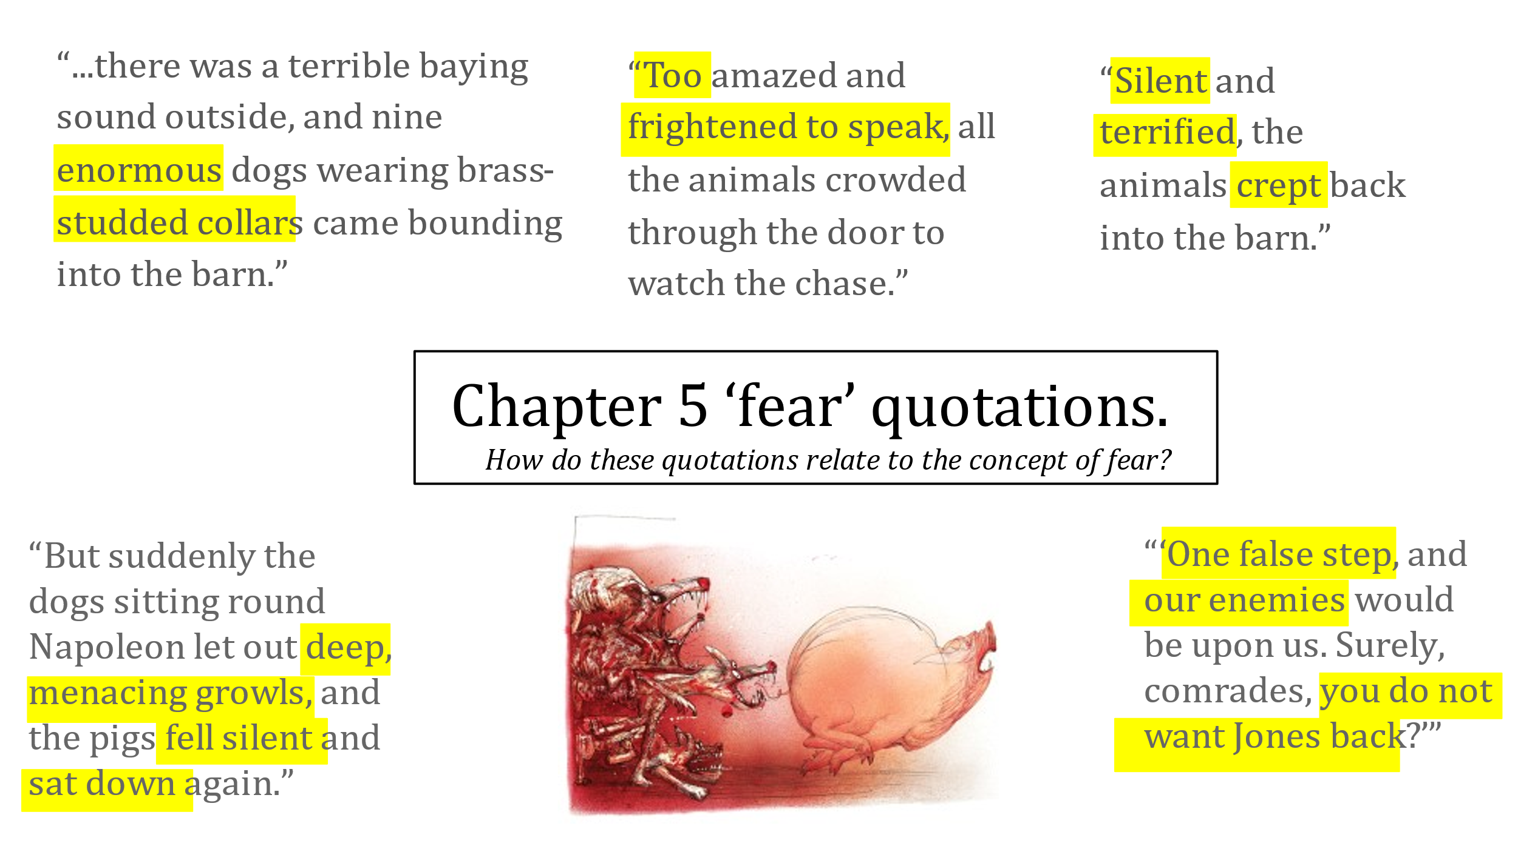

How is fear presented in Animal Farm? (DIP)

Lesson 5: Loyalty

L/I: To respond creatively to the text

Loyalty – the quality of being faithful to something or someone else

Betrayal – the violation of a person’s trust or confidence

Propaganda - the dissemination of information—facts, arguments, rumours, half-truths, or lies—to influence public opinion

Soviet Propaganda (DART)

The years from 1927 to 1938 saw Stalin wield near-absolute power over the Soviet Union. To maintain control and crush dissent—real or imagined—millions of citizens were executed or sent to the Gulag where many died, and any group within the Communist Party which looked like it might form a faction was purged. Fear of attack from the West spread, and hoped-for revolutions in Germany and other Western nations failed. Stalin, therefore, shifted rhetoric and policy from the traditional Marxist aim of international proletarian revolution to “socialism in one country.” In effect, this meant less talk about workers throughout the world and more talk of the Russian people—and of their heroic leader. If Stalin’s measures were iron-fisted, it was because Mother Russia was threatened by invasion, by spies, and by other class enemies.
Before Stalin took full control of the party, many Soviet propaganda films dealt with the themes of continuing the ideals of the Revolution, unifying the people, and preserving Bolshevik leadership. Some of these themes would continue into the Stalin years, but the focus shifted towards ideas about the “New Soviet Person” – the idea that illiterate workers and superstitious peasants would need to improve themselves
The reality of collectivization fell far short of what was promised to the peasants; it was a disastrous failure, largely responsible for famine and the deaths of millions. These embarrassing failures of the Communist Party’s policy made its defence in propaganda that much more important. Unlike the harsh reality of collectivization in the present, propaganda films were intended to reassure the people of the new future that collectivization would (supposedly) soon bring them.

- How is Stalin’s power described?
- How did he maintain control?
- What was the ‘traditional Marxist aim’?
- How did Stalin ‘shift the rhetoric’?
- How did he justify his ‘iron-fisted’ measures?
- What was the ‘new Soviet Person’?
- What was the reality of collectivisation?
- Why did this make propaganda more important?
- Why is supposedly in brackets?
- How could this be linked to Animal Farm?

Read Chapter 6

How does Napoleon’s behaviour change?
Who becomes the spokesman for the pigs?
How does he justify the move into the house?
Who does Napoleon blame for the windmill?
How does this represent propaganda?
How does this contradict with the original values of the revolution?

Write from the perspective of a loyal follower. Why are you loyal and what do you believe? (DIP)

Lesson 6: Chapter 7

L/I: To analyse the presentation of power in Animal Farm

- Who is the most powerful animal on the farm?
- Why is this?
- How does this fit with the aims of the rebellion?
Dictatorship – government by a dictator (a political leader with absolute power)

Totalitarian - a form of government that attempts to assert total control over the lives of its citizens
Read Chapter 7

Who is blamed for worsening conditions on the farm?
What happens to those who rebel against Napoleon?
What is important about Squealer’s version of the Battle of the Cowshed?
To what extent is the farm now a dictatorship?
What is power and what makes somebody powerful?
What responsibilities do those with power have?

Extract from Chapter 7 (DART)

Only Boxer remained on his feet. He fidgeted to and fro, swishing his long black tail against his sides and occasionally uttering a little whinny of surprise. Finally he said:
“I do not understand it. I would not have believed that such things could happen on our farm. It must be due to some fault in ourselves. The solution, as I see it, is to work harder. From now onwards I shall get up a full hour earlier in the mornings.”
And he moved off at his lumbering trot and made for the quarry. Having got there he collected two successive loads of stone and dragged them down to the windmill before retiring for the night.
The animals huddled around Clover, not speaking. The knoll where they were lying gave them a wide prospect across the countryside. Most of Animal Farm was within their view — the long pasture stretching down to the main road, the hayfield, the spinney, the drinking pool, the ploughed fields where the young wheat was thick and green, and the red roofs of the farm buildings with the smoke curling from the chimneys. It was a clear spring evening. The grass and the bursting hedges were gilded by the level rays of the sun. Never had the farm — and with a kind of surprise they remembered that it was their own farm, every inch of it their own property — appeared to the animals so desirable a place. As Clover looked down the hillside her eyes filled with tears. If she could have spoken her thoughts, it would have been to say that this was not what they had aimed at when they had set themselves years ago to work for the overthrow of the human race. These scenes of terror and slaughter were not what they had looked forward to on that night when old Major first stirred them to rebellion. If she herself had any picture of the future, it had been of a society of animals set free from hunger and the whip, all equal, each working according to his capacity, the strong protecting the weak, as she had protected the lost brood of ducklings with her foreleg on the night of Major’s speech. Instead — she did not know why — they had come to a time when no one dared speak his mind, when fierce, growling dogs roamed everywhere, and when you had to watch your comrades torn to pieces after confessing to shocking crimes. There was no thought of rebellion or disobedience in her mind. She knew that even as things were they were far better off than they had been in the days of Jones, and that before all else it was needful to prevent the return of the human beings. Whatever happened she would remain faithful, work hard, carry out the orders that were given to her, and accept the leadership of Napoleon. But still, it was not for this that she and all the other animals had hoped and toiled.

- Who stayed on their feet?
- Which word shows how he felt about this? What does this suggest?
- What does he see as the solution to their problems?
- What does he commit to do?
- Identify three things the animals could see on the farm.
- Why was the farm so desirable to them?
- What had Clover’s ambition been?
- What had happened instead?
- What is a rebellion?
- Was Clover going to be a rebel?

Write a description of the most powerful person in the world. This can be real or imagined (DIP).

Lesson 7: Turning Point

L/I: To analyse Orwell’s use of language to create mood

- What was the purpose of ‘Beasts of England’?
- How can music express identity?
- What is a turning point?

Read Chapter 8

How have the commandments changed? What does this suggest about the situation on the farm?

Extract from Chapter 8 (DART)

A few days later, when the terror caused by the executions had died down, some of the animals remembered–or thought they remembered–that the Sixth Commandment decreed "No animal shall kill any other animal." And though no one cared to mention it in the hearing of the pigs or the dogs, it was felt that the killings which had taken place did not square with this. Clover asked Benjamin to read her the Sixth Commandment, and when Benjamin, as usual, said that he refused to meddle in such matters, she fetched Muriel. Muriel read the Commandment for her. It ran: "No animal shall kill any other animal without cause." Somehow or other, the last two words had slipped out of the animals' memory. But they saw now that the Commandment had not been violated; for clearly there was good reason for killing the traitors who had leagued themselves with Snowball.
Throughout the year the animals worked even harder than they had worked in the previous year To rebuild the windmill, with walls twice as thick as before, and to finish it by the appointed date, together with the regular work of the farm, was a tremendous labour. There were times when it seemed to the animals that they worked longer hours and fed no better than they had done in Jones's day. On Sunday mornings Squealer, holding down a long strip of paper with his trotter, would read out to them lists of figures proving that the production of every class of foodstuff had increased by two hundred per cent, three hundred per cent, or five hundred per cent, as the case might be. The animals saw no reason to disbelieve him, especially as they could no longer remember very clearly what conditions had been like before the Rebellion. All the same, there were days when they felt that they would sooner have had less figures and more food.
All orders were now issued through Squealer or one of the other pigs. Napoleon himself was not seen in public as often as once in a fortnight. When he did appear, he was attended not only by his retinue of dogs but by a black cockerel who marched in front of him and acted as a kind of trumpeter, letting out a loud "cock-a-doodle-doo" before Napoleon spoke. Even in the farmhouse, it was said, Napoleon inhabited separate apartments from the others. He took his meals alone, with two dogs to wait upon him, and always ate from the Crown Derby dinner service which had been in the glass cupboard in the drawing-room. It was also announced that the gun would be fired every year on Napoleon's birthday, as well as on the other two anniversaries.

- How had the sixth commandment changed?
- What did Benjamin say when asked about it?
- In what ways did the animals work harder than ever before?
- How did this compare to Jones’ day?
- How did production on the farm increase?
- Who told the animals this?
- How did they feel about it?
- Who accompanied Napoleon in public?
- Where did Napoleon sleep?
- When would the gun be fired?

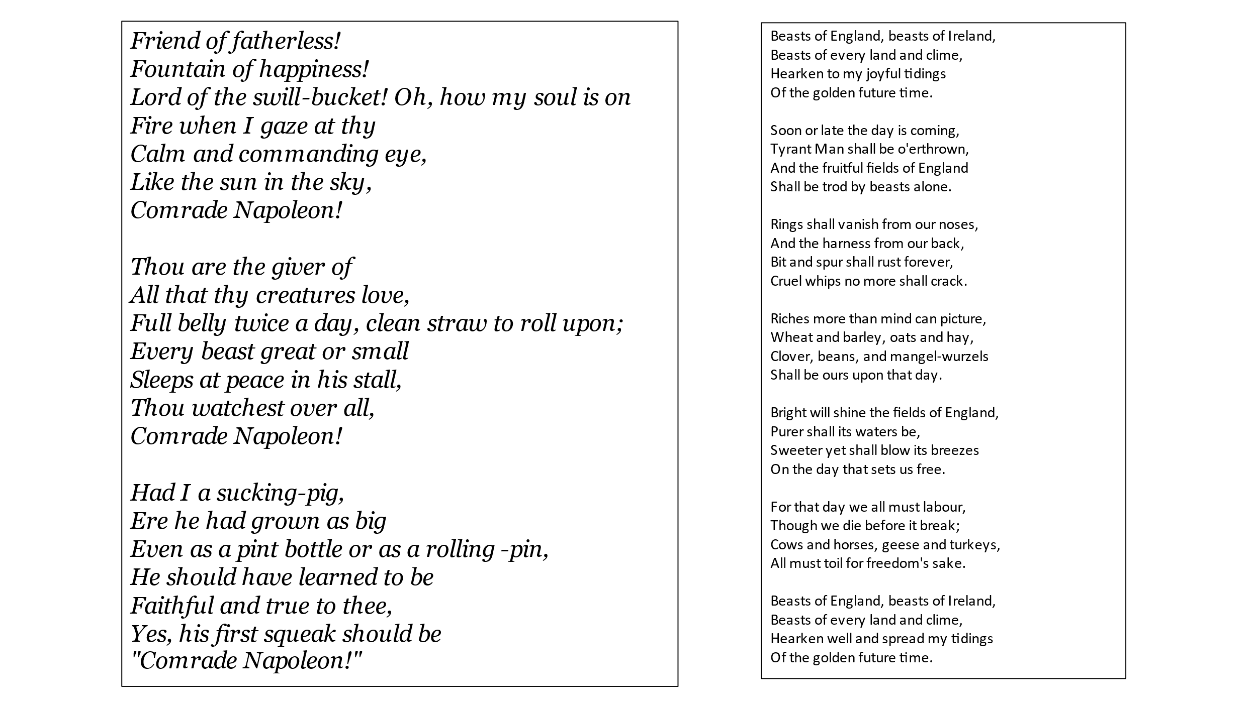

Identify three quotations from each song. How has the language changed?

How does Orwell use song lyrics in chapter 1 and chapter 8 to show the changes that have taken place on the farm? (DIP)

Lesson 8: The End of the Novel

L/I: To read and respond to the end of the novel

Read Chapter 9

What happens to Boxer? Why is this significant?

Read Chapter 10

Why has the rebellion proved pointless for most of the animals? ‘The creatures outside looked from pig to man, and from man to pig, and from pig to man again; but already it was impossible to say which was which’. Why is this ending so famous?

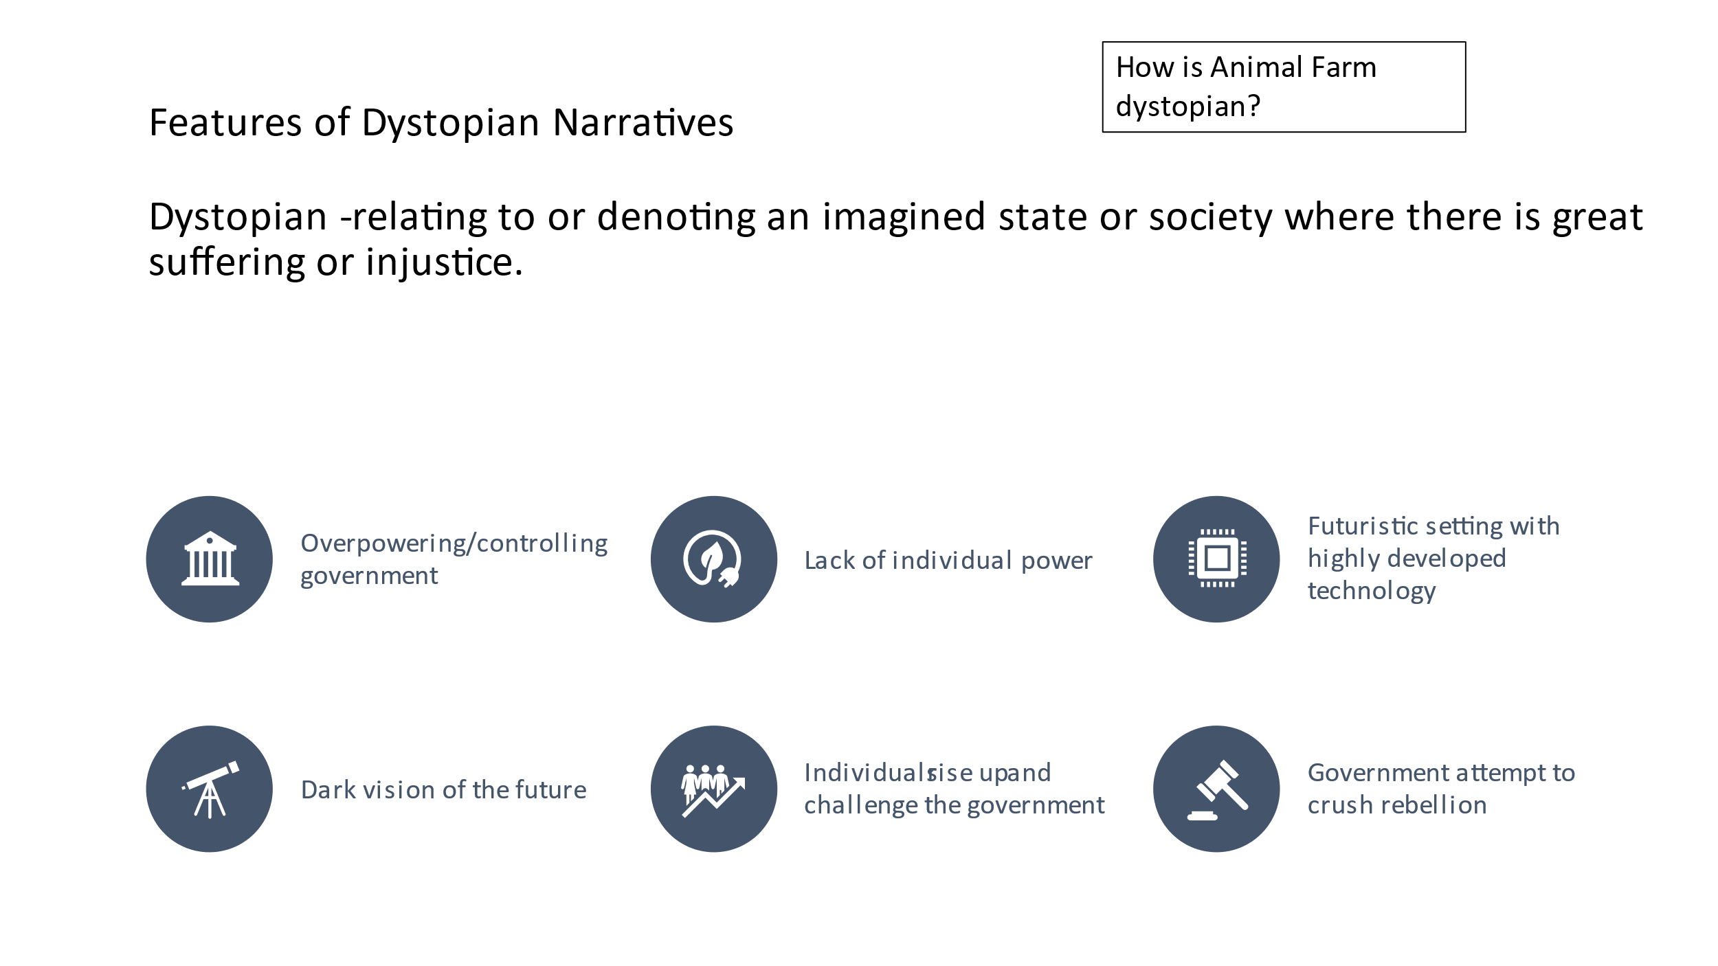
Comparison of Russian Revolution and Animal Farm (DART)

- 1859 Marx and Engels publish The Communist Manifesto. Animal Farm: Old Major lists the tenets of Animalism
- 1917 March Czar Nicholas II abdicates. A provisional republic is established. November Bolsheviks seize power. Animal Farm: Animals drive out Jones.
- 1918 The Communist Party is established. Animal Farm: Pigs take control of the farm.
- 1918-1920 Red Army, led by Trotsky, defeats Whites in the Civil War. Animal Farm: Animals, led by Snowball, defeat Jones at the Battle of the Cowshed.
- 1924 Lenin grows ill; Stalin and Trotsky compete for power. Animal Farm: Napoleon and Snowball compete for power.
- 1925 Trotsky is ousted and goes into exile. Animal Farm: Snowball is driven off the farm.
- 1928 Stalin crushes revolt by farmers who refuse to surrender their harvests. Animal Farm: Napoleon crushes revolt by hens who refuse to surrender their eggs.
- 1932 Massive famine in Soviet Union after farm production drops. Animal Farm: Animals suffer from hunger after farm harvest declines.
- 1933 Soviets begin limited trading with the West. Animal Farm: Napoleon begins limited trading with humans.
- 1934-38 Great Purge: Stalin uses secret police to eliminate opposition. Animal Farm: Napoleon uses dogs to eliminate opposition.
- 1939 Stalin signs Non-Aggression Pact with Hitler. Animal Farm: Napoleon makes timber deal with Frederick.
- 1940 Germans invade Soviet Union. Russians stop the invasion but suffer heavy
- losses. Animal Farm: Men, led by Frederick, invade the farm and destroy the
- windmill. The animals drive them off but suffer heavy losses.
- 1943 Western leaders, led by Roosevelt and Churchill, meet with Stalin. Animal Farm: Pilkington and other humans have dinner with Napoleon.

‘All animals are equal’. Why did the dream not work out? (DIP)

Lesson 9: Power and Social Class

L/I: To analyse the themes of power and social class in the novel

- Identify three direct comparisons between the Russian Revolution and Animal Farm
- Why are these important?
- What is Orwell’s point about human nature?

Animal Farm and the Russian Revolution (DART)

In 1943 the British people were full of admiration for the bravery of the Russians, led by the Communist dictator, Stalin. They were fighting against the Germans who had invaded their country. The British were dazzled by this heroism and could not see any of the faults of Communism. Orwell was a major critic of Communism following his experiences fighting in the Spanish Civil War, and he was worried the British Communists were preventing the truth about Stalin and Russia from being made known to the people. Animal Farm was to be Orwell’s alarm call to Britain and the world. Orwell was wary of totalitarianism and dictatorships, but he believed these types of leaders would be replaced by others like them unless we learn the lessons that Animal Farm is trying to teach.
How then do dictators rise to power and maintain this power? Napoleon shows us how. He begins by being part of a powerful organisation (the pig elite) but is selfish and determined (he keeps the milk for himself); he builds up a group of followers and ejects those who argue against him (the four young porkers) or who are powerful rivals (Snowball). He maintains power through terror (the dogs and the executions) and by manipulating the truth and controlling history through propaganda and the media (Squealer). He introduces a cult of personality (he seldom appears and only then accompanied by great ceremony) and makes himself indispensable to the people by confusing and frightening them about what would happen if he were not there (blaming Snowball for everything that does wrong and suggesting that Mr Jones might return).
The rivalry between Napoleon and Snowball is intended to replicate that between Trotsky and Stalin. Neither would agree with each other’s proposals and ideas about how the rebellion should proceed, but Napoleon eventually triumphed because of Snowball’s increasing obsession with his plans for the Windmill and because Napoleon had been secretly training Jessie and Bluebell’s puppies as his brutal agents of control (the KGB). Snowball, like Trotsky, was driven into exile, leaving the way free for Napoleon, like Stalin, to become more and more selfish, brutal and dictatorial.

- Why did the British admire Russia in 1943?
- What did Orwell intend Animal Farm to be?
- Identify five ways in which Napoleon establishes and maintains power
- What is the rivalry between Napoleon and Snowball meant to replicate?
- What happened to Snowball and Trotsky?

- "All men are enemies. All animals are comrades."-
- "The animals were happy as they had never conceived it possible to be. Every mouthful of food was an acute positive pleasure, now that it was truly their own food, produced by themselves and for themselves, not doled out to them by a grudging master."
- "I will work harder!“
- "FOUR LEGS GOOD, TWO LEGS BAD"
- "It was given out that the animals there practiced cannibalism, tortured one another with red-hot horseshoes, and had their females in common. This was what came of rebelling against the laws of Nature, Frederick and Pilkington said."
- "'I have no wish to take life, not even human life,' repeated Boxer, and his eyes were full of tears."
- "Napoleon is always right."
- "All that year the animals worked like slaves. But they were happy in their work; they grudged no effort or sacrifice, well aware that everything they did was for the benefit of themselves and those of their kind who would come after them, and not for a pack of idle, thieving human beings."
- "The human beings did not hate Animal Farm any less now that it was prospering; indeed, they hated it more than ever."
- "They were always cold, and usually hungry as well."
- "If she herself had had any picture of the future, it had been of a society of animals set free from hunger and the whip, all equal, each working according to his capacity, the strong protecting the weak."
- "They had come to a time when no one dared speak his mind, when fierce, growling dogs roamed everywhere, and when you had to watch your comrades torn to pieces after confessing to shocking crimes."
- "Some of the animals remembered -- or thought they remembered -- that the Sixth Commandment decreed, 'No animal shall kill any other animal.' And though no one cared to mention it in the hearing of the pigs or the dogs, it was felt that the killings which had taken place did not square with this."
- "Besides, in those days they had been slaves and now they were free, and that made all the difference, as Squealer did not fail to point out."

How does Orwell present power in Animal Farm? (DIP)

