ICT KS3 Year 8 Summer 1 Blended Learning Booklet
Using Spreadsheets in Business

Name:
Form:
Aim to complete one lesson each week. Write out the title and LI and then complete the tasks.
The Knowledge Organiser on page 4 and 5 have some key information and vocabulary to help you with this unit.
Upload all work onto ClassCharts for feedback.

Contents
Page3: Big Picture - Year 8 Overview
Page 4 - 6: Lesson 1
Page 7 - 10: Lesson 2
Pages 11 - 14: Lesson 3

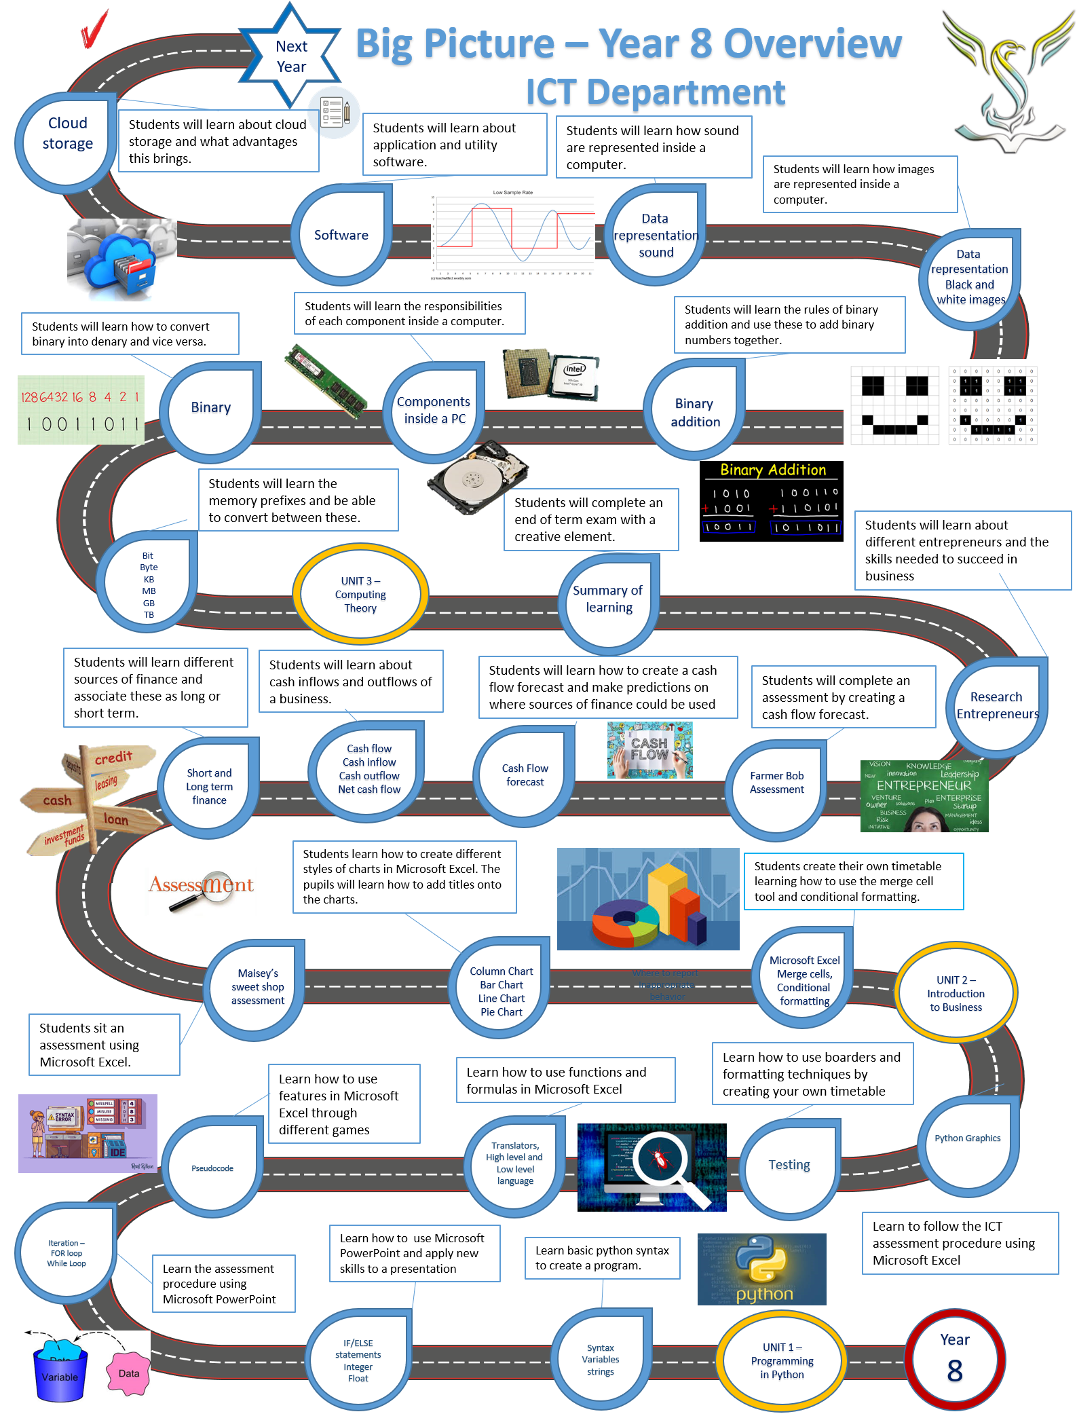

Lesson 1
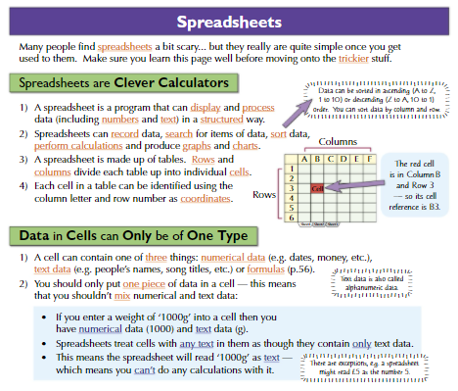
LI: to learn some basics around spreadsheets
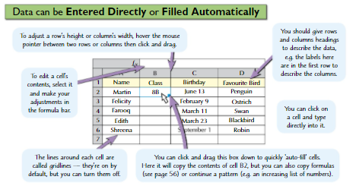
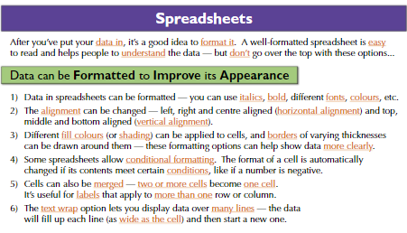

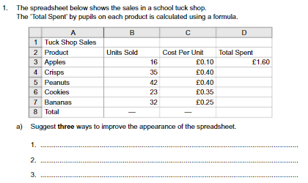

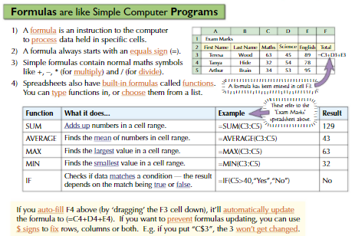
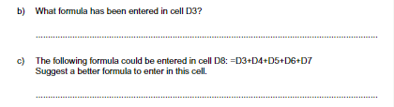

Task

Open your spreadsheet software and try to create your school timetable. You will need to change the size of the columns and rows. Try to use colour to improve the appearance of your timetable.

Lesson 2: to learn some key concepts of spreadsheets
- How much does one eye cost? ______________
- What is the cell reference of the item cost of stuffing? ______________
- What must all formulae start with? _________________
- Cell D7 contains a formula. Write down this formula __________________
- The spreadsheet should work out the profit made if the toy is sold for £5.50. (Profit is the difference between the cost to make something and how much it is sold for)
  - What changes would you need to make to the spreadsheet?
____________________________________________________
  - Add the changes to the diagram below:
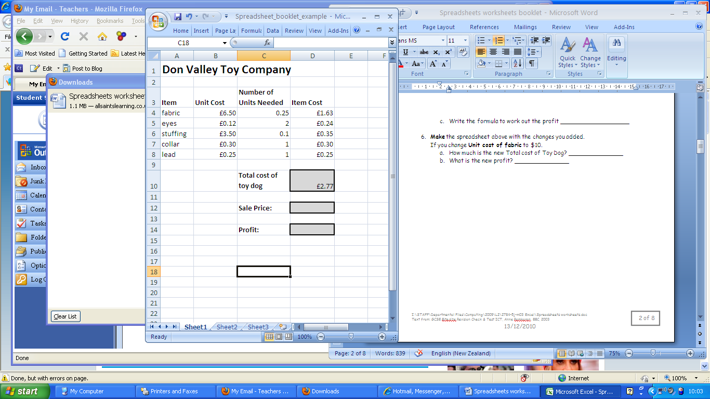
  - Write the formula to work out the profit ___________________

- Make the spreadsheet above with the changes you added.
If you change Unit cost of fabric to £10.
  - How much is the new Total cost of Toy Dog? _______________
  - What is the new profit? _______________
Spreadsheet Wordsearch 1
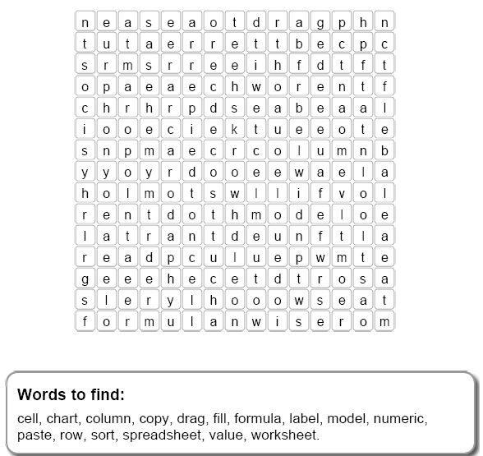

Choose carefully from the words above to complete these sentences:

- Each page of a spreadsheet is called a __________________
- A heading or a word used so the numbers make sense is called a __________________
- Each numbered horizontal line across the page is a __________________
- A __________________ is a set of vertical lines with a letter at the top
- A graph showing data is a __________________
- A calculation is made by using a __________________
- You can quickly __________________ a formula into other cells using __________________ down.

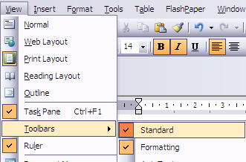
Finding Out
The picture below is part of Excel’s Standard Toolbar
(Click: View – Toolbars – Standard)

- Write in each box what the icons is for

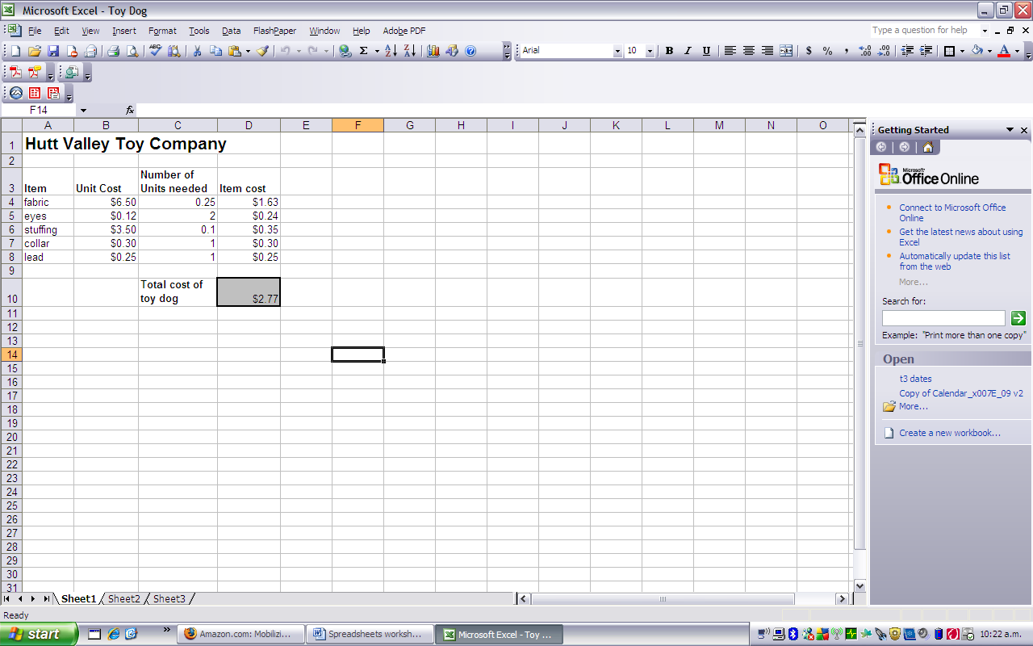
- Add the keyboard shortcuts
Format Painter
PASTE
Ctrl + __v_

Ctrl + ____

Ctrl + ____

Ctrl + ____

- Click on the AutoSum function button then Fill in the gaps below to list the other Autosum functions:
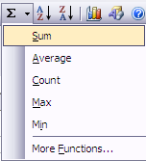
d.
c.
b.
a.
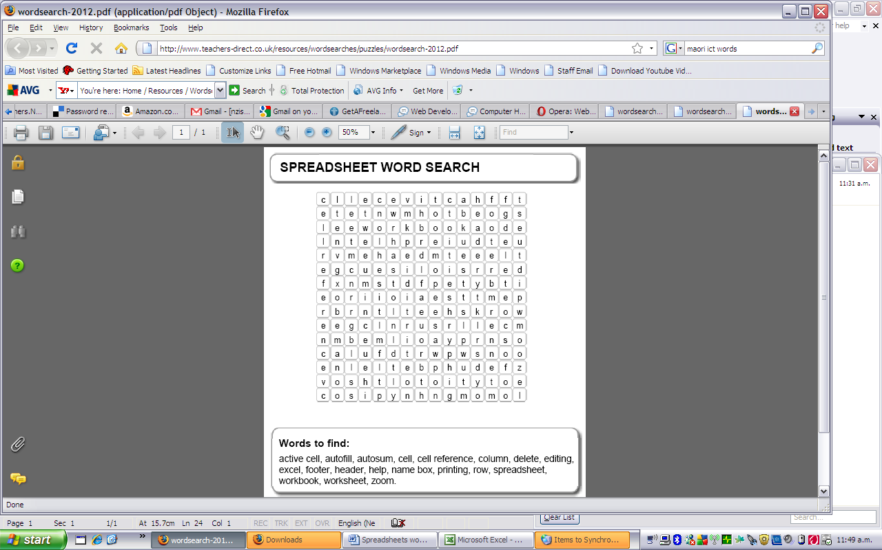
2

Choose carefully from the words above to complete these sentences:

- B8 is an address of a cell or a _____________________
- It is important to put your name at the top of the page in the __________________ before __________________ .
- A quick way to find a total from a range of cells is ___________________
- A part of the spreadsheet currently selected is the __________________
- You can add the date or page number to the bottom of the page if you customise the ______________ .
- To find out how to use the software, look in the ____________ menu.

Lesson 3: to learn the advantages of spreadsheets

What are the Advantages of Spreadsheets?
Spreadsheets are more useful than a calculator for many purposes.

Advantages:
- It can be saved and reused
- Headings and labels can be used, so numbers make sense
- All the intermediate steps in calculation can be seen
- The spreadsheet can be printed out
- Data can be changed and the spreadsheet will automatically update and produce new answers

Calculator
The calculator is more useful than the spreadsheet when:
- The calculation only has to be done once.
- Only the final answer s needed – there is no need to have headings or show intermediate answers
- There is no computer available
- The person doing the calculation doesn’t know how to use the spreadsheet software.
- A spreadsheet can be sent by email to another person
- The data in a spreadsheet can be used to produce graphs and charts

Test Yourself
Mrs Thompson and the Student Council are working out how to spend the funds raised by the Work Day on sports equipment.

- Give three reasons why a spreadsheet would be useful for this task

- Give two reasons why Mrs Thompson may decide not to use a spreadsheet.

How much do you remember about spreadsheets?

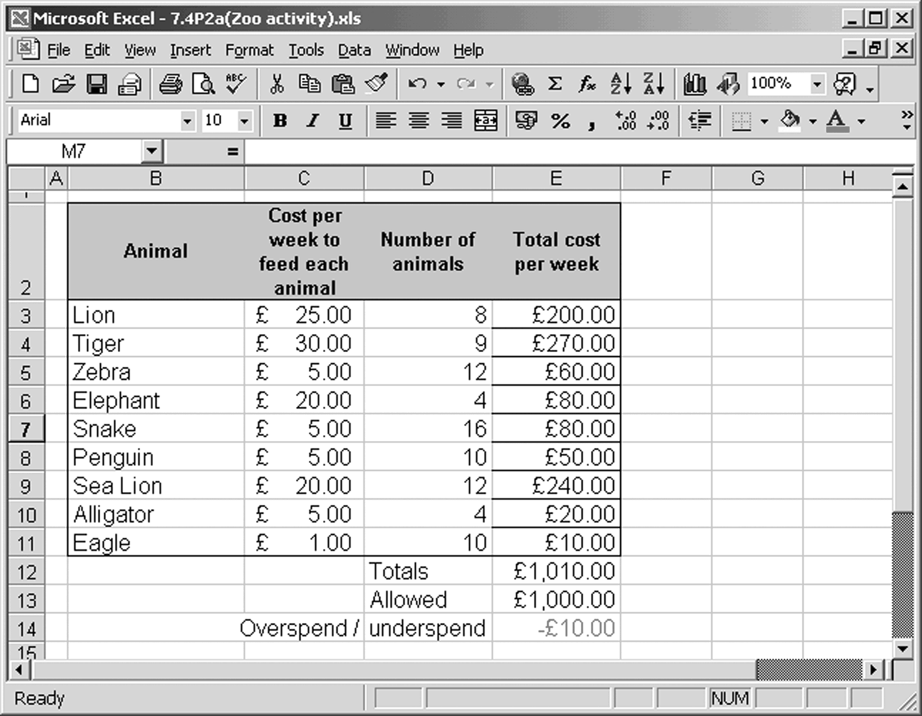

1 Look at the screen shot of a financial model of a zoo and answer these questions.

a How much does it cost to feed the lions?
b How much is spent in total each week?
c Is the zoo overspending or underspending?
2 This model is created with a spreadsheet. Label these parts of a spreadsheet on the screenshot above.

cell, column, row, label, numeric data, print button, save button, Chart Wizard button, Sort button

3 Are spreadsheets always the best tools? Look at the chart below and tick the boxes for each activity.

Spreadsheets are  the best tool to help: | True | False | Not sure
Draw pictures
Store numeric data
Draw charts and
graphs
Present information
Write reports
Make calculations

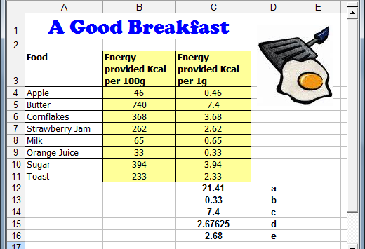

Some formulae have been written in cells C12, C13, C14, C15 and C16. l what you think each formula is doing.

 | Cell Reference | Formula | What do you think this formula is doing?
a | C12 | =SUM(C4:C11)
b | C13 | =MIN(C4:C11)
c | C14 | =MAX(C4:C11)
d | C15 | =AVERAGE(C4:C11)
e | C16 | =ROUND(C15,2)

