English Year 7 Autumn 2 Blended Learning Booklet
Telling Tales
Name:
Form:
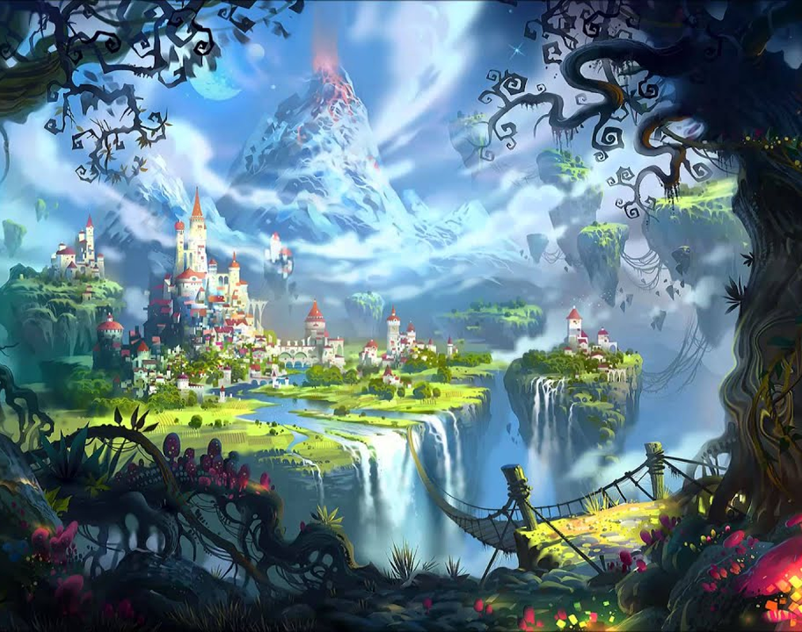

Page | Lesson Number | Title
3 | N/A | Y7 Overview
4 | N/A | Zoom In: Unit 2 Telling Tales
5 | N/A | Knowledge Organiser
6 | 1 | Introduction
8 | 2 | Genre
9 | 3 | History of Fairytales
11 | 4 | Conventions of Fairytales
12 | 5 | Morality in Fairytales
16 | 6 | Character Types
17 | 7 | Heroes and Villains
23 | 8 | Modern Heroes
24 | 9 | Story Types
25 | 10 | Narrative Structure
28 | 11 | Change Over Time
29 | 12 | Modern Fairytales
32 | 13 | Narrative v Descriptive Writing
34 | 14 | Setting in Fairytales
36 | 15 | Perspective
37 | 16 | Writing a Fairytale 1
38 | 17 | Writing a Fairytale 2
38 | 18 | Fairytale Poetry

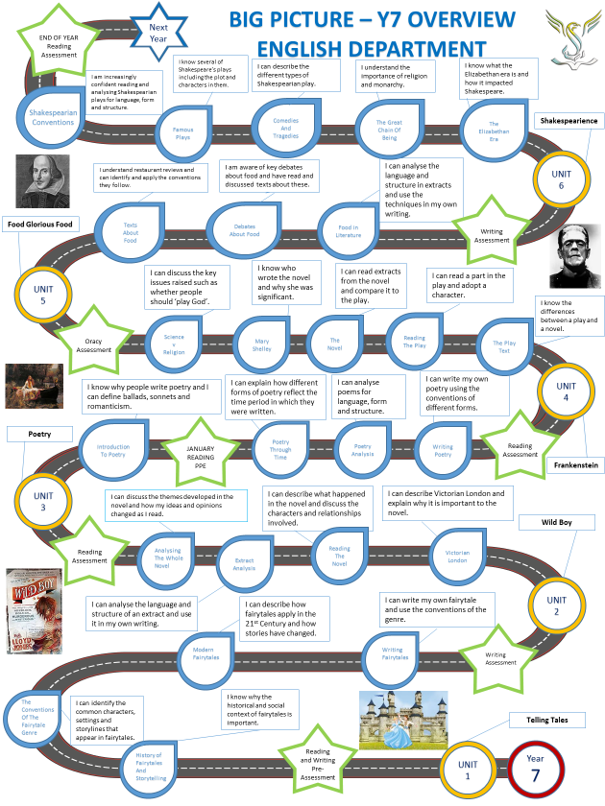

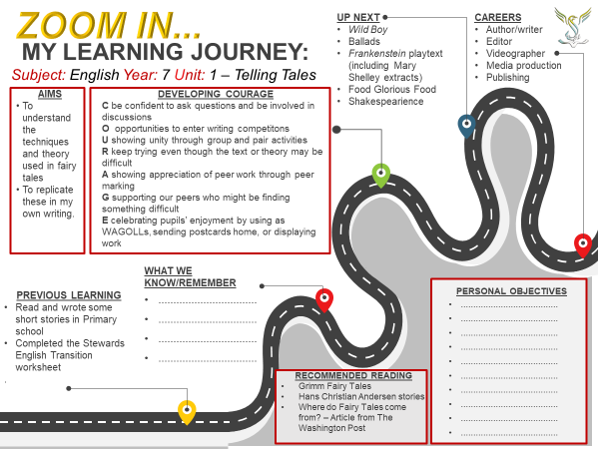
Year 7 English  Knowledge Organiser  Telling Tales | - Subject Terminology  Genre  Fairy-tale  Character  Convention  Archetype  Context  - Write a definition for each  - CHALLENGE: Can you think of at least three examples for each key word? | - History of Fairytales  Early fairytales were performed for Kings and Queens.  Many fairytales were well established stories and, while they didn’t always have a happy ending, they did include a moral  Women often used the stories to protest the unhappy lives’ society forced them into.  The Grimm brothers began to soften fairytales, so they appealed to children, often including a ‘warning’  Walt Disney made his first animated film (Snow White) in 1937 | - Conventions of Fairytales  - Magic/spells/curses  - Royalty  - Moral  - Love  - Once upon a time…  - Talking animals  - And they lived happily ever after…  - Castles  - Singing  - A problem that needs solved  - Hero and Villains  - A land far, far away…  Can you divide these in to the following four categories?  Story, setting, characters, language
- Propp’s Character Types  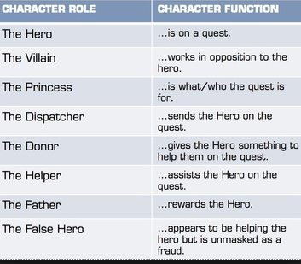 | - Booker’s Seven Storytypes  - Overcoming the Monster  - Rebirth  - Quest  - Journey and Return  - Rags to Riches  - Tragedy  - Comedy  Write an example for each: | - Narrative v Descriptive  - Write a definition for each of these terms  - What is the difference between narrative writing and descriptive writing?  Todorov’s Narrative Theory  - Equilibrium (everything as it should be)  - Disruption (by an event or emerging problem)  - Recognition of disruption  - Attempts to repair disruption  - Return to/establishment of new equilibrium | Writing a Fairytale Checklist  - Once upon a time…  - And they lived happily ever after  - Good/evil characters  - Magical setting  - Problem  - Solution  - Ambitious Vocabulary  - Varied sentence structures  - Similes  - Metaphors  - Have you used your magpie grid?  - Have you used your spelling words?

Lesson 1: Introduction

L/I: To understand the expectations of the unit and demonstrate existing skills and knowledge.

DART
Her godmother only just touched her with her wand, and, at the same instant, her clothes were turned into cloth of gold and silver, all beset with jewels. This done, she gave her a pair of glass slippers, the prettiest in the whole world. Being thus decked out, she got up into her coach; but her godmother, above all things, commanded her not to stay till after midnight, telling her, at the same time, that if she stayed one moment longer, the coach would be a pumpkin again, her horses mice, her coachman a rat, her footmen lizards, and her clothes become just as they were before.
Why did her clothes change?

What phrase shows this happened very quickly?
Identify three details about her appearance (after it changed)
Which word shows she could not stay after midnight?
Identify the things that would happen if she did
Vocabulary: You will write your own fairytales and adapt those that already exist. A well-developed vocabulary (we teach you new words each week) helps improve writing. Fill in the rows with words you could use to replace each original (and slightly boring!) word.
Happy | Scared | Sad | Nice | Pretty

Shiny | Little | Bad | Good | Big
Subject terminology is very important in English. Can you answer the following questions?
What is the difference between fiction and non-fiction?
What is a genre?
What is a convention (in literature)?
What is context?
What is the difference between a simile and a metaphor?
What is alliteration?
What is the difference between a noun and a verb?
What does an adjective describe?
What does an adverb describe?
What is a pronoun?

DIP
Write a description of this image.
Key Questions
- How many fairytales can you name?
- Do you have a favourite fairytale?
- Who do you think fairytales were written for?
- What type of things to you expect to see in a fairytale?
- Why is good description important to a story?
- How might a reader feel if there is little or no description?

Lesson 2: Genre

L/I: To understand how different genres use conventions.

A genre is a style or category of art, music, or literature.
A convention is a feature of a genre.
DART
Fill in the table by matching the following genres to the correct definition: Romance, Western, Comedy, Fairytale, Action, Horror, Spy Films, Sci-Fi
Match the examples to the genres: Star Wars, James Bond, Love Actually, Inbetweeners, Django Unchained, Cinderella, Die Hard, Woman in Black
Genre | Definition | Example
 | Deals with imaginative and futuristic concepts
 | Seeks to scare the audience
 | Love stories
 | Cowboys and gunfights
 | A short story with a moral
 | Tracking the activities of government agents
 | Designed to make people laugh
 | A series of events including violence, fighting and chases

DIP
Choose the genre you are most familiar with and write three sentences to describe a character and three sentences to describe a typical setting for this genre. This can be based on characters or settings that already exist. Use as much descriptive language as possible in your writing.
Key Questions
- Do you like to know what a film is about before you watch it?
- Can you define the word genre?
- Can you name examples of different genres?
- Can you explain why advertisers want people to know the genre of a film or book?
- Are there certain types of characters you expect to find in certain types of stories?
- Can you name a place you would expect a horror story to take place?

Lesson 3: History of Fairytales

L/I: To know and understand the historical and social context of the fairytale genre.

DART
Read the text and answer the questions in full sentences.
Origins of Fairytales
Once upon a time, fairytales were not written for children; they were performed for kings and queens for their entertainment, but always with a moral at the end. Although Charles Perrault, Hans Christian Andersen and Wilhelm and Jakob Grimm are remembered now for writing many fairytales down, most were already well-established stories.
In fact, many of the original stories were created and told by women, featuring wicked witches, ugly hags, beautiful princesses, and evil stepmothers. These women’s stories did not always have happy endings – often the women ended up in disgrace – it seems that women used the stories to protest against the unhappy lives that society forced them into: unhappy marriages they could not escape; being forced to do whatever their father or husband told them to do; working extremely hard while many men did not need to.
- Who were fairytales originally written for?
- What did fairytales always include at the end?
- Who originally created many stories and why?
Evolution of Fairytales
These tales evolved as they were passed down from mother to daughter and became tales of morality: Little Red Riding Hood teaches children not to go to the woods alone; Hansel and Gretel teaches that intelligence will save you; purity and virtue is taught through Snow White, Cinderella and Sleeping Beauty.
However, as Perrault and the brothers Grimm began recording their tales they switched the focus from the meek maidens to the handsome, charming princes. Although we think of most fairytales as being European, there is in fact evidence of a Cinderella-like story being written in China around 850AD, and there are hundreds of different versions of the tale from around the world but all include the cast-out daughter, the wicked step-family and the eventual marriage with the prince thanks to the item left behind at the ball.
- How were tales originally passed on?
- What did Little Red Riding Hood teach children?
- What did one other fairytale teach children?
- Where did the tale Cinderella originate?
The Grimm Brothers
The Grimm brothers, from Germany, first recorded the tales in all their gruesome detail (in their version of Cinderella, the step-sisters cut off their toes to force their larger feet into Cinderella’s dainty shoe!) but then, when they realised how much children enjoyed the tales, began to soften them, including more sweet characters and more moral messages. Tales such as Little Red Riding Hood and Hansel and Gretel were written to be "warning tales" for children.
Lots of stories include scenes of violence that have since been sanitized. For example, in the Grimms’ original version of Snow White, the Queen orders her Huntsman to kill Snow White (her biological daughter) and bring home the child's lungs and liver so that she can eat them. The story ends with the Queen mother dancing at Snow White's wedding wearing a pair of red-hot iron shoes that kill her. Another story ("The Goose Girl") has a servant being stripped naked and pushed into a barrel "studded with sharp nails" pointing inwards and then rolled down the street. The Grimm version of "The Frog Prince" describes the princess throwing the frog against a wall instead of kissing him. To some extent, the cruelty and violence may have reflected the medieval culture from which the tales originated, such as scenes of witches burning, as described in The Six Swans.
- Where were the Grimm brothers from?
- Why is the original story of Cinderella so gruesome?
- Why did the brothers decide to ‘soften’ their fairytales?
- What happened in the original story of Snow White?
- What happened in the ‘Goose Girl’?
- What was the big difference between the Grimms’ version of The Frog Prince and the modern version?
- Why might the tales have been so violent when originally written?
Hans Christian Andersen
Hans Christian Andersen, a Dane, also recorded many children’s stories in the 1800s: his first volume was published in 1835 and he wrote about one a year until 1872! Hans was not happy with his appearance: he was tall and skinny with a large nose. Many of his stories show how physical appearances can be deceiving and show compassion for outcasts. They also make fun of the spoiled and conceited people in the world. Andersen is so loved in Denmark there is a large statue of the Little Mermaid (which was his own original story) in Copenhagen.
- Where is Hans Christian Andersen from?
- Why do the Christian Andersen fairytales show compassion for outcasts and make fun of spoiled people?
Disney Adaptations
In 1937 Walt Disney made his first ever animated film: Snow White and the Seven Dwarves. Since then, Disney has turned many traditional fairy tales into animated films and, for younger generations, these are the definitive versions of the tales. It is important to remember, though, that the Disney versions are sometimes very different from the original, darker, more violent stories. Other adaptations include Sleeping Beauty, The Little Mermaid, Cinderella and Beauty and the Beast (a French tale first published in the 1700s).
In the 21st Century, film makers have had to twist the plots of fairytales even more to keep audiences interested in traditional tales. They have played with character types, narrative structure, and even mixed animation with ‘real’ people in films to come up with even more exciting fairytales. The only question that remains is this: are the new fairytales really better than the originals?
- What was the first animated Disney film?
- Why does Disney twist and change the original storylines?

DIP
Write a 100-word history of fairytales and identify whether the following statements are true or false:
Fairy Tales were written for common people
Early Fairy Tales were mainly written by women
Fairy Tales are passed through the generations as tales of morality
Early Fairy Tales reflected the medieval culture in which they originated
The Grimm brothers made their Fairy Tales more gruesome over time
Disney films always try to be faithful to the original story
Key Questions
- Can you identify the moral of a famous fairytale?
- What is meant by there being a ‘moral to a story’?
- Why do you think fairytales were used to teach children lessons?
- Why do you think the tales we tell children are less violent and gruesome than the original?
- Can you think of modern stories that have a ‘moral’?
- Do you think fairytales are an effective way of teaching children lessons? Do you think they would have been more effective in the past?

Lesson 4: Conventions of Fairytales

L/I: To know the conventions of a fairytale

A convention is a feature of a genre.
DART
Read the conventions of fairytales and divide them under the headings of setting, characters, and plot. Are there any others you could add?
- It usually begins with “Once upon a time,” “Long ago,” or “Once there was a …”
- The story takes place in a distant or make-believe land.
- It features imaginary characters such as dragons, fairies, elves, and giants.
- Things happen in threes and sevens (three bears, three wishes, seven brothers).
- Wishes are often granted.
- A difficult problem is solved at the end of the story.
- Good triumphs over evil.
- The story has a happy ending.
- Royal characters such as kings and princesses.
- Talking animals
- Magical elements such as magic beans, fairy dust, enchanted castle

DIP
Turn a journey to school in to a fairytale. How many conventions can you include? You may want to consider:
- Where your character lives
- Why they are going to school
- How they get there
- Who they meet on the way
- Any obstacles they encounter
WAGOLL:
Jonny hopped out of his bed in a happy mood, he glanced out of the window where the sun was smiling down into the forest teeming with wildlife, it was the perfect day. He got dressed and said goodbye to his family, he made sure the door was shut to the large oak tree that he lived in before skipping up the trail through the woods towards school.
Today was important as it was his final magic exam, as he approached the large castle where he went to school he was surprised to find that the fox who his parents had told him not to speak to had approached and was calling him from the side of the road.
‘I can’t stop’ cried Jonny, ‘I’ll be late’.
‘That doesn’t matter’ said the fox.
Key Questions
- What is meant by the word setting?
- Can you explain what a convention is?
- Can you name conventions of the fairytale genre?
- Why do many stories have similar plots?
- What do you like about your favourite genre?
- Why do we recognise conventions?

Lesson 5: Morality in Fairytales

L/I: To understand how language is used in fairytales to explore morality.

Morality – a system of behaviour that explains the difference between right and wrong
Conscience – an individual’s sense of right and wrong
DART
Read the fairytale and answer the questions that follow.
The Emperor’s New Clothes
Many years ago, there was an Emperor so exceedingly fond of new clothes that he spent all his money on being well dressed. He cared nothing about reviewing his soldiers, going to the theatre, or going for a ride in his carriage, except to show off his new clothes. He had a coat for every hour of the day, and instead of saying, as one might, about any other ruler, "The King's in council," here they always said. "The Emperor's in his dressing room."
In the great city where he lived, life was always happy. Every day many strangers came to town, and among them one day came two swindlers. They let it be known they were weavers, and they said they could weave the most magnificent fabrics imaginable. Not only were their colours and patterns uncommonly fine, but clothes made of this cloth had a wonderful way of becoming invisible to anyone who was unfit for his office, or who was unusually stupid.
"Those would be just the clothes for me," thought the Emperor. "If I wore them I would be able to discover which men in my empire are unfit for their posts. And I could tell the wise men from the fools. Yes, I certainly must get some of the stuff woven for me right away." He paid the two swindlers a large sum of money to start work at once.
They set up two looms and pretended to weave, though there was nothing on the looms. All the finest silk and the purest old thread which they demanded went into their traveling bags, while they worked the empty looms far into the night.
"I'd like to know how those weavers are getting on with the cloth," the Emperor thought, but he felt slightly uncomfortable when he remembered that those who were unfit for their position would not be able to see the fabric. It couldn't have been that he doubted himself, yet he thought he would rather send someone else to see how things were going. The whole town knew about the cloth's peculiar power, and all were impatient to find out how stupid their neighbours were.
"I'll send my honest old minister to the weavers," the Emperor decided. "He'll be the best one to tell me how the material looks, for he's a sensible man and no one does his duty better."
So, the honest old minister went to the room where the two swindlers sat working away at their empty looms.
"Heaven help me," he thought as his eyes flew wide open, "I can't see anything at all". But he did not say so.
Both the swindlers begged him to be so kind as to come near to approve the excellent pattern, the beautiful colours. They pointed to the empty looms, and the poor old minister stared as hard as he dared. He couldn't see anything, because there was nothing to see. "Heaven have mercy," he thought. "Can it be that I'm a fool? I'd have never guessed it, and not a soul must know. Am I unfit to be the minister? It would never do to let on that I can't see the cloth."
"Don't hesitate to tell us what you think of it," said one of the weavers.
"Oh, it's beautiful -it's enchanting." The old minister peered through his spectacles. "Such a pattern, what colours!" I'll be sure to tell the Emperor how delighted I am with it."
"We're pleased to hear that," the swindlers said. They proceeded to name all the colours and to explain the intricate pattern. The old minister paid the closest attention, so that he could tell it all to the Emperor. And so, he did.
The swindlers at once asked for more money, more silk and gold thread, to get on with the weaving. But it all went into their pockets. Not a thread went into the looms, though they worked at their weaving as hard as ever.
The Emperor presently sent another trustworthy official to see how the work progressed and how soon it would be ready. The same thing happened to him that had happened to the minister. He looked, and he looked, but as there was nothing to see in the looms he couldn't see anything.
"Isn't it a beautiful piece of goods?" the swindlers asked him, as they displayed and described their imaginary pattern.
"I know I'm not stupid," the man thought, "so it must be that I'm unworthy of my good office. That's strange. I mustn't let anyone find it out, though." So, he praised the material he did not see. He declared he was delighted with the beautiful colours and the exquisite pattern. To the Emperor he said, "It held me spellbound."
All the town was talking of this splendid cloth, and the Emperor wanted to see it for himself while it was still in the looms. Attended by a band of chosen men, among whom were his two old trusted officials-the ones who had been to the weavers-he set out to see the two swindlers. He found them weaving with might and main, but without a thread in their looms.
"Magnificent," said the two officials already duped. "Just look, Your Majesty, what colours! What a design!" They pointed to the empty looms, each supposing that the others could see the stuff.
"What's this?" thought the Emperor. "I can't see anything. This is terrible!
Am I a fool? Am I unfit to be the Emperor? What a thing to happen to me of all people! - Oh! It's very pretty," he said. "It has my highest approval." And he nodded approval at the empty loom. Nothing could make him say that he couldn't see anything.
His whole entourage stared and stared. One saw no more than another, but they all joined the Emperor in exclaiming, "Oh! It's very pretty," and they advised him to wear clothes made of this wonderful cloth especially for the great procession he was soon to lead. "Magnificent! Excellent! Beautiful!" were exchanged from mouth to mouth, and everyone did his best to seem well pleased. The Emperor gave each of the swindlers a cross to wear in his buttonhole, and the title of "Sir Weaver."
Before the procession the swindlers sat up all night and burned more than six candles, to show how busy they were finishing the Emperor's new clothes. They pretended to take the cloth off the loom. They made cuts in the air with huge scissors. And at last they said, "Now the Emperor's new clothes are ready for him."
Then the Emperor himself came with his noblest noblemen, and the swindlers each raised an arm as if they were holding something. They said, "These are the trousers, here's the coat, and this is the mantle," naming each garment. "All of them are as light as a spider web. One would almost think he had nothing on, but that's what makes them so fine."
"Exactly," all the noblemen agreed, though they could see nothing, for there was nothing to see.
"If Your Imperial Majesty will take your clothes off," said the swindlers, "we will help you on with your new ones here in front of the long mirror."
The Emperor undressed, and the swindlers pretended to put his new clothes on him, one garment after another. They took him around the waist and seemed to be fastening something - that was his train-as the Emperor turned around and around before the looking glass.
"How well Your Majesty's new clothes look. Aren't they becoming!" He heard on all sides, "That pattern, so perfect! Those colours, so suitable! It is a magnificent outfit."
Then the minister of public processions announced: "Your Majesty's canopy is waiting outside."
"Well, I'm supposed to be ready," the Emperor said, and turned again for one last look in the mirror. "It is a remarkable fit, isn't it?" He seemed to regard his costume with the greatest interest.
The noblemen who were to carry his train stooped low and reached for the floor as if they were picking up his mantle. Then they pretended to lift and hold it high. They didn't dare admit they had nothing to hold.
So off went the Emperor in procession under his splendid canopy. Everyone in the streets and the windows said, "Oh, how fine are the Emperor's new clothes! Don't they fit him to perfection? And see his long train!" Nobody would confess that he couldn't see anything, for that would prove him either unfit for his position, or a fool. No costume the Emperor had worn before was ever such a complete success.
"But he hasn't got anything on," a little child said.
"Did you ever hear such innocent prattle?" said its father. And one person whispered to another what the child had said, "He hasn't anything on. A child says he hasn't anything on."
"But he hasn't got anything on!" the whole town cried out at last.
The Emperor shivered, for he suspected they were right. But he thought, "This procession has got to go on." So, he walked more proudly than ever, as his noblemen held high the train that wasn't there at all.
- What did the Emperor spend all his money on?
- What did the two swindlers do?
- Why did the Emperor want to wear their clothes?
- What happened when the Emperor put their ‘clothes’ on?
- Why did a child tell him the truth?
DIP
What is the moral of the Emperor’s New Clothes? How do you know (use evidence from the text)? Does this moral still apply? How could it be adapted to modern times?
Key Questions
- What is morality?
- What is a convention?
- Can you name conventions of a fairytale?
- What would be an example of a modern story with a moral?
- Why do you think fairytales have morals in them?
- Can you think of a moral that applies specifically to modern life?
- Do you agree with the morals of fairytales? Are they still relevant?

Lesson 6: Character Types

L/I: To understand the different character types and their purpose in a fairytale.
Vladimir Propp was a Russian scholar who analysed the basic plot components of Russian folk tales to identify their narrative elements. He concluded that all the characters could be resolved into seven character types.
DART
Fill in the table by matching the following character types to the correct definition: hero, donor, false hero, princess, dispatcher, helper, villain
Match the examples to the character types: Batman (Batman), Ron and Hermione (Harry Potter), Evil Stepsisters (Cinderella), Obi Wan Kenobi (Star Wars), The Joker (Batman), Dumbledore (Harry Potter), Cinderella (Cinderella)
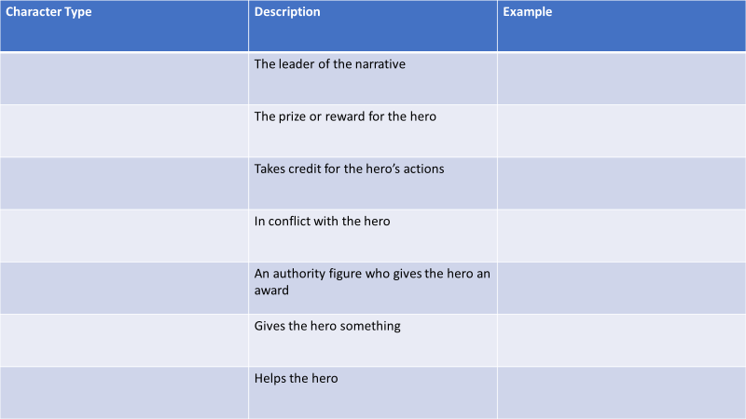
Shrek Plot Summary
Read the Shrek plot summary and identify which character fits with each of Propp’s seven character types.
Shrek is a grumpy, smelly, and ugly ogre, living peacefully in a swamp. One night, he suddenly finds his land has been squatted by a mass of fairy-tale creatures (Pinocchio, the three little pigs, Peter Pan, Snow White, Cinderella, among others), who have been banished by the evil Lord Farquaad. One of these is donkey (who just won't shut up). Accompanied by him, Shrek confronts Lord Farquaad, demanding his land back.
Farquaad does him a deal, telling him to rescue princess Fiona (Farquaad’s daughter) from a dragon-guarded castle, to get his swamp back. Shrek and Donkey go and rescue the Princess, narrowly avoiding being burned by the dragon. Fiona is disgruntled about being rescued by an ugly ogre, rather than Prince Charming. However, despite their differences, she and Shrek grow fond of each other.

On the second night of their return journey, Fiona hides in a windmill. Donkey finds her and discovers that she's turned into an ogress. She explains that she's under a spell, which can only be broken by true love's first kiss. Shrek overhears part of this but misunderstands and thinks she doesn't love him because he's ugly. Just as she decides to tell Shrek the truth, the sun rises, and she becomes a beautiful princess again.
Lord Farquaad arrives and takes Fiona to his castle, and Shrek returns to his swamp. Both are miserable. Later, Shrek, Donkey and Dragon head to Farquaad's castle, to try to stop Fiona marrying him. He tells Fiona Farquaad’s true intentions of marrying her. But the sun sets and Fiona becomes an ogress again. Farquaad doesn't want to marry her and sets the guards on everybody, but Dragon comes to the rescue and eats Farquaad. Shrek and Fiona kiss. Therefore, Fiona stays ugly (in conformity with the spell: "you find true love's first kiss and then take love's true form"), and marries Shrek, and they live "ugly" ever after.
DIP
Choose three of the characters from Shrek. Write a short explanation of why these characters fit in to their character type.
Key Questions
- What type of character do you expect the hero of the story to be?
- What type of character do you expect the villain of the story to be?
- Are all heroes the same?
- Do you agree there are only seven character types?
- What is the relationship between the hero and the villain?
- Which characters are we supposed to like and dislike?

Lesson 7: Heroes and Villains

L/I: The understand the roles of heroes and villains in fairytales.

The hero is usually faced with a problem which has to be solved. This may involve going on a journey, solving a riddle or puzzle, or undertaking a difficult task or impossible test.
The hero often has to defeat or capture the villain in the story in order to survive.
The hero often has to face danger and difficulties but wins through in the end.
DART
Read the fairytale and answer the questions that follow.
Hansel and Gretel
By a great forest, lived a poor wood-cutter with his wife and his two children. The boy was called Hansel and the girl, Gretel. He had little to bite and to break, and once when great famine fell on the land, he could no longer get even daily bread.
Now when he thought over this by night in his bed, and tossed about in his anxiety, he groaned and said to his wife, "What is to become of us. How are we to feed our poor children, when we no longer have anything even for ourselves."
"I'll tell you what, husband," answered the woman, "early to-morrow morning we will take the children out into the forest to where it is the thickest. There we will light a fire for them and give each of them one more piece of bread, and then we will go to our work and leave them alone. They will not find the way home again, and we shall be rid of them."
"No, wife," said the man, "I will not do that. How can I bear to leave my children alone in the forest? The wild animals would soon come and tear them to pieces."
"O' you fool," said she, "then we must all four die of hunger, you may as well plane the planks for our coffins," and she left him no peace until he consented.
"But I feel very sorry for the poor children, all the same," said the man. The two children had also not been able to sleep for hunger and had heard what their step-mother had said to their father.
Gretel wept bitter tears, and said to Hansel, "now all is over with us."
"Be quiet," Gretel, said Hansel, "do not distress yourself, I will soon find a way to help us."
And when the old folks had fallen asleep, he got up, put on his little coat, opened the door below, and crept outside. The moon shone brightly, and the white pebbles which lay in front of the house glittered like real silver pennies. Hansel stooped and stuffed the little pocket of his coat with as many as he could get in. Then he went back and said to Gretel, "Be comforted, dear little sister, and sleep in peace, God will not forsake us," and he lay down again in his bed.
When day dawned, but before the sun had risen, the woman came and awoke the two children, saying: “get up, you sluggards. We are going into the forest to fetch wood.” She gave each a little piece of bread, and said, "There is something for your dinner, but do not eat it up before then, for you will get nothing else."
Gretel took the bread under her apron, as Hansel had the pebbles in his pocket. Then they all set out together on the way to the forest. When they had walked a short time, Hansel stood still and peeped back at the house, and did so again and again.
His father said, "Hansel, what are you looking at there and staying behind for. Pay attention, and do not forget how to use your legs."
"Ah, father," said Hansel, "I am looking at my little white cat, which is sitting up on the roof, and wants to say good-bye to me."
The wife said, "Fool, that is not your little cat, that is the morning sun which is shining on the chimneys." Hansel, however, had not been looking back at the cat, but had been constantly throwing one of the white pebble-stones out of his pocket on the road.
When they had reached the middle of the forest, the father said, "Now, children, pile up some wood, and I will light a fire that you may not be cold." Hansel and Gretel gathered brushwood together, as high as a little hill.
The brushwood was lighted, and when the flames were burning very high, the woman said, "Now, children, lay yourselves down by the fire and rest, we will go into the forest and cut some wood. When we have done, we will come back and fetch you away".
Hansel and Gretel sat by the fire, and when noon came, each ate a little piece of bread, and as they heard the strokes of the wood-axe they believed that their father was near. It was not the axe, however, but a branch which he had fastened to a withered tree which the wind was blowing backwards and forwards. And as they had been sitting such a long time, their eyes closed with fatigue, and they fell fast asleep. When at last they awoke, it was already dark night.
Gretel began to cry and said, "How are we to get out of the forest now."
But Hansel comforted her and said, "Just wait a little, until the moon has risen, and then we will soon find the way." And when the full moon had risen, Hansel took his little sister by the hand, and followed the pebbles which shone like newly-coined silver pieces and showed them the way.
They walked the whole night long, and by break of day came once more to their father's house. They knocked at the door, and when the woman opened it and saw that it was Hansel and Gretel, she said, "You naughty children, why have you slept so long in the forest. We thought you were never coming back at all." The father, however, rejoiced, for it had cut him to the heart to leave them behind alone.
Not long afterwards, there was once more great famine throughout the land, and the children heard their mother saying at night to their father, "Everything is eaten again, we have one half loaf left, and that is the end. The children must go, we will take them farther into the wood, so that they will not find their way out again. There is no other means of saving ourselves." The man's heart was heavy, and he thought, it would be better for you to share the last mouthful with your children. The woman, however, would listen to nothing that he had to say, but scolded and reproached him. He who says a must say b, likewise, and as he had yielded the first time, he had to do so a second time also.
The children, however, were still awake and had heard the conversation. When the old folks were asleep, Hansel again got up, and wanted to go out and pick up pebbles as he had done before, but the woman had locked the door, and Hansel could not get out.
Nevertheless, he comforted his little sister, and said, "Do not cry, Gretel, go to sleep quietly, the good God will help us."
Early in the morning came the woman and took the children out of their beds. Their piece of bread was given to them, but it was still smaller than the time before. On the way into the forest Hansel crumbled his in his pocket, and often stood still and threw a morsel on the ground. "Hansel, why do you stop and look round, said the father, "go on."
"I am looking back at my little pigeon, which is sitting on the roof, and wants to say good-bye to me," answered Hansel.
"Fool," said the woman, "that is not your little pigeon, that is the morning sun that is shining on the chimney." Hansel, however, little by little, threw all the crumbs on the path.
The woman led the children still deeper into the forest, where they had never in their lives been before. Then a great fire was again made, and the mother said, "Just sit there, you children, and when you are tired you may sleep a little. We are going into the forest to cut wood, and in the evening when we are done, we will come and fetch you away." When it was noon, Gretel shared her piece of bread with Hansel, who had scattered his by the way. Then they fell asleep and evening passed, but no one came to the poor children.
They did not awake until it was dark night, and Hansel comforted his little sister and said, "Just wait, Gretel, until the moon rises, and then we shall see the crumbs of bread which I have strewn about, they will show us our way home again." When the moon came they set out, but they found no crumbs, for the many thousands of birds which fly about in the woods and fields had picked them all up.
Hansel said to Gretel, "We shall soon find the way," but they did not find it. They walked the whole night and all the next day too from morning till evening, but they did not get out of the forest, and were very hungry, for they had nothing to eat but two or three berries, which grew on the ground. And as they were so weary that their legs would carry them no longer, they lay down beneath a tree and fell asleep.
It was now three mornings since they had left their father's house. They began to walk again, but they always came deeper into the forest, and if help did not come soon, they must die of hunger and weariness. When it was mid-day, they saw a beautiful snow-white bird sitting on a bough, which sang so delightfully that they stood still and listened to it. And when its song was over, it spread its wings and flew away before them, and they followed it until they reached a little house, on the roof of which it landed. And when they approached the little house they saw that it was built of bread and covered with cakes, but that the windows were of clear sugar.
"We will set to work on that," said Hansel, "and have a good meal. I will eat a bit of the roof, and you Gretel, can eat some of the window, it will taste sweet." Hansel reached up above and broke off a little of the roof to try how it tasted, and Gretel leant against the window and nibbled at the panes.
Then a soft voice cried from the parlour - "Nibble, nibble, gnaw. Who is nibbling at my little house?"
The children answered - "The wind, the wind, the heaven-born wind," and went on eating without disturbing themselves. Hansel, who liked the taste of the roof, tore down a great piece of it, and Gretel pushed out the whole of one round window-pane, sat down, and enjoyed herself with it. Suddenly the door opened, and a woman as old as the hills, who supported herself on crutches, came creeping out. Hansel and Gretel were so terribly frightened that they let fall what they had in their hands.
The old woman, however, nodded her head, and said, "Oh, you dear children, who has brought you here. Do come in and stay with me. No harm shall happen to you." She took them both by the hand and led them into her little house. Then good food was set before them, milk and pancakes, with sugar, apples, and nuts. Afterwards two little beds were covered with clean white linen, and Hansel and Gretel lay down in them, and thought they were in heaven.
The old woman had only pretended to be so kind. She was a wicked witch, who lay in wait for children, and had only built the little house of bread to entice them there. When a child fell into her power, she killed it, cooked and ate it, and that was a feast day with her. Witches have red eyes, and cannot see far, but they have a keen scent like the beasts, and are aware when human beings draw near.
When Hansel and Gretel came into her neighbourhood, she laughed with malice, and said mockingly, "I have them, they shall not escape me again."
Early in the morning before the children were awake, she was already up, and when she saw them both sleeping and looking so pretty, with their plump and rosy cheeks, she muttered to herself, "That will be a dainty mouthful." Then she seized Hansel with her shrivelled hand, carried him into a little stable, and locked him in behind a grated door. Scream as he might, it would not help him.
Then she went to Gretel, shook her till she awoke, and cried, "Get up, lazy thing, fetch some water, and cook something good for your brother, he is in the stable outside, and is to be made fat. When he is fat, I will eat him." Gretel began to weep bitterly, but it was all in vain, for she was forced to do what the wicked witch commanded.
And now the best food was cooked for poor Hansel, but Gretel got nothing but crab-shells.
Every morning the woman crept to the little stable, and cried, "Hansel, stretch out your finger that I may feel if you will soon be fat." Hansel, however, stretched out a little bone to her, and the old woman, who had dim eyes, could not see it, and thought it was Hansel's finger, and was astonished that there was no way of fattening him. When four weeks had gone by, and Hansel remained thin, she was seized with impatience and would not wait any longer.
"Now, then, Gretel," she cried to the girl, "stir yourself, and bring some water. Let Hansel be fat or lean, to-morrow I will kill him, and cook him."
Ah, how the poor little sister did lament when she had to fetch the water, and how her tears did flow down her cheeks. "Dear God, do help us, she cried. If the wild beasts in the forest had but devoured us, we should at any rate have died together."
"Just keep your noise to yourself," said the old woman, "it won't help you at all."
Early in the morning, Gretel had to go out and hang up the cauldron with the water and light the fire. "We will bake first," said the old woman, "I have already heated the oven, and kneaded the dough."
She pushed poor Gretel out to the oven, from which flames of fire were already darting. "Creep in," said the witch, "and see if it properly heated, so that we can put the bread in." And once Gretel was inside, she intended to shut the oven and let her bake in it, and then she would eat her, too.
But Gretel saw what she had in mind, and said, "I do not know how I am to do it. How do I get in."
"Silly goose," said the old woman, "the door is big enough. Just look, I can get in myself," and she crept up and thrust her head into the oven. Then Gretel gave her a push that drove her far into it, and shut the iron door, and fastened the bolt. Oh. Then she began to howl quite horribly, but Gretel ran away, and the godless witch was miserably burnt to death.
Gretel, however, ran like lightning to Hansel, opened his little stable, and cried, "Hansel, we are saved. The old witch is dead."
Then Hansel sprang like a bird from its cage when the door is opened. How they did rejoice and embrace each other, and dance about and kiss each other. And as they had no longer any need to fear her, they went into the witch's house, and in every corner, there stood chests full of pearls and jewels.
"These are far better than pebbles," said Hansel, and thrust into his pockets whatever could be got in.
And Gretel said, "I, too, will take something home with me, and filled her pinafore full".
"But now we must be off," said Hansel, "that we may get out of the witch's forest."
When they had walked for two hours, they came to a great stretch of water.
"We cannot cross," said Hansel, "I see no foot-plank, and no bridge."
"And there is also no ferry, answered Gretel, but a white duck is swimming there. If I ask her, she will help us over. Then she cried -
"Little duck, little duck, dost thou see,
Hansel and Gretel are waiting for thee.
There's never a plank, or bridge in sight,
take us across on thy back so white."
The duck came to them, and Hansel seated himself on its back, and told his sister to sit by him.
"No," replied Gretel, "that will be too heavy for the little duck. She shall take us across, one after the other." The good little duck did so, and when they were once safely across and had walked for a short time, the forest seemed to be more and more familiar to them, and at length they saw from afar their father's house. Then they began to run, rushed into the parlour, and threw themselves round their father's neck.
The man had not known one happy hour since he had left the children in the forest. The woman, however, was dead. Gretel emptied her pinafore until pearls and precious stones ran about the room, and Hansel threw one handful after another out of his pocket to add to them. Then all anxiety was at an end, and they lived together in perfect happiness.
- What problem did Hansel and Gretel’s father face?
- What did his wife suggest?
- How did Hansel and Gretel find their way back?
- Where does the woman take them the second time? Why?
- What draws Hansel and Gretel into the house? Was this a good idea?
- How does the story end?
DIP
Who is the hero in Hansel and Gretel?
- The hero is Hansel and Gretel is …because… (give your reasons)
- This is shown when he/she … (give a specific example, can you use a quote?)
- There is further evidence shown by… (give an example of what dangers have been faced)
Challenge – Use the same writing frame to explain why there could be more than one hero.
Key Questions
- What is a hero?
- What is an archetype?
- Can heroes have flaws?
- Are all heroes the same?
- Why is the villain important to a story?
- Is a hero judged on how they look or what they do?

Lesson 8: Modern Heroes

L/I: To understand the character traits of a hero.
Choose the best five adjectives to describe a hero.
DART
Read the article and answer the following questions:
How is this teacher a hero?
What character traits do they share with fairytale heroes?
A science teacher has been hailed a hero for swiping a gun out of a student’s hand when he opened fire in his classroom. Jason Seaman, 29, took quick action when a student entered the classroom with a gun, by knocking the weapon away and tackling him to the ground.
Mr Seaman was shot three times, and a pupil, Ella Whistler, was also shot. Her family said she was in a critical but stable condition and thanked the first responders, police, and medical staff.
According to reports, the student asked to be excused from the lesson before returning with the weapons.
President Donald Trump tweeted: “Thanks to the very brave Teacher & Hero Jason Seaman of Noblesville, Indiana, for his heroic act in saving so many precious young lives. His quick and automatic action is being talked about all over the world!”
Mr. Seaman's mother posted on Facebook: "Please pray for my son Jason. This morning there was a shooting at his school Noblesville West Jr High. He was hit 3 times & is undergoing surgery now. We are told he is in good condition but haven't gotten to see him yet. I thank God that no one was killed.
She later said: "Jason is out of surgery and is doing well. 3 shots - 1 through the abdomen, 1 in the hip & 1 in the forearm. PLEASE pray for the student that was also shot."
Seventh-grader Ethan Stonebraker said the gunman had been "acting suspiciously" when he came in as the class took a test. He said: "Our science teacher immediately ran at him, swatted a gun out of his hand and tackled him to the ground. If it weren't for him, more of us would have been injured for sure." He added the teacher threw a basketball at the gunman and ran towards the bullets as students sought shelter behind a table. Ethan said it was a "shock" for the gunman to do something like this, describing the suspect as "a nice kid".
Jeremy Seaman, Mr. Seaman's brother, told The Indianapolis Star his brother had been conscious after the shooting and had called his wife to tell her he was alright. He added his brother had been a defensive end for Southern Illinois University's football team and didn't run away from trouble.
DIP
Write a description of your hero – real or imagined.
- Who is your hero?
- What language can you use to describe them?
- What heroic character traits do they demonstrate?

Key Questions
- Can you describe a modern hero?
- Have heroes changed?
- Are all heroes the same?
- What are the similarities/differences between a Disney prince and a modern hero?
- Why do people crave heroes?
- What would you change about superheroes?

Lesson 9: Story Types

L/I: To understand different story types
A literary critic called Christopher Brooker argues that all stories in the world can be place into one of seven categories. He says there are seven different ‘types’ of story.
DART
Fill in the table by matching the following story types to the correct definition: Overcoming the Monster, Rags to Riches, Voyage and Return, Tragedy, Comedy, Rebirth, The Quest
Match the examples to the story types: Jaws, A Christmas Carol, Lord of the Rings, Cinderella, Shrek, Romeo and Juliet, The Wizard of Oz
Story type | Definition | Example
 | A hero meets their downfall. Often ends in the death of main characters.
 | Characters are involved in amusing situations to make the reader laugh.
 | Characters have to fight against a powerful and dangerous enemy.
 | Characters embark on a journey in which they go through an important development.
 | A story in which a character must go on a quest to achieve something important.
 | A character’s circumstances change from poverty to wealth (material or emotional).
 | A character goes through a dramatic change in which they may find a new reason for living.

DIP
Answer the following questions in full sentences.
Why do we tell stories? Why do we not get bored of hearing the same stories? Which characters fit with each type of story? Are some story types more popular than others?
Key Questions
- Do you agree there are only seven types of story?
- What is your favourite story type?
- What is your least favourite story type?
- Do you like to know what is going to happen next in a story?
- Should all stories have a happy ending?
- Are some story types more popular than others?

Lesson 10: Narrative Structure

L/I: To understand Todorov’s narrative structure
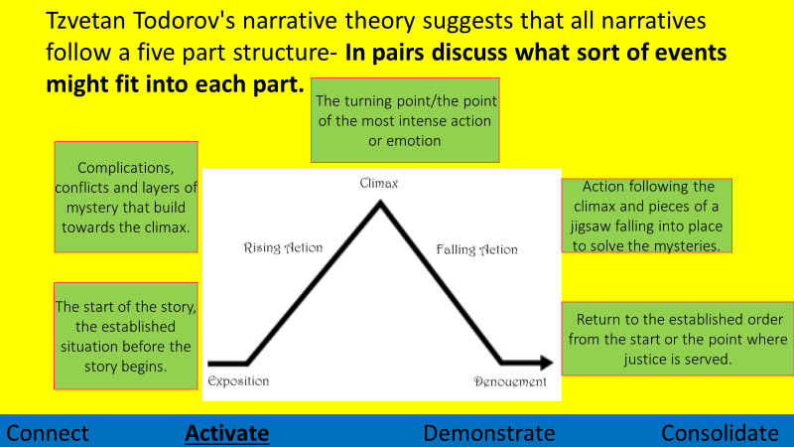
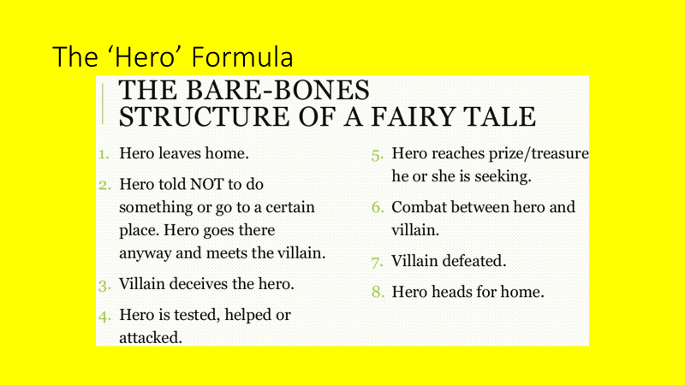
DART
Read Little Red Riding Hood. Can you map the fairytale on Todorov’s narrative structure and the ‘hero’ formula? The first two parts of both have been completed to help you.

Exposition: Little Red’s mum asks her to visit her grandma.
Rising Action: Little Red meets the wolf who persuades her to go off track.

- Little red goes to visit her grandmother.
- Little red told not to go into the woods.

Little Red Riding Hood
Once upon a time there lived in a certain village a little country girl, the prettiest creature who was ever seen. Her mother was excessively fond of her; and her grandmother doted on her still more. This good woman had a little red riding hood made for her. It suited the girl so extremely well that everybody called her Little Red Riding Hood.
One day her mother, having made some cakes, said to her, "Go, my dear, and see how your grandmother is doing, for I hear she has been very ill. Take her a cake, and this little pot of butter."
Little Red Riding Hood set out immediately to go to her grandmother, who lived in another village.
As she was going through the wood, she met with a wolf, who had a very great mind to eat her up, but he dared not, because of some woodcutters working nearby in the forest. He asked her where she was going. The poor child, who did not know that it was dangerous to stay and talk to a wolf, said to him, "I am going to see my grandmother and carry her a cake and a little pot of butter from my mother."
"Does she live far off?" said the wolf
"Oh, I say," answered Little Red Riding Hood; "it is beyond that mill you see there, at the first house in the village."
"Well," said the wolf, "and I'll go and see her too. I'll go this way and go you that, and we shall see who will be there first."
The wolf ran as fast as he could, taking the shortest path, and the little girl took a roundabout way, entertaining herself by gathering nuts, running after butterflies, and gathering bouquets of little flowers. It was not long before the wolf arrived at the old woman's house. He knocked at the door: tap, tap.
"Who's there?"
"Your grandchild, Little Red Riding Hood," replied the wolf, counterfeiting her voice; "who has brought you a cake and a little pot of butter sent you by mother."
The good grandmother, who was in bed, because she was somewhat ill, cried out, "Pull the bobbin, and the latch will go up."
The wolf pulled the bobbin, and the door opened, and then he immediately fell upon the good woman and ate her up in a moment, for it been more than three days since he had eaten. He then shut the door and got into the grandmother's bed, expecting Little Red Riding Hood, who came some time afterwards and knocked at the door: tap, tap.
"Who's there?"
Little Red Riding Hood, hearing the big voice of the wolf, was at first afraid; but believing her grandmother had a cold and was hoarse, answered, "It is your grandchild Little Red Riding Hood, who has brought you a cake and a little pot of butter mother sends you."
The wolf cried out to her, softening his voice as much as he could, "Pull the bobbin, and the latch will go up."
Little Red Riding Hood pulled the bobbin, and the door opened.
The wolf, seeing her come in, said to her, hiding himself under the bedclothes, "Put the cake and the little pot of butter upon the stool, and come get into bed with me."
Little Red Riding Hood took off her cloak and got into bed. She was greatly amazed to see how her grandmother looked in her nightclothes, and said to her, "Grandmother, what big arms you have!"
"All the better to hug you with, my dear."
"Grandmother, what big legs you have!"
"All the better to run with, my child."
"Grandmother, what big ears you have!"
"All the better to hear with, my child."
"Grandmother, what big eyes you have!"
"All the better to see with, my child."
"Grandmother, what big teeth you have got!"
"All the better to eat you up with."
And, saying these words, this wicked wolf fell upon Little Red Riding Hood, and ate her all up.
DIP
Look back at your LRRH story mountain – how are you meant to feel/react at each point?
Write a couple of sentences to describe the intended response from the reader at each point of the narrative.
Can you apply the story mountain or the hero formula to something else you have read?
Key Questions
- What is a typical beginning to a fairytale?
- What is a typical ending for a fairytale?
- What happens in Little Red Riding Hood?
- Do all stories have five part structures?
- Do modern stories fit the hero formula?
- Is there anything you could add to the structure?

Lesson 11: Change Over Time

L/I: To understand the influence of social and historical context on a story.
Fairytales often reflect the time they are created. For example, modern adaptations try to give more agency to female characters.
DART
Read the article about Moana and answer the questions that follow:
The most recent Disney princess movies have caused feminists to rejoice as Disney is finally moving in a more progressive direction. The newer princesses, Merida from Brave, Anna and Elsa from Frozen and Moana, highlight just how reflective Disney is of modern attitudes towards women, as damsels in distress are replaced with strong, independent women.
While Brave and Frozen have made noteworthy steps, Moana is the most feminist new age Disney princess. Moana is the story of a young girl, the daughter of the island chief, who sails across the ocean to find Maui, a Demi-god, to convince him to restore the heart of Te Fiti, to save her island. Moana was chosen by the ocean to cross the physical barrier of the reef and ultimately crosses the psychological barrier her own self-doubt poses.
Five reasons Moana is an unapologetic feminist film:
- It has an incredibly powerful and self-reliant female lead. Not only does Moana not need a man, she does what men, including her father and Maui, feared to do.
- It is the only Disney princess movie not to have a love interest which is a HUGE step forward for Disney. Unlike other Disney movies, romantic love is not even a subplot in Moana. Moana’s love is for her island, her people, and her family, not a strong male character.
- Moana has strong bonds with other women in her life ‚primarily her mother and grandmother. Often female characters are pitted against each other in the characteristic evil stepmother vs. good stepdaughter relationship. Here, it is the female relationships that allow Moana to do the unthinkable and cross the reef to save her people. While Moana’s father forbids her from going, her mother helps her pack and the spirit of her grandmother guides her safely across the reef and is there when Moana’s self-doubt sets in later in the movie.
- Moana is a more representative princess. While all Disney princess seems to have unbelievable tiny waists and long sinewy limbs, Moana’s body type has more average proportions. Moana’s Polynesian heritage also means children of different races find Moana more representative. Being a more accessible figure helps to minimize negative effects of having solely white, unattainably sized Disney princesses.
- Moana is not just a princess; she is a leader in her own right. Not only will she become chief of her island one day, but she actively leaves the island to save it, when others are afraid. Ultimately, she returns her people to their original way of life as voyagers.
The new type of Disney princess that Moana embodies bodes well for encouraging young girls to be strong, independent leaders. Hopefully following her example, a generation of young girls will be shattering the glass ceiling once and for all.

- What have damsels in distress been replaced with?
- What is Moana the only Disney movie not to have?
- What relationships allow Moana to save her people?
- Why is Moana a more representative princess?
- What do you think it means for young girls to ‘shatter the glass ceiling’?
- Do you think it is important for young people to have female role models in stories?
- Why is it relevant that Moana has no love interest?
DIP
Choose a modern moral or life lesson you think it is important young people learn. Incorporate this into the retelling of a fairytale.
WAGOLL
Red Riding hood woke up late one day and realised that she was not going to get to school on time, she knew she would be in a lot of trouble so she phoned the school and told them she had to visit her sick Grandmother. As she now had the day off she decided to go to the forest as her parents couldn’t find her at home, whilst walking through the forest she heard rustling and through the leaves of the forest she noticed the dark mottled fur of a ferocious looking wolf….
Moral – get a good education
Key Questions
- What is a damsel in distress?
- What is feminism?
- Are women fairly represented in Disney films?
- Can you name any strong female characters?
- Why have Disney made changes to their stories over time?
- How might they continue to change over the next ten years?

Lesson 12: Modern Fairytales – The Ickabog

L/I: To recognise fairytale conventions in modern stories.
Parody – an imitation of the style of a particular writer, artist, or genre, with deliberate exaggeration for comic effect.
Homage – special honour or respect shown publicly.
Watch the clip from Shrek and answer the following questions:
https://www.youtube.com/watch?v=OIK59oRNAIQ
How many different fairy tales are referenced?
How are they portrayed differently?
What is different about them that makes them funny?

DART
Read chapter one of the Ickabog and answer the questions that follow:
Once upon a time, there was a tiny country called Cornucopia, which had been ruled for centuries by a long line of fair-haired kings. The king at the time of which I write was called King Fred the Fearless. He’d announced the ‘Fearless’ bit himself, on the morning of his coronation, partly because it sounded nice with ‘Fred’, but also because he’d once managed to catch and kill a wasp all by himself, if you didn’t count five footmen and the boot boy.
King Fred the Fearless came to the throne on a huge wave of popularity. He had lovely yellow curls, fine sweeping moustaches and looked magnificent in the tight breeches, velvet doublets, and ruffled shirts that rich men wore at the time. Fred was said to be generous, smiled and waved whenever anyone caught sight of him and looked awfully handsome in the portraits that were distributed throughout the kingdom, to be hung in town halls. The people of Cornucopia were most happy with their new king, and many thought he’d end up being even better at the job than his father, Richard the Righteous, whose teeth (though nobody had liked to mention it at the time) were rather crooked.
King Fred was secretly relieved to find out how easy it was to rule Cornucopia. In fact, the country seemed to run itself. Nearly everybody had lots of food, the merchants made pots of gold, and Fred’s advisors took care of any little problem that arose. All that was left for Fred to do was beam at his subjects whenever he went out in his carriage and go hunting five times a week with his two best friends, Lord Spittleworth and Lord Flapoon.
Spittleworth and Flapoon had large estates of their own in the country, but they found it much cheaper and more amusing to live at the palace with the king, eating his food, hunting his stags, and making sure that the king didn’t get too fond of any of the beautiful ladies at court. They had no wish to see Fred married, because a queen might spoil all their fun. For a time, Fred had seemed to rather like Lady Eslanda, who was as dark and beautiful as Fred was fair and handsome, but Spittleworth had persuaded Fred that she was far too serious and bookish for the country to love her as queen. Fred didn’t know that Lord Spittleworth had a grudge against Lady Eslanda. He’d once asked her to marry him, but she’d turned him down.
Lord Spittleworth was very thin, cunning, and clever. His friend Flapoon was ruddy-faced, and so enormous that it required six men to heave him onto his massive chestnut horse. Though not as clever as Spittleworth, Flapoon was still far sharper than the king.
Both lords were expert at flattery and pretending to be astonished by how good Fred was at everything from riding to tiddlywinks. If Spittleworth had a particular talent, it was persuading the king to do things that suited Spittleworth, and if Flapoon had a gift, it was for convincing the king that nobody on earth was as loyal to the king as his two best friends.
Fred thought Spittleworth and Flapoon were jolly good chaps. They urged him to hold fancy parties, elaborate picnics, and sumptuous banquets, because Cornucopia was famous, far beyond its borders, for its food. Each of its cities was known for a different kind, and each was the very best in the world.
The capital of Cornucopia, Chouxville, lay in the south of the country, and was surrounded by acres of orchards, fields of shimmering golden wheat, and emerald-green grass, on which pure white dairy cows grazed. The cream, flour, and fruit produced by the farmers here was then given to the exceptional bakers of Chouxville, who made pastries.
Think, if you please, of the most delicious cake or biscuit you have ever tasted. Well, let me tell you they’d have been downright ashamed to serve that in Chouxville. Unless a grown man’s eyes filled with tears of pleasure as he bit into a Chouxville pastry, it was deemed a failure and never made again. The bakery windows of Chouxville were piled high with delicacies such as Maidens’ Dreams, Fairies’ Cradles, and, most famous of all, Hopes-of-Heaven, which were so exquisitely, painfully delicious that they were saved for special occasions and everybody cried for joy as they ate them. King Porfirio, of neighbouring Pluritania, had already sent King Fred a letter, offering him the choice of any of his daughters’ hands in marriage in exchange for a lifetime’s supply of Hopes-of-Heaven, but Spittleworth had advised Fred to laugh in the Pluritanian ambassador’s face.
‘His daughters are nowhere near pretty enough to exchange for Hopes-of-Heaven, sire!’ said Spittleworth.
To the north of Chouxville lay more green fields and clear, sparkling rivers, where jet-black cows and happy pink pigs were raised. These in turn served the twin cities of Kurdsburg and Baronstown, which were separated from each other by an arching stone bridge over the main river of Cornucopia, the Fluma, where brightly coloured barges bore goods from one end of the kingdom to another.
Kurdsburg was famous for its cheeses: huge white wheels, dense orange cannonballs, big crumbly blue-veined barrels, and little baby cream cheeses smoother than velvet.
Baronstown was celebrated for its smoked and honey-roasted hams, its sides of bacon, its spicy sausages, its melting beefsteaks, and its venison pies.
The savoury fumes rising from the chimneys of the red-brick Baronstown stoves mingled with the odorous tang wafting from the doorways of the Kurdsburg cheesemongers, and for forty miles all around, it was impossible not to salivate breathing in the delicious air.
A few hours north of Kurdsburg and Baronstown, you came upon acres of vineyards bearing grapes as large as eggs, each of them ripe and sweet and juicy. Journey onwards for the rest of the day and you reached the granite city of Jeroboam, famous for its wines. They said of the Jeroboam air that you could get tipsy simply walking its streets. The best vintages changed hands for thousands upon thousands of gold coins, and the Jeroboam wine merchants were some of the richest men in the kingdom.
But a little north of Jeroboam, a strange thing happened. It was as though the magically rich land of Cornucopia had exhausted itself by producing the best grass, the best fruit, and the best wheat in the world. Right at the northern tip came the place known as the Marshlands, and the only things that grew there were some tasteless, rubbery mushrooms and thin dry grass, only good enough to feed a few mangy sheep.
The Marshlanders who tended the sheep didn’t have the sleek, well-rounded, well-dressed appearance of the citizens of Jeroboam, Baronstown, Kurdsburg, or Chouxville. They were gaunt and ragged. Their poorly nourished sheep never fetched very good prices, either in Cornucopia or abroad, so very few Marshlanders ever got to taste the delights of Cornucopian wine, cheese, beef, or pastries. The most common dish in the Marshlands was a greasy mutton broth, made of those sheep who were too old to sell.
The rest of Cornucopia found the Marshlanders an odd bunch – surly, dirty, and ill-tempered. They had rough voices, which the other Cornucopians imitated, making them sound like hoarse old sheep. Jokes were made about their manners and their simplicity. As far as the rest of Cornucopia was concerned, the only memorable thing that had ever come out of the Marshlands was the legend of the Ickabog.
- How is this story similar to ‘typical’ fairy tales?
- How is it different?
Rowling creates a scene lovingly based on classic fairy tales whilst also poking fun at the clueless monarchs who often exist in these stories. How do the following quotes do this?
- ‘He’d announced the ‘Fearless’ bit himself, on the morning of his coronation’
- ‘Fred was said to be generous, smiled and waved whenever anyone caught sight of him’
- ‘Looked awfully handsome in the portraits that were distributed’

DIP
Explain how the Ickabog parodies a traditional fairytale King.
WAGOLL
‘Looked awfully handsome in the portraits that were distributed’
Rowling suggests that King Fred isn’t actually handsome in real life but just in the pictures that are painted of him. She specifies that he looks ‘handsome in the portraits’, by making this distinction she infers that the portraits are painted to make him look more handsome than he actually is. This tells the reader that he is possibly very vain and that the people around him don’t feel comfortable telling the truth. Furthermore, the use of the word ‘distributed’ implies that people don’t necessary want them, but he hands them out anyway. These traits parody the convention of a wise and handsome monarch that is often portrayed.
Key Questions
- What is a conventional fairytale King?
- Why do you think people know fairytales?
- Is it important to know fairytales well?
- What is the relationship between parody and homage?
- What is the effect of changing what you expect to happen in a story?
- How can you use the reader’s expectation of a story to improve your own writing?

Lesson 13: Narrative v Descriptive Writing

L/I: To understand the differences between narrative and descriptive writing.

A narrative is the story told (fiction or non-fiction) told and the order in which it is told.
Descriptive writing describes a person, place, or thing in such a way that a picture is formed in the reader’s mind.

DART

There is a legend that, once upon a time, a beautiful fairy, the Snow Queen, lived on the highest, most solitary peaks of the Alps. The mountain folk and shepherds climbed to the summits to admire her, and everyone fell head over heels in love with her. Every man would have given anything, including his life, to marry her. Indeed, their lives are just what they did give, for Fate had decided that no mortal would ever marry the Snow Queen. But despite that, many brave souls did their best to approach her, hoping always to persuade her. Each suitor could enter the great ice palace with the crystal roof, where the Queen’s throne stood. But the second he declared his love and asked for her hand, thousands of goblins appeared to grasp him and push him over the rocks, down into bottomless abysses. Without the slightest emotion, the Queen would watch the scene, her heart of ice unable to feel anything at all.
The legend of the crystal palace and the beautiful heartless Queen spread as far as the most distant alpine valley, the home of a fearless chamois hunter. Fascinated by the tale, he decided to set out and try his luck. Leaving his valley, he journeyed for days on end, climbing the snowclad mountain faces, scaling icebound peaks, and defying the bitterly cold wind that swept through the alpine gullies. More than once he felt all was lost, but the thought of the lovely Snow Queen gave him new strength and kept him moving onwards. At last, after many days climbing, he saw glinting in the sunshine before him, the tall transparent spires of the ice palace. Summoning all his courage, the young man entered the Throne Room. But he was so struck by the Snow Queen’s beauty that he could not utter a word. Shy and timid, he did not dare speak. So, he knelt in admiration before the Queen for hours on end, without opening his mouth. The Queen looked at him silently, thinking all the while that, provided he did not ask her hand in marriage, there was no need to call the goblins. Then, to her great surprise, she discovered that his behaviour touched her heart. She realised she was becoming quite fond of this hunter, much younger and more handsome than her other suitors. Time passed, and the Snow Queen dared not admit, not even to herself, that she would like to marry the young man.
In the meantime, the goblins kept watch over their mistress; first they were astonished, then they became more and more upset. For they rightly feared that their Queen might be on the point of breaking the Law and bringing down on the heads of all the Mountain People the fury of Fate. Seeing that the Queen was slow to give the order to get rid of her suitor, the goblins decided to take matters into their own hands. One night, as dusk fell, they slipped out of the cracks in the rock and clustered round the young chamois hunter. Then they hurled him into the abyss. The Snow Queen watched the whole scene from the window, but there was nothing she could do to stop them. However, her icy heart melted, and the beautiful cruel fairy suddenly became a woman. A tear dropped from her eye, the first she had ever shed. And the Snow Queen’s tear fell on to a stone where it turned into a little silvery star. This was the first edelweiss - the flower that grows only on the highest, most inaccessible peaks in the Alps, on the edge of the abyss and precipice.
- Where is the story set?
- What happened when someone declared their love to the Queen?
- Why was the hunter able to keep going?
- What did the Queen want to happen?
- What happens at the end?
- Is the Snow Queen a narrative or a description?

DIP:

Use the images below and the Snow Queen to write a description of a) the Snow Queen and b) the setting for the narrative.

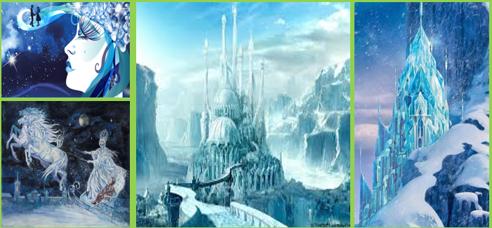

Key Questions
- What is the difference between narrative and descriptive writing?
- How does descriptive writing make a narrative more interesting?
- What would be wrong with a story that was only narrative?
- Which style is easier to write? Why?
- What fairytale conventions are relevant to the Snow Queen?
- How is the Snow Queen different to Moana?

Lesson 14: Fairytale Settings

L/I: To understand the conventions of a fairytale setting.

DART
Beauty and the Beast
Read Beauty and the Beast. How is the setting reflective of fairytale conventions?
Once upon a time there lived a wealthy merchant and his three daughters. One day, the father was to go to a far-off place, and he asked his daughters what they wanted on his return. The first and the second daughter asked for lovely dresses. But the third daughter, whose name was Beauty, said, “Father, I only need a rose plucked by your hand.” The merchant, on his way back, had to cross through the deep forest. It was dark and the merchant tried to find a place to sleep. He suddenly found a huge castle and went inside to find nobody. There was a huge table with delicious food and he ate it all. Then the merchant went into the bedroom and slept on a soft and fluffy bed. The next day, too, the merchant did not find anyone in the castle. He saw a beautiful rose bush growing in the lawn and remembered Beauty’s gift. He plucked a red rose from the bush.
Suddenly, a ferocious looking beast sprang out of the bush. He was wearing fine silk clothes and roared, “I gave you food and a bed to sleep in! And now, you are stealing my roses!” The merchant was frightened and told the Beast about Beauty’s gift. The Beast decided to let him go only if he promised to send Beauty to this castle. The merchant agreed and ran back home. He cried and told his daughters about the Beast. But Beauty loved her father a lot and agreed to go stay with the Beast. The Beast treated Beauty with a lot of kindness. He was never rude to her. He let her stay in the biggest room and let her roam in the beautiful garden. Beauty would sit near the fireplace and sew while the Beast kept her company. At first, Beauty was afraid of the Beast but slowly, she began to like him.
One day, the Beast asked Beauty to marry him, but she refused. She was still afraid of his fearful-looking face. The Beast still treated her kindly and with a lot of love. Beauty missed her father a lot. The Beast gave her a magic mirror and said, “Look at the mirror and you can see your family. Now you won’t feel lonely anymore.
One day, Beauty looked in the mirror and saw that father was very ill and dying. She went to the Beast and pleaded and cried, “Please let me go home! I only want to see my father before he dies!” But the Beast roared, “No! You promised you would never leave this castle!” Saying this, he stormed out of the room. But after some time, he came to Beauty and said, “You may go to stay with your father for seven days. But you must promise to return after that.” Beauty was very happy and agreed. Then she left and went to stay with her father. Her father, on seeing Beauty, felt very happy and soon recovered. Beauty stayed with her family for seven days and more. She forgot the Beast and his castle. But one night, she had a terrible nightmare in which she saw the Beast was very ill and about to die. He was crying, “Beauty, please come back!”
Beauty woke up and went back to the castle because she did not mean to hurt the Beast. She cried and said, “Please don’t die, Beast! I will live with you forever!” The Beast miraculously changed into a handsome prince. He said, “I was under a curse all these years and could only be relieved when someone fell in love with me. I am now cured of the curse because you truly love me.” And then, Beauty and the Beast were married and together they lived happily ever after.
DIP
Write a description of your own fairytale setting (use the image provided if you like).
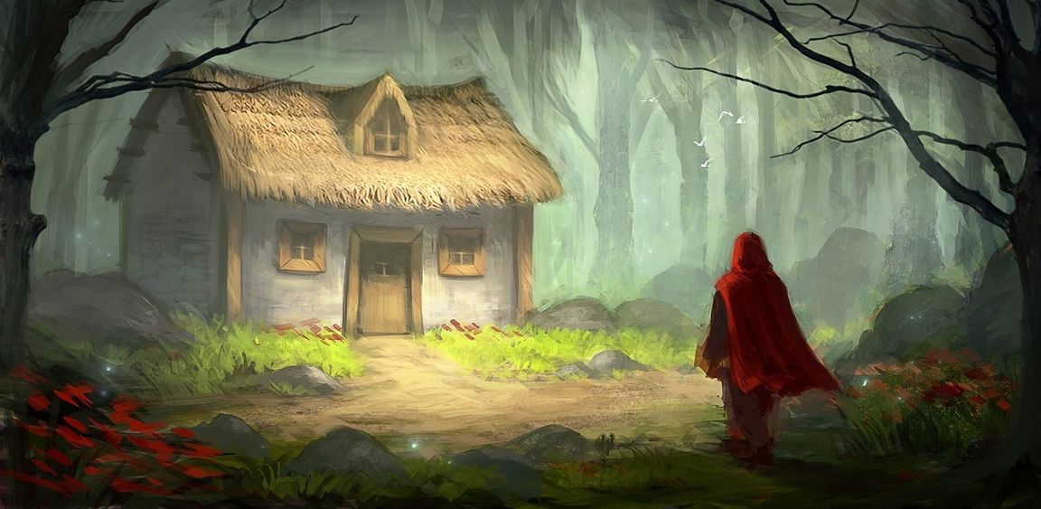
Key Questions
- What is the setting of a story?
- How does the setting show you what sort of story to expect?
- How does it feel when a story goes in a direction you don’t expect?
- Why is a simile an effective tool to describe something?
- Why do similes and metaphors make writing better?
- What does good description add to a story?

Lesson 15: Perspective

L/I: To understand narrative perspective and its effect.
Perspective is the point of view from which something is written.
DART
Goldilocks
Read Goldilocks and answer the following questions:
- What perspective is the story told from?
- What other characters are in the story?
- How might their views on the events in the story be different?

Goldilocks was a playful little girl who had lovely golden hair and that is why she was called Goldilocks. One day, while roaming the woods, she saw a pretty cottage. She went inside and saw three bowls of porridge on the table. Tasting the porridge in the biggest bowl she said, “This porridge is too hot!” She tasted some porridge from the second bowl and said, “This porridge is too cold!” Then tasting some porridge from the third bowl she said, “This porridge is just right!” and she ate all of it. After that Goldilocks felt sleepy, so she went upstairs where she saw three beds. She lay on the first bed and said, “This bed is too hard!” She lay on the second bed and said, “This bed is too soft!” Finally, she lay on the third bed and said, “This bed is just right!” And so, Goldilocks curled up and went to sleep. The cottage actually belonged to three bears. When they came home in the evening, the three bears saw that someone had been there. Mama and Papa Bear ate their porridge, but the little bear wailed, “There is nothing left in my bowl!” When they went upstairs to sleep, Papa Bear and Mama Bear found their beds had been used. Papa Bear shouted, “Someone has been sleeping in my bed!” Then, Mama Bear cried, “Someone has been sleeping in my bed!” The little bear saw Goldilocks sleeping in his bed and squealed, “Someone is still sleeping in my bed!”
Goldilocks awoke and seeing the three bears, she jumped up in fright and ran out of the door, never to be seen in the woods ever again!

DIP

Think of a fairytale we have studied. Identify the villain. Can you re-tell the story from their point of view?

WAGOLL
As the wolf walked through the forest his stomach rumbled, he was hungry and hadn’t eaten for days. The hunters had been watching for him and he had no chance to sleep either, he knew he was dying and had to do something quick before his last energy ebbed away…
Then he saw her, a dash of red flashing through the trees. A red cap that promised food, safety, and hope. He ran as fast as he could to catch up with her, he was so tired he could barely breath as he approached. He knew he was too weak to kill her now, but her grandmother, that was a different story. He walked up to the cottage and burst through the door and ate the grandmother up at once
Key Questions
- What is a perspective?
- Why is it important to consider the perspective of others?
- Can you think of something you would like people to see from your perspective?
- Whose perspective are most stories told from?
- How would stories be different if told from different perspectives?
- Is there a ‘right’ perspective?

Lesson 16: Writing a Fairytale 1

L/I: To use my learning to plan a fairytale narrative.

DART
Re-read your notes on fairytale conventions, character types, story types and the narrative structure.
- How many conventions of fairytales can you name?
- How many character types?
- How many story types?
- What happens at each stage of the narrative structure?
DIP
Plan a fairytale. Write a 100-word summary of what is going to happen. Make sure you have:
- A complete narrative structure with fairytale conventions
- Fairytale characters
- A fairytale setting
You could:
- Write an original fairytale from scratch
- Re-write a fairytale with an alternative ending
- Combine two fairytales
- Write a ‘spin-off’ fairytale about one of the minor characters
- Rewrite a fairytale from the perspective of another character
- Write a prequel or sequel (what happened before or after the original fairytale)

Key Questions
- What happens in an overcoming the monster narrative?
- What is an example of a rags to riches story?
- What is an example of a rebirth story?
- Which character types send the hero on a quest?
- How would you respond to someone saying all fairytales are the same?
- What is the most important part of a story?

Lesson 17: Writing a Fairytale 2

L/I: To use my plan to write a fairytale narrative.

DART
Read your 100-word blurb from the previous lesson. Is there anything you would add? Have you got a complete narrative structure? Do your plot, characters and setting reflect fairytale conventions?
DIP
Write your fairytale!
Key Questions
- What are proofreading and editing?
- Why are they important skills?
- Why is it important to plan before you write?
- How will earlier lessons support your writing in this lesson?
- Are there storylines, characters, or settings you would like to magpie?
- Does your writing meet the conventions of the fairytale genre?

Lesson 18: Fairytale Poetry

L/I: To consider the significance of poetry and make links with narrative and descriptive writing.

DART
Read the two poems based on fairytales below:
- What fairytales are they based on?
- How are they similar to the fairytale they are based on?
- How are they different to the fairytale they are based on?
- What do you like about them?
- What do you not like about them?
Glass Slipper Sonnet  Pity the poor step-sister those big feet  she’ll never stuff in a size-six sonnet,  her flesh so fulsome the slipper seems effete,  unworthy of the labour spent on it.  But try she must, and so she makes a pass,  jams four fat toes in the narrow throat,  the fifth pig smarting, pressed against the glass  (though pain’s no stranger—she knows it by rote.)  The other shoe drops—as it is wont to do—  a second foot is squeezed into the vamp.  She stands up straight and takes a stride towards you,  her footfall heavy as a farmgirl’s tramp.  The slipper strains against those excess feet.  She hobbles onward—she has a prince to meet. | Red Whistles at the Wolf  Red, Red’s riding in the hood  scarf on her head  lady looking good  Red, Red’s driving in the hood  convertible blush  lady’s in a rush  Lipsticked red  sunglasses red  tight dress red  retro retro red red red  Red, Red’s cruising in the hood  white hubcapped wheels  bringing those meals  Red, Red’s speeding in the hood  in her red-finned missile  gives the wolf a whistle  Red, Red’s roaring in the hood  wolf takes a jump  becomes a speed bump  Red, Red’s slowing in the hood  wolf’s now dead  don’t mess with Red

DIP
Write a poem inspired by one of the fairytales we have read.

Key Questions
- What is poetry?
- Why do people write poetry?
- How does poetry different to other forms of writing?
- Are poems narrative or descriptive?
- How can fairytales be turned in to poetry?
- What does it mean to be inspired by another piece of writing?

Attainment Band | Telling Tales
Yellow Plus | - Your writing includes imaginative and original ideas, developed with awareness of the reader and their likely response.  - You deliberately use a wide range of language devices to convey characters and setting, using a wide range of ambitious vocabulary for effect, and with accurate spelling.  - Conventions of a narrative and genre are used accurately and effectively with proof-reading helping you to make better choices in your writing.  - Cohesive paragraphing guides the reader through the text, combining with deliberately crafted sentences to alter the tone and mood throughout.  - You use a full range of punctuation accurately and for effect.
Yellow | - Your writing includes interesting characters and a setting that directly contributes to plot development.  - You use a range of language devices (e.g. simile, metaphor, personification) and use taught and increasingly ambitious vocabulary for impact and effect.  - Your work is structured deliberately to recognise conventions of narratives and genre, and for purpose or audience. Consistent proof-reading reduces errors in writing.  - Cohesive paragraphing contributes to a sensible overall structure. Your sentences are varied for impact and effect.  - You use a range of punctuation accurately (parentheses, colons before a list/to make a point).
Blue | - Your writing includes a complete plot, well-developed characters and explicitly describes setting.  - You start to use language devices and choose interesting nouns, verbs, and adjectives, and you use some taught vocabulary for impact and effect (with accurate spelling).  - Your writing is structured with deliberate progressions (e.g. uses chronological order or a clear narrative structure) and you proof-read to correct some errors after writing.  - You develop your ideas using paragraphs with some deliberate cohesion linking them together, and your sentences make use of a broad range of structures.  - You use a range of punctuation accurately (commas, end stopping, apostrophes).
Green | - You use planning or writing frames to develop ideas about plot, characters and setting.  - You start to use some detail and descriptive language, using simple vocabulary that interests, spelling most words accurately (using phonics, syllables, and affixes).  - Your ideas are organised with some clustering of related ideas, and you narrate and begin to develop ideas showing conventions of form (e.g. opening and ending).  - You paragraph with more regularity and accuracy and your sentence structure is more varied with limited range of subordinating conjunctions.  - You use simple punctuation consistently and accurately (capital letters, full stops, commas).
White | - You respond to the task by creating simple characters, settings and/or events.  - You include limited detail and use basic vocabulary, often misspelled.  - You attempt to structure your writing in chronological order.  - Your sentences are simple, and paragraphing is absent or inconsistent.  - You use simple punctuation, but your work includes errors (e.g. capital letters, full stops, commas).

