Religious Education Year 7 Autumn 2 Blended Learning Booklet
Fundamentals of Christianity and Buddhism.
Name:
Form:
Aim to complete one lesson each week. Write out the title and LI and then complete the tasks.
All video links are online using the ClassCharts link.
The Knowledge Organiser on page three has all the key information and vocabulary to help you with this unit.
Upload all work onto ClassCharts for feedback.
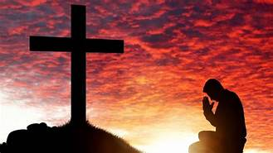
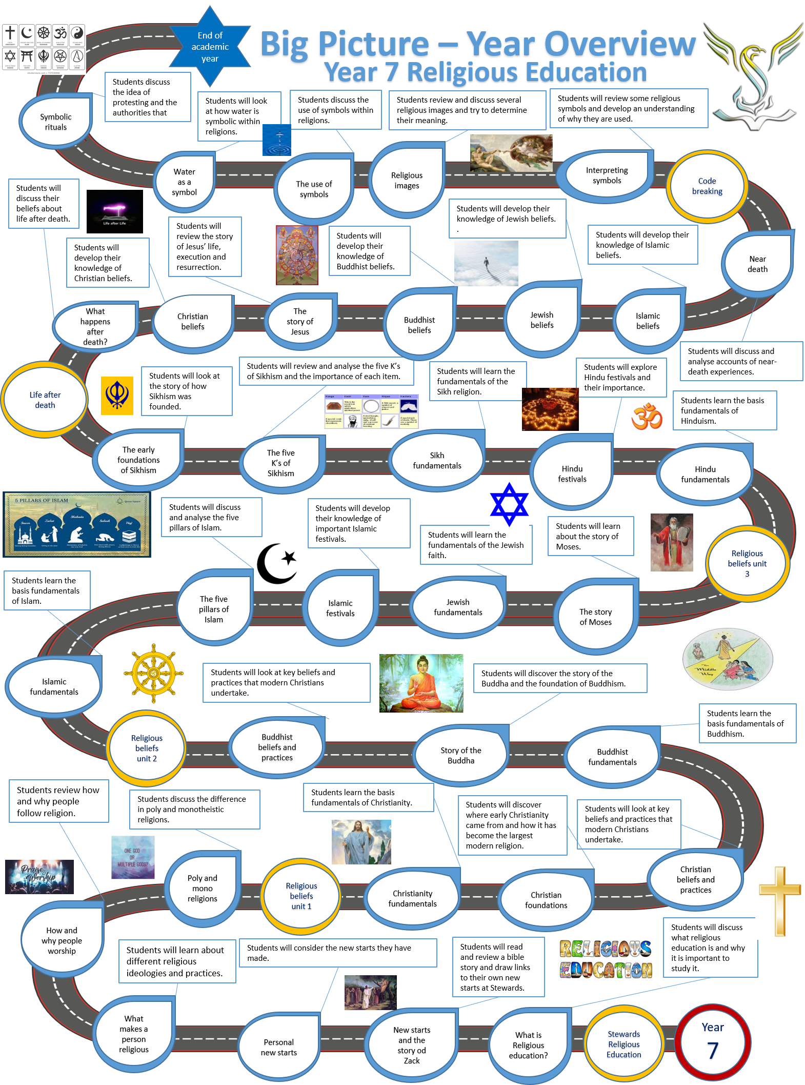

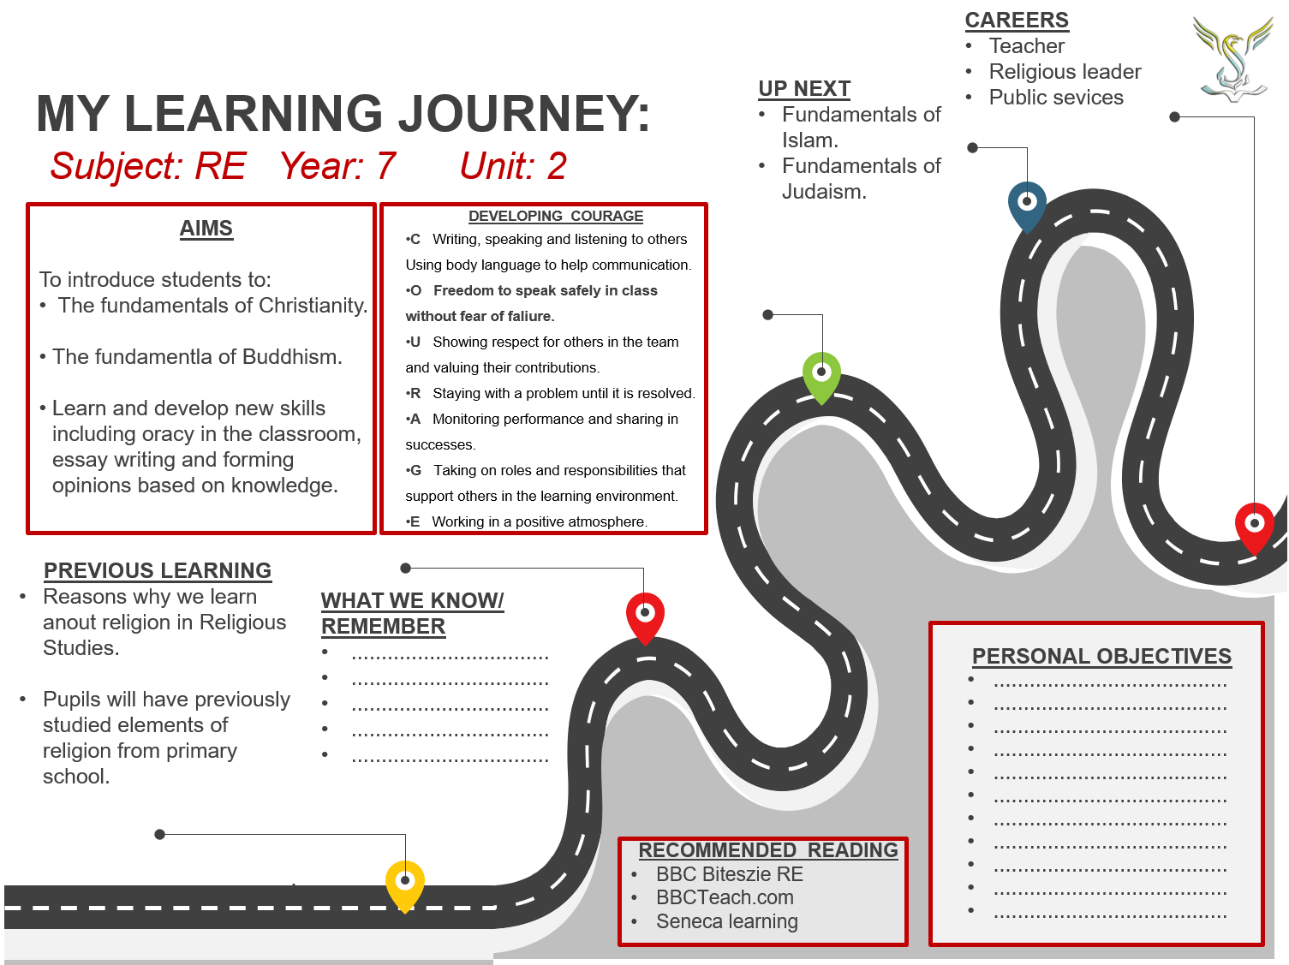
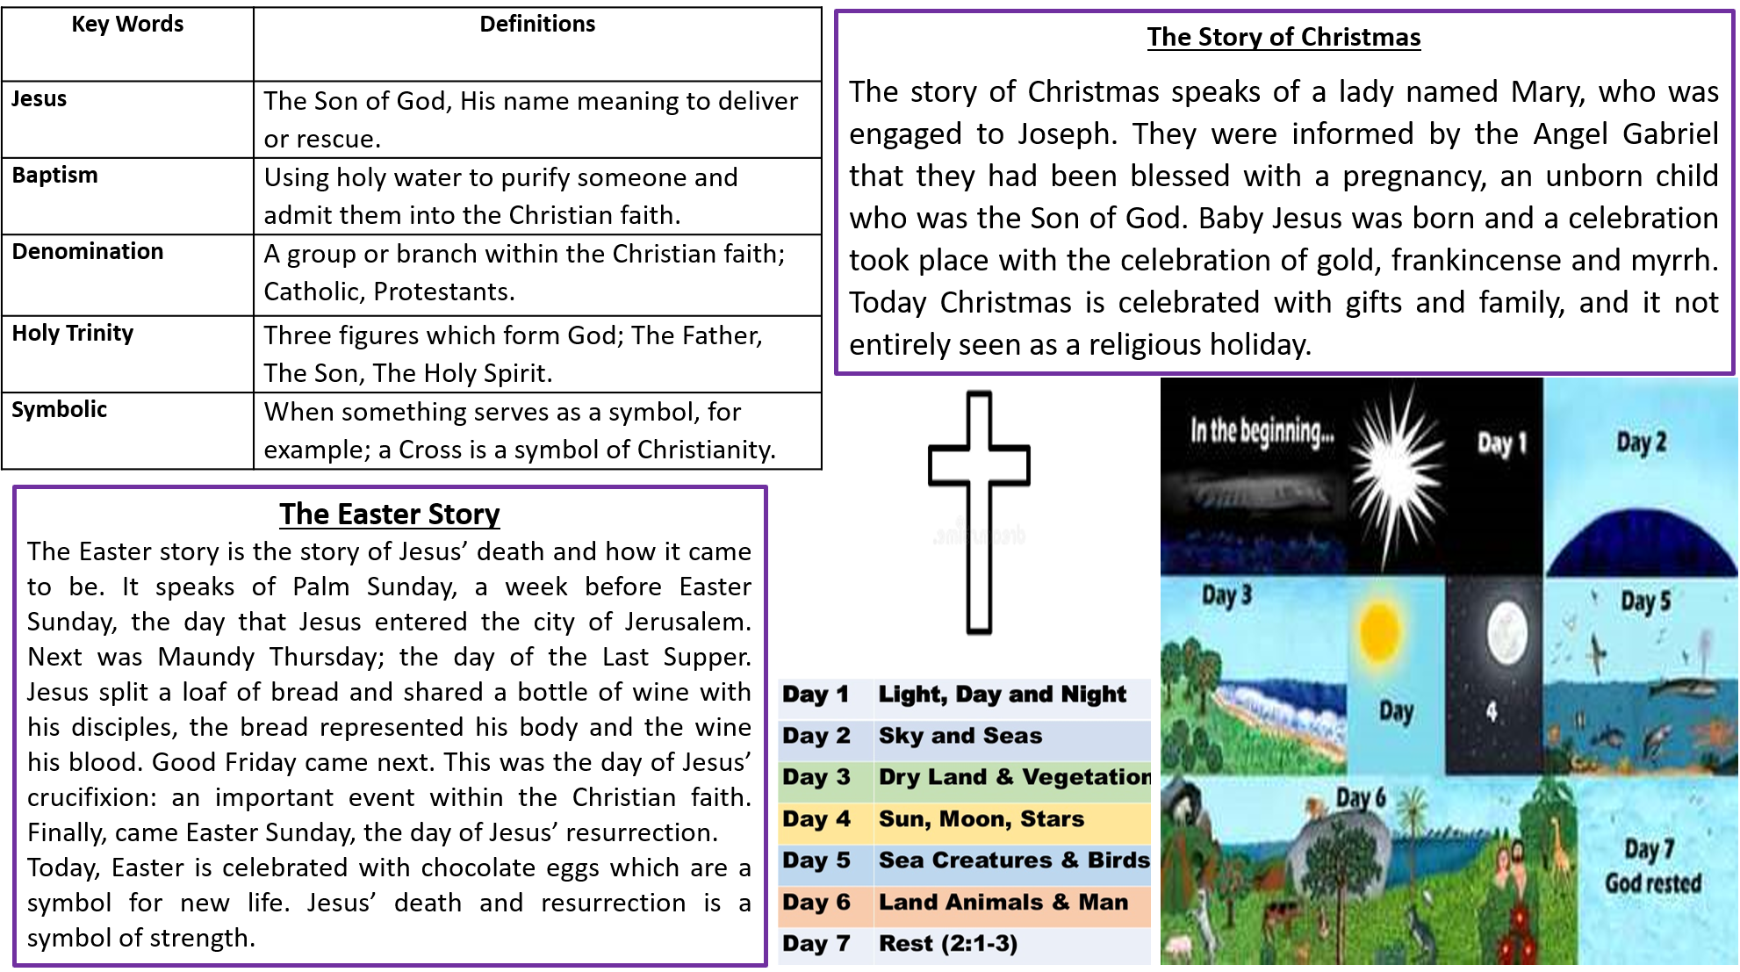

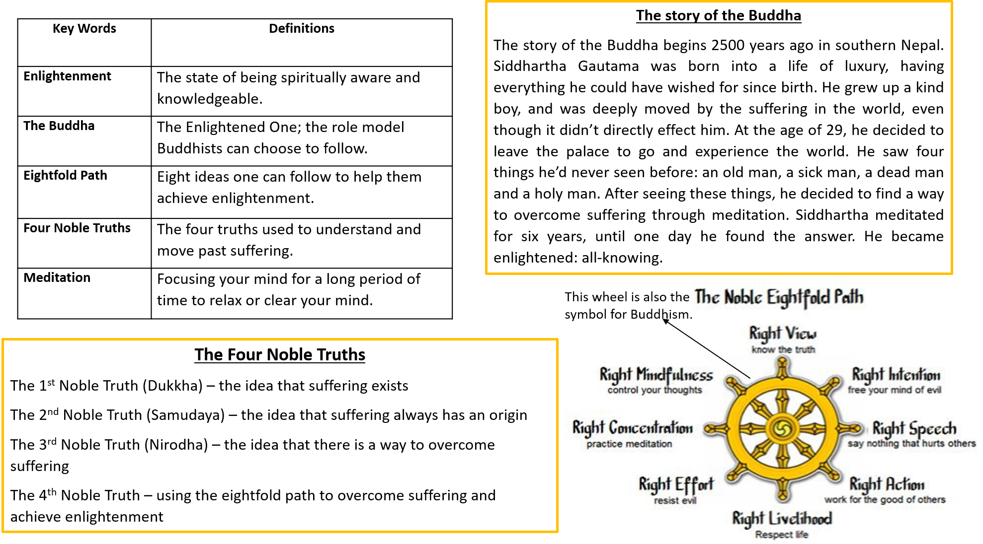

Lesson 1 Introduction to Christianity.
- LI: To develop our understanding of the fundamentals of Christianity.

What do you already know about Christianity?
- Create a mind map of everything you already know.
  - Keywords
  - Stories
  - Festivals
  - People’s names.
Where did Christianity come from?
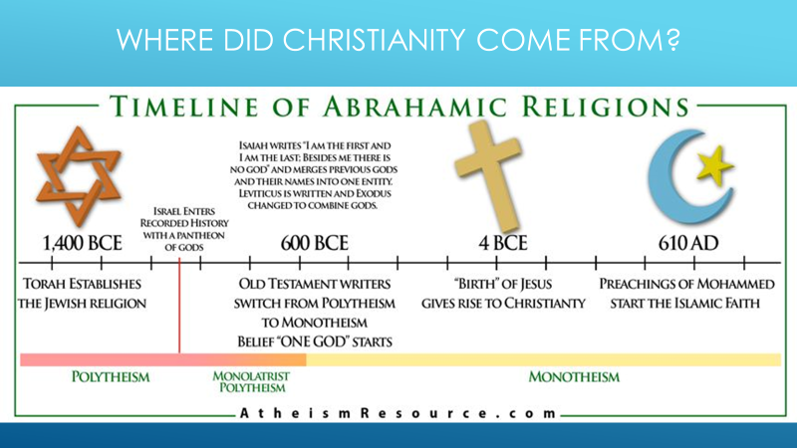

Christianity fundamentals. 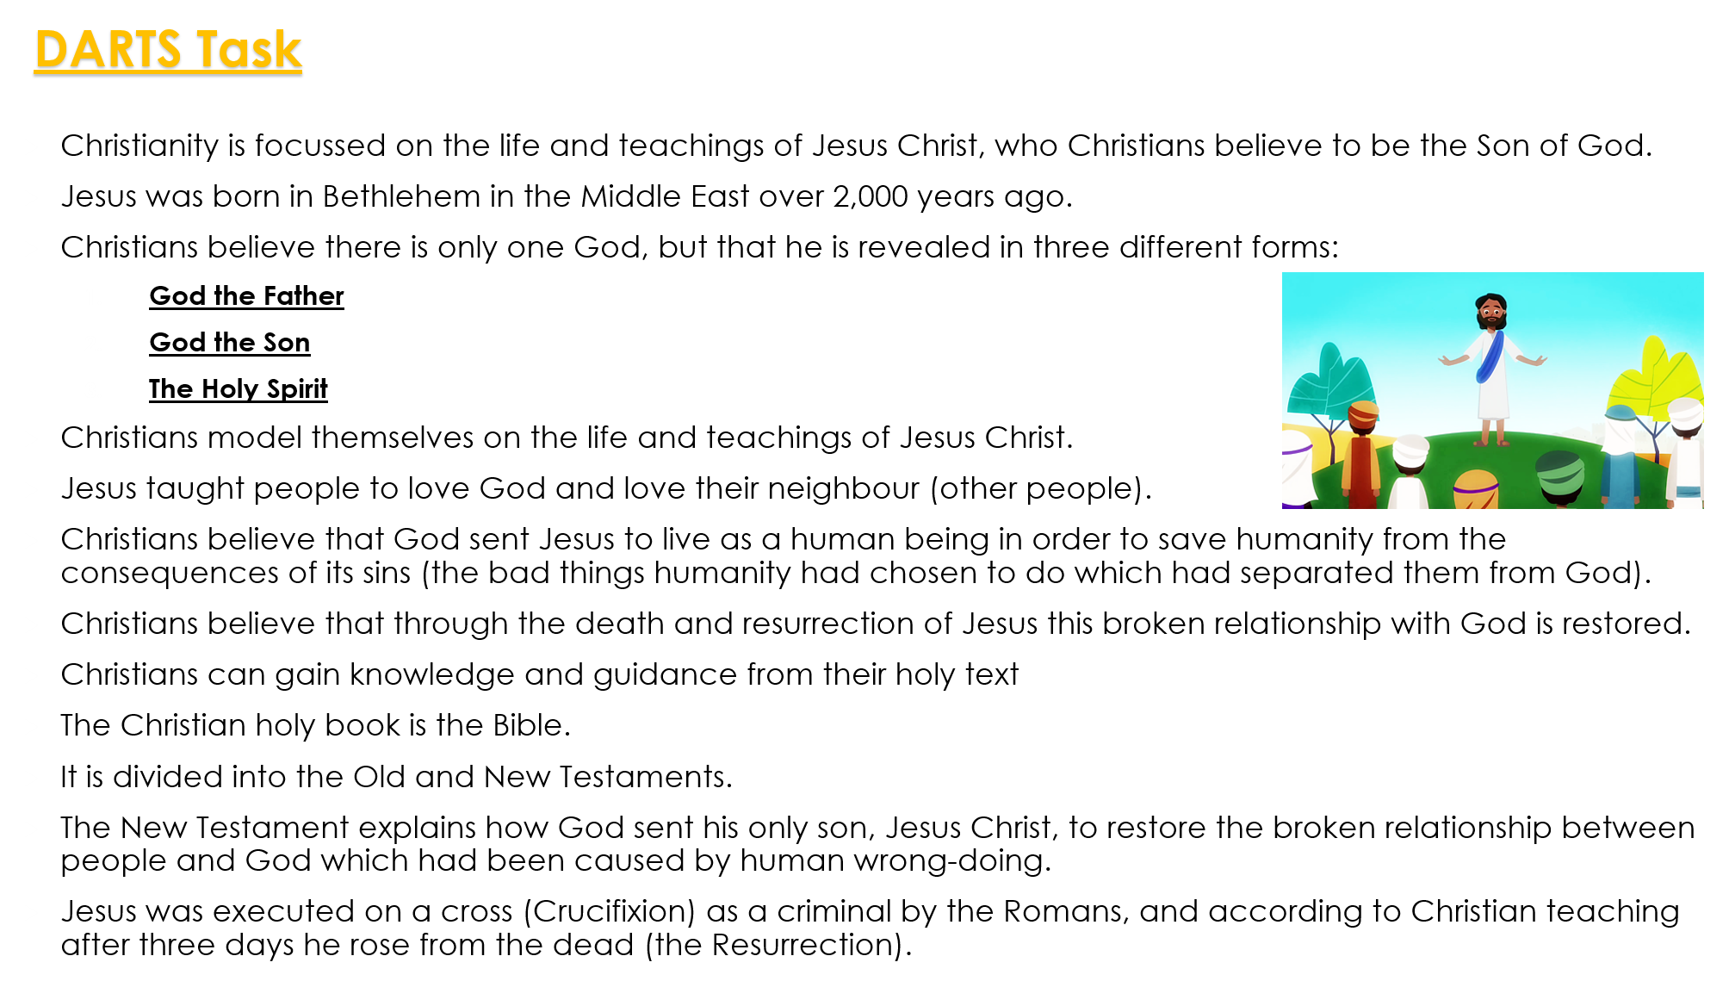
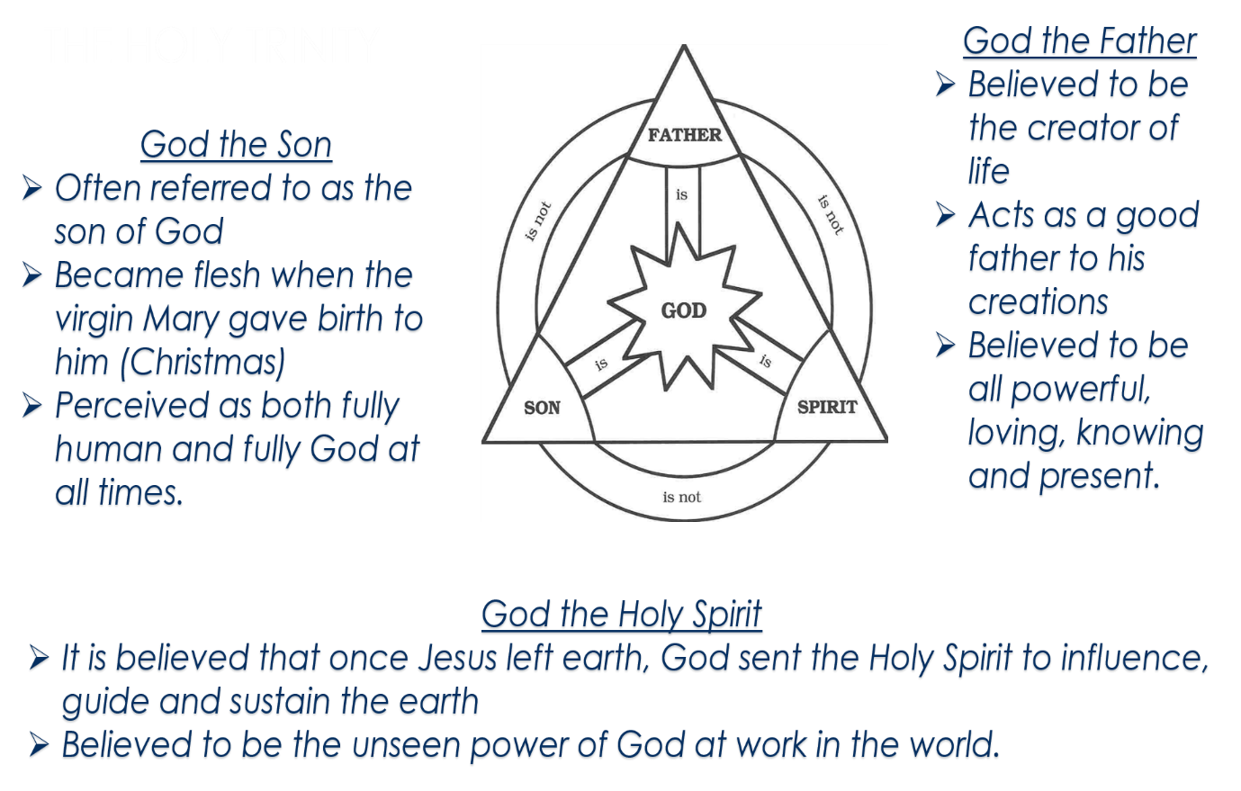
Task
Research the following points and create a poster.
- When was Christianity founded?
- What does the religions symbol look like?
- What is the name of the religious text?
- What is the place of worship called?
  - What happens there?
- Any festivals associated with the religion.
- The key individuals within the faith.
Homework:
1) Research the Christian creation story.

Lesson 2 The story of creation.
- LI: To identify the Cristian beliefs about creation.
What do you already know about the Christian story of creation?
- Create a mind map of everything you already know about creation.

- Video to support creation story knowledge.
https://www.youtube.com/watch?v=teu7BCZTgDs
Research the creation story and explain.
- What did God create on each day?
- What was the role of the Holy Spirit throughout creation?

DARTS 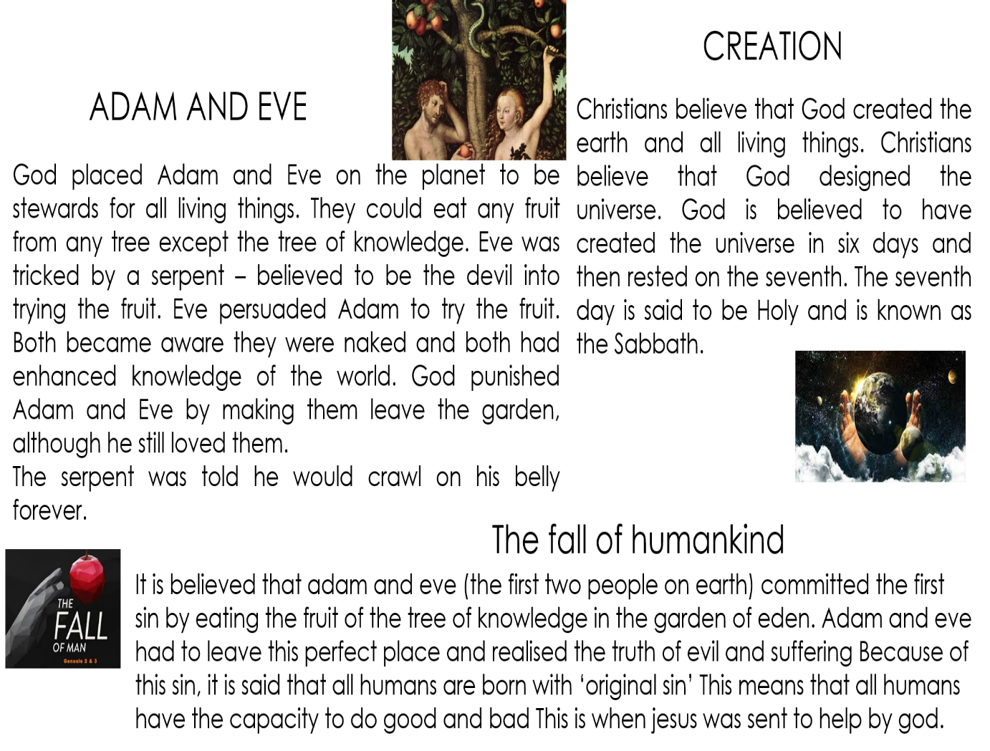
Key questions
- Who do you blame for the creation of sin? (Adam, Eve, both, the devil, God)?
I think that……. is to blame for the creation of sin because…
- Do you think God was harsh to make them leave the Garden of Eden for disobeying him?
I believe that God was / was not harsh to make Adam and Eve leave the Garden of Eden because…
- What would you have done if you were either;
  - Adam
  - Eve
  - God
If I was Adam I would have…
If I was Eve, I would have…
If I was God, I would have…

Lesson 3 Christian festivals.
- LI: To identify some key Cristian festivals and understand their importance.
What do we already know?
Question | Answer A | Answer B | Answer C | Answer D
Who was born on Christmas day? | Abraham | John the Baptist | Jesus | Moses
Where in which town was the baby born? | Nazareth | Bethlehem | Judea | Jerusalem
What are the names of the babies parents? | Mary and Joseph | Adam and Eve | James and Janine | John and Martha
What gift was not given to the new born baby? | Gold | Frankincense | Myrrh | Silver

Task
- Research the correct answer.
DIPS
The main events in Jesus’ life are celebrated in the festivals of the Christian Church:
- Research the correct answers.
- Advent – the Christian ________ begins in November with a period of preparation for the coming of the child ________. It is also the time when Christians particularly look ________ to Jesus’ Second Coming.
- Christmas – the joyful ________ of Jesus’ birth.
- Lent – a period of spiritual ________ leading up to Easter.
- Easter – commemorates the ________ and ________ of Jesus.
- Ascension – celebrates Jesus’ ascension to Heaven ________ days after Easter.
- Pentecost – celebrates the coming of the ________ ________to the disciples in Jerusalem, 50 days after Easter.

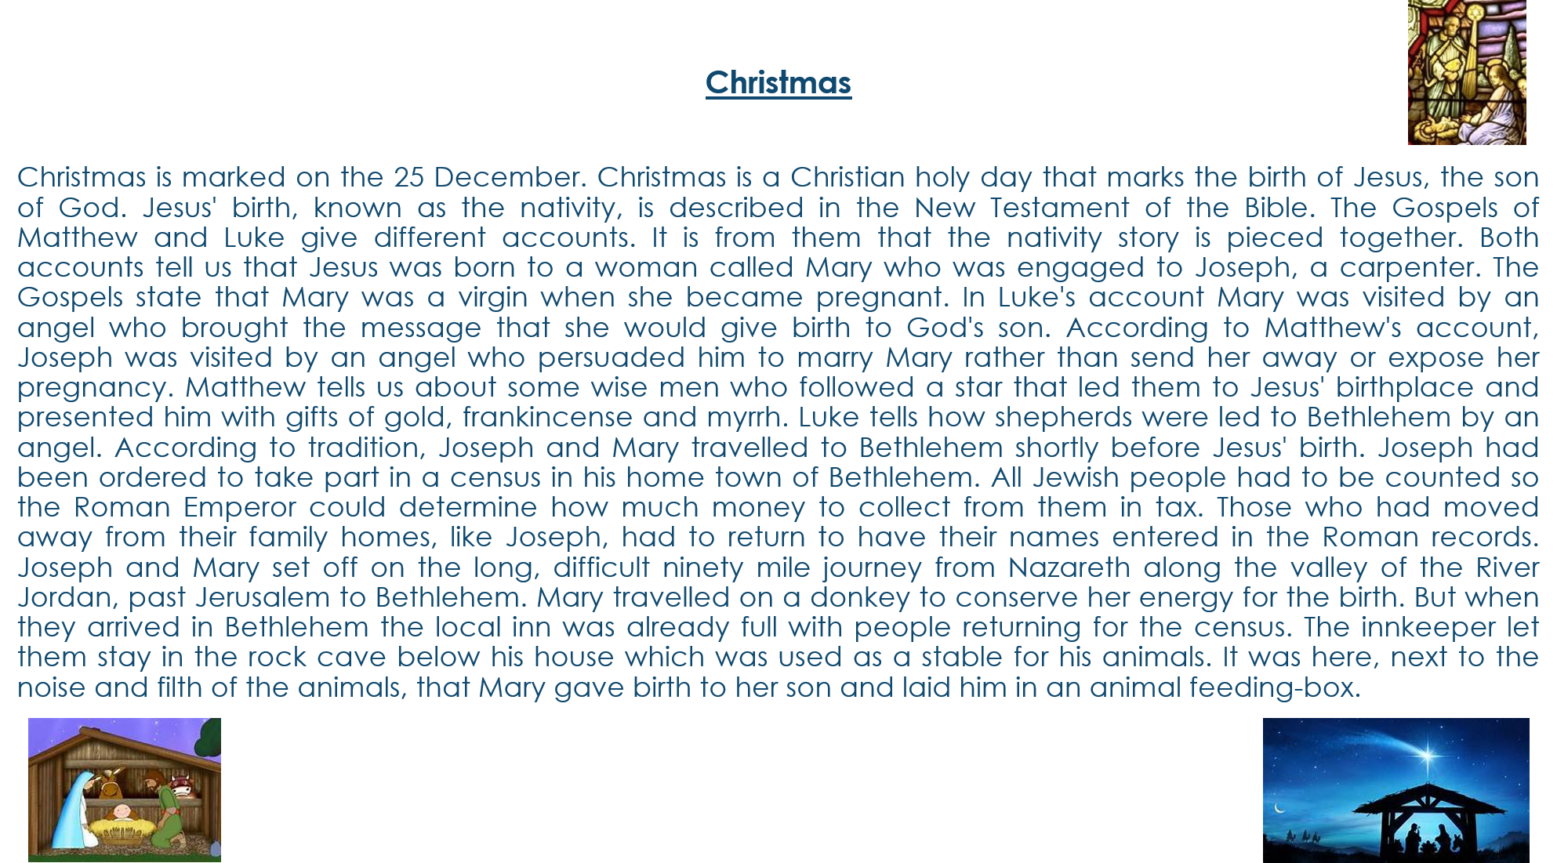
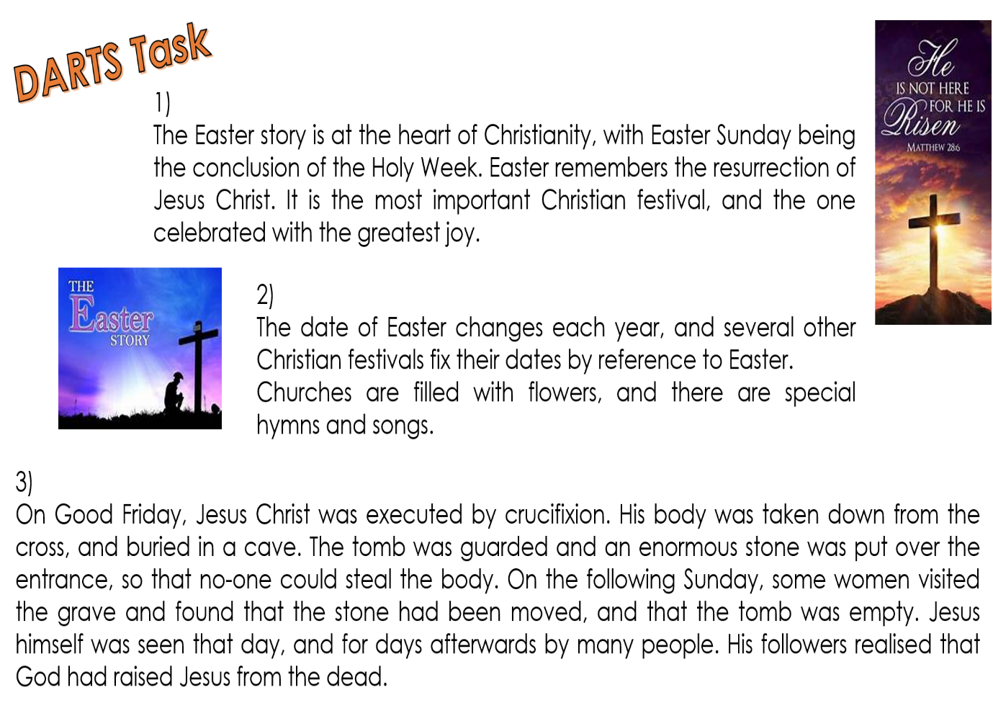
DARTS Questions
- Why is the birth of Jesus so important to Christians?
The birth of Jesus is important to Christians because…
- What is so important about the Easter story?
The importance of the Easter story is… because…
- Why do you think Easter could be considered the most important of the Christians festivals?
I think that Easter could be considered the most important Christian festival because…

Homework
Complete the table for Christian fundaments.
Table of Religion | Christianity
Founder / Leader
Symbol
Sacred Writings
Place of worship
Festivals

Lesson 4 Introduction to Buddhism.
- LI: To develop our understanding of the fundamentals of Buddhism.

What do you already know about Buddhism?
- Create a mind map of everything you already know.
  - Keywords
  - Stories
  - Festivals
  - People’s names.
DARTS
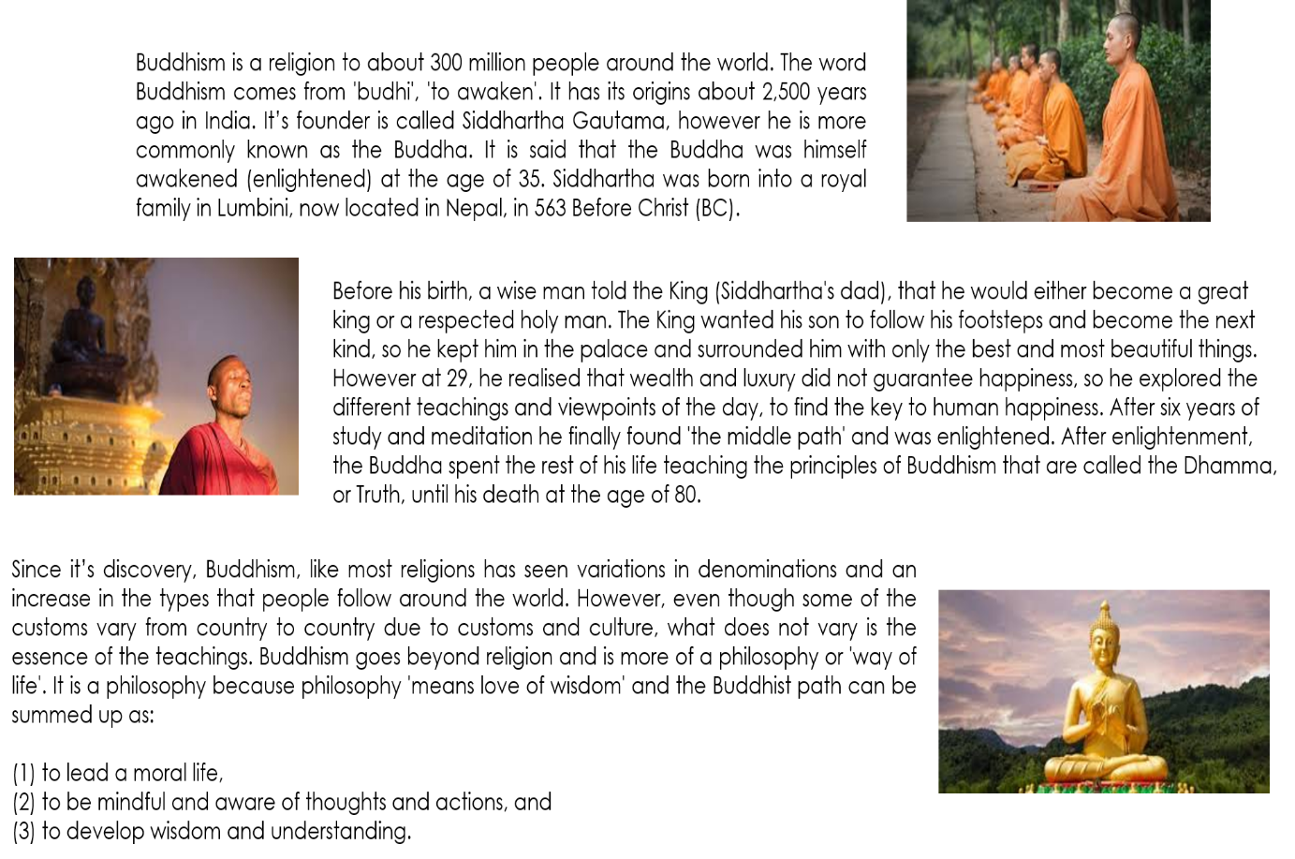Key questions
- What is the name of the man who became Buddha?
The name of the man who became Buddha is…
- How many years did the Buddha search for the answer of human suffering?
The buddha spent… years searching for the answer of human suffering.
- Why do you think the Buddha giving up his life of luxury is important for the followers of the faith?
I think that it is important / not important to Buddhists the Buddha gave up his life of luxury because…
Lesson 5 The story of the Buddha.
LI: To develop our understanding Buddhism.

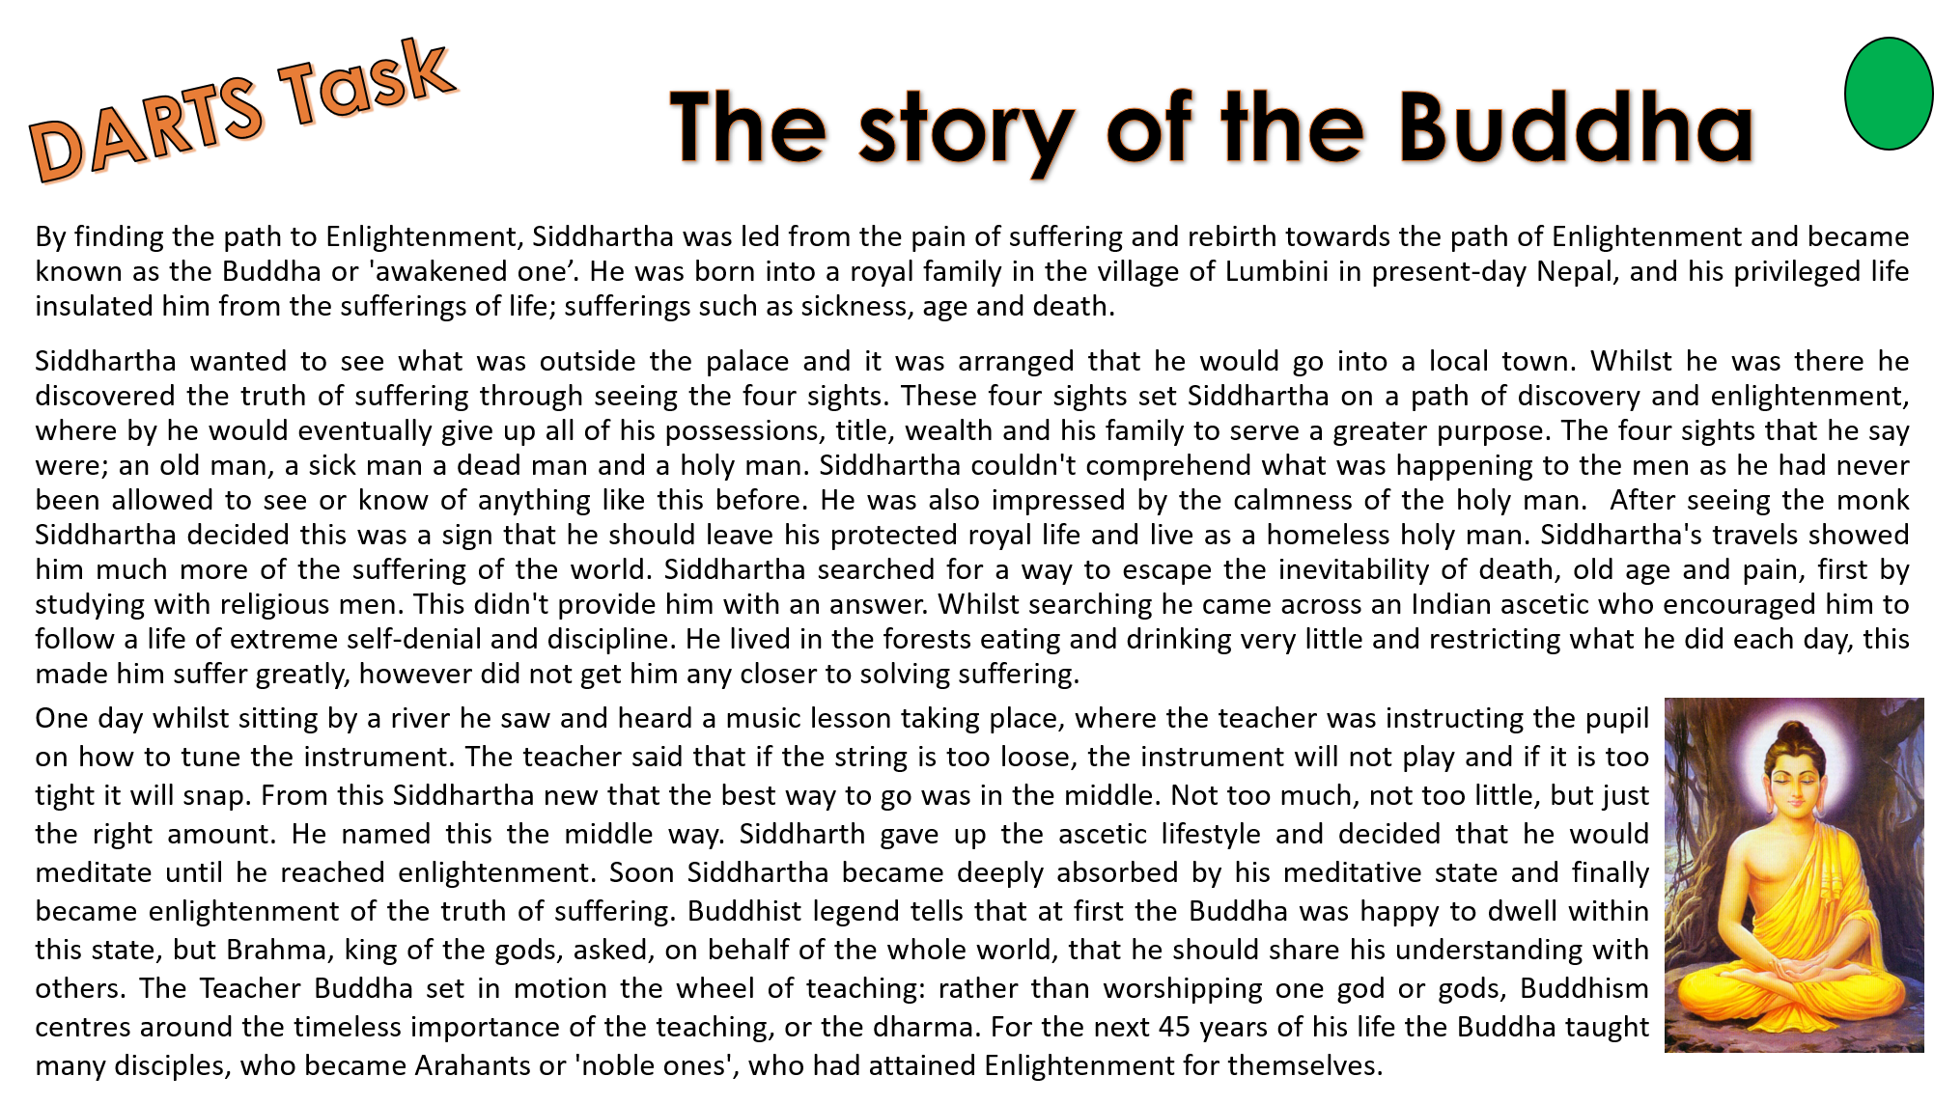
Video to support learning.
- https://www.youtube.com/watch?v=nVKK-WVW2uw
- https://www.youtube.com/watch?v=6s1WhlJh8ro
Key questions.
- Do you think Siddharth could have discovered the path to enlightenment by staying at the palace with his family and riches?
I believe that Siddhartha could / could not have discovered the path to enlightenment by staying at the palace with his family and riches because…
- Would you have given up everything to help others in this way?
I would / would not give up everything, like the Buddha to help others because…
- Do you agree with the idea of the middle way?
I agree / disagree with the idea of the middle way because…

Lesson 6 Buddhist beliefs and practices.
LI: To develop our understanding of Buddhist beliefs and practices.
Task one
- Research what the four noble truths are.
  - Explain the four parts (including Buddhist names for them)
  - Explain the eightfold path (4th noble truth)
  - Draw the eight fold path and label it.
Video to embed learning
https://www.youtube.com/watch?v=LPrC2qrs_PI
DIPS
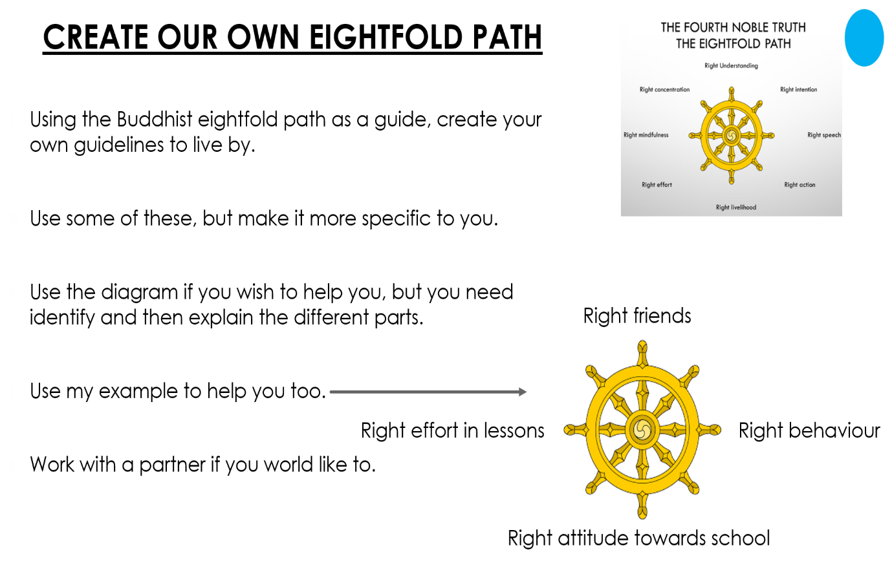

Homework
Complete the table for Christian fundaments.
Table of Religion | Buddhism
Founder / Leader
Symbol
Sacred Writings
Place of worship
Festivals

