

Stewards Academy
Year 7 Spanish
Autumn 2
Blended Learning Booklet

Mi tiempo libre (My free time)

Name ………………………….
Form ……………..
Class Teacher ………………….

YEAR 7 SPANISH
AUTUMN 2 – BLENDED LEARNING BOOKLET
Mi tiempo libre (My free time)
Lesson Title | Learning Intention | Page number
Big Picture – Year 7 Spanish |  | 3
Zoom in – Year 7 Spanish Autumn 2 |  | 4
Lesson 1:Me gustas tu | Objetivo: To be able to greet each other in Spanish and say what your name is. | 5
Lesson 2:¿Qué te gusta hacer? |  | 7
Lesson 3:¿Cantas karaoke? | Objetivo: to practise talking about what you like to do in your free time. | 9
Lesson 4:¿Qué haces cuando llueve? | Objetivo: to be able to say what you do in your free time using –ar verbs in the present tense. | 11
Lesson 5:¿Qué deportes haces? | Objetivo: to be able to talk about the weather using cuando (when). | 13
Lesson 6:Juego al fútbol | Objetivo: to learn how to talk about what sports you do using jugar and hacer | 15
Lesson 7:Repaso: Otoño 2 | Objetivo: to write about what sports we like to do | 17
Knowledge Organiser |  | 19
Assessment |  | 20
Assessment Ladder |  | 28

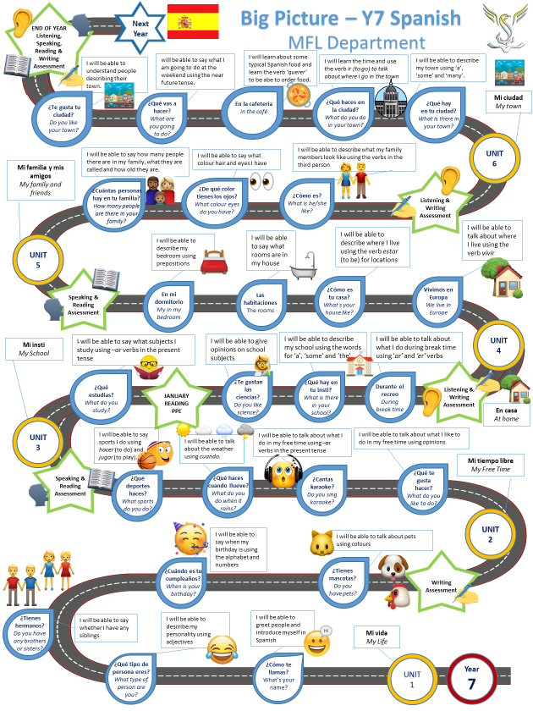

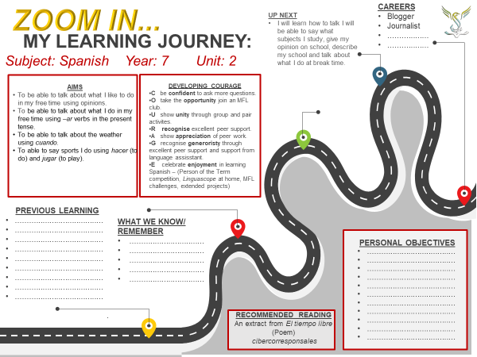

Module 2, Mi tiempo libre: Lesson 1:
Me gustas tu

Objetivo: To be able to greet each other in Spanish and say what your name is.

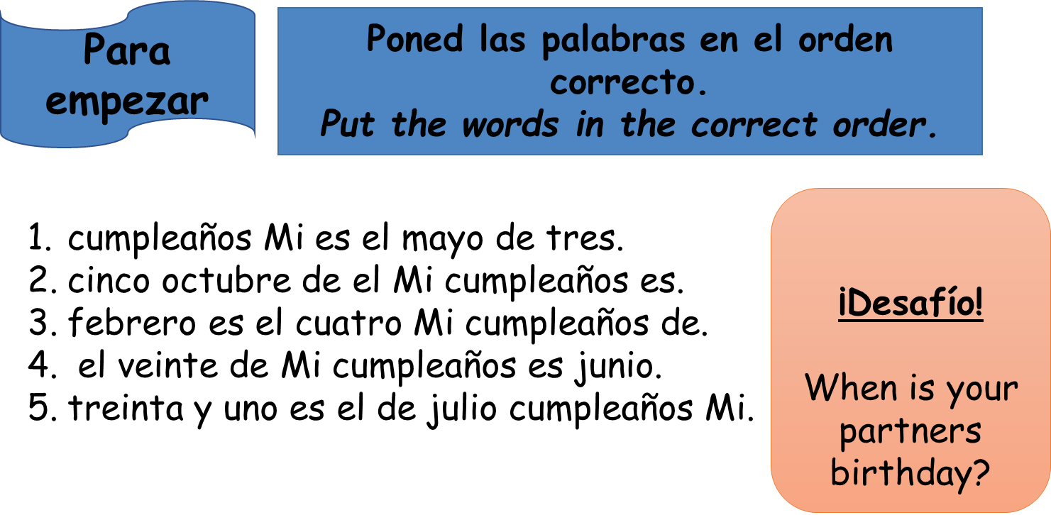

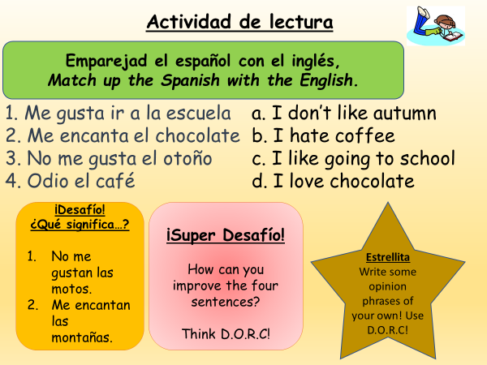
Activity 1 -

Activity 2 –
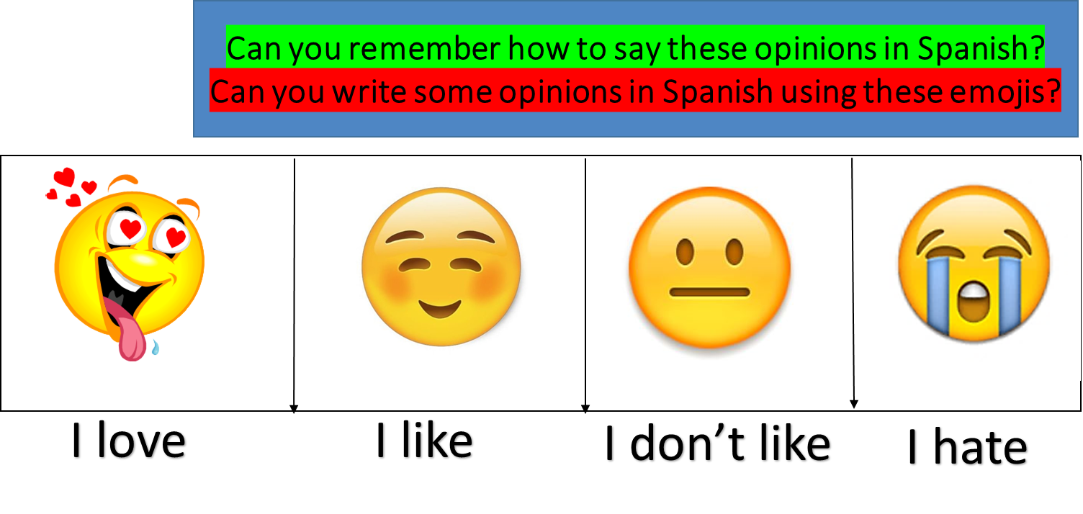

Activity 3 –
Listen to this song, and fill in the blanks in the lyrics.
https://www.youtube.com/watch?v=rs6Y4kZ8qtw
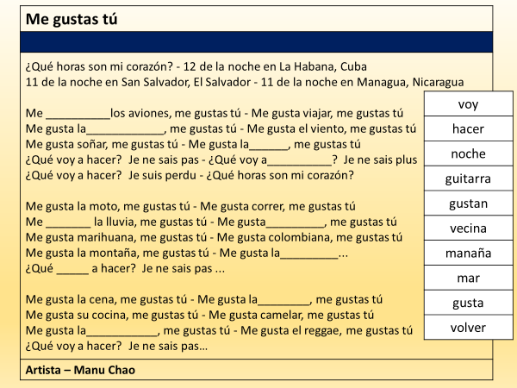

Module 2, Mi tiempo libre: Lesson 2:

¿Qué te gusta hacer?

Objetivo: to practise talking about what you like to do in your free time.

Activity 1 – Copy and match up the Spanish with the English in your books .
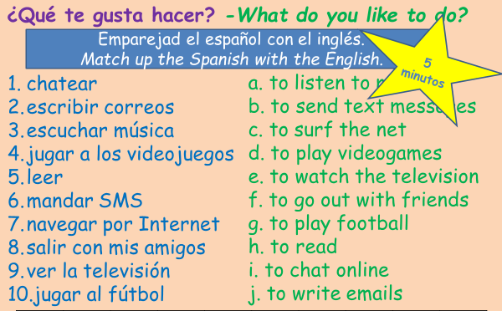

Desafío – Write what you like doing and add a reason
Me gusta ver la televisión porque es guay

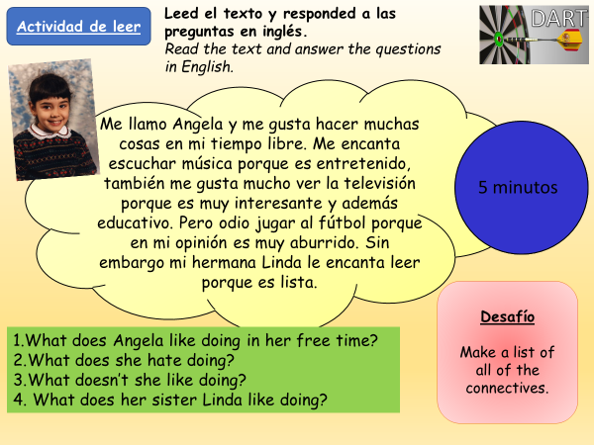
Activity 1 –

Activity 2 – Copy and translate thes sentences into Spanishn
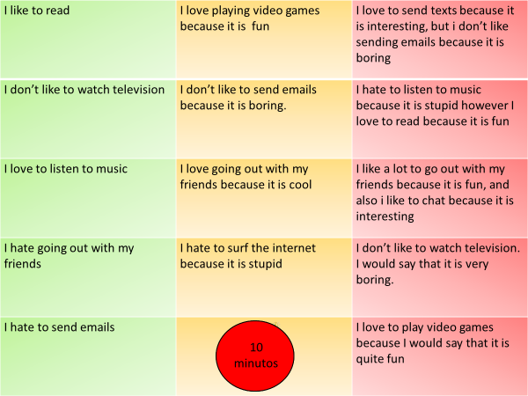

Activity 3 –
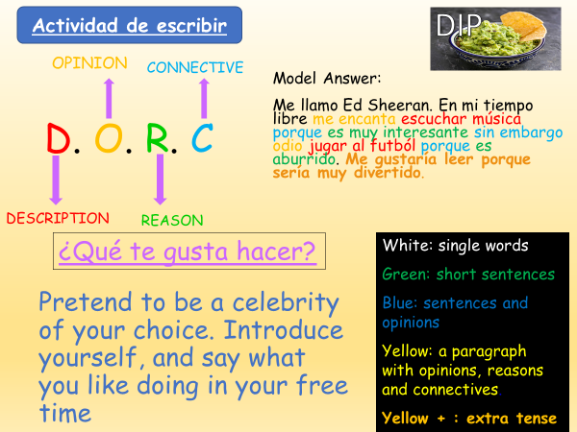

Module 2, Mi tiempo libre: Lesson 3:

¿Cantas karaoke?

Objetivo: to be able to say what you do in your free time using –ar verbs in the present tense.

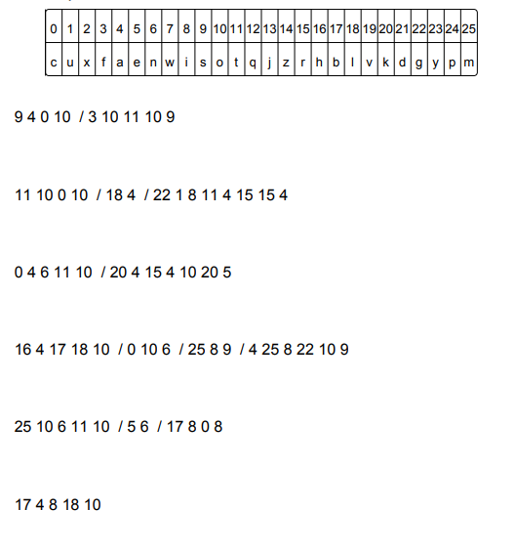
Para empezar – Crack the code in
your book to find out today’s
vocabulary. The / indicates a space

Example –

9 4 0 10/3 10 11 10 9

9 = S

4 = A

0 = C

10= O

3 = F

10= O

11= T

10= O

9 = S

SACO FOTOS

Activity 1 – Using your knowledge organiser, translate these sentences into English:
- Canto karaoke.
- Hablo con mis amigos.
- Saco fotos.
- Monto en bici.
- Toco la guitarra.
- Bailo.
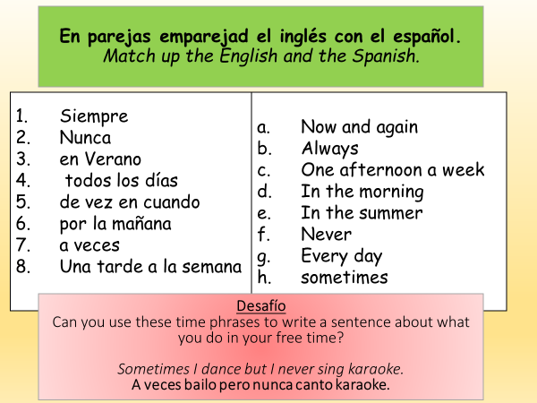
Activity 2 -

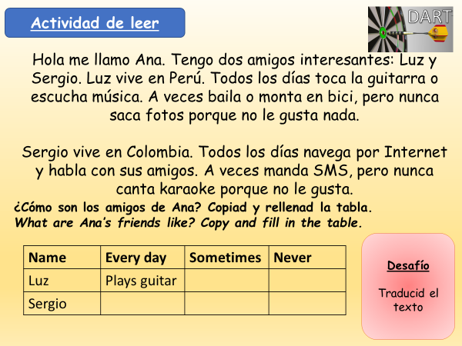
Activity 3 -

Activity 4 – Copy and translate this paragraph into English. Me gustaba = I used to like
Me llamo Justin Bieber, y en mi tiempo libre todos los días canto karaoke porque diría que es divertido. Sin embargo, nunca bailo porque es muy difícil. Pero, a veces me gusta bailar porque es interesante. Mi amigo saca fotos porque piensa que es guay. Me gustaba cantar karaoke porque era flipante.

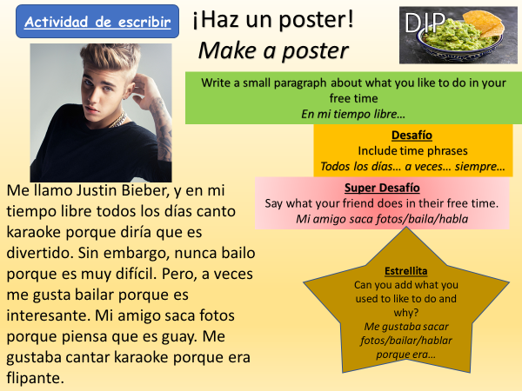
Activity 5 – Make a poster saying what you like to do in your free time.

Module 2, Mi tiempo libre: Lesson 4:

¿Qué haces cuando llueve?

Objetivo: to be able to talk about the weather using cuando (when).

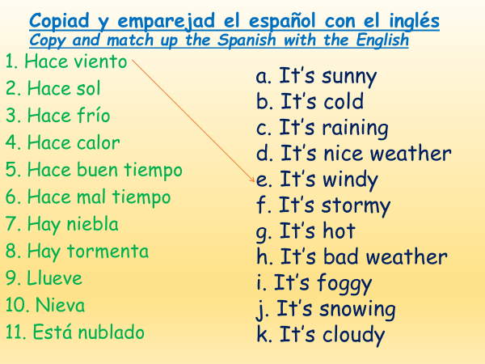
Para empezar –

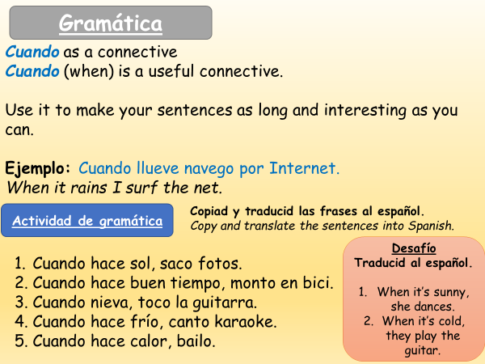
Activity 1-

Activity 2 -
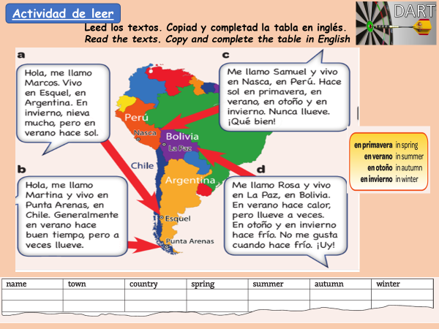

Activity 3 -
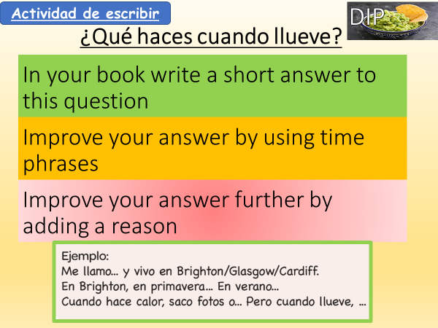

Module 2, Mi tiempo libre: Lesson 5:

¿Qué deportes haces?
Objetivo: to learn how to talk about what sports you do using jugar and hacer.
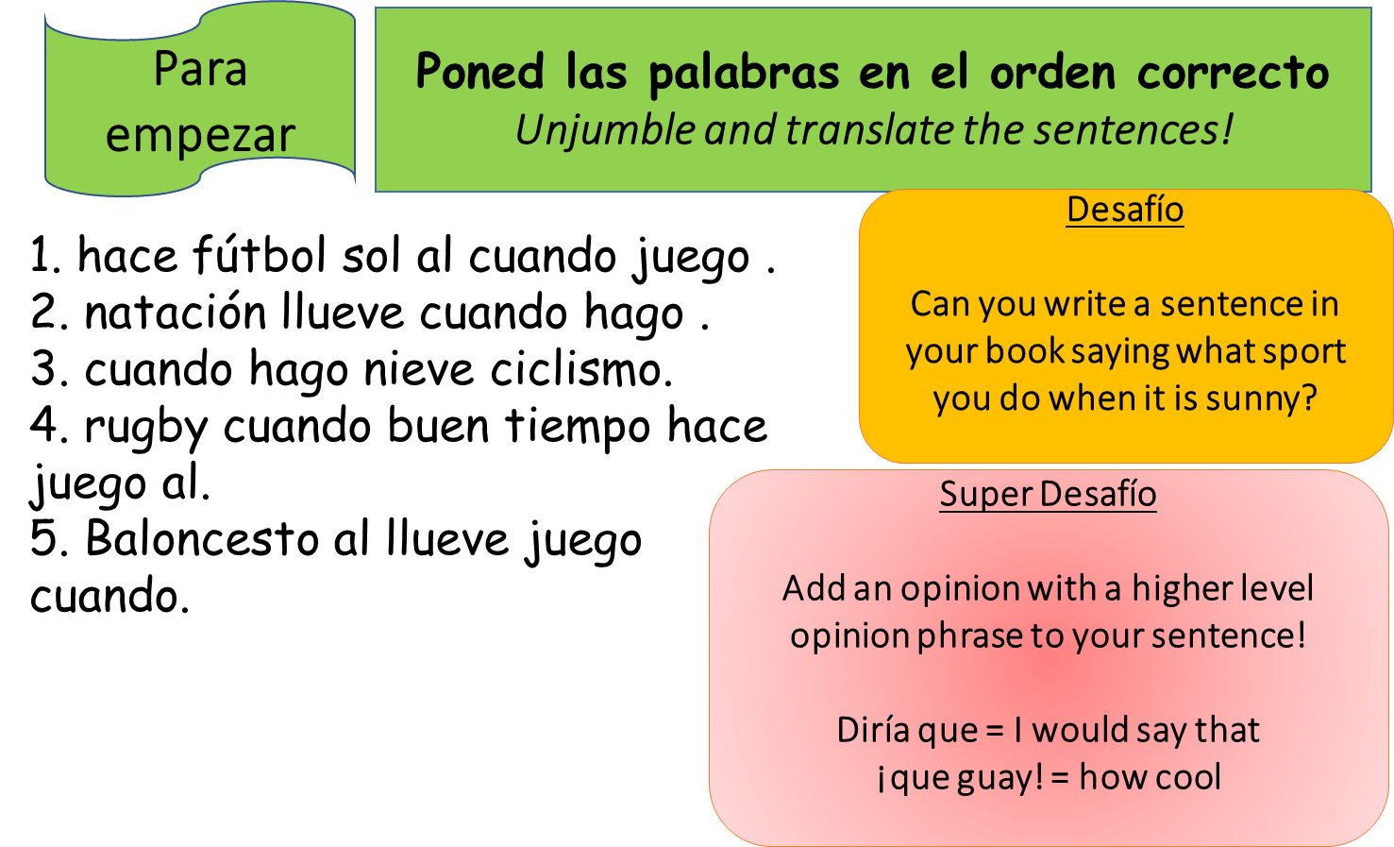

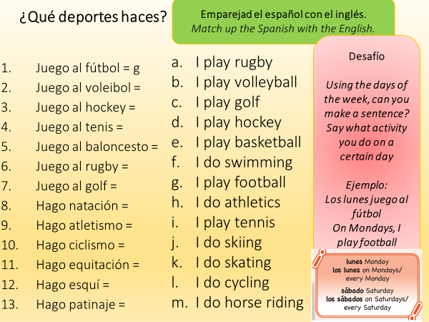
Activity 1 -

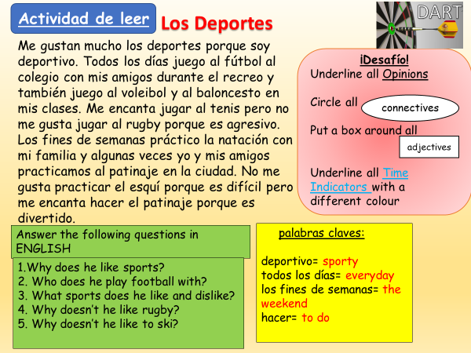
Activity 2 -

Activity 3 -
Escribe el inglés

Todos los días _____________________ una vez a la semana _____________________
Los lunes _____________________ dos veces a la semana _____________________
Nunca _____________________ los fines de semana ____________________

Activity 4 – Translate this paragraph into English.

Me gustan mucho los deportes porque soy deportivo. Todos los días juego al fútbol al colegio con mis amigos durante el recreo y también juego al voleibol y al baloncesto en mis clases. Me encanta jugar al tenis pero no me gusta jugar al rugby porque es agresivo. Los fines de semanas práctico la natación con mi familia y algunas veces yo y mis amigos practicamos al patinaje en la ciudad. No me gusta practicar el esquí porque es difícil pero me encanta hacer el patinaje porque es divertido.

Desafío – How could you improve this paragraph?

Module 2, Mi tiempo libre: Lesson 6:

Juego al fútbol
Objetivo: to write about what sports we like to do

Para empezar –
Juego al fútbol
I play rugby
Juego al tenis
I play basketball
Juego al hockey
I do athletics
Hago ciclismo
I do swimming
Hago equitación
I do skiing
Hago patinaje
Complete la tabla

Activity 1 –
Separa las palabras y traduce las frases
- Losfinesdesemanajuegoaltenis.
- Unavezalasemanahagonatación.
- Nuncahacemosesquíporqueescaro.
- Misamigosjueganalfútbolenelparque.
- Sihacesolhagoatletismoenelparque.
Activity 2 –
Traduce las frases
- Once a week I play basketball
- At the weekends I play football with my friends.
- Every day my brother does swimming.
- My friend and I play football in the park.
- I never do athletics because it’s boring.
- Twice a week I play tennis with my dad.
Desafío – Improve the sentences by making them DORC sentences!

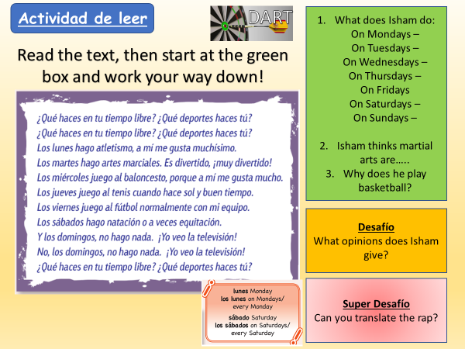
Activity 3 –

Activity 4 – Write what sports you like to do in your free time using DORC sentences

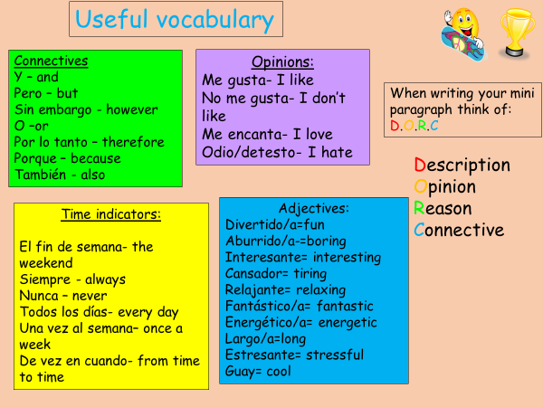

Desafío – Include an extra tense -
me gustaríá jugar – I would like to play me gustaría hacer – I would like to do
sería – it would be
Module 2, Mi tiempo libre: Lesson 7:
Repaso: Otoño 2
Objetivo: to recap learning in Otoño 2 in preparation for our reading and speaking assessment.
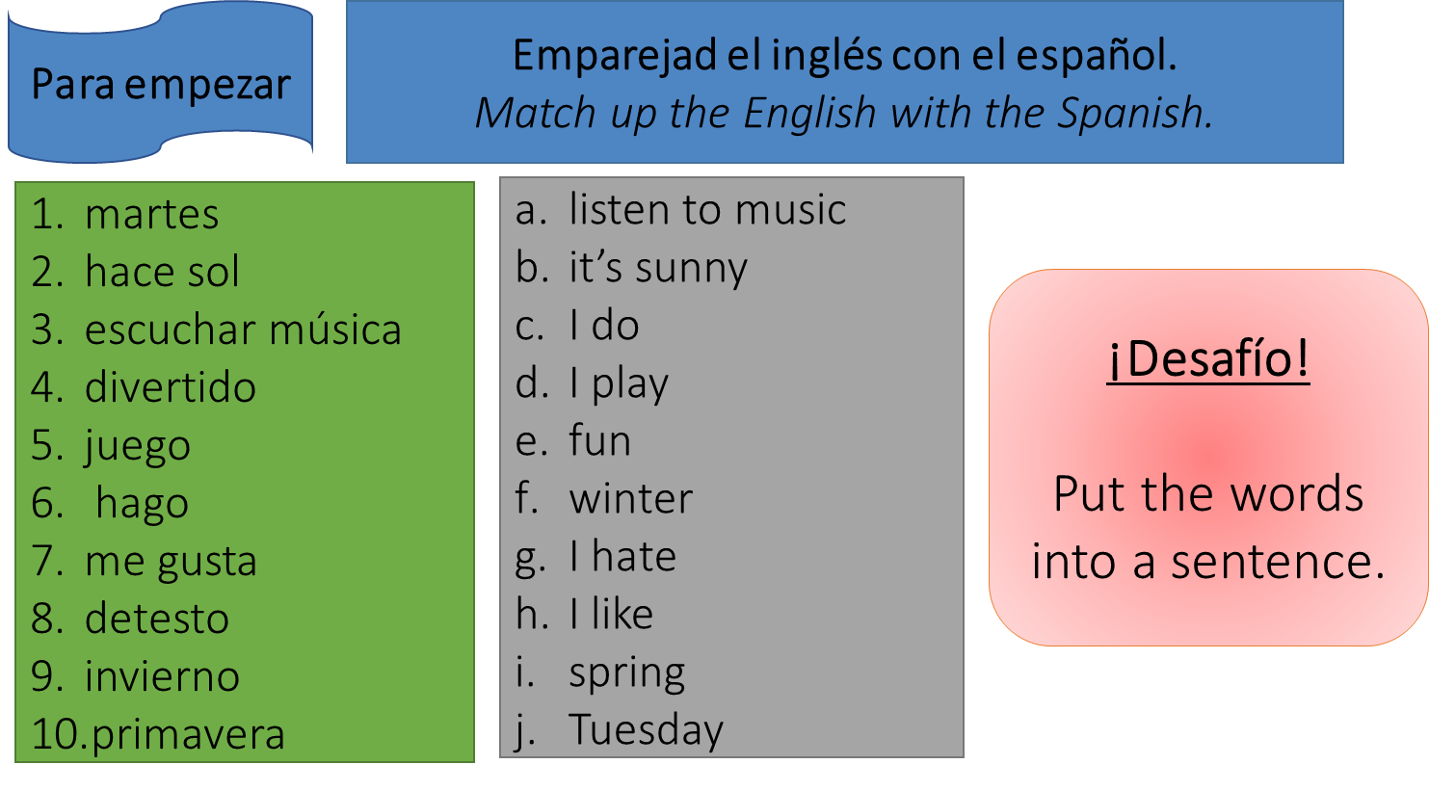

Activity 1 – For your speaking assessment, you will take part in a roleplay with your teacher. You will be able to choose between two characters, Isabel or Mateo. Your teacher will ask you 4 questions. Depending on who you choose to be will depend what you need to say in your answer. Example – If your teacher asks you question 1, and you are Isabel, you will need to say that you like chatting online and sending text messages. IN SPANISH!
Choose who you want to be for your speaking assessment, and make notes in English what you will need to say for each question.
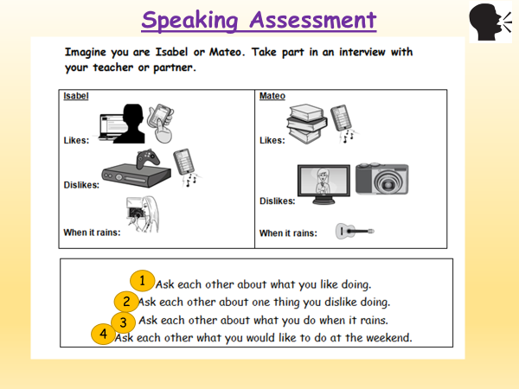
These are the 4 questions your teacher will ask you:
- ¿Qué te gusta hacer?
2. ¿Qué no te gusta hacer?
3. ¿Qué haces cuando llueve?
4. ¿Qué te gustaría hacer este fin de semana?

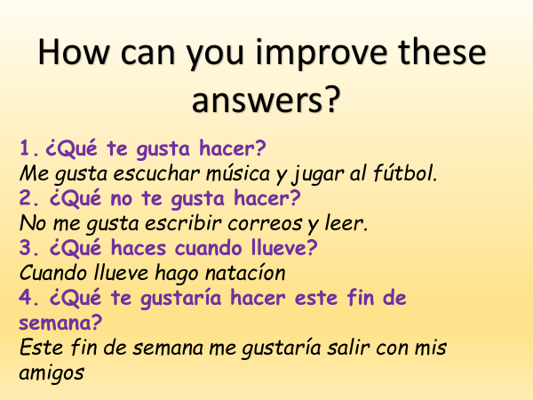
Activity 2 – Look at these model answers to the 4 questions. How can you improve them?
Think DORC!
If you are after Yellow +, think extra tenses as well!

Activity 3 – Now write your own answers in Spanish to the 4 questions, using the prompts given to you (Isabel or Mateo)
Make sure you answer with DORC sentences!
If you want a yellow plus you will also need to include a different tense!
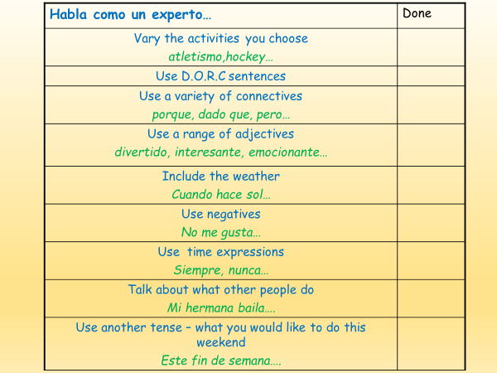
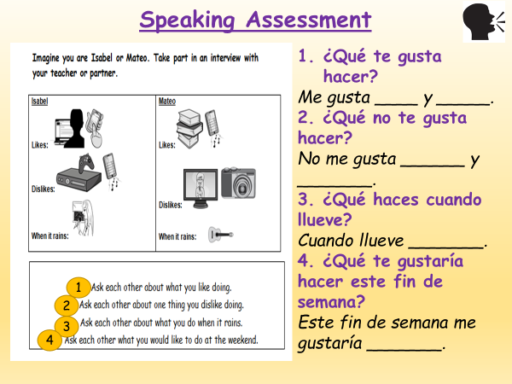

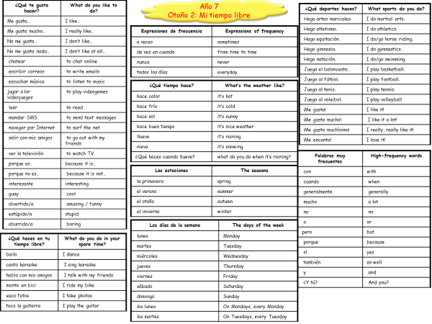

Nombre: Clase: Profesor/a:
S =
R = /60
Año 7
Otoño 1 Assessment
Mi tiempo libre
Speaking
Imagine you are Isabel or Mateo. Take part in an interview with your teacher or partner.

Isabel  Likes:    Dislikes:  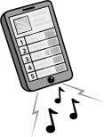  When it rains: 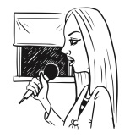 | Mateo  Likes:   Dislikes:    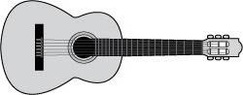  When it rains:
- Ask each other about what you like doing.
- Ask each other about one thing you dislike doing.
- Ask each other about what you do when it rains.
- Ask each other what you would like to do at the weekend.

Notes:
……………………………………………………………………………………………………………………………………………………………………………………………………………………………………………………………………………………………………………………………………………………………………………………………………………………………………………………………………………………………………………

Reading
- Match up the Spanish with the English.
Write the correct letters in the table below.

- I do
- Tuesday
- Monday
- I hate
- I do not like
- I play
- summer
- to read
- boring
- cool
- it’s cold
- it’s hot
- to listen to music
- I like
1. lunes
2. martes
3. me gusta
4. no me gusta
5. odio
6. leer
7. escuchar música
8. aburrido
9. guay
10. verano
11. hace sol
12. hace frío
13. Juego
14. Hago

1 | 2 | 3 | 4 | 5 | 6 | 7 | 8 | 9 | 10 | 11 | 12 | 13 | 14

TOTAL MARKS /14
- What day is it? Write the correct letter in the space provided.

Example: Monday | C
Tuesday
Wednesday
Thursday
Friday
Saturday
Sunday
A domingo
B viernes
C lunes
D miércoles
E sábado
F jueves
G martes

TOTAL MARKS /6

- What do they like to do? Write the correct letter in the space provided.

  A |   B
  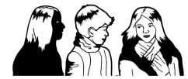  C |   D
  E | 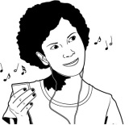    F
G | H

Example: Me gusta chatear. B
- Me gusta jugar a los videojuegos. ______
- Me gusta leer. ______
- Me gusta mandar SMS. ______
- Me gusta salir con mis amigos. ______
- Me gusta escribir correos electrónicos. ______
- Me gusta escuchar música. ______

TOTAL MARKS /6

- Who does what? Write the correct name next to each picture.

Example:   Paula

1  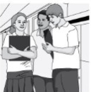 2  

3   4 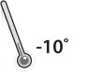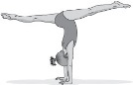

5   6  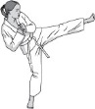

Carolina: Cuando hace calor, monto en bici.
Jaime: Cuando llueve, hablo con mis amigos.
Hugo: Cuando hace buen tiempo, juego al voleibol.
Jorge: Cuando hace frío, juego al tenis.
Pepe: Cuando nieva, hago natación.
Paula: Cuando hace sol, saco fotos.
Nuria: Cuando llueve, hago artes marciales.
Maite: Cuando hace frío, hago gimnasia.

TOTAL MARKS /6

- Read this email from Rafael. Fill in the missing words. Choose from those given.
equitación interesante aburrido años amigos juego gusta baloncesto

¡Hola! ¿Qué tal? Me llamo Rafael y tengo trece años En mi tiempo libre me gusta salir con mis 1 ____________. También me gusta leer porque es
2 _______________. No me gusta mandar SMS y no me 3 ______________ nada jugar a los videojuegos. Es muy 4 ____________________. Los sábados juego al
5 __________________ y los domingos hago 6 _________________. ¡Es guay!

TOTAL MARKS /6
- Read about Carmen’s week. Write the correct letter in the activity column and draw the correct heart(s) in the opinion column.
Los lunes hago gimnasia, pero no me gusta nada. Los martes hago artes marciales. Me gusta mucho, ¡es genial! Los miércoles me gusta ver la televisión. Los jueves toco la guitarra, pero no me gusta porque es difícil. Los viernes no saco fotos, pero me gusta mandar SMS. Los sábados hago natación, pero no me gusta nada. Los domingos hago equitación, es difícil, pero me gusta mucho.
Day | Activity | Opinion  
Example: Monday | D | 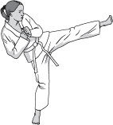    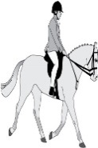  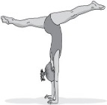  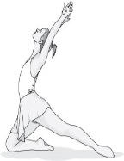  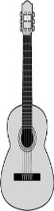  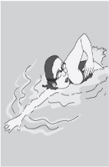      A B C D  E F G H
Tuesday
Wednesday
Thursday
Friday
Saturday
Sunday

TOTAL MARKS /12

Translation
Translate the paragraph into English.
En mi tiempo libre me encanta hacer mucho deporte. Juego al rugby y al tenis y también hago natación a veces. Cuando llueve, me gusta navegar por Internet. La música es mi pasión. El fin de semana me gustaría jugar al fútbol con mis amigos porque sería divertido.
__________________________________________________________________________________________________________________________________________________________________________________________________________________________________________________________________________________________________________________________________________________________________________________________________________________________________________________________________________________________________________________________________________________________________

TOTAL MARKS /10

Attainment Band : | Otoño 2: En mi tiempo libre
Attainment Band : | Listening | Speaking | Reading | Writing
Yellow Plus  Two Tenses | Shows understanding of a range of short passages which include opinions with basic reasons, in either the present and the past, or the present and the future tense.  Transcribes short sentences. | Takes part in short conversations on a range of topics giving opinions and reasons.  Asks spontaneous questions.  Uses the present and past or future tenses.  Uses increasingly accurate pronunciation and intonation. | Shows understanding of a range of short and longer texts (e.g. adapted adverts, poems and songs) which include opinions in the present and past or future tense.  Translates longer sentences into English. | Writes short texts giving and seeking information and opinions, using the present and past or future tense.  Translate longer sentences into Spanish.
Yellow  Longer paragraphs with opinions | Shows understanding of the main points, opinions and some details in short passages in either the present or the future tense.  Transcribes short phrases. | Takes part in simple conversations, using the present or future tense.  Gives opinions and simple reasons.  Gives information in short dialogues.  Begins to speak spontaneously. | Shows understanding of the main points, opinions and overall message in short written texts (e.g. menus, short adverts, songs, simple poems), in the present or future tense.  Translates simple sentences. | Writes short texts for different purposes using the present or the future tense.  Expresses opinions and gives simple reasons.  Translates simple sentences into Spanish.
Blue  Short Paragraphs with opinions | Shows understanding of the main points and opinions from short passages spoken clearly in the present tense.  Transcribes familiar words. | Asks and answers simple questions.  Gives simple opinions.  Takes part in brief dialogues, using short phrases using the present tense. | Shows understanding of the main points and opinions in short texts.  Translates familiar words and short phrases into English. | Writes several short sentences giving information and expressing simple opinions.  Translates familiar words and short phrases into Spanish.
Green  Sentences | Shows understanding of a range of familiar phrases and opinions, spoken clearly. | Answers simple questions.  Gives basic information and opinions. | Shows understanding of a range of familiar written phrases and opinions. | Writes a few short sentences with support, giving basic information.  Writes some familiar words from memory.
White  Words | Shows understanding of familiar words and phrases, spoken clearly and repeated if necessary. | Says single words and short phrases with support.  Copies pronunciation and intonation correctly. | Shows understanding of familiar words and phrases. | Writes or copy simple words correctly.  Labels items.  Completes short phrases or sentences.
Teacher Feedback
WWW: | EBI:

