

Stewards Academy
Year 7 French
Autumn 2 Blended Learning Booklet

Mon temps libre (My Free Time)

Name ………………………….
Form ……………..
Class Teacher ………………….

YEAR 7 FRENCH
AUTUMN 2 BLENDED LEARNING BOOKLET LEARNING OVERVIEW
Mon temps libre (My Free Time)
Lesson Title | Learning Intention | Page
Big picture – Year 7 French |  | 3
Zoom in – Year 7 French Autumn 2 |  | 4
Lesson 1:Tu es sportif ? | Objectif: to be able to say what you like to do in your free time using jouer à | 5
Lesson 2:Quand il pleut… | Objectif: to be able to say what you like doing in a sentence with the weather. Par exemple, quand il pleut, j’aime jouer au foot | 7
Lesson 3:Qu’est-ce que tu fais? | Objectif: To be able to talk about activities you do | 9
Lesson 4:Je fais de la danse | Objectif: To be able to talk about activities you do using the verb faire | 11
Lesson 5:Tu aimes faire ça? | Objectif: To be able to talk about what you like doing using aimer + the infinitive | 13
Lesson 6:Sur mon portable, j’aime bloguer | Objectif: To be able to talk about what you like doing on your phone using a variety of opinion phrases + the infinitive | 15
Lesson 7: Révisions Automnee 2 | Objectif: To prepare for our end of Autumn 2 speaking and reading assessment | 17
Knowledge Organiser |  | 19
Assessment |  | 21
Assessment Ladder |  | 28

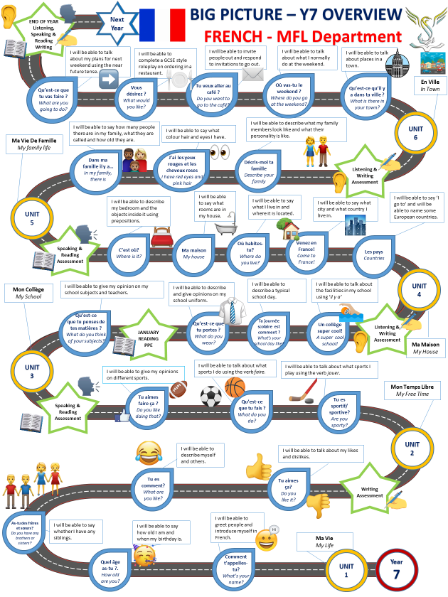

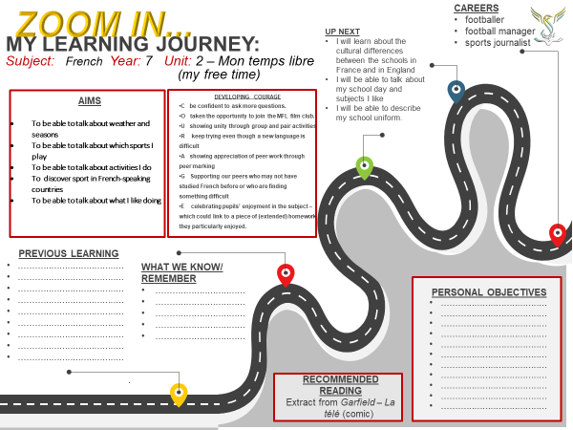

Module 2, Mon temps libre: Lesson 1:
Tu es sportif ?
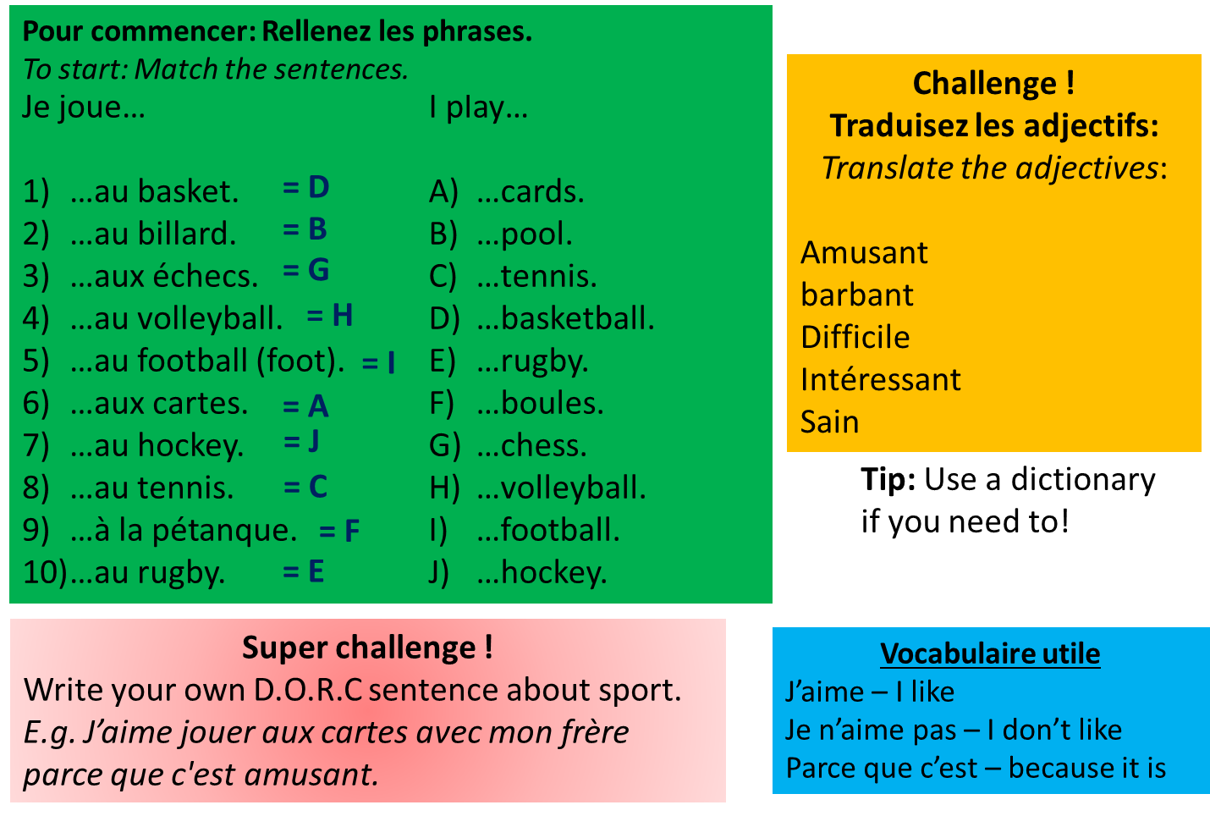
Objectif: to be able to say what you like to do in your free time using jouer à.

Activity 1 – Make notes on the verb jouer – especially à + le/la/les
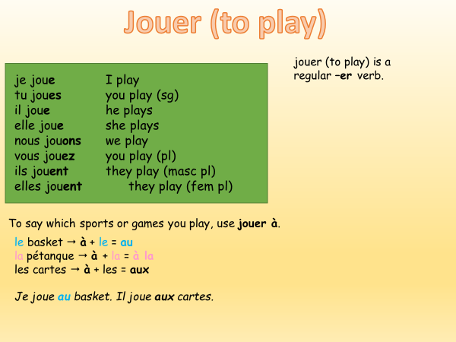

Le foot – is masculine, so à + le = au
je joue au foot

La pétanque – is feminine, so à + la = à la
Je joue à la pétanque

Les échecs – is plural, so à + les = aux
Je joue aux échecs

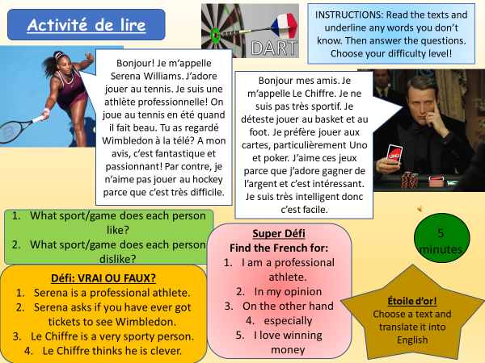
Activity 2 –

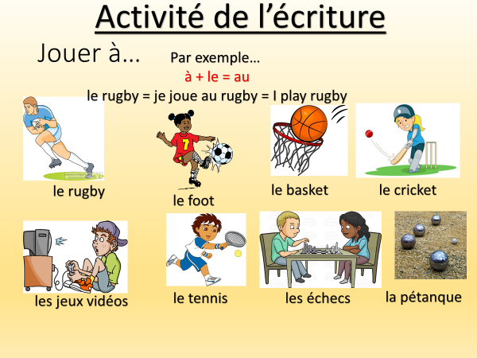
Activity 3 – Write a sentence for each sport. Challenge – write DORC sentences!

Module 2, Mon temps libre: Lesson 2:
Quand il pleut…
Objectif: to be able to say what you like doing in a sentence with the weather. Par exemple, quand il pleut, j’aime jouer au foot
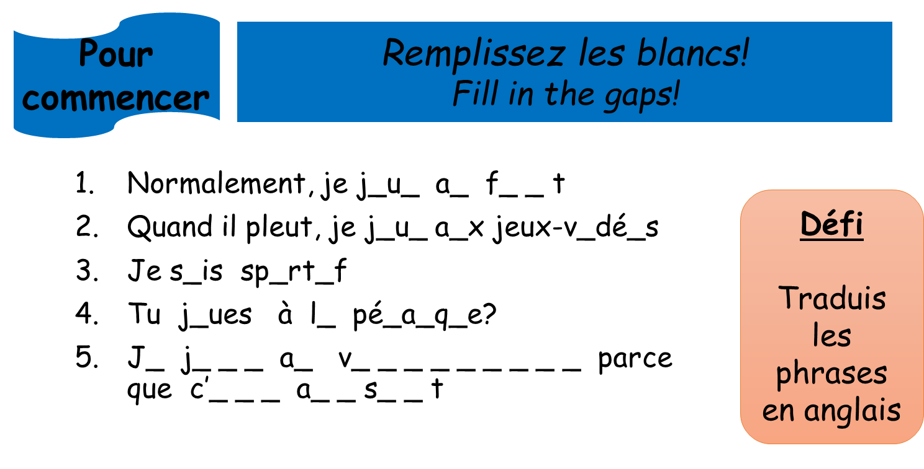

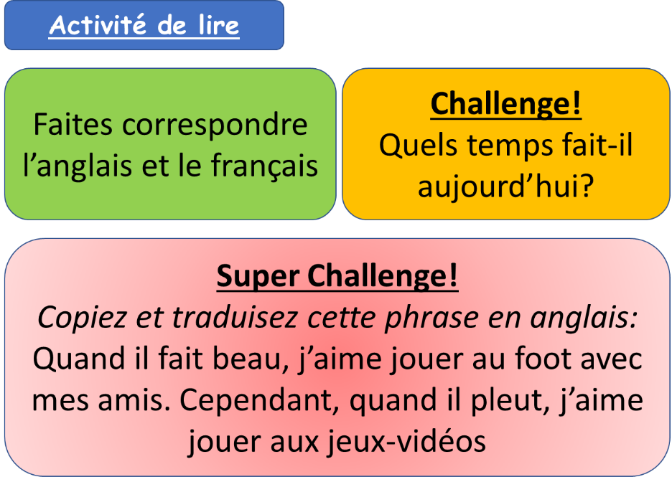
Activity 1 –
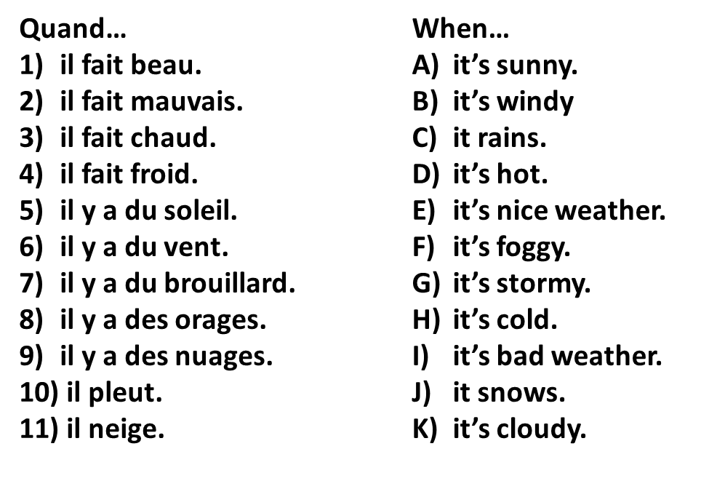
Match up the French with the
English weather
Challenge – Write a sentence in
your book describing the weather
today.
Aujourd’hui ….

Super Challenge – Copy and
translate the sentence.

Activity 3 – Make notes on using ‘quand + present tense weather’
This lesson, we are going to be looking at saying what activities we do in different weather.
For example, saying when it is sunny, I play football.
To do this is French, we need to use ‘quand’ which means when, + the weather. We then add our activity.
when it is sunny, I play football. = quand il y a du soleil je joue au foot

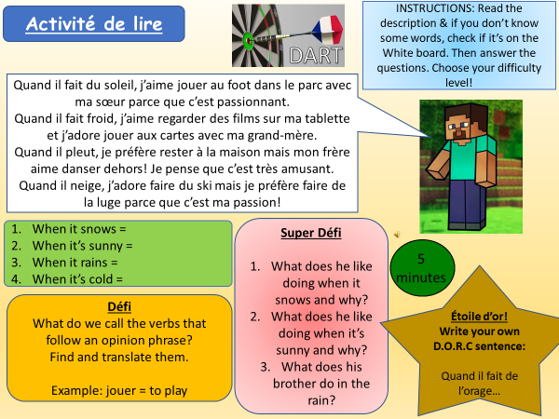
Activity 4 –

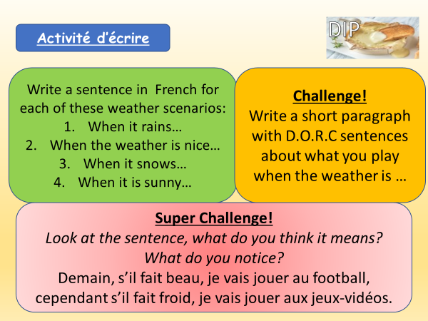
Activity 5 –

Module 2, Mon temps libre: Lesson 3:
Qu’est-ce que tu fais?
Objectif: To be able to talk about activities you do

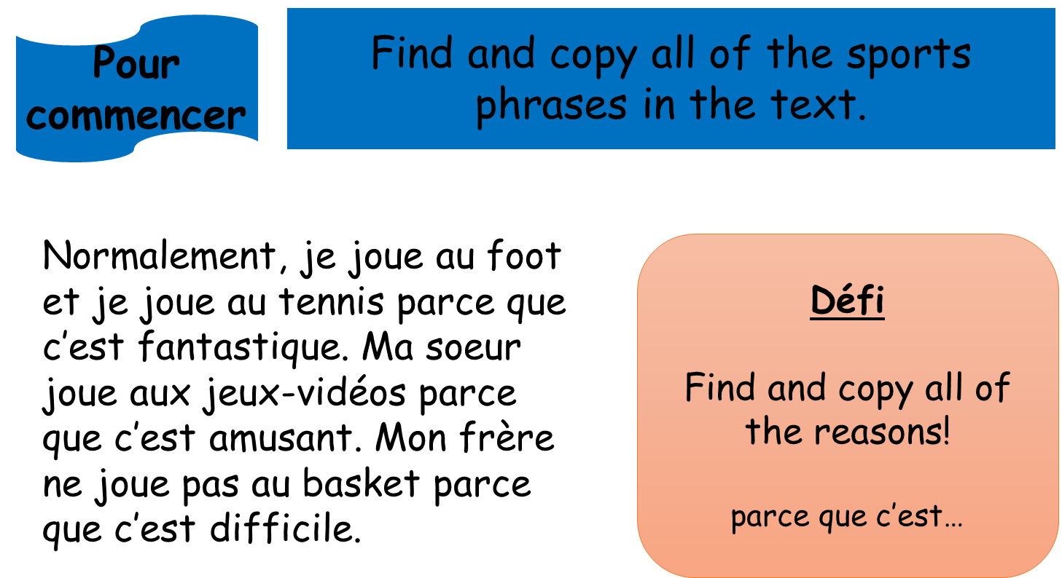

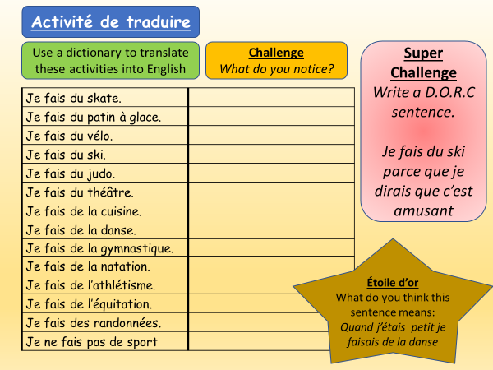
Activity 1 -

Activity 2 – Make notes on using faire de – then complete the activity
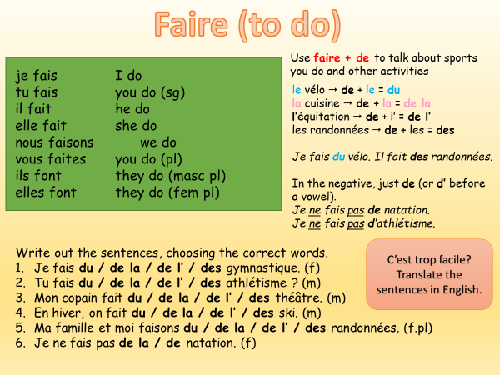

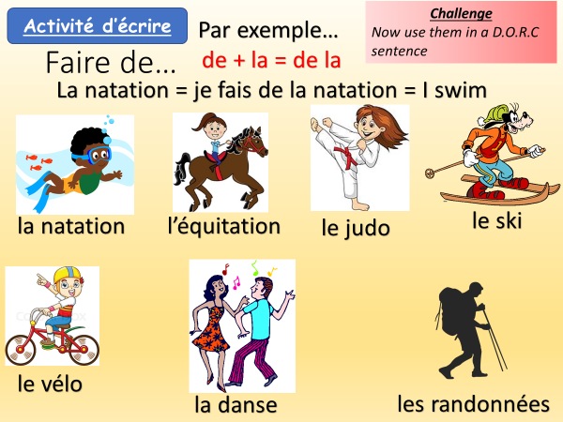
Activity 3 -

Module 2, Mon temps libre: Lesson 4:
Je fais de la danse
Objectif: To be able to talk about activities you do using the verb faire

Pour commencer – Copy and match up the frequency words
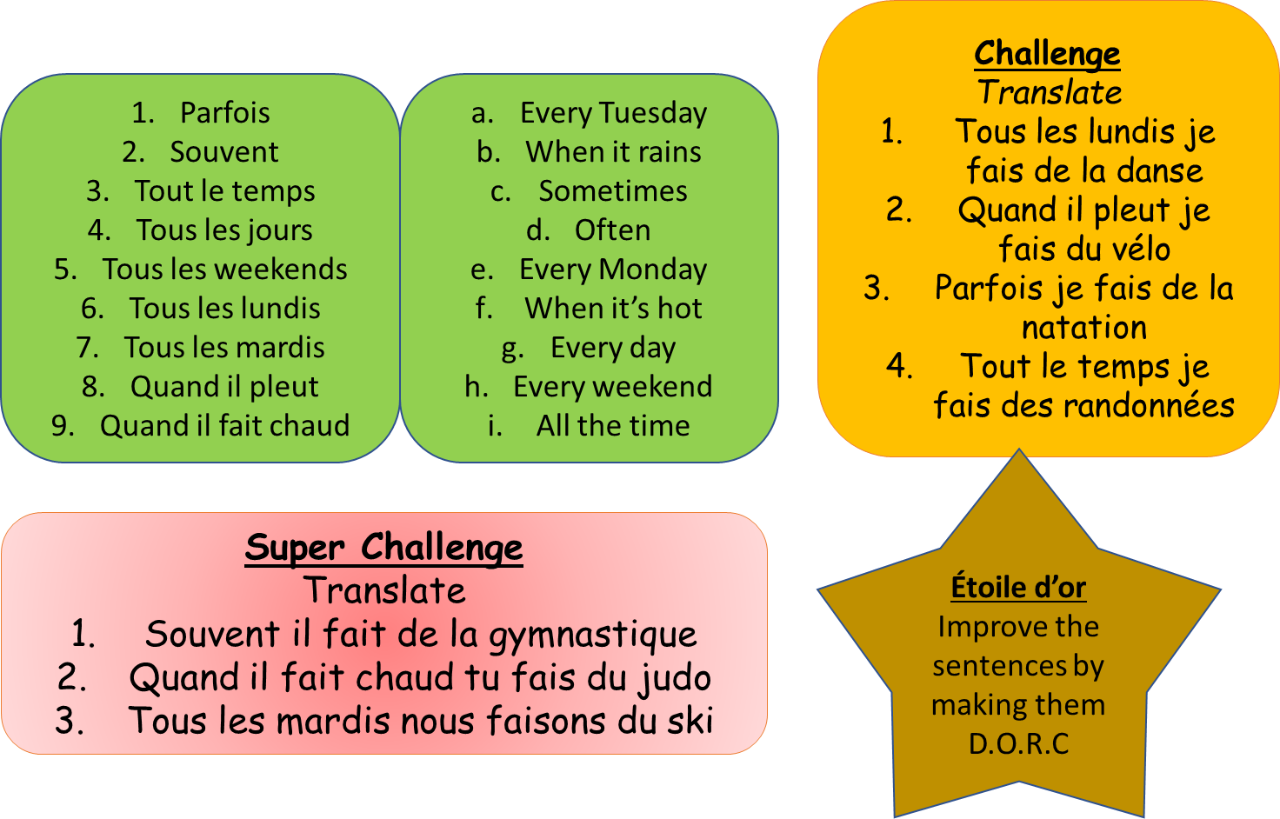

Activity 1 – Copy and translate these sentences into French
Challenge – Improve the sentences by adding a reason

- I do swimming
- I do dance
- I do cooking
- I do cycling
- He does judo
- She does athletics
- He does drama
- We do skateboarding
- We do iceskating
- We do gymnastics

Activity 2 – Copy and translate these sentences into French

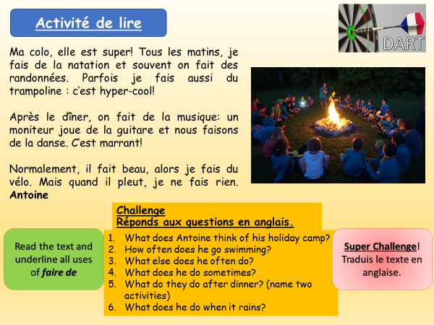

Activity 3 -

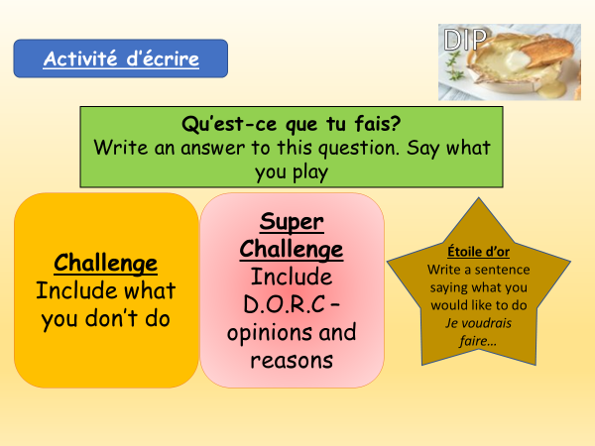

Module 2, Mon temps libre: Lesson 5:
Tu aimes faire ça?
Objectif: To be able to talk about what you like doing using aimer + the infinitive
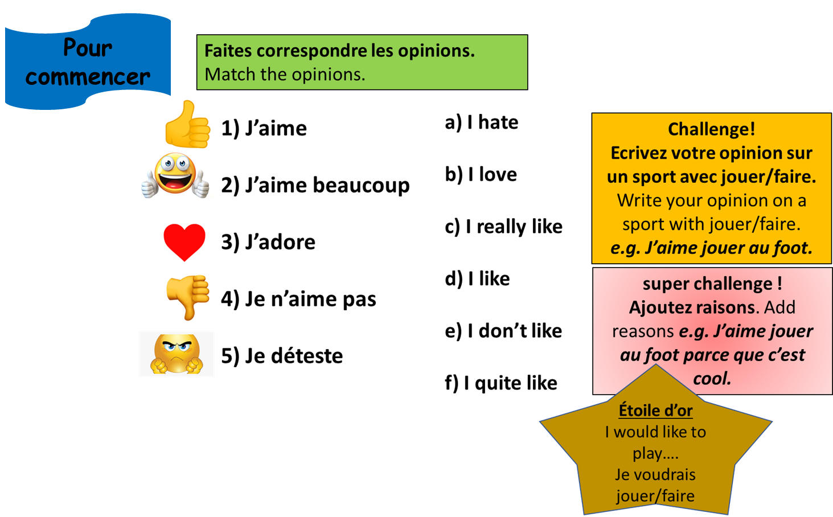

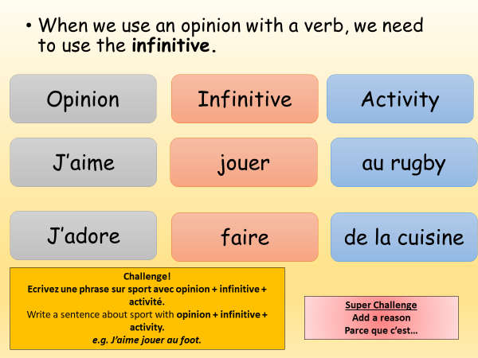
Activity 1 -

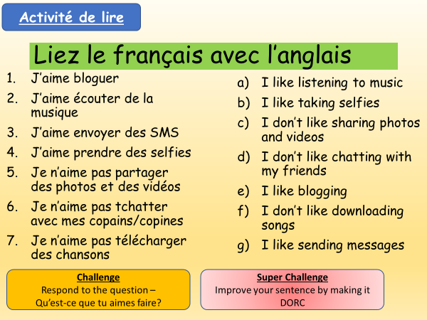
Activity 2 -

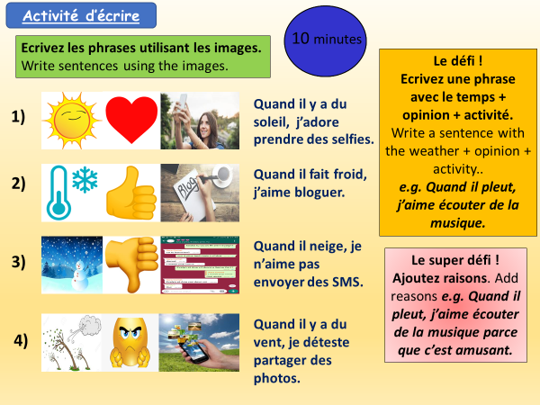
Activity 3 –

Module 2, Mon temps libre: Lesson 6:
Sur mon portable, j’aime bloguer
Objectif: To be able to talk about what you like doing on your phone using a variety of opinion phrases + the infinitive
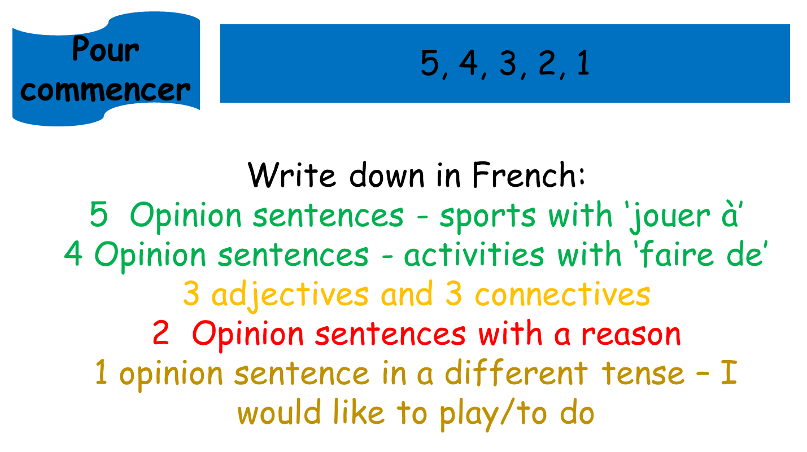

Activity 1 -
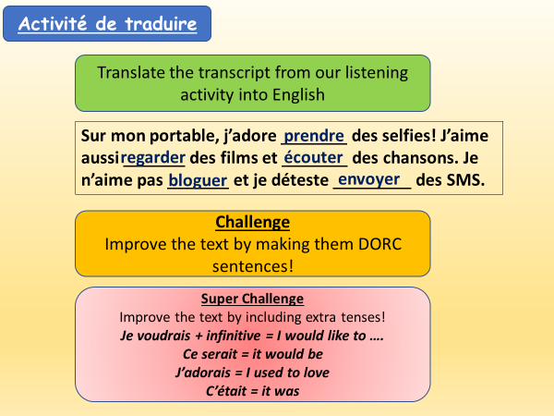

Activity 3 –
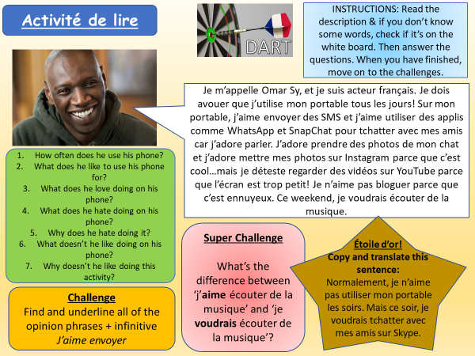

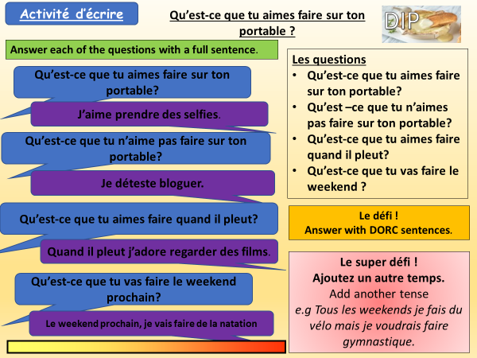
Activity 4 –

Module 2, Mon temps libre: Lesson 7:
Révisions – Automne 2
Objectif: To prepare for our end of Autumn 2 speaking and reading assessment
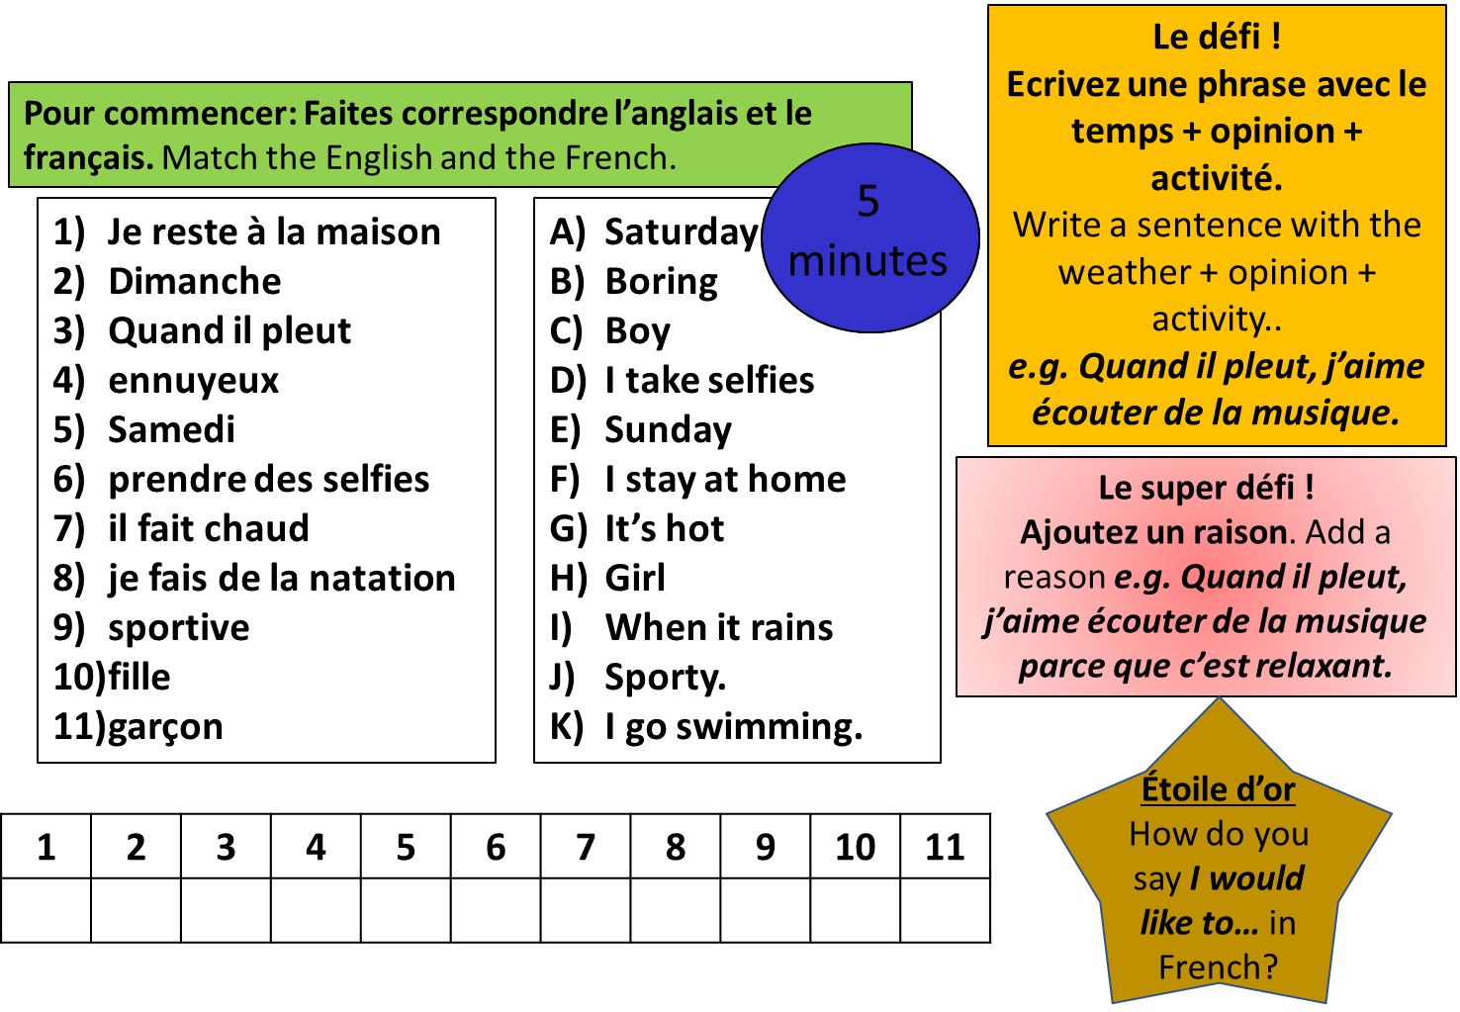

Activity 1 – For your speaking assessment, you will take part in a roleplay with your teacher. You will be able to choose between two characters, Élodie or Pierre. Your teacher will ask you 4 questions. Depending on who you choose to be will depend what you need to say in your answer. Example – If your teacher asks you question 1, and you are Isabel, you will need to say that you like chatting online and sending text messages. IN SPANISH!
Choose who you want to be for your speaking assessment, and make notes in English what you will need to say for each question.
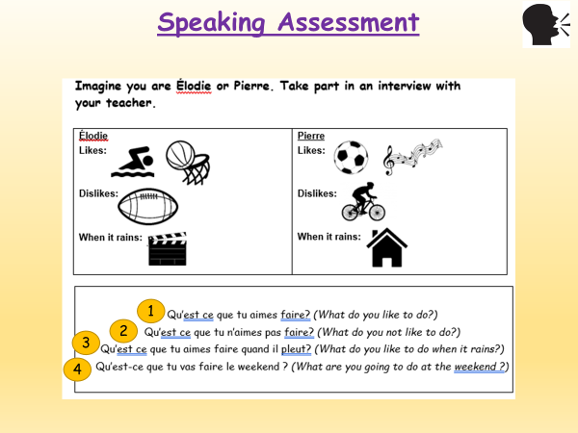
These are the 4 questions your teacher will ask you:
- Qu’est-ce que tu aimes faire?
- Qu’est-ce que tu n’aimes pas faire?
- Qu’est-ce que tu aimes faire quand il pleut?
- Qu’est-ce que tu vas faire le weekend?

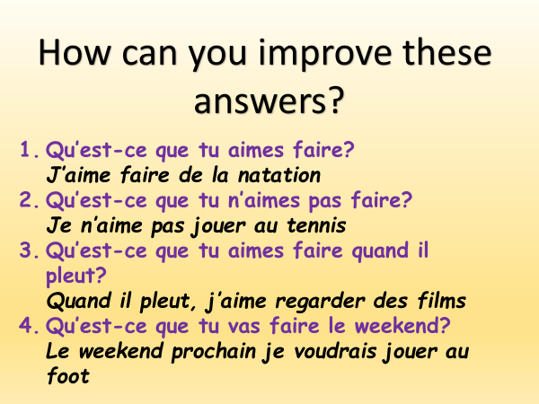
Activity 2 – Look at these model answers to the 4 questions. How can you improve them?
Think DORC!
If you are after Yellow +, think extra tenses as well!

Activity 3 – Now write your own answers in Spanish to the 4 questions, using the prompts given to you (Isabel or Mateo)
Make sure you answer with DORC sentences!
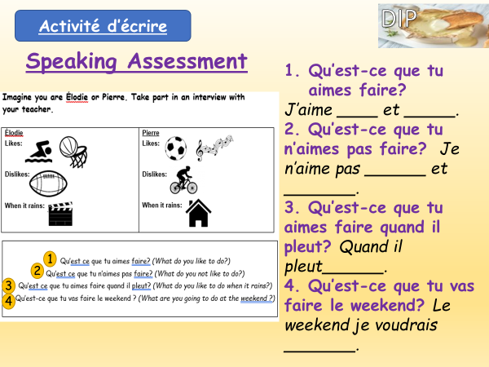
If you want a yellow plus you will also need to include a different tense!

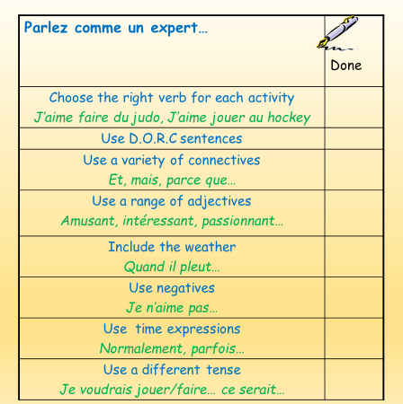

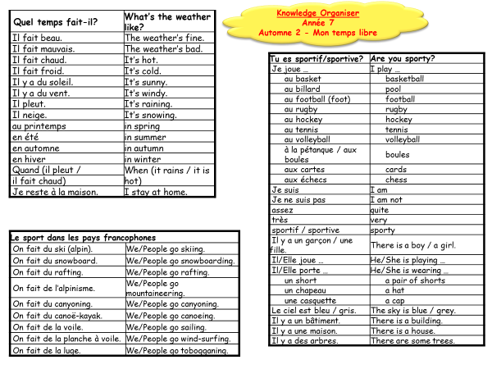

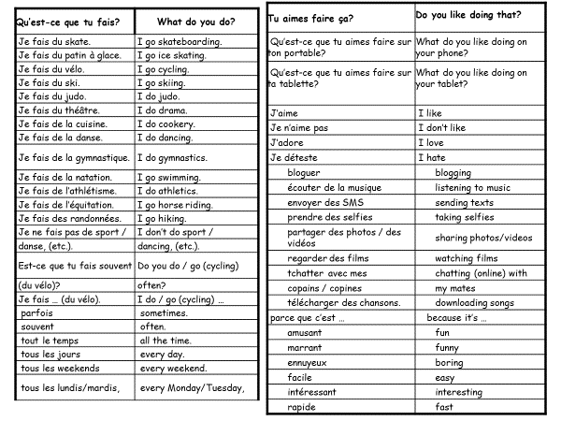

Nom: Classe: Prof:
S =
R = /52
Année 7
Automne 2 Assessment
Mon temps libre
Speaking
Imagine you are Élodie or Pierre. Take part in an interview with your teacher.

  Élodie    Likes:    Dislikes:    When it rains: |     Pierre  Likes:  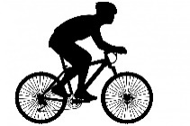  Dislikes:    When it rains:
- Qu’est ce que tu aimes faire? (What do you like to do?)
- Qu’est ce que tu n’aimes pas faire? (What do you not like to do?)
- Qu’est ce que tu aimes faire quand il pleut? (What do you like to do when it rains?)
- Qu’est-ce que tu vas faire le weekend ? (What are you going to do at the weekend ?)

Notes:
……………………………………………………………………………………………………………………………………………………………………………………………………………………………………………………………………………………………………………………………………………………………………………………………………………………………………………………………………………………………………………………………………………………………………………………………
……………………………………………………………………………………………………………………………………………………………………………………………………………………………………

Reading
- Match up the French with the English.
Write the correct letters in the table below.

- When it rains
- Tuesday
- Monday
- I hate
- I do not like
- I play football
- I swim
- to take selfies
- boring
- fun
- it’s cold
- it’s hot
- to listen to music
- I like
1. lundi
2. mardi
3. j’aime
4. je n’aime pas
5. je déteste
6. prendre des selfies
7. écouter de la musique
8. ennuyeux
9. amusant
10. je joue au foot
11. il fait chaud
12. il fait froid
13. je fais de la natation
14. quand il pleut

1 | 2 | 3 | 4 | 5 | 6 | 7 | 8 | 9 | 10 | 11 | 12 | 13 | 14

TOTAL MARKS /14

- What day is it? Write the correct letter in the space provided.

Example: Monday | C
Tuesday
Wednesday
Thursday
Friday
Saturday
Sunday
A dimanche
B vendredi
C lundi
D mercredi
E samedi
F jeudi
G mardi

TOTAL MARKS /6

- Read what these young people like doing on their mobile phones. Who makes each of the statements below? Write the correct name.
J’aime partager des vidéos. | Alice
J’aime prendre des selfies. | Marc
J’adore regarder des films. | Inès
J’aime envoyer des SMS. | Quentin
J’adore écouter de la musique. | Tiphaine
J’aime télécharger des chansons. | Rachid
J’aime tchatter avec mes amis. | Najoua
Marc
Example: I like taking selfies. _________________
1 I like sending texts. _________________
2 I like watching films. _________________
3 I like downloading songs. _________________
4 I like sharing videos. ________________
TOTAL MARKS /4

- What does Benjamin do on the different days of the week? Fill in his diary page, choosing from the words in the box.
swimming ice skating
athletics gymnastics
cycling hiking
horse riding
skateboarding
Tous les lundis, je fais de la gymnastique.
Tous les mardis, je fais du vélo avec mes amis.
Je fais du patin à glace tous les mercredis.
Tous les jeudis, je fais de l’équitation.
Je fais du skate tous les vendredis.

Example: Monday | gymnastics
Tuesday
Wednesday
Thursday
Friday
TOTAL MARKS /4
- Who does what? Write the correct name next to each picture.
Example:   Pauline

1  __ 2  

3  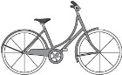 4 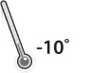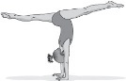

5   6  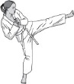

Claudette: Quand il fait chaud, je fais du vélo.
Océane: Quand il pleut, je reste à la maison.
Hugo: Quand il fait beau je joue au volleyball.
Luc: Quand il fait froid je joue au tennis.
Jean: Quand il neige, je fais de la natation.
Pauline: Quand il y a du soleil, je prends des selfies.
Claudine: Quand il pleut je fais du judo.
Hakim: Quand il fait froid, je fais de la gymnastique. TOTAL MARKS /6
- What do these young people like and not like doing? Fill in the grid in English.
Je fais du théâtre tous les weekends, j’adore ça. Je ne fais pas de sport, je déteste le sport.  Maxime | Tous les dimanches, je joue à la pétanque avec mon père, je n’aime pas ça parce que c’est ennuyeux. Je joue tout le temps aux échecs, c’est intéressant.  Zahra | Je fais souvent de la cuisine, c’est facile et marrant. Je n’aime pas regarder des films sur mon portable, c’est trop petit!  Georges

 |  | 
Example: Maxime | drama | sport
Zahra
Georges
TOTAL MARKS /4
- Read Enguerran’s description of a photo he is going to share with his friends. Complete the sentences by ticking the correct box.
Sur la photo, il y a une fille et un garçon. C’est ma sœur et moi. Il ne pleut pas, mais il y a du vent et le ciel est gris. Au fond,
il y a des arbres. Ma sœur porte un short bleu et des baskets,
et moi, je porte un short blanc et une casquette. Ma sœur adore jouer au tennis et moi, j’adore le volley, mais sur la photo, on joue à la pétanque.
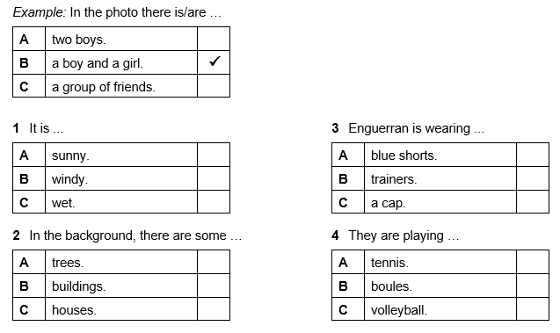

TOTAL MARKS /4
Translation
Translate the paragraph into English.
Je ne suis pas très sportive, mais en hiver avec mes amis, on fait du ski. Je dirais que c’est génial. Je n’aime pas le foot parce que c’est ennuyeux. J’adore télécharger des chansons, c’est rapide. Je fais de la danse tous les samedis et c’est très facile. Je fais du théâtre avec mes amis, c’est marrant. Quand il pleut, j’aime envoyer des SMS à mes amis, c’est intéressant. Mon frère adore jouer aux échecs, mais ce n’est pas facile. __________________________________________________________________________________________________________________________________________________________________________________________________________________________________________________________________________________________________________________________________________________________________________________________________________________________________________________________________________________________________________________________________________________________________

TOTAL MARKS /10

Assessment Ladder – Autumn 2

Current Pathway: | Automne 2 – Mon temps libre
Current Pathway: | Listening | Speaking | Reading | Writing
Yellow Plus  Two Tenses | Shows understanding of a range of short passages which include opinions with basic reasons, in either the present and the past, or the present and the future tense.  Transcribes short sentences. | Takes part in short conversations on a range of topics giving opinions and reasons.  Asks spontaneous questions.  Uses the present and past or future tenses.  Uses increasingly accurate pronunciation and intonation. | Shows understanding of a range of short and longer texts (e.g. adapted adverts, poems and songs) which include opinions in the present and past or future tense.  Translates longer sentences into English. | Writes short texts giving and seeking information and opinions, using the present and past or future tense.  Translate longer sentences into French.
Yellow  Longer paragraphs with opinions | Shows understanding of the main points, opinions and some details in short passages in either the present or the future tense.  Transcribes short phrases. | Takes part in simple conversations, using the present or future tense.  Gives opinions and simple reasons.  Gives information in short dialogues.  Begins to speak spontaneously. | Shows understanding of the main points, opinions and overall message in short written texts (e.g. menus, short adverts, songs, simple poems), in the present or future tense.  Translates simple sentences. | Writes short texts for different purposes using the present or the future tense.  Expresses opinions and gives simple reasons.  Translates simple sentences into French.
Blue  Short Paragraphs with opinions | Shows understanding of the main points and opinions from short passages spoken clearly in the present tense.  Transcribes familiar words. | Asks and answers simple questions.  Gives simple opinions.  Takes part in brief dialogues, using short phrases using the present tense. | Shows understanding of the main points and opinions in short texts.  Translates familiar words and short phrases into English. | Writes several short sentences giving information and expressing simple opinions.  Translates familiar words and short phrases into French.
Green  Sentences | Shows understanding of a range of familiar phrases and opinions, spoken clearly. | Answers simple questions.  Gives basic information and opinions. | Shows understanding of a range of familiar written phrases and opinions. | Writes a few short sentences with support, giving basic information.  Writes some familiar words from memory.
White  Words | Shows understanding of familiar words and phrases, spoken clearly and repeated if necessary. | Says single words and short phrases with support.  Copies pronunciation and intonation correctly. | Shows understanding of familiar words and phrases. | Writes or copy simple words correctly.  Labels items.  Completes short phrases or sentences.
Teacher Feedback
WWW: | EBI:

