Year 7 Drama Autumn 2Melodrama


Name:
Tutor group:
Teacher:

Aim to complete one lesson each week. Everything can be completed in the booklet and there are two blank pages at the end for extra work.
All videos are online using the classcharts link.
The Knowledge Organiser on page 5 has all the key information and vocabulary to help you with this unit.
Upload all work onto ClassCharts for feedback.

Content

Page 3- Big Picture
Page 4- Zoom In
Page 5- Knowledge Organiser
Page 6- Assessment Ladder
Page 7- Body Language and Emotions
Page 8-11- Lesson One
Page 12- Homework
Page 13-15- Lesson Two
Page 16-18- Lesson Three
Page 16-21- Lesson Four
Page 22- Lesson Five
Page 23- Lesson Six
Page 24-26- Cinderella Script (Lesson Four)
Page 27-28- Notes

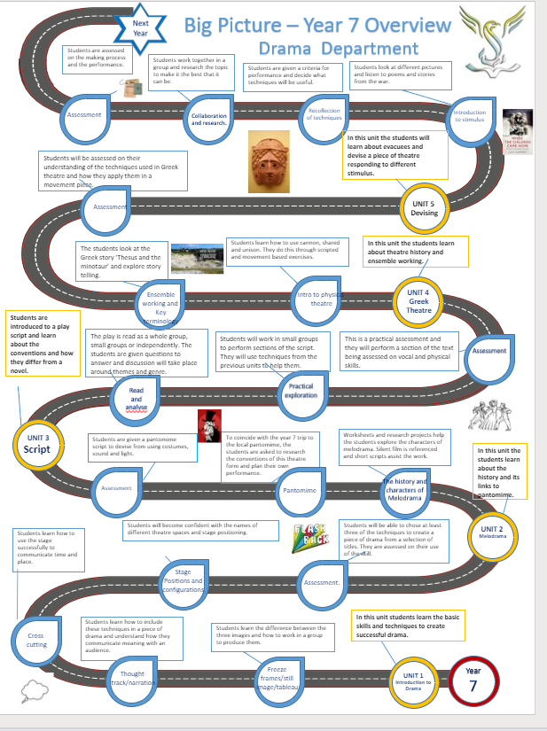

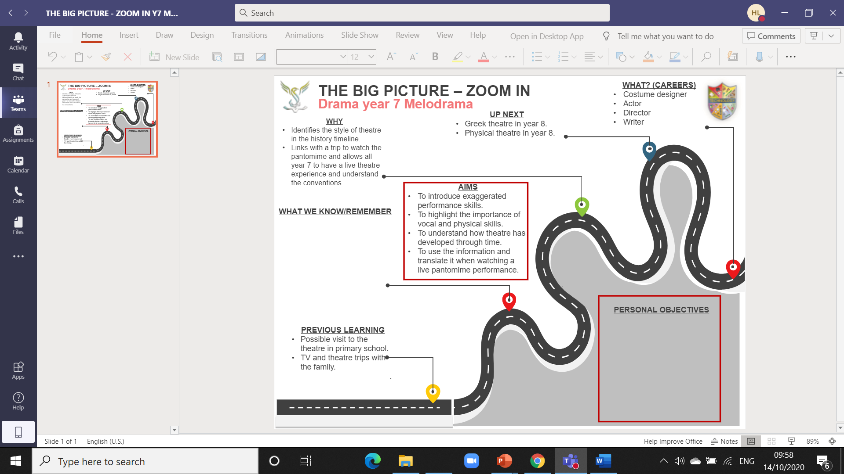
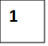  Melodrama is a mixture of two words- melody and drama.  Melodrama is a genre of drama that exaggerates plot and characters with the intention of appealing to the emotions. The form developed in France and Germany and consisted of short scenes with musical accompaniment.  Melodrama was popular until the beginning of the 1900’s.  In the 1800s, watching a melodrama was as popular as going to the cinema is today.  Often the characters were stereotypes. | When people went to see a Melodrama, they would expect certain types  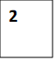  of character to appear. The characters were:  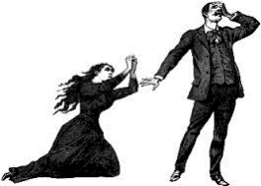  - The Hero / The Heroine  - The Villain  - The Aged Parent  - Voice of reason  - The Loveable Rogue.  - Damsel in distress  - Sidekick to either the hero or villain  These are stock characters of melodrama.  Things to consider: proxemics, tension, eye contact, dialogue, choral speaking, cannon, rhythm and tempo.  Key words  - Proxemics – The use of space. How far or how close actors are to each other.  - Transitions- The movement between still images or scenes.  - Canon – When a group of people will complete the same action, movement or gesture  one after another.  - Dialogue- A conversation or spoken word in a performance.  - Choral speaking – Speaking as a group (chorus).  - Slapstick comedy – A funny performance based on exaggerated physicality and  story lines  - Aside – A character speaks to the audience and can only be heard by the audience  and not the other characters.  - Thought tracking – All characters must be frozen. Only the character saying their  thoughts out loud can be heard by the audience.  - Episodic – A series of events and separate parts in a performance.
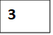
Pantomime
Fill in the blanks
- Snow White and the __________ Dwarfs
- Little ________ Riding Hood
- Puss in ___________
- ____________ Beauty
- Robin __________
- Peter ________
- Beauty and the ___________

Pantomimes The conventions of pantomime are as follows:

- Audience interaction and participation
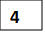
- Exaggerated characters
- Music/ singing
- Comedy/ humour
- Slapstick comedy
- Based on a fairy-tale
- Cross gender acting
- Lavish costumes and wigs

Theatrical entertainment, mainly for children, which involves music, topical jokes, and slapstick comedy and is based on a fairy tale or nursery story.
A dramatic entertainment, originating in Roman mime, in which performers express meaning through gestures accompanied by music.

Attainment Band | Skills- performing
Yellow Plus | - Exaggerated characters using voice and body language.  - Direct address to the audience through narration and an aside.  - Excellent use of gesture throughout.
Yellow | - Creating a character using exaggerated body language and facial expressions.  - Direct address to the audience using narration or an extended aside.  - Excellent use of gesture.
Blue | - Demonstrates either exaggerated vocal or physical techniques appropriate to Melodrama.  - Address the audience through an aside.  - Simple gestures to identify with a Hero, Heroine or Villain.
Green | - Demonstrates an understanding of the vocal and physical skills needed in Melodrama.  - Directly addresses the audience in a group.  - Shows understanding of the different gestures needed to portray a hero or Villain.
White | - Takes part in the performance using non-verbal communication.  - Uses exaggerated gesture in rehearsal.

Body language that shows the following emotions:

Grief – Head down, shoulders rounded, hands cupping the face. Raising the shoulders up and down, with a sobbing noise, is optional.
Fear – Face turned to the right side, with the right hand to the mouth, fingers curled under touching the top of the palm.
Horror – Eyes wide, mouth open, both hands to the cheeks with the fingers extended.
Fortitude – Body straight, chest up, hand to forehead, with the palm facing the audience and fingers curled slightly.
Love Expressed (Male) – Chest held high, right hand crosses the chest and rests on the upper left over the heart, then opens out to the right and the loved one.
Love Expressed (Female) – Chest held high, head cocked a bit to the side, opposite leg goes out with foot pointed, hands under the chin, fingers entwined and bent at the first and second knuckles (almost praying), hands go toward the loved one, smile on face.
Evil Planning – One eyebrow up, the other down, a grimace on the face and hands rubbing together, if it is a really good plan, the fingers twiddle.
Evil Sneaking – Shoulders hunched over, arm raised to cover the nose on down, eyes free to shift around the room, legs bent on the cross of the stage.
Pride – Chest up, hands with knuckles to both hips, legs slightly apart, a balanced look.
Anger – Both hands shoulder high, eyebrows pushed toward each other, face tense with a grimace, hands in tight fists.
Overwhelmed – Chin up bringing the face to look up, one arm dropped limp to the side, the other hand open with palm towards the audience on the top of the forehead.
The actors of the time were given certain “lines of business.” This meant that they were cast as a certain character type, like hero, heroine, villain, old man, comedian, etc. They learned how to speak, walk, dress, use certain facial expressions, and behave as this character type

Lesson one
LI: To introduce the style of Melodrama in its historical context.
Task one
Drawing from any previous knowledge, what do you think melodrama is?
____________________________________________________________________________________________________________________________________________________________________________________________________________
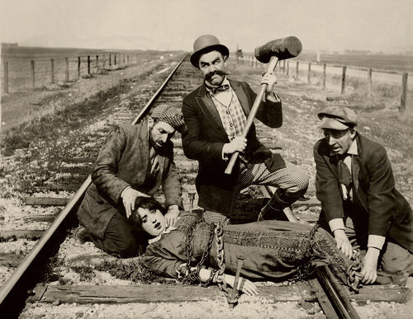
Look at the images below and answer the following questions:
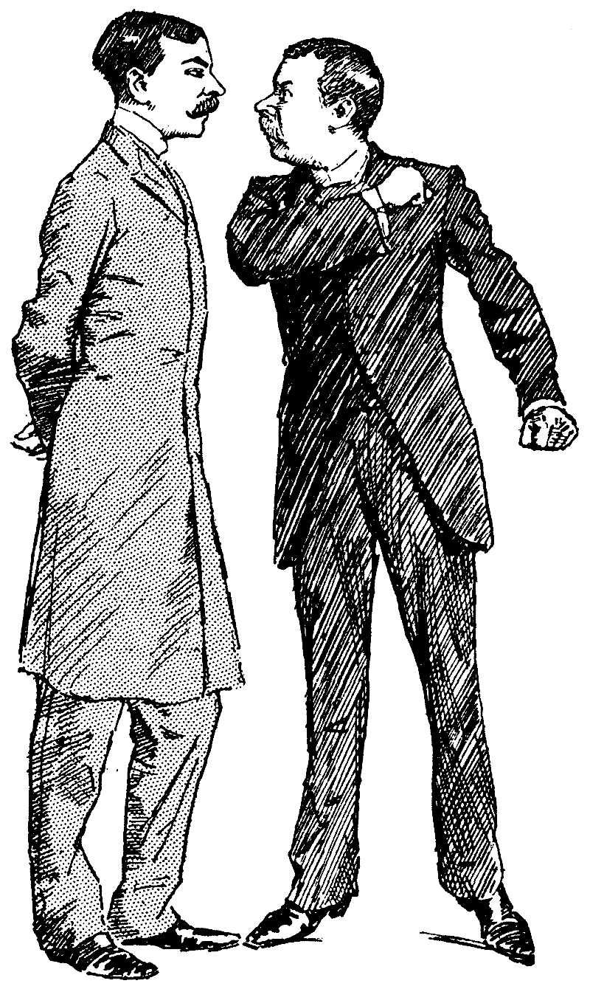
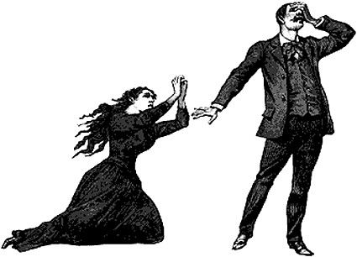
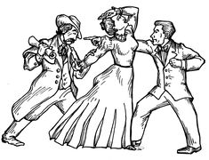
a) What time period do you think melodrama was in? Why do you think this?
____________________________________________________________________________________________________________________________________________________________________________________________________________

b) Who do you think the main characters of melodrama are? Why do you think this?
__________________________________________________________________________________________________________________________________________________________________________________________________________________________________________________________________________________________________________________

c) What might be involved in the plot (storyline)? Why do you think this?
________________________________________________________________________________________________________________________________________________________________________________________________________________________________________________________________________________________________________________________________________________________________________________________________________________________

d) How do you think an actor would need to perform their character? Why do you think this?
__________________________________________________________________________________________________________________________________________________________________________________________________________________________________________________________________________________________________________________

Can you give any examples of a melodrama performance? And how do you now know it was melodrama?
______________________________________________________________________________________________________________________________________________________________________________________________________________________________________________________________________________________________________________________________________________________________________________________________________________________________________________________________________________________________________________________________

Task two
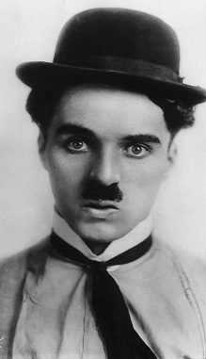
Watch the following video (link on classcharts) https://www.youtube.com/watch?v=H19jByxrqlw&list=PLyU6zePFLJ-DHO9i0CaXuyKc4pWa8Zvvs&index=7
What techniques have you noticed in this performance by Charlie Chaplin?
________________________________________________________________________________________
________________________________________________________________________________________
________________________________________________________________________________________________________________________________________________________________________________________________________________________________________________________________________________________________________________________________________________________________________________________________________________________
Some techniques that can be used in melodrama:
- Exaggerated movement
- Improbable Situations
- Unrealistic Actions
- Extreme Physicality
- Trips or collisions

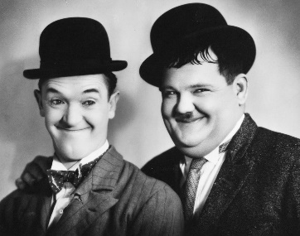
Now watch the following video and write down the techniques used by Lauren and Hardy https://www.youtube.com/watch?v=uSsqU_3_rH0
_________________________________________________________________________
__________________________________________________________________________
__________________________________________________________________________
_________________________________________________________________________
_________________________________________________________________________
__________________________________________________________________________________________________________________________________________________________________________________________________________________________________________________________________________________________________________________

Task three
How can you use melodrama to react to the following? Choose at least two and write down your facial expressions and body language.
- You realise you have just eaten a worm
- You have just one the lottery
- You find a highly poisonous spider on your shoulder
- You hit your thumb with a hammer by mistake
- You find a monster in your cupboard
1. ________________________________________________________________________
Body Language- ________________________________________________________________________________________________________________________________________________________________________________________________________________________________________________________________________________________________________________________________________________________________________________________________________________________
Facial Expression- ________________________________________________________________________________________________________________________________________________________________________________________________________________________________________________________________________________________________________________________________________________________________________________________________________________________
2. ________________________________________________________________________
Body Language- ________________________________________________________________________________________________________________________________________________________________________________________________________________________________________________________________________________________________________________________________________________________________________________________________________________________
Facial Expression- ________________________________________________________________________________________________________________________________________________________________________________________________________________________________________________________________________________________________________________________________________________________________________________________________________________________

Task four
DART activity – Read the text below and answer true of false
Melodrama is a style of theatre that was prominent in the Victorian era. It uses exaggeration and stereotyped characters to appeal to the audience’s emotions. It can be useful when working within the melodrama genre to explore stock characters, e.g. an evil villain, a wronged maiden, or a noble hero. Very clear and loud vocal delivery is needed in a melodrama, facing out to the audience, combined with large gestures and exaggerated facial expressions. The plot for a melodramatic devised piece would ideally be very sensational, designed to evoke emotion within the audience, with lots of dialogue.
- Melodrama was started in the 21st century
    - True
    - False

- Characters are there to appeal to audiences’ emotions
  - True
  - False

- A dog is an example of a stock character in melodrama
  - True
  - False

- You must be very quiet in a melodrama, facing away from your audience
  - True
  - False

- Gestures are usually small so the audience have to use binoculars to view the action
  - True
  - False

- There is a lot of dialogue in a melodramatic piece
  - True
  - False

Consolidation task
Homework
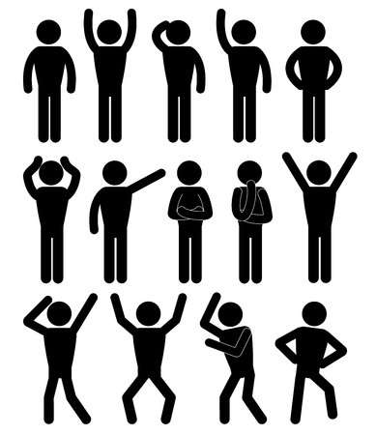
Looking at the body language below, draw in the facial expression you think best suits the emotion. Write what emotion you think they are portraying underneath or next to each picture. Use the images along the sides to help you.
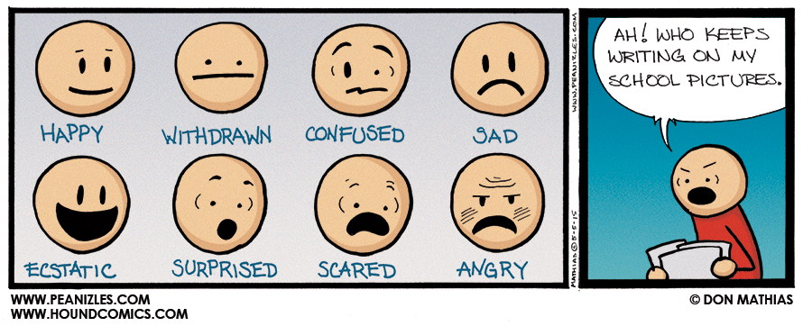

Lesson Two
LI: To understand and explore ‘Stock Characters’
Task one - Fill in the gaps.

Melodrama is a mixture of two words - _________________________ and ___________________________. Melodrama was popular until the beginning of the ________________. Melodrama usually included _________________________________ and ______________________________________________________. Storylines were often ________________________________. In the 1800s, watching a melodrama was as popular as going to the ______________________________ is today. Often the characters were based on _____________________________. These characters are called _____________________ characters.

Use these words to fill in the blanks. Think carefully!

1900s | Cinema | Special effects
Drama | Sensational | Music
Stereotypes | Melody | Stock

Task two
What is a stock character?
____________________________________________________________________________________________________________________________________________________________________________________________________________
Looking at the images below, identify your stock characters. Use the words below to help.
Sidekick | Villain | Hero | Damsel | Ageing Parent | Voice of reason
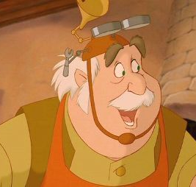
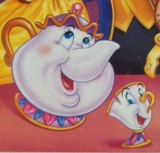
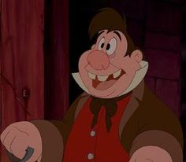
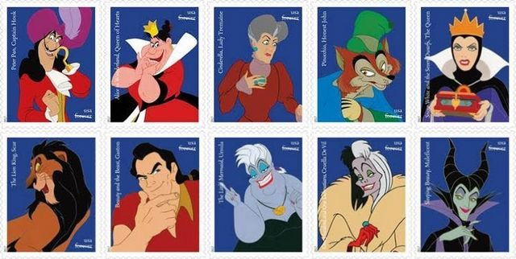
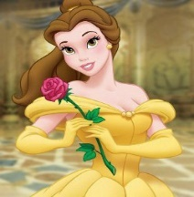
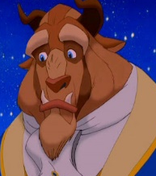

Task three
What do you think are some of the characteristics of a hero and a villain? Complete the ‘person on the wall’ diagrams below. One word has been given for each to get you started!
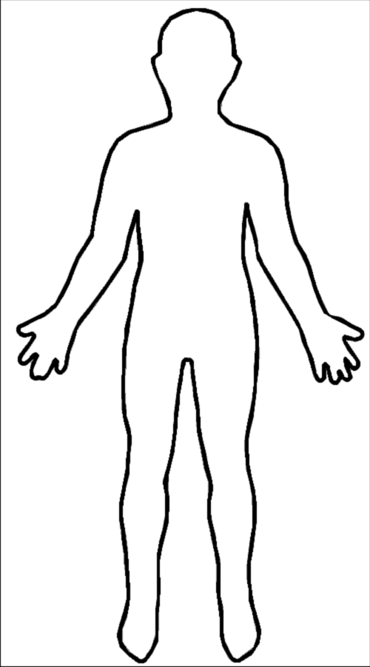
Villain
Hero
Evil
Strong
Task four
Listen to the following piece of music – Ragtime Piano by Scott Joplin
https://www.youtube.com/watch?v=fPmruHc4S9Q
Devise a short melodramatic piece based on one or more of the emotions below.
Write down any notes you have based on your performance.
- Love
- Hate
- Despair
- Laughter
- And/Or Surprised

________________________________________________________________________________________________________________________________________________________________________________________________________________________________________________________________________________________________________________________________________________________________________________________________________________________________________________________________________________________________________________________________________________________________________________________________________________________________________________________________________________________________________________________________________________________________________________________________________________________________________________________________________________________________________________________________________________________________________________________________________________________________________________________________________________________________________________________________________________________________________________________________________________________________________________________________________

Consolidation task

Homework- Design your very own Stock Character. Write down any characteristics they have and what type of character they are.

Lesson Three
LI: To perform a short melodramatic play
Task one
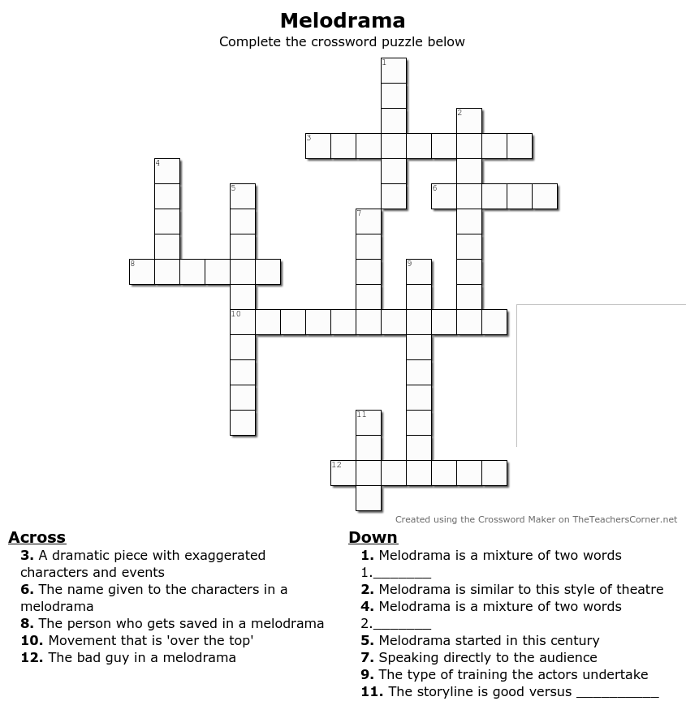
Complete the crossword

Task two
Read the following script
Villain: (grabs the Damsel in Distress) Hahaha, now you are mine!
Damsel: No, unhand me you nasty man!
Villain: And why would I do that?
Hero appears
Hero: Because I’m telling you to!
Villain: And who might you be?
Hero: I am your worst nightmare!
Villain: Oh no! (to the audience) I will flee this scene!
Villain tries to run but Hero catches him
Damsel: You are my hero!
Hero: Anything for you, my dear!
Damsel: Oh, Geoffrey!
Hero: Oh, Marie!
Villain: Oh dear!!

Your tone of voice represents your mood (e.g happy or sad) and the emotional response you want from the audience.
What different ways can we use tone and volume to say the different characters lines? Choose a character and explain the tone and volume you would use to play the role.
If I was playing the role of __________________________________________________________________________ I would _____________________________________________________________________________________________ __________________________________________________________________________________________________________________________________________________________________________________________________________________________________________________________________________________________________________________________________________________________________________________________________________________________________________________________________________________________________________________________________________________________________________________________________________________________________________________________________________________________________________________________________________
Now try some of the ways you have chosen to explore the text vocally.

Task three
Recap. Let’s see if you remember what these key words mean
Freeze frame
____________________________________________________________________________________________________________________________________________________________________________________________________________
Mime
____________________________________________________________________________________________________________________________________________________________________________________________________________
Exaggerated movement
____________________________________________________________________________________________________________________________________________________________________________________________________________
Improvisation
____________________________________________________________________________________________________________________________________________________________________________________________________________

Consolidation task
Homework – write your own short melodrama script. Use the script on page 16 to help you.

Lesson Four
LI: To understand the conventions of pantomime
Task one
DART activity - Read below and answer the questions

Pantomime is a marvellous and wonderful (if a little eccentric!) British institution.
Pantomimes take place around the Christmas period and are nearly always based on well-known children’s stories such as Peter Pan, Aladdin, Cinderella, Sleeping Beauty etc. Pantomimes are performed not only in the best theatres in the land but also in village halls throughout Britain. Whether a lavish professional performance or a hammy local amateur dramatic production, all pantomimes are well attended.
Audience participation is a very important part of a pantomime. The audience are encouraged to boo the villain whenever he enters the stage, argue with the Dame (who is always a man) and warn the Principal Boy (who is always a girl) when the villain is behind them by shouting out “He’s behind you!”.
Pantomime literally means “all kinds” of “mime” (panto-mime). It is generally acknowledged that British pantomime is modelled on the early masques of the Elizabethan and Stuart days. In the 14th century the early masques were musical, mime or spoken dramas. Slapstick is another important part of a British pantomime – the throwing of custard pies, the ugly sisters (who are always played by men) falling over, lots of silly costumes including of course, the pantomime horse which is played by two people in a horses costume.
By the end of the pantomime, the villain has been defeated, true love has conquered all and everyone lives happily ever after.

- Around what time of year do pantomimes usually take place?
_____________________________________________________________________________________________________
- Pantomime was based on early masques in what century?
_____________________________________________________________________________________________________
- Name at least one story that is told through pantomime
_____________________________________________________________________________________________________
- What are the audience encouraged to do during the performance?
____________________________________________________________________________________________________________________________________________________________________________________________________________
- Who would usually play the Dame and who would play the Principal Boy in a pantomime?
____________________________________________________________________________________________________________________________________________________________________________________________________________
- What is the literal meaning of Pantomime?
______________________________________________________________________________________________________
- What happens by the end of the pantomime?
__________________________________________________________________________________________________________________________________________________________________________________________________________________________________________________________________________________________________________________
Task two
Watch the video and answer the following questions https://www.youtube.com/watch?v=YQ5PfYZ9VaM
What is Pantomime? (use your knowledge organiser to help you)
________________________________________________________________________________________________________________________________________________________________________________________________________________________________________________________________________________________________________________________________________________________________________________________________________________________
What are the similarities between Melodrama and Pantomime?
______________________________________________________________________________________________________________________________________________________________________________________________________________________________________________________________________________________________________________________________________________________________________________________________________________________________________________________________________________________________________________________________
What are some of the conventions of pantomime? What makes a pantomime, a pantomime?
- ___________________________________________________________________________________
- ___________________________________________________________________________________
- ___________________________________________________________________________________
- ___________________________________________________________________________________
- _________________________________________________________________________________
- _________________________________________________________________________________
- _________________________________________________________________________________
- _________________________________________________________________________________

Task three
Can you name the main characters in Cinderella?

Task four
Read the script starting on page 20 and answer the following
What pantomime conventions can you add to this performance?
__________________________________________________________________________________________________________________________________________________________________________________________________________________________________________________________________________________________________________________________________________________________________________________________________________________________________________________________________________________________________________________________________________________________________________________________________________________________________________________________________________________________________________________________________________
Choosing a character, how can you use the information you have learnt about pantomime and melodrama to perform this role?
____________________________________________________________________________________________________________________________________________________________________________________________________________________________________________________________________________________________________________________________________________________________________________________________________________________________________________________________________________________________________________________________________________________________________________________________________________________________________
Use the space below to draw your character, thinking about the conventions of pantomime.
Consolidation task
Write your own short script for Cinderella, thinking carefully about all the conventions of pantomime.
It does not need to be more than one A4 piece of paper long. Use the last pages of your booklet to write your script and ideas.
Lesson Five
LI: To prepare for assessment
Task one
Define the following key words
Aside-
____________________________________________________________________________________________________________________________________________________________________________________________________________
Exaggeration –
____________________________________________________________________________________________________________________________________________________________________________________________________________
Gesture –
____________________________________________________________________________________________________________________________________________________________________________________________________________
Task two
Annotate your script using key words and phrases to explain the gestures, movement, costumes and other pantomime conventions in your performance.
Task three
Share your ideas with your peers and give each other feedback on what has been scripted.
Task four
In groups practice performing your script. Think carefully about your Assessment Ladder (page 6) and what colour you are aiming for. Write any notes about your rehearsals below.
__________________________________________________________________________________________________________________________________________________________________________________________________________________________________________________________________________________________________________________________________________________________________________________________________________________________________________________________________________________________________________________________________________________________________________________________________________________________________________________________________________________________________________________________________________________________________________________________________________________________________________________________________________________________________________________________________________________________________________________________________________________________________________________________________________________________________________________________________________________________________

Lesson 6
Assessment
Review and assess work giving verbal feedback
In the box below, write any key words given to you in feedback based on your performance.
Lesson Four-Task three script
Read the script below
Narrator: Cinderella lives in a house with her Stepmother and her two Stepsisters. Her Stepmother never works around the house. Every day she says.

Stepmother: Cinderella, wash the dishes. .. Cinderella, clean the house. .. Cinderella, work, work, work!

Narrator: Her Stepmother is not good. She is bad. One of Cinderella´s Stepsisters is ugly with a big nose. The other one is thin, with big ears, and they don´t like to work either.

Stepsister 1: Cinderella, come here!

Stepsister 2: Cinderella, sweep the floor!

Stepsister 1: Cinderella, clean my shoes!

Stepsister 2: Cinderella, comb my hair!

Narrator: Cinderella is very beautiful and a hard worker. She is good to her Stepmother and to her Stepsisters. One day they receive an invitation.

Stepsister 1: Mother, read it!

Stepsister 2: What does it say?

Stepmother: It says… Every woman is invited to a ball.

Cinderella: Oh, I want to go to the ball. I like to dance.

Stepsisters: You want to go to the ball? You must be crazy!

Cinderella: Yes, I want to go to the ball.

Narrator: Cinderella works hard. She starts making the dresses for her Stepmother and her Stepsisters. She doesn´t have time to make her own dress.

Stepsisters: We are going to the ball! We are going to the ball!

Stepmother: If you don´t have a dress, you will not go to the ball.

Narrator: Cinderella starts to cry.

Cinderella: I don´t have a pretty dress. I have an ugly dress. I am not going to the ball.

Stepsisters: What a shame! We have pretty dresses. Good-bye!

Narrator: Suddenly, Cinderella sees a very beautiful woman. It´s her Fairy Godmother.

Fairy Godmother: Now you have a pretty dress.

Narrator: Cinderella looks at her dress and says.

Cinderella: Yes, I have a pretty dress! I am going to the ball. I am happy!

Fairy Godmother: Just remember that you have to come back at twelve o´clock. Don´t forget!

Cinderella: No, I won´t forget! Good-bye.

Narrator: Cinderella goes to the ball, and when she enters the palace everybody looks at her.

Girl 1: What a pretty girl!

Girl 2: Who is she?

Narrator: The handsome prince looks at her and says.

Prince: I want to dance with her.

Narrator: He walks to where she is, and says.

Prince: Do you want to dance with me?

Cinderella: Yes, I want to dance with you.

Narrator: And they danced all night. Suddenly, Cinderella hears the clock strike.

Clock: One, two, three, four, five, six, seven, eight, nine, ten, eleven, twelve.

Cinderella: I have to go!

Narrator: Cinderella runs outside the palace, but she drops one of her shoes. The Prince runs
after her, but he doesn´t see her.

Prince: Wait! Wait! What is your name? Where do you live? Wait!

Narrator: Then he picks up the shoe and says.

Prince: Where is she? I don´t even know her name. I don´t know anything about her. I am very sad.

Narrator: Next morning, when the prince wakes up, he says.

Prince: I have to find my pretty lady. I have her shoe!

Narrator: He goes to town and looks for her in every house there is.

Prince: Is the pretty lady here?

Woman 1: No, she is not, and I don´t know where she is.

Narrator: The prince goes to another house… and another one… and another one. He doesn´t find her. At last, he goes to Cinderella´s house.

Prince: Is the pretty lady here?

Stepmother: Yes, she is. That is my daughter´s shoe…. Daughter, come here.

Stepsister 1: Yes, mother.

Stepmother: Try on the shoe.

Narrator: Her daughter, who is very fat, tries to put on the shoe.

Stepsister 1: I can´t. This shoe is too small, and my foot is fat. It hurts! This is not my shoe.

Narrator: Meanwhile, Cinderella is coming down the stairs and says.

Cinderella: That shoe is mine.

Stepsisters: Ha, ha, ha… it´s funny!

Cinderella: Yes, that shoe is mine! And I have the other one.

Narrator: Suddenly she appears with her pretty dress, and once again she looks very beautiful.

Prince: I love you! I love you! Do you want to marry me?

Cinderella: Yes, I want to marry you.

Narrator: And now Cinderella and the Prince live happily in the palace.

