History KS3 Autumn 2 Blended Learning Booklet
The Normans
Name:
Form:
Aim to complete one lesson each week. Write out the title and LI and then complete the tasks.
All video links are online using the ClassCharts link.
The Knowledge Organiser on page 3 has all the key information and vocabulary to help you with this unit.
Upload all work onto ClassCharts for feedback.
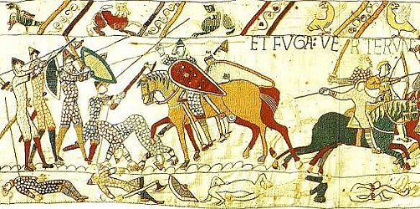

Contents
Page3: Big Picture - Year 7 Overview
Page 4: Zoom in - My Learning Journey
Page 5: Knowledge Organiser
Page 6: Lesson One – The Bayeux Tapestry
Page 9: Lesson Two – William the Conqueror
Page 12: Lesson Three - Control by Castles
Page 15: Lesson Four - Norman England
Page 18: Lesson Five - How did the Normans change England?
Page 22: Lesson Five - How did the Normans change England?

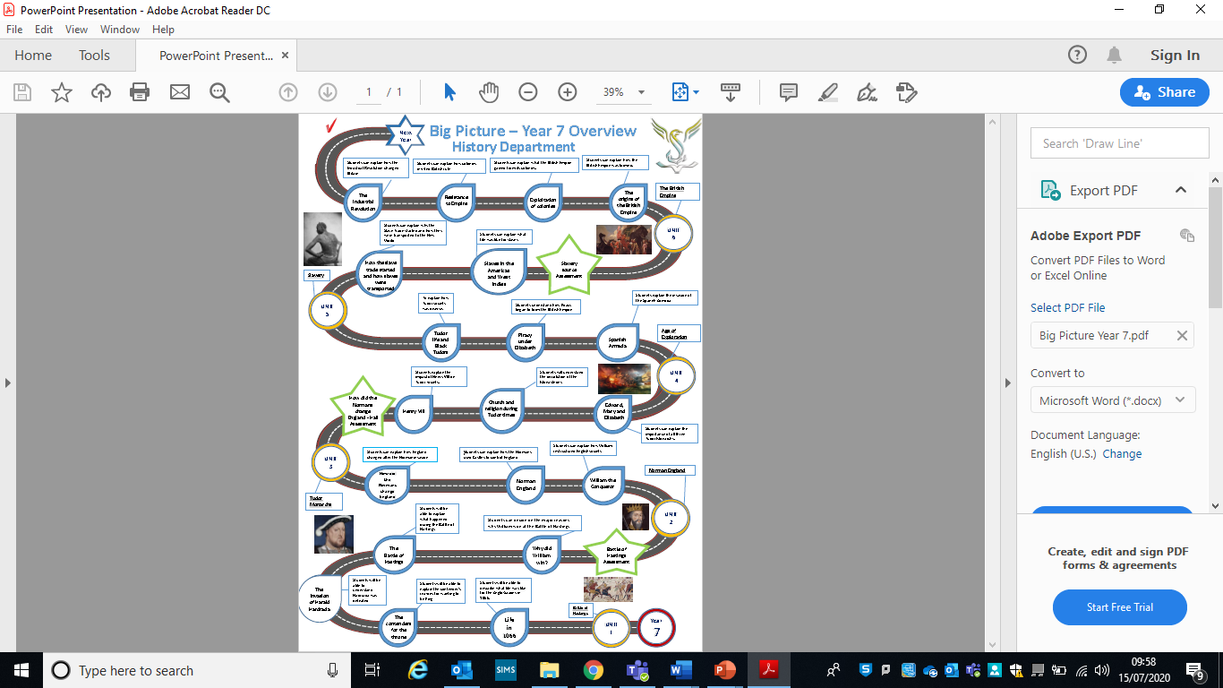
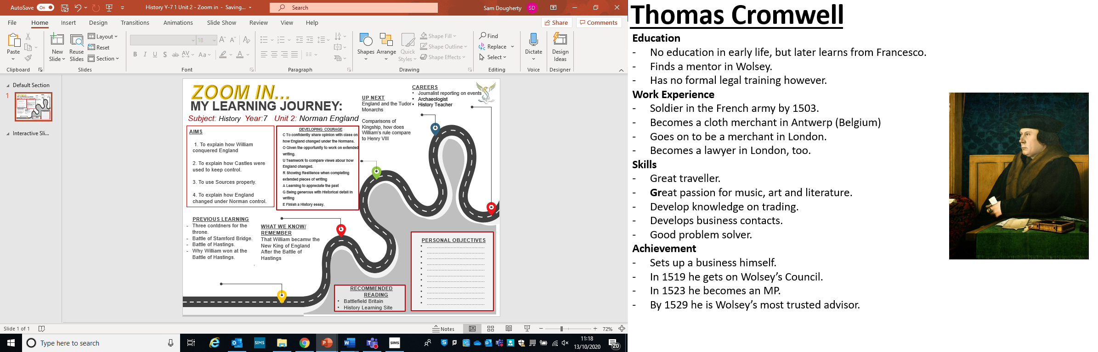
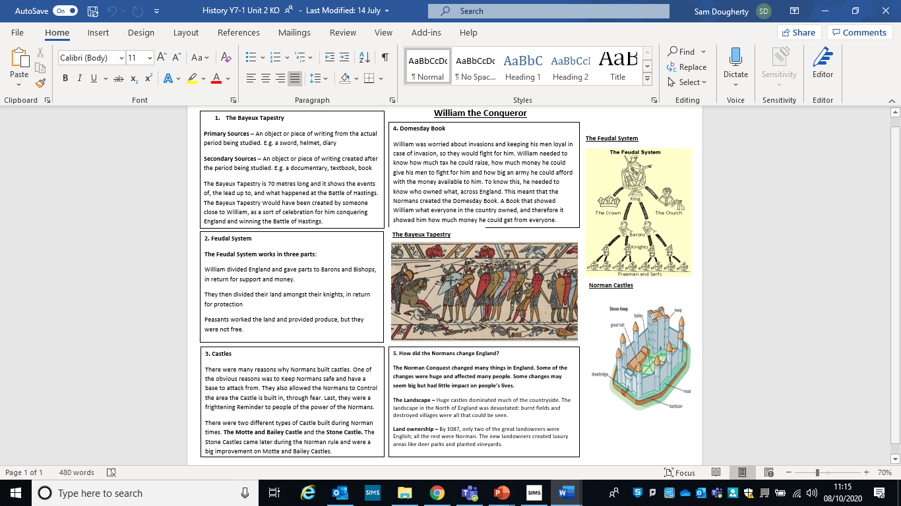
Lesson One – The Bayeux Tapestry
L/I: To understand what a historical source is.

What is a source?
A historical source is something that tells us about History.
You will be able to learn a lot about the Source if you read the information that comes along with it.
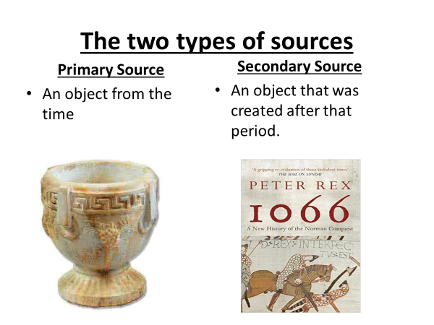

Task – Write five examples of Primary Sources and five examples of Secondary Sources:
Primary Sources:
-
-
-
-
-
Secondary Sources:
-
-
-
-
-
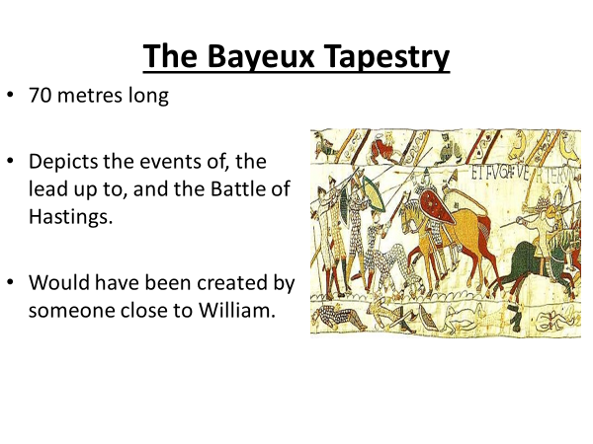
Watch the video and then try to answer the Questions below:
https://www.youtube.com/watch?v=LtGoBZ4D4_E
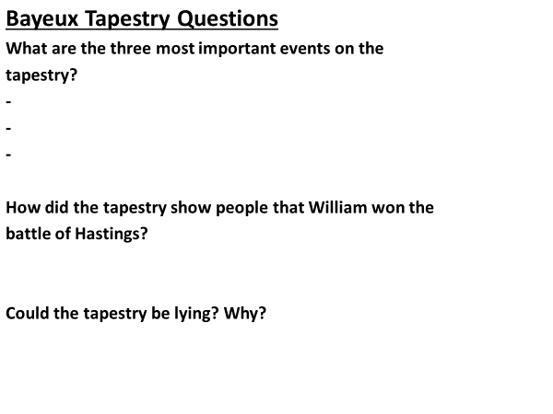
Task – Explain in your own words why we might not be able to trust all Sources.
Example to help:
- The Bayeux Tapestry was made by a Norman. Why might this affect if we can trust it or not?
- If Mr. Dougherty wrote a book saying he was the best History teacher in the world, why might this be difficult to trust?

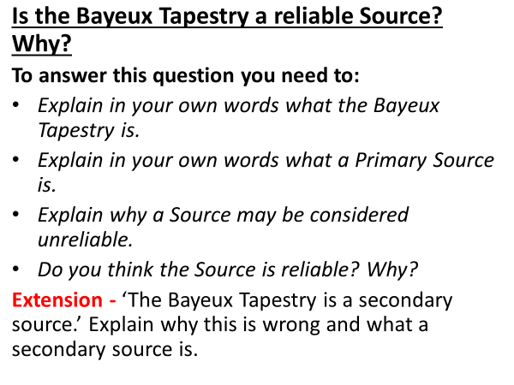

Lesson Two – William the Conqueror
L/I: To understand how William conquered England.

Use Box One on your knowledge Organiser, and knowledge from last lesson, to help you complete this starter task:

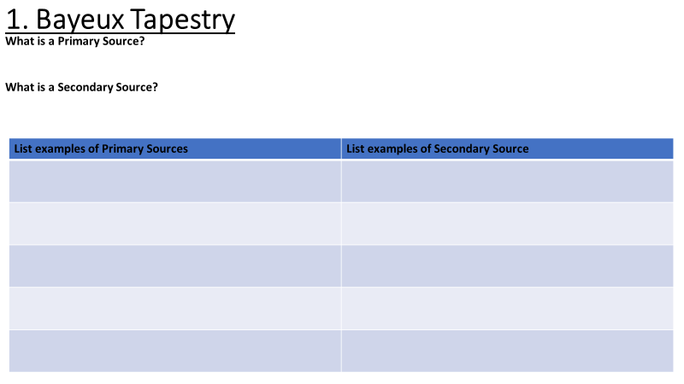
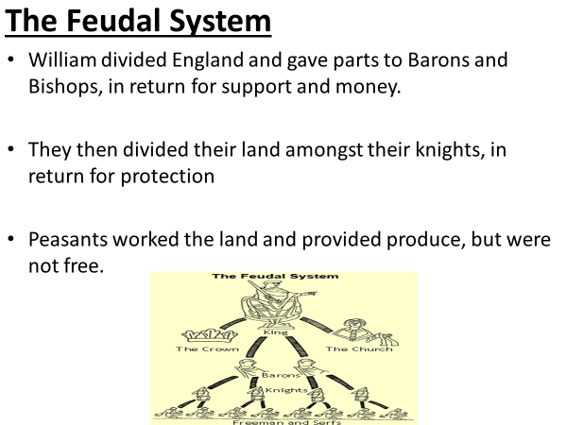

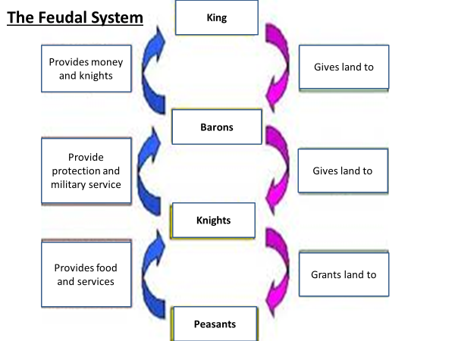

Task – Use the first Page on BBC Bitesize to write down below how the Feudal System is very different to today’s England.

https://www.bbc.co.uk/bitesize/guides/zdvdmp3/revision/1

Watch this video and answer the following questions:
https://www.youtube.com/watch?v=KGDu-_vi8sg&list=PLcvEcrsF_9zK2bOCseaghBIucwf9pcsFX&index=5

- Why wasn’t William immediately King of England?

- Why did people submit to William?

- When was William crowned?

- What were the first castles called?

- What was the purpose of castles?

- What did the Norman churches remind the English people of?

- What was the Domesday book used for?

- What did it show William?

Task - What was most important in helping William conquer England?

Describe in a couple of sentences the things that helped William conquer England.

Decide on which one you think was the most important and argue why.

Lesson Three - Control by Castles
L/I: To understand why the Normans used Castles

Use Box Two on your knowledge Organiser, and knowledge from last lesson, to help you complete this starter task:
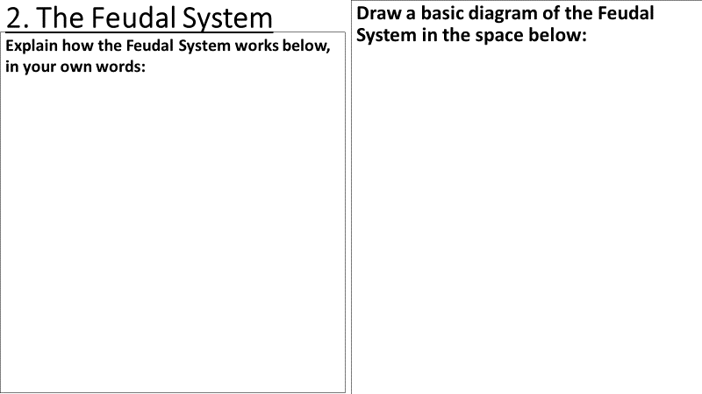

Read the following DART and highlight important points:

Norman Castles
The first Castles were made from wood. Eventually Stone replaced wood. A Castle would often be built on a ‘motte’, which was a simple mound or hill. If there was not a hill, then earth was dug to make a mound. If the Normans decided to build a castle in a town, then houses were pulled down to clear a big enough space. A ‘bailey’ was a cleared space which gave a good view of the surrounding area. It prevented people sneaking up in a surprised attack and gave defenders a clear area from which to shoot arrows. It was also a sae place where Normans could live and work.

The Normans made the English carry out all the hard work involved in building the castles. A castle was usually the highest building in an entire area. There were no castles like these in England before the Norman conquest, and this gave castles a feeling of sinister mystery and importance.
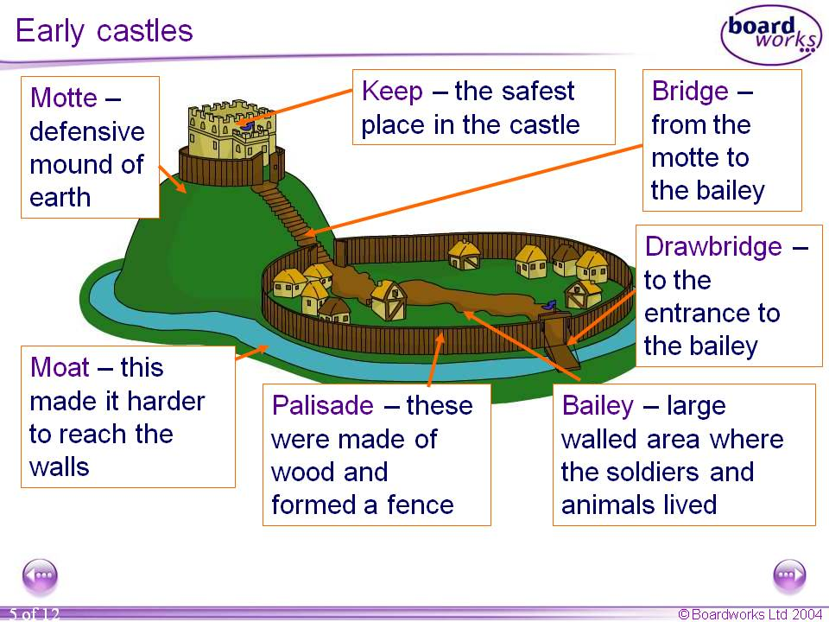
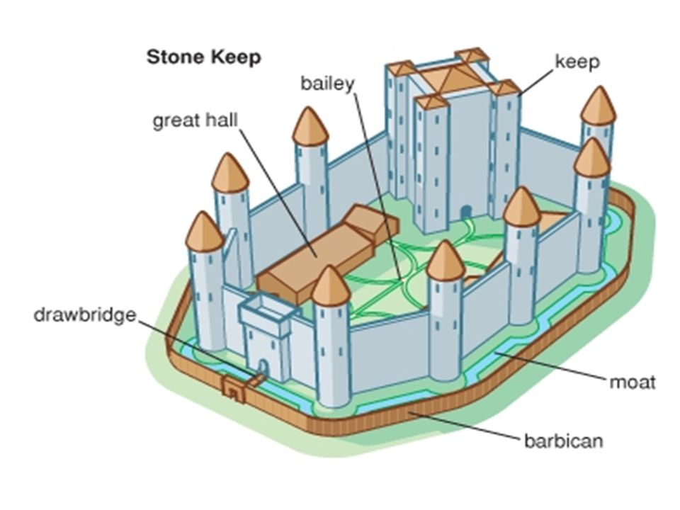
Use the pictures above and the pictures below to complete the following activity:
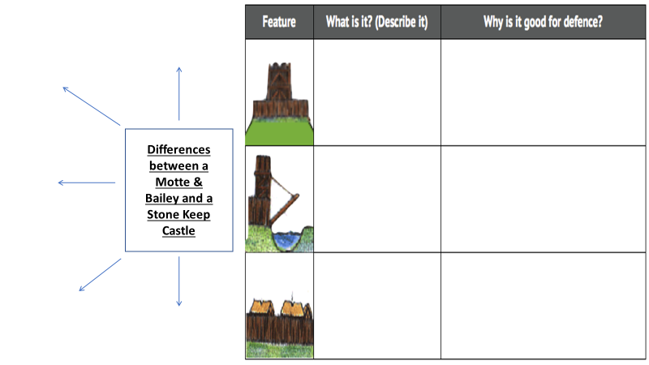

Watch the following video on Castles:
https://www.youtube.com/watch?v=9lf8ACJWk3c&t=1s

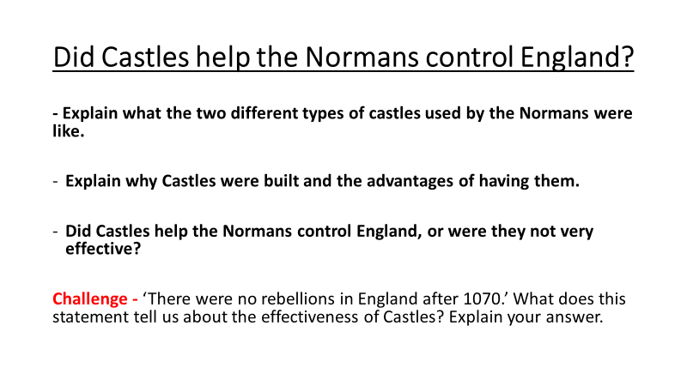
Answer the underlined question below and use the points to help you:

Lesson Four - Norman England
L/I: To decide if William was a good king.
Use Box Three on your knowledge Organiser, and knowledge from last lesson, to help you complete this starter task:

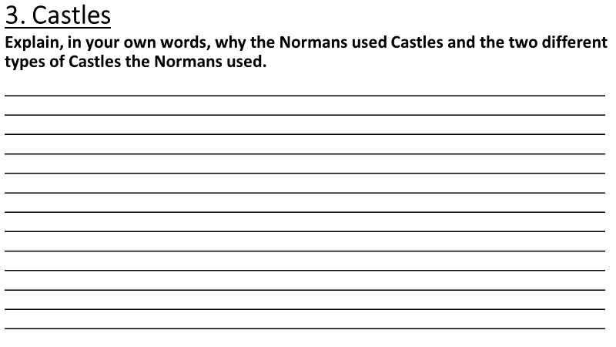
Watch the following video and make some notes below on how William is treating the English population:
https://www.youtube.com/watch?v=kNWoXlAZdkM&t=169s

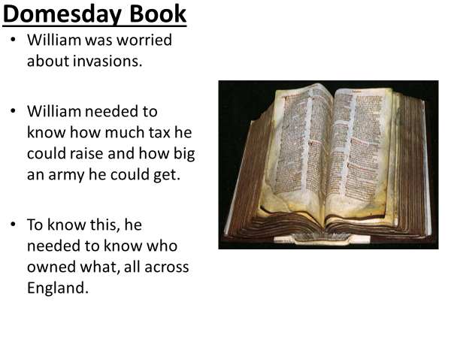
Question – Why is the Domesday Book good for William?
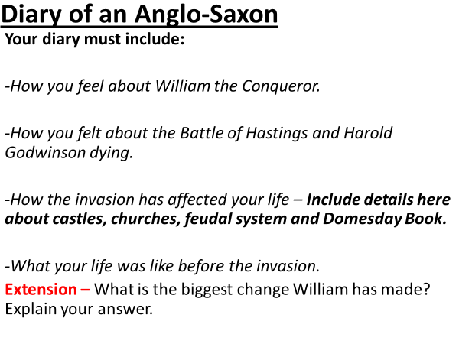
Complete the main Diary task below:

Lesson Five - How did the Normans change England?
L/I: To judge how much England changed after the Norman conquest
Use Box Four on your knowledge Organiser, and knowledge from last lesson, to help you complete this starter task:
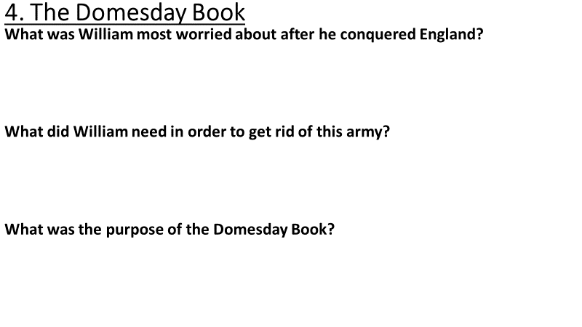
Read through information below and highlight the most important parts:

What did the Norman Conquest change?
The Landscape – Huge castles dominated much of the countryside. The landscape in the North of England was devastated: burnt fields and destroyed villages were all that could be seen.

Land ownership – By 1087, only two of the great landowners were English; all the rest were Norman. The new landowners created luxury areas like deer parks and planted vineyards.

The Church – By 1090, only one out f the 16 bishops was English; the rest were Norman. By 1200, all the wooden Saxon churches had been replaced by stone ones.

Language – New words came into the language. People began using first names like Robert, William, and Richard. Worlds like ‘beef’ and ‘pork’ were used to describe meat from cows and pigs.

Two new laws were introduced:
Forest Laws – These laws protected William’s hunting. There were vast forests in England. After the Norman conquest some forests were named ‘Royal’ forests. Ordinary people were not allowed to kill or capture any animals in royal forests and there were severe punishments if you broke the law.

Mudrum Fine – If a Norman were murdered in an area and the murderer was not caught, everyone in that area would be fined heavily for a long period of time.

Task – Use the following video to write in your own words what life was like in Norman England:
https://www.youtube.com/watch?v=bxpTxuPTklA&t=13s

Explain how each of the four different Saxons lives had changed after the Norman invasion of 1066. Use the box next to each Saxon to do so.
Wigberht
Eldrida
Alfric
Meghan
Extension – Who’s life had changed the most and why?

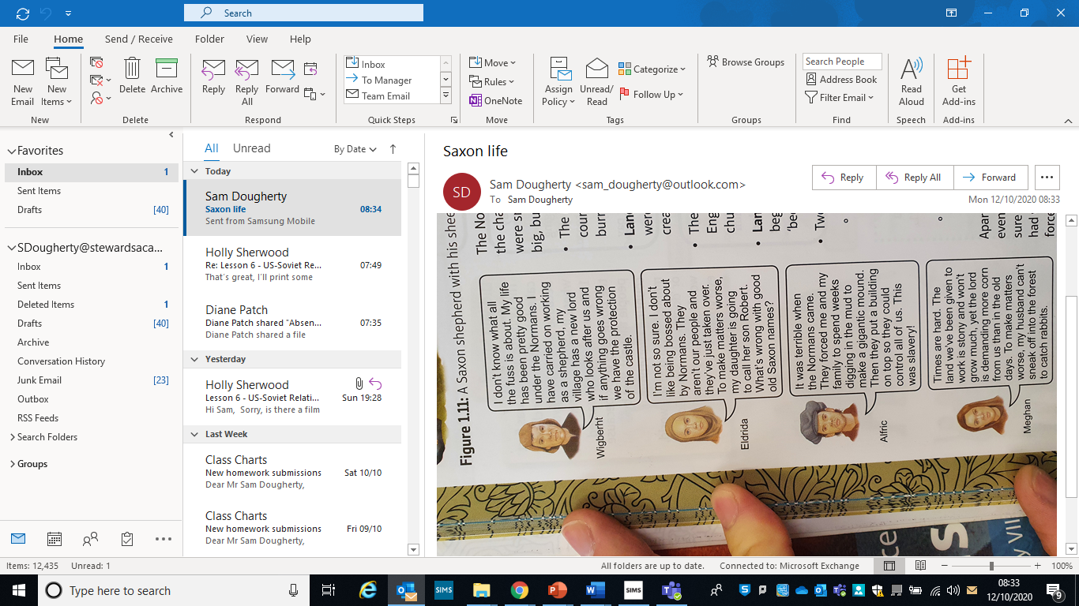

Lesson Six – How much did the Normans change England?
L/I: To answer a question with an extended piece of writing on how the Normans helped England.
Use Box Five on your knowledge Organiser, and knowledge from last lesson, to help you complete:


