Year 7 Drama Autumn 1Introduction to drama techniques
Name:
Tutor group:
Teacher:
Aim to complete one lesson each week. Everything can be completed in the booklet and there are two blank pages at the end for extra work.
All videos are online using the classcharts link.
The Knowledge Organiser on page 5 has all the key information and vocabulary to help you with this unit.
Upload all work onto ClassCharts for feedback.

Contents
Page 3: Big picture- year 7 overview
Page 4: Zoom in – My Learning Journey
Page 5: Knowledge Organiser
Page 6: Lesson 1
Page 10: Lesson 2
Page 13: Lesson 3
Page 16: Lesson 4
Page 20: Lesson 5
Page 22: Assessment Ladder.

Year 7 overview
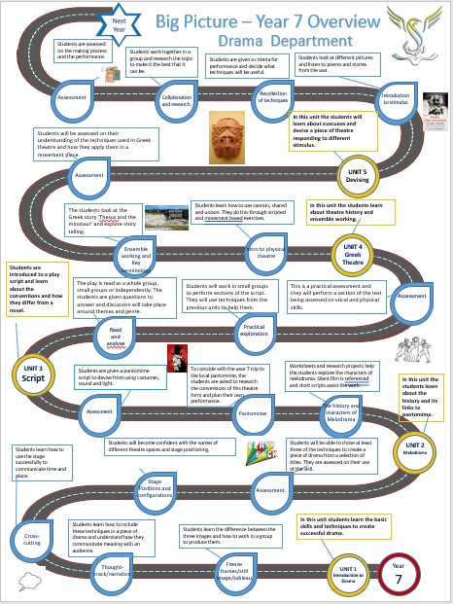

Year 7 Zoom in
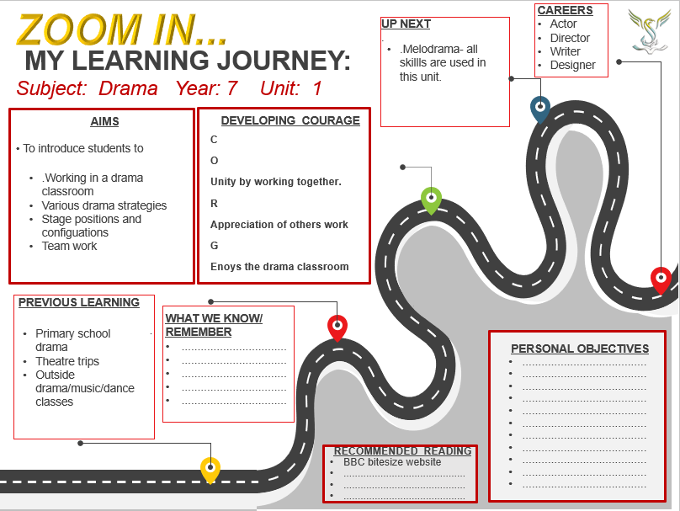

Year 7 Knowledge organiser
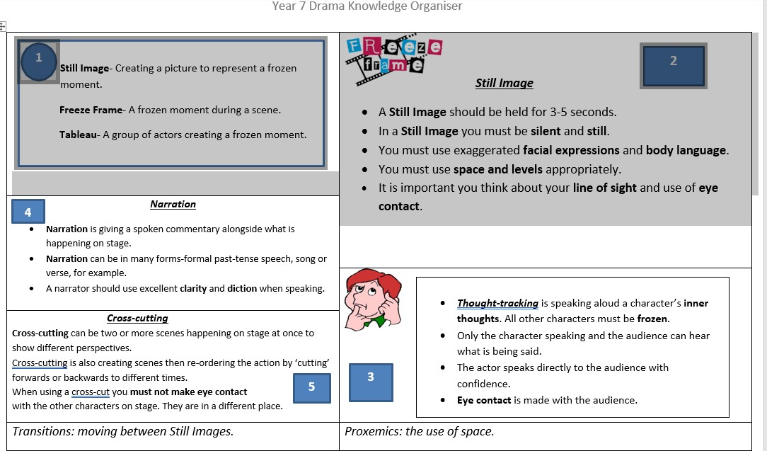
Spellings and definitions
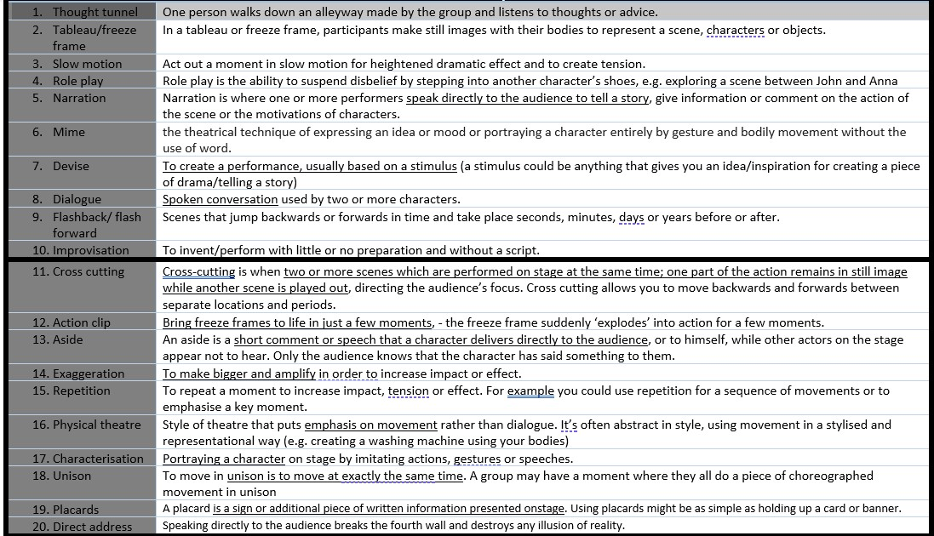
Lesson 1: Introducing drama.
LI: To understand what drama is and why it is important.
LI: To know the difference between a still image, freeze frame and tableau.
Classroom expectations
Task 1 What do you think is important in a drama classroom?
- Put your hand up to answer a question.

Task 2 Fill in the mind map with words that you relate to drama.

What does drama mean to you?

energy

Task 3 Write a paragraph about what you think drama is and why it is important.

Task 4 https://dramaresource.com/freeze-frames/
An explorative strategy is a technique to explore and deepen understanding of the drama you create. Using a range of explorative strategies in the rehearsal room gives you a box of tricks to experiment with. Having a range of ideas at your disposal moves the work forwards and prevents you from becoming stuck.
Match up the technique with the definition.

Still Image | A moment within the action that is frozen for impact.
Freeze frame | A dramatic picture with more than one person. Characters can walk in and out.
Tableau | A single, frozen picture.

To create a successful freeze frame you must:
- Hold your positions for 3-5 seconds
- Be absolutely still
- Use exaggeration in your facial expression and body language.
Practical activity
Standing up, please perform a still image of:
- An elderly man waiting at the bus stop.

- A teenager receiving top marks in their exams.

- A mother whose baby has not stopped crying for an hour.

- A homeless person asking for food.

What did you have to change to create these characters in your still image?
Key terminology- write down the definition
Facial expression-

Body language-

Exaggeration-

Gesture-

Task 5
Storyboard Use up to 6 different still images, to design the story of a family who are eating out at a restaurant. One of the family members has soup spilled over them by the waitress.

Consolidate answer:
- Mild: Name one of the three main rules of a freeze frame and why it is important.
- Medium: Describe what facial expressions and body language you would use in a still image if you were told by your teacher that you had failed all of your exams.
- Spicy: Draw/perform three freeze frames that demonstrate the word ‘isolated’.

Homework Please learn boxes 1 and 2 of your knowledge organiser.

Lesson 2: task 1 reading activity
LI: To understand thought- tracking and how to use it.

(DART) Once you have read the following, answer the questions.
Still image
This is a frozen picture which communicates meaning. It’s sometimes called a freeze frame or tableau. It can provide insight into character relationships with a clear focus upon use of space, levels, body language and facial expression.
Still images can be used in a variety of ways. During a long speech they might be used to punctuate the words with clear imagery, making the drama onstage more interesting by adding a visual dimension to the work. They can also be used for marking the moment to explore a key moment in time.
You could use still images to create a photo album as an insight into a character’s past life and relationships. It would be possible to use them to break down a complicated plot into clear snapshots of its key moments in development. Still image is also a useful way to storyboard early devised work.
Still images can be naturalistic, a photograph of an important moment or abstract, more representational of feelings or an event.
A picture paints a thousand words. Condensing emotions, events or relationships into an image is an excellent way of ensuring these are communicated in a detailed and effective way.

Thought-tracking
A thought-track is when a character steps out of a scene to address the audience about how they are feeling. Sharing thoughts in this way provides deeper insight into the character for an audience.
In rehearsal it’s an effective way of exploring characters and scenes in greater depth. Stopping the action and sharing thoughts enables the actor to fully understand how their character thinks or feels at any given moment. Sometimes the character might feel something different to the words they’re speaking. This is called subtext and thought-tracking is a useful way of exploring it to realise the many layers within a scene.

- If a freeze frame is used to ‘mark the moment’, what do you think this means?
- Who is the character speaking the thought- track to?
- Give an example of a thought-track from a character who is waiting in a queue at a bus stop in the rain.
https://dramaresource.com/thought-tracking/
Task 2- Fill in the thought track section with what you think the characters are really thinking.
Spoken words | Thought-tracking
Mrs Watson: (smiles) Come in Lee – sit down. | How am I going to tell him? He seems a nice lad.
Lee: Thanks. | She’s trying to make me feel better by smiling, but I feel awful.
Mrs Watson: Well, Lee, you did a great audition. It was clear you’d put a lot of effort into preparing.
Lee: Oh, not really. Just did my best.
Mrs Watson: In fact, there were lots of brilliant auditions.
Lee: I see.
Mrs Watson: And yours was very good indeed but I’m afraid it’s bad news. You didn’t get a place.
Lee: That’s ok, really – I’ve got some more auditions lined up.

Task 3 Fill in the blanks.
Narration is giving a …………………………………. commentary alongside what is
happening on stage. Sometimes a separate narrator tells the story of a
………………………….. while others ……………………………… it out. At other times, a
……………………………………. In the play tells the audience what is happening or has
happened in the past.
Narrating should add to what is being seen rather than simply …………………………
It. Narrators generally use different …………………………………. from the actors to describe events.
play character spoken words describe act
Task 4
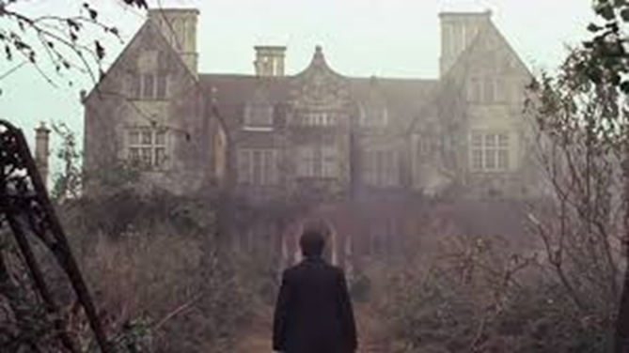
Look at the photo above. Think carefully about the image and then make up and write down an opening narration which sets the scene, creates a suitable atmosphere and introduces at least one main character.
If you were performing this, you could use a series of freeze frames to show the story the narrator is telling.
Consolidate
- Mild: What is the purpose of thought-tracking?
- Medium: What different types of narration are there?
- Spicy: What vocal and physical skills would an actor have to consider when narrating?
Homework Learn boxes 3 and 4 of your knowledge organiser
Lesson 3 - task 1 DART
LI: To understand cross- cutting and the forms it comes in.

Cross-cutting is a device to move between two or more scenes staged in the space at the same time. It’s important that the audience know which part of the action they should follow so one part of the action remains in still image while another scene is played out, directing the audience’s focus. Using this technique you can move backwards and forwards between separate locations and time frames.
For example, a theatre company is creating a piece of work exploring Christmas. The production team want to show the differences between a rich and poor family on this day. Two separate scenes are developed and placed onstage. Instead of playing simultaneously the rich family scene plays first with children opening many presents. This freezes in a still image and the poor family come to life with their simple gifts providing a contrast. This scene ends in a still image and the group cross-cut to the rich family once again who are having a lavish Christmas dinner. They freeze and the poorer family’s dinner is enacted.
Cross-cutting is an excellent way to explore the contrast between situations by making differences clear for the audience. It can also be used to give them additional information. It enables performers to move quickly between locations and scenes without interrupting the flow of the drama they’re creating. Whilst it’s a performance technique it can also be used within a workshop to place characters within different time frames for explorative purposes.
Most stories have a beginning, middle and an end. However, your drama doesn’t have to run in this linear order. Some work is non-linear in structure. This means that it doesn’t follow a chronological sequence but moves about in time. This can be an excellent device for building tension and keeping the audience engaged as the story unravels bit by bit.
1. What is the name of the drama strategy that shows you the future and the past?
2. What are the advantages and disadvantages of cross – cutting?
3. What do the words linear and chronological mean?
Watch the following video
https://www.dramacraft.net/cross-cutting1.html

Task 2
Scene 2
Marc on streets, homeless. ‘Helped’ by gang leader, Vic, and taught how to beg in return for handing over money.
Scene 1
Marc rows with his step- dad who threatens to hurt him. Marc storms out, taking his belongings with him.

Scene 3
Sheila, police officer, gives Marc advice.
Marc rejects it. Vic returns and threatens Marc who hasn’t earned enough money.
Marc returns home. Step- dad at door apologises and welcomes Marc back.

How would you use cross- cutting in the above to stop a linear storyline? Re- write it below.

What would the impact of the cross- cutting have on the audience?

Consolidate
- Mild: What are the different types of cross- cutting?
- Medium: If you make eye contact during a cross- cut, how does this affect the audience?
- Spicy: How would you use cross-cutting and still image to create an effective sequence of scenes about a teenager who’s hiding the fact that she’s playing truant from school from her mother?
Homework Learn box 5 of your knowledge organiser
Lesson 4 Task 1
LI: To identify stage positions and configurations.
LI: To make use of these in performance.
Read the passage below and answer the questions.
(DART) Types of staging.
Proscenium arch
A proscenium arch describes the frame that surrounds a stage space, separating the audience from the stage. This helps to create a fourth wall, which is particularly appropriate for naturalistic productions.
In a proscenium arch theatre, the audience all sit facing the same way. The stage is often raised and the audience usually sit in raked seating, meaning that drapes and large pieces of scenery can be used without obstructing sightlines. The blocking is relatively easy as the audience sit in one fixed position.
A disadvantage is that the audience can be quite far from the stage, making it difficult for them to see and hear the performers, or be as immersed in the action.
End-on
End-on staging is very similar to proscenium arch, but without the arch frame around the stage space.
In the round
When using in the round staging, the audience sit around the stage on all sides, and the performers enter and exit through the audience on walkways. In the round staging can provide an intimate atmosphere and fully immerse the audience in the play.
When performing in the round, performers need to move and change their positions frequently so that all audience members remain engaged and don’t look at a performer’s back for too long. In terms of design, set pieces cannot be too high or they will obstruct sightlines, and lighting can be challenging. Lanterns need to be positioned carefully so that they don’t shine into the audience’s eyes.
Traverse
A traverse stage is long and narrow with the audience sitting on either side, like a catwalk. As with theatre in the round, the audience can see each other, which helps to remind them that they are at the theatre and immerse them in the action on stage. However, it also means that scenery must be low so that it doesn’t cause obstruction, so backdrops cannot be used.
Thrust
A thrust stage sticks out into the audience, who sit on three sides. Like proscenium arch and end-on staging, there is a back wall that can be used for hanging backdrops and large scenery. Blocking is easier than in the round and traverse staging, as there is a back wall, so performers don’t have to worry about having their back to the audience.

- Draw what you think each stage type looks like in the space below. Read it carefully and sketch your ideas.
- Which stage would be best for non-naturalistic theatre and why?
- What is a disadvantage of theatre in the round?

Task 2 Watch the video and write in the correct stage positions.
https://www.bbc.co.uk/bitesize/guides/zjwp2sg/video

Centre stage

Task 3
- There you are.
B. Yes.
A. I got held up.
B. So I see.
A. Do you want a coffee or something?
B. No, I’m fine thanks.
Learn this simple dialogue with a partner.
You will need to perform it three ways:
- A and B remain far apart. You must decide whether you face each other or if backs are turned.
- A and B stand next to each other, two metres apart.
- The space changes throughout the dialogue.

Questions:
Was the first more cold or distant?
How did the changing of space in the third option affect the relationship?
What other uses of space could have been introduced?


Consolidate
- Mild: Where would you stand on stage to talk directly to the audience and why?
- Medium: If you wanted to create a performance with lots of scenery and wing space, which configuration would you use?
- Spicy: What other changes, apart from the use of space, can change the dynamics of relationships on stage?

Homework Learn the first 10 spellings and definitons in the list on your knowledge organiser page.

Lesson 5 task 1
LI: To revise stage positions and configurations
LI: To prepare for assessment.
Please answer these multiple choice questions independently.

- USR is an abbreviation of

- Upstage centre
- Upstage right
- Upstage regular

- The stage direction ‘Titania storms downstage’ suggests the actor needs to

- Walk towards the wings
- Walk towards upstage centre
- Walk towards the audience
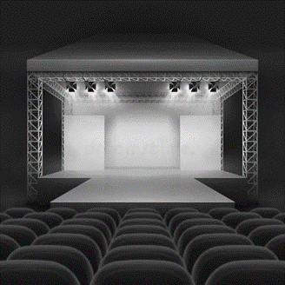

- The above stage configuration could be described as
- Traverse
- Thrust
- Proscenium arch with an apron

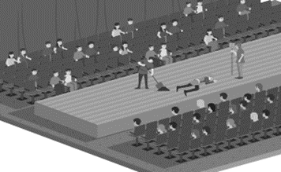

- The above stage configuration is called
- Thrust
- Traverse
- In the round

- You are performing a duologue for your class. You ask them to sit on three sides of the performance space you have marked out on the studio floor. Your audience are...

- In an ‘End On’ configuration
- In an ‘Apron’ configuration
- In a ‘Thrust’ Configuration
Assessment criteria:
- In pairs you must devise a piece of drama titled ‘The worst holiday ever.’
- You must use a still image to begin and end the piece.
- You must use at least two thought- tracks.
- You must use any form of narration.
- It must not be longer than 1 minute 30 seconds.

Assessment ladder

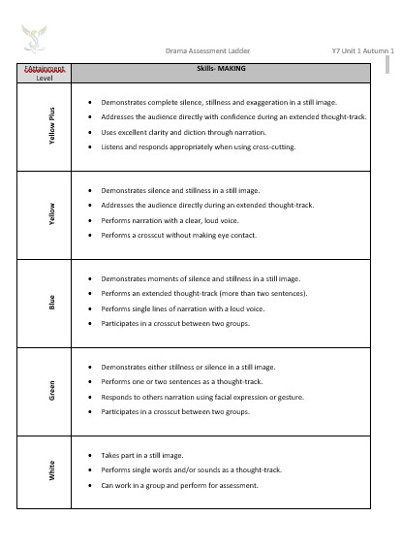
Homework Learn the last 10 spellings and definitions from your knowledge organiser page
Lesson 6
Review and assess work giving verbal feedback.
Evaluation

