History KS3 Autumn 1 Blended Learning Booklet
The Battle of Hastings
Name:
Form:
Aim to complete one lesson each week. Write out the title and LI and then complete the tasks.
All video links are online using the ClassCharts link.
The Knowledge Organiser on page 3 has all the key information and vocabulary to help you with this unit.
Upload all work onto ClassCharts for feedback.
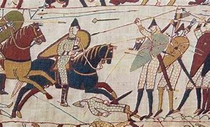

Contents
Page3: Big Picture - Year 7 Overview
Page 4: Zoom in - My Learning Journey
Page 5: Knowledge Organiser
Page 6: Lesson 1, Lesson 2
Page 7: Lesson 2
Page 8: Lesson 3, Lesson 4, Lesson 5
Page 9: Lesson 5, Lesson 6, Lesson 7
Page 10: Lesson 6, Lesson 7, Assessment Ladder

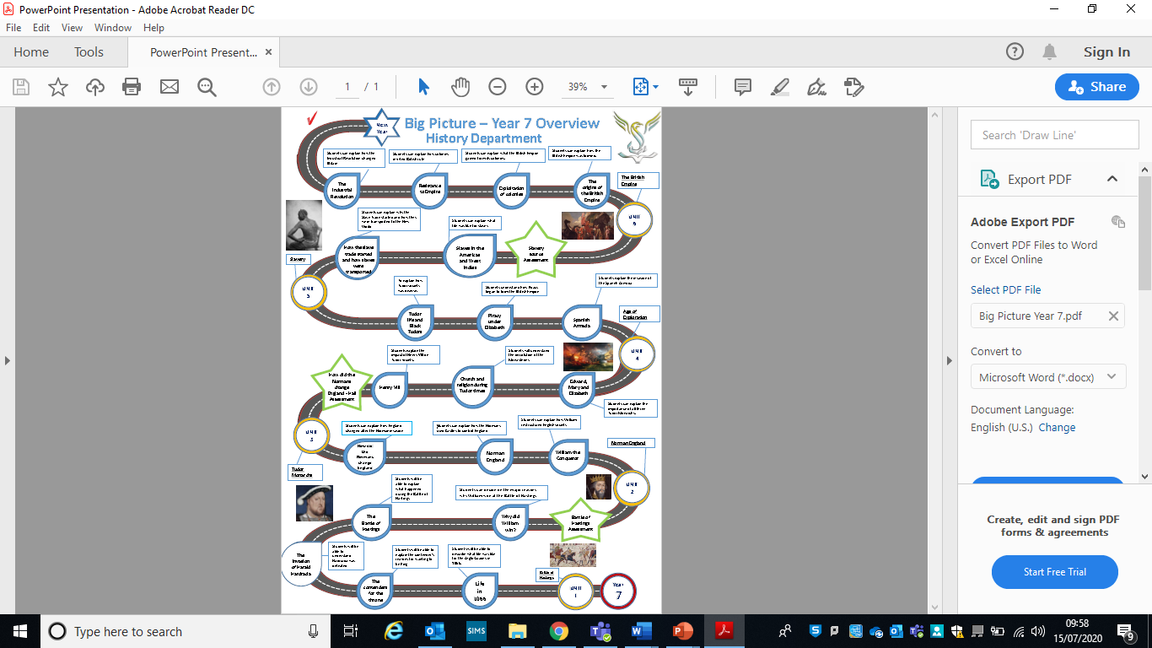

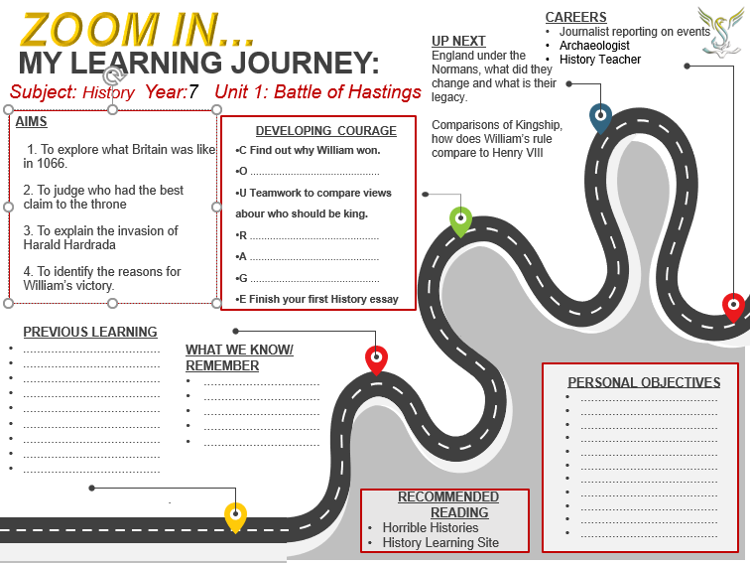
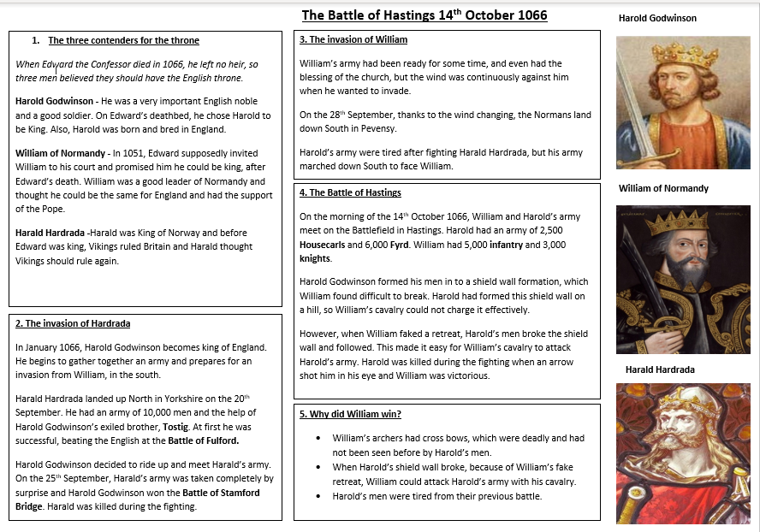

Lesson One What was England like in 1066?
- LI: to understand what England was like in 1066.

Why is History important?
www.youtube.com/watch?v=__o7rrLD32s
DART: England in 1066
England in 1066 and 2020 were very different. Historians have to question what the changes were and why they have taken place. England had a population of 2 million people. There were more sheep than people! The land was full of farms. England was ruled by the Anglo-Saxons who had taken over after the Vikings. Edward the confessor was King of England. He reigned for 24 years between 1042 and 1066. When he died in 1066 he left no heir. Three men battled to become King of England after Edward’s death. They were Harold Godwinson, Harald Hardrada and William of Normandy.
Study the summary of the Saxons on the following webpage and explore the meaning behind different surnames.
https://www.english-heritage.org.uk/learn/teaching-resources/story-of-1066/collectible-6/
What was going on in 1066?
Key questions (answer these in your books)
1. Why would someone want to be the King of England?
2. Why might there be problems with deciding who should be King?
Homework: learn box 1 of your Knowledge Organiser
Lesson Two What was life like for Anglo-Saxons?
- LI: To understand what life was like for Anglo-Saxons

Retrieval Starter: Copy and complete the following
The three contenders for the throne
When ____________________________ died in ________, he left no heir, so three men believed they should have the English throne.
Harold ________________ - He was a very important English noble and a good soldier. On Edward’s deathbed, he chose Harold to be King. Also, Harold was born and bred in __________.
William Duke of ______________ - In 1051, Edward supposedly invited William to his court and promised him he could be king, after Edward’s death. William was a good leader of Normandy and thought he could be the same for England and had the support of the _________
Harald __________________ -Harald was King of Norway and before Edward was king, ____________ ruled Britain and Harald thought they should rule again.
A fourth contender was Edwards’ nephew called ___________. He did not organise an army to stake his claim as he was too ____________.

Watch the following:
https://www.youtube.com/watch?v=-cKGz-st75w

Read the following DART to help you answer the comprehension questions below.
DART:
The Witan were an assembly of wise men. Edward could invite whoever he wanted to join the Witan. However, it made good sense to invite the most powerful men in the kingdom. These were the Earls who helped Edward rule large areas of England in return for military help if he needed it. To involve the Earls meant that they would be likely to support any decisions he made and there would be no rebellions. As well as Earls, Edwards sometimes invited Thegns, Bishops and Abbots to come along to a Witan. Witan’s did not always meet in the same place and did not always consist of the same people.
Anglo-Saxon justice was based on the family. If anyone was wronged their family was expected to seek revenge. Everyone had a life price. If a person was murdered, the murderer’s family had to pay the murdered person’s life price in full. For lesser crimes like injuring someone, only a small amount of the life price had to be handed over. Saxons held regular open-air meetings called Folkmoots which dealt with people who broke the law.
Key Questions (answer these in your book):
- Who were the Witans? What sort of people were they?
- What did they Witan do and what did they get for doing this?
- How did Anglo-Saxons get justice?
- How did Anglo-Saxons make decisions on people who broke the law?

Use the following bitesize webpage to examine Anglo-Saxon Villages:
https://www.bbc.co.uk/bitesize/topics/zxsbcdm/articles/zq2m6sg

DART:
What did the Anglo-Saxons do all day?
Working on the land
Most Anglo-Saxons lived in villages and worked on the land. There were two types of people who worked on the land:
Ceorls – Free men who worked the great open fields that surrounded the villages.
Thralls – Slaves who had to obey the Ceorls orders.
In the fields, barley, rye, and wheat was grown to make beer and bread. Sheep, hens, and cows lived in the villages alongside people. These animals produced meat, eggs, milk, and wool.
Most villages had a lord known as a ‘thegn’ who protected the villagers in times of trouble. In return for the lord’s protection, they were given food grown and made by the people in the village.
Working in towns
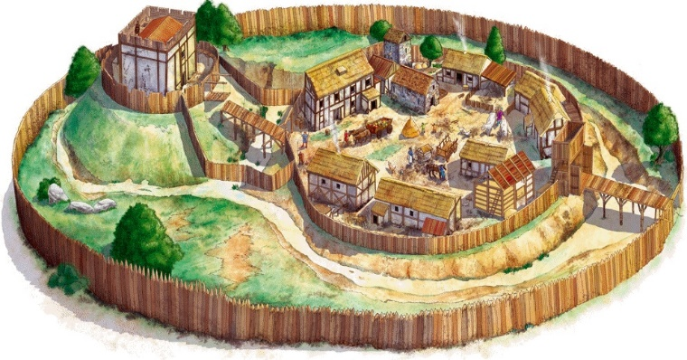
Some villages grew into towns and in the year 1000AD, about 10% of the population of England lived in a town. Towns grew from markets where people from the surrounding countryside came to buy and sell; some towns specialised in, for example leatherwork or soap making. Towns on the coast became busy ports. Ships would carry goods to other ports on the coast of England, or across the seas to Europe. By the 11th Century, England was a very wealthy country – a rich prize for any invader.
Lesson 3 Who had the best claim to the throne?
LI: to judge who had the best claim to the throne
DART:
Harold Godwinson was made king of England in 1066 but this just made William of Normandy and Harald Hardrada jealous. William of Normandy was furious that Harold had been made king and made plans to invade England. Hardrada’s ancestors had ruled England one hundred years before and he felt that the Vikings should still rule the country. Harold Godwinson was a good soldier, he was born and raised in England and was popular with nobles.
OAK ACADEMY LESSON: 1066 and the succession crisis
Key Questions (answer these in your book): Who had the best claim to the throne and why? Who had the weakest claim to the throne and why?
Extension: Does age affect your ability to rule?
Lesson 4 The invasion of Harald Hardrada
LI: To explain the Battle of Stamford Bridge
Watch the following video to answer the key questions on the battle:
https://www.youtube.com/watch?v=qtW7H7yPZLg

Key Questions (answer these in your book):
- Why was Harold waiting on the South Coast of England?
- What prevented William Duke of Normandy’s army from sailing to England?
- Who did Harald Hardrada have help from?
- What is a Huscarl?
- What is a Fyrd?
- How far did Harold travel and how long did it take him?
- How was Harald Hardrada’s army unprepared?
- What separated the two armies?
- What did both armies to do prepare for battle?
- What problem did Harald Hardrada’s army face?
- How did the battle end?
Homework: Learn box 2 of your Knowledge Organiser

Lesson 5 The Battle of Hastings
LI: To identify the reasons for William’s victory.
Retrieval Starter:
Using the following key vocabulary, summarise what happened during the invasion of England by Harald Hardrada:
- North/South
- Yorkshire 20th September
- 10,000 troops
- Tostig
- Battle of Fulford
- Battle of Stamford Bridge

Watch the following video of the battle and complete the key questions below:
https://www.youtube.com/watch?v=zigjVCFzZ38
Key Questions (answer these in your book):
- Who’s blessing did William have?
- Where did the battle take place?
- What weapon did William’s army have, that was unknown to Harold?
- What advantage did Harold’s army have?
- What did William’s cavalry do, to trick Harold’s soldiers?
- How long did the battle go on for?
- How did Harold die?
Plenary:
- List as many reasons as you can, why William won at the Battle of Hastings.
- Pick the reason that you think was the most important for William’s win at the Battle of Hastings.
Homework: Learn boxes 3-5 of your Knowledge Organiser
Lesson 6 and 7 Why did William win the Battle of Hastings?
LI: To decide what the most important cause of William’s victory was
You will be spending your next two lessons writing your first History essay. To help you prepare, we will recap the key points and use them to structure our essay.
Review: make notes on the following to help you plan your work. This would be in bullet points/mindmaps etc. Don’t forget to use your notes and the Knowledge Organiser.
- Who was able to prepare for the Battle of Hastings better? Think about what happened to the Saxons just before the battle and the Normans journey to Hastings.
- Who has the better equipped troops? Think about the weapons, cavalry, and tactics.
- Who had the crossbow? Who had cavalry and why would these be useful troops? What is the shield wall formation? Why was it effective and who used it? The battle takes place on a hill, who started with the advantage of the higher ground?
- What was the famous trick used by the Normans? How did this change the course of the battle? How was the Saxon king famously killed?
Now you are ready to start your essay (DIP). Use the following introduction model to help you start.
After Edward the Confessors death, three people battled for the throne of England, ending at the Battle of Hastings. In this answer I will be looking at each of the reasons that helped William win at the Battle of Hastings. I will also be stating which reason is the most important for William’s victory, and explaining why this is.
After your introduction, we have included a helpful plan to help you structure your answer. You should aim to write a minimum of one A4 page for your response.

Second paragraph – Better preparation.
Beginning – Little bit of info on Stamford Bridge
Middle – William being prepared, but Harold not being prepared.
End – How did it help William win?
Third paragraph – William’s army
Beginning – What is in his army?
Middle – Why is this good? Did Harold have these things?
End – How did it help William win?
Fourth paragraph – Fake retreat
Beginning – What was it?
Middle – Why was it bad for Harold?
End – How did it help William win?
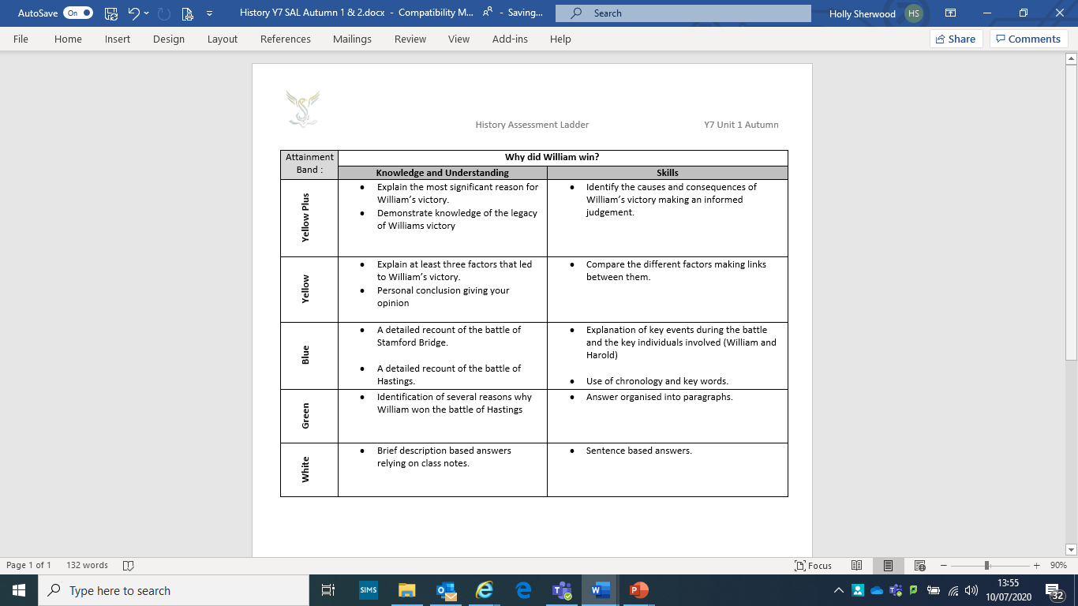
Conclusion – What was most important? Make a strong argument! Why is it your reason more important than the others?

