Geography KS3 Autumn (Year 7)
Blended Learning Booklet
Around the world
Name:
Form:
Aim to complete one lesson each week. Write out the title and LI and then complete the tasks. Upload all work onto ClassCharts for feedback.
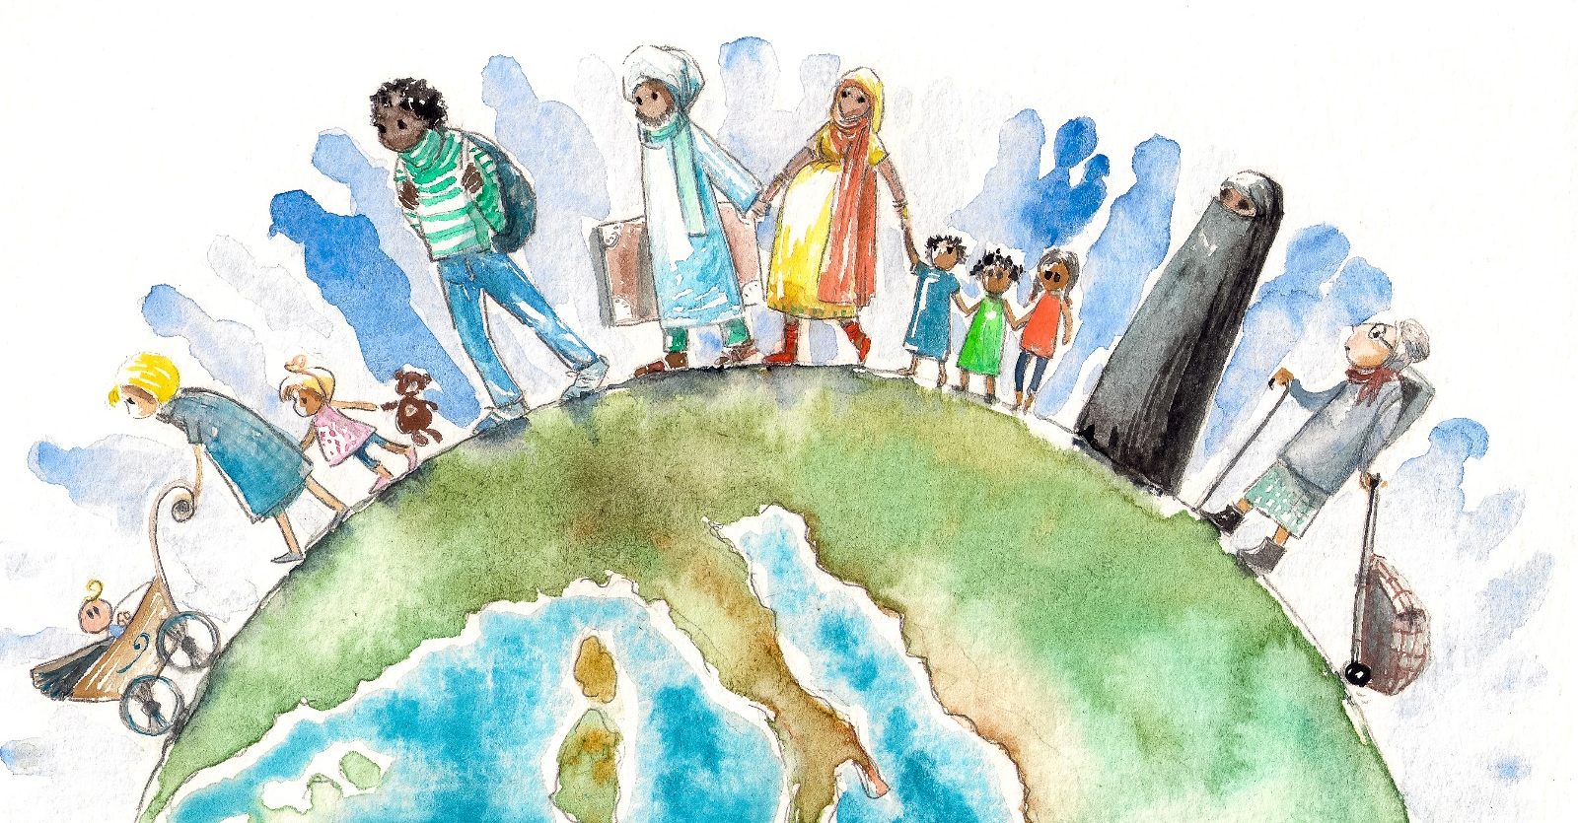

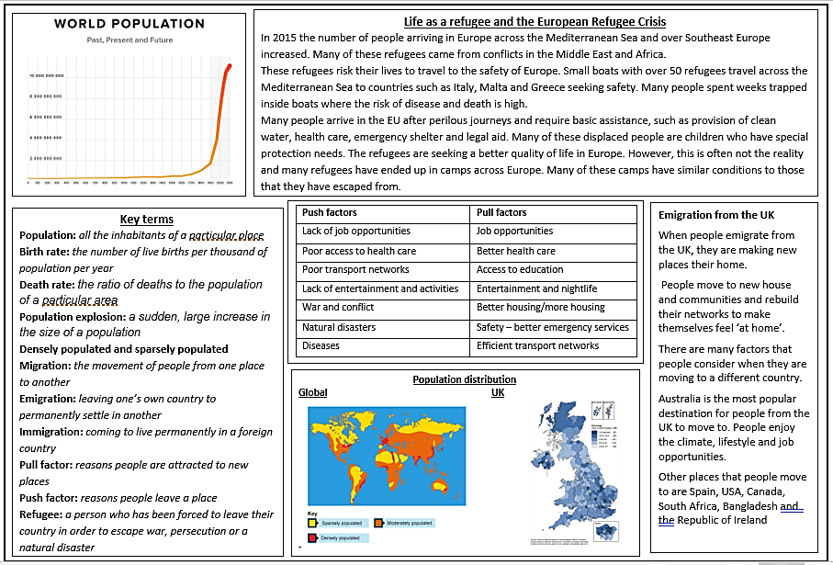

Lesson 1 - Places around the world
LI: To name and locate key features on a world map
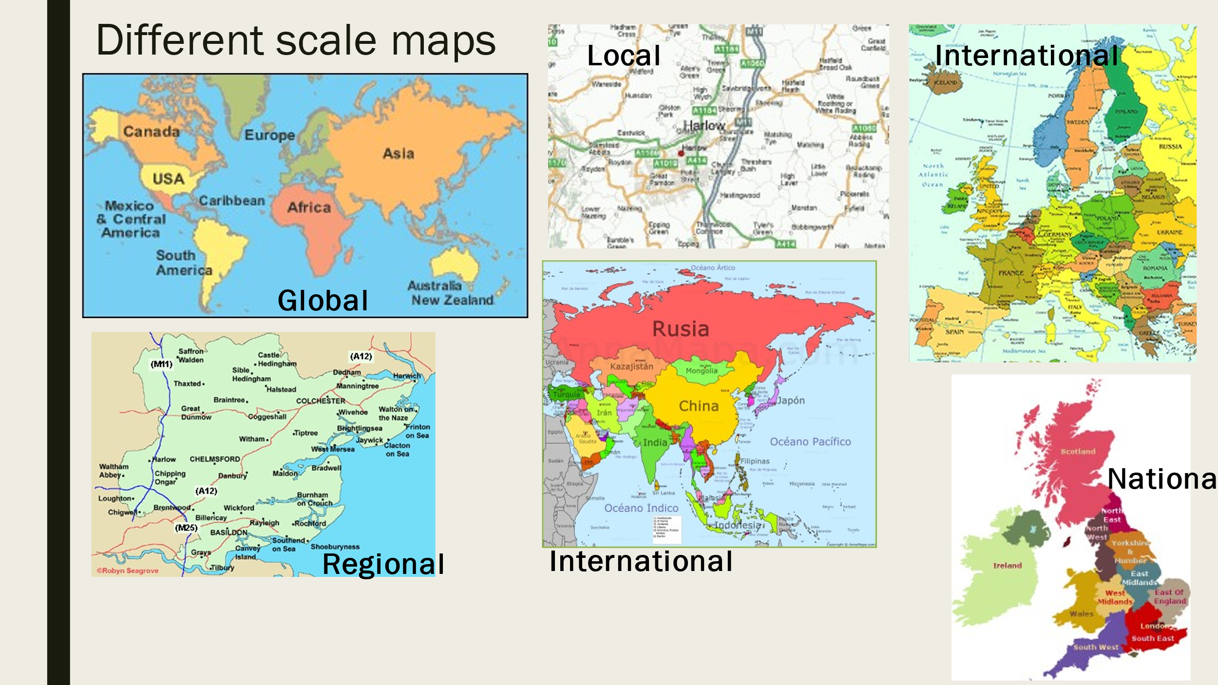
Task 1 - Reorder the different map scales from biggest to smallest

Task 2 - Use an atlas or the internet to label the different continents on your map
Task 3 - Using an atlas or the internet, you need to label and annotate your world map with key human and physical features around the world

Pacific Ocean
Atlantic Ocean
Arctic Ocean
India Ocean
UK
USA
India
China
Russia
Thailand
Democratic Republic of Congo
Morocco
South Africa
Australia
Syria
Kenya
Japan
South Korea
Somalia
Afghanistan
Norway
Mexico
Argentina
Chile
Iceland
Bolivia
Zambia

Peru

Challenges:
- Which of the continents do you think has the most people and the least people living there?
- Can you find where Harlow might be on the map?
- Can you find and label anywhere that you have been on holiday? Or anywhere you would like to go…

Lesson 2 – Place and settlement
LI: To understand site and situation
Task 1 – Copy down the key terms
- Settlement - places where people live.
- Site - this is the place where the settlement is located.
- Situation - this describes where the settlement is in relation to other settlements and the features of the surrounding area.
Farms
Market town
Village
Capital city
Regional centre
Hamlet
County town
Task 2 - Make a list or mind map of what you think the first settlers in an area would have looked for to build homes and start their lives
Task 3 - Have a go at ordering these settlements from smallest to biggest:
Challenge:
- What category do you think Harlow fits into?
- What do you think is the most important city in the UK?
- Can you name the capital cities of England, Scotland, Wales and Northern Ireland?
Task 4 - Create your own settlement

- Draw a box in your book (use a whole page)
- Draw a river passing through the box.
- Add in a hill, a woodland and a lake.
- Build a bridge over the river.
- Place your settlement somewhere in the box.
- Give it a name.
- Place a second smaller settlement (village or hamlet) in the box.
- Connect the two settlements with a road.
- Give the second settlement a name.
- Colour it in!

Lesson 3 – Push and pull factors
LI: To explore the movement of people around the UK
Task 1 – Answer the questions
1. In your opinion, what is the most important feature needed to start a settlement?
2. What is the most important feature that you would want in a place you live? Why?
Task 2 – Copy down the key terms
- Migration: the movement of people from one location to another
- Push factors: the reasons people want to leave a place
- Pull factors: the reasons people want to move to a place
- Urban: cities and towns
- Rural: countryside
- Rural-urban migration: moving from the countryside to cities
Task 3 - Can you locate and label the cities on your UK maps
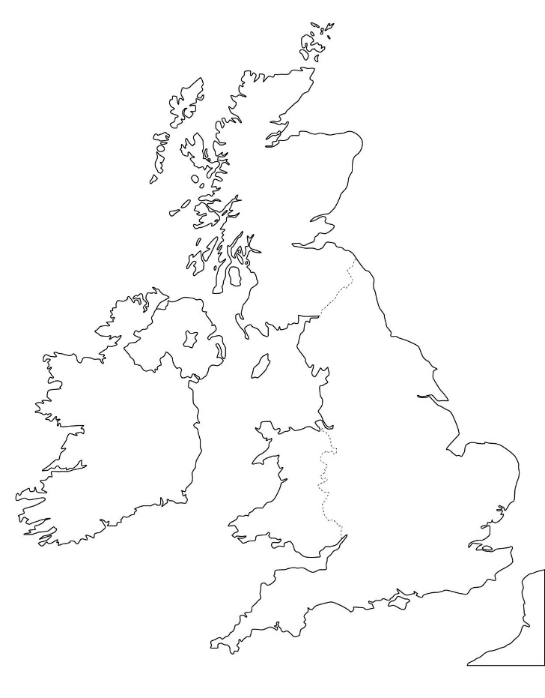
- London
- Manchester
- Birmingham
- Newcastle upon Tyne
- Cardiff
- Bristol
- Edinburgh
- Belfast
- Glasgow
- Sheffield
- Leeds

Task 4 - Draw a table. Think about moving to cities in the UK.
On one side write a list of the different pull factors of cities (why people want to move there).
On the other side write a list of the different push factors for the countryside (why people want to move away).
Challenge: Can you think of any push factors for living in a city? Why might people want to move to the countryside?
Task 5 - Do you think people are more likely to move in to or out of Harlow? Explain your choice.

Lesson 4 - Brits abroad: an introduction to emigration
LI: To identify patterns and locations of emigration from the UK
Task 1 - Study the map below. What do you think it is showing?
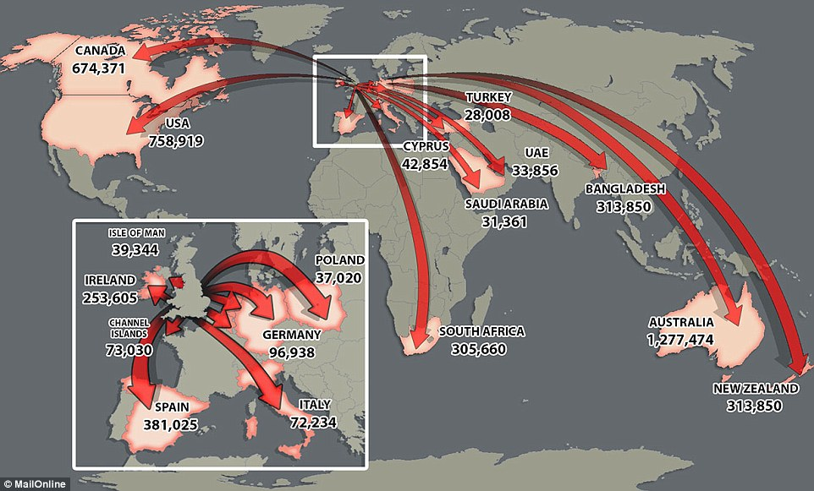
List the top 5 destinations for British emigrants.

Task 2 – Copy down the key terms
- Immigration: moving into a place (usually a country)
- Emigration: moving out of a place

Task 3 – Make a mind map or list of the reasons why people might want to leave the UK.

Task 4 – Answer the question: If you could move anywhere in the world, where would it be and why?
Structure:
State where you would want to move to
Describe where in the world it is located
Describe what the place is like (food, weather, people, activities, landscape)
Explain and justify why you want to move there
Challenge:
Suggest what might be difficult or challenging to move to a new country.
The country I would move to is… I would move here because the weather is… This mean I would be able to… I would also like to live here because… This is different to the UK because…

Lesson 5 - Global patterns of population and migration
LI: To identify global patterns of migration and population change
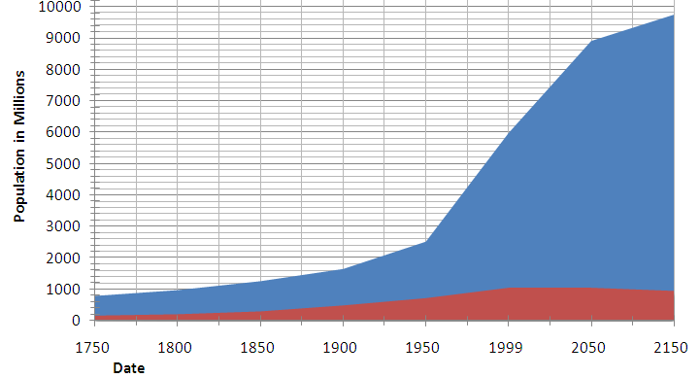
Task 1 – Describe the pattern of population change

Task 2 – Why do you think that the population has grown so much over time? Write down 4 reasons why.
1 3
2 4

Task 3 – Look at the map below (the darker the colour the more people that live in that country) and read through the DART about population distribution.
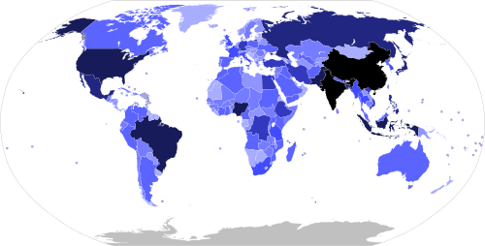
Population distribution is the spread of people across the world, that is where people live. Population density is the number of people living in a particular area – usually 1 square kilometre – and can be written as total population/land area. The population of the world is now over 7 billion people, the vast majority of whom live in the developing world. The world's population is spread unevenly across the globe with concentrations of large numbers of people living in the same area. The world as a whole has more 'empty' areas than 'crowded' areas.
Some of the more densely populated countries include the USA, Brazil, India and China. Sparely populated regions are areas that are more difficult to live in such as the Sahara, the Arctic or the Australian Outback.

Lesson 6 – Global population distribution
LI: To investigate global population distribution
Task 1 – If you could live anywhere in the world, where would it be and why?

Task 2 – Read through the key terms. Practice read, cover and write to see if you can remember.
Sparsely populated: fewer people scattered around an area. The population is low.
An example might be a county, which is a large area, but with farms located far apart across it.
Densely populated: many people crowded in a specific place. The population is high. For example, New York City is very densely populated
Watch the video at the bottom of this webpage: https://www.bbc.co.uk/bitesize/guides/zbswxnb/revision/3#:~:text=The%20population%20of%20the%20world,areas%20than%20'crowded'%20areas.

Task 3 - Create a mind map with some of the factors you think might influence where people live?
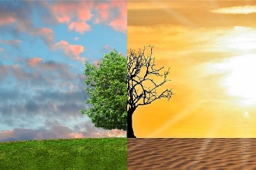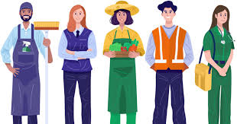
Task 4 – Read through the two places descriptions.
Which one do you think is densely populated and which do you think is sparsely populated?
Explain your decision in full sentences. Can you identify or guess where each place is?
Place A | Place B
The poor soil and climate make it difficult to live in one area  The climate is very hot and dry  Sand makes it hard to build houses and roads  It is hard to find water  There are lots of potential hazards from the environment  It is very quiet and peaceful  There is huge potential for development and growth | Low-lying and gentle sloping land  Easy access to road and communication networks  Mild and wet climate  There are 4 seasons throughout the year  Easy access to clean water and food  There are opportunities for work and education  There is high pollution  Higher risk of crime

Lesson 7 – Migrating across borders
LI: To understand how and why people move around the world
Task 1 – Read through the key terms. Practice read, cover and write to see if you can remember.
Migration: the movement of people from one location to another
Immigration: when someone enters a country
Emigration: when someone leaves a country
Push factors: the reasons people want to leave a place
Pull factors: the reasons people want to move to a place

Task 2 – Can you think of any push or pull factors? Write down your ideas below.
Push factors Pull factors
- -
- -
- -
- -
Task 3 – Watch the video: https://www.youtube.com/watch?v=LY_Yiu2U2Ts&list=PLJ8cMiYb3G5dRe4rC7m8jDaqodjZeLzCZ&index=37
And answer the following questions
Where was the migration happening?
What was happening? Was it positive or negative?
Who were the people crossing the border?
Why did these people want to cross the border?
How would you feel if you had to make this type of journey to keep you or your family safe?

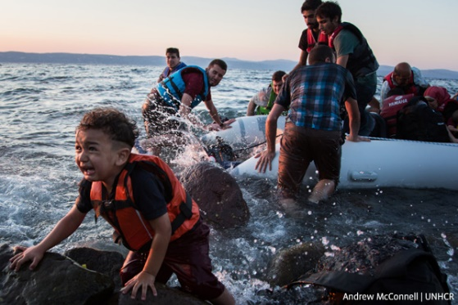
Lesson 8 & 9 – Refugees and asylum seekers
LI: To define a refugee and an asylum seeker and explore their experiences
Task 1 – Write your own definition of a refugee
Watch the video: https://www.youtube.com/watch?v=GvzZGplGbL8&t=2s

Task 2 – What is the different between an asylum seeker and refugee? Read the information below and then answer the question in full sentences.
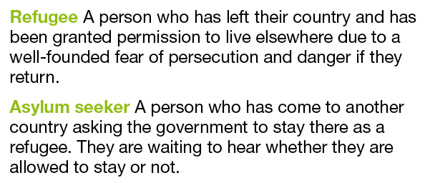

Task 3 – Colour code or label the sentences to show whether the scenario is about a migrant, refugee or an asylum seeker.
- An individual who has travelled from Syria and is waiting for their documents to go through in the UK.
- An individual who has moved from China to the USA for work.
- An individual who has moved from Bangladesh due to flooding and has been allowed to stay in India permanently.
- An individual who has moved from the UK to Spain for new life experiences.
- An individual who has travelled from Yemen because there is no food and is waiting at the border to see if they can live in France.
Task 4 – Read through the experience of Gulwali Passarlay, a refugee from Afghanistan. At the end of reading, write down 3 sentences about how it makes you feel to understand more about his experiences.
Gulwali Passarlay was 12 when he left Afghanistan nine years ago, forced by his mother to flee after US forces killed five members of his family. “I had a beautiful life. I was a shepherd; I spent much of my time with my grandparents in the mountains. My father was a doctor. But unfortunately, events happened. The Taliban wanted to recruit us. We had to flee for our lives,” he says.
He spent a year travelling, alone, through the Middle East and Europe, shunted from people trafficker to people trafficker, trying to get to the UK, where he hoped to meet up with his brother. Last year, as the European refugee crisis worsened, he found reading accounts of children making similar journeys very disturbing. “I know what it feels like to be on this risky and dangerous journey. Children die,” he says. Most troubling was “the fear of the unknown. I didn’t know what was happening, what would happen next. I saw death with my own eyes, especially when I was crossing the Mediterranean.”
He spent 49 hours with 100 other refugees in a boat designed for 50. Water started to come into the boat, and some people jumped out. He worried that if he drowned, his body would be lost, and his family would never know what had happened to him. “When I see reports of people drowning in the sea, it reminds me of my own story. I still have nightmares; it still keeps me awake.”
He was imprisoned in Turkey and Bulgaria and deported from Iran. When he was waiting in Calais, trying to get on a truck to Britain, he was arrested almost daily by the French authorities. “I was deprived of sleep by the police. They would know that I had been running all night after lorries and come back to sleep in the small tent I had made for myself with my friends, but every morning they would wake us up, say, ‘Bonjour’, take us, and put cold water on our faces and interrogate us.”
The only country where he felt the authorities had some sympathy for him as a child was Italy. “I arrived on top of a lorry engine; it was very dangerous – if I let my hands go, I would have been underneath the wheels and the tyres. I was very lucky that I survived. They arrested me on the motorway. The first thing they gave me was some food, croissants, juice. I was very hungry and thirsty. They got me new clothes because I was very dirty; they sent me to a children’s home. That was the only place I was treated as a child. It was the first place I was able to shower properly, eat properly. They were very kind people, but I had to leave Italy. I wanted to find my brother.”
He was 13 when he got to the UK (in the back of a lorry carrying bananas), but he had no passport or birth certificate, so officials in Kent interviewed him and assessed him to be 16. “They wouldn’t believe my age, they wouldn’t believe my nationality, they wouldn’t believe anything I said. I felt victimised.
He needed help to contact his brother but received no help. “They said: ‘There are more than 60 million people in the UK. We can’t find your brother.’”
His disturbed memories of his own trip here were reawakened when he visited the Calais Jungle six weeks ago, where he feels conditions have worsened. “It is shameful for Britain and the rest of Europe. The people there say, ‘We need food, we need water, we need shelter’, but what is also in short supply is dignity and respect.”
He welcomes the idea that Britain may offer sanctuary to more children who are fleeing war zones alone. “Invest in these children and they will contribute to British society. Some of them may go back to Syria and Afghanistan.” But he wants officials to remember that most refugee children’s struggles continue once they are given asylum.
“The problems don’t end. It starts again. You’re in the hands of strangers. I haven’t seen my mother for 10 years. It has been a huge battle for me. My grandmother, who was the most beloved to me, she passed away. I was not there. My little sister also passed away. I was not there. Even now I think: what is the point of this safety and security and the education and the opportunities that I have, if I’m not there with my sister, to hold her hand and be with her? Life is short.”
Glossary
Trafficker: a person who deals in something illegal.
Imprisoned: kept in prison
Deported: being sent out of a country
Deprived: a lack of
Interrogated: asked questions aggressively
Victimised: single someone out
Sanctuary: a place of safety / security

Task 5 – Answer the questions in full sentences
1. Why did Gulwali Passarlay leave Afghanistan?
2. How was his journey through the Middle East and Europe? Describe the experience, his worries and how he travelled.
3. Where did Gulwali Passarlay have the best experience on his journey?
4. Why is this the case?
5. Why did he have to leave there?
6. What was Gulwali Passarlay’s experience when he got to the UK?
7. How does he feel about it?
8. What are some of the difficulties that Gulwali Passarlay has faced in his family?
9. What are some of the positives of being granted asylum in the UK? What does he now have?
Lesson 10 – The European Refugee Crisis
LI: To explain the causes and impacts of the crisis
Task 1 – Re-read the first-hand experience of Gulwali Passarlay a refugee who travelled through Europe to seek safety in the UK.
Task 2 – Colour code the facts below to show which factors are push and which factors are pull (you might want to have a look back to Lesson 2 if you have forgotten the key terms)
Push Pull
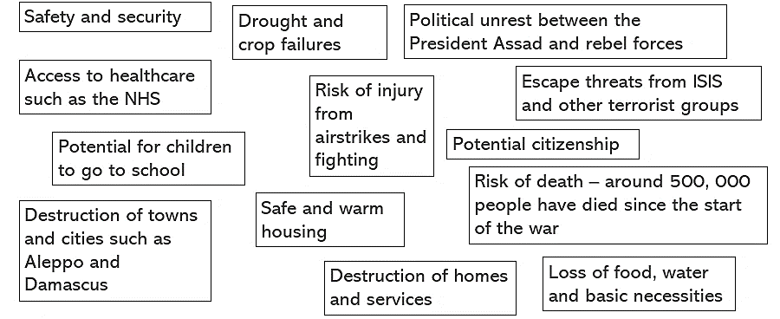
Task 3 – Watch the video about Syrian refugees
https://www.youtube.com/watch?v=2iz2tNiRpeY

Task 4 – Answer the question ‘Would you risk it?’
Write a paragraph about being a Syrian refugee trying to get into Europe:
Describe what the journey would be like.
Explain why you might want to make the journey across the Mediterranean Sea to get to Europe.
Justify why you would or wouldn't risk.
You might want to carry out some of your own research as well to find out more about the experiences of refugees

