

Year 7
Music
Spring B
BLB
Band Musicianship 1:
The Four-Chord Trick


Name: Form:
Contents
KO- Knowledge Organiser
SAL- Assessment ladder
Lesson 1- Watch up to 11 minutes 19 seconds https://classroom.thenational.academy/lessons/how-can-secondary-chords-be-introduced-in-an-accompaniment-cgrk6r?step=2&activity=video
Lesson 2 - Watch from 11 minutes 19 seconds until the end https://classroom.thenational.academy/lessons/how-can-secondary-chords-be-introduced-in-an-accompaniment-cgrk6r?step=2&activity=video
Lesson 3 – Watch up to 17 minutes 6 seconds https://classroom.thenational.academy/lessons/how-are-pop-songs-constructed-64ukct?step=2&activity=video
Lesson 4 - Watch from 17 minutes 6 seconds
https://classroom.thenational.academy/lessons/how-are-pop-songs-constructed-64ukct?step=2&activity=video
Lesson 5 – Watch up to 16 minutes 27 seconds
https://classroom.thenational.academy/lessons/performing-popular-music-drum-patterns-6hjk8t?step=2&activity=video
For all lessons, please go to:
Oak national academy ( www.thenational.academy )- Lessons- KS3-Music- Bandmusicanship1: The Four-Chord Trick – click onto appropriate lesson
Virtual instrument apps:
https://www.musicca.com/piano?
https://www.onlinepianist.com/virtual-piano
DAW app:
Please note: Instead of using Bandlab, please use https://onlinesequencer.net/ or Garage Band.
Knowledge Organiser
1. In a Major scale chords I, IV and V (1,4 and 5) are Major. Chords ii, iii and vi (2,3 and 6) are minor chords.
2. A chord progression is a set of chords played in a certain pattern. The four-chord trick uses chords I, IV, V, and vi (1, 4, 5 and 6). These can be used for multiple songs by changing the order they are played in. Chord progressions can be made more interesting by changing the rhythm (using a mixture of shorter and longer notes).
3. The start of a song without words is called the intro, if this happens at the end it is called an outro. A chorus is the catchy section repeated in a song, it has the same words/lyrics every time it returns. A verse is repeated but the lyrics change every time it returns. A bridge is a contrasting section that prepares us for the chorus, it normally happens once in the song. A pre chorus is a small run up just before the chorus starts.
4. You can record and sequence musical structures in a Digital Audio Workstation (DAW). It has many channels in which you can change the sounds to create your own virtual band. A simple song structure could be intro, verse, chorus, verse 2, chorus, outro. You could start by creating an intro with four chords, a bassline, and some drums. These can then be looped to create the rest of the song. You can add contrast by changing the rhythm in different sections.
5. Rhythm notation shows us how long we need to play notes/chords for. To create a beat with a drum kit we need three main components, snare drum (sounds like a crack), Hi-Hat cymbals (higher pitched and tinny) and Bass/ Kick drum (the lowest pitched drum). There are many other parts to a drum kit and can be made smaller or bigger by adding taking away drums. To play a rock drum beat you play hi-hat on every beat (crochets), snare drum on beats two and four (crochets), bass drum on beats 1 and 3 (crochet followed by two quavers)

SAL- Assessment Ladder

Attainment Band | Music
Yellow Plus | - You can play a selection of four-chord pop songs from start to finish.  - You can structure your own pop song in a digital audio workstation.  - You can identify different drum patterns by ear.  - You can play multiple different drumbeats.
Yellow | - You can play a complete pop song from start to finish.  - You can structure an existing pop song in a digital audio workstation.  - You know how secondary chords can be used to add interest to chord progressions.  - You can create more rhythmically exciting four-chord progressions.
Blue | - You know what the secondary chords are in a major key.  - You can create your own four-chord progression.  - You can play the Rock beat drum pattern fluently in popular music.
Green | - You know what the primary chords are in a major key.  - You can play an existing 4-chord progression(shotgun)  - You can play parts of the rock drum pattern, not fluently.
White | - You know about the different sections in a song structure.  - You can name the different parts of the drum kit.

Lesson 1 - Connect
Title- The role of Chords
LI- How can secondary chords be introduced in an accompaniment?
Lesson structure:
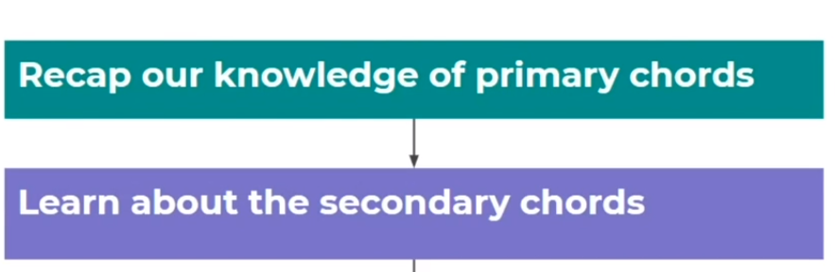

- Access the video/lesson 4 up to 11 minutes 19 seconds on the four-chord trick:
https://classroom.thenational.academy/lessons/how-can-secondary-chords-be-introduced-in-an-accompaniment-cgrk6r?step=2&activity=video

- Take the Introductory quiz … make note of your score here:
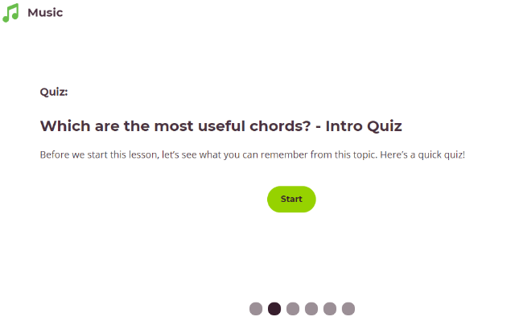
- Warm up by clapping the opposite of Miss Charatan!

Activate
- Recap primary chords I (1), IV (4) and V (5) in G Major. Chords G, C and D. Using a real, virtual instrument ( https://www.musicca.com/piano?) or if you don’t have access to these try on the blank keyboard.
STRETCH - What would these chords be in C Major? Can you transpose I, IV and V to C major?
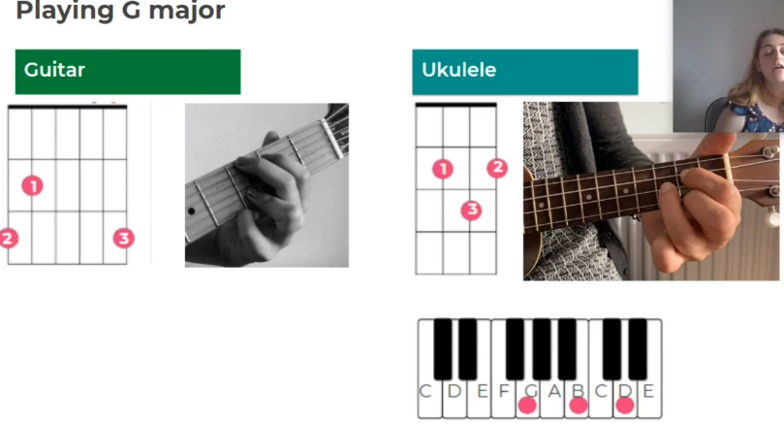
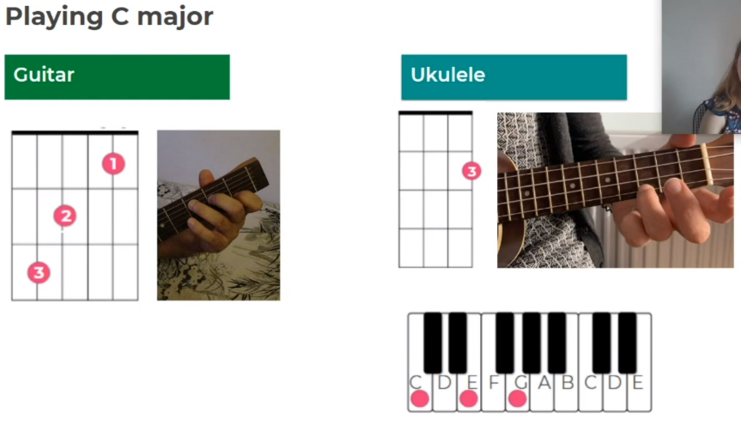

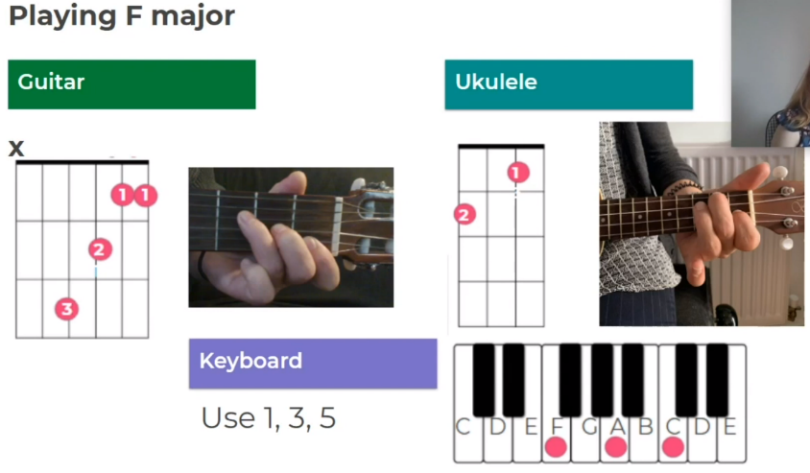

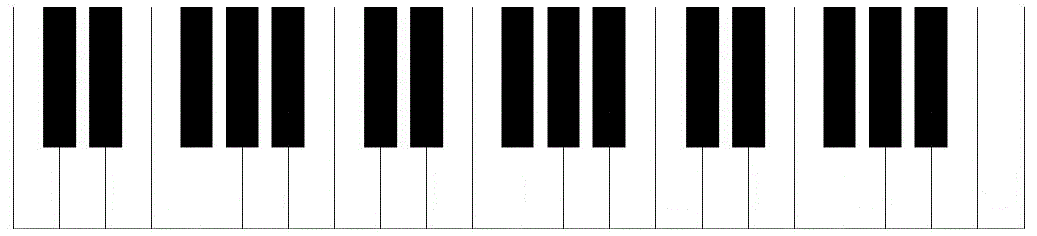
Demonstrate
Learning secondary chords in music
- Practise E minor and A minor on a real, virtual instrument or the keyboard below.
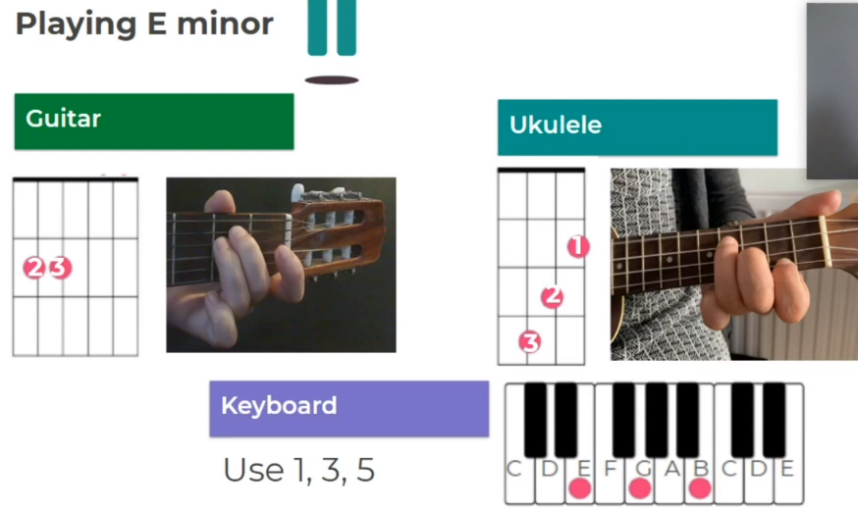

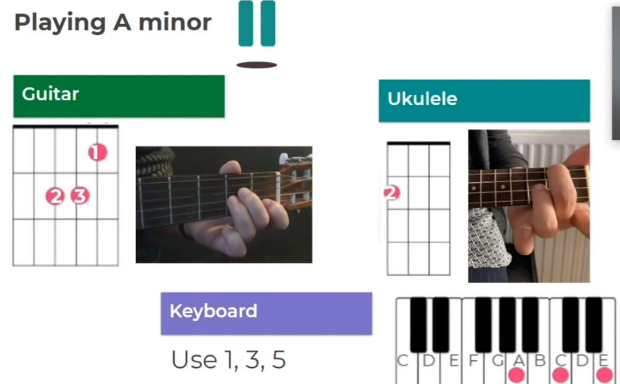

Consolidate
- Learn the pitches in D minor and practise on your instrument.
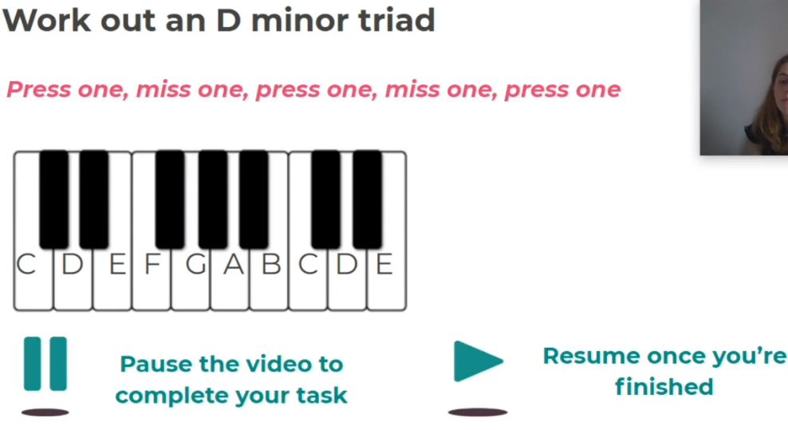

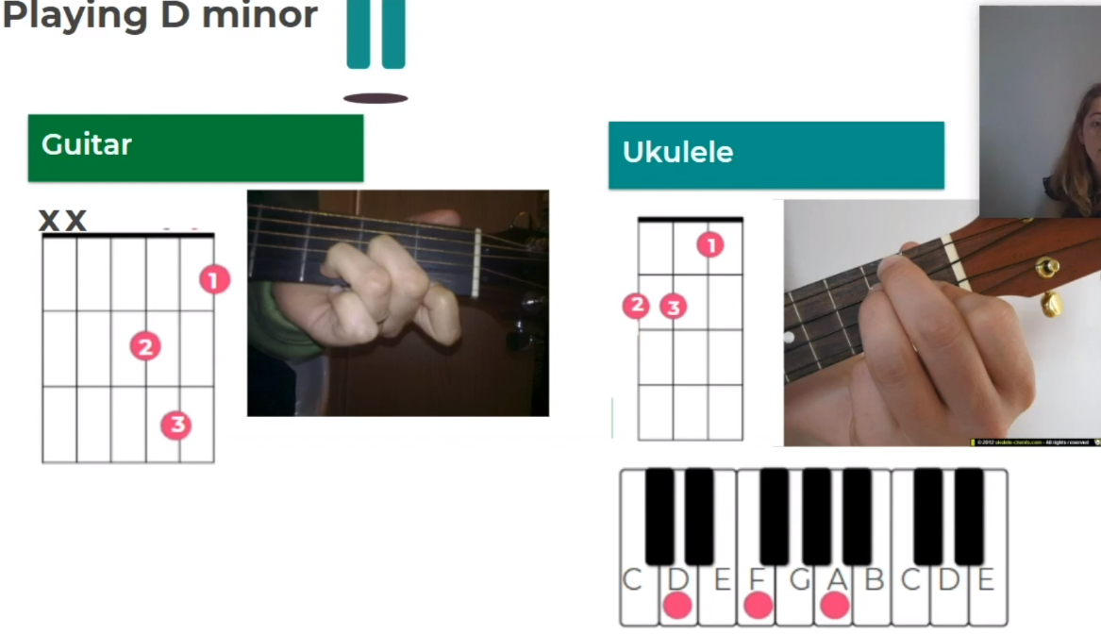

Lesson 2- Connect
Title- The role of Chords
LI- Learn how to compose a chord progression
Lesson structure
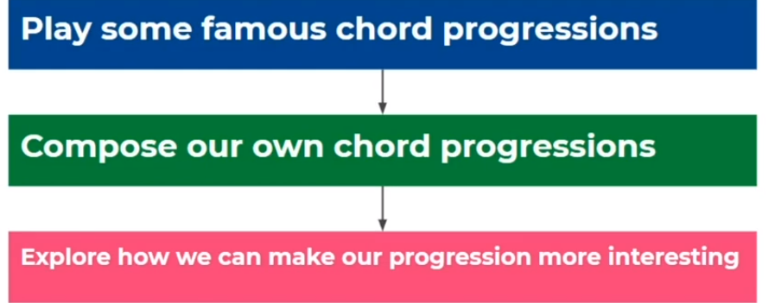
- Access the video/lesson 4 watch from 11 minutes 19 seconds until the end on the four-chord trick:
https://classroom.thenational.academy/lessons/how-can-secondary-chords-be-introduced-in-an-accompaniment-cgrk6r?step=2&activity=video

- Using the keywords below, answer the question, what is a chord progression?
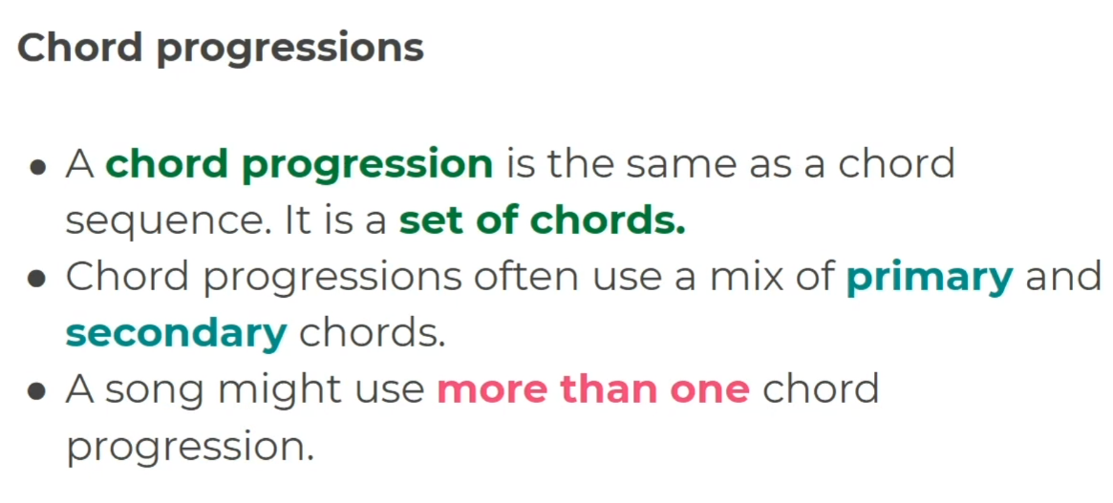

Keywords:
Set of chords
Primary
Secondary
More than one

Activate
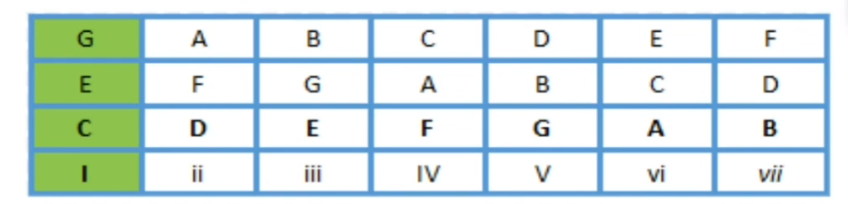
- Use the chord grid to work out the chord progressions underneath

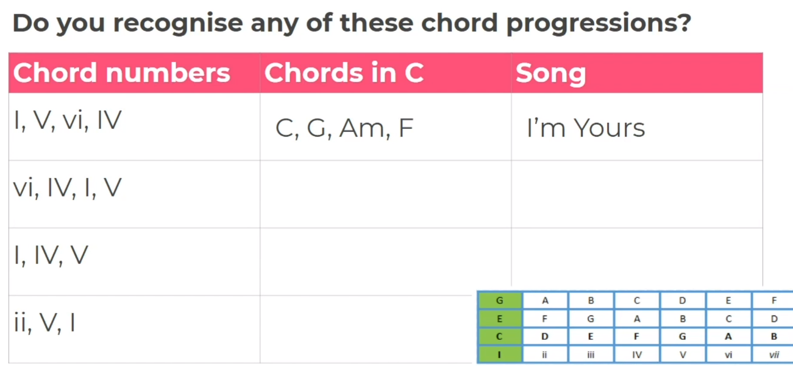

Demonstrate
- Create your own chord progression using the chord grid to help. C is a good place to start!
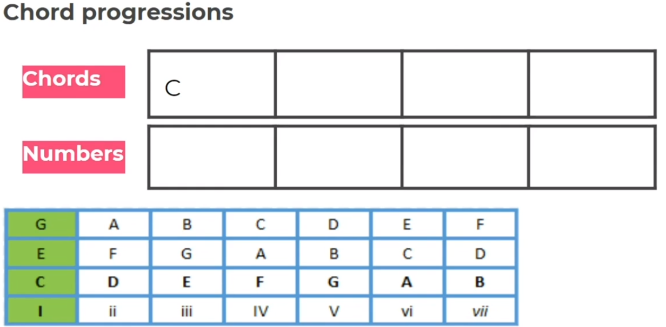

Here is an example if you get stuck:
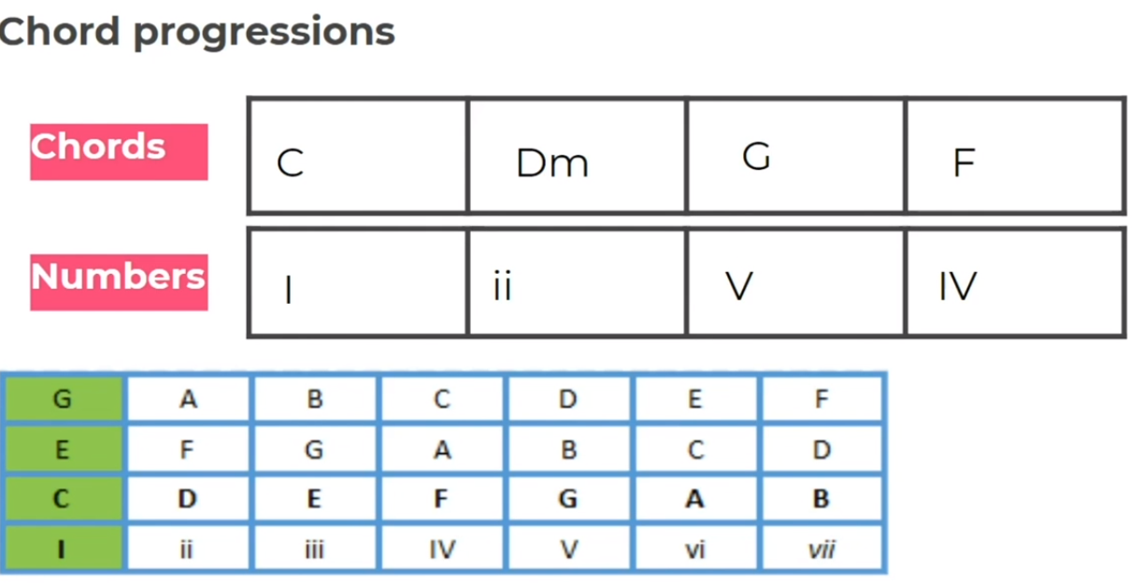

- Now practise playing your 4-bar progression!

Consolidate
How can we make the accompaniment more interesting?
- Write down three comments on how to adapt your chord progression to make it more interesting.

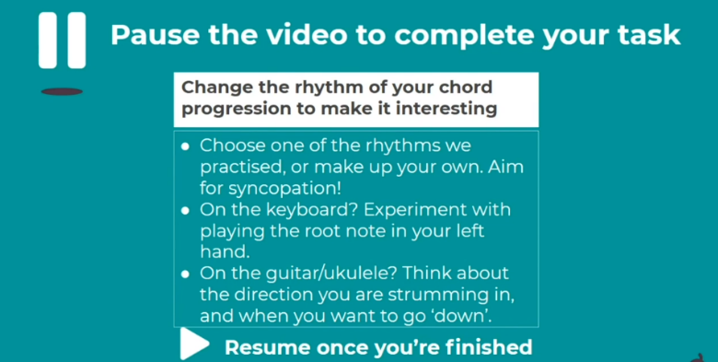
- STRETCH- Practise with your new adaptions!

1)

2)

3)
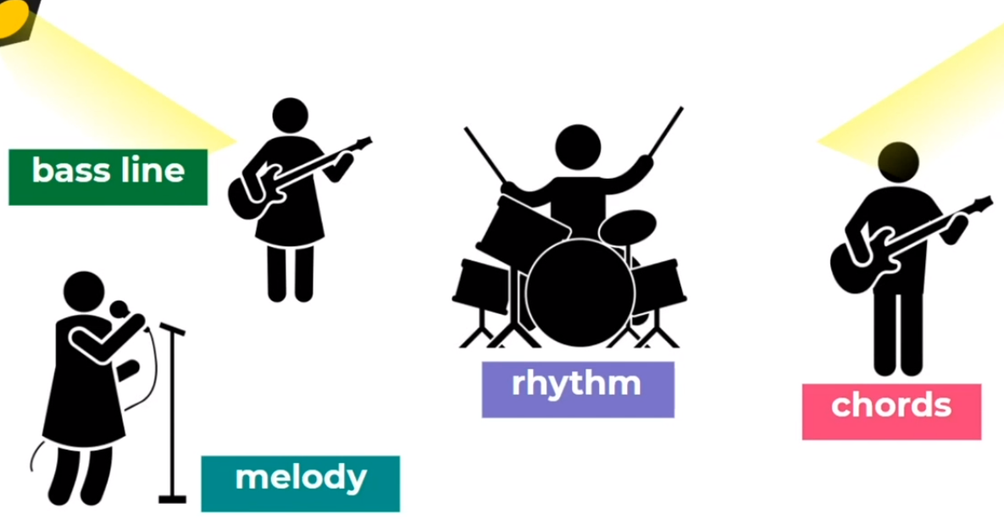

Lesson 3 - Connect
Title- The role of Chords
LI- How are pop songs constructed?
Lesson Structure:
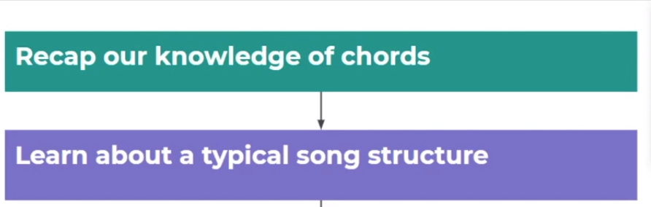
- Warm by clapping back with Miss Charatan

- Recap ALL the chords you have learnt so far!
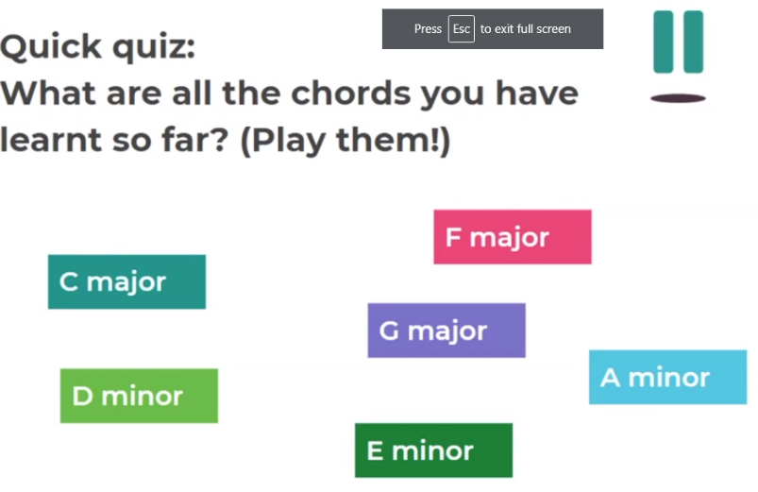

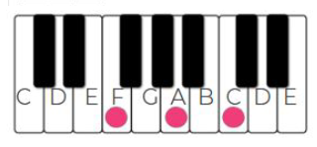
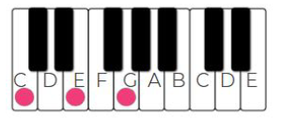
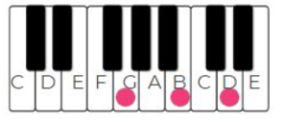
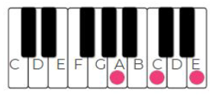
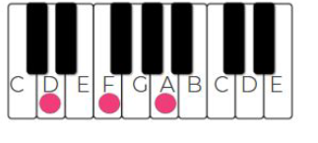

Activate
- Organise the chords on the right into primary and secondary triad boxes on the left.
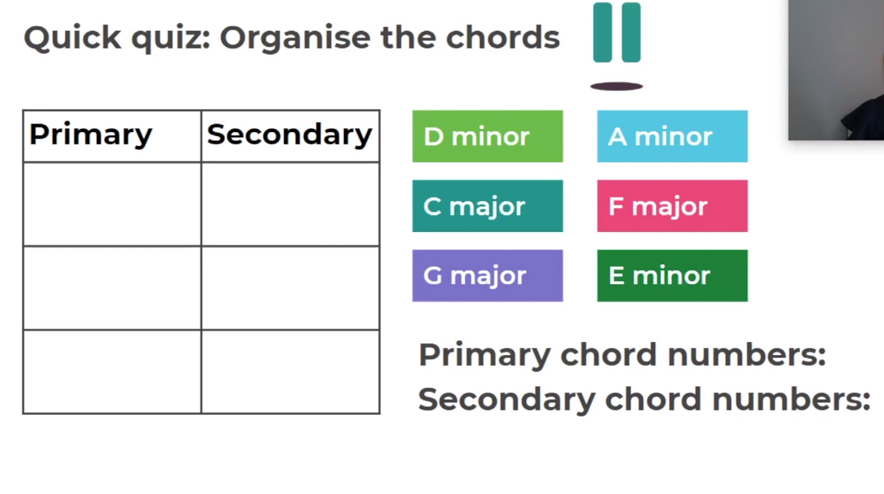
- Answer the questions on song structure below:
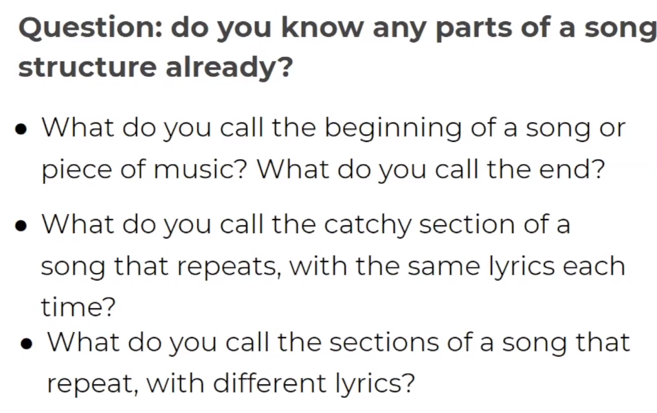

Key words:
Chorus
Intro/Outro
Verse

Demonstrate
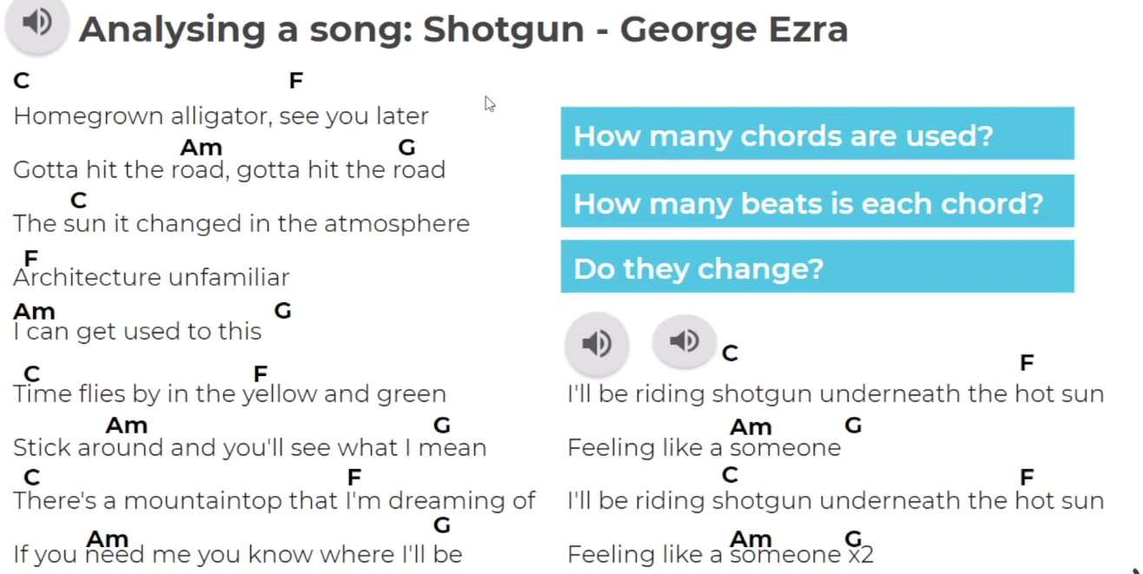
- Analyse Shotgun with Miss Charatan, answer the questions in the blue boxes.

- Where is the verse, chorus, and Intro in the song? Label them underneath:
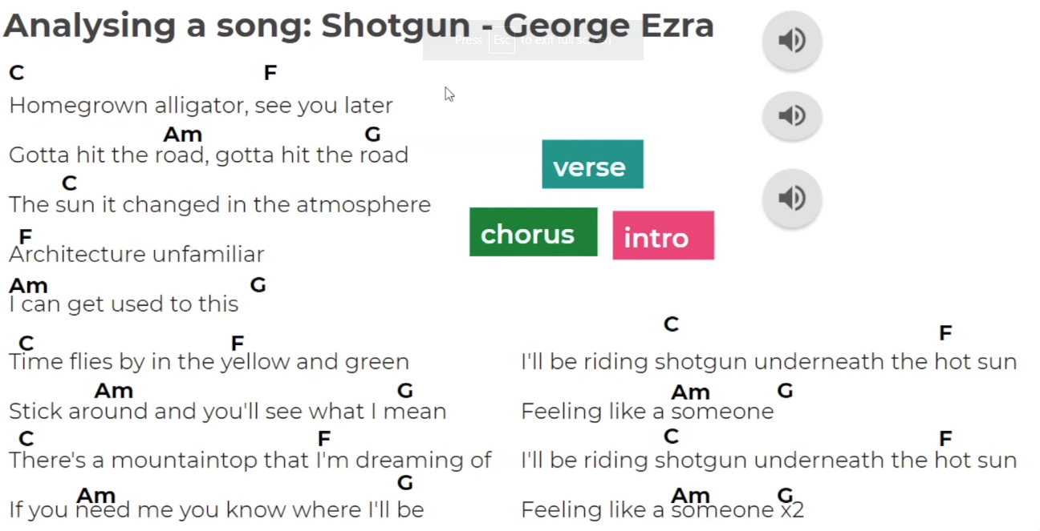

Consolidate

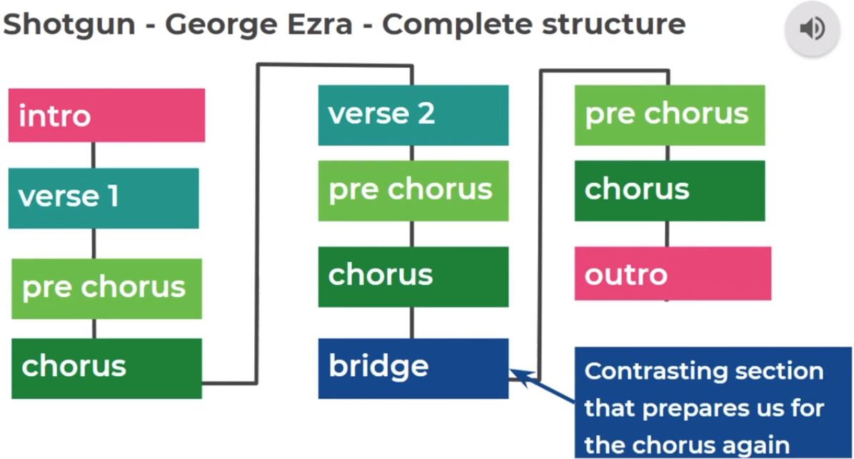
- Look at the structure for the song Shotgun

- How would you make the structure simpler, what parts could you take away?

Write your answers here:

Lesson 4 – Connect
Title- The Role of Chords
LI- Learn how to play a complete structure of a song

Lesson Structure:
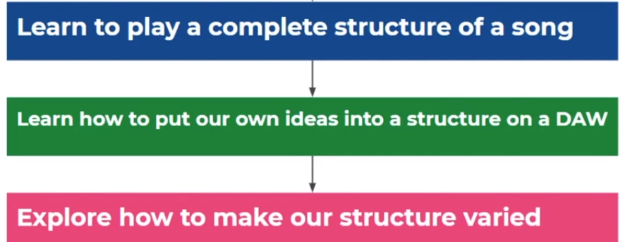

- Fill in the blanks underneath, using the words on the right
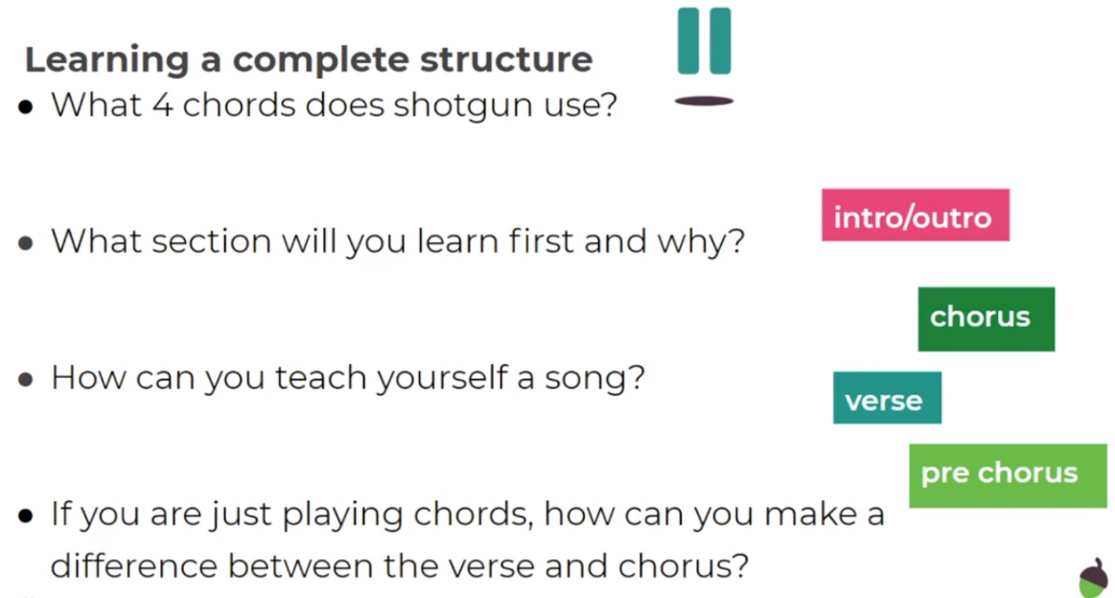

Activate
- Learn the complete structure to Shotgun, the chorus is repeated twice so is actually 16 bars.
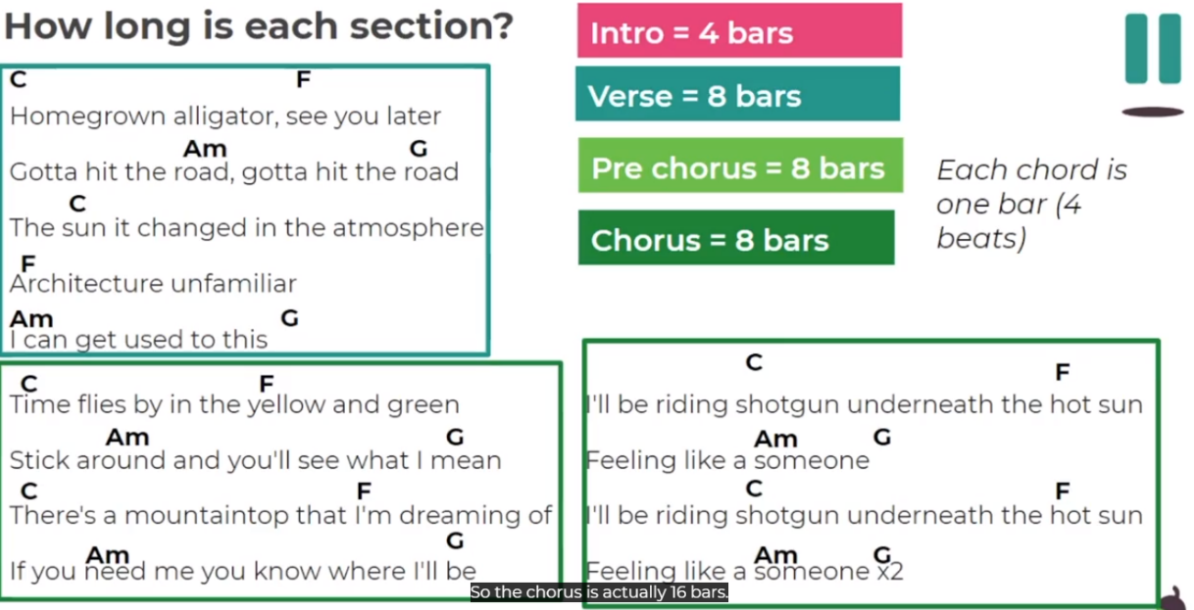

- If you have an instrument you can use or virtual one, practise the whole song now.
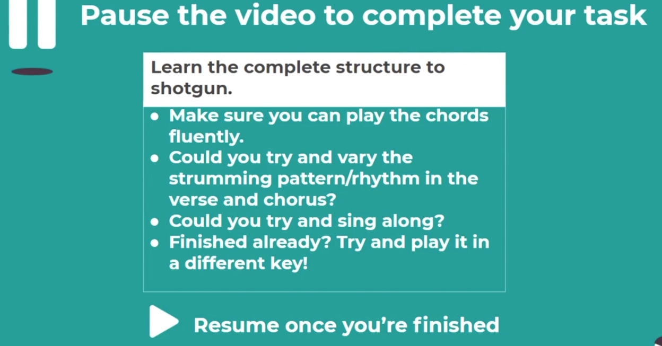

Demonstrate
- Using a free DAW (Digital Audio Workstation), create the introduction for Shotgun.
- STRETCH- create a whole song structure in the DAW, either Shotgun or your own.
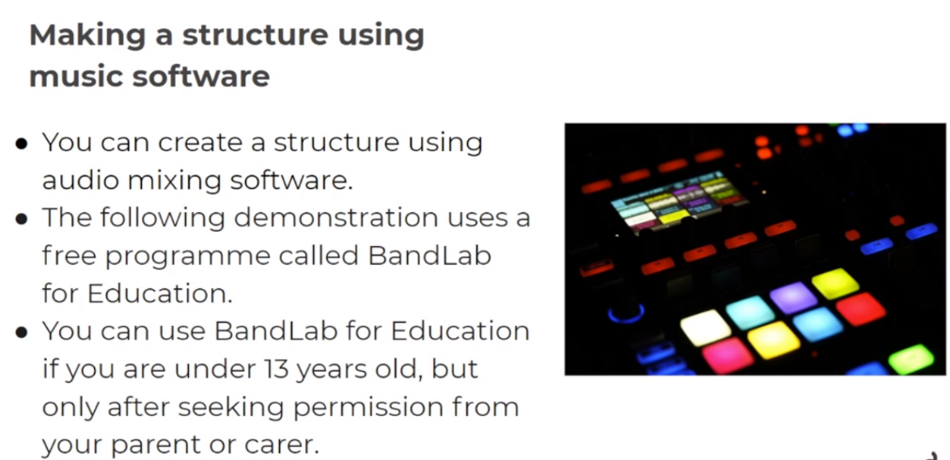

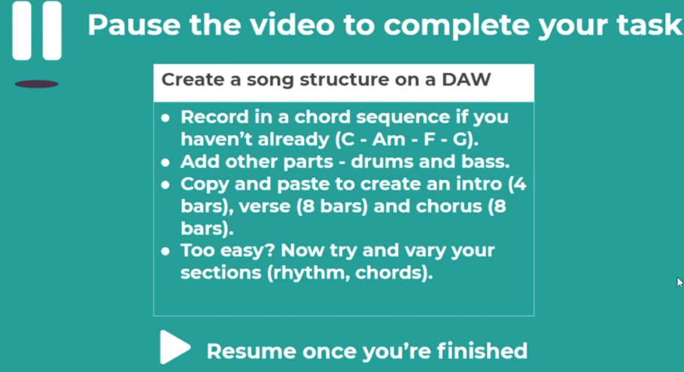

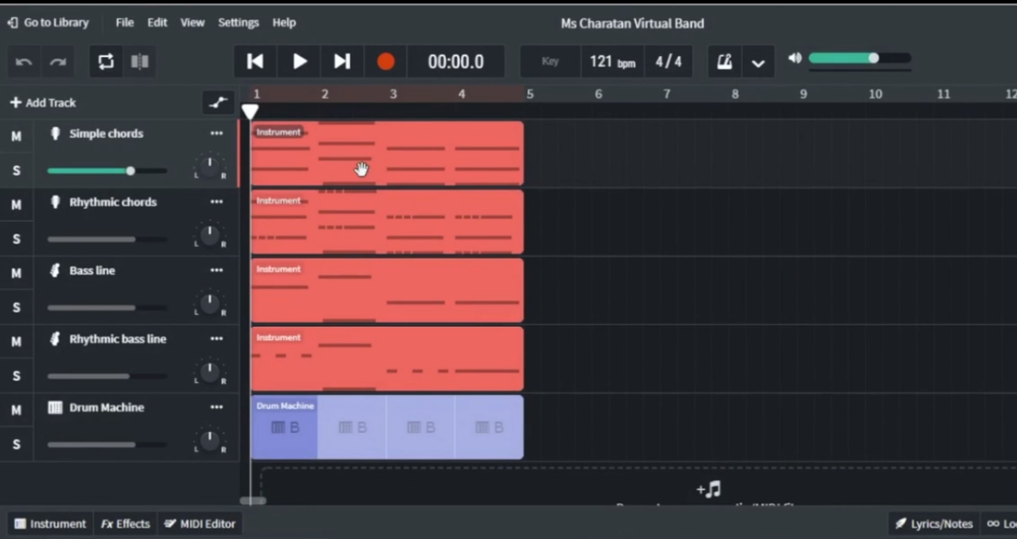
You will need to record chords, a bass line, and a drum pattern to start, which can then be copied and pasted for the rest of the song.

Consolidate
- Answer the questions below to consolidate.
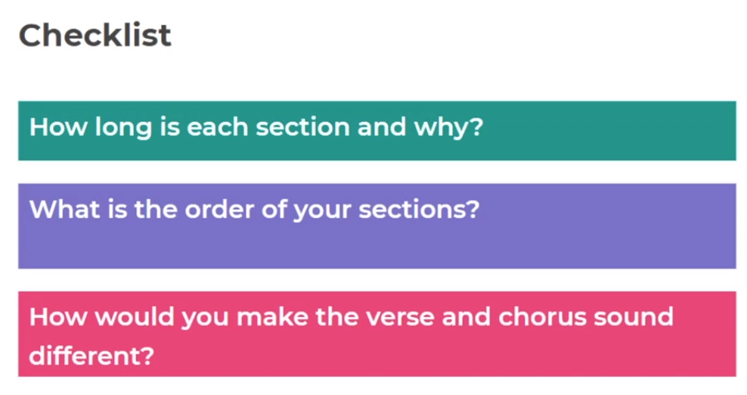
Answers:

- How would you create contrast between the verse and the chorus?

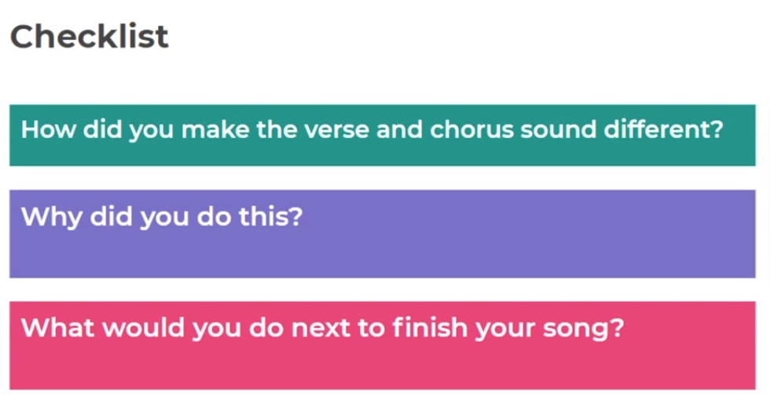

- STRETCH- Using the DAW create a contrasting verse and chorus.

Lesson 5 – Connect
Title – The Role of Chords
LI – Performing popular drum patterns
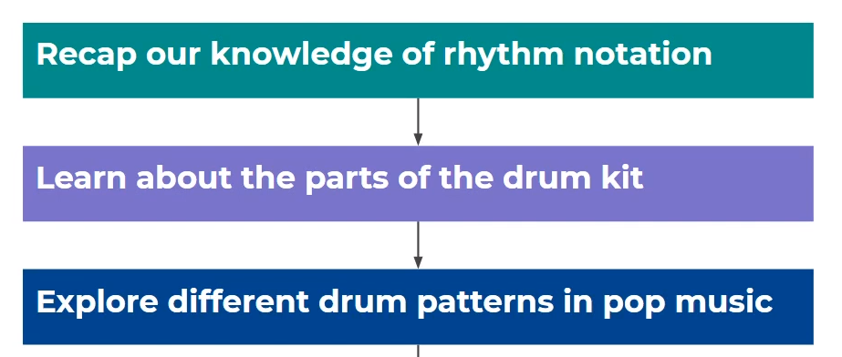
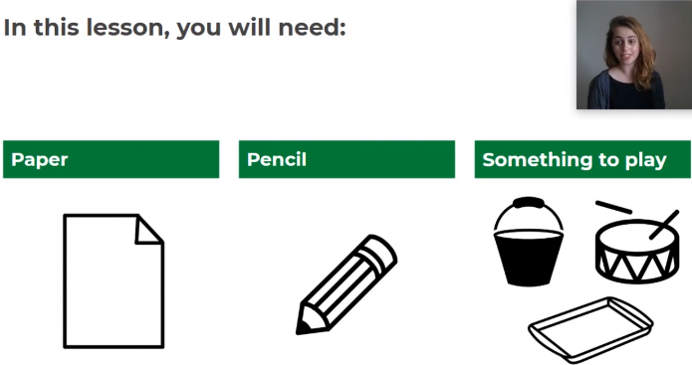
Lesson Structure:

- Warm up – work out these rhythms with Miss Charatan
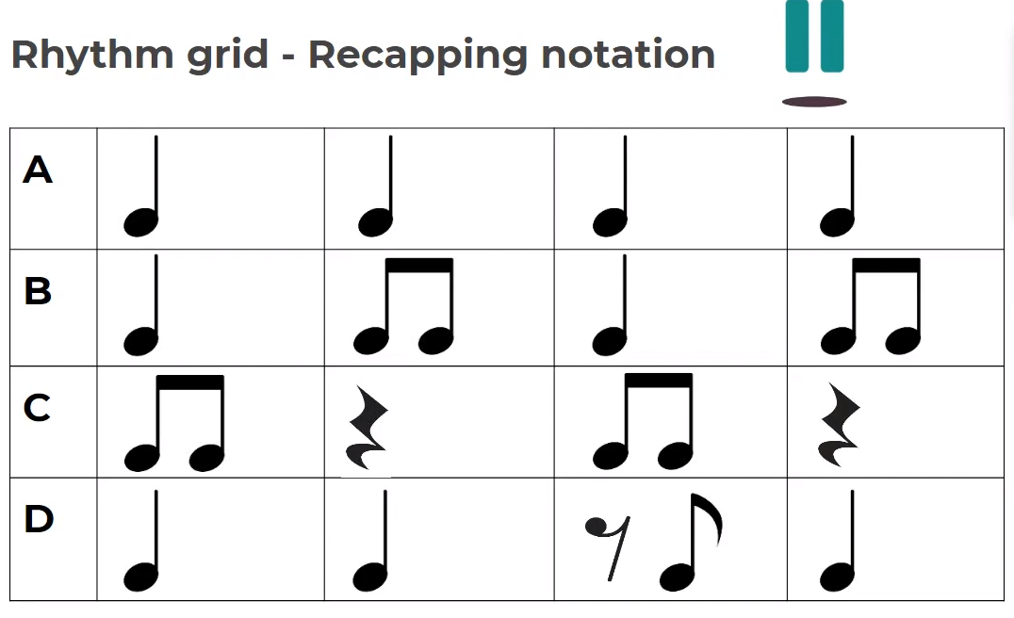

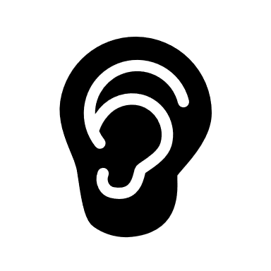
Activate
Listening task

- Listen to the track Miss Charatan plays and answer the question below:
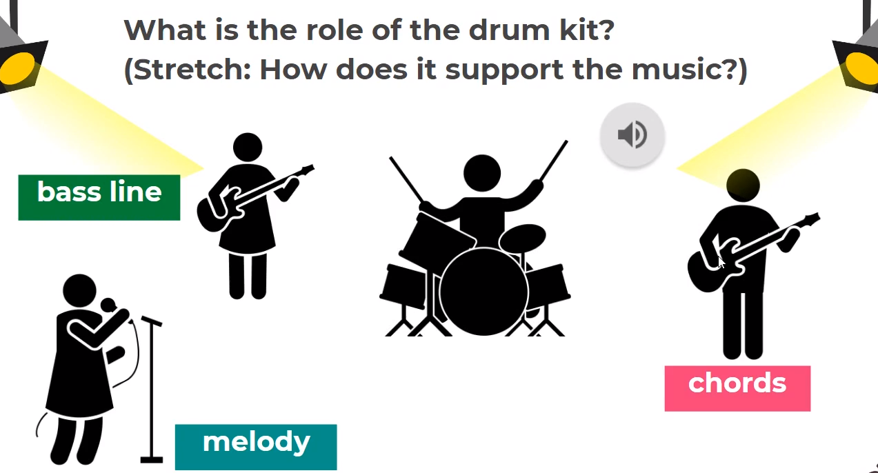

- Label the drum kit with three main sounds:
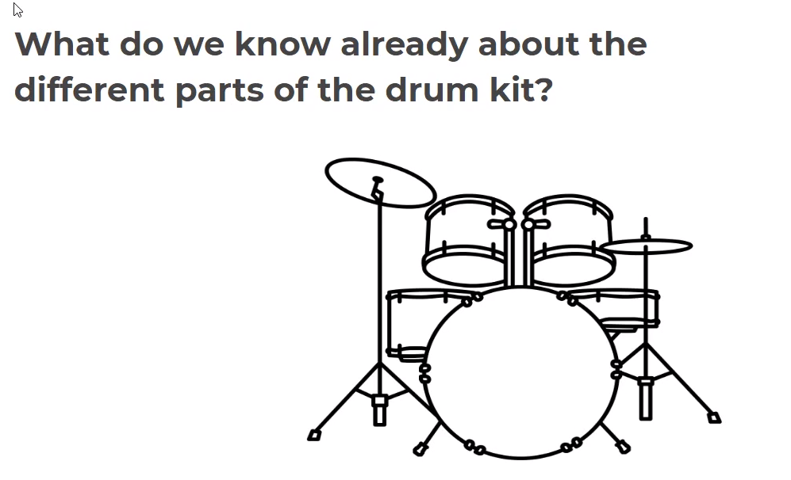
Key Words:
Hi-Hat cymbal
Snare Drum
Bass/ kick Drum
Demonstrate
- Please check with your parent/carer what you can borrow from the kitchen to create your own drum kit! If you can’t do this, try out your beat as body percussion!
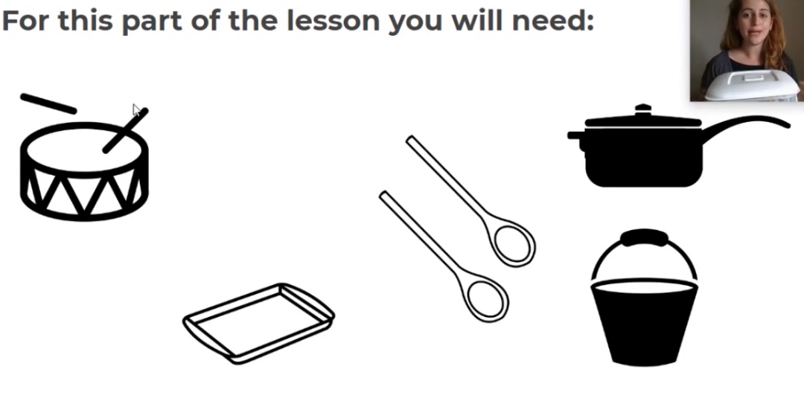

- Play a rock beat with Miss Charatan

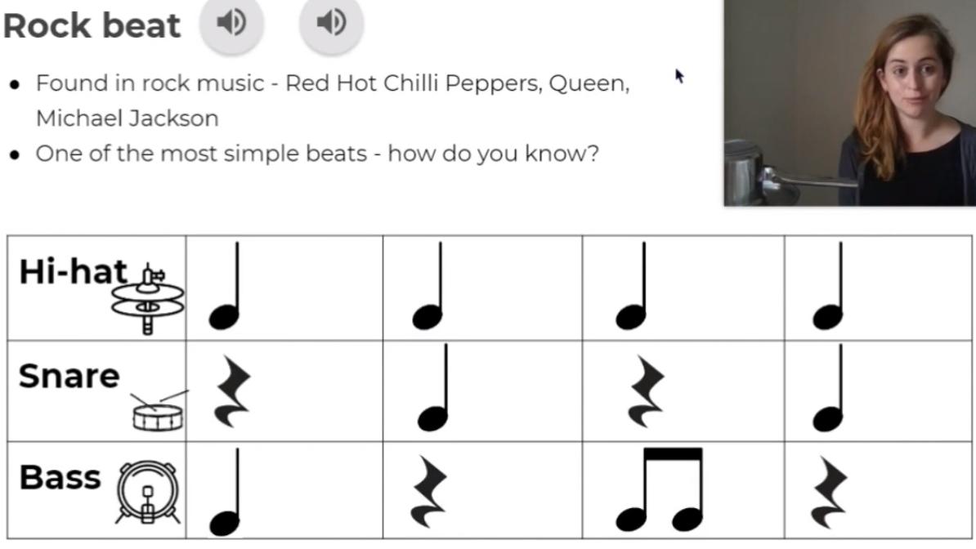

Consolidate

- Think about your performance when practising drumbeats and write a sentence each on:

- what went well….

- Even better if…….

Take the intro quiz and put your score here:

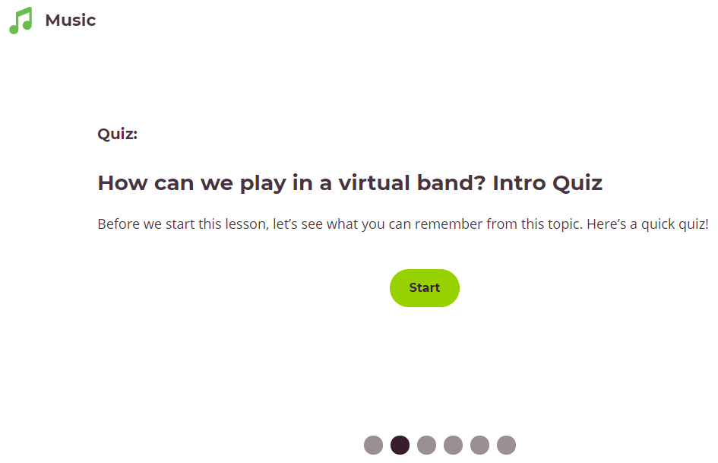



Congratulations you have completed your music Spring Term 2 booklet!

