English Year 7 Spring B
Food Glorious Food
Name:
Form:



Page | Lesson Number | Title
3 | N/A | Y7 Overview
4 | N/A | Knowledge Organiser
5 | 1 | Restaurant Review
7 | 2 | Ivy Grange Review
8 | 3 | Evaluating Reviews
9 | 4 | Comparing Reviews
10 | 5 | Descriptive Writing
11 | 6 | Review Writing
12 | 7 | Conventions of a Letter
13 | 8 | Letter Comparison
15 | 9 | Letter Writing
16 | 10 | Magazine Articles
17 | 11 | Article Writing
19 | 12 | Descriptive Writing
19 | 13 | Oliver Twist
20 | 14 | Expectations vs Reality
20 | 15 | Random Acts of Kindness
21 | 16 | Morality
22 | 17 | Oliver Twist and Wild Boy
23 | 18 | Reflecting on Oliver Twist
24 | N/A | SAL

Instructions
For each lesson:
- Write the title and L/I
- Read the stated chapters
- Answer the starter questions
- Complete the DART (challenge questions are in bold)
- Complete the DIP
- Answer the Key Questions

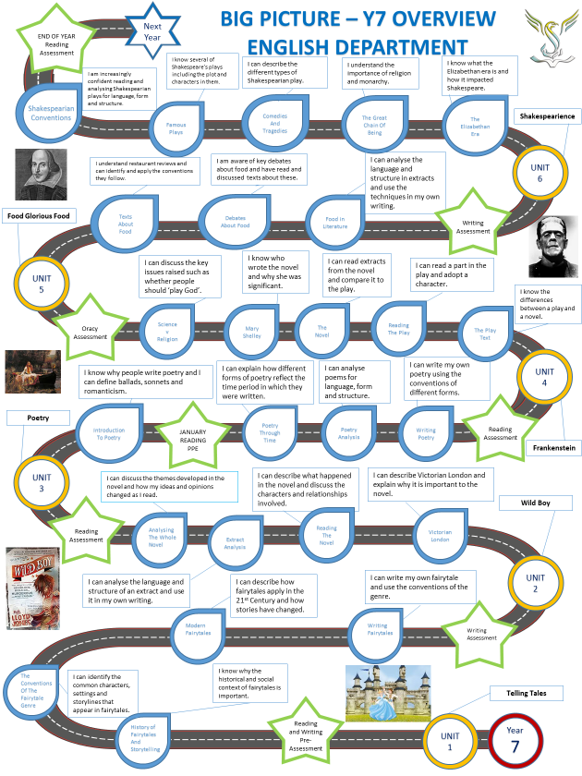

Food Glorious Food Knowledge Organiser
Purpose:
What is the purpose of your writing? Is it to…
- Persuade
- Argue
- Advise
- Inform
- Explain
Audience: who are you writing for? Is it…
        - Contemporaries
        - Children
        - Adults
        - Politicians
        - Experts

Form: what is the method for your communication? Is it…
        - An article
        - A letter
        - A speech
        - A review
        - An information guide
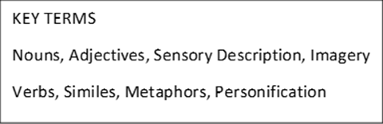
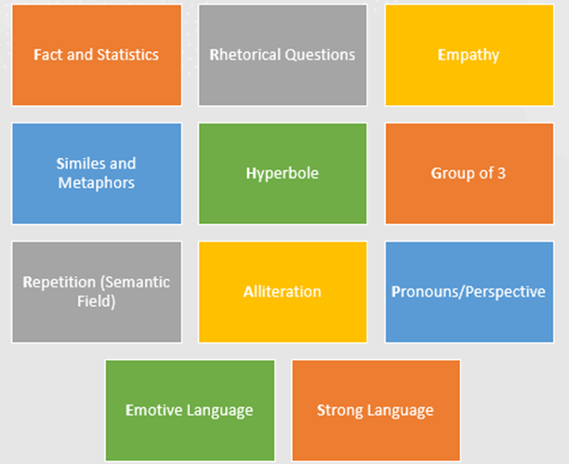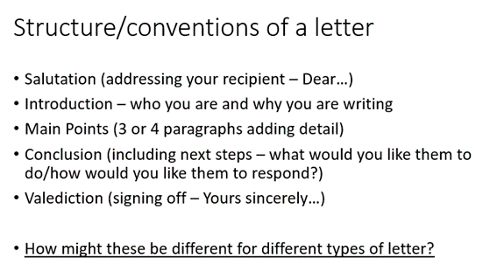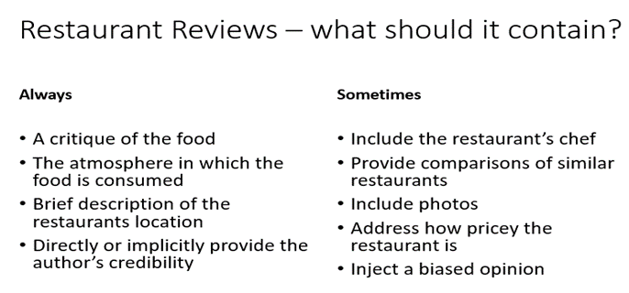
Articles
Introduction to hook the reader
Three main points
Conclusion summarising the overall message of the article

Lesson 1: Restaurant Review
LI: To know and understand the conventions of a review
KEY TERMS
PAF stands for Purpose, Audience, Form.

Purpose:
What is the purpose of your writing? Is it to…
- Persuade
- Argue
- Advise
- Inform
- Explain
Audience: who are you writing for? Is it…
        - Contemporaries
        - Children
        - Adults
        - Politicians
        - Experts

Form: what is the method for your communication? Is it…
        - An article
        - A letter
        - A speech
        - A review
        - An information guide

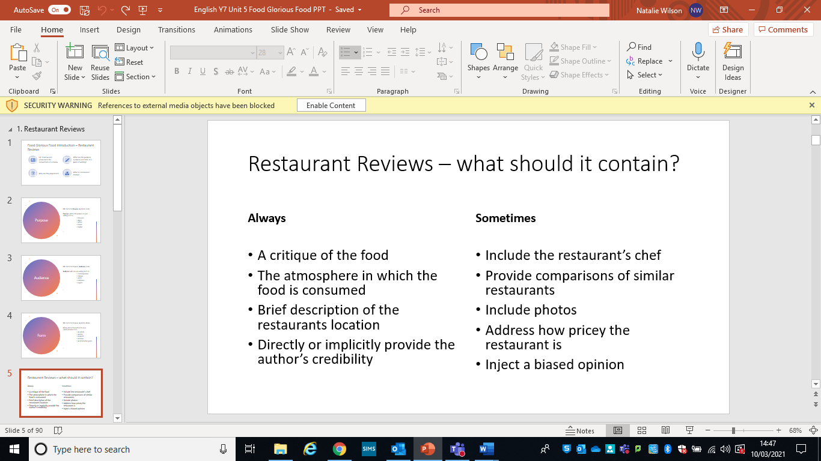

DART
Read the review and answer the following questions.
It was deadline day for our November edition. I was busy. I was stressed. I had a few thousand more words to write before the day was over and just wanted to get my head down and crack on.
However, thanks to a kind invite from Mike Goff (landlord of The Cat & Fiddle Inn on Sidmouth Road), I was due to meet my wife Jodie and my three kids Darcie, Noah and Safferty for a family restaurant review. It was such a kind offer from Mike that I decided to override my instinct to work and enjoy an hour out of my busy day to share a meal with my lovely family. It proved to be an oasis in an otherwise stressful day and a decision that I would not regret.
Upon arrival, we were given a friendly and warm welcome, shown to our reserved table and introduced to our waiter, a charming and hospitable Portuguese guy called Gui. Over the course of our lunch time, Gui was attentive, polite, engaging and managed to capture the attention and affection of my children, something that many other waiters and waitresses have tried and failed over the years. Bravo Gui. Bravo.
With kids colouring sheets, crayons and drinks delivered to our table quicker than you can say “Don’t worry darling, your Fruit Shoot will be here in a minute”, we settled in and started perusing the menu, noticing that it has been designed with both children and adults alike. The kids menu itself included a variety of tasty options for children of most culinary leanings and the adult menu was diverse, seasonal and well-priced.
In the end, we made our deliberations and opted for a Nachos Sharing Plate and Sweet Potato Fries for starters, both of which went down a treat and were polished off in no time at all.
Moving on from starters, I chose the Hunter’s Chicken (an Autumnal favourite of mine), Jodie went for Trio of Sausages with Mash and the kids opted for a Chicken & Bacon Burger, Gammon & Chips and Sausages with Beans respectively. All of our mains were generously portioned, well-executed and nicely presented. Particular stand-out elements were the nicely seasoned sausages and the Hunter’s Chicken.
The very fact that my youngest, a notoriously picky eater, partook in the starters and polished off her mains was a great complement to the chef. I think she also had a bit of a soft spot for Gui too, which probably helped (in that sort of 4-year old first crush kind of way).
Moving on to dessert (which we didn’t really have room for if I’m honest, but it felt rude not to), we ordered Waffles and Ice Cream for each of the kids and Jodie and I shared a slice of decadent Banoffee Fudge Cake.
With every course that passed, and with a lovely pint of Bath Ales Gem to accompany me along the way, the stress of the day started to slip away and I started to feel more like a balanced human again. There is a relaxed charm that the Cat & Fiddle has which seems to create a space for relaxation and taking a pause from the busyness of life. So much so, in fact, that I’ve highlighted their snug private meeting room as a future location for business meetings and interviews. Overall, the food was lovely, the dining environment pleasant and the service impeccable.
For those of you with families, I would highly recommend it as a dining destination where your children will be comfortable, relaxed and well looked after. As if the dining experience wasn’t well-suited enough to kids, there is both an indoor and outdoor play area and plenty of space for more fidgety children to stretch their legs.
As previously mentioned though, it would be a perfect venue for a team lunch, a business meeting or a small event too (as there are private spaces to hire within the cavernous pub).
So, why not head down to the Cat & Fiddle on Sidmouth Road, just a stone’s throw from the outskirts of Exeter, to sample some solid pub grub, a great range of alcoholic and non-alcoholic drinks and a healthy serving of good old-fashioned British customer service.
- Identify conventions of a review in the text.
- Did the writer enjoy their meal?

DIP
Write your own review. Use the questions below to help you.
- Why did you choose to eat there?
- Who did you eat with?
- How would you describe the setting/atmosphere?
- Did you receive a warm welcome?
- What did you eat?
- Did you and the others in your party enjoy your food?
- Was there anything particularly positive or negative about the experience?
- Would you recommend?

Key Questions
- What is a restaurant review?
- What are purpose, audience and form and why are they important?

Lesson 2: Ivy Grange Review
LI: To explain, comment on and analyse how writers use language and/or structure to achieve effects and influence readers
KEY TERMS
- Hyperbole – exaggeration
- Metaphor – a comparison stating something is something else
- Simile – a comparison stating something is like something else
- Rhetorical question – a question that does not need an answer
- Imagery – visually descriptive language
DART
Read the review and complete the table.
Ivy Grange
The chef may have been able to stand the heat in the kitchen. Unfortunately, the meal I ate at the Ivy Grange restaurant this week could not. Hard to believe, isn’t it, that a five star restaurant didn’t have the facilities to keep this particular sweet together?

Ivy Grange has lost its bounce. On this midweek outing a handful of well-off people munched their way through dishes ordered from a dull and everyday menu. The dead carnations on the table and the stains on the wallpaper didn’t help.

As a starter, an individual quiche of salmon and leeks (£3.50) was a successful (though hardly original) combination. The menu was unclear on whether it should have been served hot or cold, and in fact it was neither. It was lukewarm.

My main course, was fish which tasted (or rather didn’t) as if it had just emerged from the freezer after serving a life sentence. It was water-logged and salty, with the accompanying mushrooms about as wild as the OAP diners at the next table.
My dessert was also something of a failure. Our waiter (who looked exhausted and was extremely rude) took fifteen minutes to bring out my chocolate truffle ice-cream, by which time it had melted into soup.

At around £70 for two this meal was a disaster. Unless you are hoping for a divorce, don’t take your beloved to the Ivy Grange this Christmas.

STAR RATING (out of five):

Food **
Value *
Service **
Atmosphere *

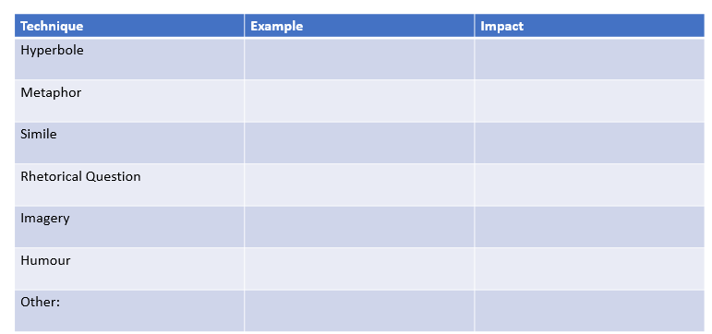

Context

DIP
Answer the question below using the sentence starters provided.

Q: How does the writer use language and structure to communicate their point of view?

- The writer uses…to show that… For example… This reveals… This suggests to the reader…
- A second technique the writer uses to show…is… For example… This highlights… The reader can infer that…
- A structural technique the writer uses to communicate…is… For example… This emphasises… This reinforces to the reader that…
Key Questions
- What did the writer think of Ivy Grange?
- How were language and structure used to communicate this opinion?

Lesson 3: Evaluating Reviews
LI: To explain how well a writer has achieved an effect
KEY TERMS
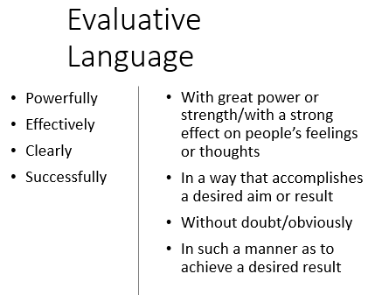
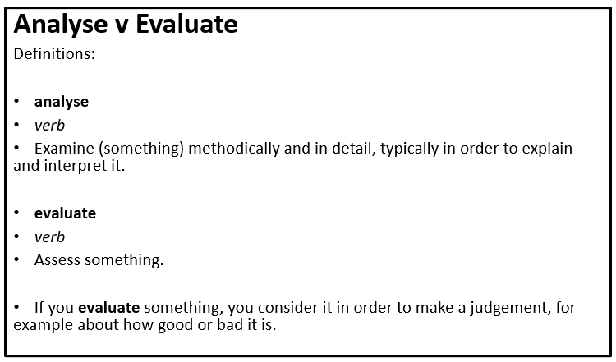

DART
Re-read the Ivy Grange review and identify an example that shows:
- The setting of the restaurant
- What happened on the visit to the restaurant
- How the writer feels about the restaurant

How do these examples seek to show whether the writer enjoyed/didn’t enjoy the visit to the restaurant? ________________________________________________________________________
DIP
Explore how successfully the writer shows he enjoyed/did not enjoy visiting the restaurant.
Include examples from the text so support your answer.
Consider:
- Things that happen in the extract
- Who is in the extract
- Where does the extract take place
- What is said in the extract

Self Evaluation
- Where have you used evaluative language in your answer?
- Have you clearly explained whether the writer has achieved the intended impact ?

Key Questions
- How does the writer describe his visit to the restaurant?
- What is evaluative language?

Lesson 4: Comparing Reviews

LI: To identify similarities and differences across two different texts
KEY TERMS
- Comparison – a consideration or estimate of the similarities or dissimilarities between two things or people
- Similarity – the fact that people or things look or are the same
- Difference - the way in which two or more things which you are comparing are not the same

DART
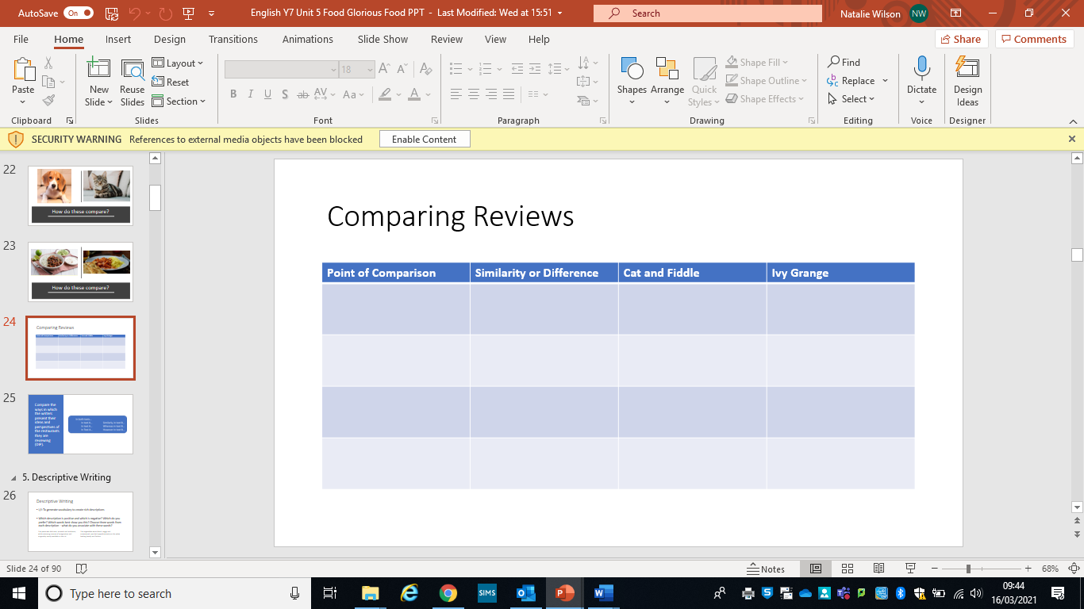
Re-read the two reviews and complete the table below:

DIP
Using the writing frame below, compare the ways in which the writers present their ideas and perspectives of the restaurants they are reviewing.
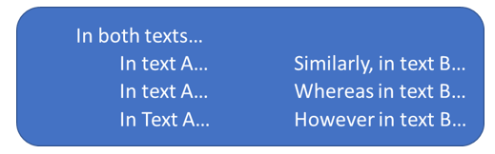

Key Questions
- What is similar and different about the two reviews?
- What is comparison and why is it useful?

Lesson 5: Descriptive Writing

LI: To generate vocabulary to create rich descriptions

DART
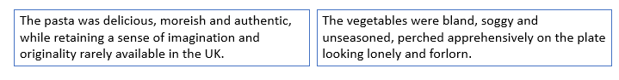
Read the two descriptions and answer the questions below.

- Which description is positive and which is negative?
- Which do you prefer?
- Which words best show you this?
- Choose three words from each description – what do you associate with these words?

DIP
Write a detailed description of one or more of the following images.
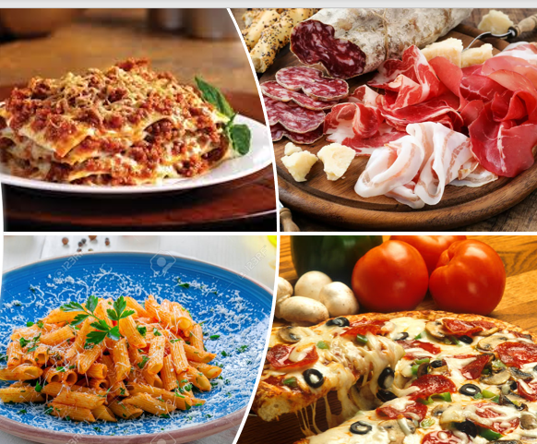
How many of the following can you include?
- Nouns
- Adjectives
- Sensory Description
- Colours
- Verbs
- Similes
- Metaphors
- Personification

Key Questions
- What is the focus of your description?
- Why is word choice important?

Lesson 6: Review Writing

LI: To write a review of a meal/restaurant
DART
Considering everything you have read or written so far this half-term identify five words to describe:
- Food
- A restaurant’s setting
- The service in a restaurant
- The cost/value for money of a restaurant

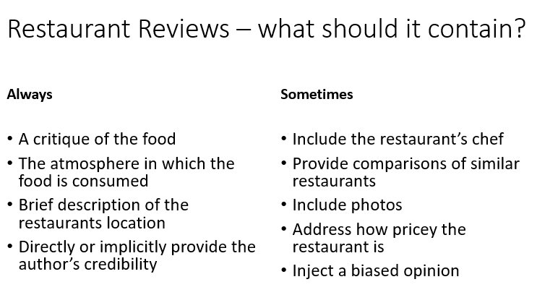
DIP

Write a review of a meal in a restaurant or at home.

Consider:
- Why did you choose to eat there?
- Who did you eat with?
- How would you describe the setting/atmosphere?
- Did you receive a warm welcome?
- What did you eat?
- Did you and the others in your party enjoy your food?
- Was there anything particularly positive or negative about the experience?
- Would you recommend?

Key Questions
- What opinions do you have about the meal you are reviewing?
- What are the conventions of a review?

Lesson 7: Conventions of a Letter

LI: To know, understand and evaluate the conventions of a letter
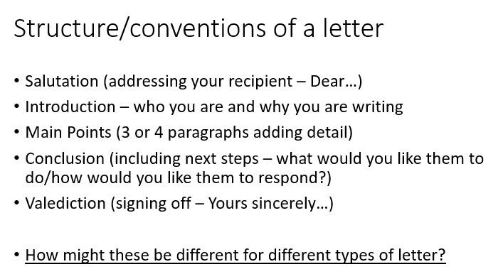

DART
Read the letter and answer the questions.
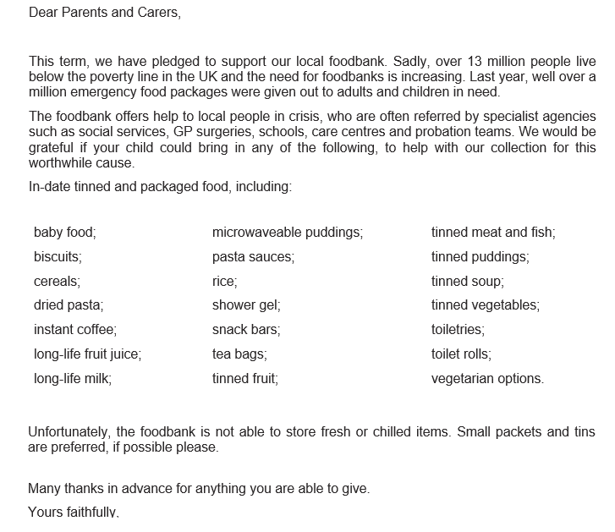

- What is the PAF of this letter?
- There are five paragraphs in the letter – what is the purpose of each paragraph? | 1.  2.  3.  4.  5.
- Can you identify any techniques used in the letter?
- What information is explicit within the letter?
- What information is implicit within the letter?

DIP
Q: How successfully does the letter achieve its aim?
Consider:
- Purpose, audience and form
- How the writer seeks to communicate their point
- What is it about?
- How does it engage the reader?
- Is there anything surprising or shocking in the letter?
- What other techniques are used?
Key Questions
- What is the purpose of the letter?
- What is evaluation?

Lesson 8: Letter Comparison
LI: To identify similarities and differences across two texts
DART
Read the letter and answer the questions.
Dear Food,
I can’t remember when we met, but it feels like you’ve always been a part of my life. I have very few memories of you from when I was young… I remember carrying cloves of garlic around in my pocket, microwaving eggs as an “experiment”, or getting my hair caught in the blender. But mostly you were just there, silently, without demands, taking care of me.
I feel like we first discovered each other when I moved to New York at 16. Suddenly I found myself practically unsupervised. I was free to indulge in milkshakes the size of my head or to sit down to a dinner of a dozen warm and gooey Krispy Kremes. Our tryst was cheap, tawdry, indulgent, and reckless … I was only interested in the worst of what you had to offer.
A brief post-college trip to Europe made me think we could have more. Fresh and crispy baguettes sprinkled with thinly cut, but richly salty meats, gooey cheeses and light but flavourful butter… Or a cup of coffee with that sweet French milk… You clearly had complexities and delicacies I had never even dreamed of. But I guess I wasn’t ready for that.
I started college and turned my back on you and all the other things I scornfully thought of as plebeian. I was a scholar now, I knew it all. Though even as I scorned you, I still turned to you in times of stress, took comfort from your fat and salt and sugar. But I never entertained the possibility that you might have more to offer, more to teach me.
Then came the rough after-college years. I worked one of those soul-crushing 9-5s. I spent hours on the crowded subway, stuffed into someone else’s sweaty armpit. In those moments when I wished I was anywhere-but-here, I found myself thinking of you, mentally planning menus or jumping off the subway to stroll through the Upper East Side groceries stores like they were museums.
I started to cook my way through our family cookbook on Sundays, our time together becoming a balm to combat the drudgery of my working week. I grew to know more about you, to be playful, experimental. After moving out of the city and planting my own garden, I gained a deep respect for you and the complex relationship between the labours and pleasures of eating.
Our relationship grew to fill my evenings and my weekends. I’d even nip off in the middle of a summer work day to pick berries, covering my fingers in the deep purple juice of wild blackberries. You were how I cared for sad friends, or introduced myself to new neighbours. You were how I celebrated and how I gathered my community.
But for some reason, your importance to me had still not sunk in. I felt like I needed to leave the kitchen and the garden, and grow up. If I wanted to build the communities I wanted to see in the world, I had to give you up, move to cities, read papers, study hard. How could I be a grown woman and affect change in the world if I was wearing a flour-dusted apron over dirt-stained knees? Who would take me seriously?
Luckily, you knew better. You waited patiently for me to find you down every road of inquiry. And I’m slowly coming to realize that you can be my answer… How I build my communities, how I connect people from different social groups or diminish my family’s fossil fuel use. You can be how I fight for equity and labour rights, how I explore history and culture. You can be my inspiration for invention and you can still be how I take care of the people I love.
Thank you for your patience, for waiting for me to figure out everything we can be together. For waiting patiently while I got over myself, my assumptions, expectations and prejudices.
I can’t wait to grow old together. Love, Me.
- What are the purpose, audience and form of this letter?
- How does the writer use food to reflect on their life? Identify five examples of the writer doing this.

DIP
Use the writing frame to compare the ways in which the writers present their ideas and perspectives in the letters about food.

Key Questions
- What are the similarities and differences between the two letters?
- What is comparison and why is it useful?

Lesson 9: Letter Writing
LI: To apply the conventions of a letter
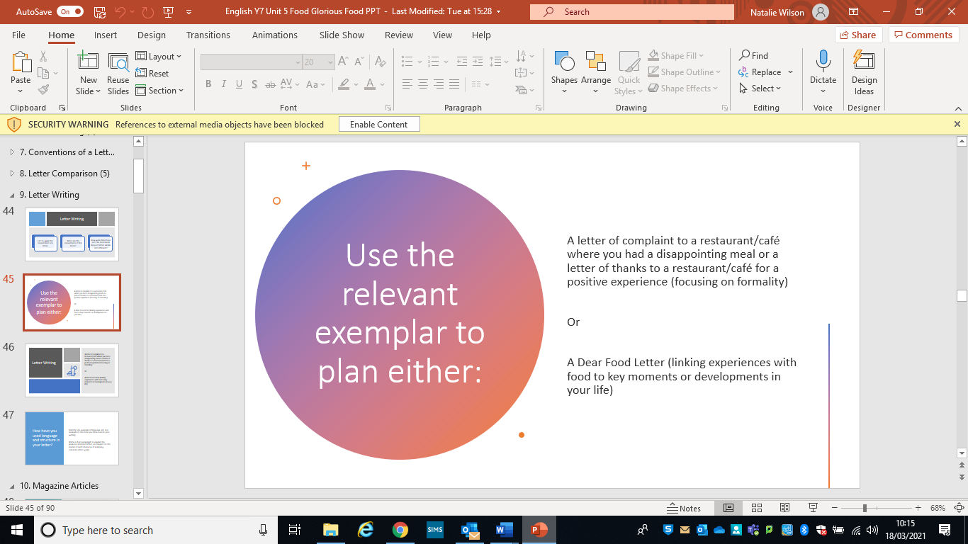

DART
Re-read the letter from previous lesson related to the chosen task.
DIP
Plan and write your letter.
Consider:
- Language and structure
- Your purpose and intended effect on the reader
Key Questions
- What is the difference between a formal and an informal letter?
- How does the writer use language and structure to show this to the reader?

Lesson 10: Magazine Articles
LI: To know and understand the conventions of a magazine article
KEY TERMS

Word play/puns
Alliteration
Personification
Direct address
Listing
Triplets
Rhetorical questions
Juxtaposition

DART
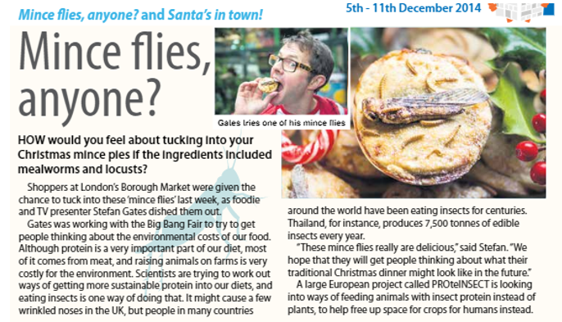
Read the two articles and answer the questions:

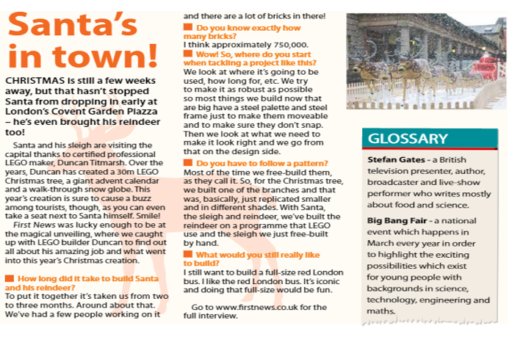

- What are the purpose, audience and form for each?
- What are the key points they make?
- What can we learn about the conventions of a magazine article?

DIP
Complete the table and answer the question.
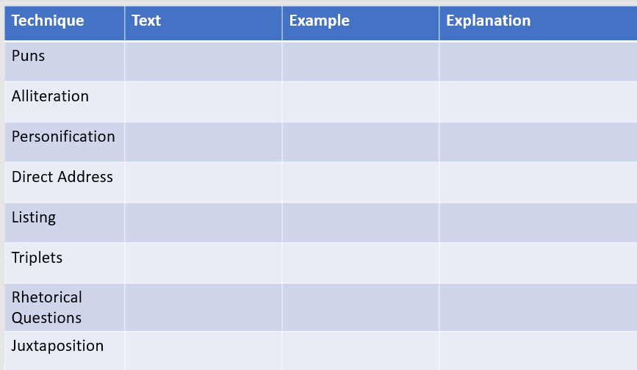

Q: How do the magazine articles use language and structure to interest and engage their readers?
- Choose four examples from your notes (combination of language and structure)
- Use examples from both articles

Key Questions
- How does the writer use language and structure to communicate their key points?
- What are the conventions of a magazine article?

Lesson 11: Article Writing
LI: To write a magazine article
Conventions of a Magazine Article
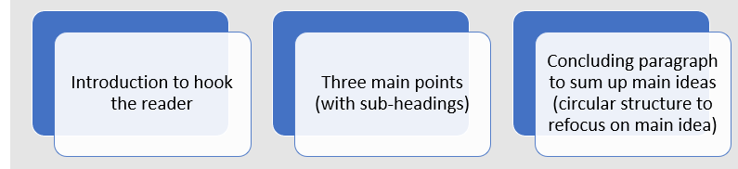

DART
Choose an article from the previous lesson. Magpie the structure to plan an article for the school magazine about how the school and pupils can tackle food waste.
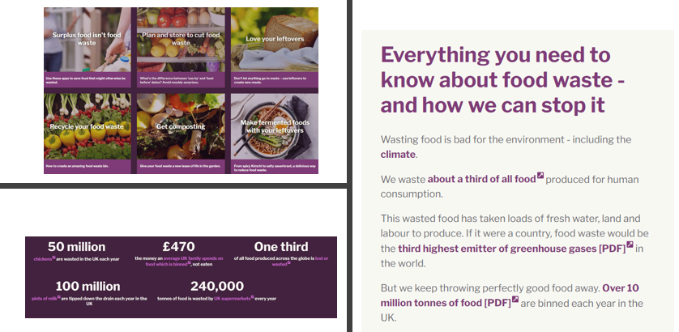
DIP

Write an article for the school magazine about how the school and pupils can tackle food waste.
Try to use the following techniques in your writing:
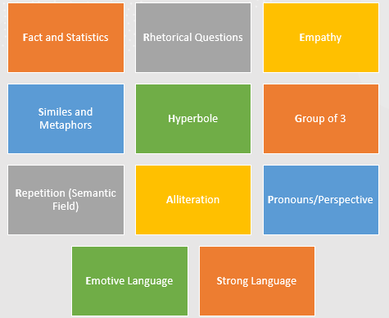

Key Questions
- How can the structure of an article you have read be used to plan your own work?
- What are the conventions of a magazine article?

Lesson 12: Descriptive Writing
LI: To identify similarities and differences across two texts and reflect them in my own writing
KEY TERMS

- Nouns
- Adjectives
- Sensory Description
- Imagery
- Verbs
- Similes
- Metaphors
- Personification

DART
Watch the clips from Oliver Twist and Harry Potter and answer the questions:
Oliver Twist: https://www.youtube.com/watch?v=NHRwmfSfl7A
Harry Potter: https://www.youtube.com/watch?v=HjUq1HSbfRU
- How is food presented?
- What nouns, adjectives and verbs could be used to describe these clips?
- Is food a necessity or a luxury in these clips?
- How do we know?
DIP
Write a 100 word description of each clip.
Focus on reflecting the differences between the clips that have been identified.
Key Questions
- How is food presented differently in the two clips?
- Why is word choice important?

Lesson 13: Oliver Twist
LI: To introduce the plot, setting and characters of the novel
DART
Read chapters 1-3 of ‘Oliver Twist’ and answer the questions:
- What happens in the opening to the novel?
- What characters do we meet?
- How does it remind you of anything you have read before?
- Identify five key events that take place in the first three chapters of the novel. | 1.  2.  3.  4.  5

DIP:
Write from the perspective of Oliver.
Consider:
- Why does he make the decision to leave the workhouse?
- Include as many details from the novel as possible

Key Questions
- What happens at the start of the novel?
- Why is perspective important in writing?

Lesson 14: Expectations vs Reality
LI: To respond to a text through creative writing
DART
Read chapters 4-6 of ‘Oliver Twist’ and answer the questions:
- What was Oliver expecting?
- How did things work out for him in comparison to this?

DIP
Write about a time something did not work out as planned.
Your response can be real or imagined and can be based on the novel or your own experiences.
Key Questions
- What was the difference between Oliver’s hopes and expectations and the reality of what happened?
- Why is it useful to use what you have read in your own writing?

Lesson 15: Random Acts of Kindness
LI: To respond to a text through creative writing
DART
Read chapters 7-9 of ‘Oliver Twist’ and answer the questions:
- Who tries to help Oliver?
- Why do they do this?
- How does this help his situation?

DIP
Write about the nicest thing anybody has ever done for you.
Your responses can be real or imagined and can be based on the novel or your own experiences.
Key Questions
- Who helps Oliver with the predicament he is facing?
- What motivates human behaviour?

Lesson 16: Morality
LI: To respond to a text through creative writing
Key Terms
- Morality - principles concerning the distinction between right and wrong or good and bad behaviour
- Moral - what societies sanction as right and acceptable
- Immoral - not conforming to accepted standards of morality
- Amoral - unconcerned with the rightness or wrongness of something
- Moral dilemma - a situation in which a difficult choice has to be made between two courses of action

DART
Read chapters 10-12 of ‘Oliver Twist’ and answer the questions:
- What is the moral dilemma Oliver faces?
- What are his options?
- What are the factors impacting his decision?

DIP
‘You should always stand up for what is right’.
Q: Do you agree or disagree with this statement?
Use ‘boxing arguments’ and the WAGOLL to help you.
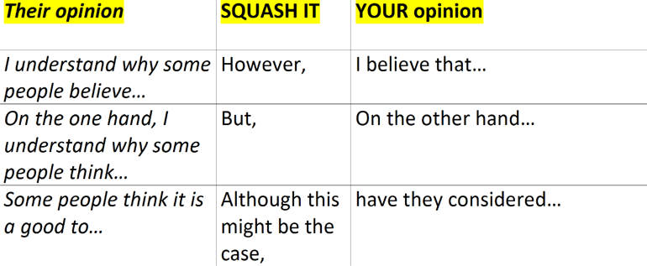

WAGOLL
Equal Pay For Sports Men and Women
I understand why some people believe men should be paid more for sport than women because there are more supporters and therefore they generate more money. However, I believe that men and women make the same sacrifices and I wouldn’t want my daughter to earn less than my son for doing the same job.

Key Questions
- What is the moral dilemma Oliver faces?
- What are boxing arguments and how do they influence your writing?

Lesson 17: Oliver Twist and Wild Boy
LI: I can compare the presentation of a theme in two texts
DART
Read chapters 13-15 of ‘Oliver Twist’ and answer the questions:
- How is friendship presented in Oliver Twist?
- Who are Oliver’s friends?
- Which characters are not trying to support him?

DIP
Complete the comparison grid before answering the question.
Use the writing frame to help you.
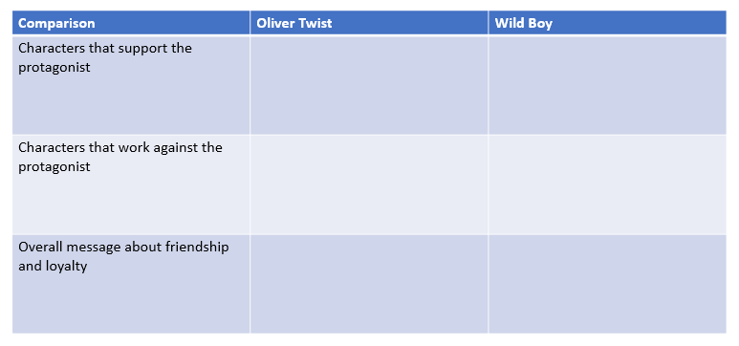

Q: How are friendship and loyalty presented in Oliver Twist and Wild Boy?
Friendship and loyalty are presented through the characters who support Oliver Twist and Wild Boy. In Oliver Twist… In Wild Boy… This shows the importance of friendship because…
A second way friendship and loyalty are presented is…
The overall message about friendship and loyalty in these two texts is…
Key Questions
- How is friendship presented in Oliver Twist and Wild Boy?
- What does it mean to compare and why is it important?

Lesson 18: Reflecting on Oliver Twist
LI: To respond to a text through creative writing
DART
Read chapters 16-18 of ‘Oliver Twist’ and answer the questions:
- Write down the five most important things that happened in the novel. | 1.  2.  3.  4.  5.
- What are your feelings towards/what is your response to the ending?

DIP
Write about an incident that taught you an important lesson.
Your response can be real or imagined and can be based on the novel or your own experiences.
Key Questions
- What is the main message in Oliver Twist?
- Why is it important to consider and reflect on a complete story line?

Attainment Band | Food Glorious Food
Yellow Plus | - Your writing includes imaginative and original ideas, developed with awareness of the reader and their likely response.  - You deliberately use a wide range of language devices to convey characters and setting, using a wide range of ambitious vocabulary for effect, and with accurate spelling.  - Conventions of a narrative and genre are used accurately and effectively with proof-reading helping you to make better choices in your writing.  - Cohesive paragraphing guides the reader through the text, combining with deliberately crafted sentences to alter the tone and mood throughout.  - You use a full range of punctuation accurately and for effect.
Yellow | - Your writing includes interesting characters and a setting that directly contributes to plot development.  - You use a range of language devices (e.g. simile, metaphor, personification) and use taught and increasingly ambitious vocabulary for impact and effect.  - Your work is structured deliberately to recognise conventions of narratives and genre, and for purpose or audience. Consistent proof-reading reduces errors in writing.  - Cohesive paragraphing contributes to a sensible overall structure. Your sentences are varied for impact and effect.  - You use a range of punctuation accurately (parentheses, colons before a list/to make a point).
Blue | - Your writing includes a complete plot, well-developed characters and explicitly describes setting.  - You start to use language devices and choose interesting nouns, verbs, and adjectives, and you use some taught vocabulary for impact and effect (with accurate spelling).  - Your writing is structured with deliberate progressions (e.g. uses chronological order or a clear narrative structure) and you proof-read to correct some errors after writing.  - You develop your ideas using paragraphs with some deliberate cohesion linking them together, and your sentences make use of a broad range of structures.  - You use a range of punctuation accurately (commas, end stopping, apostrophes).
Green | - You use planning or writing frames to develop ideas about plot, characters and setting.  - You start to use some detail and descriptive language, using simple vocabulary that interests, spelling most words accurately (using phonics, syllables, and affixes).  - Your ideas are organised with some clustering of related ideas, and you narrate and begin to develop ideas showing conventions of form (e.g. opening and ending).  - You paragraph with more regularity and accuracy and your sentence structure is more varied with limited range of subordinating conjunctions.  - You use simple punctuation consistently and accurately (capital letters, full stops, commas).
White | - You respond to the task by creating simple characters, settings and/or events.  - You include limited detail and use basic vocabulary, often misspelled.  - You attempt to structure your writing in chronological order.  - Your sentences are simple, and paragraphing is absent or inconsistent.  - You use simple punctuation, but your work includes errors (e.g. capital letters, full stops, commas).

