History Year 7 KS3 Spring 1 Blended Learning Booklet
Tudor Monarchs
Name:
Form:
Aim to complete one lesson each week. Write out the title and LI and then complete the tasks.
All video links are online using the ClassCharts link.
The Knowledge Organiser on page 3 has all the key information and vocabulary to help you with this unit.
Upload all work onto ClassCharts for feedback.
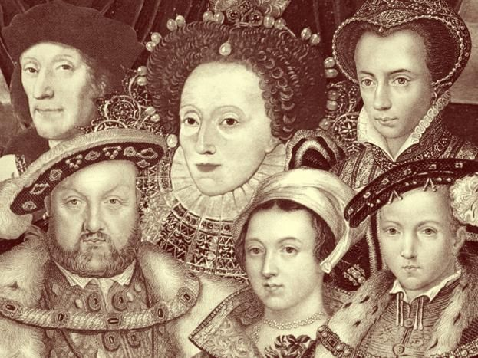

Contents
Page3: Big Picture - Year 7 Overview
Page 4: Zoom in - My Learning Journey
Page 5: Knowledge Organiser
Page 6: Lesson One – Henry VII
Page 10: Lesson Two – Catholics and Protestants
Page 15: Lesson Three – Henry VIII
Page 19: Lesson Four – Henry VIII and The Dissolution of the Monasteries
Page 25: Lesson Five – Bloody Queen Mary
Page 31: Lesson Six – The Spanish Armada

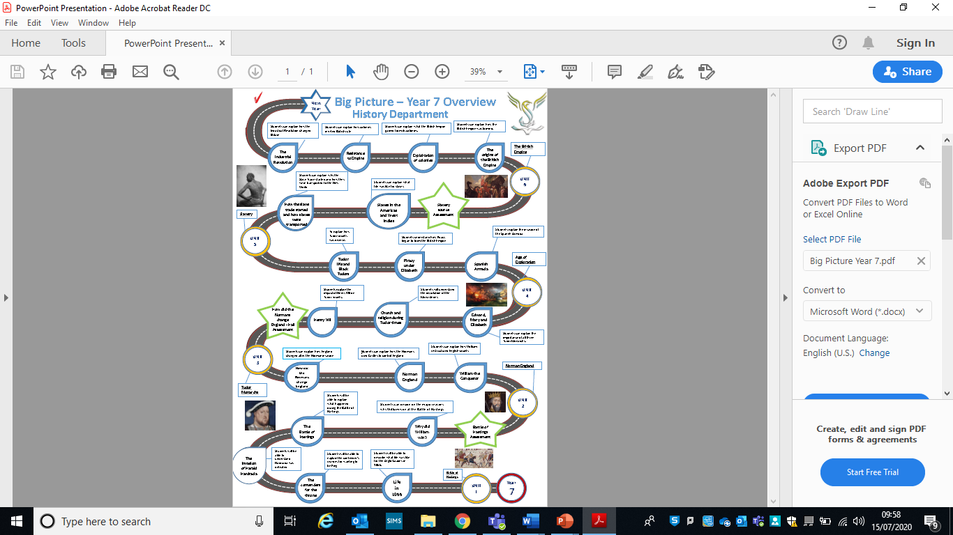
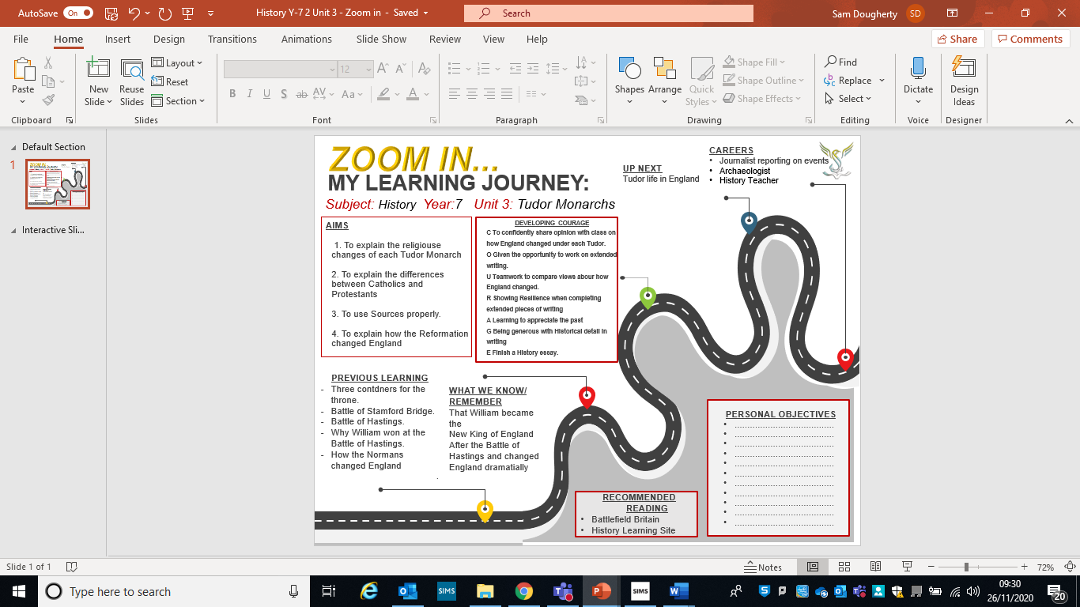
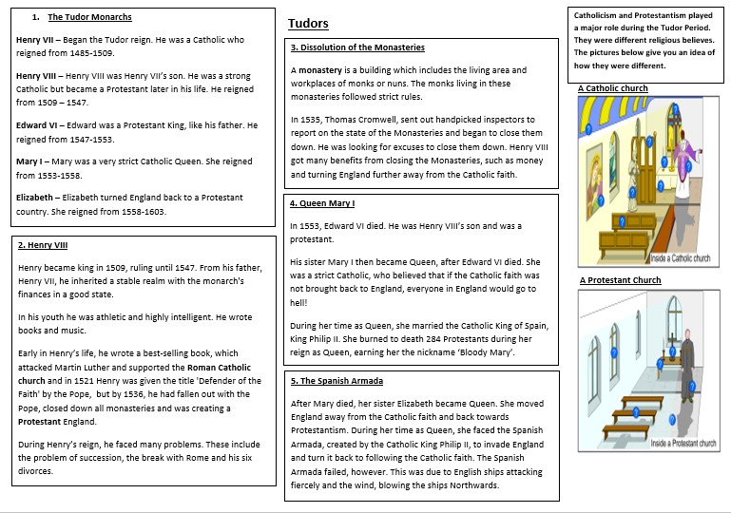
Lesson One – Henry VII
L/I: To look at Henry VII and to know the differences between Catholic and Protestant.

Read through the information on Henry VII below:

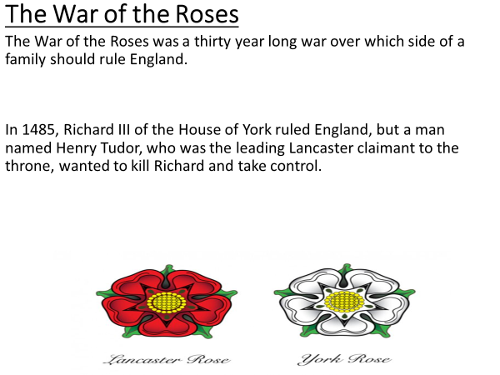
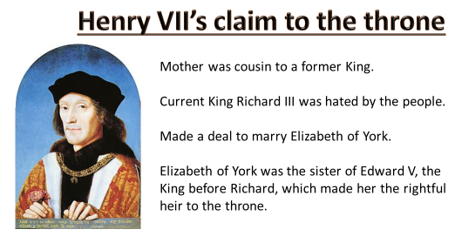

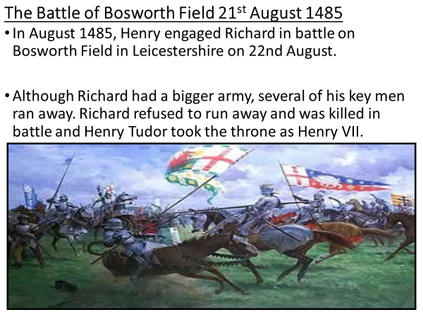
Activity One - Watch the following video on Battle of Bosworth Field and answer the questions below. Begin the video at

The Battle of Bosworth Field
- Where was:
Richard?

Henry?

- What was Thomas Stanley doing?

- What were the army sizes of:
Richard –
Henry –
Thomas Stanley –

- What did Thomas Stanley do?

- How did the battle end?

- What happened after the battle?

- What war did this battle end?

Main activity - Write an account of the Battle of Bosworth Field
Explain in three small paragraphs:
How and why the Battle began.

What happened during the Battle?

How the Battle ended and the result.

Extension – Did Henry VII have a strong claim to the throne? You must explain your answer.

Lesson Two – Catholics and Protestants
L/I: To understand why the differences between Catholics and Protestants were so important.

Starter - Use Box One on your knowledge Organiser, to help you complete this starter task:

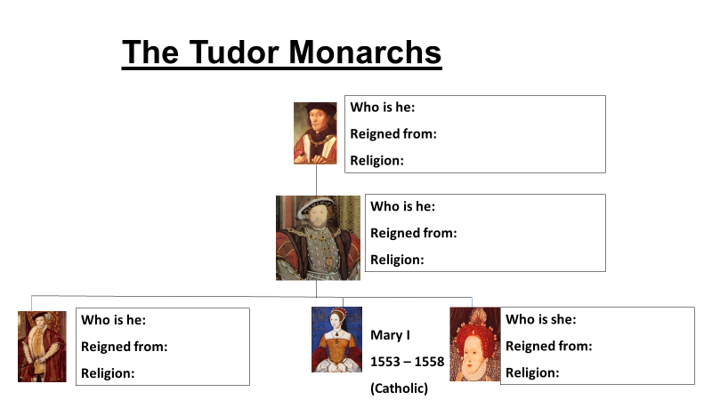

Activity One – Read through the differences between Catholics and Protestants, then answer the questions below:

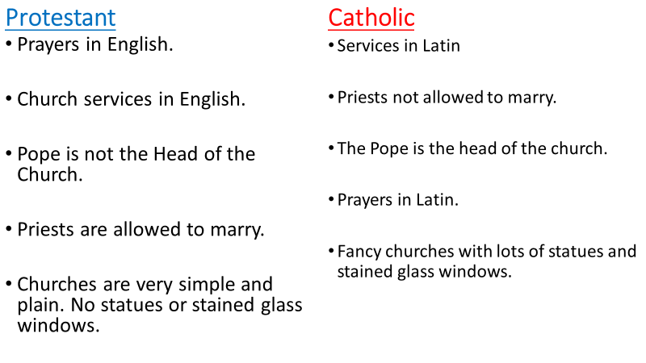
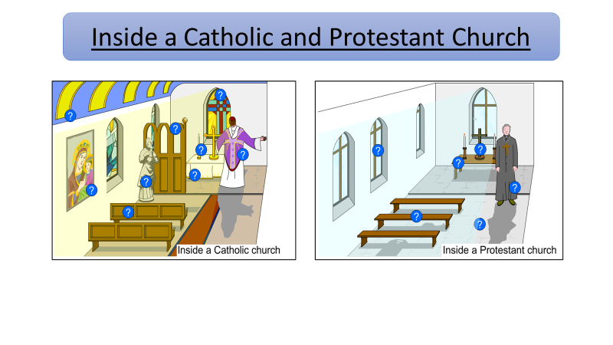
- Why do you think Catholics and Protestants may not get along?

- What is the biggest difference between the two churches? Explain your answer.

Extension - ‘Catholic’s and Protestants are the same.’ How much do you agree with this statement? Why?

Activity Two – Read through the following text and highlight the answers to the next set of questions.
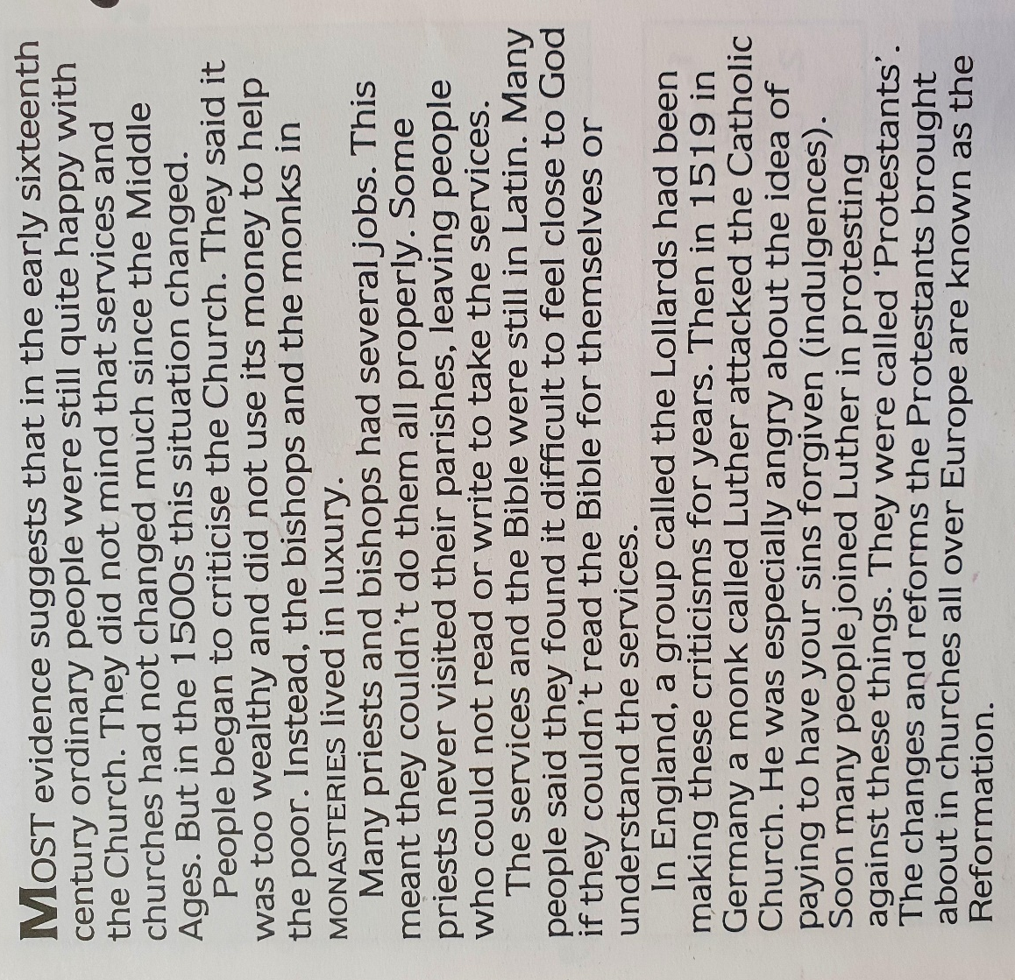

Highlight answers to these questions in the text above:
- What was the attitude towards the church in the early sixteenth century?
- Why were people criticising the church in the 1500s? There are multiple reasons.
- What happened in 1519?
- Who were the protestants?
- What was the Reformation?
Once you have found all the answers in the text, watch the following video:
https://www.youtube.com/watch?v=FhGGjRjvq7w

Main activity:
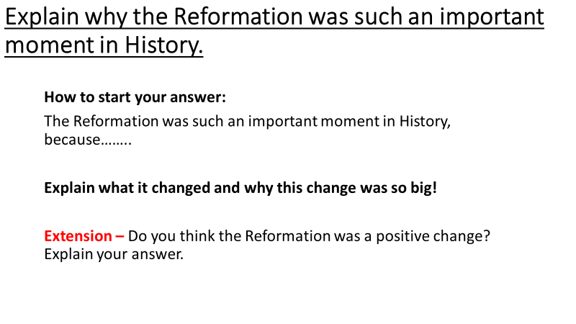

Lesson Three – Henry VIII
L/I: To explain Henry’s biggest problems during his reign as King.

Starter - Use Box Two on your knowledge Organiser, to help you complete this starter task:
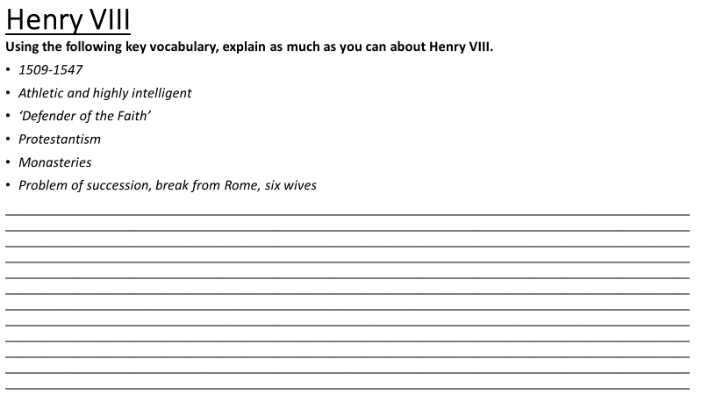

Activity One – Read the following information and watch the following video
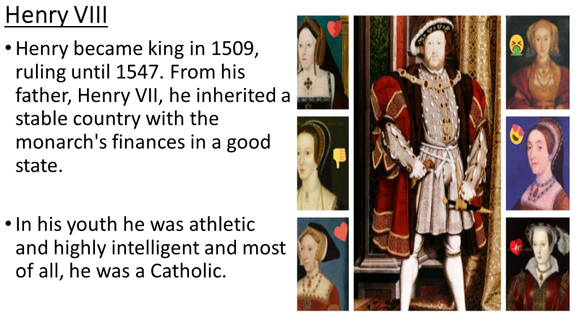
https://www.youtube.com/watch?v=X1ZKbFz7558

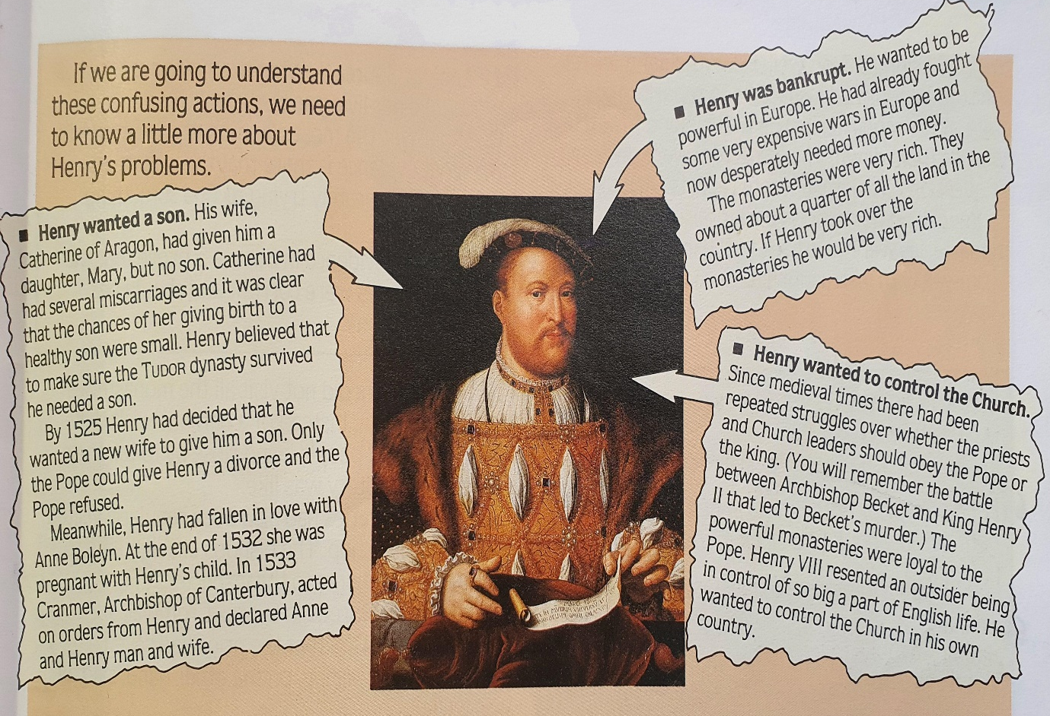
Activity Two – Read the following information and answer the question below

Why did Henry break away from the Catholic Church?
Try to include a bit of information from each major reason in your answer.

Activity Three – Read through the information below, to understand how Henry VIII changed England from being Catholic to being Protestant

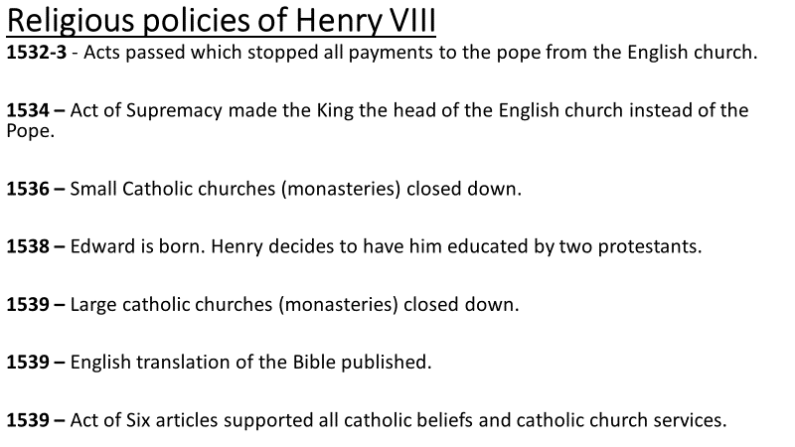

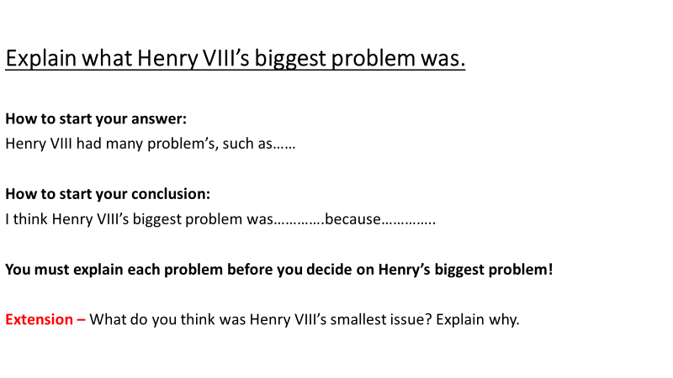
Main activity – Use the information above, which discussed Henry’s major problems, and answer the question below

Lesson Four - Henry VIII and the dissolution of the monasteries
L/I: To explain why Henry closed the monasteries.

Starter - Use Box Three on your knowledge Organiser, to help you complete this starter task:
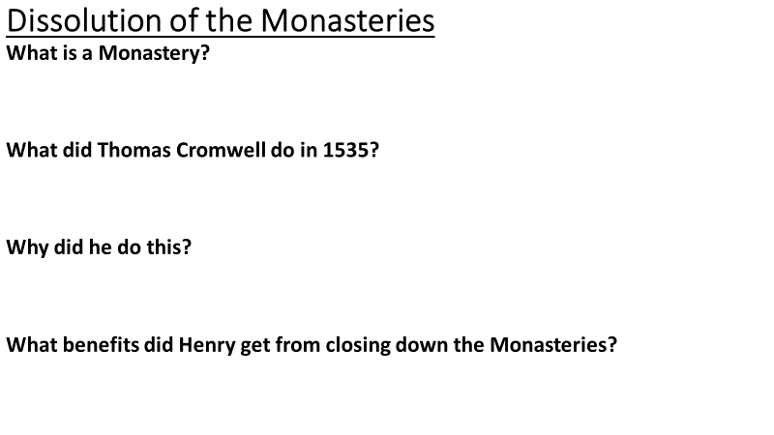

Activity One – Read through how Catholic nuns and monks are supposed to live:

Rules for Monks and nuns
They should:
- Live as poor people.
- Not marry or have sexual relations.
- Look after the poor, sick and old.
- Give shelter and food to travellers.
- Eat simply.
- Wear simple, rough clothes.
- Have just a mattress, blanket and pillow on their bed.
- Help to educate children.
- Copy out precious and rare text.

Once you have read how monks are supposed to live, use the text below and the monk’s rules, to help you answer the following questions:

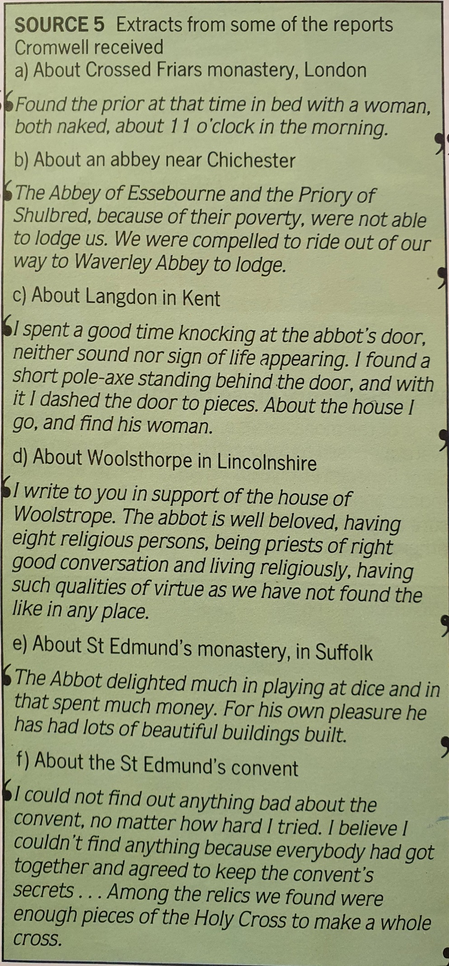
Why did Henry close the monasteries?
- Look at Source 5 above. What examples are there of monks not living as they should?

- What was the most common crime reported?

- What letter (a-f) tells us there was nothing wrong with one of the convents? Explain how it tells us this.

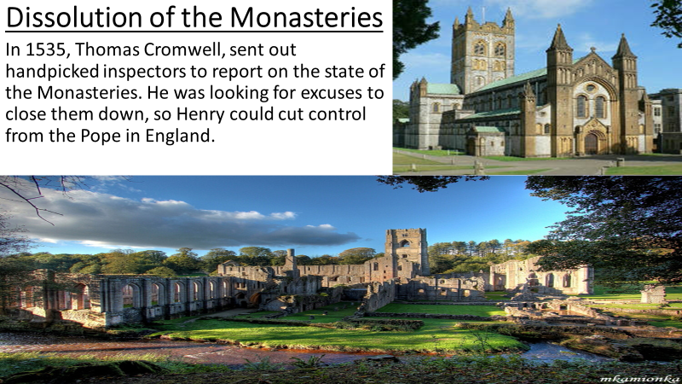

Activity Two – Read through the following information and highlight other reaons why Henry closed the Monasteries
The dissolution of the Monasteries
The Reformation in Tudor England was a time of unprecedented change. One of the major outcomes of the Reformation was the destruction of the monasteries which began in 1536.
The Reformation came about when Henry VIII wished to divorce his first wife, Catherine of Aragon, who had failed to give him a male heir. When the Pope refused to grant the divorce, Henry set up the Church of England. The Act of Supremacy in 1534 confirmed the break from Rome, declaring Henry to be the Supreme Head of the Church of England.
The monasteries were a reminder of the power of the Catholic Church. It was also true that the monasteries were the wealthiest institutions in the country, and Henry’s lifestyle, along with his wars, had led to a lack of money. Monasteries owned over a quarter of all the cultivated land in England. By destroying the monastic system Henry could acquire all its wealth and property whilst removing its Papist influence.
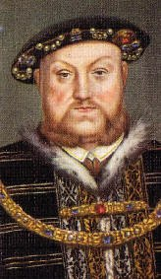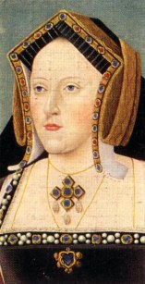
Henry VIII and Catherine of Aragon
Monastic land and buildings were confiscated and sold off to families who sympathised with Henry’s break from Rome. By 1540 monasteries were being dismantled at a rate of fifty a month.
After the disposal of their monastic lands and buildings, most monks and nuns were given money or pensions. However, there were some abbots and religious house leaders who refused to comply. They were executed and their monasteries destroyed. Thousands of monastic servants suddenly found themselves without employment.
Many people, particularly in the North of England, were against the Dissolution. Here the old Catholic faith remained especially strong. In October 1536 a large rebel army of over 30,000 people marched to York and demanded that the monasteries should be reopened. This march became known as the Pilgrimage of Grace. The rebels were promised a pardon and a Parliament in York to discuss their demands, and they disbanded. However, they had been tricked; Henry gave orders that the leaders of the rebellion should be arrested and around 200 people were executed.
Main activity – Watch this vide and then use everything from today’s lesson to answer the question below
https://www.youtube.com/watch?v=7lTfsQgVGmE

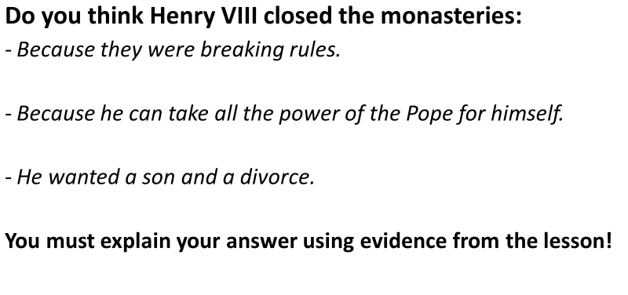

Lesson Five - Bloody Queen Mary
L/I: To decide if Mary I deserves to be called Bloody Mary.

Starter - Use Box Four on your knowledge Organiser, to help you complete this starter task:

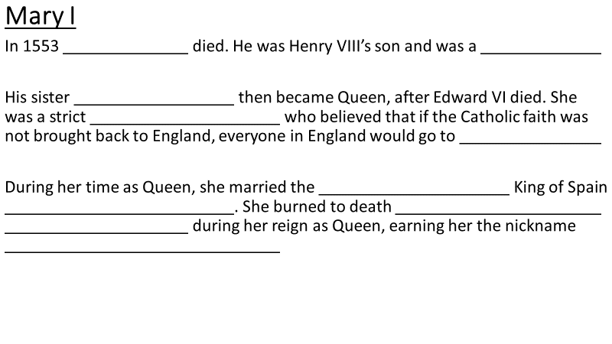
Red through who Mary was to begin the lesson
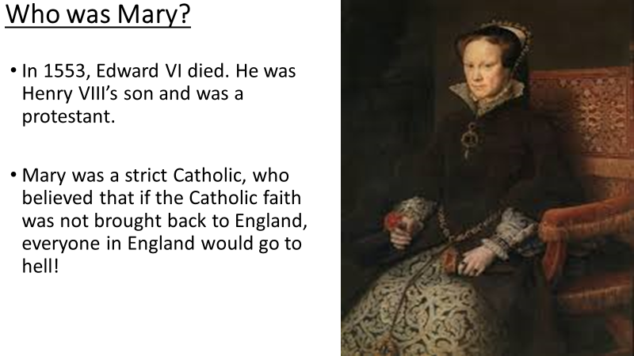

Activity One – Use the information below to help you answer the question.

Was it easy for Mary to change England back to being Catholic once again?
Look at the six bullet points below

For each point, explain whether this would have made it easy, or hard, for Mary to turn England back to being Catholic.

- Protestantism had only been the official religion of England for six years. Before that, England had been a Catholic country for hundreds of years. Many people would be glad to go back to the Catholic ideas.
- Henry VIII had already closed all the Monasteries and sold their land to rich and important people. They did not want to give the land back to Mary.
- There were many protestants in England who hated the Pope and Catholicism.
- Mary was 37 and had no children. The next in line for the throne, Elizabeth, was a protestant.
- 400 of the most important Protestant leaders left England when Mary became Queen.
- When Mary became Queen, the protestants who remained in England tried to replace her, but they gained no support.

Bullet Point 1.
Did this make it easy for Mary to change England back to being Catholic, yes, or no? Why?

Bullet Point 2.
Did this make it easy for Mary to change England back to being Catholic, yes, or no? Why?

Bullet Point 3.
Did this make it easy for Mary to change England back to being Catholic, yes, or no? Why?

Bullet Point 4.
Did this make it easy for Mary to change England back to being Catholic, yes, or no? Why?

Bullet Point 5.
Did this make it easy for Mary to change England back to being Catholic, yes, or no? Why?

Bullet Point 6.
Did this make it easy for Mary to change England back to being Catholic, yes, or no? Why?

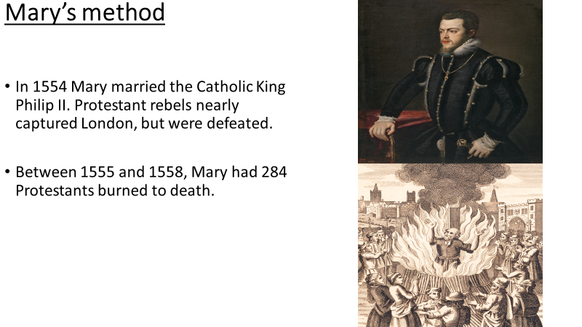

Activity Two – Read through the information below to see how Mary dealt with Protestants
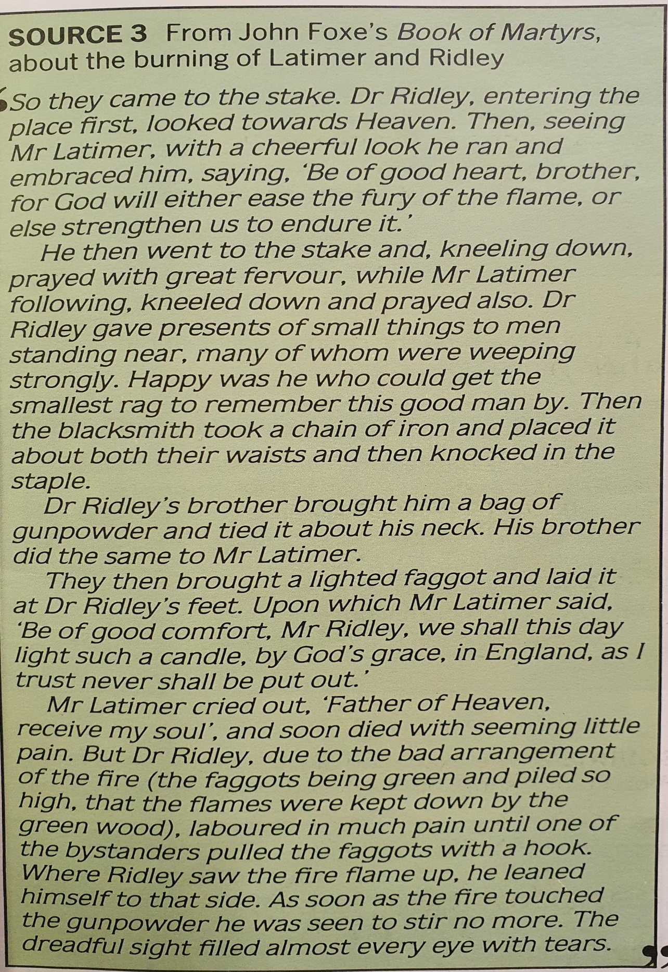

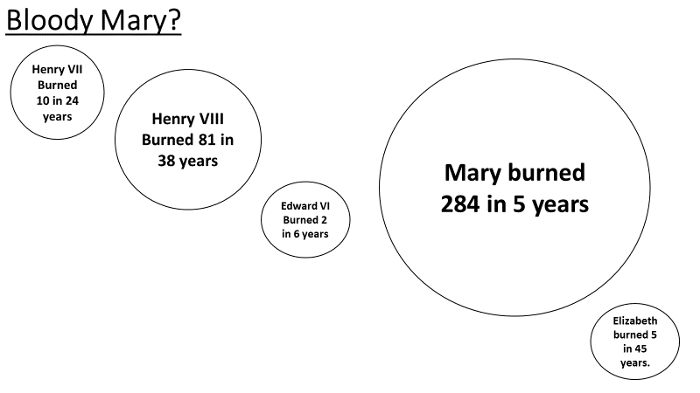

Main activity:

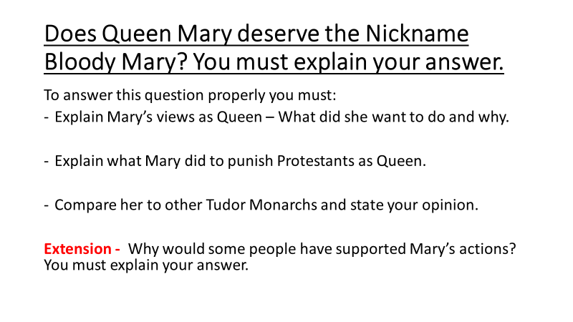

Lesson Six - Elizabeth and the Spanish Armada
L/I: To explain what the Spanish Armada was and why it failed.
Starter - Use Box Five on your knowledge Organiser, to help you complete this starter task:

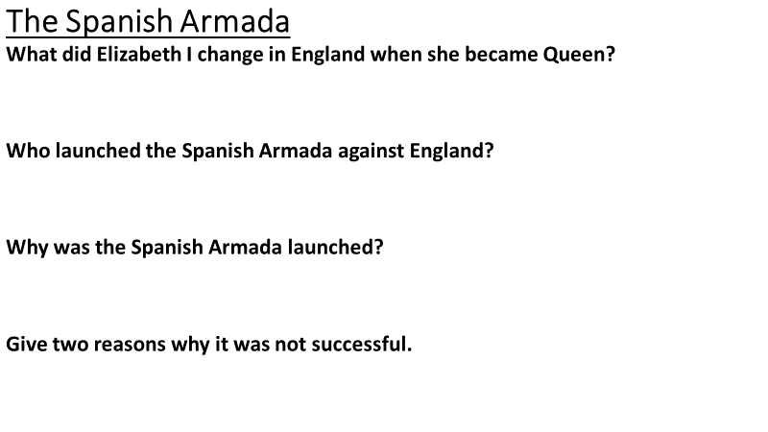

Activity One – Read through the information below
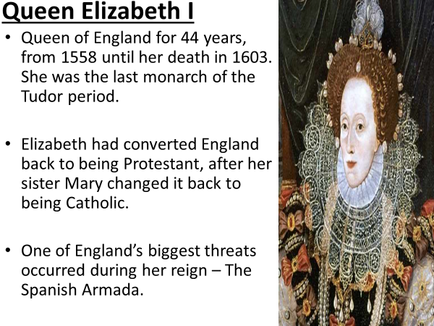
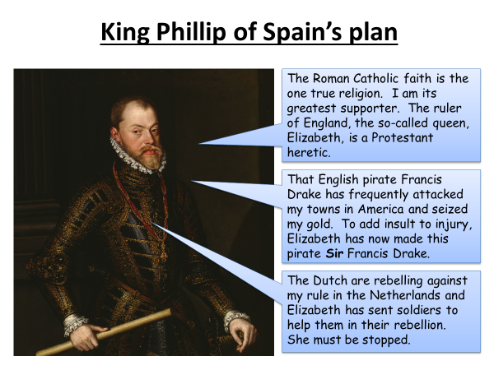

Main activity – Watch the following video and answers the questions below
https://www.dailymotion.com/video/x489m4y


