Geography KS3 Spring (Year 7)
Blended Learning Booklet
Global Hazards
Name:
Form:
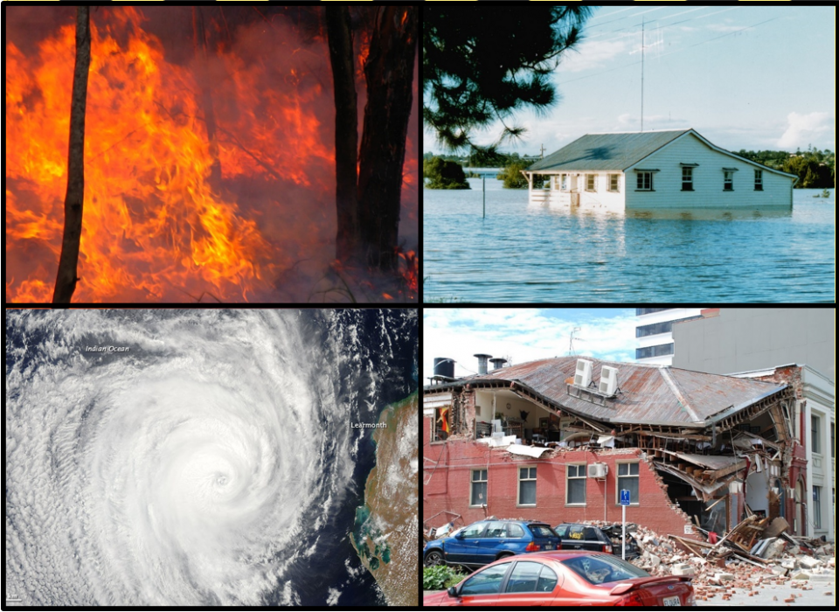
Aim to complete one lesson each week. Write out the title and LI and then complete the tasks. Upload all work onto ClassCharts for feedback.

Knowledge Organiser Y7-2
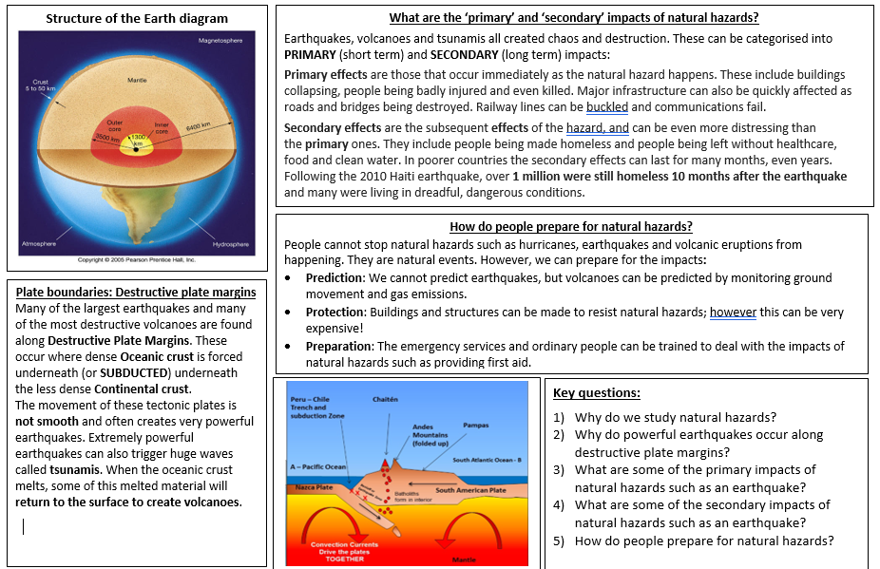
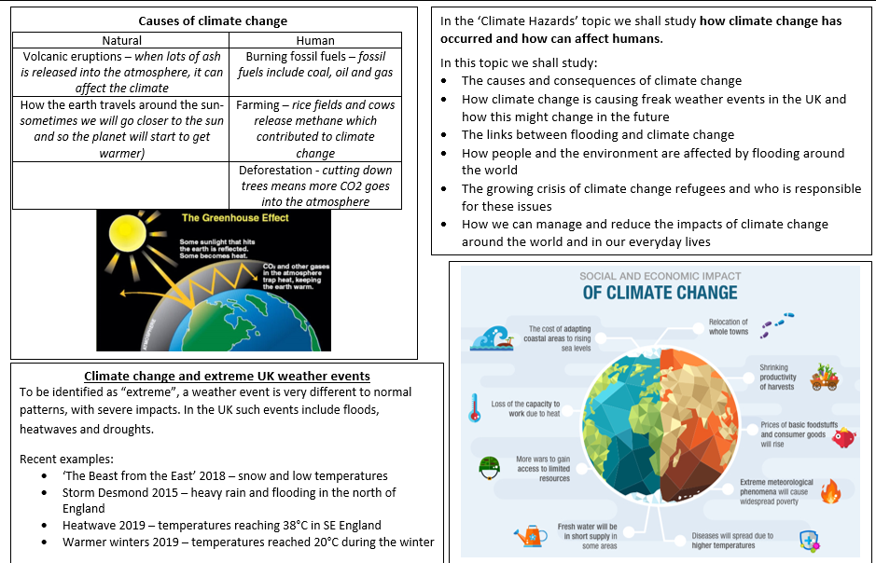
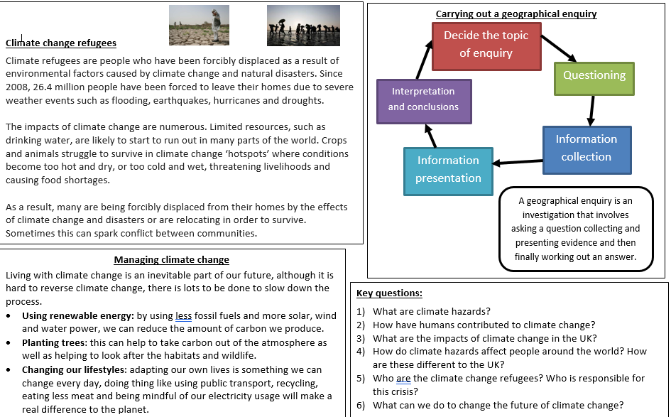

Lesson 1- What are natural hazards?
LI: To define natural hazards and be able to provide examples
Task 1 - In your own words, define a natural hazard. Can you identify all the natural hazards on the booklet cover?
Tsunami | Blizzard | Avalanche | Cyclone | Drought
Hurricane | Volcanic eruption | Landslide | Heavy snow and hail | Heatwave
Heavy rain | Earthquake | Flooding | Pyroclastic flow | Tornado
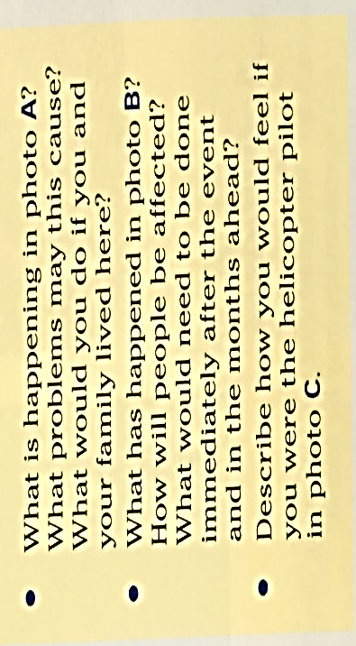
Task 2 - Colour code the hazards to show whether they are tectonic or weather-related hazards.

Task 3 - Complete the activities using the images below:
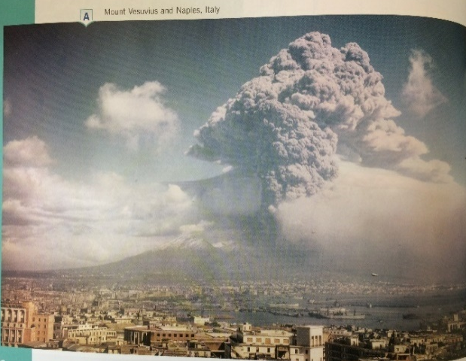
A

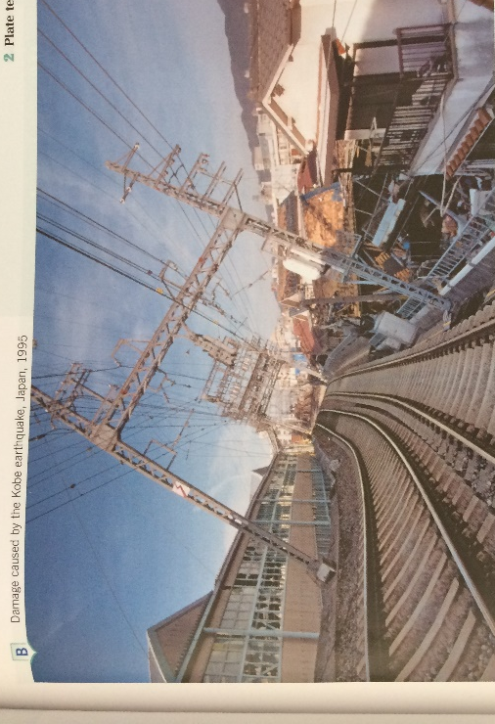
B
C
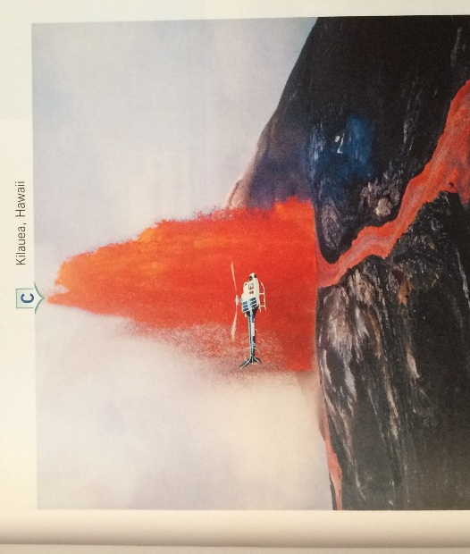

Task 4 - Summary – Can you name…
A hazard that would affect the UK
A hazard that would affect coastal areas (areas near the sea)
A hazard that could cause a refugee crisis

Lesson 2 – The structure of the earth and plate tectonics
LI: To explain the distribution of tectonic hazards around the world
Task 1 – Recap and write down: 1 hazard that affects the UK, 2 impacts of hazards on people, 3 examples of tectonic hazards.
Task 2 – Label and colour the diagram of the structure of the earth
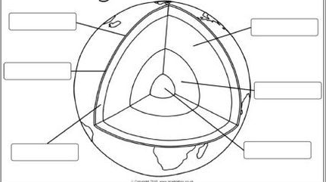
Labels
Outer core
Mantle
Crust
Inner core
Tectonic plates
Ocean

Task 3 – Watch the video about tectonic plates and plate movement: https://www.youtube.com/watch?v=UvIDxu7twpc
Task 4 – Number the images below from oldest to newest for tectonic plate movement and position
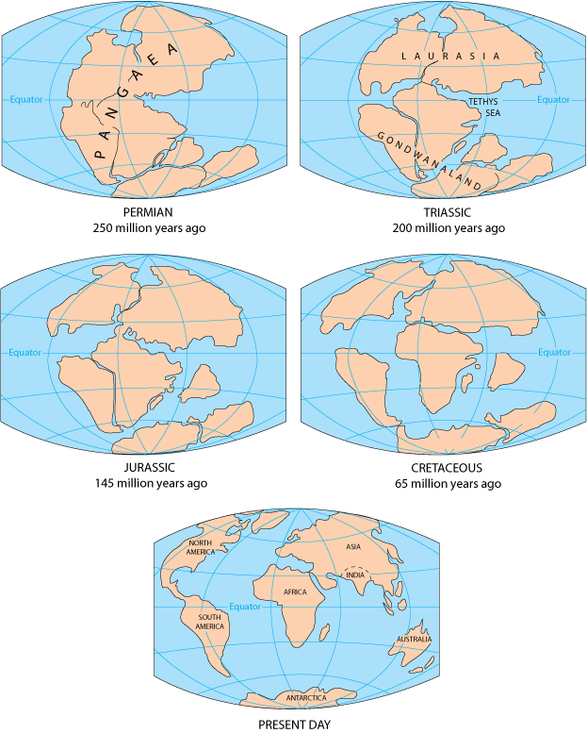

Task 5 – Today our world looks like the map below. Underneath the surface it is broken into tectonic plates that are still constantly moving – they just move so slowly that we never really noticed until a tectonic disaster happens. Fill in the gaps to label the names of the different tectonic plates
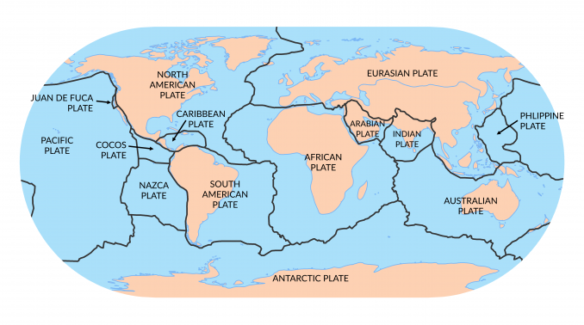

Antarctic Plate Pacific Plate North American Plate
Indian Plate South American Plate Philippine Plate
Eurasian Plate Australian Plate

Task 6 - What is the restless earth?
The word restless means something that has no rest, it is constantly moving around.
Think back to our lesson on the earth’s structure and tectonic plates. Complete the sentence below to describe why you think our world might be called the restless earth.
Our earth is sometimes called ‘the restless earth because…’
Eurasian Plate Antarctic Plate African Plate
Pacific Plate Indian Plate South American Plate

Lesson 3 – Earthquakes
LI: To describe how earthquake are caused and how they can impact people and the environment
Task 1 - Using only 20 words (or less), can you describe what tectonic plates are and how they are linked to volcanoes and earthquakes?
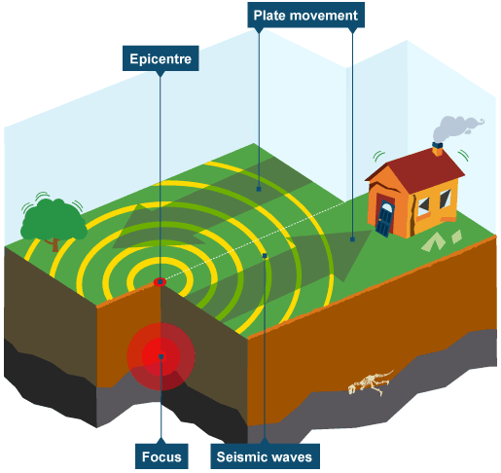
Task 2 – Read through the information about conservative plate boundaries and earthquakes and answer the questions
A conservative plate boundary, sometimes called a transform plate margin, occurs where plates slide past each other in opposite directions, or in the same direction but at different speeds. Friction is eventually overcome, and the plates slip past in a sudden movement. The shockwaves created produce an earthquake. This occurs at the San Andreas Fault in California.
Large earthquakes are usually connected with plate boundaries. Earthquakes happen often but most are too small for us to notice. Seismometers record earth movements.
An earthquake is a sudden shockwave caused by rocks being under stress from the movements of plates at plate boundaries. Eventually the stress in the rock builds up enough to deform and reach breaking point. At that point, the stored up energy is released in the form of shockwaves.
- What is the other name for a conservative plate boundary?
- What is the force that builds up between the two plates?
- What are the types of waves that create an earthquake?
- Name the device that measures earthquakes.
Task 3 – Imagine that you are a journalist reporting about the Haiti earthquake. Your task is to write a front-page article suitable for a national newspaper. Use the information below and your own research.

Social impacts (effects on people)
- 3 million people affected.
- Over 220,000 deaths.
- 300,000 injured.
- 1.3 million made homeless.
- Several hospitals collapsed.

Economic impacts (effects on money/jobs)
- 30,000 commercial buildings collapsed.
- Businesses destroyed.
- Damage to the main clothing industry.
- Airport and port damaged.
Haiti is part of a large Caribbean island.

Cause of the earthquake
Haiti lies right on the boundary of the Caribbean and North American plates. There was slippage along a conservative plate boundary that runs through Haiti.
On 12 January 2010, a magnitude 7 earthquake hit Haiti at 16:53 local time. The earthquake's epicentre was 25 km west of Port-au-Prince, the capital. Most people, businesses and services were in the capital.

Many of the effects were immediate or primary, e.g. injuries from falling buildings. Some secondary effects didn't happen until many months later, e.g. cholera outbreaks. The effects of this earthquake were particularly bad because of the following reasons:
- there were very few earthquake-resistant buildings
- buildings and other structures were poorly built
- the epicentre was near to the capital
- there were few resources to rescue or treat injured people

Haiti is a very poor country without the money and resources to redevelop. It is one of the least developed countries in the world with most Haitians living on $2 or less per day, about £1.30.
Because there were few earthquake-resistant buildings, the devastation was massive. Many buildings simply collapsed or were damaged beyond repair.

Response to the earthquake

Primary responses
- Neighbouring Dominican Republic provided emergency water and medical supplies as well as heavy machinery to help with search and rescue underneath the rubble, but most people were left to dig through the rubble by hand.
- Emergency rescue teams arrived from several countries, e.g. Iceland.
- Medical teams began treating the injured - temporary field hospitals were set up by organisations like the International Committee of the Red Cross.
- GIS was used to provide satellite images and maps of the area, to assist aid organisations.
- People from around the world watched the news from Haiti on TV and through social networks. Many pledged money over their mobile phones.
- United Nations troops and police were sent to help distribute aid and keep order.

Secondary responses
- Money was pledged by organisations and governments to assist in rebuilding, but only slow progress had been made after one year.
- After one year, there were still 1,300 camps.
- 'Cash for work' programs are paying Haitians to clear rubble.
- Small farmers are being supported - so crops can be grown.
- Schools are being rebuilt.

Plan your article using the writing frame. Don’t forget that a good newspaper report:
- Has a snappy headline
- Starts with a single statement which catches the reader’s attention
- Describe in more detail what happened and why
- Frequently includes interview with experts and/or eyewitnesses (you might need to make some characters up)
- Often finishes with a concluding paragraph

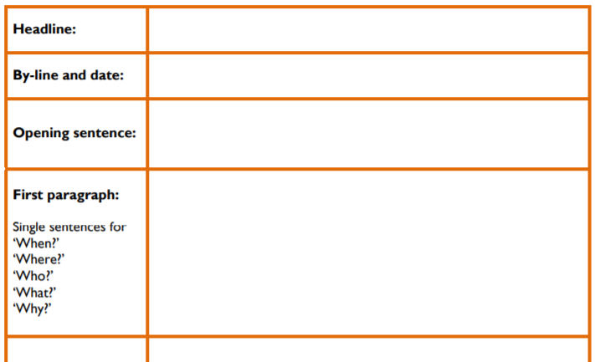

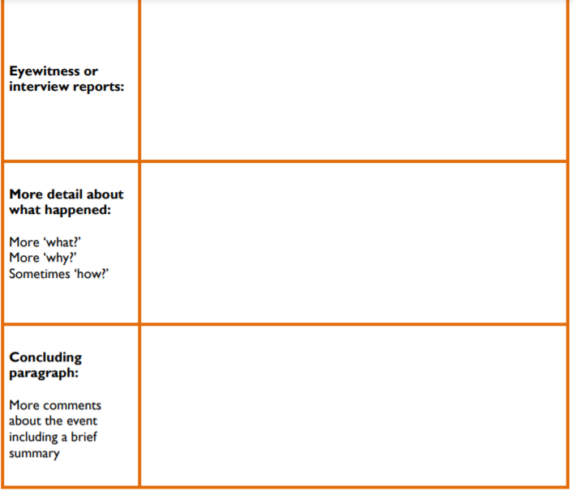
Lesson 4 – Volcanoes
LI: To describe how volcanic eruptions are caused and investigate an example
Task 1 - Destructive plate boundary gap fill (you can use your knowledge organiser)
Many of the largest ___earthquakes____ and many of the most destructive volcanoes are found along destructive plate _____margins______. These occur where dense _____oceanic____ crust is forced underneath the less dense continental crust.
The movement of these ______tectonic___ plates is not smooth and often creates very ____powerful______ earthquakes. Extremely powerful earthquakes can also trigger huge waves called ______tsunamis_____. When the oceanic crust _____melts____, some of this melted material will return to the surface to create _______volcanoes_____.
Earthquakes Tectonic Melts
Tsunamis Powerful Oceanic
Volcanoes Margins

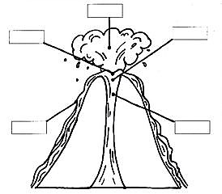
Task 2 – Along these destructive plate boundaries is where we often find volcanoes.
Label the diagram of a volcano

Magma
Lava
Smoke
Crater
Vent

Task 3 - Watch the video about the Montserrat volcanic eruption: https://www.youtube.com/watch?v=jBQk2dzo9yM
Task 4 – Read through the DART to learn more about what happened before, during and after the Montserrat eruption and answer the questions.
DART: The Eruption of Montserrat
About Montserrat
Montserrat is a small mountainous island in the Caribbean and is an overseas British territory, this means that it has strong links with the UK. It is a volcanic island as it is located on a destructive plate boundary It is a small island with many active volcanoes that are in the Soufriere Hills which are in the south of the island. The northern parts of the island have black-sand beaches, coral reefs, cliffs and shoreline caves.
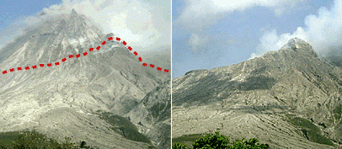
The Eruption
The volcano is called Chances Peak and is in the south of the island in the Soufriere Hills. Before 1995 it had been dormant for over 300 years and so people were not expecting the volcano to erupt.
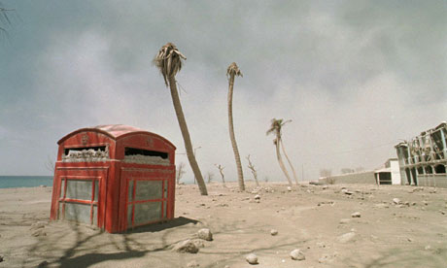
In 1995 the volcano began to give off warning signs of an eruption (small earthquakes and eruptions of dust and ash). Once Chances Peak had woken up it then remained active for five years! The most intense eruptions occurred in 1997. Throughout theses years, Montserrat was devastated by pyroclastic flows, lahars, lava flows, ash and smoke. The small population of the island (11,000 people) was evacuated in 1995 to the north of Montserrat as well as to neighbouring islands and the UK.
The Impacts of the Eruption
Primary effects
Throughout the 3 years, there were many impacts for the island of Monserrat. 23 people died during the eruptions even though half of the island was evacuated. This left the north part of the island uninhabited. The capital city, Plymouth, now looks like a ghost town as it is not safe to return to this area. One of the biggest problems was the ash that came from the volcano, crops and animals were destroyed by the layers of ash that covered surrounding areas and rivers began to flood.
Secondary effects
One of the main secondary effects was the loss of tourism due to the destruction of the airport and that the island was no longer safe for people to visit. The community has also been affected because lots of people had to evacuate the island and this has led to families being split up and people living in temporary housing.
The Aftermath of the Eruptions
To help with the impacts of the eruption, £41 million in aid was donated by the British government. Lots of this money was used to help people to move to places of safety when they were evacuated. There was also a big push to help prepare for future eruptions. More education has been provided for local people and the Montserrat Volcano Observatory was set up to help monitor activity. Around the observatory is an exclusion zone where is it not safe for people to live and sometimes the scientists will have to leave the area if there is a high risk or danger.
- Describe the location of Montserrat
- How is Montserrat linked to the UK?
- What type of plate margin is Montserrat located on?
- Why were people not expecting the volcano to erupt?
- How did people know that the volcano was going to erupt?
- Describe how people were affected by the eruptions.
- Name one place that was impacted by the eruption. Can you give a phrase to show that the area has changed?
- How much money was given by the British to help with the eruption?
- Why did the British government help the island of Montserrat?
- How have Montserrat prepared for future eruptions?

Task 5 – Create a timeline of events or draw a cartoon strip about what happened with the eruption of Montserrat.
Lesson 5 – Tsunamis
LI: To understand the causes and impacts of the 2004 Boxing Day tsunami
*Challenge*: Can you find out what the Japanese word ‘tsunami’ translates to in English?
Task 1 - Watch the videos on tsunamis:
https://www.youtube.com/watch?v=Wx9vPv-T51I
https://www.youtube.com/watch?v=_oPb_9gOdn4
https://www.youtube.com/watch?v=oWzdgBNfhQU
From the videos, pick 5 key phrases or 7 key words to do with tsunamis based on your understanding
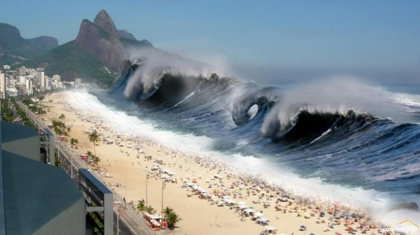
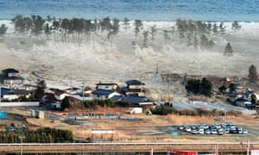
If you can’t watch the videos, what words or phrases can you think of to do with the images below?
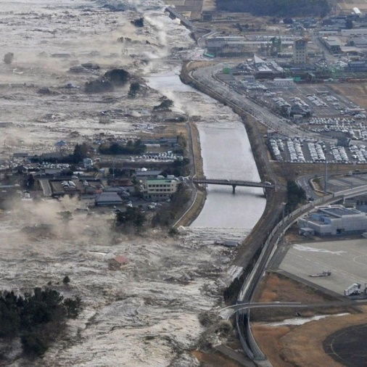
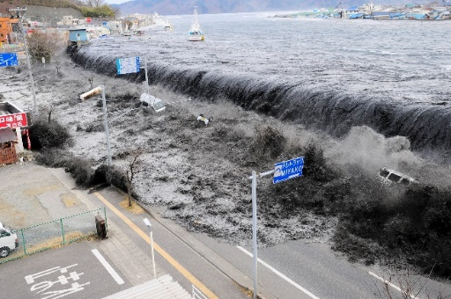

Task 2 - What is a tsunami? Complete the gap fill.
A tsunami is a series of ………………………………… made in a body of water by a sudden …………………………………. This sudden disturbance pushes a large column of ………………………. upwards creating a …………………… Tsunamis are also known as seismic waves or ……………………………………………………
tidal waves tsunami water
waves disturbance

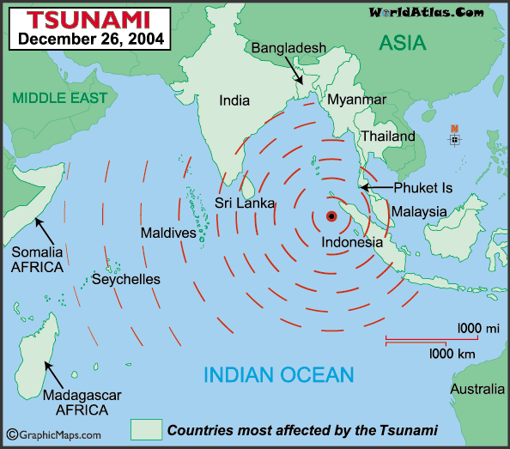
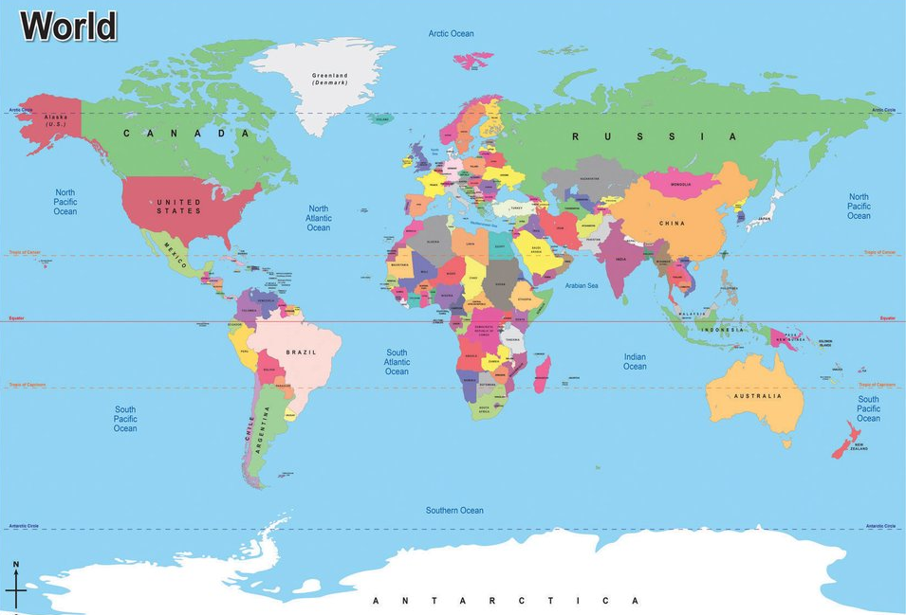
Task 3 - Describe the location of the tsunami and the countries affected.
Continent
Compass points
Countries
Oceans and seas

Task 4 – Read through the information about the Boxing Day tsunami.
At 1am on 26th December 2004 a massive 9.1 magnitude underwater earthquake caused a tsunami in the Indian Ocean. The earthquake happened on a destructive plate boundary. It would become the deadliest tsunami ever recorded in history.

Task 5 - Using the images below, describe how you think tsunamis are caused.
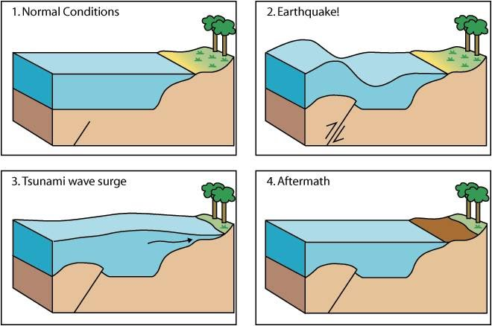
Watch this video to help: https://www.bbc.co.uk/news/science-environment-12739417
*Challenge*
Go back to Lesson 2, can you work out which two plates caused the earthquake for the Boxing Day Tsunami?
Words to include:
Tectonic plates Movement Surge
Earthquake Pressure Flood
Wave Wall of water

Task 6 – Read through the impacts of the Boxing Day tsunami and complete the activities on the next page
Environmental impacts
- Crops destroyed. Farmland ruined by salt water.
- 8 million litres of oil escaped from oil plants in Indonesia.
- Mangrove forests along the coast were destroyed.
- Coral reefs and coastal wetlands damaged.

Economic impacts
- Fishing industry devastated – boats, nets and equipment destroyed. An estimated 60% of Sri Lanka’s fishing fleet destroyed.
- Rebuilding cost billions of dollars.
- Loss of earnings from tourism - visitors to Phuket dropped 80% in 2005.
- Communications damaged, e.g. roads, bridges and rail networks

Social impacts
- 230 000 deaths.
- 1.7 million homeless.
- 5-6 million needing emergency aid, e.g. food and water.
- Threat of disease.
- 1,500 villages destroyed in northern Sumatra.

Activities:
- Write down 10 words about tsunamis. (for example: waves, floods, bad, injury)

- Using the above information, describe the impacts of the Boxing Day tsunami.

- How would you feel if you had been on holiday in one of the countries during the tsunami?
*Challenge*: Do you think there have been any long-term impacts (years after the tsunami)?
Task 7 - Using what you have learnt about the Boxing Day Tsunami 2004, you are going to write a diary entry imagining you are a survivor of the event.
You need to include

- What happened?
- What did the wave/flooding look like?
- How did you feel before, during and after the wave hit?
- Can you describe what the area looked like before, during and after?
- How were you affected?
- Was your family affected?
- How did people respond to the event?
- What are the short- and long-term impacts for you?

Here is an account of a survivor, Edie, to give you some ideas:
"We set off on Boxing Day morning for a day of kayaking," she recalls. Her mother, Sally, and younger sister Alice, 23, were holidaying in Thailand with Edie and her boyfriend Matt.
"We hired two kayaks and set off from a beach and spent a few minutes paddling across the sea," recalls Edie. "We came to rest at a beautiful spot. I felt so happy at that moment I wanted to take a picture of my mother and sister.
"When I lowered my camera, the air felt different somehow. It felt wrong. I looked out to sea and in the very distance I could see a ridge - a wave - moving towards us across the sea which was otherwise flat. I knew something was very wrong."
But nearly a mile out to sea there was no chance of escape.
"I don't really remember when the wave hit me but it knocked me straight into a cliff face and I was tumbling under the water pushed by the force of the wave for what felt like minutes until I surfaced and saw my family all there alive," she says. "But unfortunately, another wave came, and the same thing happened. I was knocked against the rock face again and when I eventually surfaced, they had been swept away."
Despite being badly injured, Edie managed to wait for the water levels to drop then crawled through a gap in the rocks. Cut and bleeding, she dragged herself away from the cliffs until she came to a beach. There she was reunited with Matt, also injured but alive. After hospital treatment in Thailand she returned to the UK to a life transformed by loss.
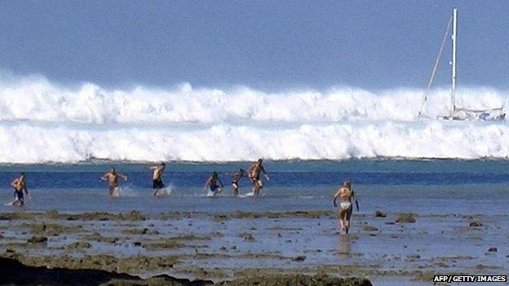
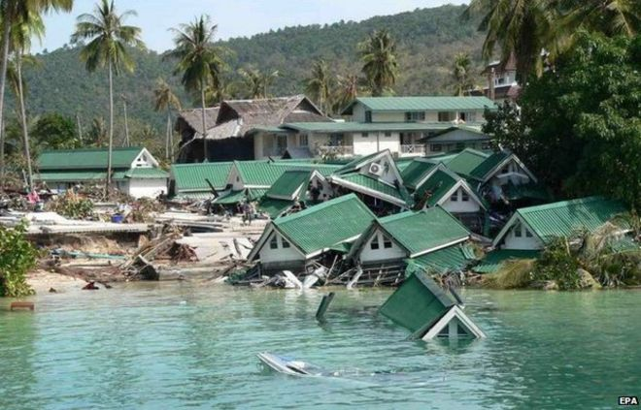
Lesson 6 – Climate change
LI: To discuss the causes and impacts of climate change
Task 1 - In your own words, define climate change.
Task 2 - Watch this video: https://www.youtube.com/watch?v=dcBXmj1nMTQ
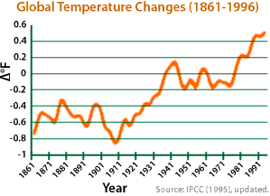
.Task 3 - Using the graph, describe what has been happening to the world’s climate in the last 150 years.

Task 4 - Using the key, colour code the table to show the different categories of impacts.
Social = To do with people, where they live and their well-being
Economic = To do with money, jobs, trading, costs, paying for repairs/replacements and development
Environmental = To do with weather, climate, habitats, natural events, animals, plants
Social Economic Environmental
S
Ec
Env
Tropical storms that will cost a lot of money | Loss of habitats in cold environments | Extreme weather events will cause poverty | Diseases will spread
Disappearance of 1 million species | More wars to get resources | 35 million people affected by flooding | Oceans becoming more acidic which will affect wildlife
Deaths due to wildfires and heatwaves | Less oxygen in the oceans | More expensive goods and food | Fresh drinking water might run out
More hot deserts around the world | Lots of people having to migrate | More extreme weather events | Less food available

Lesson 7 - Extreme weather in the UK
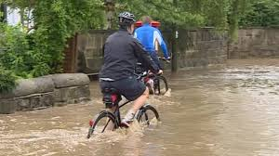
LI: To explore how climate change causes extreme weather events in the UK
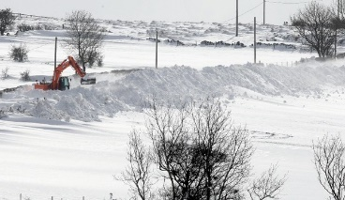
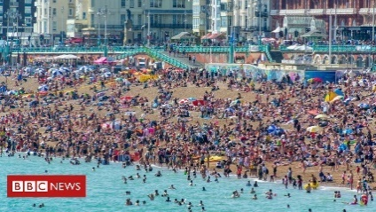
Task 1 - Using the images, write down 5 examples of extreme weather in the UK.
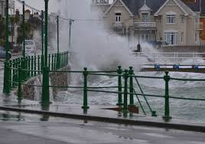
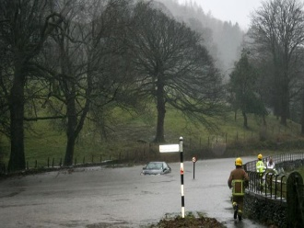

Task 2 – Read through and copy down the bullet points about climate change and extreme UK weather.
- In recent years, the UK has experienced more extreme weather
- This is when a weather event is significantly different from the average or usual weather pattern
- Many of these events have been linked to climate change
Task 3 – Read through the case studies of extreme weather in the UK (page 21).

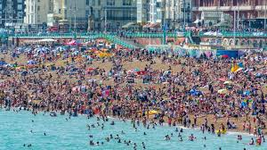
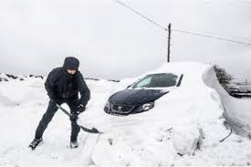
Task 4 – Pick one of the weather events. For the example, you need to write a weather report for the event and a short survival guide to give to people affected by the weather event.

Name of event: UK Heatwave 2019
Weather type: High temperatures and sunny
Time of year: July 2019
General weather conditions:
July 2019 saw the highest temperatures ever recorded in the UK. There was also low rainfall in some areas of the UK with the west of the UK seeing its driest July for years. The days and nights were warmer than usual with temperatures across the UK an average of 1.2°C warmer than average record. In Cambridge, there was recorded an all-time high temperature of 38.7°C on Thursday 25th July. Along with the high temperatures and low rainfall, there were lots of sunny days with few clouds in the sky.
Impacts:
There were lots of positive impacts of the warm weather as people had the opportunity to be outside, going to parks and the beach. Lots of businesses in seaside areas made lots of money during the high temperatures. There were also increased sales of BBQ foods and ice creams across the UK.
The government put out heat warnings for the whole of the UK and there were lots of public messages about keeping hydrated, finding shade and making sure people were protected by the sun.
The hot weather also led to many thunderstorms and on the 23rd July, there were around 48,000 strikes of lightning in one night. This disrupted power and internet in some areas.
There were also issues with the trains as the high temperatures had caused some of the railways to melt and so the trains were restricted on how fast they could go. Many lines were cancelled, meaning it was difficult for people to get to work. In London, the tubes became dangerous due to high temperatures with lots of people being unwell. There were temperatures of over 40°C on the Central Line.
Responses:
There was little that could be done to manage the impacts of the heatwave. The focus was on slowing down transport lines and encouraging people not to travel if they didn’t need to.
There was also a big push on sun safety and ensuring that people were drinking lots of water and not spending long hours in the heat.
Name of event: The Beast from the East
Weather type: Storms and snow
Time of year: February and March 2018
General weather conditions:
The weather during the Beast from the East included snowfall and sub-zero temperatures as result of freezing air from Siberia. There were cold and wintery conditions which were unusual for this time of year. The air that was blown over from Russia and Siberia was very cold and dry. This led to temperatures of around -5°C but felt as cold as -15°C. Heavy snow fell across lots of the UK and there were lots of issues with ice roads as well.
Impacts:
During the Beast from the East 10 people died due to the bad weather conditions. Up to 50cm of snow fell on areas of high ground and the countryside has some of the worst affected areas.
Many people were affected by the snow with hundreds of schools being forced to close and hospitals struggling to work as normal. Rail services and flights were cancelled around the UK which caused lots of problems for people getting to work and helping those in need during the snow. Ice caused problems on the road with some people stuck in their cars for long periods of time and a higher risk of crashes.
There were also food and gas shortages in some areas that were badly affected as people were trying to stock up supplies that they might need while the weather lasted.
Responses:
Red weather warning issues were given across parts of Scotland, Devon, Somerset and Wales. The police in these areas declared the snow a major incident because of the problems it was causing.
Many soldiers were used to help provide help and relief to villages around the UK that had been cut off during the snow and where normal cars couldn’t reach. They moved supplies into these areas and helped get doctors to people that needed. It was mainly elderly people that were most in need of help during the snow and storms.

Lesson 8 - Climate change refugees
LI: To explore the relationship between climate change and migration
Task 1 – Complete the gap fill.
Climate __________ appears to be intensifying _________ around the world. More _____ are now being affected by flooding and the floods that hit are more ___ than ever before. Climate change causes more flooding because of heavier rain, more ___ _____ and higher ______________ ______ .
Climate scientists have been ______ for years that climate change would make weather events more _ ________ and happen more often. The evidence now shows that they were __ ____ .
Right Hurricanes Predicting Flooding
Change Disastrous Countries Extreme Sea levels

Task 2 - Describe what you can see in the pictures below. Use the questions to help you!
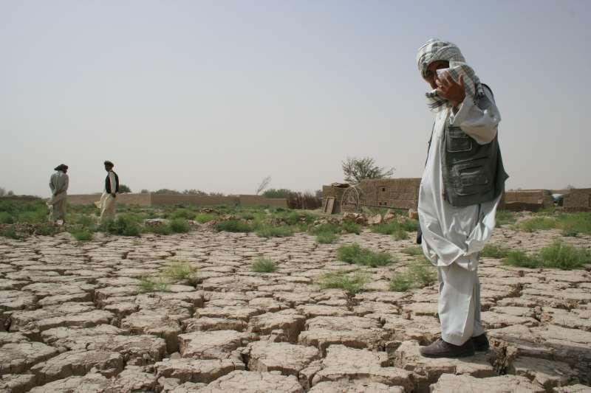
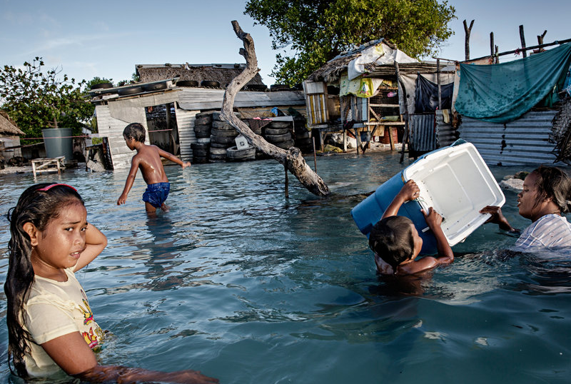

What is happening?
Why has it happened?
What might be the problems?
How do you think the people feel?

Task 3 - Watch the videos:
https://www.youtube.com/watch?v=46yvAKge3qQ
https://www.youtube.com/watch?v=m0xD4lg2Vmg

Task 4 - Think back to last topic (Migration, Population and Refugees). Write your own definition of what you think a climate change refugee and an environmental migrant is.

Task 5 - Climate change refugees are often affected by flooding in the places that they live. Complete the flow chart below to show the link between climate change and flooding.
Words to fill in: Global warming Sea level rise Warmer temperatures
Climate change Flooding Ice melts
Warmer temperatures Global warming Sea level rise

Flooding
Climate change

Task 6 - Read through the DART below, highlight all the phrases to show the impact of climate change on these people.
Climate refugees are defined as people who have been forcibly displaced as a result of environmental factors caused by climate change and natural disasters.
Every year since 2008, 26.4 million people have been forced to leave their homes due to events such as flooding, earthquakes, hurricanes and droughts.
Due to global warming, soon, Latin America will have less drinking water, Europe’s seaside flooding will rise and the death rate from disease associated with floods and droughts is expected to increase in Asia. In Africa, between 75 and 250 million people are predicted to not have enough water by next year.
The world’s poorest people will be hit the hardest. Rising sea-levels and extreme weather events will be disastrous for those living in drought or flood-prone places.
People are going to struggle to access clean water and there might be food shortages in some of the worst affected areas. Lots of the at-risk places are also farming communities and flooding or drought will destroy their food. Like the people in Kiribati, houses might also be lost. People will have to move to places where flooding doesn’t happen. This might mean families being split up, children having to leave school and people’s things being lost/damaged.
*Challenge*: Write a letter to one of the biggest polluting countries (China, USA, India, Russia, Japan) explaining who climate refugees are and why these countries need to start taking responsibility.
Lesson 9 – Managing climate change
LI: To evaluate how humans are responding to climate change
Task 1 - Correct the mistakes in the paragraph below to show what you know about climate change.

Climate change is something that affects everyone around the world in the same way. The average temperature of the earth is current decreasing and is known as global warming. Some of the causes of climate change include driving cars, volcanic eruptions and using renewable energy (like solar power).
People and the environment are both impacted by climate change. One of the big problems is that the ice is melting which causes sea levels to go down. This has led to many animals and plants becoming endangered.
Rising sea levels also causes more flooding which affect millions of people. Climate change refugees are forced to leave their homes because they want to go on holiday somewhere sunny. Some of the problems faced by climate change refugees include loss of homes, lack of clean water and food running out.
Task 2 –
Why is it important that we start to protect the environment?
Try to think of 7 reasons.

Task 3 - Find the definition of the following words:

Conservation
Renewable energy
Fossil fuels
Endangered
Extinct
Pollution

Task 4 - What can we do to help to slow down climate change?
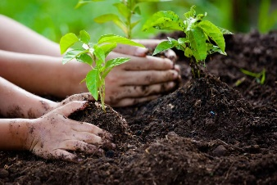
Match the picture to the strategy that is being described.
Eat less meat

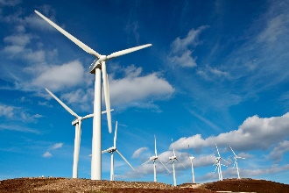
Planting more trees

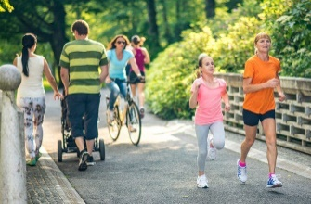
Recycling

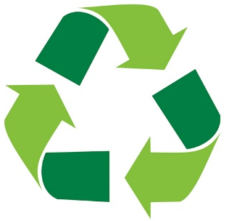
Running/cycling instead of using a car

Using renewable energy (wind and solar)
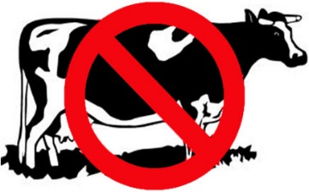

Which do you think is the best method? Why do you think this?
*Challenge* Why do certain strategies work better in some places than others?
For example, why are solar panels going to work better in Spain than Scotland? Why is planting trees easier in Devon than London?
Task 5 - Read through the DART and fill out the table to describe the different strategies to reduce the rate of climate change.
Using renewable energy (solar and winder power)
Using alternative energy reduce the use of fossil fuels (coal, gas and oil). This will reduce the amount of carbon dioxide released into the atmosphere and when we burn fossil fuels it produces lots of pollution that goes into the air. Lots of countries are trying to find new types of energy. This is a good method because it means less CO2 is produced and energy lasts for longer, but it can be very expensive and so it’s right for all countries. Other sources of energy can also sometimes need certain a weather/climate.
Planting trees
This means that there will be more trees to absorb the carbon dioxide in the air (photosynthesis). Tree are also good because when they are alive, they store lots of carbon, so it isn’t in the atmosphere. Planting more trees isn’t just about climate change, trees are also important habitats for wildlife, and they can make places much nicer to live in. We can all this multipurpose. However, to plant trees we need to have access to lots of trees and space. Trees also take a long time to grow to full size (when they absorb the most CO2) – the oldest tree in the world is around 4,700 years old!
Eating less meat
We now know that cows are a big contributor to climate change (with all the methane they produce when they fart). Therefore, the less meat and dairy that we eat, the less need there will be to have such big farms which can be big carbon and methane polluters. Also thinking about where your food is coming from so it isn’t travelling thousands of miles across the world will also reduce the amount of carbon in the air. Transporting exotic fruits and vegetables from one destination to another requires a lot of energy, usually from the burning of fossil fuels, which contributes to greenhouse gas emissions and global warming. A risk of this change is that farmers will suffer if people aren’t buying their meat. But it’s all about balance and being aware of your environmental impact without changing everything.
Walking/running/cycling instead of using cars
Walking, running, cycling, or using public transport rather than fossil fuel powered cars helps to reduce the amount of greenhouse gasses we produce. In London, there is a congestion charge to try and reduce the amount of people driving around the city. There are also other health benefits of running, walking and cycling instead of using cars all the time so both individuals and the environment can benefit. But, sometimes using cars is unavoidable and some areas are poorly connected, so people need to drive to work, school and shops. When people are so used to using cars every day, it is hard to change the attitudes of whole countries.
Recycling
Reducing, reusing and recycling helps to conserve resources and energy, and reduce pollution and greenhouse gas emissions produced. Recycling is a very popular method which means that we don’t have to keep making as much plastic, cardboard, paper and metal. Both plastic and metal need lots of fossil fuels to be made which we know, puts carbon into the air. Paper and cardboard are made by cutting down trees which are important carbon stores. This strategy is good because it can be made accessible to lots of people – in the UK we have recycling bins everywhere. However, it can be expensive, and many countries don’t have any proper rubbish collection. Also, there are lots of things that can’t be recycled and if people don’t recycle then there will still be demand for certain things that can be bad for the environment.
*Challenge* International Agreements
These include the Kyoto Agreement 2005 and the Paris Agreement 2020. Countries will meet and sign agreements to reduce the amount of carbon and pollution that they produce. If they don’t stick to it, they might have to pay lots of money. These agreements are great if countries want to sign up and stick to what they have set out, if we have the whole world working towards the same outcome then it’ll be easier to achieve. But this isn’t always the case. For example, the USA has now opted out of the Paris Agreement 2020 and as one of the biggest polluters in the world this is a worry for the environment. Also, there often aren’t serious consequences if countries don’t reach the targets.

Strategy | Description (Tell me about the strategy in your own words) | Positives | Negatives | Whole country or individuals?
Planting more trees
Eating less meat
Recycling
Using renewable energy (wind and solar)
Walking / running / cycling instead of using a car

*Challenge*
International agreements

Lesson 10 – Extension Activities
Create a guide to inform people about how they can be more environmentally friendly and reduce their contribution to global warming. Think about the changes that people can make daily. This can include things such as eating less meat, recycling, using public transport and walking more.
Or
Create a guide for Stewards Academy about what could be done in school to reduce our impact on the environment. What advice could you give to teachers and students to make sure they are doing their bit?

Using Maths Skills in Geography
- 500 people are affected by a small earthquake in Italy. £7000 is donated to help the people. If the money is split equally, how much will everyone receive?
- In Japan there are 5 earthquakes in 1 month. The magnitudes of these earthquakes are: 5.5, 6.1, 4.5, 3.2 and 7.8.
Calculate the average magnitude of earthquakes for this month.
- On a conservative plate boundary, the plates move 0.2cm past each other every year. How many years will it take for the plates to move 2 meters?
- 200 years b. 1000 years c. 10 years
- After a flooding disaster in Kiribati, 15% of the population leave the islands. Before the flood there were 100,000 people living there.
- Calculate how many people left the island because of the flood
- Calculate the remaining population on Kiribati
- A survey is carried out to find out what people are doing about climate change. 100 people are asked, and the results are in the table below:
How many of the following options do you do in your daily life?
Recycling | 80
Walking/running rather than driving a car | 25
Eating less meat | 50
Use renewable energy | 5
- What fraction of people said, ‘Walking/running rather than driving a car’?
- What percentage of people said, ‘Use renewable energy’?
- How many more people would need to say ‘Recycling’ to make it 100% of people?

