English Year 7 Spring A
Blended Learning Booklet
Poetry Through Time
Name:
Form:
English Teacher:
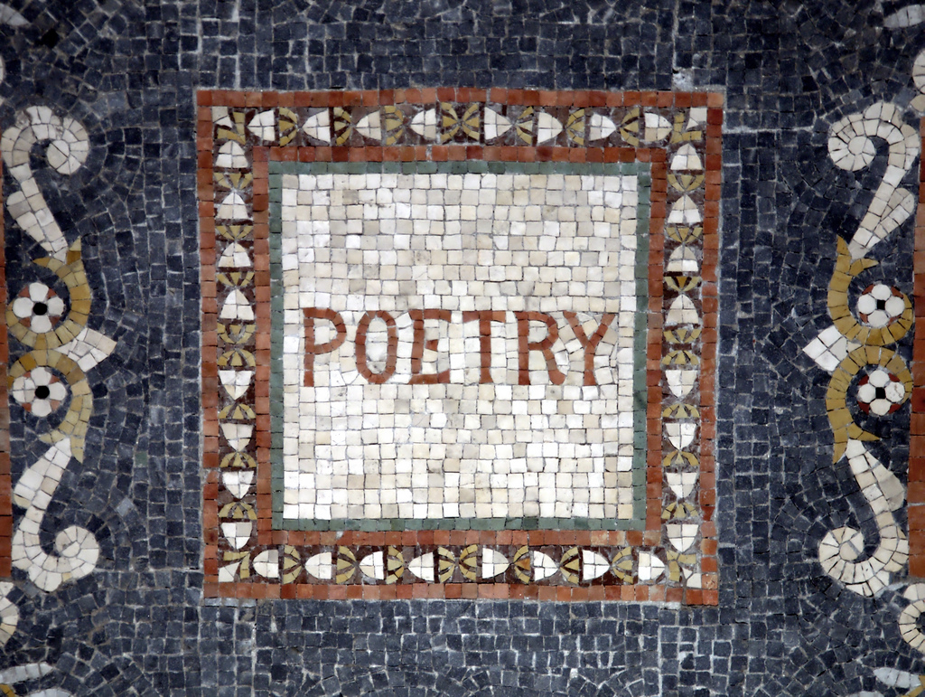

Contents

Page Number | Lesson Number | Title
6 | 1 | Introduction to Poetry
8 | 2 | Beowulf
10 | 3 | Paradise Lost
12 | 4 | Sonnets
15 | 5 | The Tyger
18 | 6 | Daffodils
21 | 7 | London
22 | 8 | London through Time
25 | 9 | Rime of the Ancient Mariner
27 | 10 | The Lady of Shalott
29 | 11 | If
30 | 12 | Maya Angelou
32 | 13 | Refugee Poetry
35 | 14 | Conflict Poetry
37 | 15 | Family Reunions
38 | 16 | Writing you own Ballad
42 | SAL

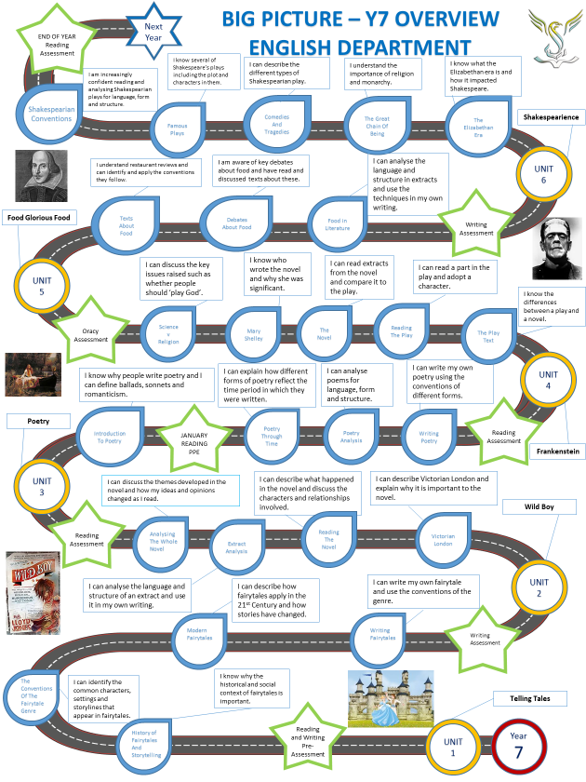

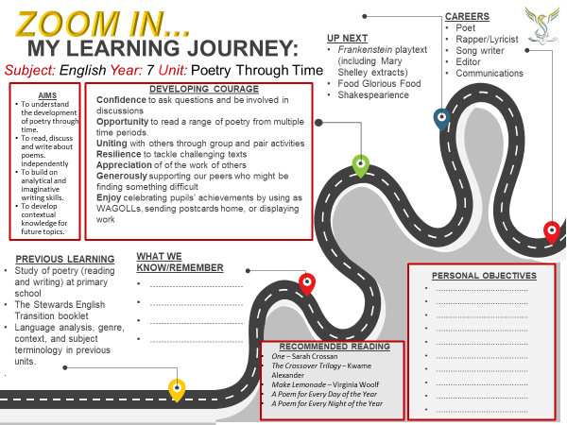

Knowledge Organiser

The Oral Tradition  - Old English poetry was part of the oral tradition meaning it would be spoken or sung rather than written down.  - Old English poems were meant to be performed rather than read silently.  - Beowulf is about a king who has a problem and needs warriors to help him; this is a very typical theme in Old English poetry. There is only one single thousand-year old manuscript that tells the story of Beowulf. | Sonnets  - A sonnet is 14-line poem with a variable rhyme scheme originating in Italy and brought to England in the 16th century.  - The Petrarchan sonnet divides the 14 lines into two sections: an eight-line stanza (octave) rhyming ABBAABBA, and a six-line stanza (sestet) rhyming CDCDCD or CDECDE.  - The Shakespearean sonnet condenses the 14 lines into one stanza of three quatrains and a concluding couplet, with a rhyme scheme of ABABCDCDEFEFGG. | Romantic Poetry  - During the 18th and 19th centuries the UK (along with most of Europe) saw a massive migration of rural workers into large towns and cities (the Industrial Revolution).  - Wordsworth and Blake were among those who developed the poetry of Romanticism, believing the Industrial Revolution to be causing more harm than good.  - Romanticism was a celebration of the natural, artistic, and emotional world in everyday language of the time (not romantic love).
Ballads  - The ballad began as a folk song and continues today in popular music. Many love songs today can be considered ballads.  - Almost all ballads are narrative, which means they tell a story. There is usually a moral to the story or a message for the reader at the end.  - A typical ballad consists of stanzas that contain a quatrain, or four poetic lines. The meter or rhythm of each line is usually iambic, and the rhyme scheme often ABAB. | Conflict Poetry  - WW1 poetry described the terror of the trenches and the futility of war. Poets were often clearly pro-war, such as Rupert Brooke, or clearly anti-war, such as Wilfred Owen.  - The poems for which Wilfred Owen is remembered capture the death and destruction of the battlefield in unflinching detail, making a nonsense of the customary patriotic tub-thumping about duty and heroism.  - Here, Bullet is a book of poems about the war in Iraq. It is a first person account of the Iraq War by a soldier-poet. | Contemporary Poetry  - Maya Angelou (1928-2014) was an American poet and civil rights activist. She was respected as a spokesperson for black people and women, and her works have been considered a defence of black culture.  - Brian Bilston and Warsan Shire highlight the plight of refugees. A refugee is someone who is outside their own country and unable to return because they believe that their life is in danger because of their race, nationality, religion, political opinion, or social group. Often refugees are displaced because of natural disaster or war.

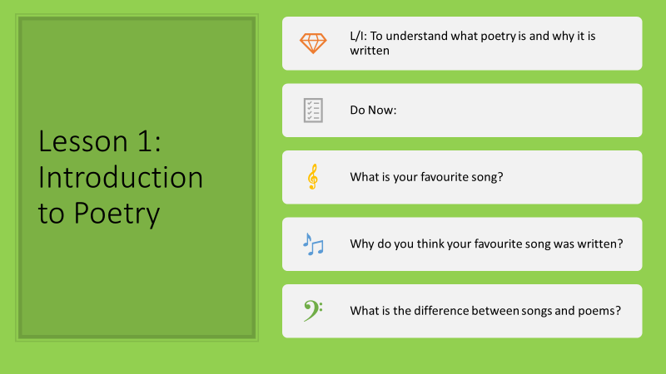
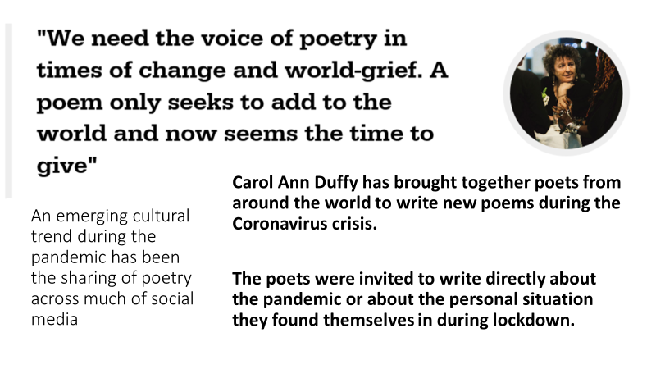
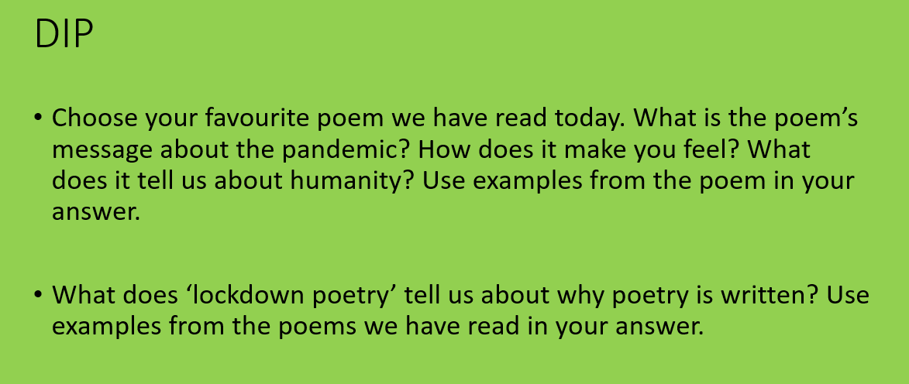
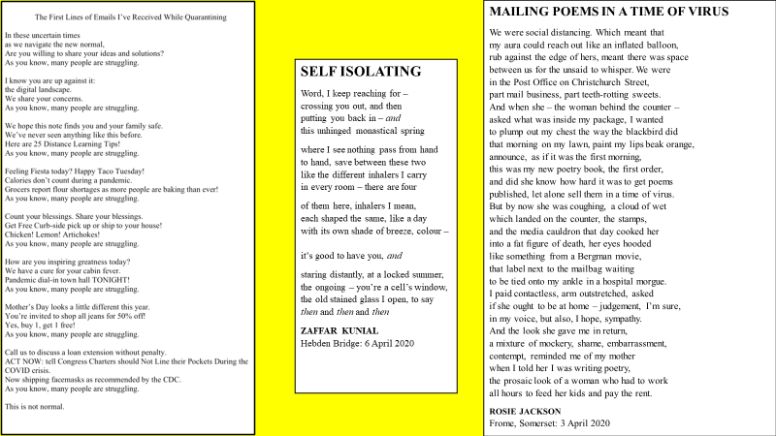
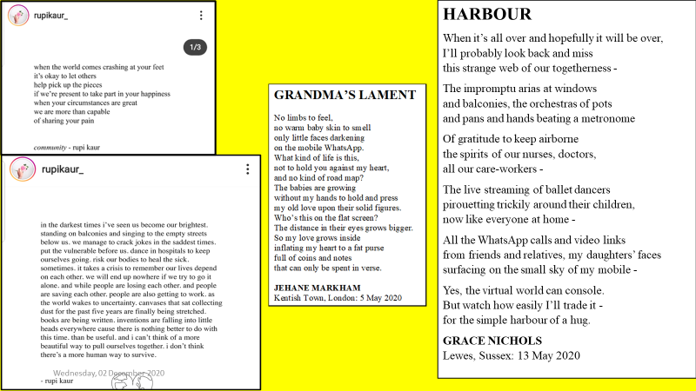
********************************************************************************

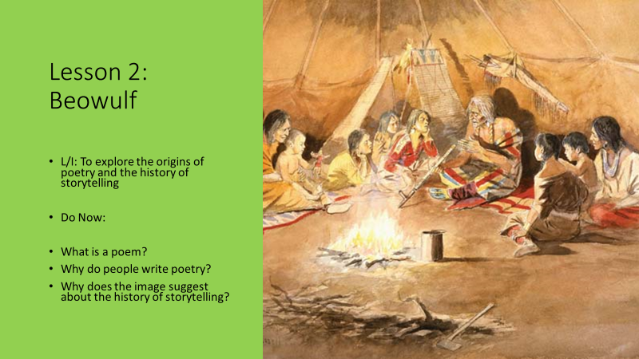
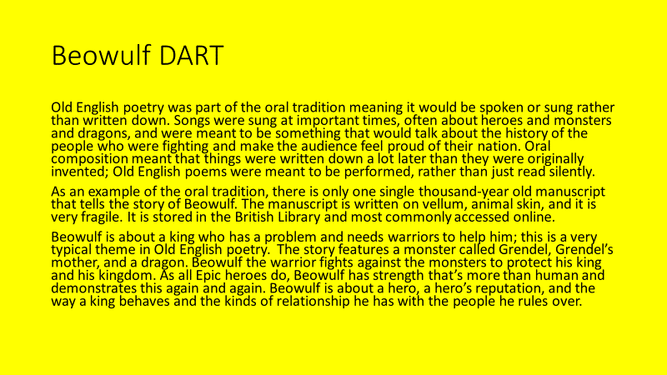
- What is the oral tradition?
- When did people sing songs and what were they often about?
- Where is the original Beowulf manuscript stored?
- What is Beowulf and what does he do?
- Who is Grendel?
- Why were Old English poems performed orally and not written down?

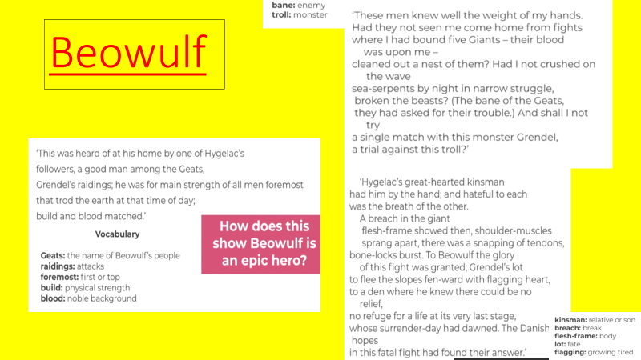
What do the following tell us about Beowulf?
- ‘A good man’
- ‘He was of main strength of all men foremost’
- ‘Build and blood matched’
- ‘These men knew well’
- ‘Bound five giants’
- ‘Great-hearted kinsman’
- ‘Shoulder muscles sprang apart’
- ‘To Beowulf the glory of this fight was granted’
- Anything else you can identify in the three extracts

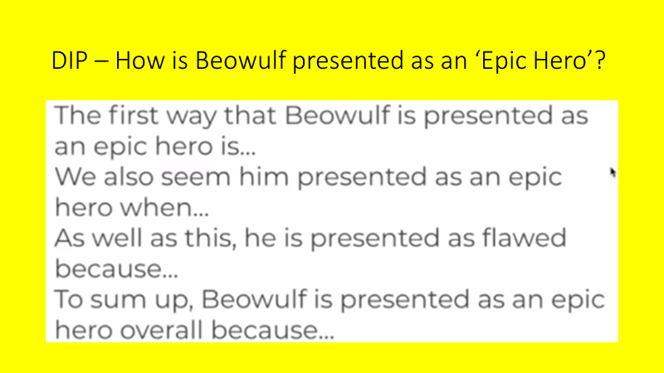
*************************************************************************
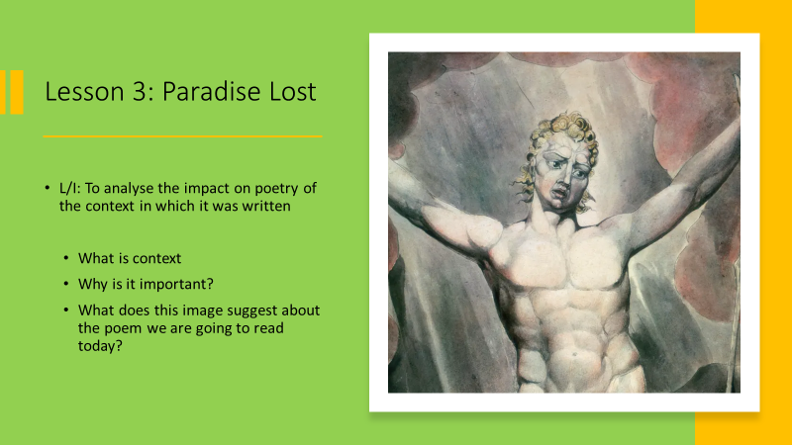
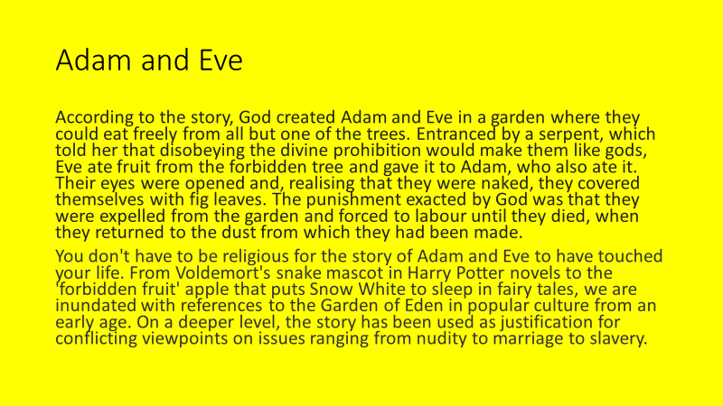
- Who does Christianity believe created Adam and Eve?
- What were Adam and Eve told they were not allowed to do?
- Why did Eve eat fruit from the tree?
- What punishment did Adam and Eve receive?
- Which character reflects this story in Harry Potter?
- Why could this story be used as justification for certain historical views of women?

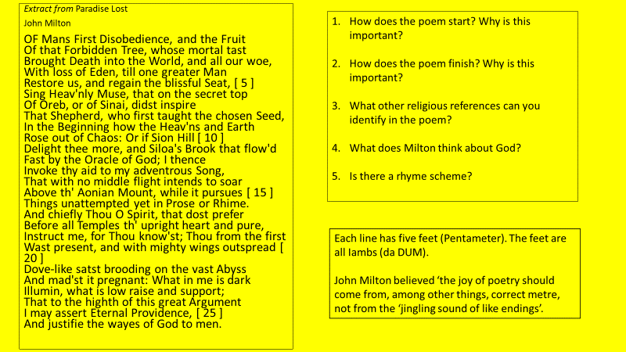
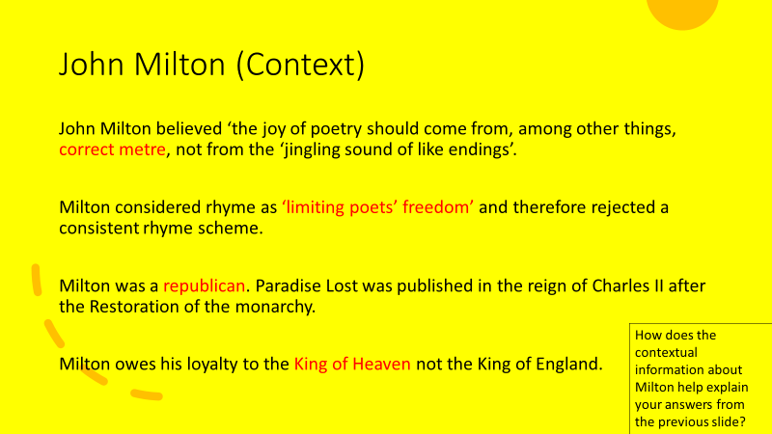
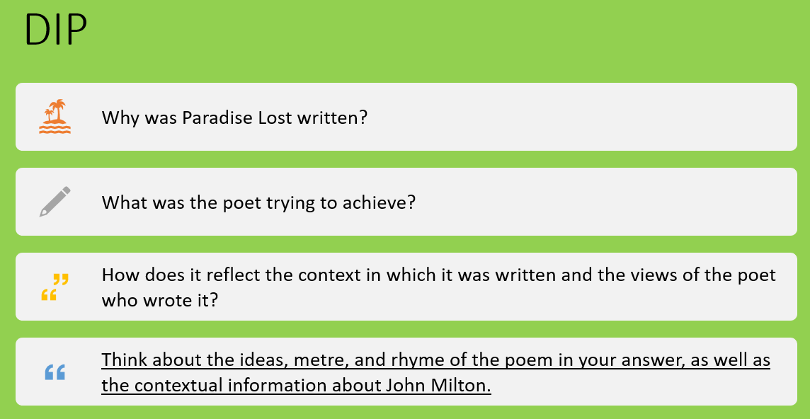
****************************************************

Lesson 4: Sonnets
L/I: To understand and explore the importance of poetic form
What is rhyme?
What is rhyme scheme?
What is the form of a poem?
- Rhyme is the correspondence of sound between words or the ending of words
- A rhyme scheme is a pattern of rhyme within a poem
- The form of a poem the overarching structure or pattern of the poem - how it

DART: History of the Sonnet
A sonnet is 14-line poem with a variable rhyme scheme originating in Italy and brought to England in the 16th century. Literally a “little song,” the sonnet traditionally reflects upon a single sentiment, with a clarification or “turn” of thought in its concluding lines. There are many different types of sonnets:
The Petrarchan sonnet, perfected by the Italian poet Petrarch, divides the 14 lines into two sections: an eight-line stanza (octave) rhyming ABBAABBA, and a six-line stanza (sestet) rhyming CDCDCD or CDECDE.
The Italian sonnet is an English variation on the traditional Petrarchan version. The octave’s rhyme scheme is preserved, but the sestet rhymes CDDCEE.
The English (or Shakespearean) sonnet condenses the 14 lines into one stanza of three quatrains and a concluding couplet, with a rhyme scheme of ABABCDCDEFEFGG.

DART Questions:
- How many lines are in a sonnet?
- What does the word sonnet translate to in English?
- What is the difference between an octave and a sestet?
- What is the rhyme scheme of a Petrarchan sonnet?
- What does a Shakespearian sonnet end with?
- Why do poets use strict poetic forms?

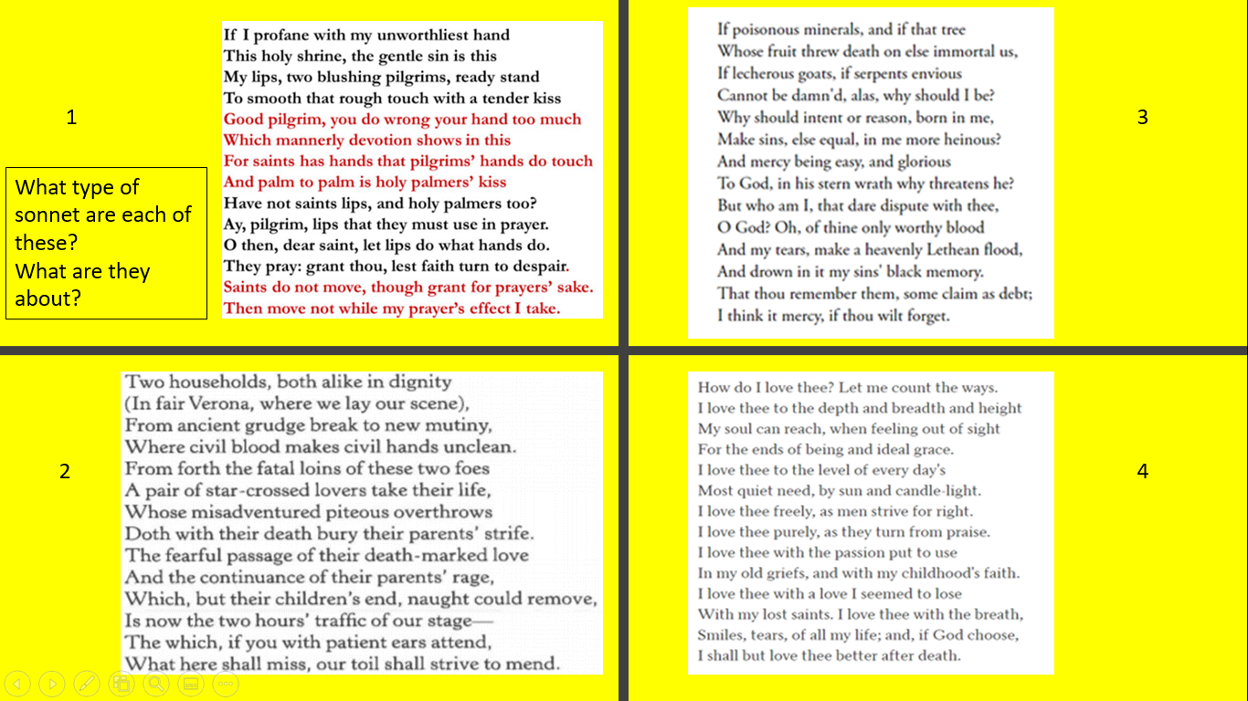
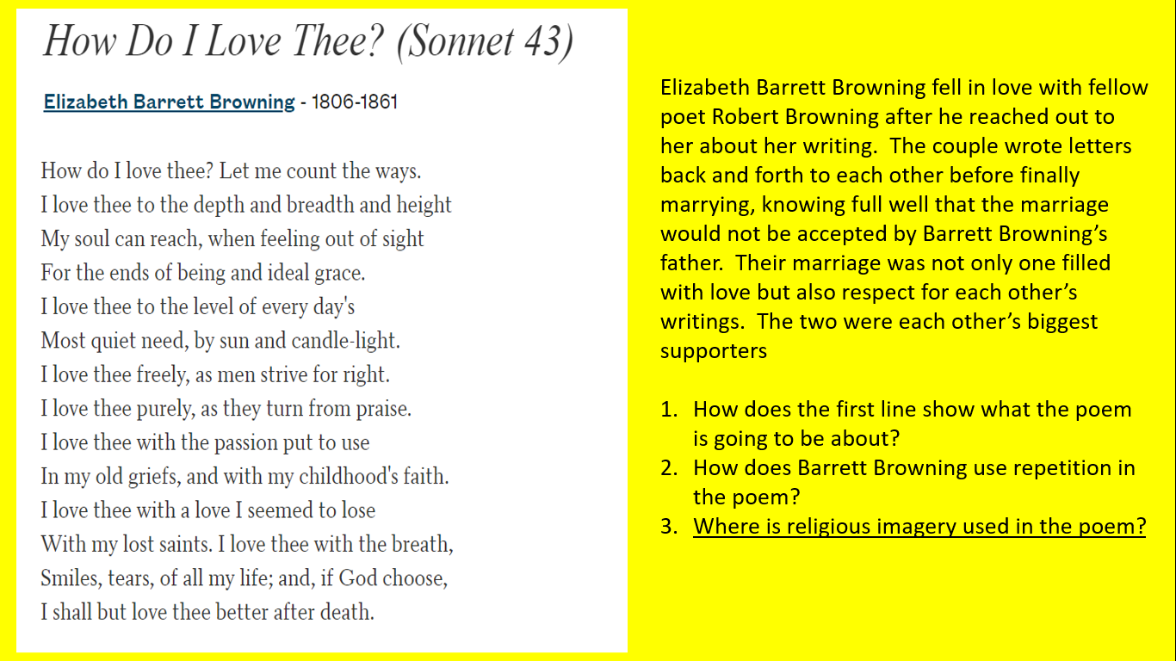
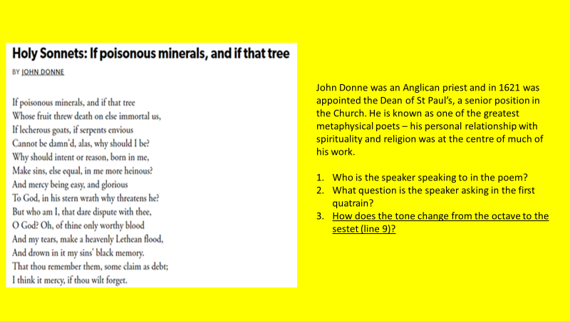
DIP Task: What is a sonnet? Think about:
- Your DART answers
- The different forms of a sonnet
- The examples we have read and the themes/ideas they include
- Why people write sonnets
- The context (time period) in which they were often written and how this impacts their content

**********************************************************************************
Lesson 5: Tyger by William Blake
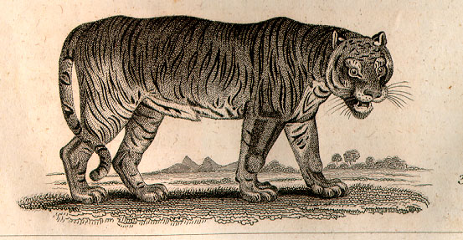
L/I: To analyse the use of language in poetry to create specific effects
Do Now:
What does romantic mean?
What is a romantic poem?
How would you feel if you encountered a tiger?

Romantic Poetry

- Romantic poetry is the poetry of the Romantic era, an artistic, literary, musical and intellectual movement that originated in Europe towards the end of the 18th century.
- Romantic poetry is the poetry of sentiments, emotions and imagination.

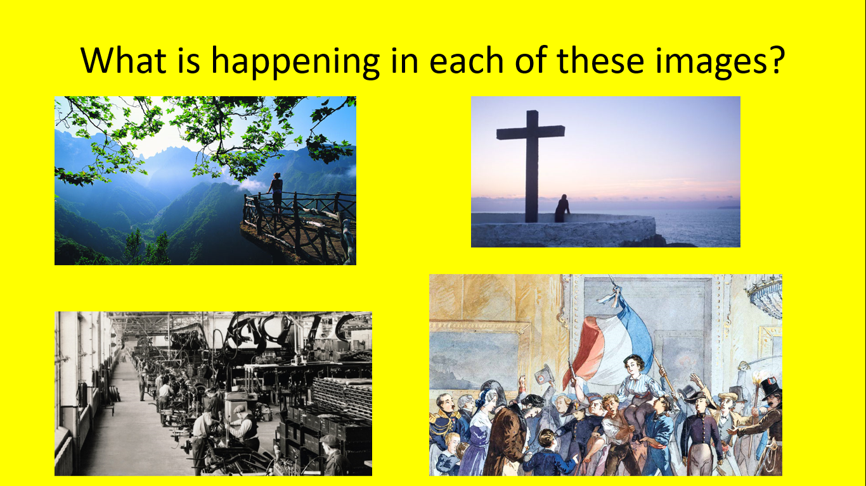

DART
Romanticism was closely tied to the Industrial Revolution in Europe. From the latter decades of the 18th century to the middle of the 19th century, most of Europe and particularly what is now the United Kingdom saw a massive migration of rural workers into large towns and cities. These workers were making the jump in order to work in the large factories that were springing up all over metropolitan areas as manufacturing capacity, aided by steam engines and copious supplies of coal, exploded all across Europe.
William Blake believed the Industrial Revolution was causing more harm than good. He described it as evil, strong and cold, compared it to the devil, and hated that it forced children to work. Blake thought people were trapped in the Industrial Revolution and were unable to escape, and believed that it prevented people from understanding the true beauty of the natural world.

DART Questions
- When was the romantic period?
- What was taking place in Europe at this time?
- Where did rural workers migrate to?
- What aided the growth of factories?
- What did Blake believe about the developments of this time period?
- How might these views impact Blake’s descriptions of natural beauty?

Use these questions to guide your annotations
- What is the rhyme scheme?
- Where does Blake use repetition? Why?
- What do ‘burning bright’, ‘fire of thine eyes’ and ‘fearful symmetry’ suggest the poet thinks about the tiger?
- Who does Blake think created the tiger? How do we know?
- Why does Blake ask so many questions?
- Which theme do ‘shoulder’, ‘hammer’, ‘chain’ and ‘furnace’ all link to?
- Why is the final word in the poem significant?
- What is Blake suggesting about the power of nature?

The Tyger BY WILLIAM BLAKE

Tyger Tyger, burning bright,
In the forests of the night;
What immortal hand or eye,
Could frame thy fearful symmetry?

In what distant deeps or skies.
Burnt the fire of thine eyes?
On what wings dare he aspire?
What the hand, dare seize the fire?

And what shoulder, & what art,
Could twist the sinews of thy heart?
And when thy heart began to beat,
What dread hand? & what dread feet?

What the hammer? what the chain,
In what furnace was thy brain?
What the anvil? what dread grasp,
Dare its deadly terrors clasp!

When the stars threw down their spears
And water'd heaven with their tears:
Did he smile his work to see?
Did he who made the Lamb make thee?

Tyger Tyger burning bright,
In the forests of the night:
What immortal hand or eye,
Dare frame thy fearful symmetry?

- What is the poem about?
- What message is the poet trying to communicate?
- What do you like about the poem/what does the poet do well?
- What do you not like about the poem?
- What patterns do you notice in the poem?
- What puzzles you about the poem?

How does Blake use language and structure to describe the tiger?
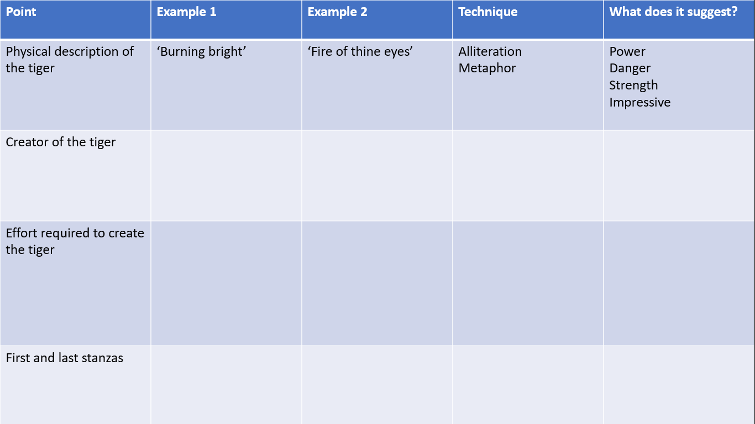
WAGOLL
Blake uses language to describe the physical features of the tiger. For example, he tiger is described as ‘burning bright’ and as having ‘fire in thine eyes’. The fire metaphor used in both these examples suggests the tiger is powerful, dangerous and strong as it ‘burns bright’ like a powerful fire, and this strength is clearly evident in the tiger’s eyes. This shows the reader Blake is in awe of the tiger, believing it to be a hugely impressive and dominant animal.
DIP TASK: Write a paragraph of your own using your notes and the WAGOLL as a guide.

**********************************************************************************

Lesson 6: Daffodils
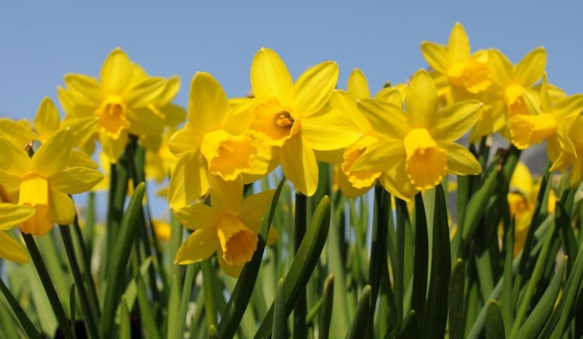
L/I: To compare two poems and explore the romantic genre
Do Now:
- What is the image of?
- What time of year do you associate with the image?
- How does the image make you feel?

DART: William Wordsworth biography
William Wordsworth (1770-1850) was one of the leading poets of his generation and, together with such contemporaries as Blake, Coleridge, and Keats, developed the poetry of Romanticism. This is not to be confused with the poetry of romantic love; but, rather, it was a celebration of the natural, artistic and emotional world in everyday language of the time. Wordsworth once famously described poetry as the ‘spontaneous overflow of powerful feelings’ and a good deal of his poetry sets out his feelings in response to his experiences of the world around him. Wordsworth was born in the Lake District and spent much of his life there, although in his early life he also spent time in France during the French Revolution and undertook a walking tour of France and Switzerland, whose landscapes made a great impression on him. Many of his poems show his deep understanding and sympathy for his surroundings.

DART Questions:
- Who were Wordsworth’s contemporaries?
- What should romantic poetry not be confused with?
- What type of language did romantic poets use?
- Where was Wordsworth born?
- What happened while he was in France?
- How might the answers to question 4 and 5 impact Wordsworth’s view of the world?

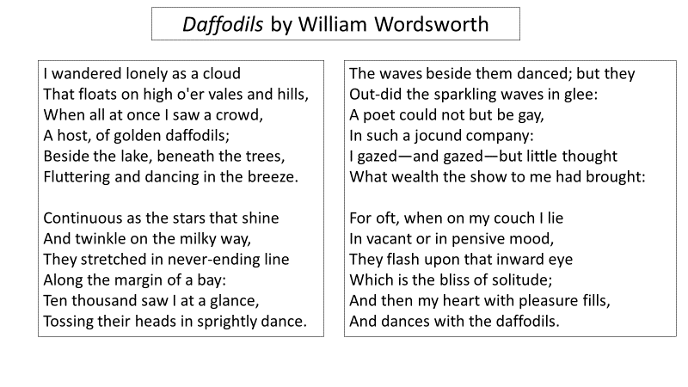
- Wordsworth describes the feeling of coming across thousands of daffodils blooming in front of a lake, and the recollection of these feelings later
- How does this match with Wordsworth’s views on poetry?
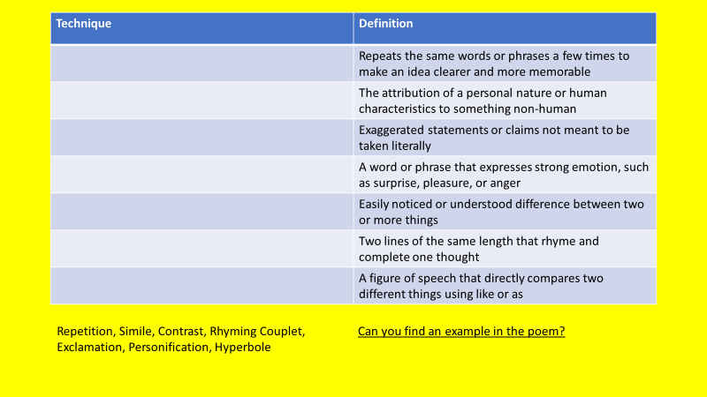
Big Think Questions
- How does Wordsworth describe the daffodils in the poem?
- Can you find examples?
- How does this compare to the way Blake describes the tiger?

Daffodils
Wordsworth uses language to explore the power of nature in Daffodils. For example, the daffodils are described as ‘fluttering and dancing in the breeze’ and ‘tossing their heads in sprightly dance.’ The repetition of the idea of dancing, using personification to bring the daffodils to life, suggests the daffodils are creating feelings of happiness, as you tend to dance when you are in a good mood or celebrating. This shows the reader the power of nature to create and influence the mood.
Wordsworth uses nature to explore the power of nature in daffodils. For example, the daffodils are described as being ‘continuous as the stars that shine and twinkle on the milky way’. The hyperbole shows how many daffodils there are and what an impressive sight it is while the idea of ‘stars’ suggest they are ‘out of this world’ and are bright and beautiful in the way that stars are. This suggests to the reader they are more beautiful than anything on earth and are more like stars because they are so pretty
Tyger
Blake uses language to describe the physical features of the tiger. For example, the tiger is described as ‘burning bright’ and as having ‘fire in thine eyes’. The fire metaphor used in both these examples suggests the tiger is powerful, dangerous and strong as it ‘burns bright’ like a powerful fire, and this strength is clearly evident in the tiger’s eyes. This shows the reader Blake is in awe of the tiger, believing it to be a hugely impressive and dominant animal.
Blake uses language to describe the creator of the tiger and therefore show how special the tiger is. For example, ’what immortal hand?’ and ‘he who made the Lamb?’ show us God created the tiger. This imagery and these rhetorical questions suggest the person who made the tiger will never die and therefore it must have been God. This shows the reader that only God could make something so special and strong, and if not God then it could not have been anyone else.
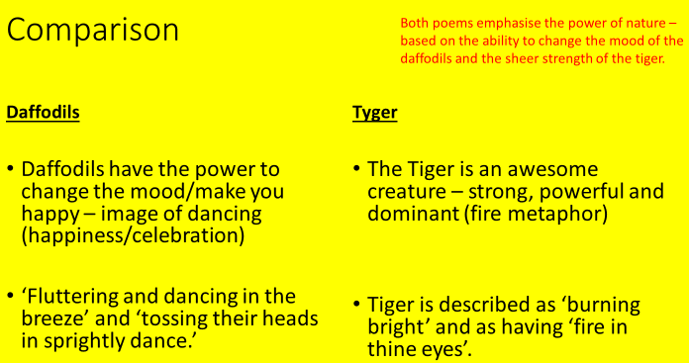
DIP TASK
How do the poems present nature? Write a paragraph – use the sentence stems below to help:
- Blake and Wordsworth both present the power of nature in their poems.
- Wordsworth uses… to present daffodils as…
- Blake uses…to present daffodils as…
- This is clearly different because…
- However, it could be considered similar because…
- What do we know about the romantic poet’s view of nature?
- How is this shown in these two poems?

***********************************************************************
Lesson 7: London
- LI: to respond creatively to and magpie from a poem

Do now:
- Which William Blake poem did we recently read?
- What is Blake’s view of nature?
- How does this suggest he might describe a city?

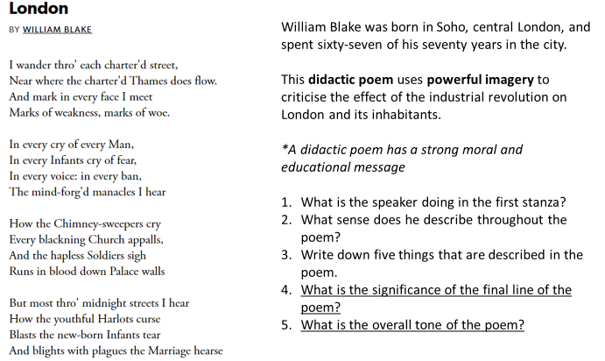

DART: Modern London
London is the most dynamic city in the world today. In the 21st century it has become the most powerful, the most dynamic, the most culturally focused city on earth. No other city comes close. Not New York. Not Paris. Not Shanghai. Not Hong Kong.
The decor and architecture of important London buildings once seemed to represent a conscious desire to be part of an imaginary immemorial London, whereas these days every new building wants to look like the future.
The city is again full of the “London Lights”, the artists, scientists, writers, architects, musicians and engineers who, like their forebears in the first half of the 19th century, through their genius and courage, luck and misfortune, anger and charm, moved mountains to put London at the cutting edge of cultural change.
In the last 10 years visitors to London have increased by 43.5 per cent, with eight out of 10 of those saying culture and heritage is why they come. In a way, culture has become the city’s business model. After all, it works: The British Museum gets more visitors than Belgium, we have 22 million theatre admissions a year, the O2 Arena is the number one venue in the world, and Tate Modern is the most visited contemporary art gallery.
DART Questions:
- What has 21st Century London become?
- Which cities is it compared to?
- What do new buildings want to look like?
- What are the ‘London Lights’?
- What three specific venues are mentioned in the final paragraph?
- What other reasons can you think of to visit London?
What images of modern London could you include in a poem? Make two lists, one with positive images and one with negative images. What sounds could you put with your chosen images?
DIP Task:
Use the structure of Blake’s poem (four quatrains, focus on sounds, imagining you are walking through London) to write a poem about modern London.

***********************************************************************
Lesson 8: London through Time
L/I: To compare the presentation of the same setting across different poems
Do now:
- What impression of London did Blake create in his poem?
- Why was this?
- How does modern London compare?
DART London in Literature
Shakespeare’s London was a rapidly-expanding and bustling city. Its populace of roughly 100,000 people included royalty, nobility, merchants, artisans, labourers, actors, beggars, thieves, prostitutes and spies, as well as refugees who had fled from political and religious persecution on the continent.
The 18th century saw the birth of industrialisation; the growth of radicalism and an increasingly repressive state. In London, extreme luxury sat alongside extreme poverty. The poet and engraver William Blake composed his poem, ‘London’ in the summer of 1792, the same year in which the French Revolution broke out across the channel.
No author is more famous for capturing the darker side of early Victorian London than Charles Dickens. Dickens’ Oliver Twist tells the story of an orphan who spends his early years in a workhouse and later becomes part of a pickpocket gang, controlled by the manipulative Fagin. A response to the newly passed Poor Law amendments, the novel is as much social commentary as it is entertainment.
It wasn’t just novelists who were interested in the less salubrious side of the capital – the slums, poverty, housing crisis and the plight of the 19th-century urban poor. In one of the first pieces of investigative journalism, in his London Labour and the London Poor (1865), Henry Mayhew conducted interviews with street-sellers, sweepers, rag-pickers and sewer-hunters, in order to share their stories with the reading public.
DART Questions
- How many people lived in Shakespeare’s London?
- What sat alongside extreme luxury in 18th Century London?
- Who wrote Oliver Twist?
- What is a social commentary?
- What was the ‘less salubrious’ side of London?
- Why is so much literature set in London?

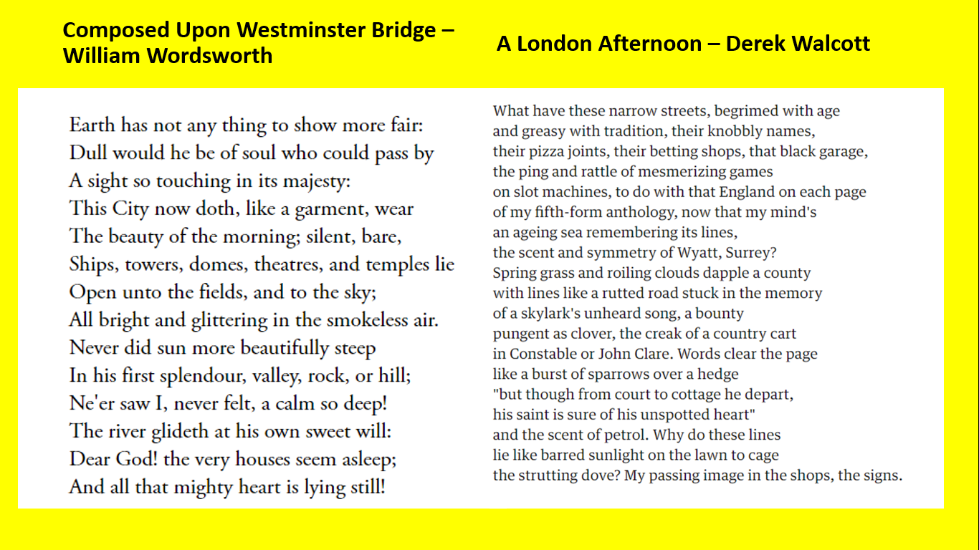
What image of London is presented by each poem?
Identify two quotations from each of the three poems we have read. What does each quote tell us about London?
DIP Task:
How is London presented in different poetry?
Sentence stems to help:
Blake’s London presents the city as…
This shows…
This suggests Blake believes…
In comparison, Wordsworth’s Composed Upon Westminster Bridge describes London as…
This shows…
This similarity/difference could be because…
Finally, Walcott presents a more modern perspective of London in ‘A London Afternoon’.
He writes…
This shows…
This is an accurate/inaccurate presentation of modern London because…

*****************************************************************************
Lesson 9: The Rime of the Ancient Mariner
L/I: To analyse the use of language in poetry to create specific effects
- What is a mariner?
- Why might we listen to an ‘ancient mariner’?

DART: What is a ballad?
A ballad is a type of poem that is sometimes set to music. Ballads have a long history and are found in many cultures. The ballad actually began as a folk song and continues today in popular music. Many love songs today can be considered ballads.
A typical ballad consists of stanzas that contain a quatrain, or four poetic lines. The meter or rhythm of each line is usually iambic, which means it has one unstressed syllable followed by a stressed syllable. In ballads, there are usually eight or six syllables in a line. Like any poem, some ballads follow this form and some don't, but almost all ballads are narrative, which means they tell a story. They is usually a moral to the story or a message for the reader at the end.
Because the ballad was originally set to music, some ballads have a refrain, or a repeated chorus, just like a song does. Similarly, the rhyme scheme is often ABAB because of the musical quality of this rhyme pattern.
While ballads have always been popular, it was during the Romantic movement of poetry in the late 18th century that the ballad had a resurgence and became a popular form. Many famous romantic poets, like William Wordsworth, wrote in the ballad form.

DART Questions:
- What is a ballad?
- How many lines are in a stanza?
- Why are most ballads ‘narrative’?
- What is a refrain?
- When did the ballad become a popular form?

PART 1 Summary
A young man is on the way to a wedding when he walks past an old man (the mariner)
The mariner starts to tell a story about being on a ship that was trapped in the ice
The appearance of an Albatross breaks the ice and the ship is freed
The mariner shoots the Albatross
What is the significance of shooting the Albatross?

PART I
It is an ancient Mariner,
And he stoppeth one of three.
'By thy long grey beard and glittering eye,
Now wherefore stopp'st thou me?

The Bridegroom's doors are opened wide,
And I am next of kin;
The guests are met, the feast is set:
May'st hear the merry din.'

He holds him with his skinny hand,
'There was a ship,' quoth he.
'Hold off! unhand me, grey-beard loon!'
Eftsoons his hand dropt he.

He holds him with his glittering eye—
The Wedding-Guest stood still,
And listens like a three years' child:
The Mariner hath his will.

The Wedding-Guest sat on a stone:
He cannot choose but hear;
And thus spake on that ancient man,
The bright-eyed Mariner.

'The ship was cheered, the harbour cleared,
Merrily did we drop
Below the kirk, below the hill,
Below the lighthouse top.

The Sun came up upon the left,
Out of the sea came he!
And he shone bright, and on the right
Went down into the sea.

Higher and higher every day,
Till over the mast at noon—'
The Wedding-Guest here beat his breast,
For he heard the loud bassoon.

The bride hath paced into the hall,
Red as a rose is she;
Nodding their heads before her goes
The merry minstrelsy.

The Wedding-Guest he beat his breast,
Yet he cannot choose but hear;
And thus spake on that ancient man,
The bright-eyed Mariner.

And now the STORM-BLAST came, and he
Was tyrannous and strong:
He struck with his o'ertaking wings,
And chased us south along.

With sloping masts and dipping prow,
As who pursued with yell and blow
Still treads the shadow of his foe,
And forward bends his head,
The ship drove fast, loud roared the blast,
And southward aye we fled.

And now there came both mist and snow,
And it grew wondrous cold:
And ice, mast-high, came floating by,
As green as emerald.

And through the drifts the snowy clifts
Did send a dismal sheen:
Nor shapes of men nor beasts we ken—
The ice was all between.

The ice was here, the ice was there,
The ice was all around:
It cracked and growled, and roared and howled,
Like noises in a swound!

At length did cross an Albatross,
Thorough the fog it came;
As if it had been a Christian soul,
We hailed it in God's name.

It ate the food it ne'er had eat,
And round and round it flew.
The ice did split with a thunder-fit;
The helmsman steered us through!

And a good south wind sprung up behind;
The Albatross did follow,
And every day, for food or play,
Came to the mariner's hollo!

In mist or cloud, on mast or shroud,
It perched for vespers nine;
Whiles all the night, through fog-smoke white,
Glimmered the white Moon-shine.'

'God save thee, ancient Mariner!
From the fiends, that plague thee thus!—
Why look'st thou so?'—With my cross-bow
I shot the ALBATROSS.

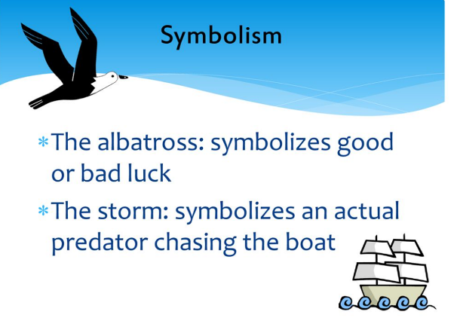
- Simile – something is like or as something else

- Personification – describing something as human when it is not

- Sensory description – see, hear, touch/feel, smell, taste

- Alliteration – repetition of a letter or sound
- Onomatopoeia – using words that sound like the noises the words refer to
- Assonance – the similarity in sound between two syllables that are close together, e.g. back

DIP Task: How does Coleridge use language in the Time of the Ancient Mariner?
- Samuel Taylor Coleridge uses similes in the Rime of the Ancient Mariner. For example, he describes the wedding guest as listening ‘like a three years child’. This simile shows he was totally focused on what the mariner was saying to him and suggests that he looked young and innocent compared to the older man.
- Coleridge uses personification. For example…
- Sensory description also helps create the imagery in the Rime of the Ancient Mariner. For example…

****************************************************************************************************
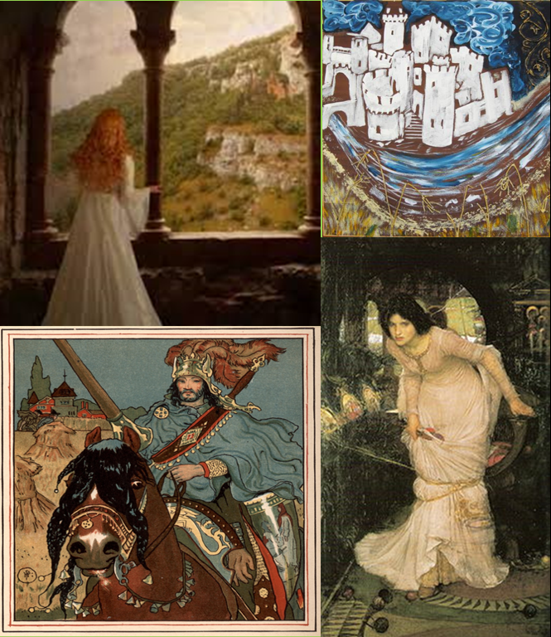
Lesson 10: The Lady of Shalott
L/I: To analyse the overall structure of a text to identify how key ideas are developed

Do now:
What do these images suggest about the Lady of Shalott and the story?

DART: Victorian Women
The Lady of Shalott was written in 1832. The Victorian era (1837-1901) was characterised by a very strict set of rules governing social interactions. Women, especially upper class women, were relegated to the domestic sphere and often barred by their fathers and husbands from participating in society . Interactions between men and women were often limited to family relations. Women mostly remained indoors and performed household tasks like weaving, cooking, and cleaning. The isolation experienced by the Lady of Shalott echoes the situation of many Victorian woman, who had very few rights and almost no personal independence.

- When was the Lady of Shalott written?
- By what was the Victorian era characterised?
- Which men could women interact with?
- What jobs did most women do?
- What did Victorian women not have?
Challenge
What can we assume about the Lady of Shalott from the context in which the poem was written?
What order do you think these events happened?
- Sir Lancelot, a handsome knight, rides past. He is brilliantly dressed on a wonderful horse, and he is singing.
- A description of the city of Camelot. It has a river surrounded by fields. There are willow trees and flowers. On the river there are large barges drawn by horses. In the fields workers are cutting the barley. There is a large grey building with towers.
- The Lady sings as she floats down the river. As she drifts down to Camelot she slowly dies.
- The Lady disobeys what she has been told. She looks out of the window. The mirror cracks. She knows her final punishment has come.
- A woman sits alone in a room. She is weaving a magic web. She is cursed and isn’t allowed to look out of the window. She sits in front of a mirror and watches in it reflections of what is happening outside the window. She sees many different sights.
- In Camelot people gather to look at the Lady in the boat. Sir Lancelot sees her. He says sadly that she was very beautiful. He hopes that God will bless her now that she is dead.
- The weather is dark and stormy. The Lady finds a boat tied up by the river. She lies down in it.

DIP Task:
What does the Lady of Shalott reveal about the purpose of a ballad?
Think about:
- Why does the Lady of Shalott die?
- What is the moral of the ballad?
- How does this reflect the time period in which it was written?

*********************************************************************
Lesson 11 If
L/I: To analyse the impact on poetry of the context in which it was written

Do Now:
- What is the best piece of advice you have ever received?
- Who gave it to you?

DART: Victorian Men
Victorian society often placed unrealistic expectations on all people. Although men were in almost all senses regarded as superior to women during this time, there was an immense pressure to conform to societal roles and expectations. If they did not meet these standards and expectations that society had set for them they were deemed as unacceptable and not suitable for marriage. Men were expected to earn money and lead their family, becoming head of a household and providing for a wife and children. If a man was not married society would assumed he was unable to support a family and that he had therefore failed. A man's masculinity was also determined by his occupation. Reputable occupations for middle and upper class men within society included engineering, careers in medicine, and careers in law. Society expected a man to be well-dressed, respectful, and kind-hearted. In times of war a man would be judged on his bravery, sense of patriotic duty, and willingness to fight.

DART Questions:
- What type of expectations did Victorian society place on ‘all people’?
- What were men expected to do?
- What would society assume about an unmarried man?
- Identify three ‘reputable’ occupations
- How else would a man be judged?
- How do expectations of men compare to those of women?

Context
- If by Rudyard Kipling was published in 1895.
- It is widely regarded as an example of Victorian era stoicism.
- If was either written for Kipling’s son, or as a tribute for Dr Leander Starr Jameson who fought bravely in the Boer War.
- Stoicism - teaches the development of self-control and fortitude as a means of overcoming destructive emotion. A stoic is someone who seems indifferent to emotions.

If you can keep your head when all about you
Are losing theirs and blaming it on you,
If you can trust yourself when all men doubt you,
But make allowance for their doubting too;
If you can wait and not be tired by waiting,
Or being lied about, don’t deal in lies,
Or being hated, don’t give way to hating,
And yet don’t look too good, nor talk too wise:

- What advice is being given in the first stanza?
- What advice would you give to a young person today?

DIP Task:
Can you write an eight line stanza for a young person in the 21st century using the form and structure established by Kipling?
Challenge: How would the content of your stanza be different if you were writing to a boy or a girl? Can you write another one?

***************************************************************************
Lesson 12 Maya Angelou
L/I: To analyse the impact on poetry of the context in which it was written

Do now:
- How have African Americans historically been treated?
- How did this situation originate?
- Why would it have been particularly challenging to be an African American woman?

DART: Barack Obama
I cried my first tears of joy when, one Tuesday night in 2008, Barack Obama took the stage of Grant Park in Chicago; he just won the election. I watched his speech from a bar in downtown San Francisco, as fellow patrons stared at the TV screens, stunned. Never had I felt such a sense of simultaneous relief and satisfaction after the political theatrics of a presidential election. Obama’s election gave me a reason to feel optimistic about the course of the nation. He proved possible what people from minority communities could previously only imagine – never attain – as the barriers of white supremacy were still well intact. But in turn, the new President was assigned a task that was doomed from the start: that he, by virtue of being the first black man to occupy the White House Oval Office, would somehow absolve the United States of its racist history.
Even in his optimism – heroically maintained in the gloomy final days of his administration – President Obama conceded that, although “race relations are better than they were 10 or 20 or 30 years ago”, the hurdles of racism still have yet to be cleared. “After my election there was talk of a post-racial America,” he said in his farewell speech. “Such a vision, however well-intended, was never realistic. Race remains a potent and often divisive force in our society.” It would have been naïve to think that one president could dismantle centuries of American white supremacy in only eight years. That is simply not how history, let alone the US political system, works. But the significance of Obama lies in his experience as a non-white person in America – something literally no other president of the United States has had. For years, the concept of a president who was not white seemed like an impossibility.
- What are ‘tears of joy’?
- In what year was Barack Obama elected?
- What he was the first black man to do?
- Why was he ‘doomed from the start’?
- How did Obama assess the progress made?
- Why was Obama’s election so significant?

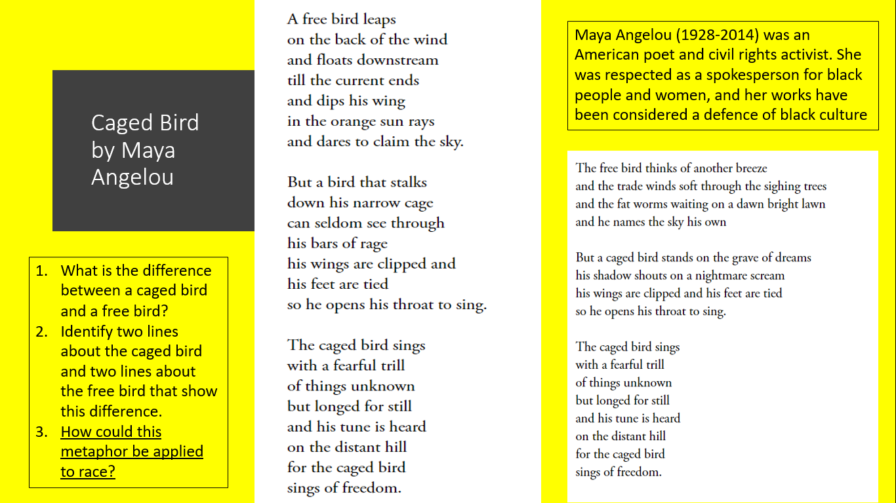
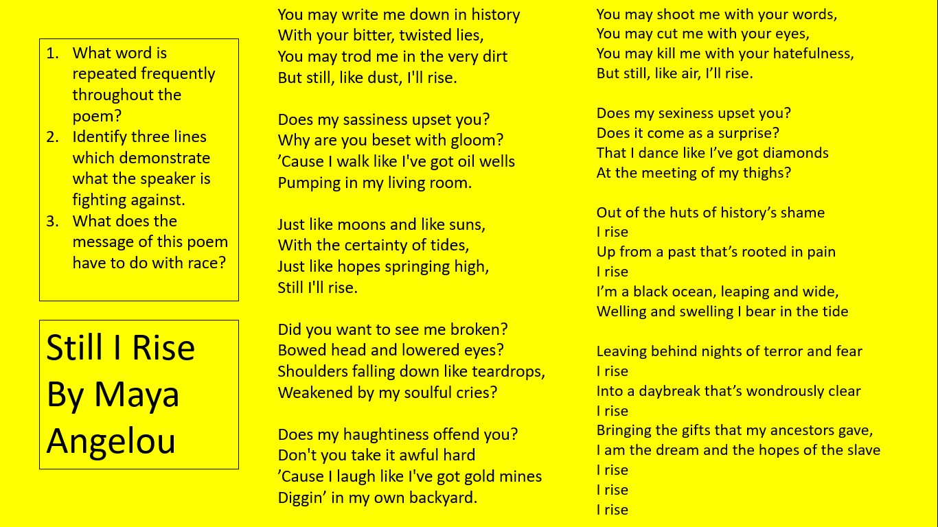
DIP – How does Maya Angelou use her poetry to promote racial equality?

- Maya Angelou was…and uses her poetry to promote racial equality.
- In the poem Caged Bird Angelou is showing…
- For example…
- The metaphor is powerful because..
- This suggests…
- Similarly, in the poem ‘Still I Rise’ Angelou is arguing…
- For example…
- The repetition of rise shows…
- This suggests…
- Angelou’s poetry is historically significant because…
- The events of 2020 showed this because…

***************************************************************************
Lesson 13: Refugee Poetry
L/I: To analyse how language, form and structure is used in poetry to create specific effects

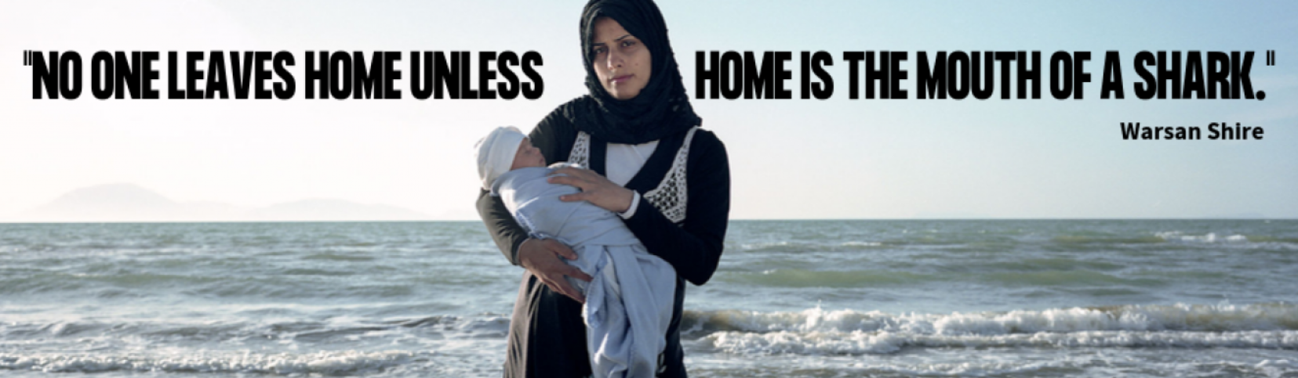
- What literary device is used in this quotation?
- Explode the quotation – what does it show about why people become refugees?

DART: Refugees
According to the United Nations, a refugee is someone who:
- believes that their life is in danger because of their race, nationality, religion, political opinion or social group;
- is outside their own country;
- is too afraid to return to their country.
- People become refugees when one or more of their basic human rights are abused. Many are victims of war, political, religious and other forms of persecution.
- In the initial chaos of fleeing and seeking safety in another country, most victims lose virtually every right and material possession they own– their homes, personal belongings, schooling and health care, close family members and sometimes even their identities. No one likes or chooses to be a refugee. Being a refugee means more than just being a foreigner. It means living in exile and often depending on others for basic needs such as food, clothing and shelter.
- In total, some 50 million people around the world might be described as victims of forced displacement. Around 14 million people are refugees in the conventional sense of the word: people who have left their own country to escape from persecution, armed conflict or violence. Nearly two-thirds of the world's refugees are in the Middle East and Africa.

- DART Questions
- What is a refugee?
- What are human rights?
- Identify three things refugees might lose.
- How many refugees are there in the world?
- What proportion of refugees are in the Middle East and Africa?
- Why do refugees need other people to stand up for their rights

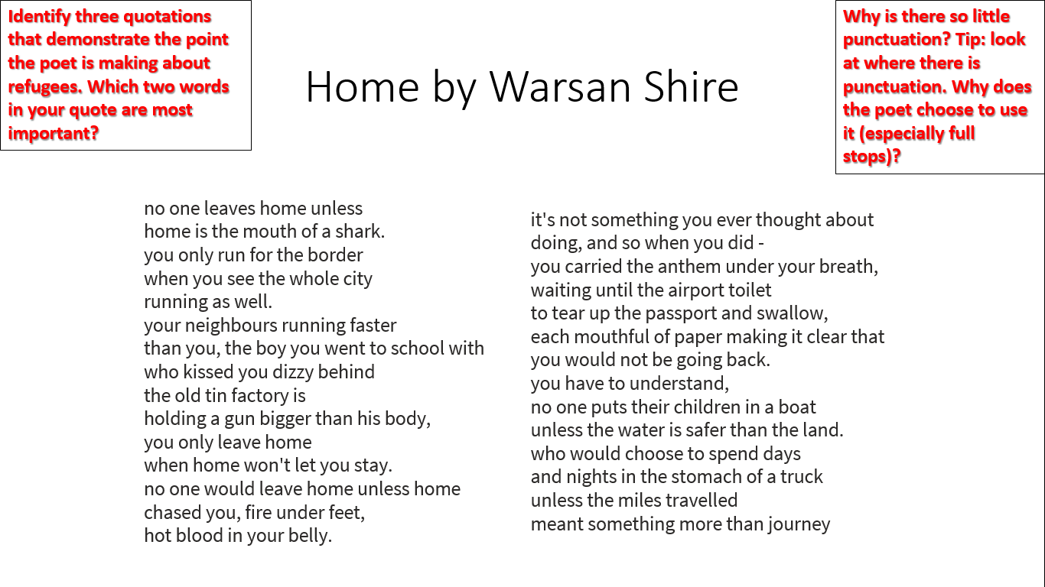
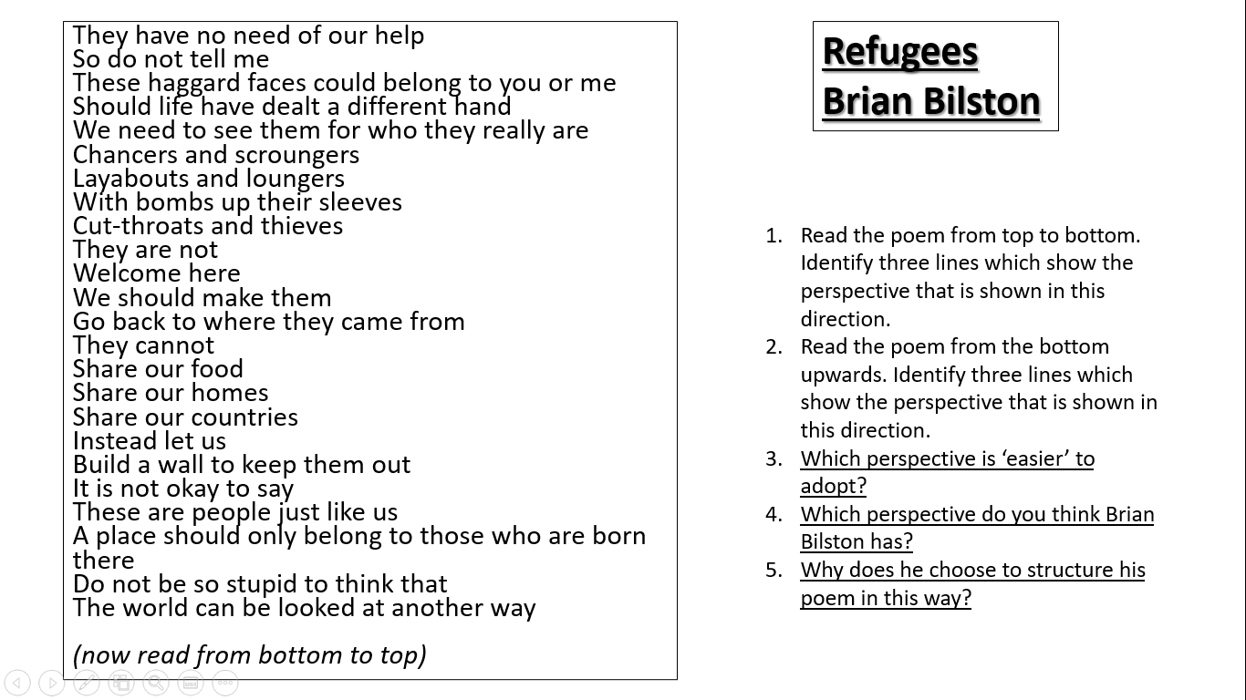
DIP Task: What are Warsan Shire and Brian Bilston’s views on refugees and how they should be treated?
Warsan Shire believes…
For example…
This shows…
This suggests…
This is an important message because…
Brian Bilston believes…
For example…
This shows…
This suggests…
Bilston wants people to adopt the…perspective because…

***************************************************************************

Lesson 14: Conflict Poetrytry
L/I: To compare poetry about the same themes from different time periods
- What is conflict?
- What were conditions like in World War One?
- How would warfare have changed by the Iraq War in 2003?

DART: Wilfred Owen
Wilfred Owen
Wilfred Owen, the great British war poet, was killed in action as he led a raiding party across the Sambre-Oise Canal in northern France on 4 November 1918, just a week before the Armistice was signed and the First World War brought to a close. His mother received the news by telegram on Armistice Day as the church bells of Shrewsbury rang out in celebration of victory. Owen was just 25 when he met his end.
Owen enlisted in the British Army in 1915, commissioned into the Manchester Regiment. After completing basic training in Essex, he arrived at the front in January 1917. The carnage he encountered left him traumatised. After being blown up by a trench mortar and suffering concussion, he was diagnosed with shell shock and dispatched to the Craiglockhart War Hospital near Edinburgh. He returned to combat in late August 1918, never to return. The body of work he left behind, however, stands for the ages.
The poems for which Wilfred Owen is remembered capture the death and destruction of the battlefield in unflinching detail, his graphic reportage of bootless soldiers trudging exhausted through mud, choking on mustard gas and dying for nothing tangled in briars of barbed wire making a nonsense of the customary patriotic tub-thumping about duty and heroism.
DART Questions
- On what date did Wilfred Owen die and how old was he?
- Why was the timing of his death particularly tragic?
- What happened to Owen in 1917 and what was he diagnosed with?
- What do Owen’s poems capture?
- What do they make a nonsense of?
- Why do people write poetry about conflict and war?

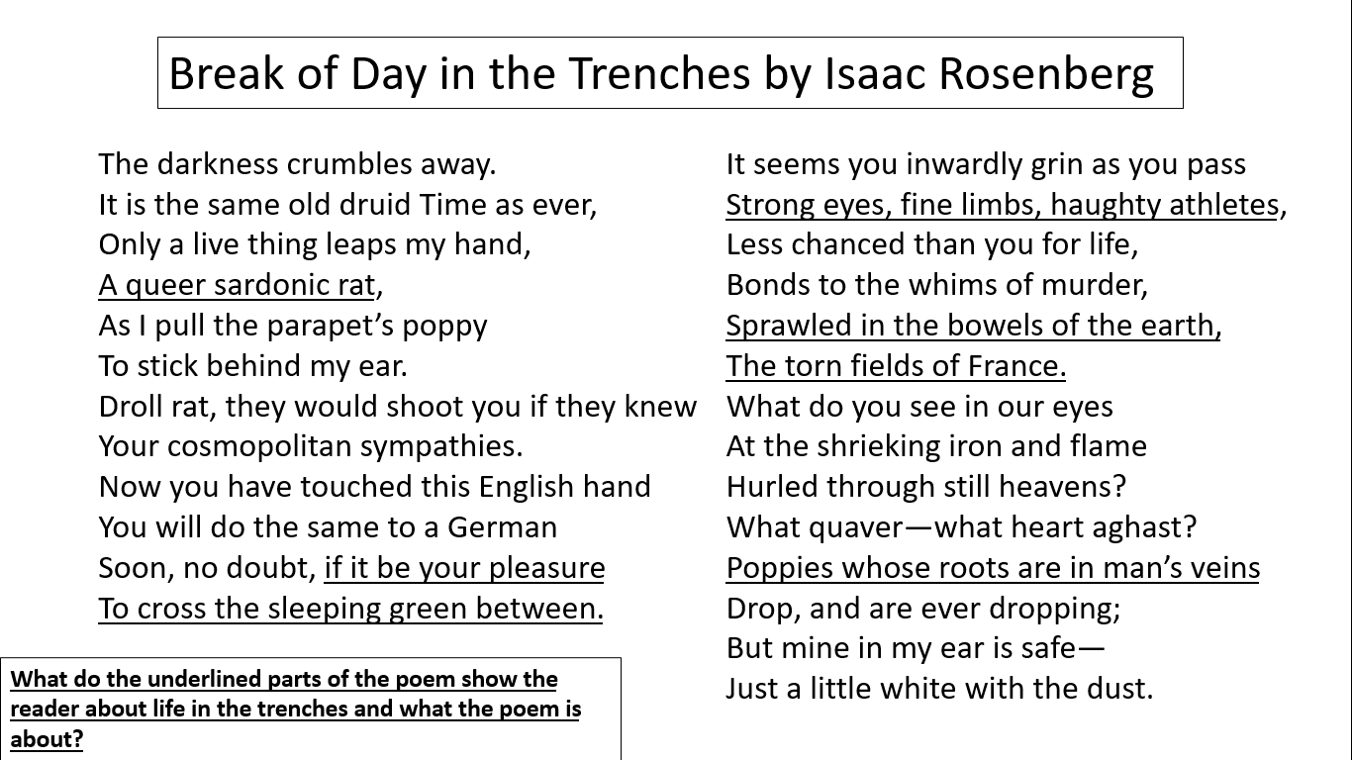
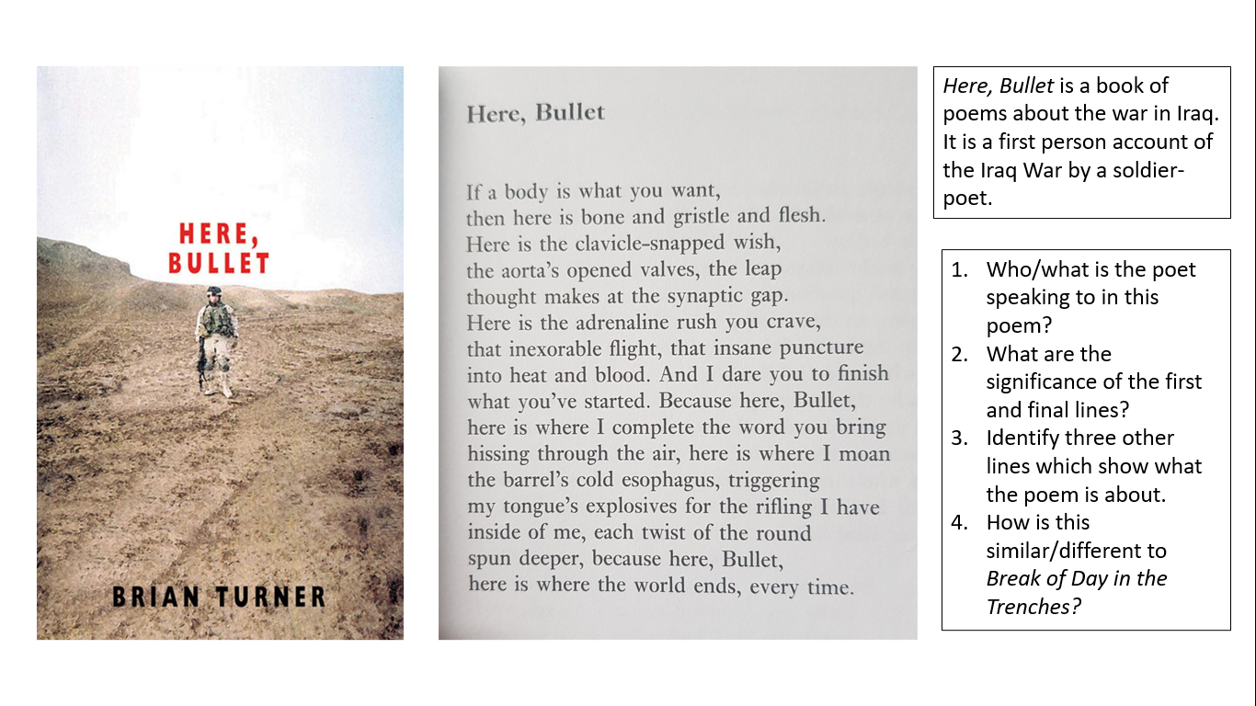
DIP Task – Why do poets write about conflict?
Sentence stems to help:
Poets have always written about conflict. For example, Isaac Rosenberg and Wilfred Owen wrote about…and Brian Turner wrote about…
Wilfred Owen’s poetry is famous for…
He died…
Isaac Rosenberg wrote… This poem is about…For example…This shows…Rosenberg chooses to focus on this because…
Here, Bullet is a book of…
Brian Turner was a…
He addressed his poetry to the bullet. For example… This shows… This suggests Turner believes that war is…
Rosenberg and Turner’s poetry is similar/different because…

**************************************************************************
Lesson 15: Family Reunions
L/I: To respond creatively to and magpie from a poem
- Write down five positive words you associate with family.
- Write down five negative words you associate with family.
- Why do people write poetry about real life events?

DART: Sylvia Plath’s Early Life
Sylvia Plath was born in Boston, Massachusetts, on October 27, 1932, to Otto and Aurelia Plath. Her father, a professor of biology (the study of plant and animal life) at Boston University and a well-respected authority on bees, died when she was eight years old. She was left with feelings of grief, guilt, and anger that would haunt her for life and led her to create most of her poetry. Plath gave the appearance of being a socially well-adjusted child. She was also an excellent student who dazzled her teachers in the Winthrop, Massachusetts, public school system and earned straight A's and praise for her writing abilities. She was just eight and a half when her first poem was published in the Boston Herald.
Plath lived in Winthrop with her mother and younger brother, Warren, until 1942. In September 1950 Plath entered Smith College in Northampton, Massachusetts, on a scholarship (money given to a gifted student to attend college). There she once again excelled in her studies academically and socially. Referred to as "the golden girl" by teachers and peers, she planned her writing career in detail. She filled notebooks with stories and poems, shaping her words carefully and winning many awards.
1. How old was Plath when her father died?
- What three emotions was she left feeling?
- What did Plath’s teachers think of her?
- Where did she attend college?
- What was she referred to?
- What does the information about Plath suggest she might think of the idea of family?

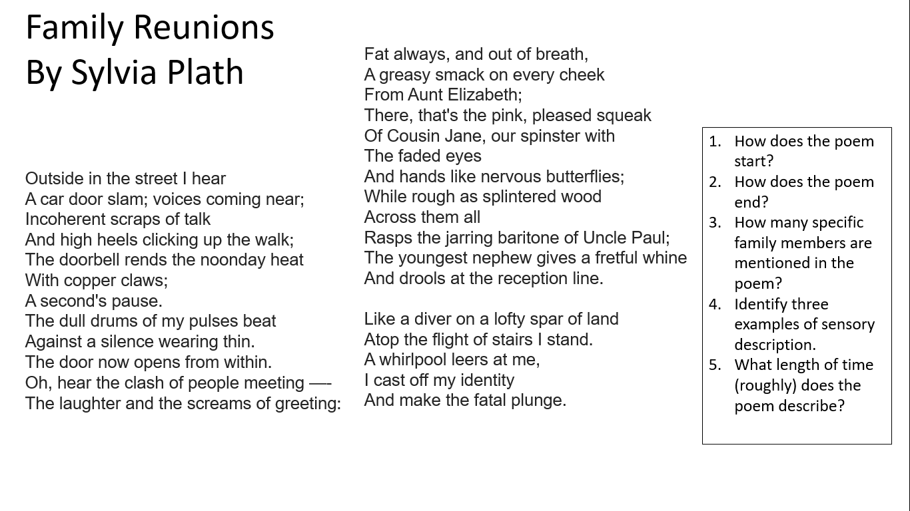
DIP TASK – Write about a time you did something you didn’t want to do
- Write for thirty minutes
- Focus on a very small event such as Plath’s family reunion (you can base your work on this poem if you would like)
- How are you feeling?
- Why do you not want to do what you have to do?
- Use as much descriptive detail as possible.
- Can you use sensory description?

***************************************************************************

Lesson 16: Writing Your Own Ballad
L/I: To recognise the conventions of ballads

DART: The Hillsborough Disaster
1989: Football fans crushed at Hillsborough
At least 93 football supporters have been killed in Britain's worst-ever sporting disaster. They were crushed to death at Hillsborough stadium in Sheffield during the FA Cup semi-final between Nottingham Forest and Liverpool.
The crush is said to have resulted from too many Liverpool fans being allowed in to the back of an already full stand at the Leppings Lane end of the ground.
More than 2,000 Liverpool fans had still not got into the stadium when the match started at 1500.
A police spokesman said orders were given for the gate to the stand to be opened because they believed the pressure of fans outside the ground was "a danger to life".
But as fans rushed in, those already there were pushed forward and crushed against the high, wired-topped safety fences.
However, it was more than five minutes into the match before what was happening became apparent to those not in the Leppings Lane stand.
Then, alerted by fans spilling through a narrow gap onto the pitch or being lifted by others into the seating areas above, a policeman ran onto the field and ordered the referee to stop the game.
Bodies
But improved security measures recently introduced at grounds to keep rival fans apart meant, for many, there was no escape from the crush.
Police and match officials attempted to help those trapped clamber over the safety barrier.
Bodies were lifted forward and laid out on the pitch - many of them teenagers and children.
Other injured fans were ferried to ambulances on stretchers improvised from crash barriers and advertising hoardings.
At least 200 people were injured, about 20 seriously.
Some fans have said bad ticket allocation contributed to the disaster.
Liverpool has far more supporters than Nottingham Forest but were given 6,000 fewer tickets and allocated the smaller Leppings Lane stand.

DART Questions
- What year did the tragedy take place?
- What is Hillsborough?
- How many supporters died?
- Which teams were playing?
- How many fans were not inside when the match kicked off?
- What order did the police give?
- What happened when the gates were opened?
- Why did a police officer run on to the pitch?
- What age were most of the casualties?
- Which team was given more tickets to the game?

THE BALLAD OF HILLSBOROUGH
The Liverpool supporters
Were given the smaller end;
Crammed behnd the goalmouth,
The fans were tightly penned –

Penned, penned in their thousands,
Penned in under the sky
No one there had reckoned
That ninety-five would die.

The barriers all buckled,
They couldn’t take the strain
The cheers of jubilation
Turned into cries of pain.

And when at last they noticed,
The police unlocked a gate,
But the exit was too narrow,
And they’d opened it too late
The nation watched in horror,
Stunned with disbelief
As the shadows from the goalmouth
Stained a football pitch with grief.

An inquiry has been opened
To find out who’s to blame,
But for those who lost their dear ones
Nothing will be the same.

For nothing brings the dead back,
Post mortems, flowers or prayers,
It’s like reaching the top of the stairwell
And finding there are no stairs.

That drop into the darkness
Goes down and down and down;
And grief’s black water well there,
Inviting you to drown.

Never to see your loved ones,
Or hear them on the phone –
It’s hard to believe when it happens
That you’ll never walk alone.
But down at the Kop at Anfield,
The goalmouth shows it’s true:
The scarves around the crossbar
Are knotted red and blue.

Despite divided loyalties
Liverpool loved its own,
And every tribute there proclaims:
You’ll never walk alone –
Not by the banks of the Mersey
Nor down the terraced streets;
Beneath the great cathedrals
A city’s warm heart beats.

And now in the cold spring sunset,
The Liver Bird’s aflame
The Phoenix rose from the ashes;
A city can do the same.
By Simon Rae

Write a Ballad about the bombing at the at the Ariana Grande concert.
https://www.bbc.co.uk/newsround/40009766

DIP – Write your Ballad
- 7 stanzas
- 4 lines per stanza
- ABCB rhyme scheme
- Questions/dialogue

Suggested Outline:
- Ariana Grande concert in Manchester coming to an end
- There was a terrorist attack – a bomb went off and there was mass panic
- Eye-witness descriptions
- 22 people were killed and 59 were injured
- Details about one of those who was killed
- How people have responded
- Ariana Grande’s response

***************************************************************************

Attainment Band | Poetry
Yellow Plus | - Your understanding of a text goes beyond what is literally on the page to fully consider the conventions of genre and the influence of context.  - Your responses to the text are detailed and supported with relevant and focussed (word-level) evidence.  - You give detailed explanation and analysis beginning to explore the deliberate impact of the writer’s choices on the reader.  - You make interesting and perceptive critical judgements directly supported by relevant and focussed (word-level) evidence.  - You explain the effect of a range of devices.
Yellow | - Your understanding of a text is more nuanced and includes a basic sense of genre and the context in which it was written.  - Your responses to the text are valid, sometimes original, and clearly supported and explained with relevant evidence from the text.  - Your explanation and analysis are well developed, referring to the impact or effect on the reader.  - You make increasingly critical judgements that are clearly supported and explained with relevant evidence from the text.  - You identify and label a range of devices.
Blue | - Your explanations of the text are simple, identifying explicit meaning.  - Your responses to the text are valid and supported by/based on relevant evidence from the text.  - Your answers include an attempt at explanation or basic analysis of your points, i.e. why a point is important or relevant in answering the question.  - You make basic judgements supported with some relevant evidence from the text.  - You identify and label simple language devices.
Green | - You can describe the text.  - Your responses to the text are simple but valid with some relevant reference to the text.  - There is little or no explanation or analysis in your answers.  - You make simple but unfocused judgements with no relevant supporting examples from the text.  - You identify simple language devices without using subject terminology.
White | - You can re-tell the text.  - Your responses are simple with little or no evidence from the text.  - There is no explanation of your responses.  - You make little or no judgement of the text.  - You do not identify any language devices.

