English Year 7 Summer A Blended Learning Booklet
Frankenstein
Name:
Form:
English Teacher:
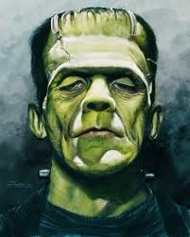

Contents

Page Number | Lesson Number | Title
7 | 1 | The gothic
11 | 2 | Prologue and Act 1
12 | 3 | Imaginative Writing
15 | 4 | Act 2
16 | 5 | Tension in Act 2
17 | 6 | Act 3
19 | 7 | Sympathy for Frankenstein’s Monster
20 | 8 | Imaginative Writing 2
21 | 9 | Act 4
22 | 10 | Overview of Frankenstein
23 | 11 | Themes
26 | 12 | Evaluating a sense of danger
27 | 13 | Argumentative Writing
29 | 14 | Nature vs Nurture
30 | 15 | Frankenstein on Trial
32 | SAL

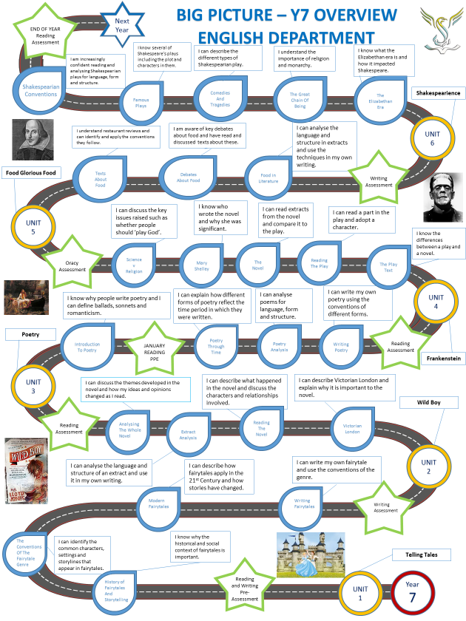

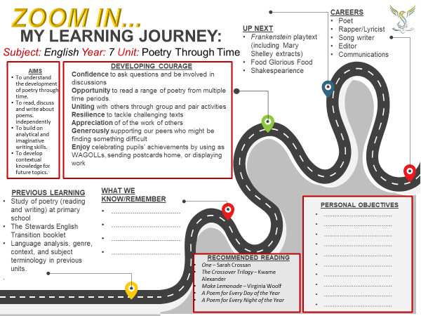
- Quick introduction:
“Frankenstein” is the famous story of a young man who thinks he can change the world by making better human beings. Instead he creates a living monster with a mind of its own….
- Plot |  | - Themes
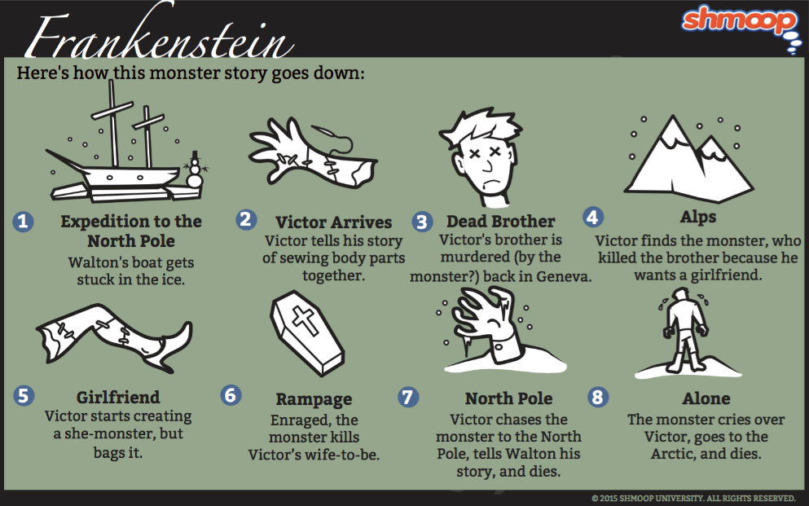 |  | 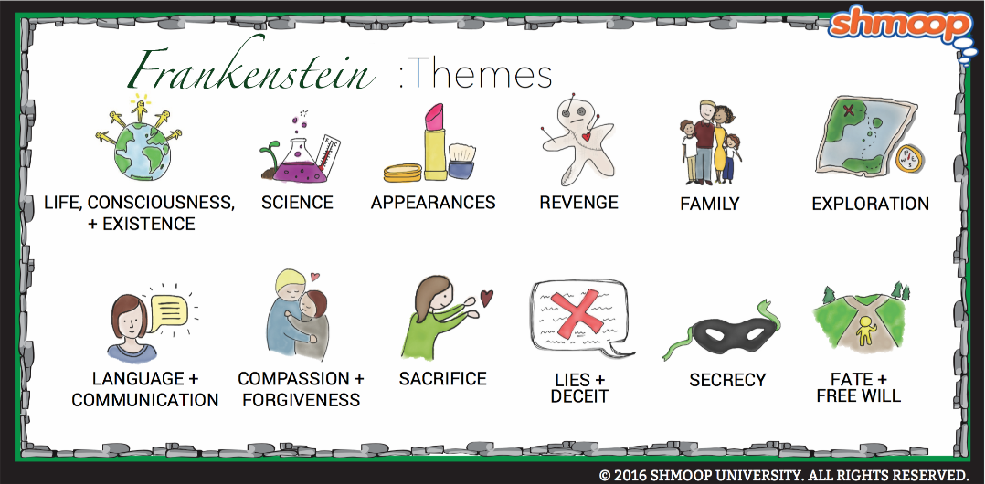
- Gothic Fiction Conventions | - Play Script Conventions | - Characters
- Dark/abandoned/decaying settings  - Supernatural beings  - Curses/prophecies  - Uses elements of horror  - Damsels in distress  - Heroes/Anti-heroes  - Romanticised past | - May include a prologue  - Dialogue  - Monologue/soliloquy  - Set design  - Stage directions  - Casting directions  - Lighting  - Costume  - Entrances/exits | Captain Walton: a brave arctic explorer; listens to Frankenstein’s story  Frankenstein: protagonist of the play – he believes he can improve the world; creates the monster  Clerval: friend of Frankenstein; impressed but anxious about Frankenstein’s achievements  Elizabeth: loves Frankenstein  William: Frankenstein’s youngest brother; first to be murdered  Felix: quick-tempered son in the DeLacey family  Agathe: blind daughter in the DeLacey family  Monster: creature made of parts of corpses; feared by his creator and human-kind  The Monster’s Bride: another monster created for Frankenstein’s monster as a bride
- Context |  | - Subject-terms
- The novel was written by Mary Shelley in 1818, but published anonymously with an introduction from her husband, Percy Bysshe Shelley  - She wrote Frankenstein after Byron (a famous writer) introduced a challenge to decide who could write the best ghost story amongst their friends  - Republished in 1831 under her name. She also wrote a new introduction to the novel.  - Mary Shelley was born in London in 1797 to radical philosopher, William Godwin, and Mary Wollstonecraft (author of “A Vindication of the Rights of Woman”).  - Her mother died shortly after giving birth to her  - She has a lack of affection from her stepmother  - Shelley’s father disowned her after her elopement to Percy Shelley in 1816  - Mary was exposed to the same influences as her husband, and this Romanticism influenced her work  - 3 of 4 of her children died young  - Her husband also died  - Shelley had an interest in science  - Mary did not remarry and died in London in 1851  - The play script was adapted by Phillip Pullman in. His most noticeable adaptation is that Agathe is the blind character who the monster befriends (in Shelley’s novel, it was a blind father)  - Pullman was interested in how the story shows language and humanity as linked |  | Prologue: an introductory section to the play/book  Epilogue: a section or speech at the end of a book or play that serves as a comment on or a conclusion to what has happened.  Stage direction: an instruction in the text of a play indicating the movement, position, or tone of an actor, or the sound effects and lighting.  Props: is an object used on stage or screen by actors during a performance; theatrical property.  Stage set scenery and other properties used to identify the location of a dramatic production  Casting: selecting a certain type of actor, dancer, singer, or extra for a particular role or part in a script,  Tone: The general mood or attitude of a piece of writing  Pathetic fallacy: providing human emotion and behaviour to things found in nature that are not human  Gesture: a movement of part of the body, especially a hand or the head, to express an idea or meaning

Lesson 1 - The Gothic
L/I – To know and understand the conventions of Gothic fiction
Do Now -
Write down 3 things you know about Frankenstein.
- This could be ANYTHING –
What would you expect to see in a GOTHIC story? Use the pictures below to help you make a list.

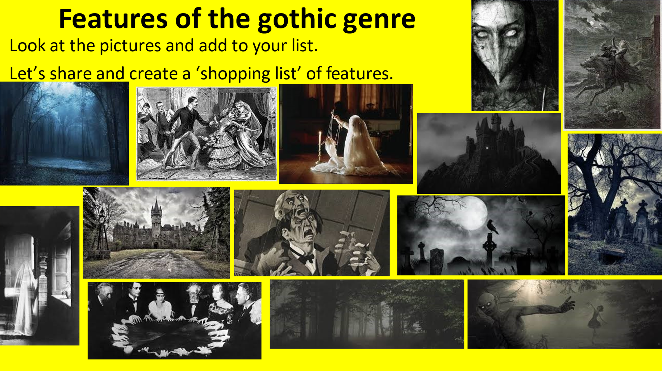

As you can see from the images, gothic literature often tells stories designed to create fear, terror and suspense. The settings are often inhospitable wilderness and forests, abandoned mansions, haunted castles. It introduces supernatural villains who are capable of great wickedness, traumatised heroes and damsels in distress.

Terror and Wonder: 10 key elements of Gothic literature
- Set in a haunted castle or house. ...
- A damsel in distress. ...
- An atmosphere of mystery and suspense. ...
- There is a ghost or monster. ...
- The weather is always awful. ...
- Dreaming/nightmares. ...
- Burdened male protagonist. ...
- Melodrama.

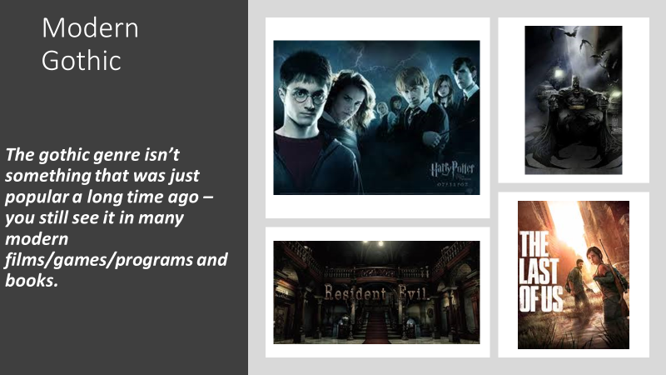
********************************************************************************
This term we will be studying a play adaptation of one of the most famous gothic novels – Frankenstein
- Mary Shelley wrote Frankenstein in 1816.
- She was staying with Lord Byron and Percy Shelley (amongst others)
- They were bored so decided to have a competition – who could write the best scary story.
That night she had a dream…she is reported to have said “I’ve found it! What will terrify me will terrify others. I need only describe the spectre which had haunted my midnight pillow”
She had a dream about a mad scientist, this became the famous story:
- Frankenstein is the story of a doctor who ‘plays God’ by creating a man from the body parts of corpses.
- He brings him to life with electricity.
- He then rejects the monster because he is so ugly.
- The monster is exiled as society rejects him.
- He grows to hate his creator who has caused him so much pain and swears revenge.
- It is possibly the most famous novel in the gothic genre.
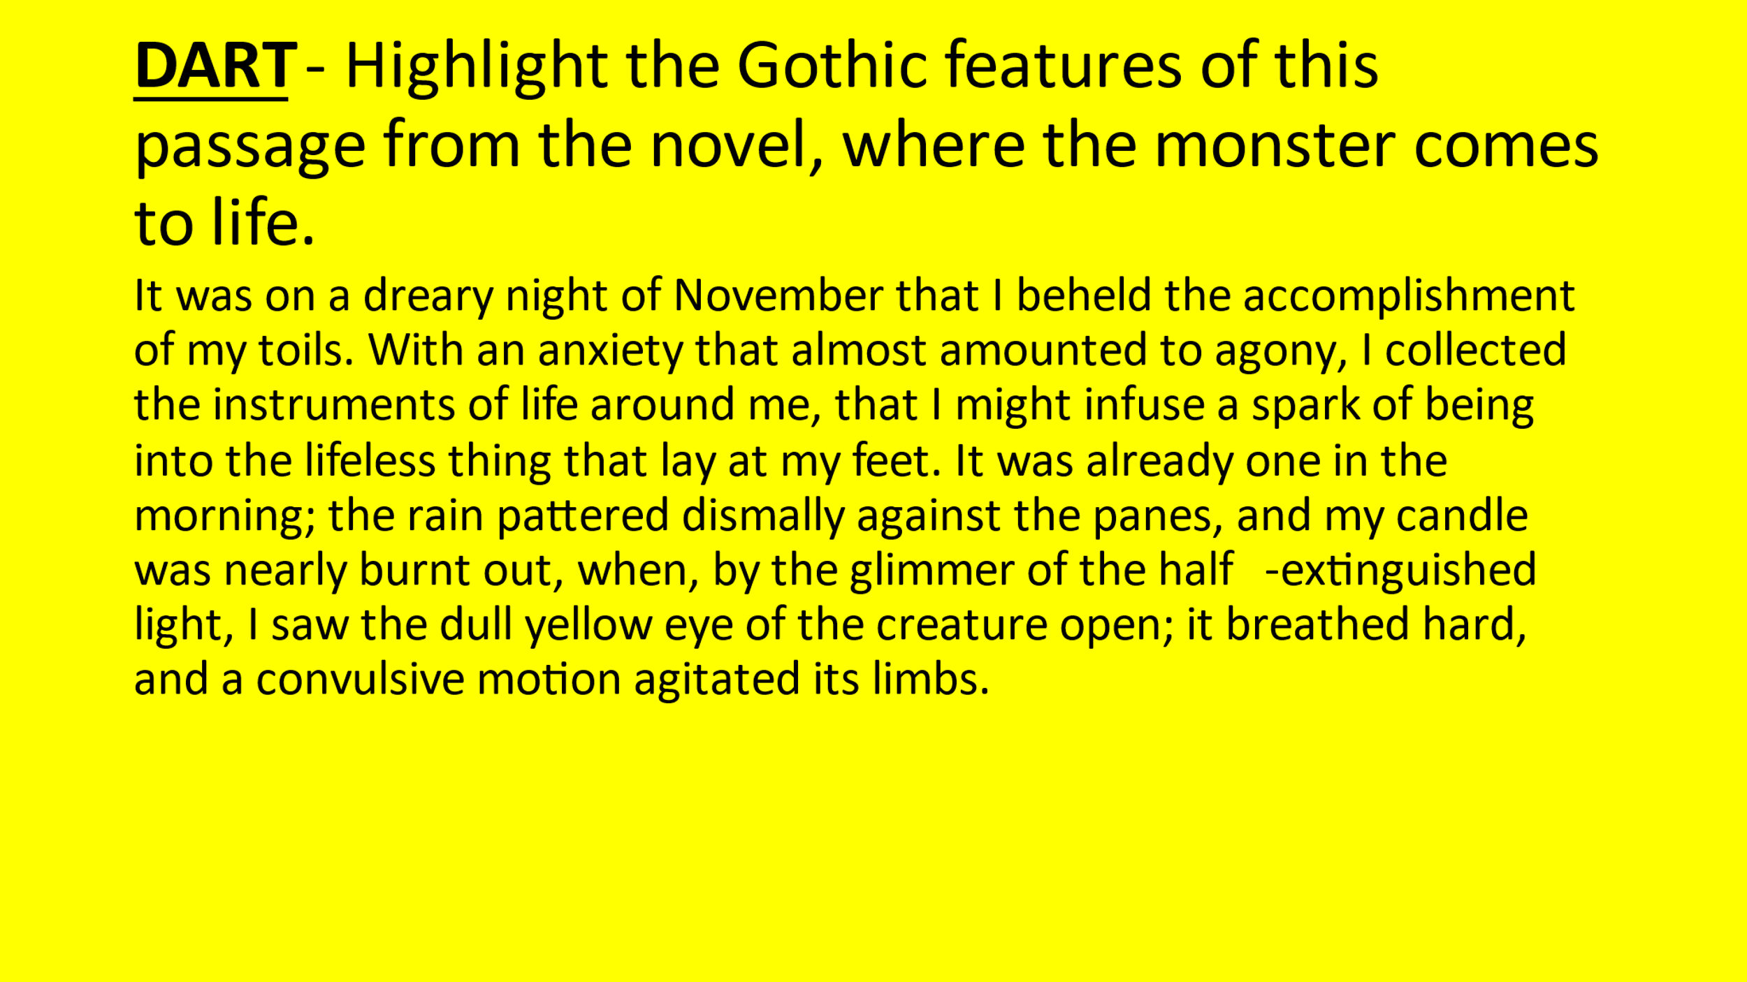
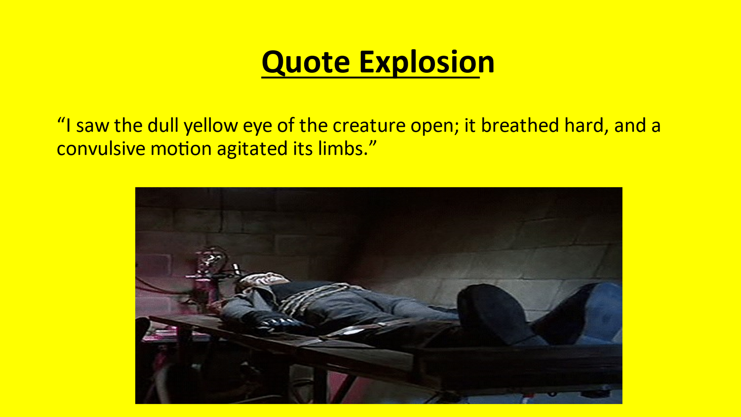
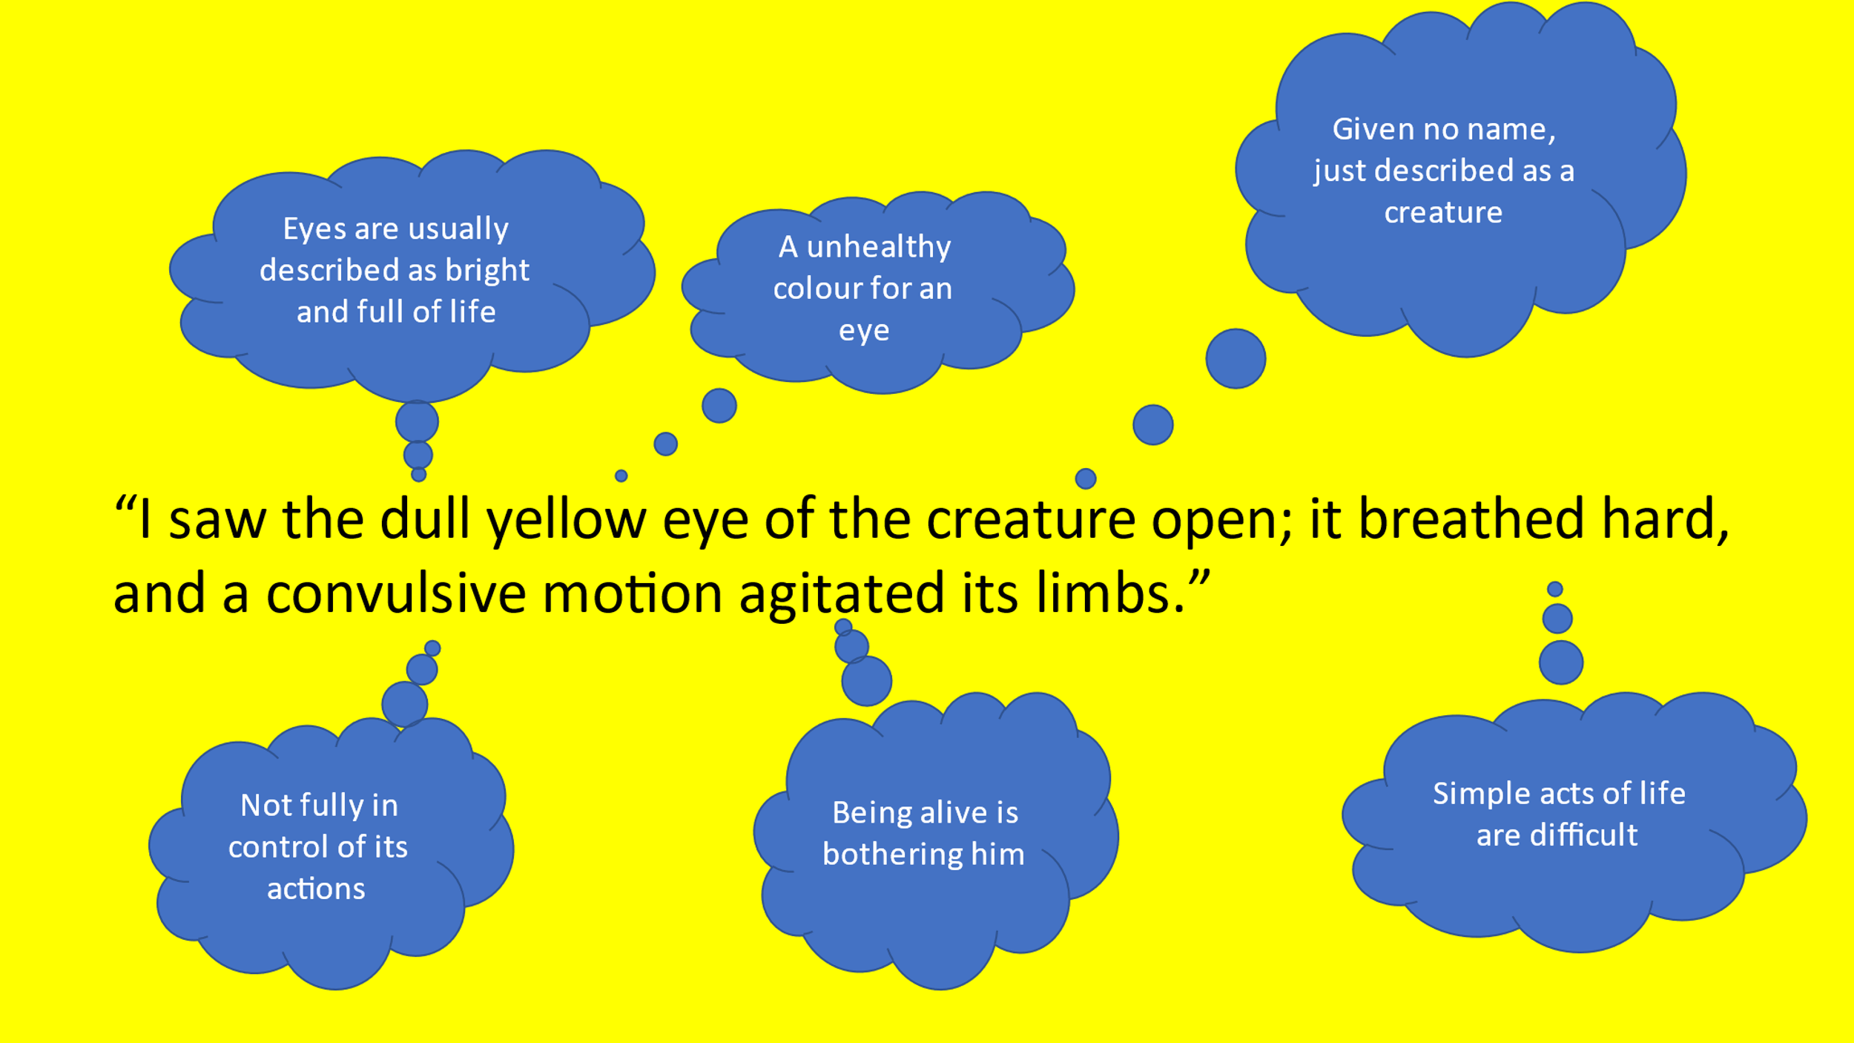
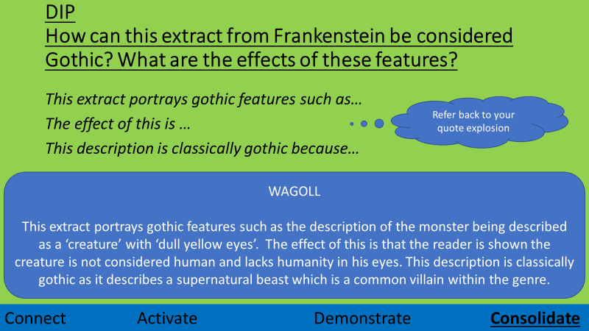

Lesson 2 –
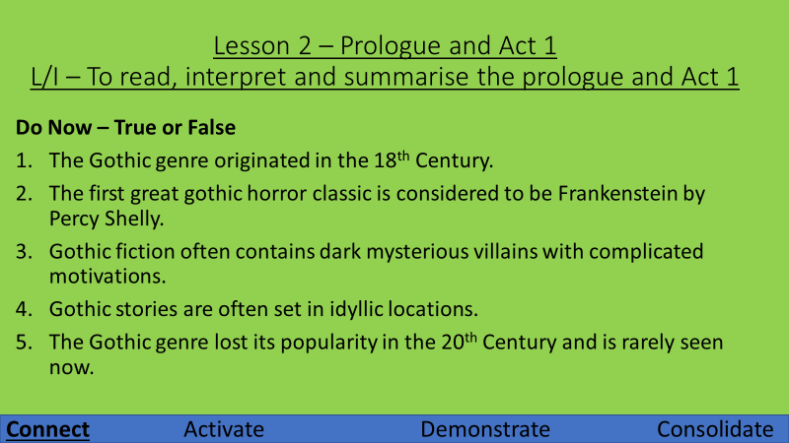
Read the prologue - answer the following questions:
- What do you think is the purpose of a prologue?
- Why is the ship stuck?
- Why is Captain Walton worried his men will go mad?
- What does Captain Walton see in the distance?
- What atmosphere do you think is created in the prologue? How do you think this is done?

Now read Act 1 – If you have someone to read other parts that would be great!
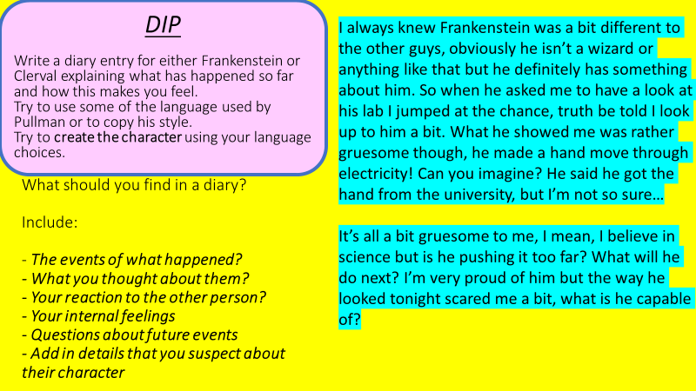

Lesson 3 -
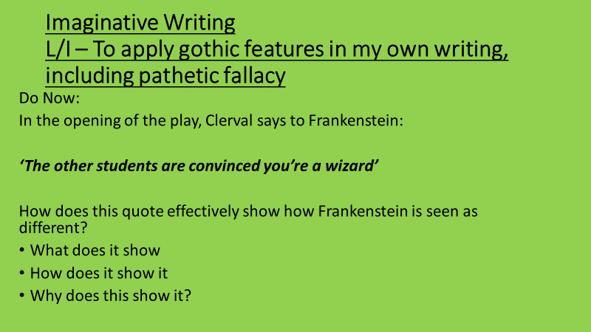
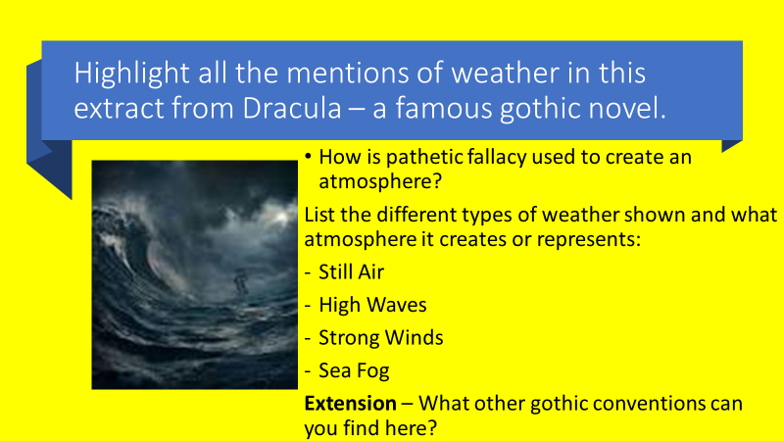
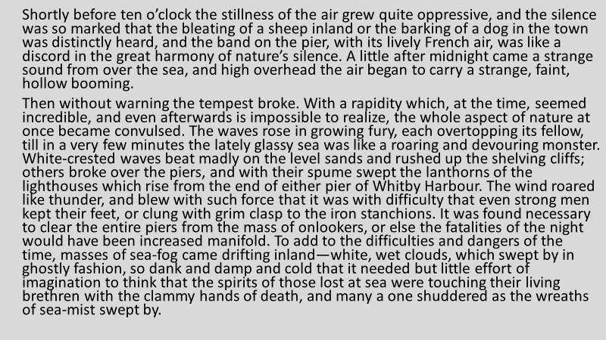
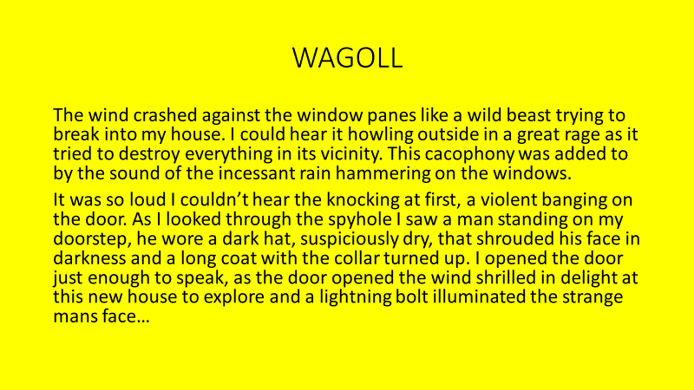
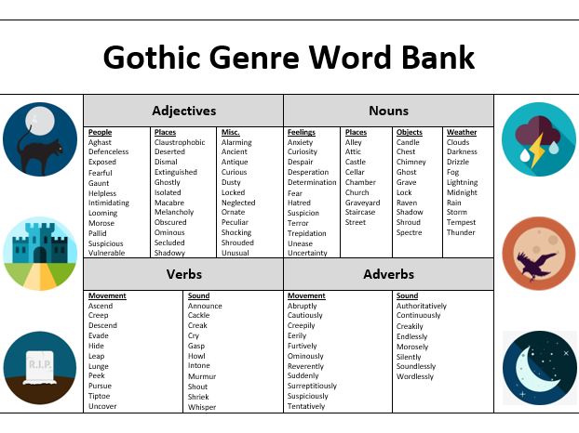
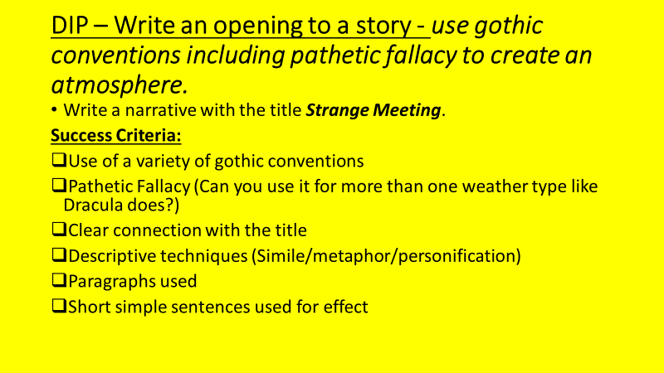

Lesson 4 -

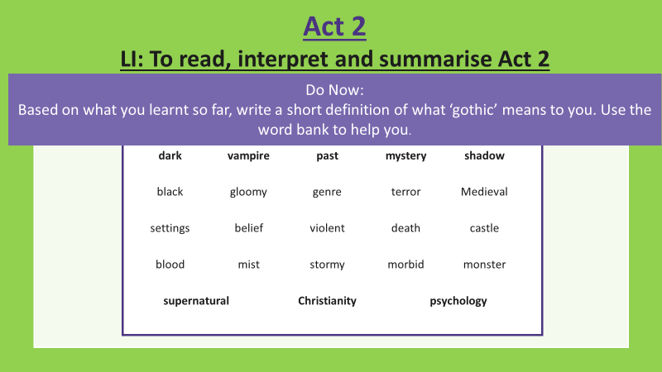

Read Act 2 – Then answer the questions
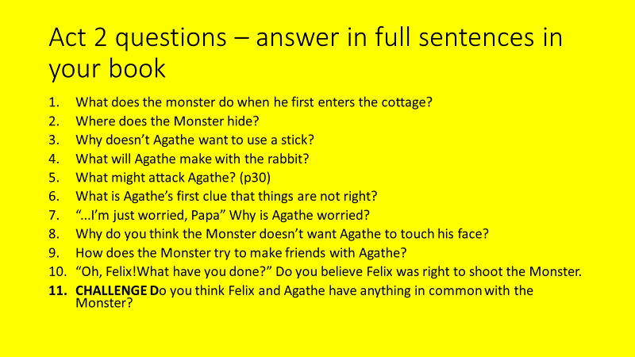
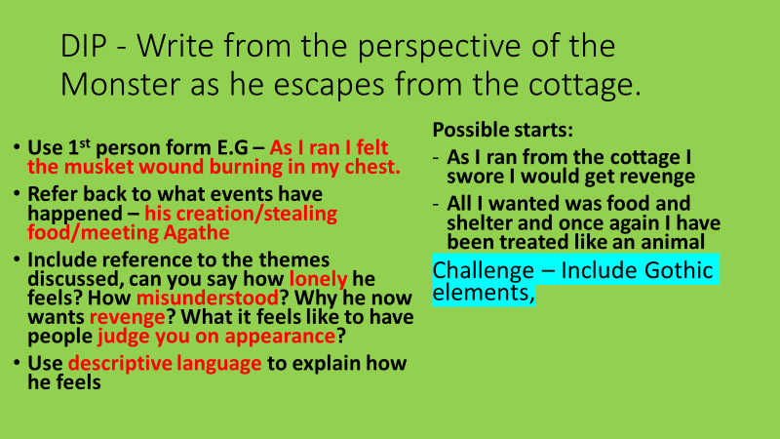

Lesson 5 - Tension in Act 2
LI: To evaluate how successful the writer is at creating tension (Act 2, pages 28-31)
Do now:
Write a sentence summarising Act 2 (maximum 10 words!)

Tension: What is it and how is it created?
- Let’s re-read pages 28-31 thinking about how tension is created.
- What is the audience tense about – what are we afraid might happen? List the different ideas.
- Find three quotes or stage directions that show tension.

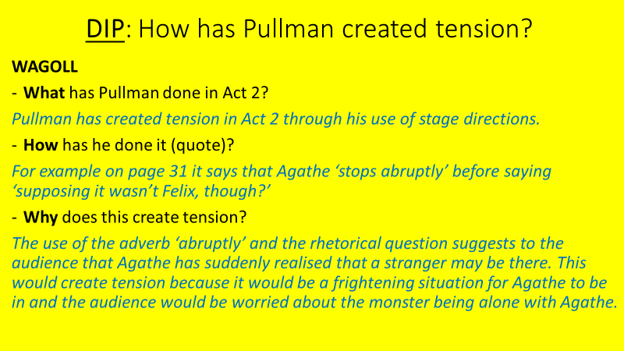
Self-Evaluate
- Have you made your point?
- Have you used a quote from the play showing how Pullman uses tension?
- Have you explained why this creates tension?

Lesson 6 – Act 3
L/I – To read, interpret and summarise Act 3
Do Now – Are these statements True or False:
- Agathe isn’t scared of the Monster because she sees him collecting wood for her.
- Felix and Agathe are political refugees.
- The monster wants to stay with Felix and Agathe.
- Felix shoots the monster because he was attacking Agathe.
- The monster screams for revenge.

Now read through Act 3 - As we read, start considering themes.
- How is the idea of revenge portrayed in this act?
- How is the idea of loneliness shown?

Once you have finished, answer the following questions:
- What is different in Frankenstein’s Geneva study to his university study?
- Why is Elizabeth upset?
- What is the priest carrying?
- How did Frankenstein’s brother die?
- Why does Elizabeth scream?
- How does the monster defend his evil actions?
- What does the monster want Frankenstein to do for him? Why?
- Why do you think Frankenstein accepted the monster’s demands?
- How has the monster changed since we last saw him? Find a quote that shows this difference and explain.
- CHALLENGE: ‘The monster is no longer innocent’ – explain whether you agree with this statement or not, use a quote.

In Act 3, Frankenstein makes the decision to create a bride for the monster.
DIP – Explain whether you think this was the right or wrong thing to do, include both sides of the argument.

Lesson 7 – Sympathy for Frankenstein’s monster
L/I – To analyse how the writer uses language to create sympathy for the monster.
Do Now:
Find 3 quotes in Act 3 that show the monster is considered to be less than human.
Explode one of your quotes – what does it show about what people think of the Monster?
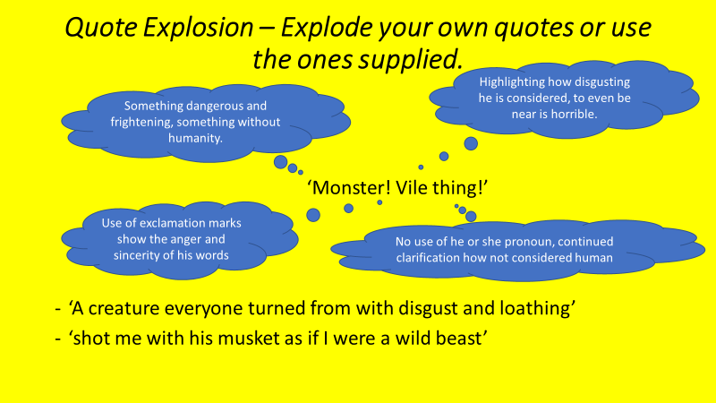
The following extract is from the novel – REMEMBER WHAT WE ARE READING IS AN ADAPTION – Read and annotate how language is used to create sympathy for the monster:

"For some days I haunted the spot where these scenes had taken place, sometimes wishing to see you, sometimes resolved to quit the world and its miseries forever. At length I wandered towards these mountains, and have ranged through their immense recesses, consumed by a burning passion which you alone can gratify. We may not part until you have promised to comply with my requisition. I am alone and miserable; man will not associate with me; but one as deformed and horrible as myself would not deny herself to me. My companion must be of the same species and have the same defects. This being you must create."

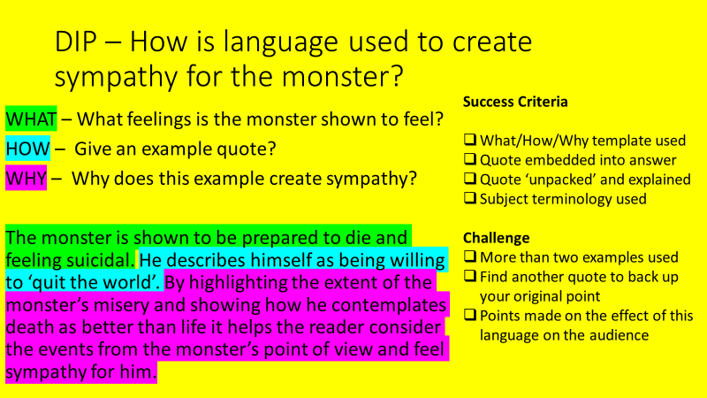

Lesson 8 – LI: To use what I have learnt about language for effect in my own writing
Do Now:
Which one of these descriptions do you prefer? Be specific and give a reason.
- The castle leers over the countryside, mocking the landscape that surrounds it.
- The castle is old and abandoned, it can be seen from miles around.

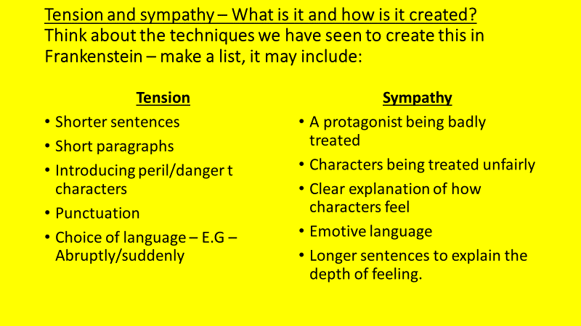
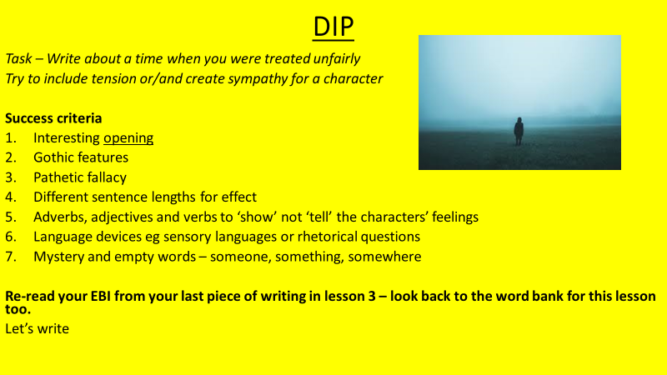

Lesson 9 – Act 4
L/I – To read, interpret and summarise Act 4

After you have read Act 4 – answer the following questions:

- How much time has passed since Act 3?
- Elizabeth said Frankenstein has changed, when did this change start?
- How do we know Elizabeth feels guilty entering Frankenstein’s study?
- Why does Clerval think the Monster killed William?
- What do you think Clerval is planning to do on page 51?
- In the Monster’s opinion, what is the difference between Frankenstein’s creation and humans?
- How does the Monster feel when he sees his bride for the first time? (p51)
- Describe in your own words what happens after Clerval pulls out the wires until Frankenstein arrives.
- Do you think the Monster is right to make Frankenstein suffer?
- The Monster believes humans to be cruel and evil. Do you agree or disagree with this statement?

DIP - Write a one paragraph review of the play, include:
- A summary of what it is about
- What you liked about it
- What you disliked about it
- A rating out of 5 stars (5 stars being the best)

Lesson 10 – Overview of Frankenstein
L/I – To familiarise myself with the plot of Frankenstein

Who do you think is the villain in Frankenstein? Explain your answer.

Once you have done this - Watch the summary of the NOVEL
Remember – what we read is an adaptation.
Make a note of the main differences that Pullman made.
Challenge – why do you think he may have made the changes? Consider what a play can do that a novel cannot.
- https://www.youtube.com/watch?v=XRppXdKDY_c&t=71s

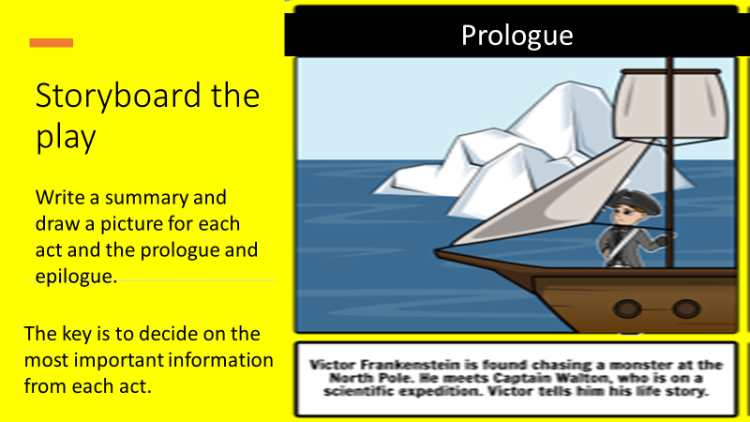

- Once you have done this, take a moment to reflect on the story - Were the characters of Frankenstein and the monster different to how you had imagined, or popular culture had you imagining?

Lesson 11 – Themes
L/I – To explore the themes in Frankenstein and how they are presented.

Do Now:
Write a definition of the following words:
- Revenge
- Monstrosity
- Religion
- Ambition
- Loneliness
- Innocence
- Prejudice

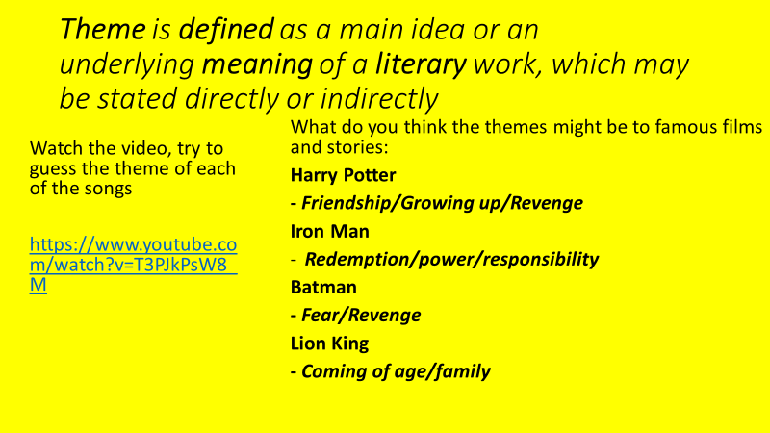

Have a look at the table below that explains the main themes in Frankenstein. From the list of quotes, decide which quote best fits which theme:
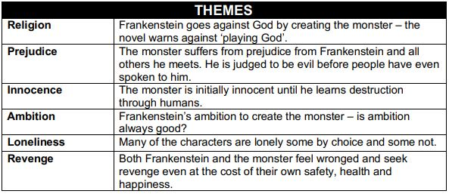
- ‘…a creature like a man, but huge and hideous beyond belief.’

- ‘Yes, if we're lucky tonight and it storms…well, my dear fellow, we’re in the threshold of a new age.’
- And I thought: the power that can do that is the power of life and death. I’ll harness it. I’ll study it and master it and make it work for mankind.’
- You’ve no idea how lonely it’s been…I’ve been working at this for six years now.’
- ‘I’m worried. I have such dreams…I see Victor in them, and there’s something horrible pursuing him – or is he pursuing it?’
- Clerval, I beg you – leave me alone – you don’t know how dangerous this could be.’
- ‘This is pure evil, Frankenstein.’
- ‘But you’re not what I thought you’d be…I thought I was making an angel…I thought I was making something better than human!’
- ‘I will not hurt anyone. I am their friend. Friend of everyone.’
- ‘Men see me, they hurt me…But I am good. I want to love them, not hurt, not kill.’
- ‘Evil? Evil – you want evil? – then I shall be evil! I shall be terror and hatred and revenge – revenge!’
- ‘We should have helped him, Felix. He was an outcast just like us.’

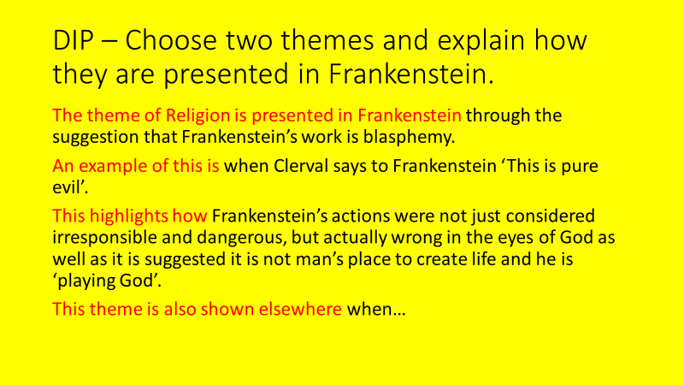

Lesson 12 – Evaluating a sense of danger
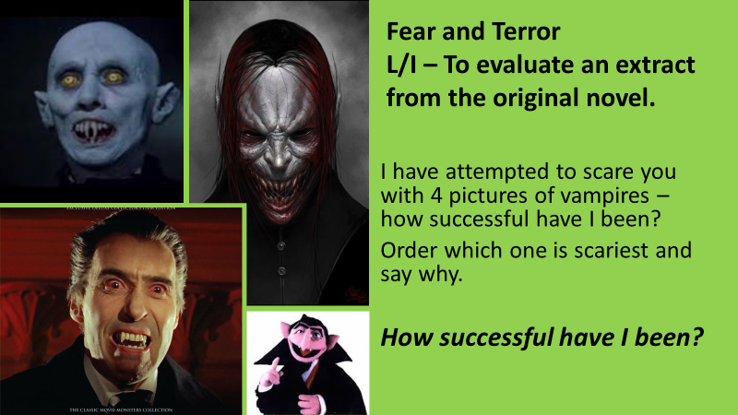
We are going to try to use the same skill now whilst analysing this extract from the novel. In this extract, the monster is threatening Dr Frankenstein.
As you read, consider – How effective has Shelley been in creating a sense of danger for Dr Frankenstein? How much do you believe that Dr Frankenstein is in genuine danger?
Write down five quotations from the extract – how does each quote create a sense of danger?
"You are in the wrong," replied the fiend;"and instead of threatening, I am content to reason with you. I am malicious because I am miserable. Am I not shunned and hated by all mankind? You, my creator, would tear me to pieces and triumph; remember that, and tell me why I should pity man more than he pities me? You would not call it murder if you could precipitate me into one of those ice-rifts and destroy my frame, the work of your own hands. Shall I respect man when he condemns me? Let him live with me in the interchange of kindness, and instead of injury I would bestow every benefit upon him with tears of gratitude at his acceptance. But that cannot be; the human senses are insurmountable barriers to our union. Yet mine shall not be the submission of abject slavery. I will revenge my injuries; if I cannot inspire love, I will cause fear, and chiefly towards you my arch-enemy, because my creator, do I swear inextinguishable hatred. Have a care; I will work at your destruction, nor finish until I desolate your heart, so that you shall curse the hour of your birth."

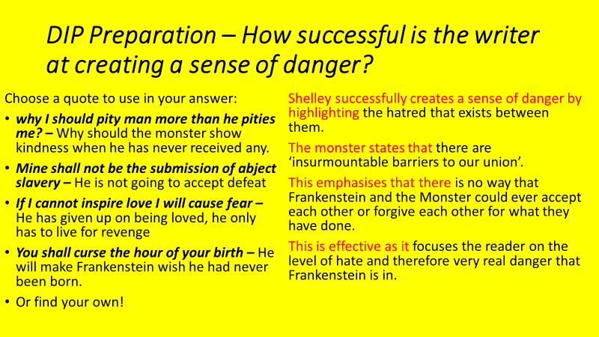
Word Bank
Powerfully
Effectively
Successfully
Skilfully
Considerably
Specifying
Emphasises
Focuses

Lesson 13 – Argumentative Writing
L/I – To write an argumentative article

Do Now:
Think back to act 1, what were the reasons that Clerval was so shocked by Frankenstein’s work?
Do you agree with them?

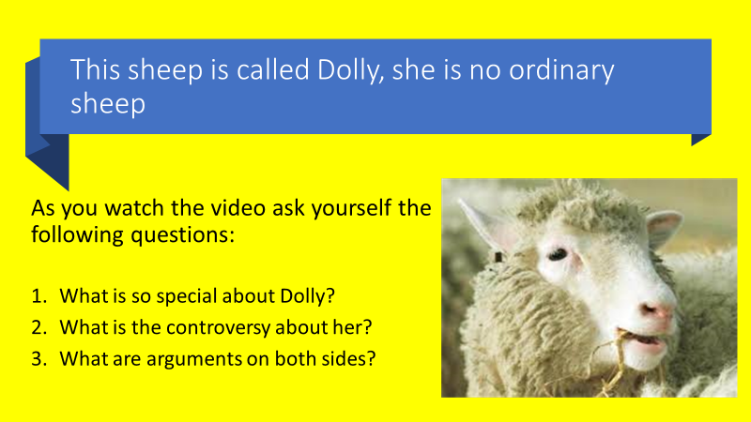

https://www.bbc.co.uk/bitesize/clips/zkj9wmn

You are going to use this information to write your own article.
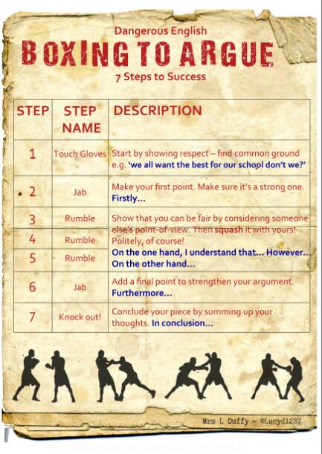

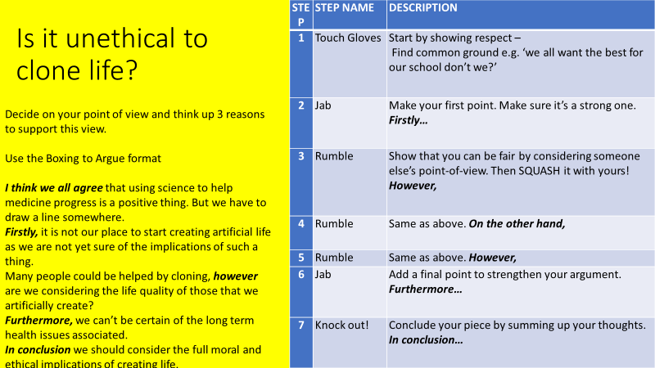
Lesson 14 – Nature vs Nurture
L/I – To prepare for a debate

Do Now:
- Do you think the monster is to blame for his actions so far?
- Can you find evidence from the play to support your view?

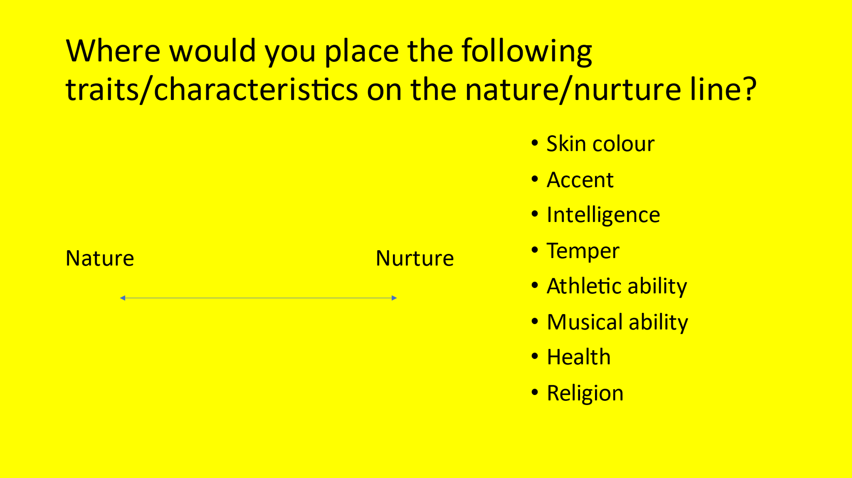
DIP – Prepare a speech for a debate on the statement below – remember this is being written with the intention to be spoken, not to be read. How are you going to engage your audience?

Once you have completed - Consolidate – Practice reading your speech to yourself, see if you can find someone to practice on, can you improve it? Use more of AFOREST? Can your argument be made clearer?

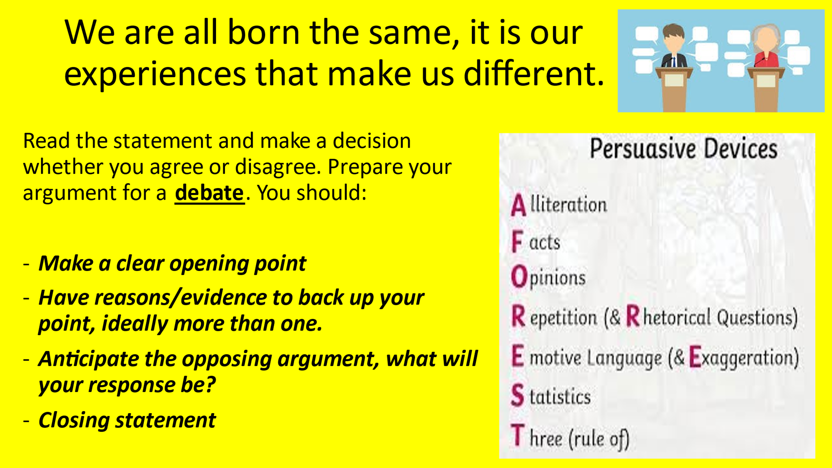

Lesson 15 – Frankenstein on Trial
LI: To plan and prepare an argument evaluating who is guilty of the murders

Do Now:
- If a dog bites someone, who is guilty? The dog or the owner?
- In your own words describe what ‘nature vs nurture’ means

Prepare:

What criminal charges could be pressed against Frankenstein?
- 3 counts of murder
- Crimes against God
- Robbing graves

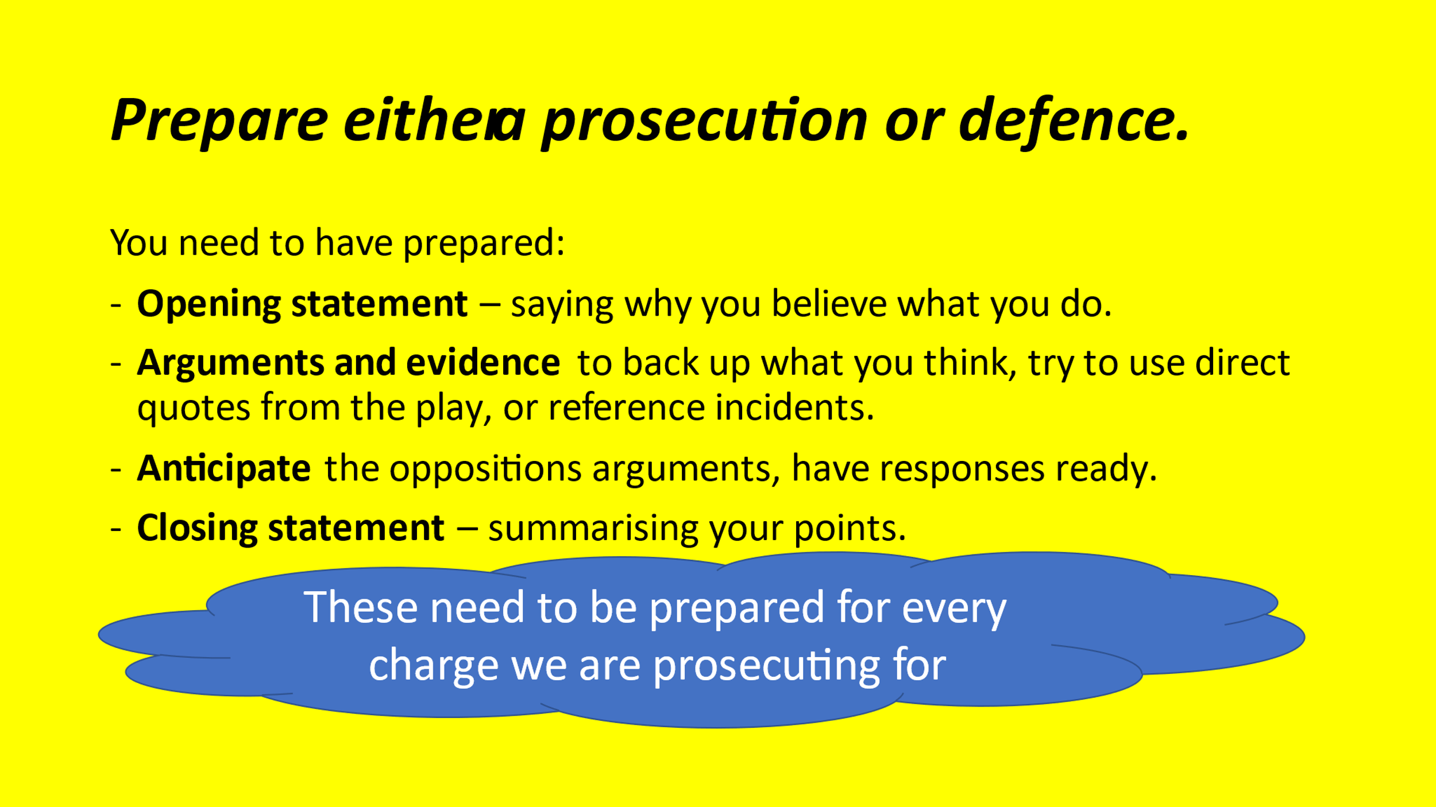

DIP - Once you gathered all your evidence, prepare your court case and write up your speech in an engaging and persuasive way.

Attainment Band | Frankenstein
Yellow Plus | - You provide direct rebuttal to counterarguments or adjust your own opinions to reflect the strengths of points that others have made.  - You actively seek the views of others to challenge and develop your own, ensuring all participants have the opportunity to speak.  - You make consistent and effective use of body language and other forms of non-verbal communication both while speaking and listening.  - All elements of your language use are specific and precise.  - You provide overall reflections, conclusions, or balanced assessment of the discussion.
Yellow | - Your arguments build on things you or others have previously said, starting to consider and critically engage with alternative ideas or opinions.  - You demonstrate the value of contributions from others by building on their points or respectfully challenging them where you do not agree.  - You consciously seek to engage your audience while speaking, e.g. explicitly using body language or the tone of your voice. You react and respond to what the speaker says, and you are able to refocus quickly.  - Your vocabulary choices are ambitious, including attempts at technical or subject-specific terminology. You demonstrate a firm grasp of your context.  - You present alternative arguments or ask questions to respectfully challenge.
Blue | - You formulate your own response or opinions and provide detailed reasons to support your ideas. You make consistent use of scaffolds or sentence stems.  - You respect the views of others and their right to have an opinion. You ask questions to clarify your understanding or to support them to justify their point.  - You speak clearly and at an appropriate volume. You make good eye contact with the speaker or your audience and provide the speaker with nods or short words of encouragement.  - Your vocabulary, register, grammar, and level of formality are appropriate for the context.  - You can develop or run with an idea and ask questions to clarify meaning.
Green | - You formulate your own responses or opinions with simple justification. You volunteer ideas unprompted and make some use of scaffolds and sentence stems.  - You are fully focused on the speaker and you remain calm and still while listening carefully to what they have to say.  - You are comfortable making yourself head but there are occasional issues with volume. You make some eye contact with the speaker or your audience.  - You move beyond simple word choices and register/grammar attempt to reflect your setting or audience.  - You can instigate a discussion by providing the first opinion.
White | - You attempt to answer a question or make a verbal contribution when prompted by the teacher or another pupil.  - You understand only one person should speak at a time and you are mostly focused on the speaker.  - What you say can be understood, and you look at the person who is speaking.  - The vocabulary you use makes sense.  - You can repeat what somebody else has said.

