
English Literature
Paper 1


Overview of English Literature Paper 1
Exam Board: AQA
Time: 1 hour 45 minutes
Content: Macbeth and A Christmas Carol

You should spend 50 minutes on Macbeth and 50 minutes on A Christmas Carol. This then gives you 5 minutes to check your work.
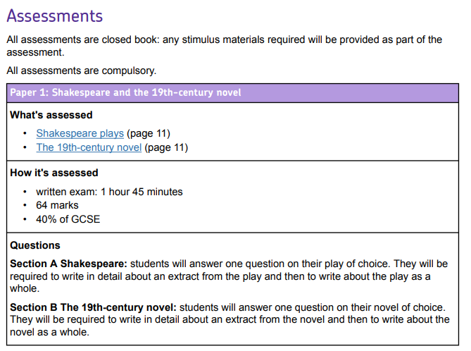

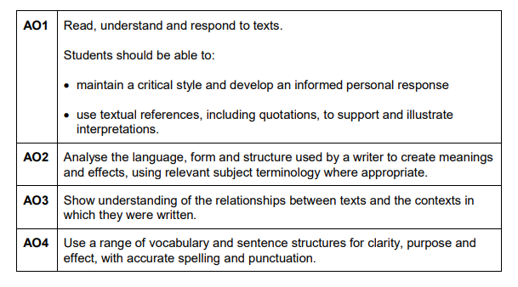
Mark Scheme
For each exam you will be marked on the following assessment objectives:

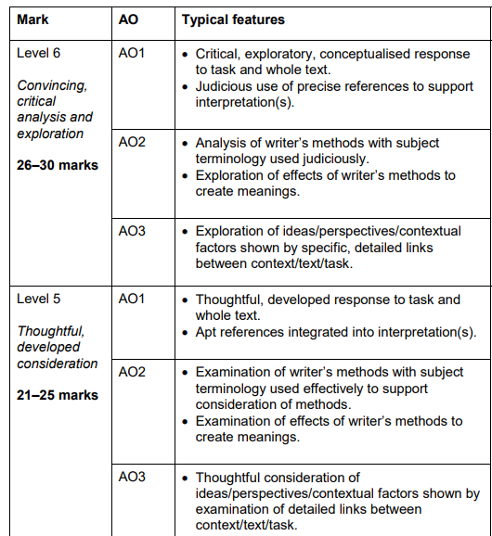
AO1- you need to build an argument across your essay. You need to discuss the whole text as well as the extract.

AO2- you need to explore the use of language and structure. What is the writer trying to convey? Why are they wanting to show their audience this?

AO3- context doesn’t just mean the Victorian period or the Jacobean era. You need to think about the themes being used and the writers’ intentions.

Essay Structure
Introduction
Every essay you write should include an introduction. In your introduction you need to include an overview of the text, some key themes and a link to the exam question.
Macbeth
The eponymous play Macbeth clearly conveys the repercussions of committing regicide. Shakespeare wrote the play after the foiled gunpowder plot, therefore using it to insight fear into his audience and demonstrate the punishments for going against the Divine Right of Kings. The relationship between Macbeth and Lady Macbeth is used to…
Only the underlined section would change depending on what the given exam question is.
A Christmas Carol
A Christmas Carol by Dickens focuses on the redemption of the cold-hearted Scrooge. Dickens uses the novella as a critique of the indifference that the wealthy had of the poor and the selfish pursuit of materialistic wealth that was often seen in the period. (insert link to the questions here)

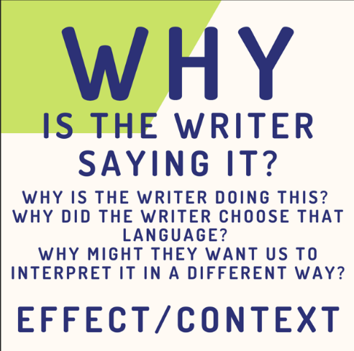
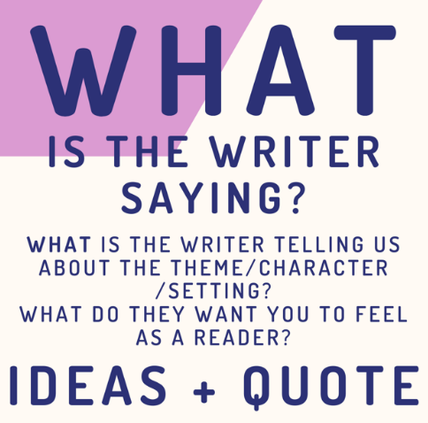
Paragraph Structure
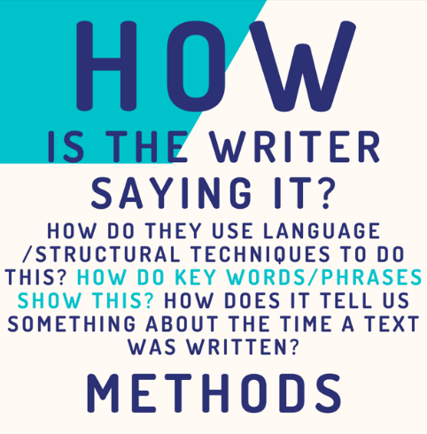
Topic sentence linked to the question
Evidence from the text. If it’s from the extract, it’s a direct quotation. If it’s from elsewhere, it can just be a moment. It doesn’t have to be an exact quotation.
Explanation and analysis- zoom in on key words. What is the effect? Why have they been chosen?
Link everything back to the question/theme/context. You do not have to put historical context into every paragraph! It doesn’t need to come into your essay at all.

At the beginning of ACC, Dickens presents family to be an annoyance for Scrooge which is evident when his nephew visits him at his place of work. When Fred visits Scrooge he announces, ‘A Merry Christmas, uncle!’ showing how friendly and excitable he is. Dickens purposefully uses Fred as the anthesis of Scrooge to demonstrate to his readers how one should behave towards their family. The use of the exclamation even after Scrooge has been rude to his nephew conveys how Fred will continue to try and have a relationship with his uncle regardless of his behaviour. Dickens uses this uncomfortable exchange to show the importance of familial relationships and how Scrooge had a lack of them at the beginning of the novella.

Topic sentence linked to the question

Evidence from the text.

Explanation and analysis- zoom in on key words. What is the effect? Why have they been chosen?

Link everything back to the question/theme/context.

Essay Structure
Step 1- read and highlight the question. Cross out the words ‘starting with this extract’. DO NOT READ THE EXTRACT YET
Step 2- write down everything you know about the question from the text
Step 3- read and annotate the extract
Step 4- slot the extract into your ideas. Remember, you MUST talk about the text in chronological order
Step 5- write your introduction. It needs to outline an argument
Step 6- write your essay! Always write in chronological order and slot in the extract
Top Tips
- Do not write about the extract first
- Always plan your answer before reading the extract
- You do not have to know quotations. You will get your AO2 marks from the extract

Macbeth Past Questions
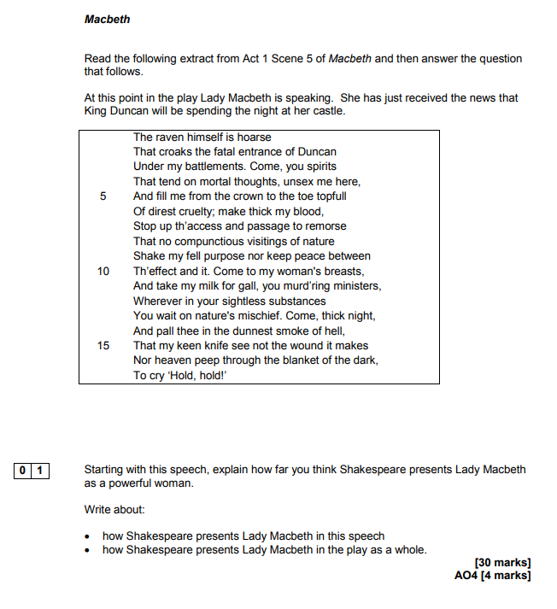
Step 1- read and highlight the question. Cross out the words ‘starting with this extract’. DO NOT READ THE EXTRACT YET
Step 2- write down everything you know about the question from the text
Step 3- read and annotate the extract
Step 4- slot the extract into your ideas. Remember, you MUST talk about the text in chronological order
Step 5- write your introduction. It needs to outline an argument
Step 6- write your essay! Always write in chronological order and slot in the extract

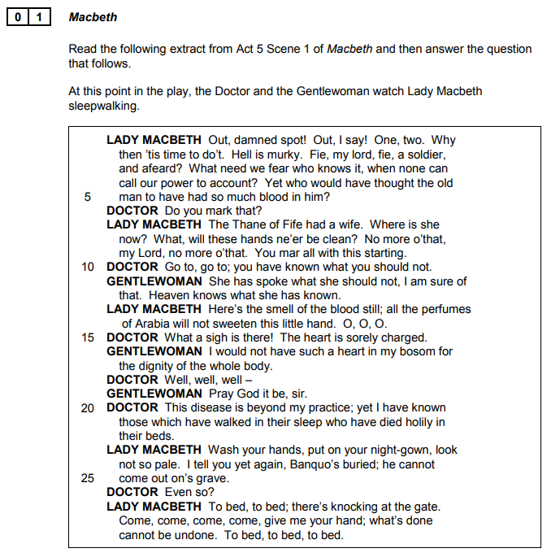

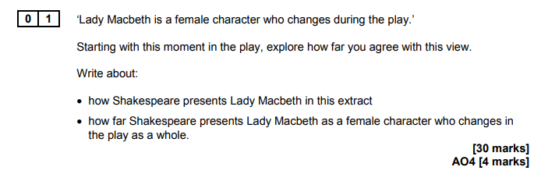

Step 1- read and highlight the question. Cross out the words ‘starting with this extract’. DO NOT READ THE EXTRACT YET
Step 2- write down everything you know about the question from the text
Step 3- read and annotate the extract
Step 4- slot the extract into your ideas. Remember, you MUST talk about the text in chronological order
Step 5- write your introduction. It needs to outline an argument
Step 6- write your essay! Always write in chronological order and slot in the extract

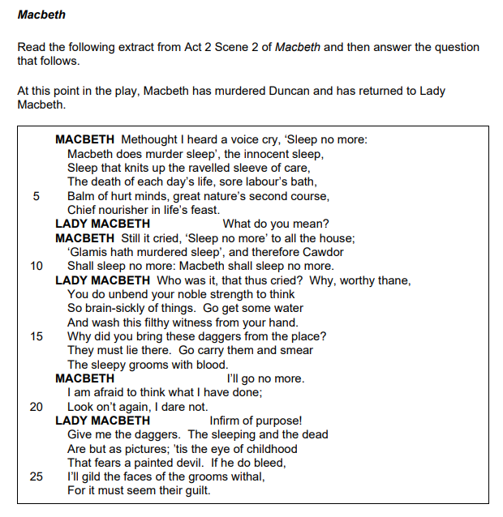

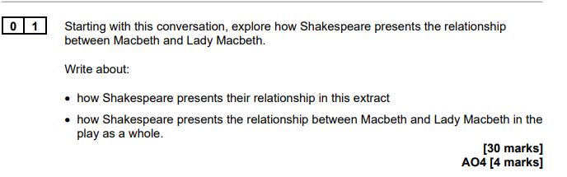

Step 1- read and highlight the question. Cross out the words ‘starting with this extract’. DO NOT READ THE EXTRACT YET
Step 2- write down everything you know about the question from the text
Step 3- read and annotate the extract
Step 4- slot the extract into your ideas. Remember, you MUST talk about the text in chronological order
Step 5- write your introduction. It needs to outline an argument
Step 6- write your essay! Always write in chronological order and slot in the extract

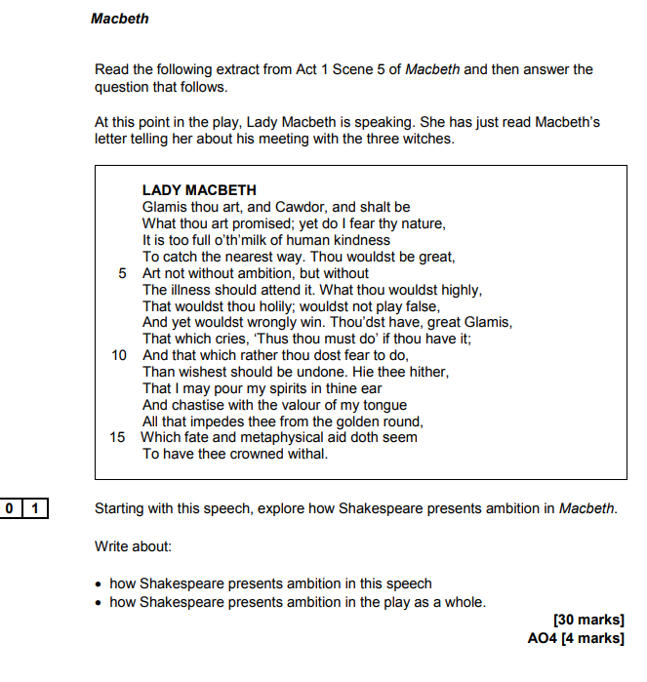

Step 1- read and highlight the question. Cross out the words ‘starting with this extract’. DO NOT READ THE EXTRACT YET
Step 2- write down everything you know about the question from the text
Step 3- read and annotate the extract
Step 4- slot the extract into your ideas. Remember, you MUST talk about the text in chronological order
Step 5- write your introduction. It needs to outline an argument
Step 6- write your essay! Always write in chronological order and slot in the extract

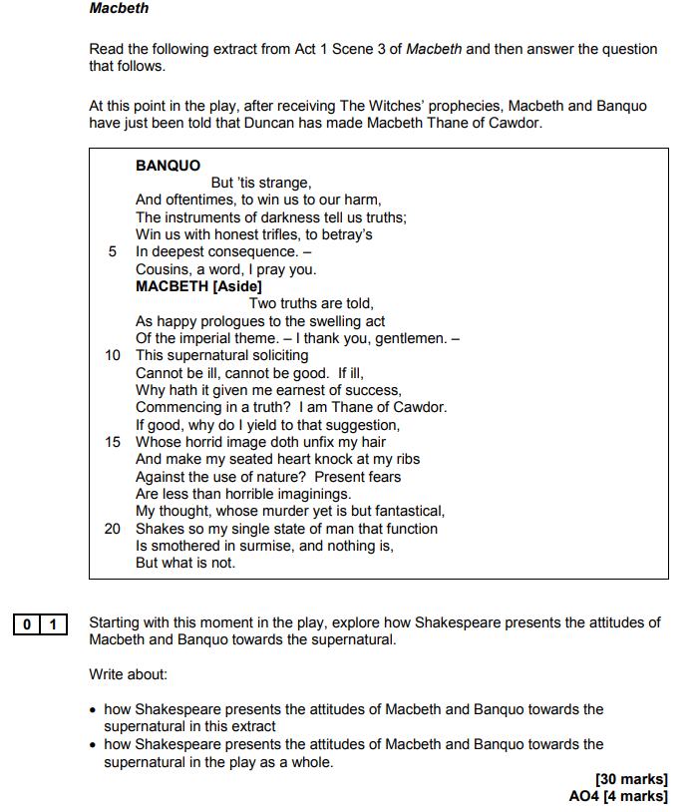

Step 1- read and highlight the question. Cross out the words ‘starting with this extract’. DO NOT READ THE EXTRACT YET
Step 2- write down everything you know about the question from the text
Step 3- read and annotate the extract
Step 4- slot the extract into your ideas. Remember, you MUST talk about the text in chronological order
Step 5- write your introduction. It needs to outline an argument
Step 6- write your essay! Always write in chronological order and slot in the extract

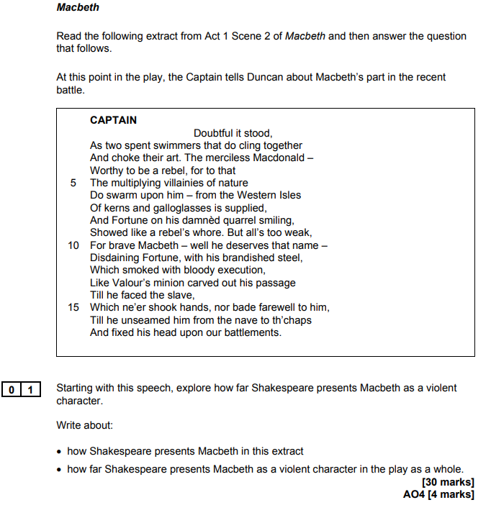

Step 1- read and highlight the question. Cross out the words ‘starting with this extract’. DO NOT READ THE EXTRACT YET
Step 2- write down everything you know about the question from the text
Step 3- read and annotate the extract
Step 4- slot the extract into your ideas. Remember, you MUST talk about the text in chronological order
Step 5- write your introduction. It needs to outline an argument
Step 6- write your essay! Always write in chronological order and slot in the extract

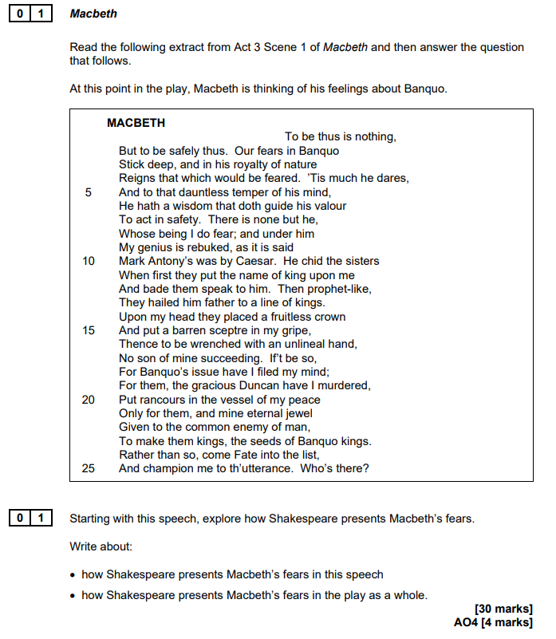

Step 1- read and highlight the question. Cross out the words ‘starting with this extract’. DO NOT READ THE EXTRACT YET
Step 2- write down everything you know about the question from the text
Step 3- read and annotate the extract
Step 4- slot the extract into your ideas. Remember, you MUST talk about the text in chronological order
Step 5- write your introduction. It needs to outline an argument
Step 6- write your essay! Always write in chronological order and slot in the extract

A Christmas Carol Past Questions
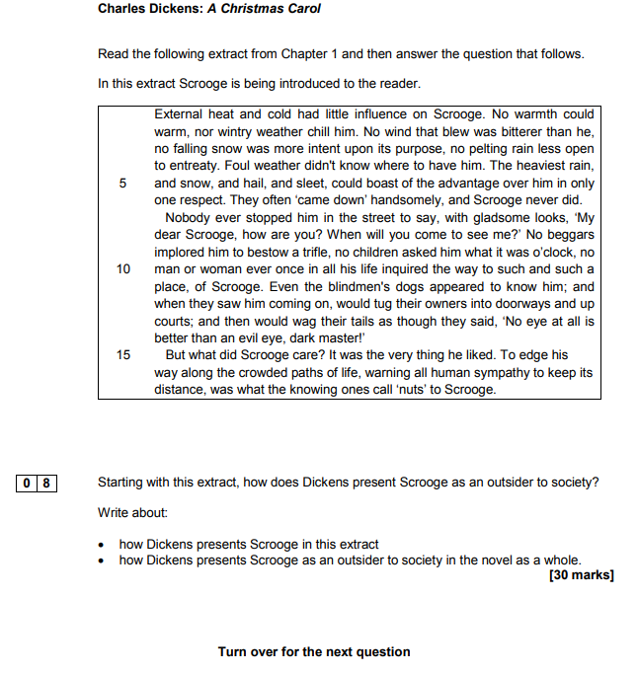

Step 1- read and highlight the question. Cross out the words ‘starting with this extract’. DO NOT READ THE EXTRACT YET
Step 2- write down everything you know about the question from the text
Step 3- read and annotate the extract
Step 4- slot the extract into your ideas. Remember, you MUST talk about the text in chronological order
Step 5- write your introduction. It needs to outline an argument
Step 6- write your essay! Always write in chronological order and slot in the extract
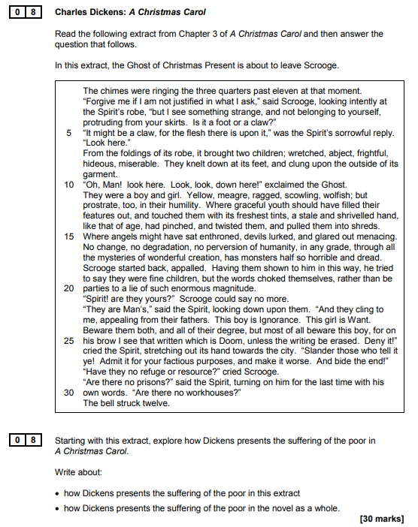

Step 1- read and highlight the question. Cross out the words ‘starting with this extract’. DO NOT READ THE EXTRACT YET
Step 2- write down everything you know about the question from the text
Step 3- read and annotate the extract
Step 4- slot the extract into your ideas. Remember, you MUST talk about the text in chronological order
Step 5- write your introduction. It needs to outline an argument
Step 6- write your essay! Always write in chronological order and slot in the extract
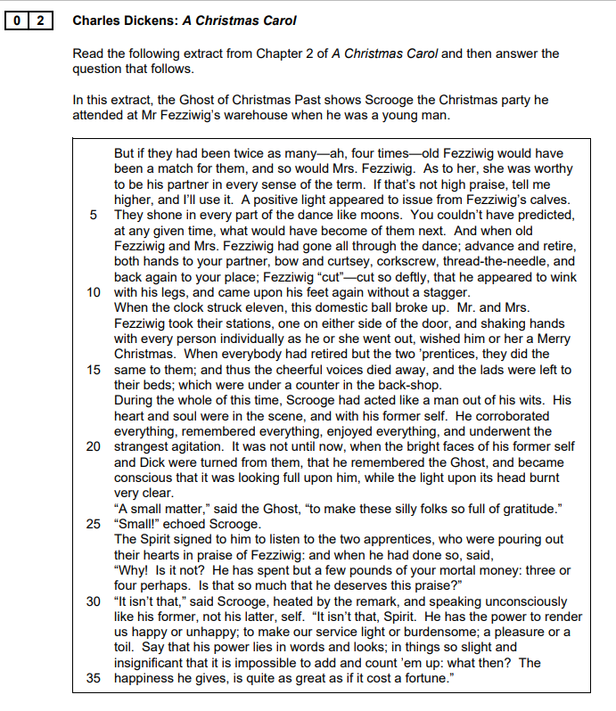

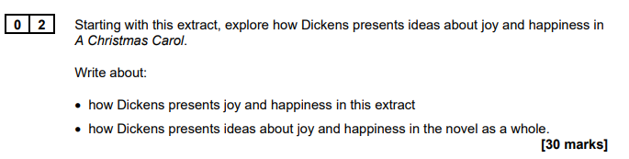

Step 1- read and highlight the question. Cross out the words ‘starting with this extract’. DO NOT READ THE EXTRACT YET
Step 2- write down everything you know about the question from the text
Step 3- read and annotate the extract
Step 4- slot the extract into your ideas. Remember, you MUST talk about the text in chronological order
Step 5- write your introduction. It needs to outline an argument
Step 6- write your essay! Always write in chronological order and slot in the extract
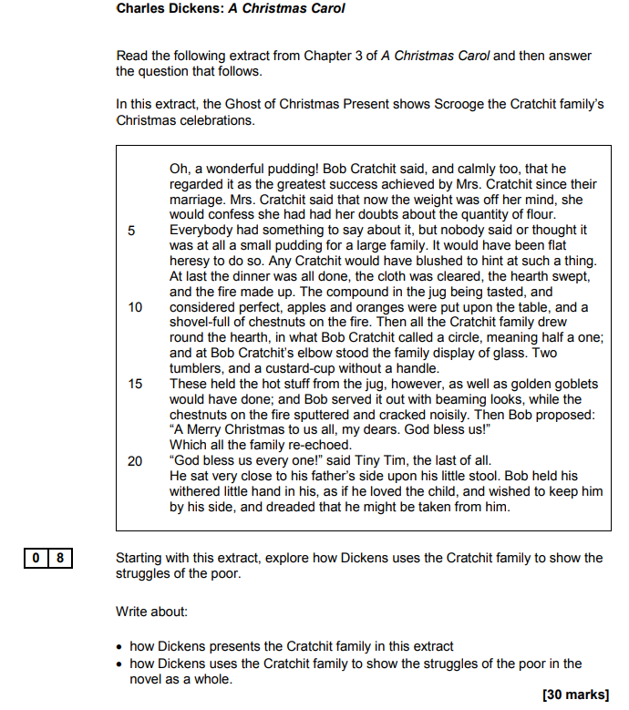

Step 1- read and highlight the question. Cross out the words ‘starting with this extract’. DO NOT READ THE EXTRACT YET
Step 2- write down everything you know about the question from the text
Step 3- read and annotate the extract
Step 4- slot the extract into your ideas. Remember, you MUST talk about the text in chronological order
Step 5- write your introduction. It needs to outline an argument
Step 6- write your essay! Always write in chronological order and slot in the extract

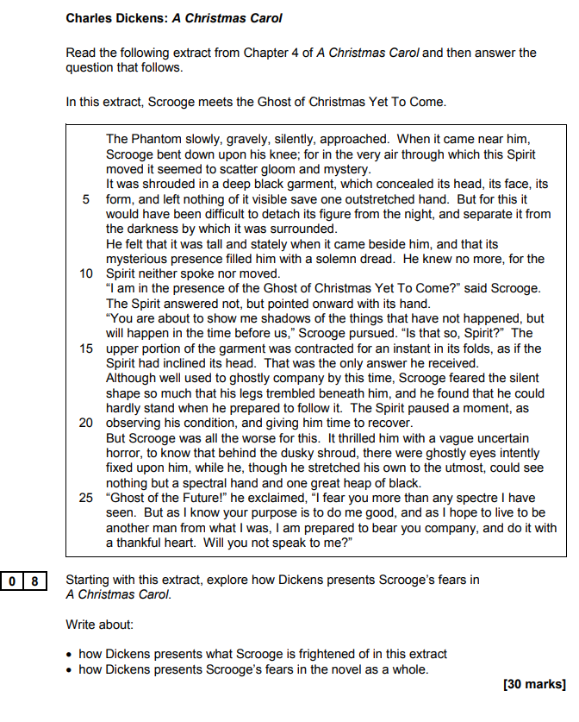

Step 1- read and highlight the question. Cross out the words ‘starting with this extract’. DO NOT READ THE EXTRACT YET
Step 2- write down everything you know about the question from the text
Step 3- read and annotate the extract
Step 4- slot the extract into your ideas. Remember, you MUST talk about the text in chronological order
Step 5- write your introduction. It needs to outline an argument
Step 6- write your essay! Always write in chronological order and slot in the extract
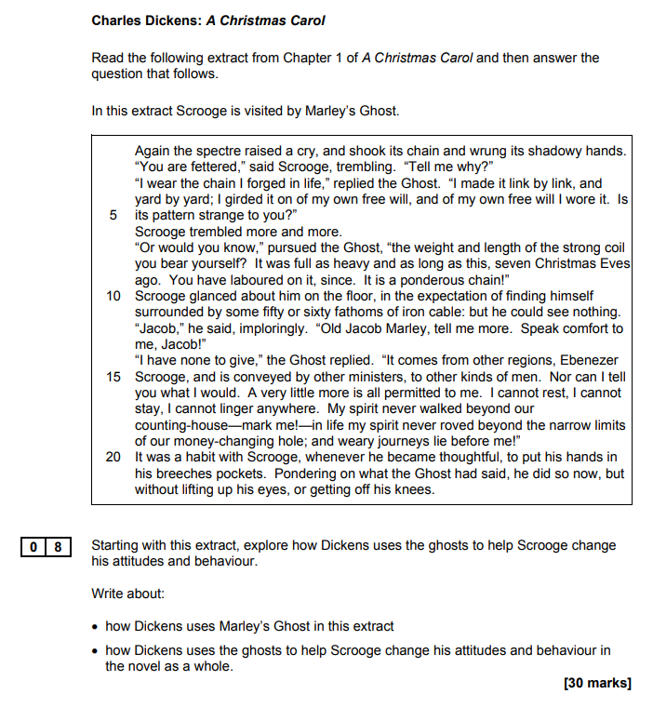
Step 1- read and highlight the question. Cross out the words ‘starting with this extract’. DO NOT READ THE EXTRACT YET
Step 2- write down everything you know about the question from the text
Step 3- read and annotate the extract
Step 4- slot the extract into your ideas. Remember, you MUST talk about the text in chronological order
Step 5- write your introduction. It needs to outline an argument
Step 6- write your essay! Always write in chronological order and slot in the extract

