
English Language
Paper 1


Overview of English Language Paper 1
Exam Board: AQA
Time: 1 hour 45 minutes
Content: Explorations in Creative Reading and Writing (fictional texts)

You will be given one extract from either the 19th, 20th or 21st Century. There will be 4 reading questions and one writing question.
Question 1- select 4 true statements (5 minutes)
Question 2- language analysis (15 minutes)
Question 3- structure analysis (15 minutes)
Question 4- evaluation (25 minutes)
Question 5- narrative/descriptive writing (45 minutes)
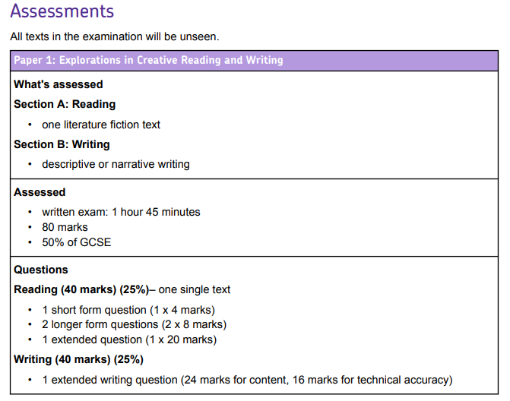

Question 2 -Language analysis
You will be given a section of the text that you are expected to analyse.
Step 1- read the question and highlight what it is asking you to analyse
Step 2- Spend 3 minutes annotating finding around 4-5 quotations that answer the question
Step 3- begin writing. You do not need an introduction.

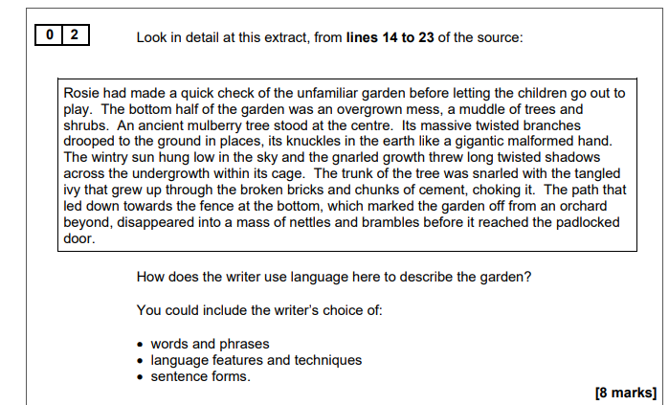

Sentence Starters
The writer uses language to describe the (insert question) through the phrase ‘(insert quotation- no longer than 5 words)’. This suggests that ________________________________________. Furthermore, the use of the word conveys how/shows/demonstrates/creates the idea/atmosphere _______________________________ __________________________________. It could also suggest _______________________________________.
As the extract continues, the writer uses the phrase ‘(insert quotation- no longer than 5 words)’. This suggests that ________________________________________. Furthermore, the use of the word conveys how/shows/demonstrates/creates the idea/atmosphere _______________________________ __________________________________. It could also suggest _______________________________________.
You need to have at least 4 quotations from across the given lines

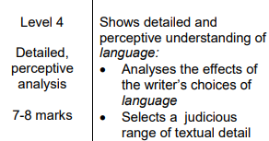
You need to explore the effect of the language used.
You need a wide range of quotations.
Explore the atmosphere/tone being created.

Question 3 -Structure analysis
This has now changed. They will now specify an effect. Questions will read:
How has the writer structured the text to create tension?
OR
How has the writer structured the text to create fear?
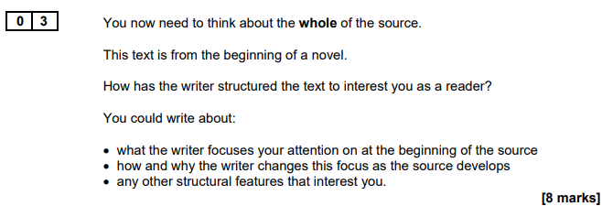

You will need to look at the whole of the text for this question.
Step 1- read the whole extract
Step 2- highlight the first and last sentence of the extract. Are they different or similar? Why?
Step 3- find 2 other areas of the text that are interesting/link to the question. Try and be on the look out for techniques
Step 4- begin writing

Sentence Starters
The writer opens the text with the focus on ___________ which creates (insert question) because ____________ ______________________________. As the opening paragraph continues, the writer focuses on ‘__________’ which further builds/creates (insert question) because _______________________________.
As the extract continues, the writer zooms in on (this will be whatever Q2 focused on) which creates/suggests/conveys/demonstrates ________________________________________________________. The writer uses the phrase ‘_____________________’ to show _________________________________________.
Furthermore, the extract continues with ________________________________________________. This suggests/shows/creates _____________________________________________________________________.
At the end of the extract, the writer __________________________________________.
You need to have spoken about the whole extract. Do not just write about one section!

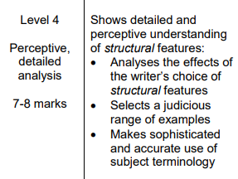
Structural Techniques
Focus Flashback
Zoom in Beginning
Zoom out Middle
Shift in focus End
Paragraph Chronological order
Short sentences Dialogue
Character Motif/pattern
Setting Contrast

Question 4 -Evaluation
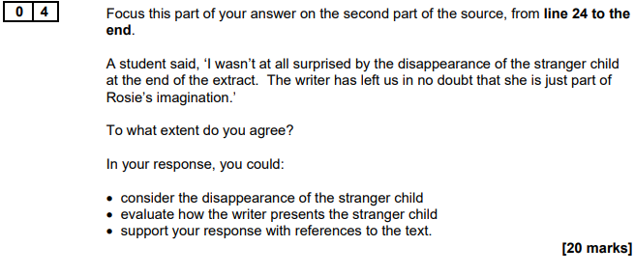
You will be given a certain section of the text to focus on. DO NOT TALK ABOUT THINGS OUTSIDE OF THESE LINES.
Step 1- read and highlight the question
Step 2- draw a box around the given lines
Step 3- number each paragraph/section with how far you agree out of 10
Step 4- find at least one quotation per section to support your number
Step 5- begin to write your answer

There will be two sections of the statement that you will need to discuss

1-2 limited
3-4 some
5-6 clear
7-8 evident
9-10 substantial

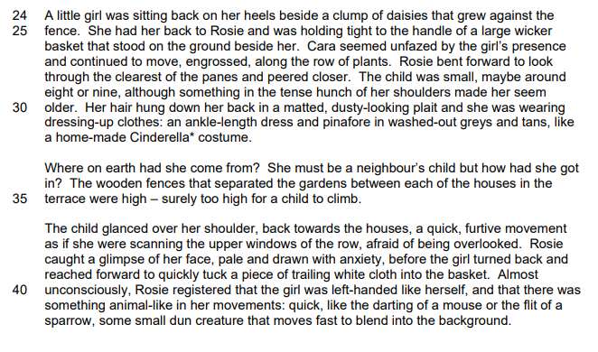
8
7

At the beginning of this section of the text, where (insert what is happening), there is (insert your word) evidence that (insert the question). The use of the phrase ‘(insert quotation)’. This creates the idea that OR This suggests that… The use of the word ‘(insert word from the quotation)’ suggests/conveys/shows/demonstrates…

As the extract continues, there is an increase/decrease in presentation that (insert question). The use of the phrase ‘(insert quotation)’. This creates the idea that OR This suggests that… The use of the word ‘(insert word from the quotation)’ suggests/conveys/shows/demonstrates…

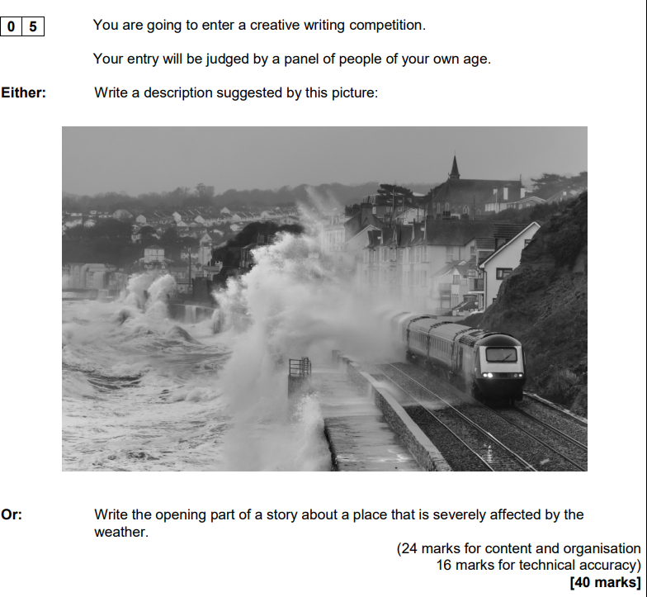
Question 5- Creative Writing

You will be given two questions, but you only have to answer one.

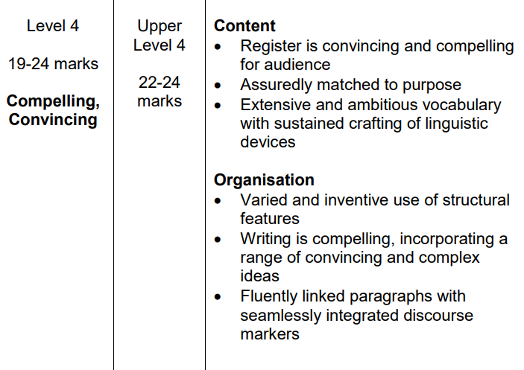
AO5
- Your work is clear. It makes sense
- You need to use a range of interesting and engaging vocabulary
- Paragraphs used correctly
- Range of structural devices (flashback, short sentences etc.)

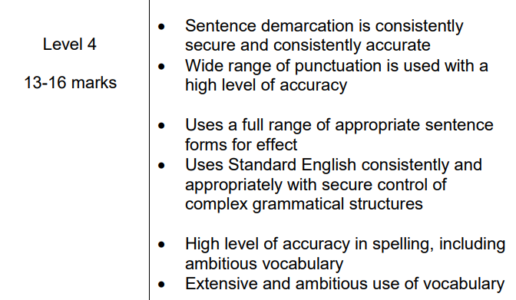
AO6
- Punctuation used correctly
- A wide range of punctuation
- A range of sentences for effect
- Interesting and engaging vocabulary
- Correct spelling



